Supplemental Material
Content

Figure S1. Relationship of FA values to age and Diagnosis
Figure S2. Relationship of FA values to age of illness onset and illness duration
Figure S3. Decreased FA in patients with BD associated with antipsychotic treatment
Figure S4. Decreased FA in patients with BD associated with anticonvulsant treatment
Figure S5. Increased FA in patients with BD associated with lithium treatment
Figure S6. Results of the meta-analysis based on bilateral tracts

Table S1. Demographic details of the contributing sites

Table S2. Available clinical data for each site
Table S3. Demographic details of the original samples (resampled sites)

Table S4. Diffusion tensor imaging acquisitions parameters for each site
Table S5. Description of the ROIs
Table S6. Mega-analysis: Linear mixed model results for FA differences between bipolar patients and healthy controls after controlling for average FA. age and sex
Table S7. Mega-analysis: Linear mixed model results for the interaction between diagnosis and age after controlling for sex
Table S8. Mega-analysis: Linear mixed model results for the interaction between diagnosis and sex after controlling for age
Table S9. Mega-analysis: Linear mixed model results for the main effect of the age of onset after controlling for age and sex
Table S10. Mega-analysis: Linear mixed model results for the main effect of illness duration after controlling for age and sex
Table S11. Mega-analysis: Linear mixed model results for the main effect of antipsychotic treatment after controlling for age and sex
Table S12. Mega-analysis: Linear mixed model results for the main effect of anticonvulsant treatment after controlling for age and sex
Table S13. Mega-analysis: Linear mixed model results for the main effect of lithium treatment after controlling for age and sex
Table S14. Mega-analysis: Linear mixed model results for the main effect of antidepressant treatment after controlling for age and sex
Table S15. Mega-analysis: Linear mixed model results for the main effect of the severity of the disease (density of episodes) after controlling for age and sex
Table S16. Mega-analysis: Linear mixed model results for the main effect of history of psychotic symptoms after controlling for age and sex
Table S17. Mega-analysis: Linear mixed model results for the main effect of type of bipolar disorder after controlling for age and sex
Table S18. Meta-analysis on bilateral tracts: Cohen’s d values, their s.e., P-values and I² values (heterogeneity between sites) sorted by effect size (descending order) for FA differences between patients with bipolar disorder and healthy controls after controlling for age and sex.

Supplemental Figures

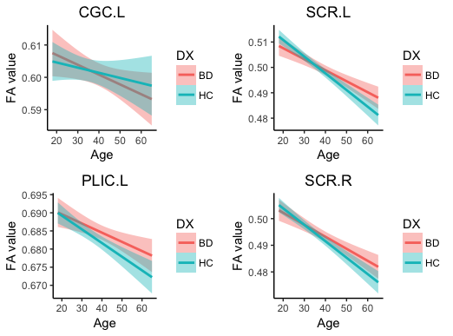

Figure S1. Relationship of FA values to age and diagnosis (BD = Bipolar disorder; CGC.L = left cingulum; HC = Healthy controls; PLIC.L = left posterior limb of the internal capsule; SCR.R/L = superior corona radiata left/right)

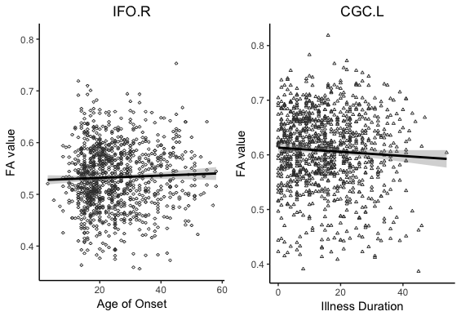

Figure S2. Relationship of FA values to age of illness onset and illness duration (IFO.R = right inferior fronto-occipital fasciculus; CGC.L = left cingulum)

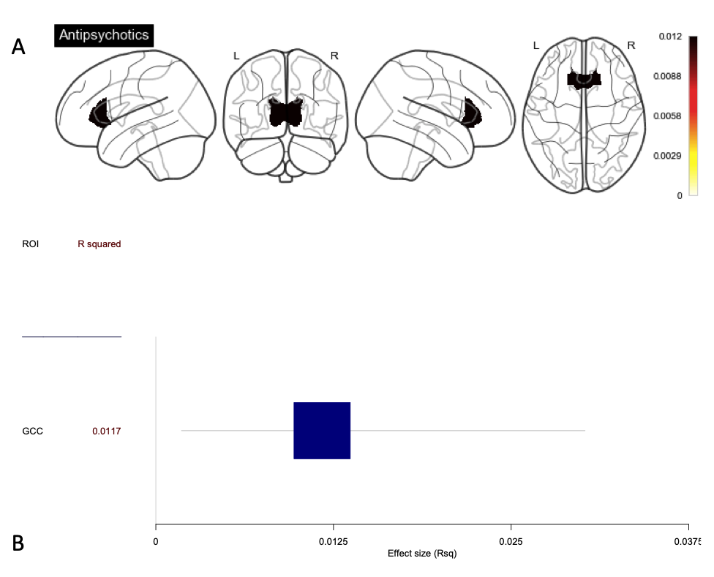

Figure S3. Decreased FA in patients with BD associated with antipsychotic treatment.
A) Effect sizes of fractional anisotropy (FA) differences between patients ON vs. OFF Antipsychotic treatment projected on white matter (WM) tracts showing significant difference. B) R squared effect size with confidence interval sorted in increase magnitude for the regions showing significant differences between patients ON vs. OFF Antipsychotics.

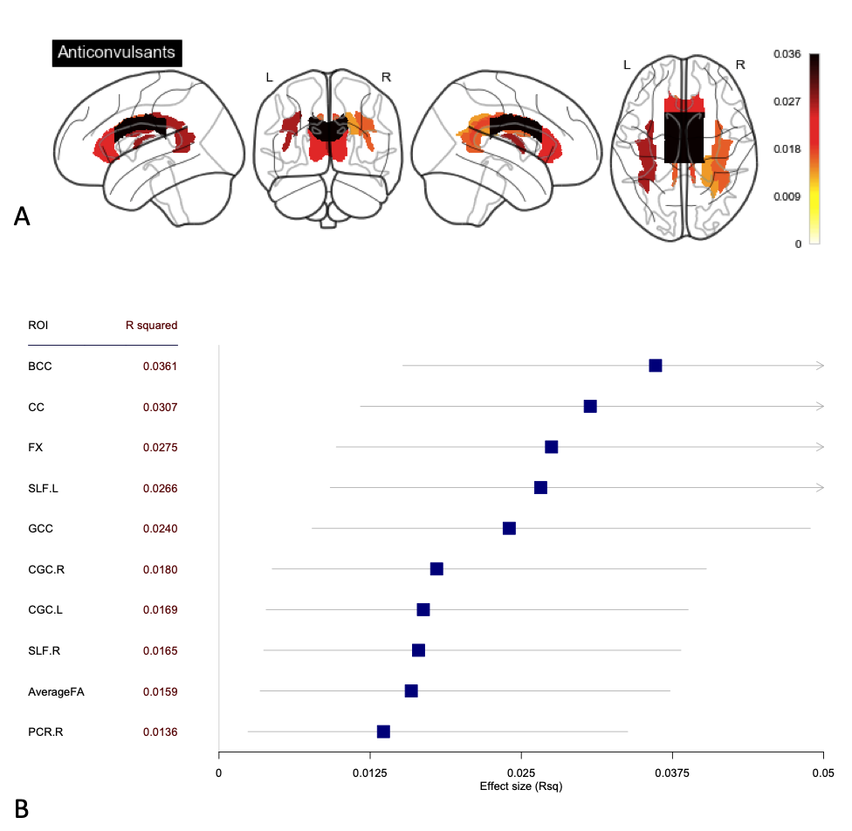

Figure S4. Decreased FA in patients with BD associated with anticonvulsant treatment.
A) Effect sizes of fractional anisotropy (FA) differences between patients ON vs. OFF Anticonvulsant treatment projected on white matter (WM) tracts showing significant difference. B) R squared effect size with confidence interval sorted in increase magnitude for the regions showing significant differences between patients ON vs. OFF Anticonvulsants

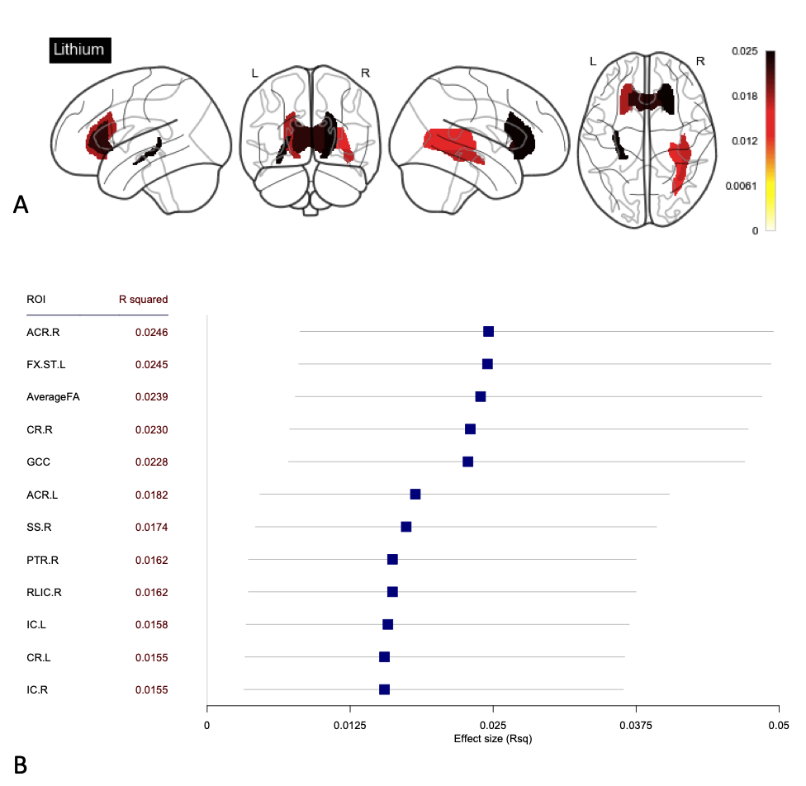

Figure S5. Increased FA in patients with BD associated with lithium treatment.
A) Effect sizes of fractional anisotropy (FA) differences between patients ON vs. OFF Lithium treatment projected on white matter (WM) tracts showing significant difference. B) R squared effect size with confidence interval sorted in increase magnitude for the regions showing significant differences between patients ON vs. OFF Lithium.

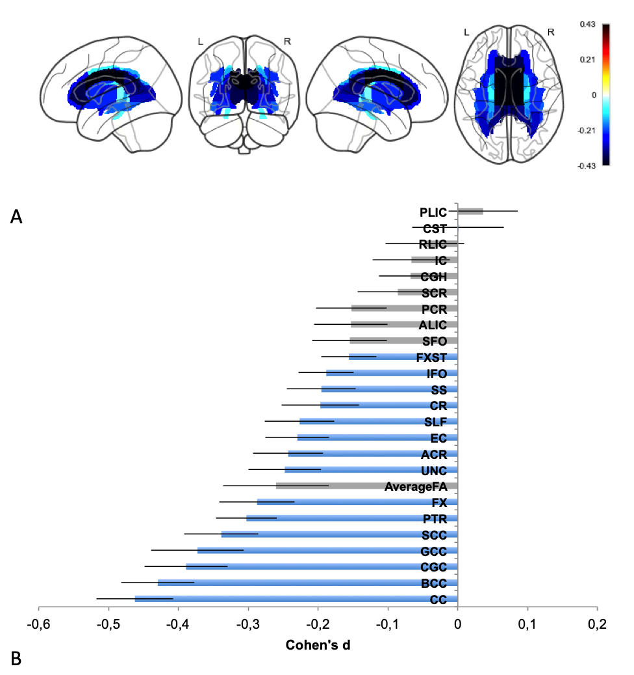

Figure S6. Results of the meta-analysis based on bilateral tracts. A) Effect sizes of fractional anisotropy (FA) differences between patients with bipolar disorder (BD) and healthy controls projected on the 25 white matter (WM) tracts analyzed. B) Cohen’s d effect size sorted in increase magnitude for significant differences between bipolar patients and healthy controls. Significant findings after Bonferroni correction are highlighted in blue. Error bars represent standard error.

Supplemental Tables

Table S1. Demographic details of the contributing sites
Cohort | Bipolar Patients |  |  | Healthy Controls
 | N | Age | %F | N | Age | %F | N Tot.
1_Munster | 41 | 39.0 | 51.2% | 122 | 37.9 | 53.3% | 163
2_UNSW | 61 | 25.3 | 68.9% | 80 | 22.7 | 53.8% | 141
3.1_UNC | 60 | 33.9 | 60.0% | 42 | 33.3 | 50.0% | 102
3.2_UNC | 20 | 34.5 | 35.0% | 9 | 35.2 | 11.1% | 29
4_UCT | 20 | 29.8 | 55.0% | 24 | 26.0 | 45.8% | 44
5_KI | 38 | 41.3 | 65.8% | 12 | 42.5 | 25.0% | 50
6_Cardiff | 63 | 43.8 | 63.5% | 40 | 43.5 | 60.0% | 103
7.1_Edimburgh | 12 | 44.8 | 33.3% | 34 | 36.9 | 47.1% | 46
7.2_Edimburgh | 27 | 46.3 | 63.0% | 24 | 43.8 | 58.3% | 51
8.1_IoL | 35 | 35.1 | 51.4% | 104 | 33.1 | 40.4% | 139
8.2_IoL | 18 | 36.1 | 72.2% | 57 | 25.0 | 49.1% | 75
8.3_IoL | 84 | 32.2 | 72.6% | 96 | 32.2 | 62.5% | 180
9.1_Oslo_TOP | 57 | 31.5 | 50.9% | 174 | 32.4 | 41.4% | 231
9.2_Oslo_Malt | 42 | 36.0 | 73.8% | 41 | 33.8 | 56.1% | 83
10_VitaSalute | 204 | 46.0 | 65.2% | 136 | 33.0 | 55.1% | 340
11_FIDMAG | 58 | 41.9 | 58.6% | 52 | 39.5 | 53.8% | 110
12_Creteil | 34 | 36.1 | 38.2% | 52 | 34.9 | 55.8% | 86
13_UCLA | 238 | 46.5 | 52.9% | 156 | 43.2 | 49.4% | 394
15_Mannheim | 41 | 40.8 | 56.1% | 37 | 40.7 | 54.1% | 78
16_UCSD | 39 | 45.8 | 71.8% | 58 | 48.8 | 48.3% | 97
17_Grenoble | 18 | 43.3 | 50.0% | 12 | 43.6 | 66.7% | 30
19_SaoPaulo | 40 | 29.1 | 65.0% | 42 | 27.4 | 35.7% | 82
20_Pittsburgh | 77 | 33.5 | 74.0% | 36 | 34.1 | 69.4% | 113
21_Columbia | 75 | 39.6 | 64.0% | 0 |  |  | 75
22_Singapour | 44 | 34.5 | 59.1% | 44 | 34.1 | 52.3% | 88
23_Halifax | 36 | 45.4 | 58.3% | 67 | 33.6 | 62.7% | 103
TOTAL | 1482 | 39.6 | 60.7% | 1551 | 35.1 | 51.1% | 3033

Table S2. Available clinical data for each site
 | 1_Munster |  |  | 2_UNSW |  |  | 3.1_UNC |  |  | 4_UCT |  |  | 6_Cardiff |  |  | 7.1_Edimburgh
 | count | mean | std | count | mean | std | count | mean | std | count | mean | std | count | mean | std | count | mean | std
Age of Onset | 41 | 26.0 | 9.6 | 57 | 16.1 | 3.6 | NA |  |  | 20 | 22.0 | 4.4 | 50 | 19.6 | 7.1 | NA
Illness Duration | 41 | 12.9 | 10.1 | 57 | 9.2 | 4.1 | NA |  |  | 20 | 7.9 | 5.6 | 50 | 24.0 | 8.7 | NA
Density of Episodes | 38 | 1.3 | 1.6 | 27 | 2.2 | 1.5 | NA |  |  | NA |  |  | NA |  |  | NA
Depression score
HDRS-17
HDRS-21 | 35 | 22.3 | 5.1 |  |  |  |  |  |  | 20 | 2.8 | 4.1 | 63 | 3.8 | 3.6 | 12 | 4.2 | 7.6
MADRS |  |  |  | 48 | 10.6 | 9.7 | 57 | 15.6 | 11.7
Number of Depressive Episodes | 41 | 6.5 | 4.9 | 55 | 9.4 | 7.1 | 57 | 12.5 | 8.0 | NA |  |  | NA |  |  | NA
Mania Score (YMRS) | 40 | 4.0 | 4.4 | 48 | 4.9 | 4.4 | 57 | 4.9 | 5.0 | 20 | 1.7 | 3.9 | 63 | 2.7 | 2.8 | 11 | 3.5 | 4.1
Number of Manic Episodes | 40 | 2.4 | 3.1 | 27 | 9.4 | 7.2 | 56 | 9.9 | 8.9 | NA |  |  | NA |  |  | NA
Total Episodes | 40 | 9.0 | 6.2 | 27 | 18.6 | 11.1 | 56 | 22.2 | 14.2 | NA |  |  | NA |  |  | NA
On Medication | 41 | 0.9 | 0.3 | 58 | 0.8 | 0.4 | 55 | 0.3 | 0.5 | 20 | 1.0 | 0.0 | 63 | 0.8 | 0.4 | 11 | 0.5 | 0.5
Antipsychotics | 41 | 0.7 | 0.5 | 58 | 0.3 | 0.5 | 55 | 0.1 | 0.3 | 20 | 0.7 | 0.5 | 63 | 0.4 | 0.5 | 11 | 0.4 | 0.5
Anticonvulsants | 41 | 0.3 | 0.5 | 55 | 0.6 | 0.5 | 55 | 0.2 | 0.4 | 20 | 0.6 | 0.5 | 63 | 0.4 | 0.5 | NA
Antidepressants | 41 | 0.5 | 0.5 | 58 | 0.4 | 0.5 | 55 | 0.2 | 0.4 | 20 | 0.1 | 0.2 | 63 | 0.5 | 0.5 | 11 | 0.2 | 0.4
Lithium | 41 | 0.3 | 0.5 | 58 | 0.3 | 0.4 | 55 | 0.1 | 0.3 | 19 | 0.4 | 0.5 | 63 | 0.2 | 0.4 | 11 | 0.2 | 0.4
Lifetime alcohol abuse | NA |  |  | 2 | 1.0 | 0.0 | NA |  |  | NA |  |  | NA |  |  | NA
History of psychotic symptoms | NA |  |  | 56 | 0.3 | 0.5 | 57 | 0.8 | 0.4 | 20 | 1.0 | 0.0 | 63 | 0.2 | 0.4 | NA
Onset time |  |  |  |  |  |  | NA |  |  |  |  |  |  |  |  | NA
Early | 12 |  |  | 46 |  |  |  |  |  | 4 |  |  | 28
Intermediate | 21 |  |  | 11 |  |  |  |  |  | 16 |  |  | 20
Late | 8 |  |  |  |  |  |  |  |  |  |  |  | 2
BD Type |  |  |  |  |  |  |  |  |  |  |  |  | NA
BD1 | 27 |  |  | 32 |  |  | 45 |  |  | 20 |  |  |  |  |  | 12
BD2 | 13 |  |  | 26 |  |  | 12
Mood phase |  |  |  |  |  |  |  |  |  |  |  |  |  |  |  | NA
Depressed | 41 |  |  | 2 |  |  | 28
Euthymic |  |  |  |  |  |  | 20 |  |  | 20 |  |  | 63
Hypomanic |  |  |  |  |  |  | 2
Manic |  |  |  |  |  |  | 2
NA: Not Available

Table S2. Available clinical data for each site (continuation)
 | 7.2_Edimburgh |  |  | 9.2_Oslo_Malt |  |  | 10_VitaSalute |  |  | 11_FIDMAG |  |  | 12_Creteil |  |  | 13_UCLA
 | count | mean | std | count | mean | std | count | mean | std | count | mean | std | count | mean | std | count | mean | std
Age of Onset | NA |  |  | 41 | 16.0 | 6.0 | 204 | 30.8 | 10.4 | 56 | 26.1 | 8.8 | 30 | 22.2 | 8.0 | 224 | 29.6 | 10.5
Illness Duration | NA |  |  | 41 | 20.6 | 6.8 | 204 | 15.2 | 10.4 | 56 | 15.6 | 8.7 | 30 | 12.7 | 9.7 | 224 | 16.4 | 11.0
Density of Episodes | NA |  |  | NA |  |  | 198 | 0.8 | 0.9 | 44 | 0.6 | 0.5 | NA |  |  | NA
Depression score |  |  |  |  |  |  | NA |  |  |  |  |  |  |  |  | NA
HDRS-17
HDRS-21 | 27 | 6.3 | 4.5 |  |  |  |  |  |  | 54 | 2.3 | 2.8
MADRS |  |  |  | 40 | 9.8 | 7.1 |  |  |  |  |  |  | 30 | 5.3 | 7.4
Number of Depressive Episodes | NA |  |  | NA |  |  | 200 | 5.0 | 4.8 | 46 | 3.5 | 3.7 | NA |  |  | NA
Mania Score (YMRS) | 27 | 2.1 | 2.9 | 38 | 2.6 | 2.4 | NA |  |  | 55 | 1.1 | 1.8 | 29 | 4.5 | 6.0 | NA
Number of Manic Episodes | NA |  |  | NA |  |  | 201 | 3.1 | 3.9 | 48 | 3.1 | 2.7 | NA |  |  | NA
Total Episodes | NA |  |  | NA |  |  | 200 | 8.1 | 7.8 | 45 | 6.7 | 4.7 | NA |  |  | NA
On Medication | 25 | 1.0 | 0.2 | 40 | 0.8 | 0.4 | NA |  |  | 55 | 1.0 | 0.1 | 31 | 1.0 | 0.2 | 230 | 0.9 | 0.3
Antipsychotics | 25 | 0.5 | 0.5 | 39 | 0.2 | 0.4 | NA |  |  | 55 | 0.6 | 0.5 | 31 | 0.5 | 0.5 | 230 | 0.4 | 0.5
Anticonvulsants | 25 | 0.4 | 0.5 | 40 | 0.6 | 0.5 | NA |  |  | 54 | 0.4 | 0.5 | 31 | 0.5 | 0.5 | 230 | 0.2 | 0.4
Antidepressants | 25 | 0.4 | 0.5 | 40 | 0.3 | 0.5 | NA |  |  | 54 | 0.3 | 0.5 | 31 | 0.3 | 0.5 | 230 | 0.2 | 0.4
Lithium | 25 | 0.6 | 0.5 | 40 | 0.1 | 0.2 | NA |  |  | 54 | 0.8 | 0.4 | 31 | 0.5 | 0.5 | 230 | 0.7 | 0.5
Lifetime alcohol abuse | NA |  |  | NA |  |  | NA |  |  | NA |  |  | NA |  |  | NA
History of psychotic symptoms | NA |  |  | NA |  |  | 204 | 0.3 | 0.4 | 54 | 0.8 | 0.4 | 24 | 0.9 | 0.3 | 223 | 0.8 | 0.4
Onset time | NA
Early |  |  |  | 32 |  |  | 27 |  |  | 11 |  |  | 9 |  |  | 32
Intermediate |  |  |  | 8 |  |  | 116 |  |  | 34 |  |  | 19 |  |  | 131
Late |  |  |  | 1 |  |  | 61 |  |  | 11 |  |  | 2 |  |  | 61
BD type |  |  |  |  |  |  |  |  |  |  |  |  | NA |  |  | NA
BD1 | 27 |  |  |  |  |  |  |  |  | 58
BD2 |  |  |  | 42
Mood phase | NA |  |  |  |  |  |  |  |  |  |  |  |  |  |  | NA
Depressed |  |  |  |  |  |  | 178 |  |  |  |  |  | 11
Euthymic |  |  |  |  |  |  | 6 |  |  | 57 |  |  | 19
Hypomanic
Manic |  |  |  |  |  |  | 16
NA: Not Available

Table S2. Available clinical data for each site (continuation)
 | 15_Mannheim |  |  | 16_UCSD |  |  | 17_Grenoble |  |  | 19_SaoPaulo |  |  | 20_Pittsburgh |  |  | 21_Columbia |  |  | 22_Singapour
 | count | mean | std | count | mean | std | count | mean | std | count | mean | std | count | mean | std | count | mean | std | count | mean | std
Age of Onset | 41 | 23.5 | 10.3 | 39 | 18.0 | 4.0 | 13 | 29.3 | 9.6 | 35 | 23.6 | 6.9 | 77 | 18.3 | 6.1 | 74 | 22.3 | 9.3 | 44 | 30.0 | 10.5
Illness Duration | 41 | 17.2 | 10.9 | 39 | 27.7 | 9.7 | 13 | 14.8 | 8.5 | 35 | 5.3 | 6.3 | 77 | 15.2 | 8.0 | 74 | 18.1 | 11.0 | 43 | 4.6 | 5.3
Density of Episodes | NA |  |  | 39 | 0.5 | 0.3 | 8 | 1.1 | 1.1 | NA |  |  | NA |  |  | 60 | 0.5 | 0.6 | NA
Depression score |  |  |  |  |  |  |  |  |  | NA |  |  |  |  |  |  |  |  | NA
HDRS-17 |  |  |  | 39 | 2.6 | 2.0 |  |  |  |  |  |  | 76 | 11.7 | 8.6
HDRS-21 |  |  |  |  |  |  |  |  |  |  |  |  |  |  |  | 74 | 5.5 | 7.6
MADRS | 41 | 1.9 | 2.9 |  |  |  | 14 | 10.4 | 7.9
Number of Depressive Episodes | NA |  |  | 39 | 8.8 | 7.0 | 12 | 5.4 | 5.5 | NA |  |  | 77 | 2.9 | 1.8 | 60 | 2.3 | 3.7 | NA
Mania Score (YMRS) | NA |  |  | 39 | 1.3 | 1.5 | NA |  |  | NA |  |  | NA |  |  | 74 | 0.8 | 2.6 | 44 | 3.5 | 4.9
Number of Manic Episodes | NA |  |  | 39 | 4.8 | 5.4 | 9 | 4.4 | 3.4 | NA |  |  | NA |  |  | 65 | 3.0 | 3.1 | NA
Total Episodes | NA |  |  | 39 | 13.6 | 10.2 | 9 | 10.7 | 9.1 | NA |  |  | NA |  |  | 60 | 5.4 | 5.9 | NA
On Medication | 41 | 0.8 | 0.4 | 39 | 1.0 | 0.0 | NA |  |  | NA |  |  | 77 | 0.7 | 0.4 | 74 | 0.9 | 0.3 | 44 | 1.0 | 0.0
Antipsychotics | 0 |  |  | 39 | 0.5 | 0.5 | NA |  |  | NA |  |  | 77 | 0.6 | 0.5 | 74 | 0.6 | 0.5 | 44 | 0.8 | 0.4
Anticonvulsants | 41 | 0.6 | 0.5 | 39 | 0.5 | 0.5 | NA |  |  | NA |  |  | NA |  |  | 74 | 0.6 | 0.5 | 44 | 0.5 | 0.5
Antidepressants | 41 | 0.5 | 0.5 | 39 | 0.5 | 0.5 | NA |  |  | NA |  |  | 77 | 0.5 | 0.5 | 74 | 0.1 | 0.3 | 44 | 0.1 | 0.3
Lithium | 41 | 0.3 | 0.5 | 38 | 0.2 | 0.4 | NA |  |  | NA |  |  | NA |  |  | 74 | 0.4 | 0.5 | 44 | 0.4 | 0.5
Lifetime alcohol abuse | NA |  |  | 34 | 0.1 | 0.3 | NA |  |  | NA |  |  | NA |  |  | 74 | 0.2 | 0.4 | 44 | 0.0 | 0.0
History of psychotic  symptoms | NA |  |  | 37 | 0.7 | 0.5 | 14 | 0.3 | 0.5 | 38 | 0.2 | 0.4 | NA |  |  | 74 | 0.7 | 0.5 | 44 | 0.3 | 0.4
Onset time
Early | 16 |  |  | 23 |  |  | 1 |  |  | 8 |  |  | 51 |  |  | 31 |  |  | 3
Intermediate | 20 |  |  | 16 |  |  | 8 |  |  | 26 |  |  | 26 |  |  | 34 |  |  | 28
Late | 5 |  |  |  |  |  | 4 |  |  | 1 |  |  |  |  |  | 9 |  |  | 13
BD type | NA
BD1 |  |  |  | 39 | 1.0 | 0.0 | 6 |  |  | 17 |  |  | 77 |  |  | 67 |  |  | 44
BD2 |  |  |  |  |  |  | 8 |  |  | 21 |  |  |  |  |  | 7
Mood phase | NA |  |  |  |  |  |  |  |  | NA |  |  |  |  |  |  |  |  | NA
Depressed |  |  |  |  |  |  |  |  |  |  |  |  | 33 |  |  | 20
Euthymic |  |  |  | 39 |  |  | 15 |  |  |  |  |  | 44 |  |  | 53
Hypomanic
Manic
Table S3. Demographic details of the original samples (resampled sites)
 | Bipolar Patients |  |  | Healthy Controls |  |  |  | Age |  | Sex
 | N | Age | %F | N | Age | %F | N Tot. | t | p-value | χ² | p-value
1 Munster
Original sample | 41 | 39.0 | 51.2% | 432 | 37.4 | 56.5% | 473 | -0.81 | 0.42 | 0.23 | 0.63
Final sample |  |  |  | 122 | 37.9 | 53.3% | 163 | -0.49 | 0.62 | 0.00 | 0.96
Original vs. Final (HC) |  |  |  |  |  |  |  | -0.41 | 0.68 | 0.28 | 0.60
5 KI
Original sample | 77 | 41.7 | 62.3% | 12 | 42.5 | 25.0% | 89 | 0.25 | 0.80 | 4.49 | 0.03
Final sample | 38 | 41.3 | 65.8% |  |  |  | 50 | 0.39 | 0.70 | 4.61 | 0.03
Original vs. Final (BD) |  |  |  |  |  |  |  | 0.25 | 0.80 | 0.02 | 0.88
8.1 IoL
Original sample | 35 | 35.0 | 51.4% | 161 | 33.0 | 46.0% | 196 | -1.16 | 0.25 | 0.16 | 0.69
Final sample |  |  |  | 104 | 33.1 | 40.4% | 139 | -0.88 | 0.38 | 0.89 | 0.34
Original vs. Final (HC) |  |  |  |  |  |  |  | -0.40 | 0.69 | 0.59 | 0.44
8.2 IoL
Original sample | 18 | 35.9 | 72.2% | 217 | 26.4 | 48.8% | 235 | -3.45 | <0.001 | 2.76 | 0.10
Final sample |  |  |  | 57 | 25.0 | 49.1% | 75 | -3.55 | <0.001 | 2.09 | 0.15
Original vs. Final (HC) |  |  |  |  |  |  |  | 0.83 | 0.41 | 0.01 | 0.91
9.1 Oslo_TOP
Original sample | 57 | 31.5 | 50.9% | 275 | 31.9 | 41.5% | 332 | 0.36 | 0.72 | 1.35 | 0.25
Final sample |  |  |  | 174 | 32.4 | 41.4% | 231 | 0.63 | 0.52 | 1.21 | 0.27
Original vs. Final (HC) |  |  |  |  |  |  |  | -0.63 | 0.53 | 0.01 | 0.93

Table S4. Diffusion tensor imaging acquisitions parameters for each site
Cohort | Scanner | Field Strength | Nb of Acquisitions | Voxel size (mm) | Slice Thickness | Nb of gradient directions | b-values | Nb of b=0 scans | Reference
1_Munster | Phillips Intera | 3T | 1 | 1.8 × 1.8 | 3.6 | 20 | 1000 | 1 | Repple et al., 2017
2_UNSW | Philips Achieva | 3T | 2 |  | 2.5 | 32 | 1000 | 1 | Roberts et al., 2016
3.1_UNC | Siemens Allegra | 3T | 1 | 2 × 2 | 2 | 30 | 1000 | 2 | Bauer et al., 2015
3.2_UNC | Phillips Intera | 3T | 1 | 2.3 × 2.3 | 2.3 | 35 | 900 | 1 | Benedetti et al., 2011
4_UCT | Siemens Allegra | 3T | 1 | 1.8 × 1.8 | 4 | 30 | 1000 | 2 | ~
5_KI | GE Signa Excite | 1.5T | 1 | 0.9375 × 0.9375 | 2.5 | 45 | 1000 | 6
6_Cardiff | GE HD | 3T | 2 | 2.4 × 2.4 | 2.4 | 30 | 1200 | 3 | Caseras et al., 2015
7.1_Edimburgh | GE Signa | 1.5T | 1 | 2.5 × 2.5 | 2.5 | 65 | 1000 | 7 | Sprooten et al., 2011. 2013
7.2_Edimburgh | Siemens Magnetom Verio | 3T | 1 | 2.5 x 2.5 | 2.5 | 56 | 1000 | 6 | Alloza et al., 2016. 2017
8.1_IoL | Siemens | 3T | 1 | 1.56 × 1.56 | 3 | 12 | 1000 | 1 | ~
8.2_IoL | Siemens Magnetom Allegra | 3T | 1 | 1.7 × 1.7 | 3 | 32 | 1000 | 1 | ~
8.3_IoL | Siemens Magnetom Allegra | 3T | 1 | 1.7 × 1.7 | 3 | 55 | 800 | 1 | ~
9.1_Oslo_TOP | GE HDxt | 3T | 1 | 1.875 × 1.875 | 2.5 mm | 30 | 1000 | 2 | Tønnesen et al., in press
9.2_Oslo_Malt | Philips Achieva | 3T | 1 | 2 × 2 | 2 mm | 32 | 1000 | 2 | Elvsåshagen et al., 2015
10_VitaSalute | Phillips Intera | 3T | 1 | 2.14 × 3.71 | 2.3 | 35 | 900 | 1 | Bolttini et al., 2015; Polletti et al.. 2015
11_FIDMAG | GE Signa | 3T | 1 | 2.2 × 2.2 | 3 | 55 | 1500 | 1 | Canales-Rodriguez et al., 2013
12_Creteil | Siemens TrioTrim | 3T | 1 | 2 × 2 | 2 | 41 | 1000 | 1 | Sarrazin et al., 2014
13_UCLA | Phillips Achieva | 3T | 2 | 2 × 2 | 2 | 30 | 1000 | 5 | Abramovic et al., 2018
15_Mannheim | Siemens TrioTrim | 3T | 1 | 2 × 2 | 2 | 41 | 1000 | 1 | Sarrazin et al., 2014
16_UCSD | GE Signa | 3T | 1 | 2.5 × 2.5 | 2.5 | 51 | 1000 | 2 | McKenna et al., 2015
17_Grenoble | Philips Achieva | 3T | 1 | 3 × 3 | 3 | 30 | 1400 | 5 | Favre et al., 2016
19_SaoPaulo | Siemens Espree | 1.5T | 2 | 2 × 2 | 2.7 | 64 | 1000 | 1 | Serpa et al., 2017
20_Pittsburgh | Siemens TrioTrim | 3T | 1 | 2 × 2 | 2 | 41 | 1000 | 1 | Sarrazin et al., 2014
21_Columbia | Phillips Ingenia | 3T | 1 | 1.75 × 1.75 | 2 | 16 | 1000 | 1 | ~
22_Singapour | Philips Achieva | 3T | 1 | 1 × 1 | 3 | 15 | 800 | 1 | Chan et al., 2010
23_Halifax | GE Signa | 1.5T | 2 | 1.875 × 1.875 | 2 | 31 | 900 | 2 | ~

Table S5. Description of the ROIs
Abbreviation | Full tract name
AverageFA | Full skeleton average FA
ACR (L and R) | Anterior corona radiata
ALIC (L and R) | Anterior limb of internal capsule
BCC | Body of corpus callosum
CC (BCC. GCC and SCC) | Corpus callosum
CGC (L and R) | Cingulum (cingulate gyrus)
CGH (Land R) | Cingulum (hippocampal portion)
CR (L and R) | Corona radiata
CST (L and R) | Corticospinal tract
EC (L and R) | External capsule
FX | Fornix
FXST (L and R) | Fornix (cres) / Stria terminalis
GCC | Genu of corpus callosum
IC (L and R) | Internal capsule
IFO (L and R) | Inferior fronto-occipital fasciculus
PCR (L and R) | Posterior corona radiata
PLIC (L and R) | Posterior limb of internal capsule
PTR (L and R) | Posterior thalamic radiation
RLIC (L and R) | Retrolenticular part of internal capsule
SCC | Splenium of corpus callosum
SCR (L and R) | Superior corona radiata
SFO (L and R) | Superior fronto-occipital fasciculus
SLF (L and R) | Superior longitudinal fasciculus
SS (L and R) | Sagittal stratum
UNC (L and R) | Uncinate fasciculus

Table S6. Mega-analysis: Linear mixed model results for FA differences between bipolar patients and healthy controls after controlling for average FA. age and sex
ROI | β | s.e | t-value | P_{corr}>|t| | R² | [0.025 | 0.975] | Sign.
Projection fibers
PTR.R | 0.0070 | 0.0011 | 6.2650 | 1.88E-08 | 0.0129 | 0.0061 | 0.0222 | ***
PTR.L | 0.0052 | 0.0011 | 4.6106 | 1.84E-04 | 0.0071 | 0.0023 | 0.0143 | ***
ACR.L | 0.0035 | 0.0008 | 4.3049 | 7.59E-04 | 0.0059 | 0.0017 | 0.0127 | ***
CR.L | 0.0020 | 0.0006 | 3.4714 | 2.31E-02 | 0.0038 | 0.0007 | 0.0096 | *
ACR.R | 0.0027 | 0.0008 | 3.1646 | 6.90E-02 | 0.0033 | 0.0004 | 0.0086 | NS
CST.R | -0.0043 | 0.0016 | -2.7357 | 2.76E-01 | 0.0025 | 0.0002 | 0.0074 | NS
CST.L | -0.0041 | 0.0016 | -2.5615 | 4.61E-01 | 0.0022 | 0.0001 | 0.0068 | NS
PLIC.L | -0.0024 | 0.0009 | -2.6194 | 3.90E-01 | 0.0022 | 0.0001 | 0.0069 | NS
CR.R | 0.0014 | 0.0006 | 2.5148 | 5.26E-01 | 0.0020 | 0.0001 | 0.0066 | NS
PLIC.R | -0.0021 | 0.0009 | -2.3315 | 8.71E-01 | 0.0018 | 0.0001 | 0.0061 | NS
ALIC.L | 0.0016 | 0.0009 | 1.8808 | 1.00E+00 | 0.0012 | 0.0000 | 0.0049 | NS
PCR.R | 0.0015 | 0.0008 | 1.8055 | 1.00E+00 | 0.0011 | 0.0000 | 0.0047 | NS
ALIC.R | 0.0014 | 0.0008 | 1.6572 | 1.00E+00 | 0.0009 | 0.0000 | 0.0044 | NS
IC.R | -0.0010 | 0.0006 | -1.6292 | 1.00E+00 | 0.0009 | 0.0000 | 0.0043 | NS
RLIC.R | -0.0015 | 0.0010 | -1.4661 | 1.00E+00 | 0.0007 | 0.0000 | 0.0039 | NS
PCR.L | 0.0011 | 0.0008 | 1.3801 | 1.00E+00 | 0.0006 | 0.0000 | 0.0037 | NS
IC.L | -0.0007 | 0.0006 | -1.1002 | 1.00E+00 | 0.0004 | 0.0000 | 0.0031 | NS
RLIC.L | -0.0010 | 0.0009 | -1.1352 | 1.00E+00 | 0.0004 | 0.0000 | 0.0032 | NS
SCR.L | 0.0007 | 0.0008 | 0.8565 | 1.00E+00 | 0.0002 | 0.0000 | 0.0027 | NS
SCR.R | 0.0002 | 0.0008 | 0.2327 | 1.00E+00 | 0.0000 | 0.0000 | 0.0018 | NS
Association fibers
CGC.R | 0.0102 | 0.0012 | 8.7512 | 0.00E+00 | 0.0244 | 0.0147 | 0.0365 | ***
CGC.L | 0.0101 | 0.0012 | 8.5796 | 0.00E+00 | 0.0235 | 0.0139 | 0.0353 | ***
EC.L | 0.0035 | 0.0007 | 4.6869 | 1.28E-04 | 0.0072 | 0.0024 | 0.0145 | ***
UNC.L | 0.0077 | 0.0019 | 4.1426 | 1.55E-03 | 0.0057 | 0.0016 | 0.0124 | **
UNC.R | 0.0072 | 0.0017 | 4.1581 | 1.45E-03 | 0.0057 | 0.0016 | 0.0124 | **
EC.R | 0.0028 | 0.0007 | 4.0297 | 2.52E-03 | 0.0054 | 0.0014 | 0.0119 | **
SLF.L | 0.0027 | 0.0007 | 3.8338 | 5.67E-03 | 0.0048 | 0.0011 | 0.0110 | **
IFO.R | 0.0052 | 0.0016 | 3.3555 | 3.53E-02 | 0.0038 | 0.0006 | 0.0094 | *
SFO.R | 0.0031 | 0.0012 | 2.6982 | 3.08E-01 | 0.0024 | 0.0002 | 0.0072 | NS
SFO.L | 0.0028 | 0.0012 | 2.3277 | 8.80E-01 | 0.0018 | 0.0001 | 0.0062 | NS
IFO.L | 0.0034 | 0.0017 | 2.0041 | 1.00E+00 | 0.0014 | 0.0000 | 0.0053 | NS
CGH.L | -0.0027 | 0.0016 | -1.7013 | 1.00E+00 | 0.0010 | 0.0000 | 0.0045 | NS
FX.ST.R | 0.0021 | 0.0013 | 1.6852 | 1.00E+00 | 0.0009 | 0.0000 | 0.0045 | NS
FX.ST.L | 0.0014 | 0.0012 | 1.1819 | 1.00E+00 | 0.0005 | 0.0000 | 0.0033 | NS
SS.R | 0.0012 | 0.0010 | 1.1667 | 1.00E+00 | 0.0005 | 0.0000 | 0.0033 | NS
CGH.R | 0.0004 | 0.0017 | 0.2501 | 1.00E+00 | 0.0000 | 0.0000 | 0.0018 | NS
Commissural fibers
CC | 0.0093 | 0.0007 | 13.2778 | 0.00E+00 | 0.0535 | 0.0390 | 0.0701 | ***
BCC | 0.0115 | 0.0011 | 10.7620 | 0.00E+00 | 0.0363 | 0.0243 | 0.0506 | ***
GCC | 0.0091 | 0.0009 | 10.2340 | 0.00E+00 | 0.0327 | 0.0213 | 0.0463 | ***
SCC | 0.0056 | 0.0008 | 7.1338 | 5.39E-11 | 0.0164 | 0.0086 | 0.0266 | ***
FX | 0.0153 | 0.0023 | 6.5437 | 3.10E-09 | 0.0145 | 0.0072 | 0.0243 | ***
*p_{corr}<0.05; **p_{corr}<0.01; ***p_{corr}<0.001; ns: not significant
Table S7. Mega-analysis: Linear mixed model results for the interaction between diagnosis and age after controlling for sex
ROI | β | s.e | t-value | P_{corr}>|t| | R² | [0.025 | 0.975] | Sign.
Projection fibers
SCR.L | -0.0003 | 0.0001 | -3.5478 | 1.74E-02 | 0.0041 | 0.0008 | 0.0099 | *
SCR.R | -0.0003 | 0.0001 | -3.5516 | 1.71E-02 | 0.004 | 0.0008 | 0.0099 | *
PLIC.L | -0.0003 | 0.0001 | -3.4784 | 2.25E-02 | 0.0039 | 0.0007 | 0.0096 | *
RLIC.R | -0.0003 | 0.0001 | -2.9505 | 1.41E-01 | 0.0028 | 0.0003 | 0.0079 | NS
IC.L | -0.0002 | 0.0001 | -2.6094 | 4.01E-01 | 0.0021 | 0.0001 | 0.0067 | NS
PLIC.R | -0.0002 | 0.0001 | -2.41 | 7.05E-01 | 0.0019 | 0.0001 | 0.0062 | NS
RLIC.L | -0.0002 | 0.0001 | -2.4163 | 6.93E-01 | 0.0019 | 0.0001 | 0.0063 | NS
IC.R | -0.0002 | 0.0001 | -2.3367 | 8.59E-01 | 0.0017 | 0.0000 | 0.006 | NS
CR.L | -0.0001 | 0.0001 | -2.0933 | 1.00E+00 | 0.0014 | 0.0000 | 0.0054 | NS
CR.R | -0.0001 | 0.0001 | -1.5521 | 1.00E+00 | 0.0008 | 0.0000 | 0.0041 | NS
CST.L | -0.0002 | 0.0001 | -1.5389 | 1.00E+00 | 0.0008 | 0.0000 | 0.004 | NS
PTR.R | -0.0002 | 0.0001 | -1.5621 | 1.00E+00 | 0.0008 | 0.0000 | 0.0041 | NS
PCR.L | -0.0001 | 0.0001 | -1.275 | 1.00E+00 | 0.0005 | 0.0000 | 0.0035 | NS
PCR.R | -0.0001 | 0.0001 | -1.1434 | 1.00E+00 | 0.0004 | 0.0000 | 0.0032 | NS
CST.R | -0.0001 | 0.0001 | -1.0153 | 1.00E+00 | 0.0003 | 0.0000 | 0.0029 | NS
ACR.L | 0.0000 | 0.0001 | -0.4703 | 1.00E+00 | 0.0001 | 0.0000 | 0.002 | NS
ACR.R | 0.0000 | 0.0001 | 0.5016 | 1.00E+00 | 0.0001 | 0.0000 | 0.0021 | NS
PTR.L | 0.0000 | 0.0001 | -0.4327 | 1.00E+00 | 0.0001 | 0.0000 | 0.002 | NS
ALIC.L | 0.0000 | 0.0001 | 0.044 | 1.00E+00 | 0.0000 | 0.0000 | 0.0017 | NS
ALIC.R | 0.0000 | 0.0001 | -0.0098 | 1.00E+00 | 0.0000 | 0.0000 | 0.0017 | NS
Association fibers
CGC.L | 0.0004 | 0.0001 | 3.552 | 1.71E-02 | 0.004 | 0.0008 | 0.0099 | *
CGC.R | 0.0004 | 0.0001 | 3.1548 | 7.14E-02 | 0.0032 | 0.0004 | 0.0085 | NS
IFO.R | 0.0003 | 0.0001 | 2.1526 | 1.00E+00 | 0.0015 | 0.0000 | 0.0056 | NS
EC.L | 0.0001 | 0.0001 | 1.9514 | 1.00E+00 | 0.0012 | 0.0000 | 0.005 | NS
CGH.L | 0.0002 | 0.0001 | 1.4147 | 1.00E+00 | 0.0006 | 0.0000 | 0.0038 | NS
EC.R | 0.0001 | 0.0001 | 1.269 | 1.00E+00 | 0.0005 | 0.0000 | 0.0034 | NS
UNC.L | 0.0002 | 0.0002 | 1.0521 | 1.00E+00 | 0.0004 | 0.0000 | 0.003 | NS
SS.R | -0.0001 | 0.0001 | -0.9555 | 1.00E+00 | 0.0003 | 0.0000 | 0.0028 | NS
UNC.R | 0.0001 | 0.0002 | 0.9697 | 1.00E+00 | 0.0003 | 0.0000 | 0.0029 | NS
CGH.R | 0.0001 | 0.0002 | 0.7894 | 1.00E+00 | 0.0002 | 0.0000 | 0.0025 | NS
IFO.L | 0.0001 | 0.0001 | 0.6747 | 1.00E+00 | 0.0001 | 0.0000 | 0.0023 | NS
SS.L | 0.0000 | 0.0001 | 0.3963 | 1.00E+00 | 0.0001 | 0.0000 | 0.0019 | NS
FX.ST.L | 0.0000 | 0.0001 | 0.0921 | 1.00E+00 | 0.0000 | 0.0000 | 0.0017 | NS
FX.ST.R | 0.0000 | 0.0001 | 0.3056 | 1.00E+00 | 0.0000 | 0.0000 | 0.0018 | NS
SFO.L | 0.0000 | 0.0001 | -0.3409 | 1.00E+00 | 0.0000 | 0.0000 | 0.0019 | NS
SFO.R | 0.0000 | 0.0001 | -0.1596 | 1.00E+00 | 0.0000 | 0.0000 | 0.0017 | NS
Commissural fibers
FX | 0.0006 | 0.0002 | 3.0578 | 9.90E-02 | 0.0031 | 0.0004 | 0.0083 | NS
BCC | 0.0003 | 0.0001 | 2.8544 | 1.91E-01 | 0.0026 | 0.0002 | 0.0076 | NS
CC | 0.0002 | 0.0001 | 2.7143 | 2.94E-01 | 0.0023 | 0.0002 | 0.0071 | NS
SCC | 0.0002 | 0.0001 | 2.2962 | 9.56E-01 | 0.0016 | 0.0000 | 0.0058 | NS
GCC | 0.0001 | 0.0001 | 1.0939 | 1.00E+00 | 0.0004 | 0.0000 | 0.0031 | NS
AverageFA | 0.0000 | 0.0001 | 0.2674 | 1.00E+00 | 0.0000 | 0.0000 | 0.0018 | NS
*p_{corr}<0.05; **p_{corr}<0.01; ***p_{corr}<0.001; ns: not significant
Table S8. Mega-analysis: Linear mixed model results for the interaction between diagnosis and sex after controlling for age
ROI | β | s.e | t-value | P_{corr}>|t| | R² | [0.025 | 0.975] | Sign.
Projection fibers
CST.L | 0.0036 | 0.0032 | 1.1213 | 1.00E+00 | 4.00E-04 | 0.0000 | 0.0031 | NS
PLIC.L | 0.0018 | 0.0019 | 0.9093 | 1.00E+00 | 3.00E-04 | 0.0000 | 0.0027 | NS
RLIC.R | -0.0022 | 0.0023 | -0.947 | 1.00E+00 | 3.00E-04 | 0.0000 | 0.0028 | NS
ALIC.L | 0.0016 | 0.002 | 0.778 | 1.00E+00 | 2.00E-04 | 0.0000 | 0.0025 | NS
PLIC.R | 0.0017 | 0.0019 | 0.8925 | 1.00E+00 | 2.00E-04 | 0.0000 | 0.0027 | NS
PTR.L | -0.0022 | 0.0026 | -0.8601 | 1.00E+00 | 2.00E-04 | 0.0000 | 0.0026 | NS
RLIC.L | -0.0018 | 0.0021 | -0.8785 | 1.00E+00 | 2.00E-04 | 0.0000 | 0.0027 | NS
ALIC.R | 0.0012 | 0.002 | 0.5892 | 1.00E+00 | 1.00E-04 | 0.0000 | 0.0022 | NS
CR.R | -7.00E-04 | 0.0016 | -0.4065 | 1.00E+00 | 1.00E-04 | 0.0000 | 0.0019 | NS
CST.R | -0.0019 | 0.0031 | -0.6116 | 1.00E+00 | 1.00E-04 | 0.0000 | 0.0022 | NS
IC.L | 8.00E-04 | 0.0015 | 0.5028 | 1.00E+00 | 1.00E-04 | 0.0000 | 0.0021 | NS
IC.R | 8.00E-04 | 0.0016 | 0.4977 | 1.00E+00 | 1.00E-04 | 0.0000 | 0.002 | NS
PCR.L | -0.0012 | 0.002 | -0.6023 | 1.00E+00 | 1.00E-04 | 0.0000 | 0.0022 | NS
SCR.L | -0.0011 | 0.0019 | -0.5508 | 1.00E+00 | 1.00E-04 | 0.0000 | 0.0021 | NS
ACR.L | 3.00E-04 | 0.0021 | 0.1473 | 1.00E+00 | 0.0000 | 0.0000 | 0.0017 | NS
ACR.R | -8.00E-04 | 0.0022 | -0.3583 | 1.00E+00 | 0.0000 | 0.0000 | 0.0019 | NS
CR.L | -6.00E-04 | 0.0017 | -0.3605 | 1.00E+00 | 0.0000 | 0.0000 | 0.0019 | NS
PCR.R | -5.00E-04 | 0.002 | -0.2282 | 1.00E+00 | 0.0000 | 0.0000 | 0.0018 | NS
PTR.R | 4.00E-04 | 0.0025 | 0.1701 | 1.00E+00 | 0.0000 | 0.0000 | 0.0017 | NS
SCR.R | -6.00E-04 | 0.0019 | -0.3349 | 1.00E+00 | 0.0000 | 0.0000 | 0.0019 | NS
Association fibers
IFO.R | -0.01 | 0.0033 | -3.0479 | 1.02E-01 | 0.0029 | 0.0000 | 0.008 | NS
CGC.R | 0.005 | 0.0028 | 1.7798 | 1.00E+00 | 0.001 | 0.0000 | 0.0045 | NS
CGH.L | -0.0059 | 0.0034 | -1.7031 | 1.00E+00 | 9.00E-04 | 0.0000 | 0.0043 | NS
CGC.L | 0.0045 | 0.0029 | 1.5653 | 1.00E+00 | 8.00E-04 | 0.0000 | 0.004 | NS
CGH.R | -0.0037 | 0.0036 | -1.0018 | 1.00E+00 | 3.00E-04 | 0.0000 | 0.0029 | NS
IFO.L | -0.0036 | 0.0035 | -1.0194 | 1.00E+00 | 3.00E-04 | 0.0000 | 0.0029 | NS
SFO.L | 0.0025 | 0.0027 | 0.957 | 1.00E+00 | 3.00E-04 | 0.0000 | 0.0028 | NS
FX.ST.L | -0.0016 | 0.0025 | -0.6307 | 1.00E+00 | 1.00E-04 | 0.0000 | 0.0022 | NS
SS.L | 0.0014 | 0.0022 | 0.626 | 1.00E+00 | 1.00E-04 | 0.0000 | 0.0022 | NS
SS.R | -0.0012 | 0.0024 | -0.5259 | 1.00E+00 | 1.00E-04 | 0.0000 | 0.0021 | NS
EC.L | 4.00E-04 | 0.0018 | 0.2114 | 1.00E+00 | 0.0000 | 0.0000 | 0.0018 | NS
EC.R | -3.00E-04 | 0.0017 | -0.194 | 1.00E+00 | 0.0000 | 0.0000 | 0.0018 | NS
FX.ST.R | -5.00E-04 | 0.0027 | -0.1923 | 1.00E+00 | 0.0000 | 0.0000 | 0.0018 | NS
SFO.R | 5.00E-04 | 0.0026 | 0.1898 | 1.00E+00 | 0.0000 | 0.0000 | 0.0018 | NS
UNC.L | -4.00E-04 | 0.0038 | -0.0933 | 1.00E+00 | 0.0000 | 0.0000 | 0.0017 | NS
UNC.R | -9.00E-04 | 0.0037 | -0.2371 | 1.00E+00 | 0.0000 | 0.0000 | 0.0018 | NS
Commissural fibers
BCC | 0.003 | 0.0027 | 1.1148 | 1.00E+00 | 4.00E-04 | 0.0000 | 0.0031 | NS
CC | 0.002 | 0.002 | 1.0086 | 1.00E+00 | 3.00E-04 | 0.0000 | 0.0029 | NS
SCC | 0.0014 | 0.0018 | 0.7638 | 1.00E+00 | 2.00E-04 | 0.0000 | 0.0024 | NS
FX | 0.002 | 0.0048 | 0.4108 | 1.00E+00 | 1.00E-04 | 0.0000 | 0.002 | NS
GCC | 0.0011 | 0.0023 | 0.5008 | 1.00E+00 | 1.00E-04 | 0.0000 | 0.0021 | NS
AverageFA | 8.00E-04 | 0.0012 | 0.6545 | 1.00E+00 | 1.00E-04 | 0.0000 | 0.0023 | NS
*p_{corr}<0.05; **p_{corr}<0.01; ***p_{corr}<0.001; ns: not significant
Table S9. Mega-analysis: Linear mixed model results for the main effect of the age of onset after controlling for age and sex
ROI | β | s.e | t-value | P_{corr}>|t| | R² | [0.025 | 0.975] | Sign.
Projection fibers
ACR.L | 0.0003 | 0.0001 | 2.6615 | 3.48E-01 | 0.0071 | 0.0006 | 0.0207 | NS
CR.L | 0.0002 | 0.0001 | 2.3380 | 8.61E-01 | 0.0055 | 0.0002 | 0.0179 | NS
CR.R | 0.0002 | 0.0001 | 2.2438 | 1.00E+00 | 0.0050 | 0.0001 | 0.0171 | NS
ACR.R | 0.0002 | 0.0001 | 1.9447 | 1.00E+00 | 0.0038 | 0.0000 | 0.0149 | NS
SCR.R | 0.0002 | 0.0001 | 1.7881 | 1.00E+00 | 0.0033 | 0.0000 | 0.0137 | NS
PCR.R | 0.0002 | 0.0001 | 1.6102 | 1.00E+00 | 0.0026 | 0.0000 | 0.0125 | NS
PCR.L | 0.0002 | 0.0001 | 1.4896 | 1.00E+00 | 0.0023 | 0.0000 | 0.0117 | NS
PTR.L | 0.0002 | 0.0001 | 1.3563 | 1.00E+00 | 0.0019 | 0.0000 | 0.0108 | NS
SCR.L | 0.0001 | 0.0001 | 1.3337 | 1.00E+00 | 0.0018 | 0.0000 | 0.0107 | NS
ALIC.L | -0.0001 | 0.0001 | -1.0869 | 1.00E+00 | 0.0012 | 0.0000 | 0.0089 | NS
CST.R | -0.0002 | 0.0002 | -0.9603 | 1.00E+00 | 0.0009 | 0.0000 | 0.0082 | NS
CST.L | -0.0002 | 0.0002 | -0.9041 | 1.00E+00 | 0.0008 | 0.0000 | 0.0079 | NS
PTR.R | 0.0001 | 0.0001 | 0.9111 | 1.00E+00 | 0.0008 | 0.0000 | 0.0080 | NS
RLIC.L | 0.0001 | 0.0001 | 0.8016 | 1.00E+00 | 0.0007 | 0.0000 | 0.0074 | NS
IC.L | 0.0001 | 0.0001 | 0.7028 | 1.00E+00 | 0.0005 | 0.0000 | 0.0068 | NS
PLIC.R | 0.0001 | 0.0001 | 0.5126 | 1.00E+00 | 0.0003 | 0.0000 | 0.0060 | NS
IC.R | 0.0000 | 0.0001 | 0.4846 | 1.00E+00 | 0.0002 | 0.0000 | 0.0059 | NS
RLIC.R | 0.0000 | 0.0001 | -0.2657 | 1.00E+00 | 0.0001 | 0.0000 | 0.0051 | NS
ALIC.R | 0.0000 | 0.0001 | 0.2089 | 1.00E+00 | 0.0000 | 0.0000 | 0.0050 | NS
PLIC.L | 0.0000 | 0.0001 | 0.1223 | 1.00E+00 | 0.0000 | 0.0000 | 0.0049 | NS
Association fibers
IFO.R | 0.0006 | 0.0002 | 3.2871 | 4.60E-02 | 0.0110 | 0.0020 | 0.0270 | *
EC.R | 0.0003 | 0.0001 | 2.9818 | 1.29E-01 | 0.0088 | 0.0011 | 0.0236 | NS
CGC.L | 0.0005 | 0.0002 | 2.8530 | 1.94E-01 | 0.0080 | 0.0008 | 0.0222 | NS
IFO.L | 0.0005 | 0.0002 | 2.6649 | 3.44E-01 | 0.0074 | 0.0007 | 0.0212 | NS
UNC.L | 0.0005 | 0.0002 | 2.2933 | 9.69E-01 | 0.0054 | 0.0002 | 0.0179 | NS
SFO.R | 0.0003 | 0.0001 | 2.2371 | 1.00E+00 | 0.0051 | 0.0002 | 0.0172 | NS
SS.L | 0.0002 | 0.0001 | 1.9842 | 1.00E+00 | 0.0040 | 0.0001 | 0.0152 | NS
UNC.R | 0.0004 | 0.0002 | 1.9647 | 1.00E+00 | 0.0040 | 0.0001 | 0.0152 | NS
EC.L | 0.0002 | 0.0001 | 1.9242 | 1.00E+00 | 0.0037 | 0.0000 | 0.0146 | NS
SS.R | 0.0002 | 0.0001 | 1.7892 | 1.00E+00 | 0.0033 | 0.0000 | 0.0138 | NS
CGC.R | 0.0003 | 0.0002 | 1.7141 | 1.00E+00 | 0.0029 | 0.0000 | 0.0130 | NS
FX.ST.R | 0.0001 | 0.0002 | 0.9169 | 1.00E+00 | 0.0008 | 0.0000 | 0.0080 | NS
CGH.L | 0.0001 | 0.0002 | 0.6215 | 1.00E+00 | 0.0004 | 0.0000 | 0.0065 | NS
CGH.R | 0.0001 | 0.0002 | 0.3677 | 1.00E+00 | 0.0001 | 0.0000 | 0.0054 | NS
FX.ST.L | 0.0000 | 0.0001 | 0.1687 | 1.00E+00 | 0.0000 | 0.0000 | 0.0049 | NS
SFO.L | 0.0000 | 0.0001 | 0.1087 | 1.00E+00 | 0.0000 | 0.0000 | 0.0049 | NS
Commissural fibers
BCC | 0.0003 | 0.0002 | 1.8871 | 1.00E+00 | 0.0035 | 0.0000 | 0.0143 | NS
CC | 0.0002 | 0.0001 | 1.3904 | 1.00E+00 | 0.0019 | 0.0000 | 0.0107 | NS
FX | 0.0003 | 0.0003 | 0.8971 | 1.00E+00 | 0.0009 | 0.0000 | 0.0081 | NS
GCC | 0.0001 | 0.0001 | 0.9023 | 1.00E+00 | 0.0008 | 0.0000 | 0.0078 | NS
SCC | 0.0000 | 0.0001 | 0.2070 | 1.00E+00 | 0.0000 | 0.0000 | 0.0050 | NS
AverageFA | 0.0001 | 0.0001 | 0.9947 | 1.00E+00 | 0.0009 | 0.0000 | 0.0083 | NS
*p_{corr}<0.05; **p_{corr}<0.01; ***p_{corr}<0.001; ns: not significant
Table S10. Mega-analysis: Linear mixed model results for the main effect of illness duration after controlling for age and sex
ROI | β | s.e | t-value | P_{corr}>|t| | R² | [0.025 | 0.975] | Sign.
Projection fibers
ACR.L | -0.0003 | 0.0001 | -2.7453 | 2.71E-01 | 0.0076 | 0.0007 | 0.0215 | NS
CR.L | -0.0002 | 0.0001 | -2.5332 | 5.04E-01 | 0.0064 | 0.0004 | 0.0196 | NS
CR.R | -0.0002 | 0.0001 | -2.1679 | 1.00E+00 | 0.0047 | 0.0001 | 0.0165 | NS
ACR.R | -0.0002 | 0.0001 | -1.8110 | 1.00E+00 | 0.0033 | 0.0000 | 0.0139 | NS
SCR.R | -0.0002 | 0.0001 | -1.7912 | 1.00E+00 | 0.0033 | 0.0000 | 0.0138 | NS
PCR.L | -0.0002 | 0.0001 | -1.7643 | 1.00E+00 | 0.0032 | 0.0000 | 0.0136 | NS
PTR.L | -0.0002 | 0.0001 | -1.6710 | 1.00E+00 | 0.0029 | 0.0000 | 0.0129 | NS
PCR.R | -0.0002 | 0.0001 | -1.5641 | 1.00E+00 | 0.0025 | 0.0000 | 0.0121 | NS
SCR.L | -0.0002 | 0.0001 | -1.4233 | 1.00E+00 | 0.0021 | 0.0000 | 0.0113 | NS
PTR.R | -0.0002 | 0.0001 | -1.2733 | 1.00E+00 | 0.0017 | 0.0000 | 0.0102 | NS
RLIC.L | -0.0001 | 0.0001 | -1.0650 | 1.00E+00 | 0.0012 | 0.0000 | 0.0089 | NS
ALIC.L | 0.0001 | 0.0001 | 1.0584 | 1.00E+00 | 0.0011 | 0.0000 | 0.0088 | NS
CST.R | 0.0002 | 0.0002 | 1.0531 | 1.00E+00 | 0.0011 | 0.0000 | 0.0087 | NS
PLIC.L | -0.0001 | 0.0001 | -0.8603 | 1.00E+00 | 0.0008 | 0.0000 | 0.0077 | NS
PLIC.R | -0.0001 | 0.0001 | -0.8208 | 1.00E+00 | 0.0007 | 0.0000 | 0.0075 | NS
CST.L | 0.0001 | 0.0002 | 0.6888 | 1.00E+00 | 0.0005 | 0.0000 | 0.0068 | NS
IC.L | -0.0001 | 0.0001 | -0.6047 | 1.00E+00 | 0.0004 | 0.0000 | 0.0064 | NS
IC.R | 0.0000 | 0.0001 | -0.4595 | 1.00E+00 | 0.0002 | 0.0000 | 0.0058 | NS
RLIC.R | 0.0001 | 0.0001 | 0.4572 | 1.00E+00 | 0.0002 | 0.0000 | 0.0058 | NS
ALIC.R | 0.0000 | 0.0001 | -0.2475 | 1.00E+00 | 0.0001 | 0.0000 | 0.0051 | NS
Association fibers
CGC.L | -0.0005 | 0.0002 | -3.4074 | 3.00E-02 | 0.0114 | 0.0022 | 0.0275 | *
IFO.R | -0.0006 | 0.0002 | -3.1400 | 7.64E-02 | 0.0100 | 0.0016 | 0.0255 | NS
IFO.L | -0.0005 | 0.0002 | -2.7288 | 2.84E-01 | 0.0077 | 0.0008 | 0.0218 | NS
EC.R | -0.0002 | 0.0001 | -2.5777 | 4.44E-01 | 0.0066 | 0.0004 | 0.0199 | NS
EC.L | -0.0002 | 0.0001 | -2.2117 | 1.00E+00 | 0.0049 | 0.0001 | 0.0169 | NS
UNC.L | -0.0004 | 0.0002 | -2.1851 | 1.00E+00 | 0.0049 | 0.0001 | 0.0170 | NS
SFO.R | -0.0003 | 0.0001 | -2.0946 | 1.00E+00 | 0.0045 | 0.0001 | 0.0161 | NS
SS.L | -0.0002 | 0.0001 | -2.0805 | 1.00E+00 | 0.0044 | 0.0001 | 0.0160 | NS
CGC.R | -0.0003 | 0.0002 | -1.9837 | 1.00E+00 | 0.0039 | 0.0001 | 0.0150 | NS
SS.R | -0.0003 | 0.0001 | -1.9477 | 1.00E+00 | 0.0039 | 0.0001 | 0.0150 | NS
UNC.R | -0.0004 | 0.0002 | -1.8732 | 1.00E+00 | 0.0036 | 0.0000 | 0.0145 | NS
FX.ST.R | -0.0001 | 0.0002 | -0.8743 | 1.00E+00 | 0.0008 | 0.0000 | 0.0078 | NS
CGH.L | -0.0001 | 0.0002 | -0.6632 | 1.00E+00 | 0.0004 | 0.0000 | 0.0067 | NS
SFO.L | -0.0001 | 0.0001 | -0.5378 | 1.00E+00 | 0.0003 | 0.0000 | 0.0061 | NS
CGH.R | -0.0001 | 0.0002 | -0.3894 | 1.00E+00 | 0.0001 | 0.0000 | 0.0055 | NS
FX.ST.L | 0.0000 | 0.0001 | -0.2810 | 1.00E+00 | 0.0001 | 0.0000 | 0.0052 | NS
Commissural fibers
BCC | -0.0004 | 0.0002 | -2.5197 | 5.23E-01 | 0.0063 | 0.0004 | 0.0194 | NS
CC | -0.0002 | 0.0001 | -2.1649 | 1.00E+00 | 0.0045 | 0.0001 | 0.0162 | NS
FX | -0.0004 | 0.0003 | -1.3161 | 1.00E+00 | 0.0018 | 0.0000 | 0.0107 | NS
SCC | -0.0001 | 0.0001 | -1.3216 | 1.00E+00 | 0.0017 | 0.0000 | 0.0103 | NS
GCC | -0.0002 | 0.0001 | -1.2453 | 1.00E+00 | 0.0015 | 0.0000 | 0.0098 | NS
AverageFA | -0.0001 | 0.0001 | -1.2889 | 1.00E+00 | 0.0016 | 0.0000 | 0.0100 | NS
*p_{corr}<0.05; **p_{corr}<0.01; ***p_{corr}<0.001; ns: not significant
Table S11. Mega-analysis: Linear mixed model results for the main effect of antipsychotic treatment after controlling for age and sex
ROI | β | s.e | t-value | P_{corr}>|t| | R² | [0.025 | 0.975] | Sign.
Projection fibers
PTR.R | -0.0072 | 0.0023 | -3.0870 | 9.19E-02 | 0.0107 | 0.0014 | 0.0286 | NS
ALIC.R | -0.0044 | 0.0020 | -2.2611 | 1.00E+00 | 0.0058 | 0.0001 | 0.0201 | NS
PTR.L | -0.0051 | 0.0024 | -2.1038 | 1.00E+00 | 0.0050 | 0.0001 | 0.0188 | NS
ACR.R | -0.0036 | 0.0021 | -1.7238 | 1.00E+00 | 0.0034 | 0.0000 | 0.0155 | NS
SCR.R | 0.0025 | 0.0018 | 1.3796 | 1.00E+00 | 0.0022 | 0.0000 | 0.0129 | NS
CST.R | 0.0038 | 0.0030 | 1.2665 | 1.00E+00 | 0.0018 | 0.0000 | 0.0119 | NS
ACR.L | -0.0020 | 0.0020 | -1.0048 | 1.00E+00 | 0.0012 | 0.0000 | 0.0101 | NS
RLIC.R | 0.0023 | 0.0022 | 1.0322 | 1.00E+00 | 0.0012 | 0.0000 | 0.0103 | NS
PLIC.R | 0.0016 | 0.0020 | 0.8259 | 1.00E+00 | 0.0008 | 0.0000 | 0.0090 | NS
RLIC.L | -0.0017 | 0.0021 | -0.8433 | 1.00E+00 | 0.0008 | 0.0000 | 0.0091 | NS
ALIC.L | -0.0013 | 0.0019 | -0.6673 | 1.00E+00 | 0.0005 | 0.0000 | 0.0080 | NS
CR.L | -0.0006 | 0.0016 | -0.3817 | 1.00E+00 | 0.0002 | 0.0000 | 0.0066 | NS
CR.R | -0.0007 | 0.0016 | -0.4303 | 1.00E+00 | 0.0002 | 0.0000 | 0.0068 | NS
IC.L | -0.0003 | 0.0015 | -0.2197 | 1.00E+00 | 0.0001 | 0.0000 | 0.0061 | NS
PCR.R | -0.0006 | 0.0019 | -0.2868 | 1.00E+00 | 0.0001 | 0.0000 | 0.0063 | NS
PLIC.L | 0.0006 | 0.0020 | 0.3111 | 1.00E+00 | 0.0001 | 0.0000 | 0.0064 | NS
SCR.L | 0.0005 | 0.0019 | 0.2494 | 1.00E+00 | 0.0001 | 0.0000 | 0.0062 | NS
CST.L | 0.0002 | 0.0032 | 0.0465 | 1.00E+00 | 0.0000 | 0.0000 | 0.0058 | NS
IC.R | -0.0002 | 0.0015 | -0.1418 | 1.00E+00 | 0.0000 | 0.0000 | 0.0059 | NS
PCR.L | 0.0004 | 0.0019 | 0.2056 | 1.00E+00 | 0.0000 | 0.0000 | 0.0061 | NS
Association fibers
CGC.R | -0.0063 | 0.0027 | -2.3384 | 8.62E-01 | 0.0062 | 0.0002 | 0.0208 | NS
CGH.R | 0.0064 | 0.0034 | 1.8703 | 1.00E+00 | 0.0039 | 0.0000 | 0.0165 | NS
SS.L | -0.0036 | 0.0022 | -1.6379 | 1.00E+00 | 0.0031 | 0.0000 | 0.0148 | NS
FX.ST.L | -0.0038 | 0.0026 | -1.4904 | 1.00E+00 | 0.0025 | 0.0000 | 0.0136 | NS
IFO.R | 0.0041 | 0.0032 | 1.2832 | 1.00E+00 | 0.0019 | 0.0000 | 0.0121 | NS
UNC.R | -0.0042 | 0.0035 | -1.2046 | 1.00E+00 | 0.0017 | 0.0000 | 0.0115 | NS
CGC.L | -0.0030 | 0.0029 | -1.0630 | 1.00E+00 | 0.0013 | 0.0000 | 0.0104 | NS
CGH.L | 0.0036 | 0.0033 | 1.0819 | 1.00E+00 | 0.0013 | 0.0000 | 0.0105 | NS
SFO.R | -0.0025 | 0.0025 | -1.0080 | 1.00E+00 | 0.0012 | 0.0000 | 0.0102 | NS
IFO.L | 0.0019 | 0.0033 | 0.5738 | 1.00E+00 | 0.0004 | 0.0000 | 0.0075 | NS
FX.ST.R | -0.0013 | 0.0026 | -0.4725 | 1.00E+00 | 0.0003 | 0.0000 | 0.0070 | NS
SFO.L | -0.0008 | 0.0026 | -0.3147 | 1.00E+00 | 0.0001 | 0.0000 | 0.0064 | NS
SS.R | 0.0006 | 0.0023 | 0.2544 | 1.00E+00 | 0.0001 | 0.0000 | 0.0062 | NS
UNC.L | 0.0012 | 0.0036 | 0.3209 | 1.00E+00 | 0.0001 | 0.0000 | 0.0064 | NS
EC.L | -0.0003 | 0.0017 | -0.1763 | 1.00E+00 | 0.0000 | 0.0000 | 0.0060 | NS
EC.R | 0.0003 | 0.0017 | 0.1942 | 1.00E+00 | 0.0000 | 0.0000 | 0.0060 | NS
Commissural fibers
GCC | -0.0075 | 0.0023 | -3.2668 | 4.98E-02 | 0.0117 | 0.0018 | 0.0302 | *
CC | -0.0063 | 0.0021 | -3.0509 | 1.04E-01 | 0.0103 | 0.0012 | 0.0279 | NS
BCC | -0.0071 | 0.0028 | -2.5688 | 4.56E-01 | 0.0075 | 0.0004 | 0.0231 | NS
SCC | -0.0040 | 0.0019 | -2.1257 | 1.00E+00 | 0.0050 | 0.0001 | 0.0188 | NS
FX | -0.0084 | 0.0054 | -1.5540 | 1.00E+00 | 0.0029 | 0.0000 | 0.0143 | NS
AverageFA | -0.0010 | 0.0011 | -0.8975 | 1.00E+00 | 0.0009 | 0.0000 | 0.0092 | NS
*p_{corr}<0.05; **p_{corr}<0.01; ***p_{corr}<0.001; ns: not significant
Table S12. Mega-analysis: Linear mixed model results for the main effect of anticonvulsant treatment after controlling for age and sex
ROI | β | s.e | t-value | P_{corr}>|t| | R² | [0.025 | 0.975] | Sign.
Projection fibers
PCR.R | -0.0069 | 0.0021 | -3.3148 | 4.22E-02 | 0.0136 | 0.0024 | 0.0338 | *
CR.R | -0.0054 | 0.0017 | -3.2047 | 6.18E-02 | 0.0126 | 0.0019 | 0.0322 | NS
PTR.R | -0.0080 | 0.0025 | -3.1994 | 6.30E-02 | 0.0126 | 0.0019 | 0.0322 | NS
PTR.L | -0.0077 | 0.0026 | -3.0027 | 1.21E-01 | 0.0111 | 0.0014 | 0.0299 | NS
ALIC.R | -0.0059 | 0.0021 | -2.7939 | 2.35E-01 | 0.0095 | 0.0009 | 0.0273 | NS
ACR.R | -0.0057 | 0.0022 | -2.6141 | 4.01E-01 | 0.0085 | 0.0006 | 0.0255 | NS
CR.L | -0.0041 | 0.0017 | -2.4766 | 5.93E-01 | 0.0076 | 0.0004 | 0.0240 | NS
ACR.L | -0.0050 | 0.0021 | -2.4018 | 7.28E-01 | 0.0071 | 0.0003 | 0.0232 | NS
PCR.L | -0.0048 | 0.0021 | -2.3433 | 8.52E-01 | 0.0069 | 0.0003 | 0.0228 | NS
IC.R | -0.0036 | 0.0016 | -2.1823 | 1.00E+00 | 0.0058 | 0.0001 | 0.0208 | NS
SCR.R | -0.0041 | 0.0020 | -2.0911 | 1.00E+00 | 0.0055 | 0.0001 | 0.0202 | NS
ALIC.L | -0.0037 | 0.0020 | -1.8152 | 1.00E+00 | 0.0040 | 0.0000 | 0.0173 | NS
IC.L | -0.0027 | 0.0016 | -1.7522 | 1.00E+00 | 0.0038 | 0.0000 | 0.0168 | NS
CST.R | -0.0052 | 0.0032 | -1.6540 | 1.00E+00 | 0.0033 | 0.0000 | 0.0159 | NS
SCR.L | -0.0030 | 0.0021 | -1.4442 | 1.00E+00 | 0.0027 | 0.0000 | 0.0144 | NS
RLIC.L | -0.0031 | 0.0022 | -1.3928 | 1.00E+00 | 0.0024 | 0.0000 | 0.0139 | NS
RLIC.R | -0.0027 | 0.0024 | -1.1045 | 1.00E+00 | 0.0015 | 0.0000 | 0.0116 | NS
CST.L | -0.0023 | 0.0034 | -0.6705 | 1.00E+00 | 0.0006 | 0.0000 | 0.0085 | NS
PLIC.R | -0.0015 | 0.0021 | -0.6992 | 1.00E+00 | 0.0006 | 0.0000 | 0.0088 | NS
PLIC.L | 0.0000 | 0.0022 | 0.0061 | 1.00E+00 | 0.0000 | 0.0000 | 0.0062 | NS
Association fibers
CGC.R | -0.0110 | 0.0029 | -3.8530 | 5.55E-03 | 0.0180 | 0.0044 | 0.0403 | **
CGC.L | -0.0111 | 0.0030 | -3.7420 | 8.61E-03 | 0.0169 | 0.0039 | 0.0388 | **
UNC.L | -0.0097 | 0.0039 | -2.4862 | 5.77E-01 | 0.0078 | 0.0004 | 0.0244 | NS
CGH.L | -0.0081 | 0.0034 | -2.3756 | 7.81E-01 | 0.0068 | 0.0002 | 0.0226 | NS
EC.R | -0.0041 | 0.0018 | -2.3298 | 8.83E-01 | 0.0066 | 0.0002 | 0.0223 | NS
FX.ST.L | -0.0051 | 0.0027 | -1.8931 | 1.00E+00 | 0.0044 | 0.0000 | 0.0182 | NS
SS.L | -0.0039 | 0.0023 | -1.6724 | 1.00E+00 | 0.0035 | 0.0000 | 0.0163 | NS
SS.R | -0.0041 | 0.0025 | -1.6238 | 1.00E+00 | 0.0033 | 0.0000 | 0.0158 | NS
UNC.R | -0.0060 | 0.0038 | -1.5720 | 1.00E+00 | 0.0031 | 0.0000 | 0.0154 | NS
FX.ST.R | -0.0035 | 0.0029 | -1.2180 | 1.00E+00 | 0.0018 | 0.0000 | 0.0124 | NS
IFO.L | -0.0035 | 0.0035 | -1.0100 | 1.00E+00 | 0.0013 | 0.0000 | 0.0109 | NS
EC.L | -0.0016 | 0.0018 | -0.9167 | 1.00E+00 | 0.0010 | 0.0000 | 0.0102 | NS
SFO.L | 0.0021 | 0.0028 | 0.7723 | 1.00E+00 | 0.0008 | 0.0000 | 0.0092 | NS
SFO.R | -0.0018 | 0.0027 | -0.6788 | 1.00E+00 | 0.0006 | 0.0000 | 0.0086 | NS
IFO.R | -0.0013 | 0.0034 | -0.3913 | 1.00E+00 | 0.0002 | 0.0000 | 0.0071 | NS
CGH.R | -0.0010 | 0.0037 | -0.2715 | 1.00E+00 | 0.0001 | 0.0000 | 0.0066 | NS
Commissural fibers
BCC | -0.0158 | 0.0029 | -5.4986 | 2.27E-06 | 0.0361 | 0.0152 | 0.0649 | ***
CC | -0.0110 | 0.0022 | -5.0988 | 1.88E-05 | 0.0307 | 0.0117 | 0.0579 | ***
FX | -0.0270 | 0.0058 | -4.6796 | 1.48E-04 | 0.0275 | 0.0097 | 0.0536 | ***
GCC | -0.0109 | 0.0024 | -4.4986 | 3.46E-04 | 0.0240 | 0.0077 | 0.0489 | ***
SCC | -0.0047 | 0.0020 | -2.3090 | 9.33E-01 | 0.0065 | 0.0002 | 0.0220 | NS
AverageFA | -0.0044 | 0.0012 | -3.6932 | 1.04E-02 | 0.0159 | 0.0034 | 0.0373 | *
*p_{corr}<0.05; **p_{corr}<0.01; ***p_{corr}<0.001; ns: not significant
Table S13. Mega-analysis: Linear mixed model results for the main effect of lithium treatment after controlling for age and sex
ROI | β | s.e | t-value | P_{corr}>|t| | R² | [0.025 | 0.975] | Sign.
Projection fibers
ACR.R | 0.0098 | 0.0022 | 4.3826 | 5.84E-04 | 0.0246 | 0.0081 | 0.0495 | ***
CR.R | 0.0073 | 0.0017 | 4.2513 | 1.04E-03 | 0.0230 | 0.0072 | 0.0473 | **
ACR.L | 0.0080 | 0.0021 | 3.7595 | 8.03E-03 | 0.0182 | 0.0046 | 0.0404 | **
PTR.R | 0.0091 | 0.0026 | 3.5568 | 1.75E-02 | 0.0162 | 0.0036 | 0.0375 | *
RLIC.R | 0.0087 | 0.0025 | 3.5297 | 1.93E-02 | 0.0162 | 0.0036 | 0.0375 | *
IC.L | 0.0056 | 0.0016 | 3.5275 | 1.95E-02 | 0.0158 | 0.0034 | 0.0369 | *
CR.L | 0.0059 | 0.0017 | 3.4685 | 2.42E-02 | 0.0155 | 0.0033 | 0.0365 | *
IC.R | 0.0059 | 0.0017 | 3.4902 | 2.24E-02 | 0.0155 | 0.0032 | 0.0364 | *
RLIC.L | 0.0068 | 0.0022 | 3.0481 | 1.05E-01 | 0.0121 | 0.0018 | 0.0313 | NS
SCR.R | 0.0057 | 0.0020 | 2.8866 | 1.76E-01 | 0.0110 | 0.0014 | 0.0294 | NS
ALIC.L | 0.0060 | 0.0021 | 2.9003 | 1.68E-01 | 0.0107 | 0.0013 | 0.0290 | NS
PTR.L | 0.0075 | 0.0027 | 2.8255 | 2.13E-01 | 0.0103 | 0.0012 | 0.0284 | NS
SCR.L | 0.0057 | 0.0021 | 2.7274 | 2.87E-01 | 0.0100 | 0.0010 | 0.0278 | NS
PCR.R | 0.0057 | 0.0021 | 2.6698 | 3.41E-01 | 0.0093 | 0.0008 | 0.0268 | NS
ALIC.R | 0.0049 | 0.0022 | 2.2939 | 9.70E-01 | 0.0067 | 0.0002 | 0.0223 | NS
PLIC.R | 0.0035 | 0.0022 | 1.6092 | 1.00E+00 | 0.0034 | 0.0000 | 0.0159 | NS
PCR.L | 0.0030 | 0.0021 | 1.4321 | 1.00E+00 | 0.0027 | 0.0000 | 0.0144 | NS
PLIC.L | 0.0029 | 0.0022 | 1.3210 | 1.00E+00 | 0.0023 | 0.0000 | 0.0135 | NS
CST.L | 0.0044 | 0.0035 | 1.2713 | 1.00E+00 | 0.0021 | 0.0000 | 0.0129 | NS
CST.R | 0.0032 | 0.0032 | 1.0049 | 1.00E+00 | 0.0013 | 0.0000 | 0.0108 | NS
Association fibers
FX.ST.L | 0.0119 | 0.0027 | 4.3822 | 5.85E-04 | 0.0245 | 0.0080 | 0.0493 | ***
SS.R | 0.0094 | 0.0026 | 3.6641 | 1.16E-02 | 0.0174 | 0.0042 | 0.0393 | *
CGH.L | 0.0111 | 0.0035 | 3.2283 | 5.70E-02 | 0.0131 | 0.0022 | 0.0328 | NS
SS.L | 0.0073 | 0.0024 | 3.1023 | 8.74E-02 | 0.0126 | 0.0020 | 0.0320 | NS
CGH.R | 0.0116 | 0.0037 | 3.1033 | 8.71E-02 | 0.0121 | 0.0018 | 0.0313 | NS
FX.ST.R | 0.0081 | 0.0029 | 2.7559 | 2.63E-01 | 0.0097 | 0.0010 | 0.0275 | NS
EC.R | 0.0036 | 0.0018 | 1.9808 | 1.00E+00 | 0.0050 | 0.0001 | 0.0192 | NS
EC.L | 0.0036 | 0.0018 | 1.9405 | 1.00E+00 | 0.0049 | 0.0001 | 0.0188 | NS
CGC.L | 0.0052 | 0.0031 | 1.6898 | 1.00E+00 | 0.0037 | 0.0000 | 0.0164 | NS
UNC.R | 0.0057 | 0.0039 | 1.4547 | 1.00E+00 | 0.0028 | 0.0000 | 0.0146 | NS
CGC.R | 0.0034 | 0.0029 | 1.1563 | 1.00E+00 | 0.0017 | 0.0000 | 0.0120 | NS
SFO.R | 0.0031 | 0.0027 | 1.1439 | 1.00E+00 | 0.0017 | 0.0000 | 0.0120 | NS
UNC.L | 0.0044 | 0.0040 | 1.1083 | 1.00E+00 | 0.0016 | 0.0000 | 0.0118 | NS
SFO.L | 0.0028 | 0.0028 | 0.9873 | 1.00E+00 | 0.0013 | 0.0000 | 0.0108 | NS
IFO.L | 0.0025 | 0.0036 | 0.6903 | 1.00E+00 | 0.0006 | 0.0000 | 0.0087 | NS
IFO.R | 0.0022 | 0.0035 | 0.6514 | 1.00E+00 | 0.0006 | 0.0000 | 0.0085 | NS
Commissural fibers
GCC | 0.0106 | 0.0025 | 4.2885 | 8.87E-04 | 0.0228 | 0.0071 | 0.0470 | ***
CC | 0.0063 | 0.0022 | 2.8365 | 2.06E-01 | 0.0102 | 0.0011 | 0.0281 | NS
FX | 0.0138 | 0.0059 | 2.3171 | 9.13E-01 | 0.0072 | 0.0003 | 0.0232 | NS
BCC | 0.0066 | 0.0030 | 2.1916 | 1.00E+00 | 0.0062 | 0.0002 | 0.0213 | NS
SCC | 0.0028 | 0.0021 | 1.3687 | 1.00E+00 | 0.0024 | 0.0000 | 0.0136 | NS
AverageFA | 0.0054 | 0.0012 | 4.4518 | 4.27E-04 | 0.0239 | 0.0077 | 0.0485 | ***
*p_{corr}<0.05; **p_{corr}<0.01; ***p_{corr}<0.001; ns: not significant
Table S14. Mega-analysis: Linear mixed model results for the main effect of antidepressant treatment after controlling for age and sex
ROI | β | s.e | t-value | P_{corr}>|t| | R² | [0.025 | 0.975] | Sign.
Projection fibers
ALIC.R | -0.0051 | 0.0020 | -2.5249 | 5.17E-01 | 0.0066 | 0.0003 | 0.0212 | NS
SCR.R | -0.0044 | 0.0019 | -2.3167 | 9.13E-01 | 0.0057 | 0.0002 | 0.0196 | NS
ACR.L | -0.0042 | 0.0020 | -2.0573 | 1.00E+00 | 0.0045 | 0.0001 | 0.0172 | NS
CR.R | -0.0034 | 0.0017 | -2.0765 | 1.00E+00 | 0.0045 | 0.0001 | 0.0174 | NS
ACR.R | -0.0041 | 0.0022 | -1.8867 | 1.00E+00 | 0.0038 | 0.0000 | 0.0159 | NS
CR.L | -0.0027 | 0.0016 | -1.6719 | 1.00E+00 | 0.0030 | 0.0000 | 0.0142 | NS
CST.R | 0.0054 | 0.0031 | 1.7092 | 1.00E+00 | 0.0030 | 0.0000 | 0.0143 | NS
ALIC.L | -0.0023 | 0.0020 | -1.1809 | 1.00E+00 | 0.0014 | 0.0000 | 0.0106 | NS
SCR.L | -0.0021 | 0.0020 | -1.0522 | 1.00E+00 | 0.0012 | 0.0000 | 0.0099 | NS
PLIC.R | -0.0020 | 0.0021 | -0.9514 | 1.00E+00 | 0.0010 | 0.0000 | 0.0093 | NS
IC.R | -0.0016 | 0.0016 | -0.9545 | 1.00E+00 | 0.0009 | 0.0000 | 0.0092 | NS
PTR.L | -0.0024 | 0.0025 | -0.9436 | 1.00E+00 | 0.0009 | 0.0000 | 0.0092 | NS
PCR.L | -0.0013 | 0.0020 | -0.6453 | 1.00E+00 | 0.0004 | 0.0000 | 0.0075 | NS
PCR.R | -0.0012 | 0.0020 | -0.6054 | 1.00E+00 | 0.0004 | 0.0000 | 0.0073 | NS
PLIC.L | 0.0010 | 0.0021 | 0.4857 | 1.00E+00 | 0.0003 | 0.0000 | 0.0067 | NS
RLIC.R | 0.0012 | 0.0023 | 0.5191 | 1.00E+00 | 0.0003 | 0.0000 | 0.0069 | NS
IC.L | -0.0007 | 0.0015 | -0.4480 | 1.00E+00 | 0.0002 | 0.0000 | 0.0065 | NS
PTR.R | -0.0006 | 0.0024 | -0.2265 | 1.00E+00 | 0.0001 | 0.0000 | 0.0058 | NS
RLIC.L | -0.0008 | 0.0022 | -0.3532 | 1.00E+00 | 0.0001 | 0.0000 | 0.0062 | NS
CST.L | 0.0002 | 0.0034 | 0.0701 | 1.00E+00 | 0.0000 | 0.0000 | 0.0056 | NS
Association fibers
SFO.R | -0.0068 | 0.0026 | -2.6302 | 3.82E-01 | 0.0074 | 0.0004 | 0.0225 | NS
CGC.R | -0.0060 | 0.0028 | -2.1492 | 1.00E+00 | 0.0048 | 0.0001 | 0.0179 | NS
UNC.R | -0.0071 | 0.0037 | -1.9309 | 1.00E+00 | 0.0040 | 0.0000 | 0.0163 | NS
SS.L | -0.0040 | 0.0023 | -1.7513 | 1.00E+00 | 0.0033 | 0.0000 | 0.0148 | NS
EC.L | -0.0028 | 0.0018 | -1.5948 | 1.00E+00 | 0.0027 | 0.0000 | 0.0135 | NS
EC.R | -0.0028 | 0.0017 | -1.6061 | 1.00E+00 | 0.0027 | 0.0000 | 0.0136 | NS
CGC.L | -0.0042 | 0.0029 | -1.4536 | 1.00E+00 | 0.0022 | 0.0000 | 0.0125 | NS
SFO.L | -0.0039 | 0.0027 | -1.4290 | 1.00E+00 | 0.0022 | 0.0000 | 0.0125 | NS
IFO.R | -0.0046 | 0.0034 | -1.3635 | 1.00E+00 | 0.0020 | 0.0000 | 0.0120 | NS
FX.ST.L | -0.0028 | 0.0027 | -1.0339 | 1.00E+00 | 0.0011 | 0.0000 | 0.0097 | NS
IFO.L | -0.0032 | 0.0034 | -0.9335 | 1.00E+00 | 0.0009 | 0.0000 | 0.0092 | NS
FX.ST.R | -0.0024 | 0.0028 | -0.8527 | 1.00E+00 | 0.0008 | 0.0000 | 0.0086 | NS
UNC.L | -0.0026 | 0.0038 | -0.6753 | 1.00E+00 | 0.0005 | 0.0000 | 0.0077 | NS
CGH.R | -0.0020 | 0.0036 | -0.5524 | 1.00E+00 | 0.0003 | 0.0000 | 0.0070 | NS
SS.R | 0.0007 | 0.0024 | 0.3065 | 1.00E+00 | 0.0001 | 0.0000 | 0.0060 | NS
CGH.L | -0.0005 | 0.0034 | -0.1426 | 1.00E+00 | 0.0000 | 0.0000 | 0.0057 | NS
Commissural fibers
GCC | -0.0051 | 0.0024 | -2.1478 | 1.00E+00 | 0.0047 | 0.0001 | 0.0177 | NS
BCC | -0.0056 | 0.0028 | -1.9742 | 1.00E+00 | 0.0041 | 0.0000 | 0.0165 | NS
CC | -0.0036 | 0.0021 | -1.6807 | 1.00E+00 | 0.0029 | 0.0000 | 0.0141 | NS
FX | -0.0089 | 0.0056 | -1.5776 | 1.00E+00 | 0.0027 | 0.0000 | 0.0137 | NS
SCC | 0.0003 | 0.0020 | 0.1396 | 1.00E+00 | 0.0000 | 0.0000 | 0.0057 | NS
AverageFA | -0.0020 | 0.0012 | -1.6539 | 1.00E+00 | 0.0027 | 0.0000 | 0.0137 | NS
*p_{corr}<0.05; **p_{corr}<0.01; ***p_{corr}<0.001; ns: not significant
Table S15. Mega-analysis: Linear mixed model results for the main effect of the severity of the disease (density of episodes) after controlling for age and sex
ROI | β | s.e | t-value | P_{corr}>|t| | R² | [0.025 | 0.975] | Sign.
Projection fibers
SCR.R | 0.0036 | 0.0014 | 2.5624 | 4.73E-01 | 0.0145 | 0.0007 | 0.0458 | NS
ACR.L | 0.0040 | 0.0016 | 2.5147 | 5.41E-01 | 0.0143 | 0.0006 | 0.0454 | NS
CR.R | 0.0032 | 0.0013 | 2.5537 | 4.85E-01 | 0.0143 | 0.0006 | 0.0455 | NS
CR.L | 0.0031 | 0.0012 | 2.5493 | 4.91E-01 | 0.0142 | 0.0006 | 0.0453 | NS
ACR.R | 0.0036 | 0.0017 | 2.0845 | 1.00E+00 | 0.0100 | 0.0001 | 0.0377 | NS
SCR.L | 0.0029 | 0.0015 | 1.9722 | 1.00E+00 | 0.0088 | 0.0001 | 0.0353 | NS
ALIC.R | 0.0019 | 0.0014 | 1.3671 | 1.00E+00 | 0.0041 | 0.0000 | 0.0254 | NS
PCR.L | 0.0019 | 0.0015 | 1.2839 | 1.00E+00 | 0.0037 | 0.0000 | 0.0244 | NS
PCR.R | 0.0018 | 0.0014 | 1.2789 | 1.00E+00 | 0.0037 | 0.0000 | 0.0243 | NS
CST.R | 0.0019 | 0.0021 | 0.9099 | 1.00E+00 | 0.0018 | 0.0000 | 0.0192 | NS
ALIC.L | 0.0012 | 0.0013 | 0.8765 | 1.00E+00 | 0.0017 | 0.0000 | 0.0187 | NS
CST.L | 0.0018 | 0.0021 | 0.8331 | 1.00E+00 | 0.0015 | 0.0000 | 0.0182 | NS
RLIC.L | 0.0011 | 0.0015 | 0.7749 | 1.00E+00 | 0.0013 | 0.0000 | 0.0176 | NS
PTR.L | 0.0011 | 0.0019 | 0.5846 | 1.00E+00 | 0.0008 | 0.0000 | 0.0155 | NS
IC.L | 0.0006 | 0.0011 | 0.5073 | 1.00E+00 | 0.0006 | 0.0000 | 0.0146 | NS
IC.R | 0.0006 | 0.0012 | 0.4728 | 1.00E+00 | 0.0005 | 0.0000 | 0.0143 | NS
PLIC.L | -0.0004 | 0.0014 | -0.2614 | 1.00E+00 | 0.0002 | 0.0000 | 0.0128 | NS
PTR.R | 0.0004 | 0.0019 | 0.2121 | 1.00E+00 | 0.0001 | 0.0000 | 0.0126 | NS
PLIC.R | -0.0002 | 0.0014 | -0.1068 | 1.00E+00 | 0.0000 | 0.0000 | 0.0122 | NS
RLIC.R | 0.0000 | 0.0016 | 0.0138 | 1.00E+00 | 0.0000 | 0.0000 | 0.0121 | NS
Association fibers
IFO.L | 0.0076 | 0.0025 | 3.0748 | 9.89E-02 | 0.0218 | 0.0028 | 0.0576 | NS
FX.ST.L | 0.0047 | 0.0017 | 2.6955 | 3.22E-01 | 0.0160 | 0.0010 | 0.0484 | NS
EC.L | 0.0032 | 0.0013 | 2.4325 | 6.79E-01 | 0.0132 | 0.0005 | 0.0435 | NS
UNC.R | 0.0060 | 0.0026 | 2.3095 | 9.42E-01 | 0.0122 | 0.0003 | 0.0418 | NS
IFO.R | 0.0052 | 0.0023 | 2.2636 | 1.00E+00 | 0.0116 | 0.0003 | 0.0407 | NS
UNC.L | 0.0060 | 0.0028 | 2.1621 | 1.00E+00 | 0.0108 | 0.0002 | 0.0393 | NS
EC.R | 0.0028 | 0.0013 | 2.1786 | 1.00E+00 | 0.0106 | 0.0002 | 0.0389 | NS
SFO.R | 0.0034 | 0.0017 | 2.0770 | 1.00E+00 | 0.0097 | 0.0001 | 0.0371 | NS
CGC.R | 0.0040 | 0.0021 | 1.8870 | 1.00E+00 | 0.0079 | 0.0001 | 0.0337 | NS
SFO.L | 0.0025 | 0.0017 | 1.4489 | 1.00E+00 | 0.0047 | 0.0000 | 0.0268 | NS
CGC.L | 0.0025 | 0.0022 | 1.1777 | 1.00E+00 | 0.0031 | 0.0000 | 0.0228 | NS
FX.ST.R | 0.0022 | 0.0020 | 1.1200 | 1.00E+00 | 0.0028 | 0.0000 | 0.0221 | NS
SS.L | 0.0013 | 0.0016 | 0.8416 | 1.00E+00 | 0.0016 | 0.0000 | 0.0185 | NS
CGH.L | 0.0017 | 0.0025 | 0.7019 | 1.00E+00 | 0.0011 | 0.0000 | 0.0166 | NS
CGH.R | -0.0010 | 0.0025 | -0.4058 | 1.00E+00 | 0.0004 | 0.0000 | 0.0138 | NS
SS.R | 0.0006 | 0.0018 | 0.3344 | 1.00E+00 | 0.0003 | 0.0000 | 0.0133 | NS
Commissural fibers
FX | 0.0081 | 0.0038 | 2.1252 | 1.00E+00 | 0.0107 | 0.0002 | 0.0391 | NS
GCC | 0.0042 | 0.0019 | 2.2101 | 1.00E+00 | 0.0105 | 0.0002 | 0.0386 | NS
BCC | 0.0047 | 0.0022 | 2.1405 | 1.00E+00 | 0.0102 | 0.0002 | 0.0381 | NS
CC | 0.0034 | 0.0016 | 2.0533 | 1.00E+00 | 0.0091 | 0.0001 | 0.0360 | NS
SCC | 0.0009 | 0.0013 | 0.6331 | 1.00E+00 | 0.0009 | 0.0000 | 0.0159 | NS
AverageFA | 0.0017 | 0.0009 | 1.8859 | 1.00E+00 | 0.0073 | 0.0000 | 0.0325 | NS
*p_{corr}<0.05; **p_{corr}<0.01; ***p_{corr}<0.001; ns: not significant
Table S16. Mega-analysis: Linear mixed model results for the main effect of history of psychotic symptoms after controlling for age and sex
ROI | β | s.e | t-value | P_{corr}>|t| | R² | [0.025 | 0.975] | Sign.
Projection fibers
ACR.L | -0.0012 | 0.0022 | -0.5402 | 1.00E+00 | 0.0004 | 0.0000 | 0.0072 | NS
ACR.R | -0.0013 | 0.0024 | -0.5327 | 1.00E+00 | 0.0004 | 0.0000 | 0.0072 | NS
ALIC.L | -0.0003 | 0.0021 | -0.1477 | 1.00E+00 | 0.0000 | 0.0000 | 0.0057 | NS
ALIC.R | -0.0002 | 0.0022 | -0.1122 | 1.00E+00 | 0.0000 | 0.0000 | 0.0056 | NS
CR.L | -0.0008 | 0.0018 | -0.4293 | 1.00E+00 | 0.0002 | 0.0000 | 0.0067 | NS
CR.R | 0.0001 | 0.0018 | 0.0423 | 1.00E+00 | 0.0000 | 0.0000 | 0.0055 | NS
CST.L | -0.0038 | 0.0033 | -1.1308 | 1.00E+00 | 0.0017 | 0.0000 | 0.0112 | NS
CST.R | -0.0019 | 0.0032 | -0.5965 | 1.00E+00 | 0.0005 | 0.0000 | 0.0075 | NS
IC.L | -0.0006 | 0.0016 | -0.3550 | 1.00E+00 | 0.0002 | 0.0000 | 0.0063 | NS
IC.R | 0.0000 | 0.0017 | -0.0149 | 1.00E+00 | 0.0000 | 0.0000 | 0.0055 | NS
PCR.L | 0.0016 | 0.0021 | 0.7485 | 1.00E+00 | 0.0008 | 0.0000 | 0.0085 | NS
PCR.R | 0.0033 | 0.0021 | 1.5751 | 1.00E+00 | 0.0033 | 0.0000 | 0.0149 | NS
PLIC.L | -0.0024 | 0.0022 | -1.0963 | 1.00E+00 | 0.0016 | 0.0000 | 0.0110 | NS
PLIC.R | 0.0000 | 0.0022 | 0.0013 | 1.00E+00 | 0.0000 | 0.0000 | 0.0055 | NS
PTR.L | -0.0017 | 0.0027 | -0.6045 | 1.00E+00 | 0.0005 | 0.0000 | 0.0076 | NS
PTR.R | -0.0001 | 0.0027 | -0.0246 | 1.00E+00 | 0.0000 | 0.0000 | 0.0055 | NS
RLIC.L | -0.0011 | 0.0022 | -0.4927 | 1.00E+00 | 0.0003 | 0.0000 | 0.0070 | NS
RLIC.R | 0.0004 | 0.0024 | 0.1453 | 1.00E+00 | 0.0000 | 0.0000 | 0.0057 | NS
SCR.L | -0.0011 | 0.0021 | -0.5232 | 1.00E+00 | 0.0004 | 0.0000 | 0.0072 | NS
SCR.R | -0.0003 | 0.0020 | -0.1440 | 1.00E+00 | 0.0000 | 0.0000 | 0.0057 | NS
Association fibers
CGC.L | -0.0035 | 0.0032 | -1.0975 | 1.00E+00 | 0.0016 | 0.0000 | 0.0110 | NS
CGC.R | -0.0048 | 0.0031 | -1.5234 | 1.00E+00 | 0.0031 | 0.0000 | 0.0144 | NS
CGH.L | -0.0016 | 0.0035 | -0.4633 | 1.00E+00 | 0.0003 | 0.0000 | 0.0068 | NS
CGH.R | 0.0033 | 0.0037 | 0.8846 | 1.00E+00 | 0.0010 | 0.0000 | 0.0094 | NS
EC.L | -0.0014 | 0.0019 | -0.7280 | 1.00E+00 | 0.0007 | 0.0000 | 0.0084 | NS
EC.R | -0.0001 | 0.0019 | -0.0487 | 1.00E+00 | 0.0000 | 0.0000 | 0.0055 | NS
FX.ST.L | -0.0064 | 0.0028 | -2.2698 | 1.00E+00 | 0.0069 | 0.0004 | 0.0217 | NS
FX.ST.R | -0.0026 | 0.0030 | -0.8820 | 1.00E+00 | 0.0010 | 0.0000 | 0.0094 | NS
IFO.L | -0.0022 | 0.0035 | -0.6273 | 1.00E+00 | 0.0005 | 0.0000 | 0.0078 | NS
IFO.R | 0.0008 | 0.0033 | 0.2582 | 1.00E+00 | 0.0001 | 0.0000 | 0.0060 | NS
SFO.L | -0.0032 | 0.0028 | -1.1372 | 1.00E+00 | 0.0017 | 0.0000 | 0.0113 | NS
SFO.R | -0.0042 | 0.0027 | -1.5727 | 1.00E+00 | 0.0033 | 0.0000 | 0.0149 | NS
SS.L | -0.0028 | 0.0024 | -1.1941 | 1.00E+00 | 0.0019 | 0.0000 | 0.0118 | NS
SS.R | -0.0022 | 0.0025 | -0.8900 | 1.00E+00 | 0.0011 | 0.0000 | 0.0095 | NS
UNC.L | 0.0020 | 0.0040 | 0.5047 | 1.00E+00 | 0.0003 | 0.0000 | 0.0071 | NS
UNC.R | 0.0065 | 0.0038 | 1.7152 | 1.00E+00 | 0.0040 | 0.0000 | 0.0162 | NS
Commissural fibers
BCC | -0.0034 | 0.0031 | -1.1091 | 1.00E+00 | 0.0017 | 0.0000 | 0.0111 | NS
CC | -0.0029 | 0.0023 | -1.2899 | 1.00E+00 | 0.0022 | 0.0000 | 0.0124 | NS
FX | -0.0027 | 0.0060 | -0.4591 | 1.00E+00 | 0.0003 | 0.0000 | 0.0069 | NS
GCC | -0.0021 | 0.0026 | -0.8192 | 1.00E+00 | 0.0009 | 0.0000 | 0.0089 | NS
SCC | -0.0025 | 0.0020 | -1.2569 | 1.00E+00 | 0.0021 | 0.0000 | 0.0121 | NS
AverageFA | -0.0003 | 0.0013 | -0.2259 | 1.00E+00 | 0.0001 | 0.0000 | 0.0058 | NS
*p_{corr}<0.05; **p_{corr}<0.01; ***p_{corr}<0.001; ns: not significant
Table S17. Mega-analysis: Linear mixed model results for the main effect of type of bipolar disorder after controlling for age and sex
ROI | β | s.e | t-value | P_{corr}>|t| | R² | [0.025 | 0.975] | Sign.
Projection fibers
PLIC.R | -0.0085 | 0.0038 | -2.1963 | 1.00E+00 | 0.0138 | 0.0013 | 0.0392 | NS
PLIC.L | -0.0081 | 0.0041 | -2.0027 | 1.00E+00 | 0.0114 | 0.0006 | 0.0353 | NS
IC.R | -0.0049 | 0.0029 | -1.7031 | 1.00E+00 | 0.0082 | 0.0002 | 0.0296 | NS
IC.L | -0.0043 | 0.0028 | -1.5501 | 1.00E+00 | 0.0068 | 0.0001 | 0.0269 | NS
ALIC.L | -0.0055 | 0.0036 | -1.5176 | 1.00E+00 | 0.0066 | 0.0001 | 0.0265 | NS
ALIC.R | -0.0051 | 0.0039 | -1.3134 | 1.00E+00 | 0.0050 | 0.0000 | 0.0232 | NS
SCR.R | -0.0035 | 0.0034 | -1.0117 | 1.00E+00 | 0.0030 | 0.0000 | 0.0186 | NS
SCR.L | -0.0036 | 0.0036 | -0.9998 | 1.00E+00 | 0.0029 | 0.0000 | 0.0185 | NS
CR.L | -0.0023 | 0.0031 | -0.7515 | 1.00E+00 | 0.0016 | 0.0000 | 0.0151 | NS
ACR.L | -0.0020 | 0.0038 | -0.5227 | 1.00E+00 | 0.0008 | 0.0000 | 0.0123 | NS
CR.R | -0.0016 | 0.0032 | -0.5032 | 1.00E+00 | 0.0007 | 0.0000 | 0.0121 | NS
PTR.L | 0.0020 | 0.0045 | 0.4418 | 1.00E+00 | 0.0006 | 0.0000 | 0.0115 | NS
RLIC.L | 0.0014 | 0.0040 | 0.3627 | 1.00E+00 | 0.0004 | 0.0000 | 0.0107 | NS
CST.L | -0.0019 | 0.0062 | -0.2980 | 1.00E+00 | 0.0003 | 0.0000 | 0.0101 | NS
PCR.R | -0.0010 | 0.0037 | -0.2698 | 1.00E+00 | 0.0002 | 0.0000 | 0.0099 | NS
CST.R | -0.0009 | 0.0059 | -0.1509 | 1.00E+00 | 0.0001 | 0.0000 | 0.0093 | NS
PCR.L | -0.0006 | 0.0037 | -0.1620 | 1.00E+00 | 0.0001 | 0.0000 | 0.0093 | NS
ACR.R | -0.0004 | 0.0042 | -0.0863 | 1.00E+00 | 0.0000 | 0.0000 | 0.0090 | NS
PTR.R | -0.0006 | 0.0045 | -0.1286 | 1.00E+00 | 0.0000 | 0.0000 | 0.0092 | NS
RLIC.R | -0.0002 | 0.0042 | -0.0446 | 1.00E+00 | 0.0000 | 0.0000 | 0.0090 | NS
Association fibers
CGC.R | 0.0064 | 0.0052 | 1.2306 | 1.00E+00 | 0.0043 | 0.0000 | 0.0218 | NS
SS.L | 0.0048 | 0.0042 | 1.1503 | 1.00E+00 | 0.0038 | 0.0000 | 0.0207 | NS
SFO.L | -0.0055 | 0.0051 | -1.0784 | 1.00E+00 | 0.0034 | 0.0000 | 0.0196 | NS
SS.R | 0.0046 | 0.0043 | 1.0671 | 1.00E+00 | 0.0033 | 0.0000 | 0.0194 | NS
IFO.L | 0.0046 | 0.0062 | 0.7354 | 1.00E+00 | 0.0016 | 0.0000 | 0.0149 | NS
IFO.R | -0.0036 | 0.0060 | -0.6039 | 1.00E+00 | 0.0011 | 0.0000 | 0.0133 | NS
UNC.L | -0.0028 | 0.0068 | -0.4176 | 1.00E+00 | 0.0005 | 0.0000 | 0.0112 | NS
CGC.L | 0.0020 | 0.0053 | 0.3799 | 1.00E+00 | 0.0004 | 0.0000 | 0.0108 | NS
CGH.L | -0.0026 | 0.0067 | -0.3912 | 1.00E+00 | 0.0004 | 0.0000 | 0.0109 | NS
FX.ST.R | 0.0019 | 0.0051 | 0.3702 | 1.00E+00 | 0.0004 | 0.0000 | 0.0108 | NS
CGH.R | -0.0024 | 0.0070 | -0.3496 | 1.00E+00 | 0.0003 | 0.0000 | 0.0105 | NS
EC.L | -0.0010 | 0.0033 | -0.3109 | 1.00E+00 | 0.0003 | 0.0000 | 0.0103 | NS
FX.ST.L | -0.0014 | 0.0048 | -0.2943 | 1.00E+00 | 0.0002 | 0.0000 | 0.0101 | NS
EC.R | -0.0007 | 0.0034 | -0.1985 | 1.00E+00 | 0.0001 | 0.0000 | 0.0095 | NS
SFO.R | 0.0002 | 0.0049 | 0.0322 | 1.00E+00 | 0.0000 | 0.0000 | 0.0090 | NS
UNC.R | -0.0005 | 0.0067 | -0.0750 | 1.00E+00 | 0.0000 | 0.0000 | 0.0090 | NS
Commissural fibers
BCC | 0.0077 | 0.0053 | 1.4441 | 1.00E+00 | 0.0060 | 0.0000 | 0.0253 | NS
FX | 0.0123 | 0.0098 | 1.2608 | 1.00E+00 | 0.0046 | 0.0000 | 0.0224 | NS
CC | 0.0043 | 0.0039 | 1.1003 | 1.00E+00 | 0.0034 | 0.0000 | 0.0198 | NS
SCC | 0.0032 | 0.0036 | 0.8976 | 1.00E+00 | 0.0023 | 0.0000 | 0.0169 | NS
GCC | -0.0001 | 0.0045 | -0.0229 | 1.00E+00 | 0.0000 | 0.0000 | 0.0089 | NS
AverageFA | -0.0001 | 0.0023 | -0.0619 | 1.00E+00 | 0.0000 | 0.0000 | 0.0090 | NS
*p_{corr}<0.05; **p_{corr}<0.01; ***p_{corr}<0.001; ns: not significant

Table S18. Meta-analysis on bilateral tracts: Cohen’s d values, their s.e., P-values and I² values (heterogeneity between sites) sorted by effect size (descending order) for FA differences between patients with bipolar disorder and healthy controls after controlling for age and sex.
ROI | Cohen’s d | s.e. | p-value | I² | p-value (corr) | Sign.
Projection fibers
PTR | -0.3028 | 0.0435 | 3.42E-12 | 12.5713 | 2.67E-08 | ***
ACR | -0.2431 | 0.0500 | 1.15E-06 | 30.8127 | 3.74E-05 | ***
CR | -0.1969 | 0.0552 | 3.63E-04 | 42.6360 | 8.83E-03 | **
ALIC | -0.1532 | 0.0527 | 3.64E-03 | 37.3747 | 2.06E-01 | NS
PCR | -0.1524 | 0.0504 | 2.50E-03 | 32.0257 | 2.20E-01 | NS
SCR | -0.0860 | 0.0574 | 1.34E-01 | 46.9618 | 1.00E+00 | NS
IC | -0.0665 | 0.0555 | 2.31E-01 | 43.3278 | 1.00E+00 | NS
RLIC | -0.0471 | 0.0563 | 4.03E-01 | 44.8564 | 1.00E+00 | NS
CST | 0.0002 | 0.0656 | 9.98E-01 | 59.2586 | 1.00E+00 | NS
PLIC | 0.0363 | 0.0495 | 4.64E-01 | 29.9668 | 1.00E+00 | NS
Association fibers
CGC | -0.3892 | 0.0594 | 5.83E-11 | 49.4365 | 4.58E-08 | ***
UNC | -0.2479 | 0.0519 | 1.80E-06 | 35.3111 | 2.26E-04 | ***
EC | -0.2298 | 0.0453 | 3.95E-07 | 18.3200 | 3.66E-05 | ***
SLF | -0.2266 | 0.0496 | 4.92E-06 | 29.9764 | 3.66E-04 | ***
SS | -0.1954 | 0.0494 | 7.71E-05 | 29.6040 | 4.33E-03 | **
IFO | -0.1885 | 0.0393 | 1.60E-06 | 0.0000 | 9.45E-05 | ***
FXST | -0.1560 | 0.0393 | 7.12E-05 | 0.0185 | 1.47E-02 | *
SFO | -0.1548 | 0.0535 | 3.84E-03 | 39.1925 | 1.57E-01 | NS
CGH | -0.0678 | 0.0454 | 1.35E-01 | 18.7281 | 1.00E+00 | NS
Commissural fibers
CC | -0.4625 | 0.0552 | 5.08E-17 | 41.3049 | 7.86E-12 | ***
BCC | -0.4297 | 0.0524 | 2.32E-16 | 35.4795 | 5.41E-11 | ***
GCC | -0.3729 | 0.0662 | 1.78E-08 | 59.3947 | 6.87E-06 | ***
SCC | -0.3387 | 0.0532 | 1.97E-10 | 37.9064 | 5.66E-08 | ***
FX | -0.2876 | 0.0536 | 8.19E-08 | 39.0287 | 7.84E-05 | ***
AverageFA | -0.2604 | 0.0756 | 5.69E-04 | 69.2396 | 1.66E-01 | NS
*p_{corr}<0.05; **p_{corr}<0.01; ***p_{corr}<0.001; ns: not significant

