SUPPLEMENTARY METHODS AND MATERIALS
Whole-brain fMRI data analysis
A post-hoc whole-brain fMRI analysis was performed to evaluate mood- and sex-dependent interactions on the relationship between BOLD responses in areas outside our stress response circuitry ROIs and cardiovagal activity in response to negative stimuli. For this analysis, a one-sample t-test was performed to examine changes in the BOLD response to negative>neutral stimuli across the full sample (n=50), with a whole-brain, voxel-wise family-wise error (FWE)- corrected threshold of p<0.05. Average parameter estimates (percent signal change values) were extracted from areas that showed a significant activation to the task using REX and were used in GLM analyses stratified by sex to assess the modulatory role of depressed mood on the relationship between BOLD response to negative stimuli and cardiovagal activity. For the evaluation of interactions with depressed mood, POMS depression/dejection subscale scores were included in the model and regression coefficients were calculated for subjects with high and low levels of depressive symptoms. Statistical analyses were performed using STATA (StataCorp, College Station TX).

SUPPLEMENTARY RESULTS
Significant activation in response to negative stimuli was found in visual cortex, dorsolateral prefrontal cortex, middle temporal gyrus, thalamus, insula, posterior cingulate cortex and precuneus (Figure S1). Multivariate GLM stratified by sex revealed that depressed mood significantly modulated the relationship between posterior cingulate cortex (PCC) and cardiovagal response to the negative stimuli in women (F (3,22) = 3.33, p=0.04) and not men. Further analyses revealed that women with higher depressed mood scores had a significant association between low cardiovagal response and increased PCC activation
(β=-0.012, t (22) =-2.41, p=0.026, Adj R²=0.24), whereas no significant associations were found in men (Figure S2). A significant interaction was also found between depressed mood and the association between activation of the left insula (INS) and changes in cardiovagal activity (F (3,22) = 3.98, p=0.02). Similar to findings with PCC, women with high levels of depressed mood showed an inverse relationship between cardiovagal response and left INS activation (β=-0.021, t (22) =-3.17, p=0.005, Adj R²=0.28), whereas no significant effects were observed in women with low levels of depressed mood or men with high or low depressed mood scores (Figure S3). No significant associations with cardiovagal activity were found for the other areas activated in response to the stress task.

SUPPLEMENTARY FIGURE LEGENDS
Figure S1. Whole-brain activation map showing significant activation in response to negative stimuli of areas including visual cortex, dorsolateral prefrontal cortex, middle temporal gyrus, thalamus, insula, posterior cingulate cortex and precuneus.

Figure S2. Impact of depressed mood and sex on the relationship between PCC activity and cardiovagal regulation in response to negative affective stimuli. Women with high depressed mood scores presented an inverse relationship between cardiovagal response (HFn) and PCC activation (β=-0.012, t (22) =-2.41, p=0.026, Adj R²=0.24). No significant associations were found in males.

Figure S3. Impact of depressed mood and sex on the relationship between left INS activity and cardiovagal regulation in response to negative affective stimuli. Women with high depressed mood scores presented a significant negative relationship between cardiovagal response and left INS activity (β=-0.021, t (22) =-3.17, p=0.005, Adj R²=0.28). No significant associations were found in men.

Figure S1.
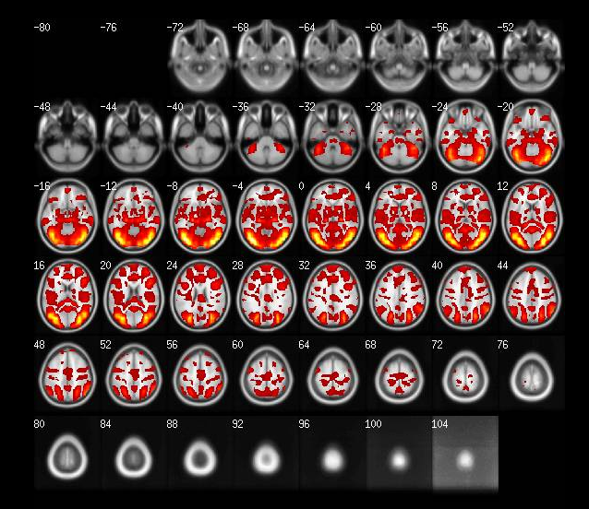

Figure S2.
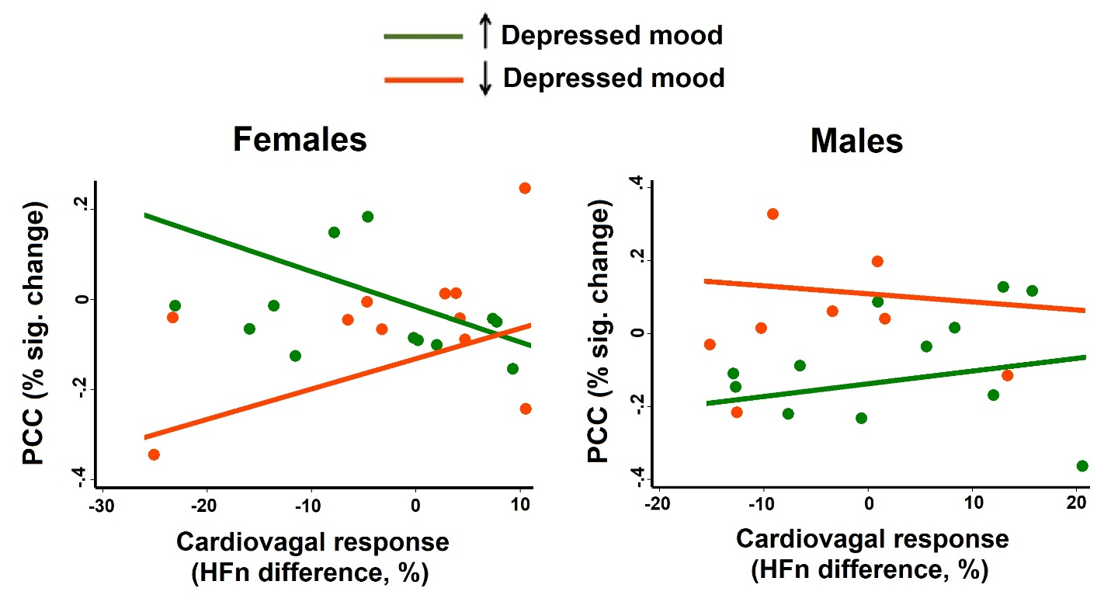

Figure S3.
