Supplemental Figures

Figure 1S. Insomnia MR to MDD Leave one out egger

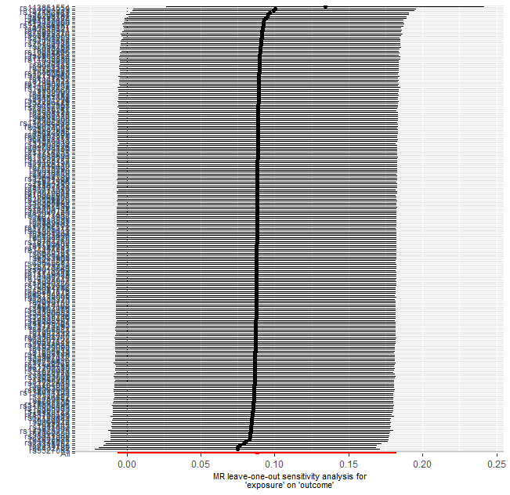

Figure 2S. Insomnia MR to BP Leave one out egger

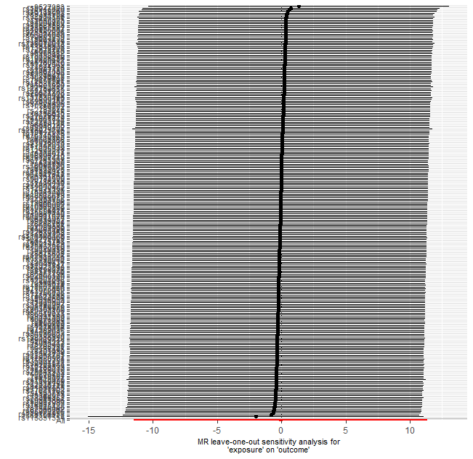

Figure 3S. Insomnia MR to SB-Cohort_2019 Leave one out egger
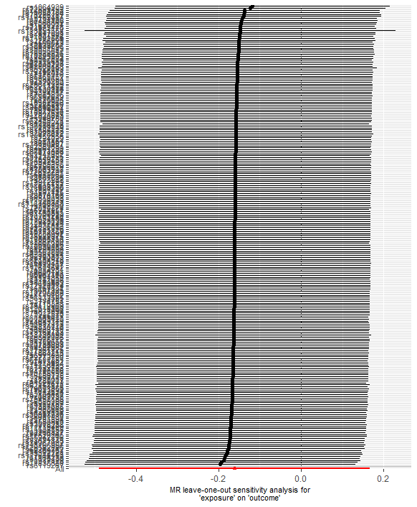

Figure 4S. Insomnia MR to SB in MDD Leave one out egger

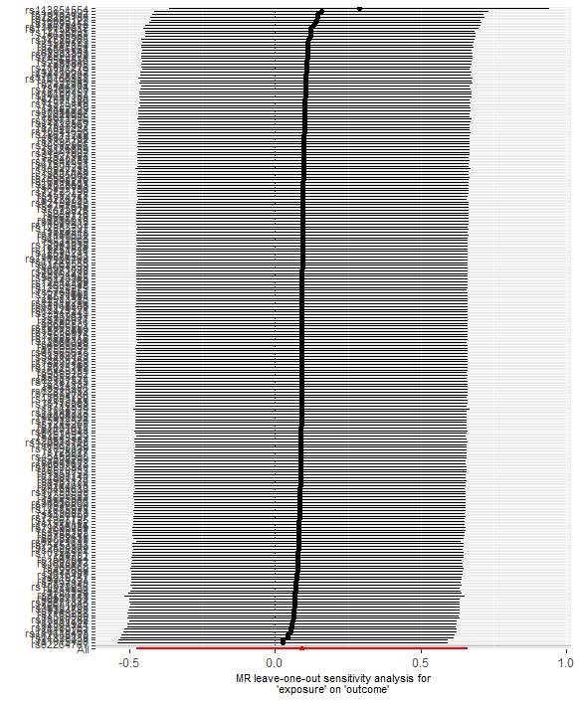

Figure 5S. Insomnia MR to SB-Cohort_2020 Leave one out egger

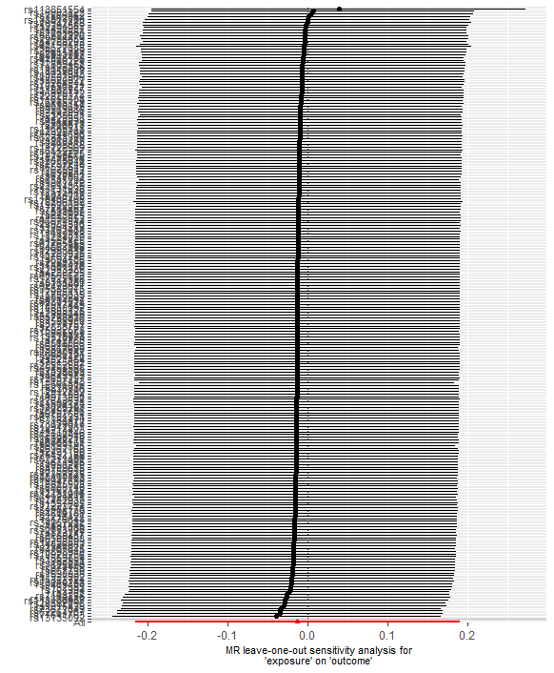

Figure 6S. Insomnia MR to MDD Leave one out IWV

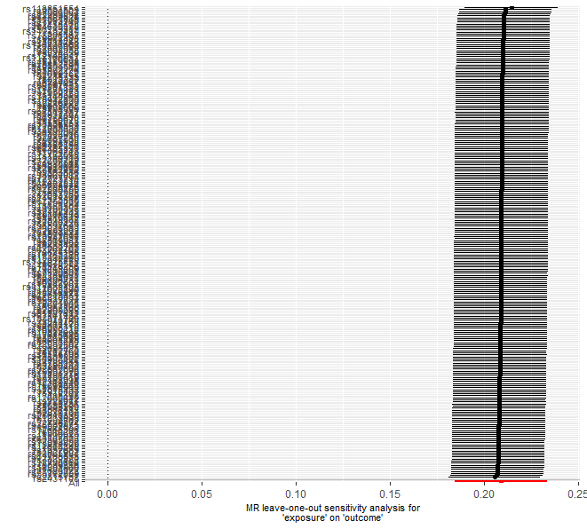

Figure 7S. Insomnia MR to BP Leave one out IWV
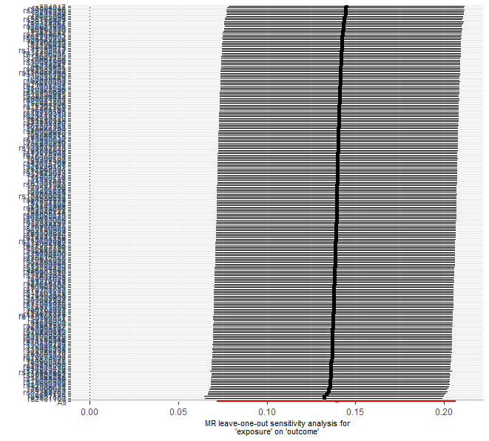

Figure 8S. Insomnia MR to SB-Cohort-2019 Leave one out IWV
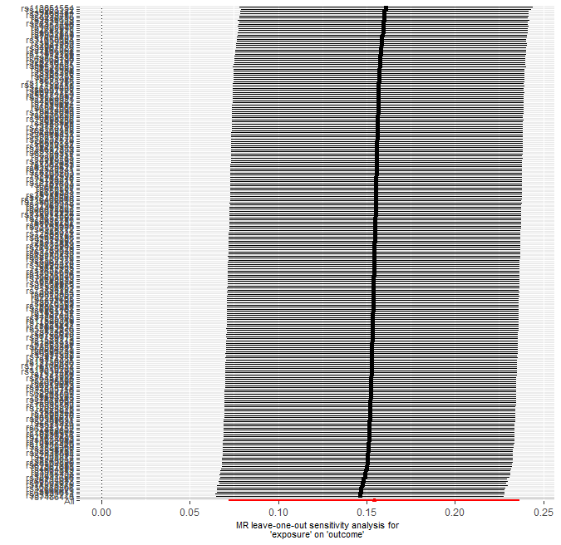

Figure 9S. Insomnia MR to SB in MDD Leave one out IWV

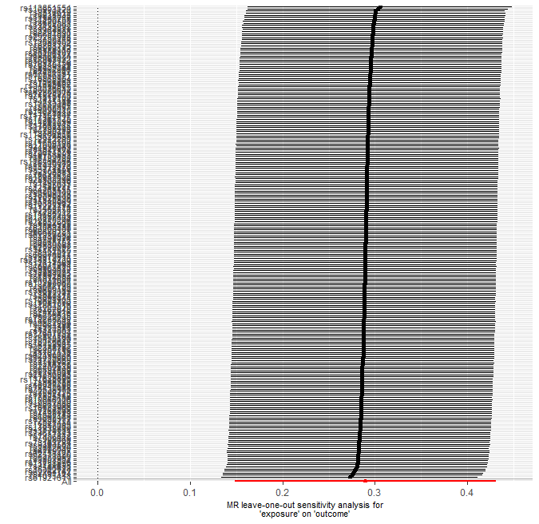

Figure 10S. Insomnia MR to SB-Cohort-2020 Leave one out IWV

