Supplement
Supplemental Methods
Clinical assessments (latency between visits). The average time between the initial screen visit, during which data for the EOD and TEI were collected, and MRI visit was 111 days. The minimum time latency was 21 days; one outlier (614 days) affected this average.
Affective Stroop Task. The trauma-relevant images included scenes related to traumatic experiences endorsed by our study population, based on our earlier studies, which indicate a high amount of interpersonal trauma and assault involving a weapon[1, 2]. Trauma-relevant stimuli included scenes of assault and gun violence—all but one of these scenes included people in the images. Approximately half of the positive stimuli were pictures that included people (43%), and a minority included animals (17%), activities (theme park, 6%; sports, 23%), or nature scenes (12%). Neutral stimuli included a similar proportion of person-related images (36%) and nature scenes (14%) but also included object stimuli (50%). A majority of the images were obtained from the International Affective Picture System [IAPS; 3]. Practice trials (with a separate set of distractor images) were administered to all participants prior to the scan, and task proficiency (accuracy on a majority of trials) was required before actual task administration. On some trials, the number of numbers in number stimulus images is incongruent with the actual number displayed, posing heightened attentional demands on those trials. In addition, the task includes trials with no cognitive demands (“view only” trials). Error rates and response times were recorded and analyzed. The task comprises two separate 8-minute runs with different stimuli; each run block has 16 trials for each of three conditions: number congruent, number incongruent, and passive viewing of distractor images for a total of 144 trials per run. A total of 40 fixation trials (2500 ms duration) are also randomly presented in each run. Distractor and number stimuli are each presented for 400 ms, followed by a blank screen (1300 ms). Each trial includes two identical distractor stimuli. Distractor images are unique for each trial condition.

Supplemental Results

Supplemental Table 1. Affective Stroop Performance

Trial Type Mean SD
Trauma-relevant, number congruent | .10 | .14
Positive, number congruent | .09 | .14
Neutral, number congruent | .08 | .13
Trauma-relevant, number incongruent | .11 | .16
Positive, number incongruent | .12 | .17
Neutral, number incongruent | .10 | .16
Response time (ms)

Trauma-relevant, number congruent | 898.18 | 163.31
Positive, number congruent | 889.70 | 159.73
Neutral, number congruent | 876.77 | 154.39
Trauma-relevant, number incongruent | 947.47 | 157.43
Positive, number incongruent | 945.90 | 161.44
Neutral, number incongruent | 941.16 | 152.66

Below we describe patterns of brain-wide response to different Affective Stroop trials:

Trauma-relevant stimuli (including number congruent and number incongruent trials). In the entire sample, increased response to trauma-relevant distractor trial stimuli was observed in the lingual gyrus, postcentral gyrus, precentral gyrus, caudate, globus pallidus, inferior frontal gyrus, and precuneus (p<.05, FWE corrected); these findings are described in the Supplement, Table S2a and Figure S1a.

Positive distractor stimuli (including number congruent and number incongruent trials). In the entire sample, increased response to positive distractor trial stimuli was observed in the cerebellum, as well as the superior frontal gyrus, various aspects of the parietal cortex, and putamen, as indicated in the Supplement, Table S2b and Figure S1b.

Supplemental Table 2. Anatomical locations of voxel-wide BOLD response to Affective Stroop distractor trials
2a. | Brodmann Area | x | y | z | Cluster size (mm³)
Trauma-relevant trials (p<.05, FWE corrected)
Lingual gyrus, occipital lobe | 18 | -6 | -97 | -5 | 2504
 |  | -42 | -64 | -17
 |  | 39 | -46 | -23
Postcentral gyrus, parietal lobe | 2 | -54 | -25 | 40 | 253
 |  | -48 | -28 | 49
 |  | -48 | -37 | 52
Caudate |  | -15 | -1 | 16 | 27
 |  | -21 | -10 | 10
Globus pallidus |  | 18 | -10 | -2 | 10
Inferior frontal gyrus | 44 | -57 | 11 | 16 | 35
 |  | -54 | 14 | 1
Precuneus, parietal lobe | 7 | -21 | -67 | 52 | 12
Precentral gyrus | 6 | -42 | -16 | 64 | 10
2b.
Positive trials (p<.05, FWE corrected)
Cerebellum |  | -27 | -79 | -17 | 1799
 |  | 21 | -79 | -17
 |  | -15 | -79 | -14
Parietal cortex, postcentral gyrus | 40 | -54 | -28 | 52 | 205
 |  | -51 | -25 | 37
 |  | -45 | -28 | 43
Superior frontal gyrus | 6 | -30 | -4 | 70 | 12
Superior parietal lobe | 7 | -30 | -52 | 40 | 17
Putamen |  | -18 | -1 | 16 | 15

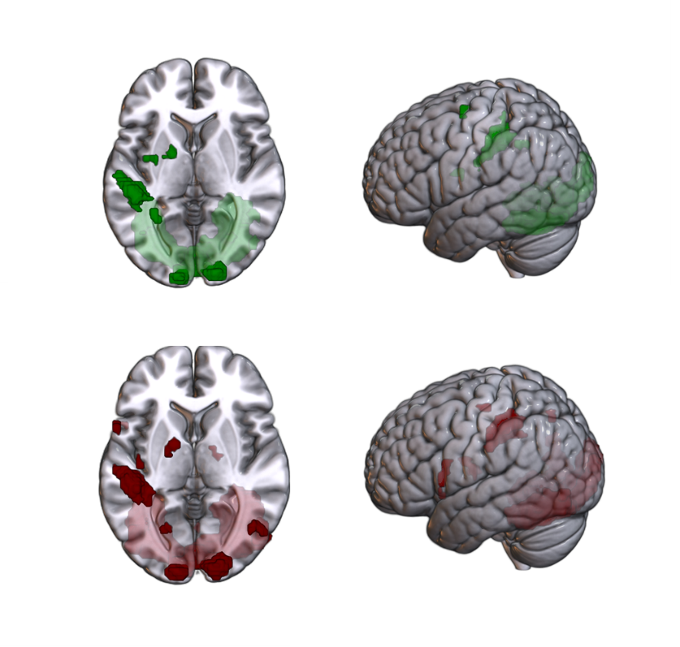
Supplemental Figure 1:
Top panel: Voxel-wide BOLD response to positive affective number Stroop distractor trials
Bottom panel: Voxel-wide BOLD response to trauma-relevant affective number Stroop distractor trials

References
1. Gillespie, C.F., et al., Trauma exposure and stress-related disorders in inner city primary care patients. General Hospital Psychiatry, 2009. 31(6): p. 505-514.
2. Gluck, R.L., et al., Trauma exposure and stress-related disorders in a large, urban, predominantly African-American, female sample. Arch Womens Ment Health, 2021.
3. Lang, P.J., M.M. Bradley, and B.N. Cuthbert, International Affective Picture System (IAPS): Digitized photographs, instruction manual and affective ratings. 2005, University of Florida: Gainesville, FL.

