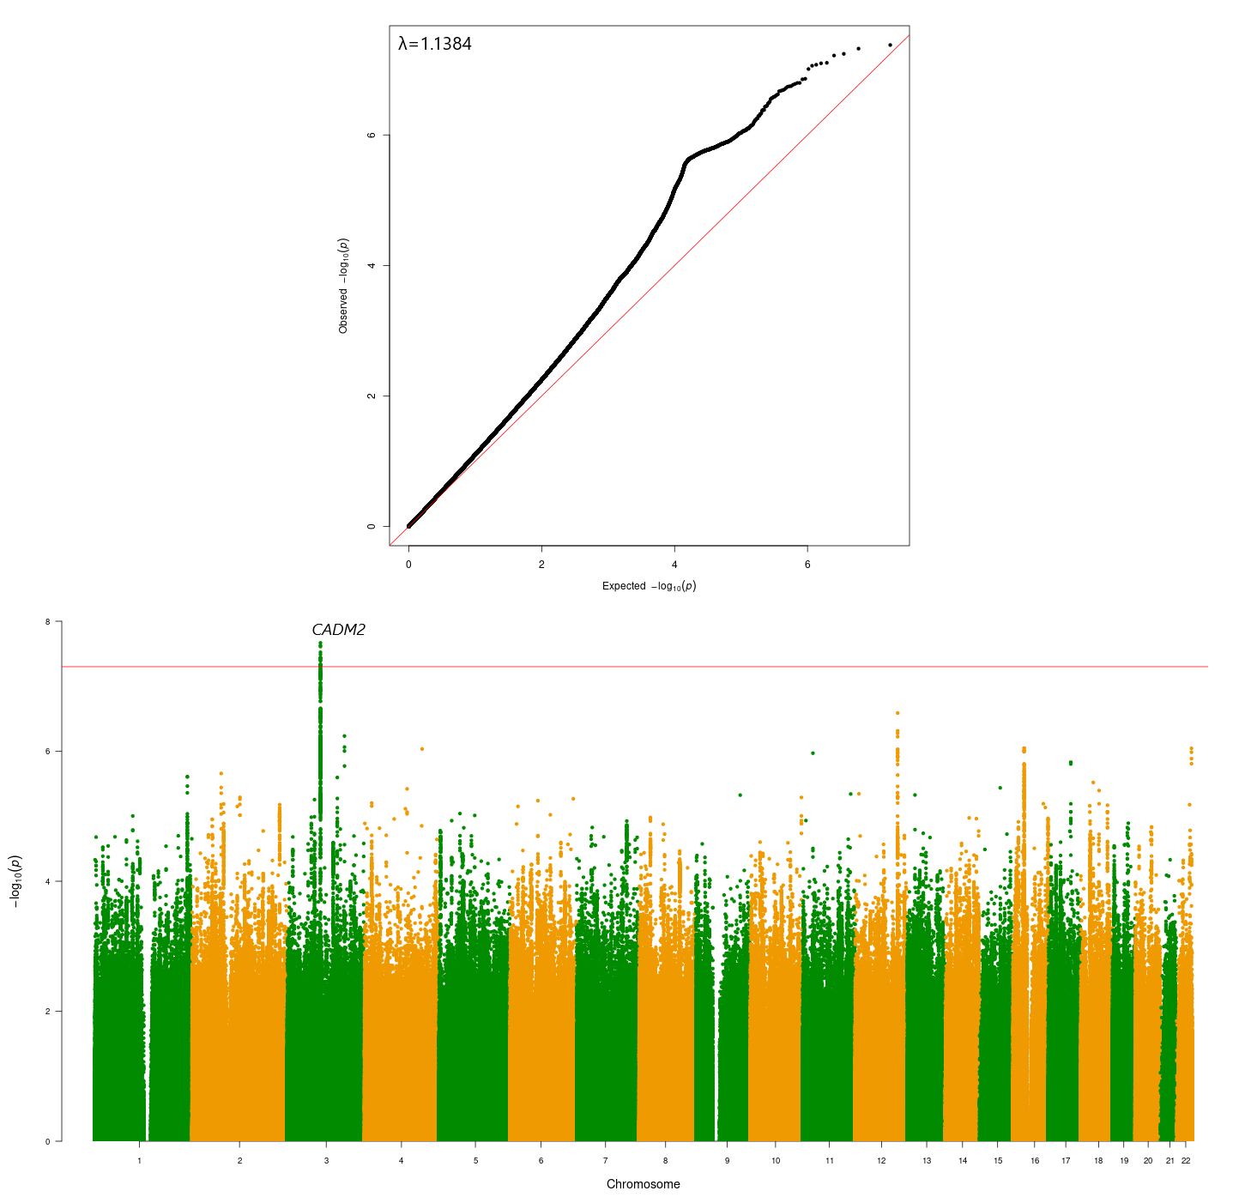
Figure S1: EUR GWAS (All of Us) of CanLU

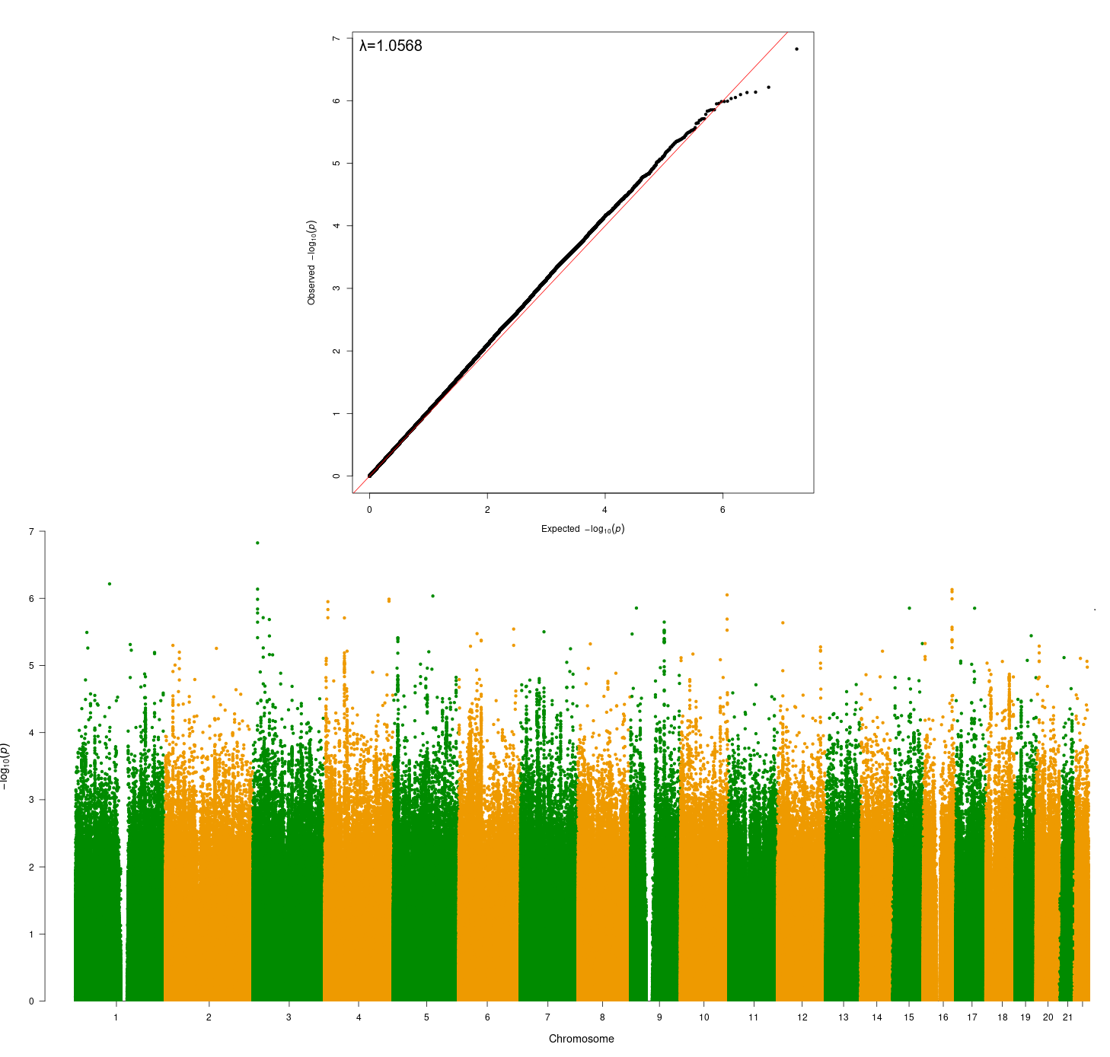
Figure S2: AFR GWAS (All of Us) of CanLU

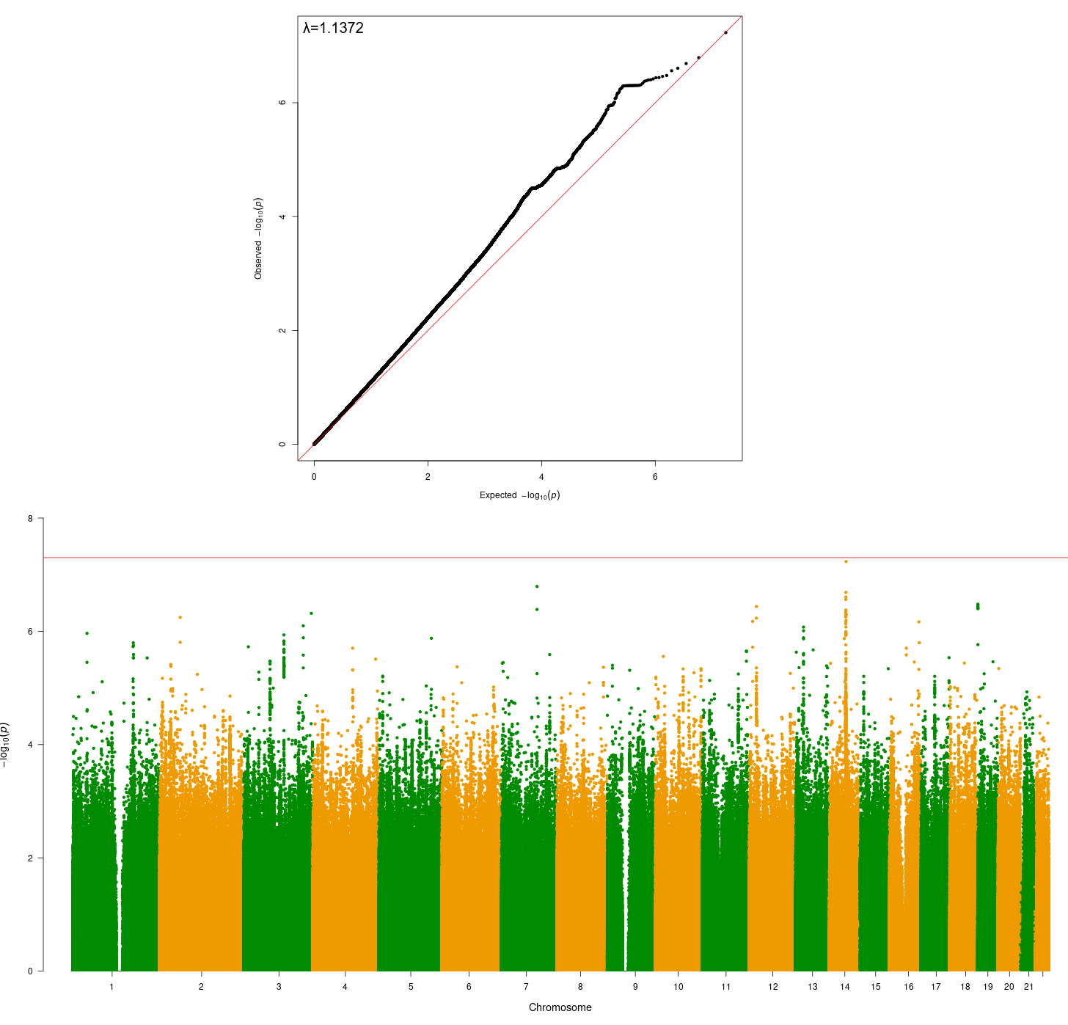
Figure S3: AMR GWAS (All of Us) of CanLU

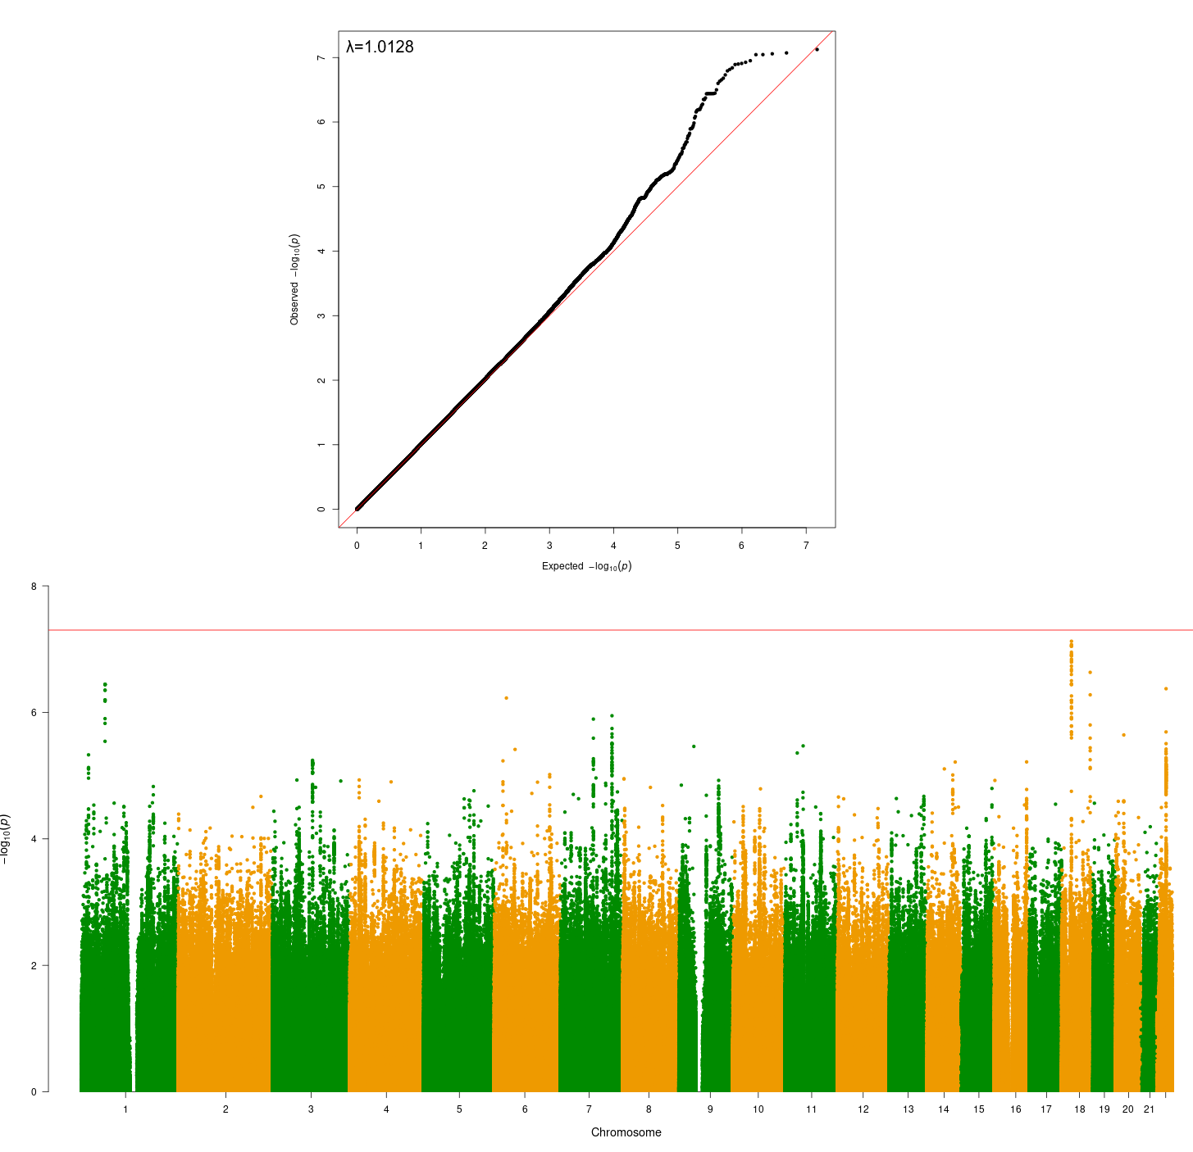
Figure S4: EAS GWAS (All of Us) of CanLU

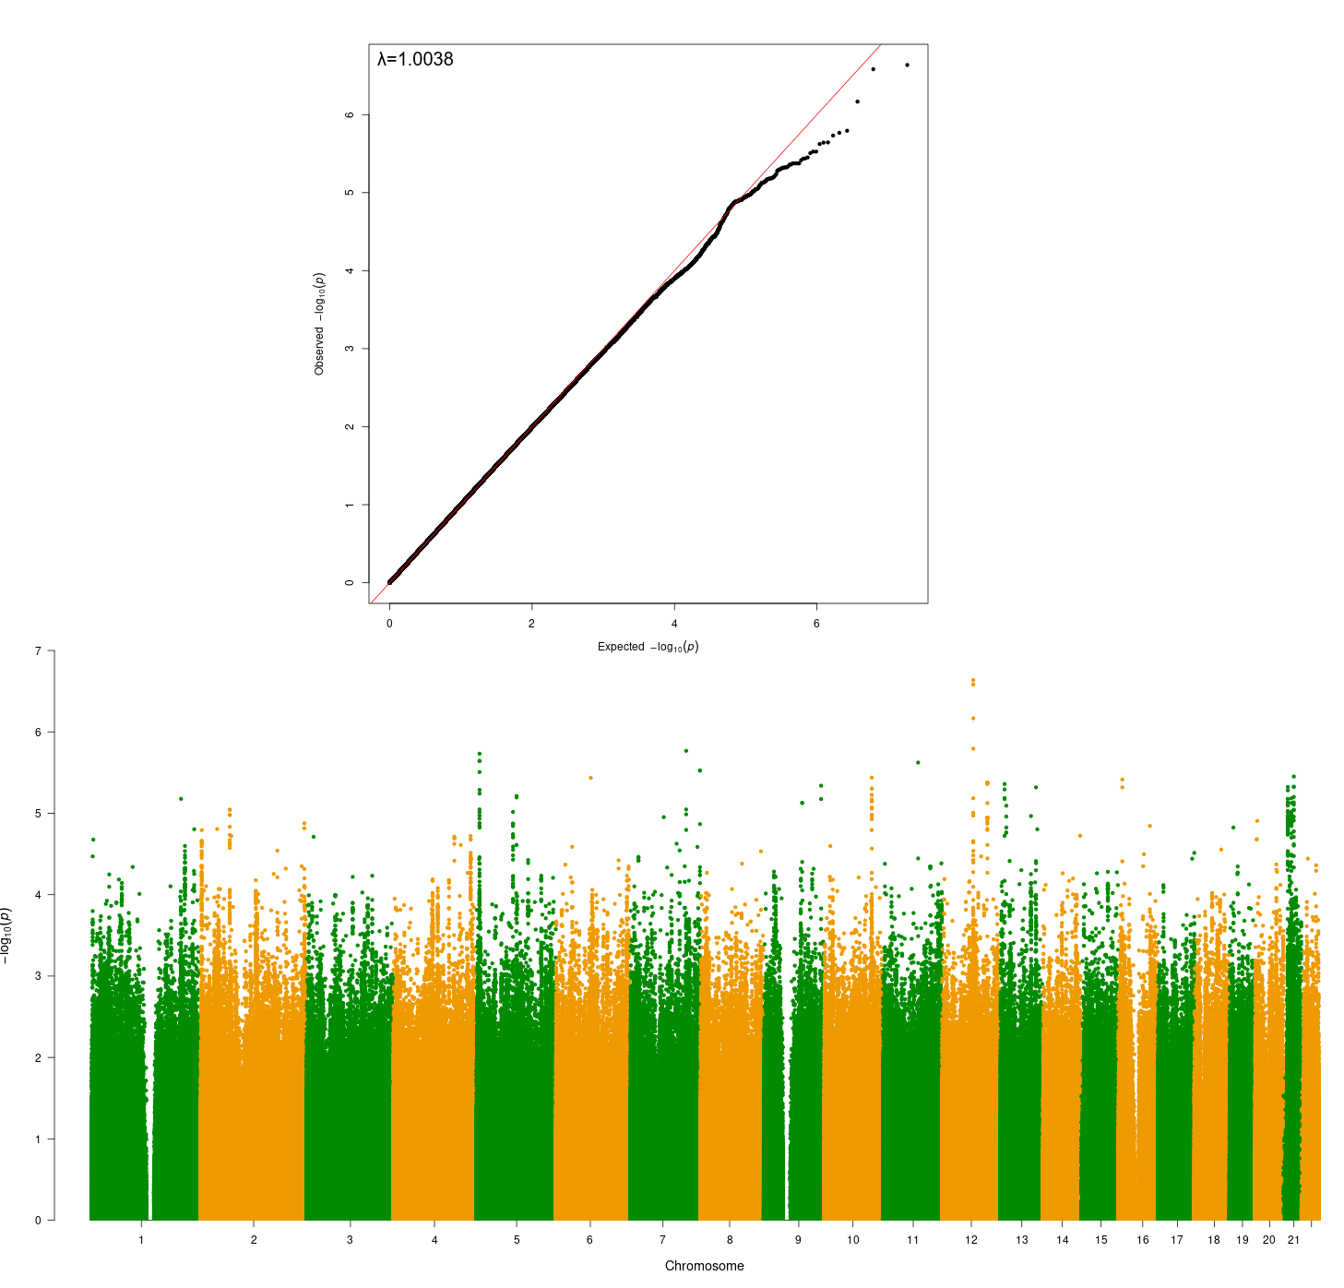
Figure S5: SAS GWAS (All of Us) of CanLU

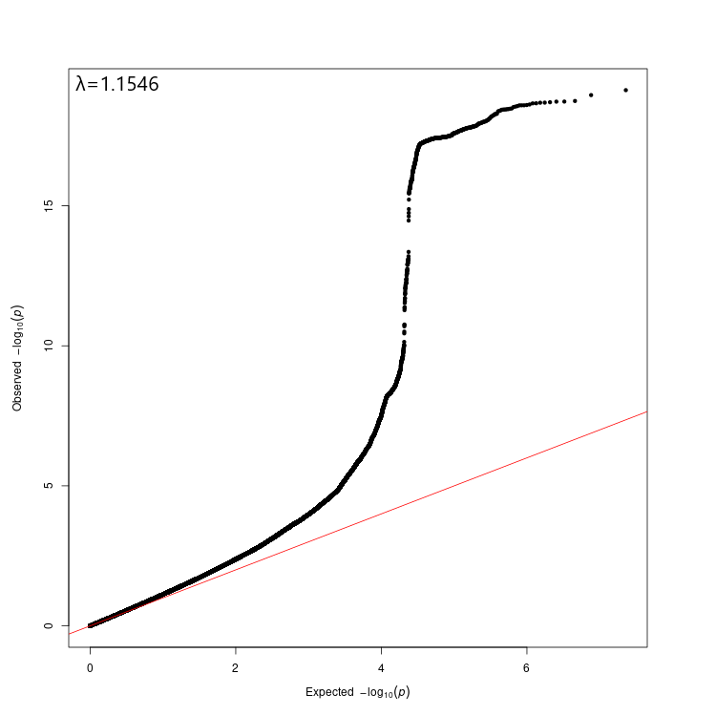
Figure S6: QQ plot of the EUR GWAS meta-analysis

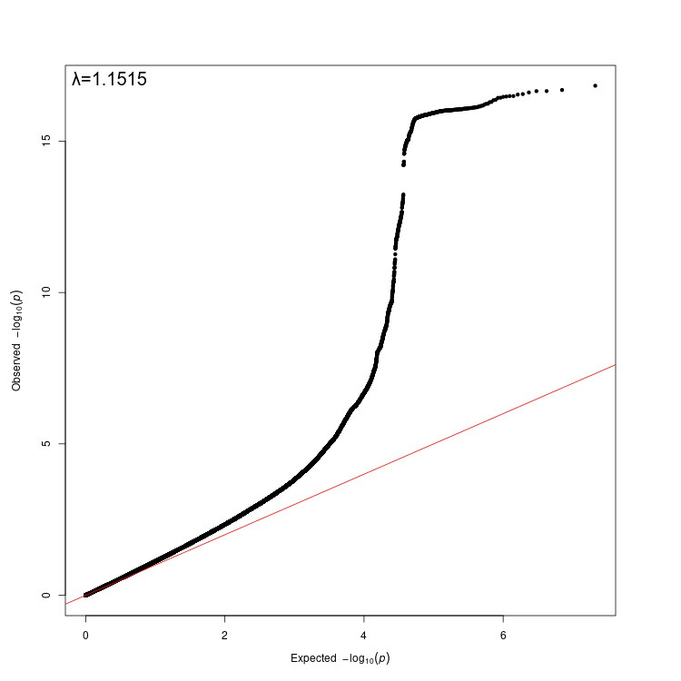
Figure S7: QQ plot of the cross-ancestry GWAS meta-analysis

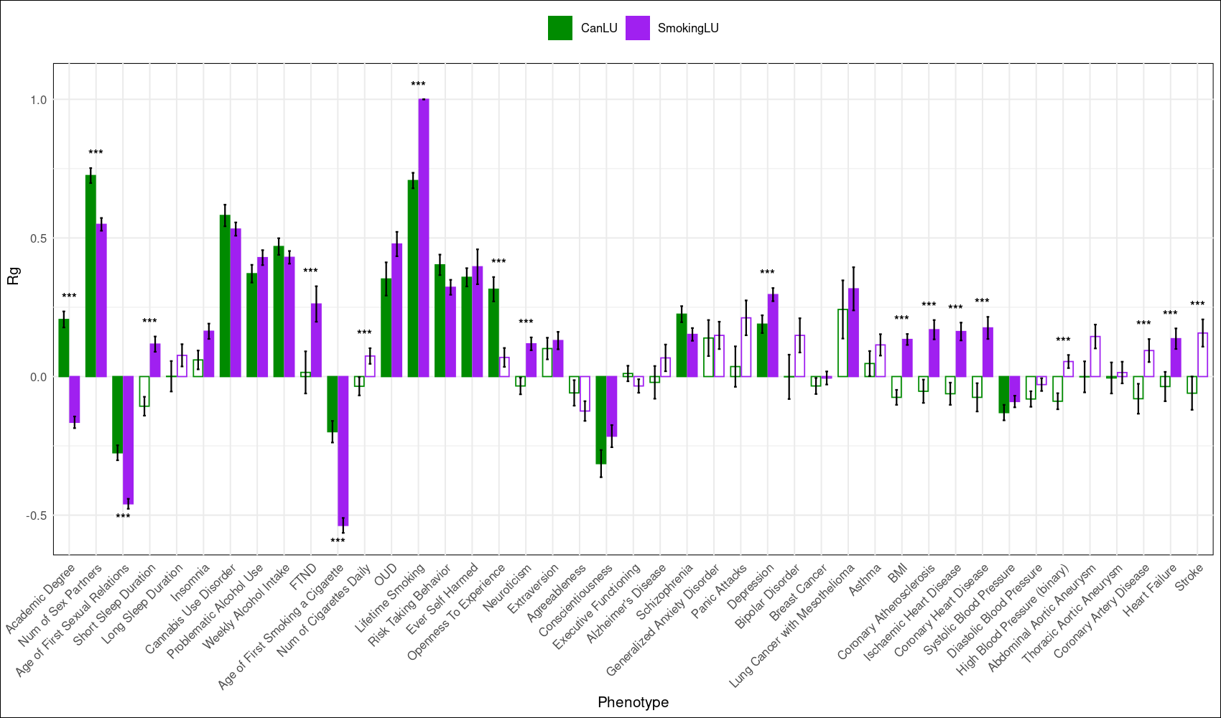

Figure S8: Genetic correlations between lifetime smoking (smoking LU) and a list of traits, compared to the genetic correlations between these traits and CanLU (CanLU data is similar to that presented in Figure 2 in the manuscript). Empty bars represent non-significant r_{g} values. For each pair, differences in r_{g} were measured using a Wald test, accounting for the covariance between the estimates (*** p<3.88x10⁻⁴).

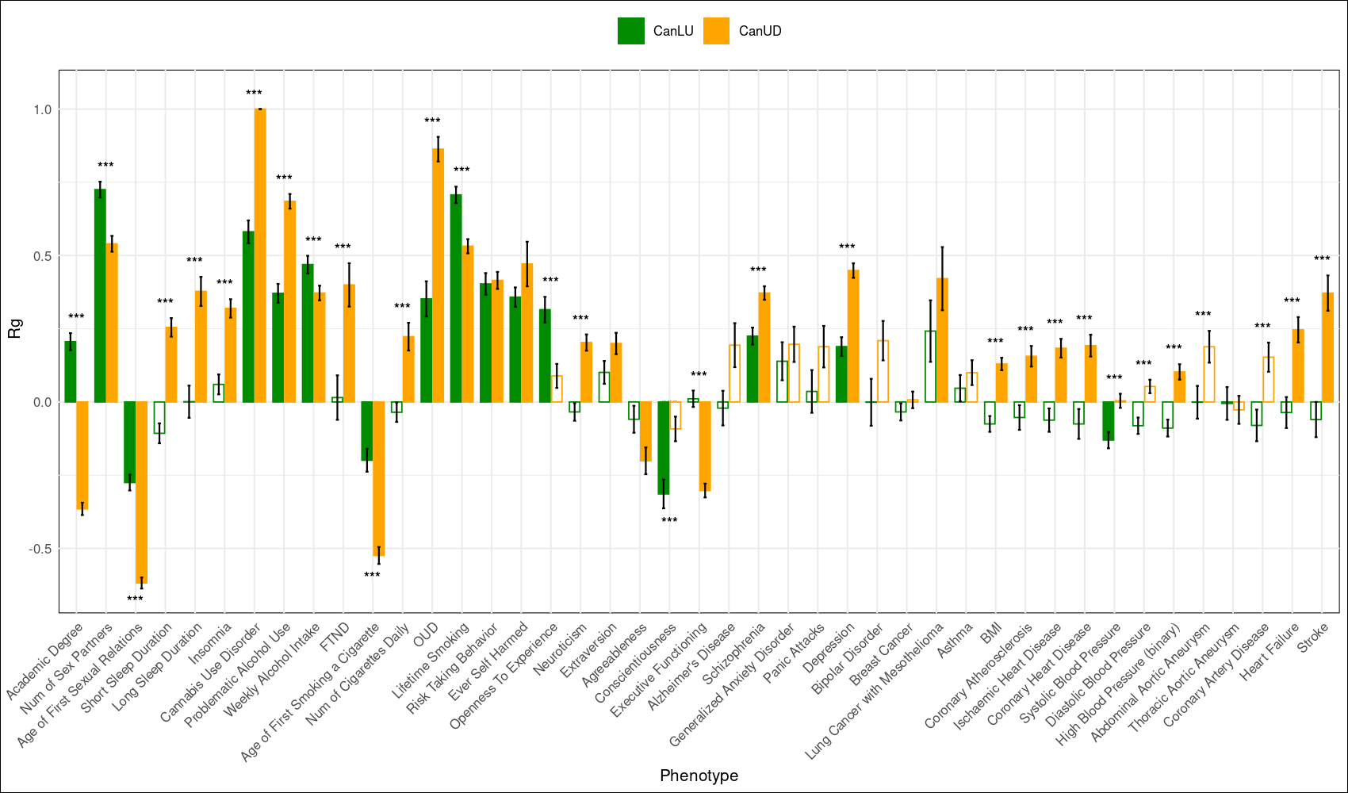
Figure S9: Genetic correlations between cannabis use disorder (CanUD) and a list of traits, compared to the genetic correlations between these traits and CanLU (CanLU data is similar to that presented in Figure 2 in the manuscript). Empty bars represent non-significant r_{g} values. For each pair, differences in r_{g} were measured using a Wald test, accounting for the covariance between the estimates (*** p<3.88x10⁻⁴).

