Comparing affective bias modification by first- and second-generation antidepressants in male rats using a translational behavioural task

Katie A Kamenish¹, Emma N Cahill¹, Emma S J Robinson^{1*}

Supplementary materials

Supplementary Figures

Figure S1
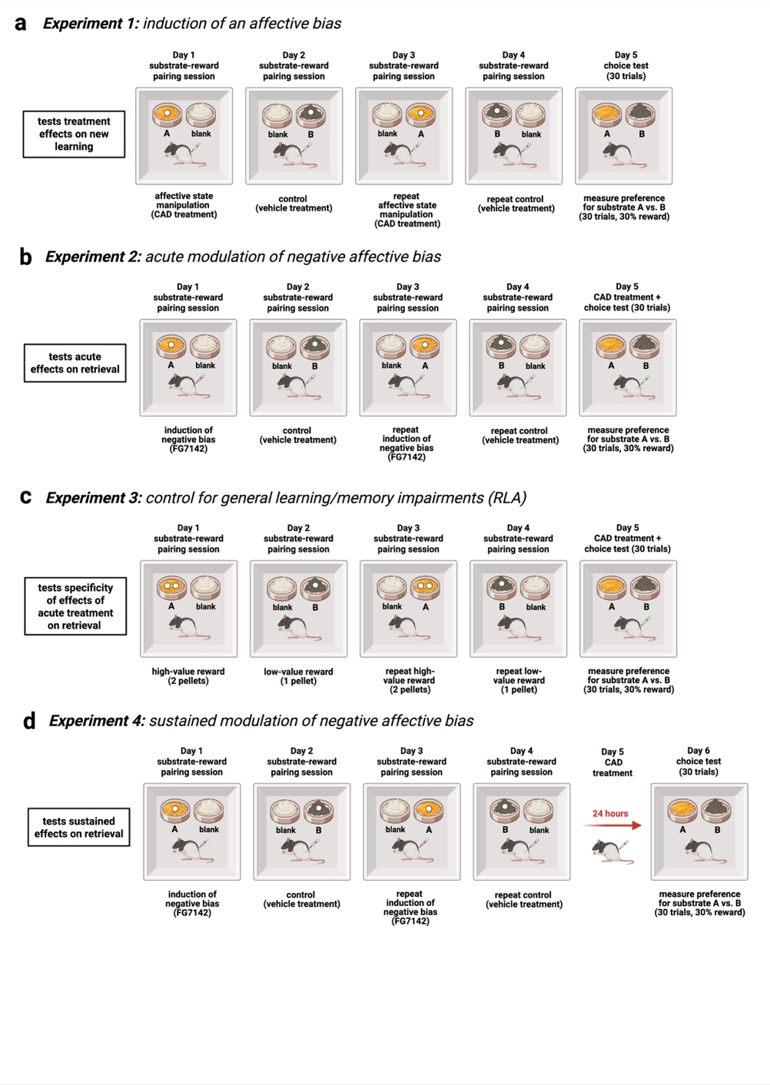

Figure S1: Overview of ABT and RLA protocols comparing CAD classes on affective bias modulation. The ABT measures affective biases in rodents by creating two reward memories under an affective state manipulation or neutral/control state. This assay posits that affective bias changes perceived reward value, gauged by preferences for substrate-reward associations learned during affective versus neutral states. In the task, animals associate a digging substrate with a food reward. The reward value of each experience is kept equal as animals undergo four pairing sessions across four days followed by a choice test presenting both substrates, and choice bias is assessed over 30 randomly reinforced trials. Panel a outlines the protocol for assessing new learning effects, with treatments administered prior to pairing sessions and affective bias quantified at retrieval during choice testing. Panel b shows the protocol for assessing acute attenuation of established negative bias by CADs, where a negative bias is first generated during pairing sessions by administration of FG7142, then the CAD is administered before the choice test. Treatments showing acute negative bias attenuation are further tested with the RLA protocol in panel c to confirm if ABT effects are specific to affective state modulation and not due to non-specific reward learning impairments. A positive bias is generated by varying reward value (one versus two pellets) pairings. CAD treatments are then administered before the choice test to measure impact on retrieval of reward-induced bias. In absence of any non-specific effects, animals proceed with the ABT protocol in panel d. Following negative bias induction by FG7142, treatments are administered 24 hours before the choice test to evaluate sustained negative bias modulation. Created in BioRender. Kamenish, K. (2025) https://BioRender.com/r770b6n

Figure S2
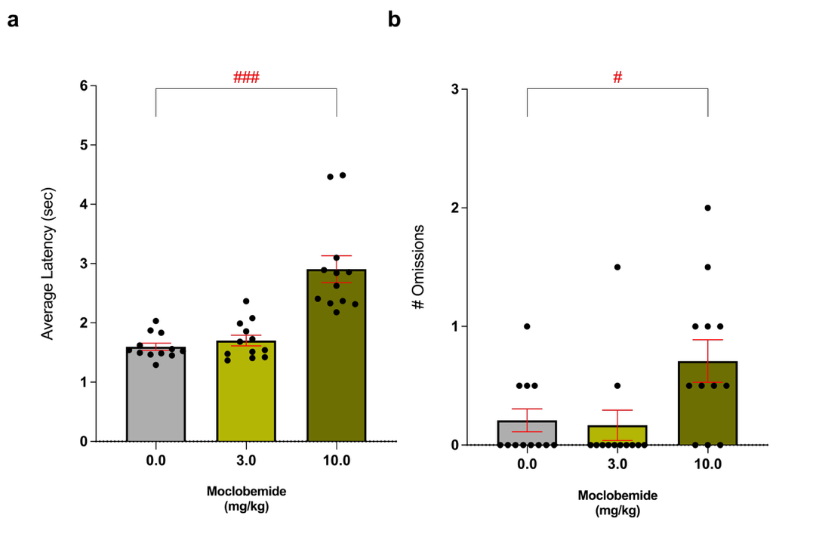

Figure S2: Moclobemide produced non-specific effects on task performance during substrate-reward pairing sessions. When administered prior to pairing sessions, moclobemide (3 and 10 mg/kg, n=12) significantly increased latency to respond during pairing trials (F_{(2,22)}=23.29, p=0.0003) but only at the highest dose of 10 mg/kg (p=0.0005) and not at 3 mg/kg (p=0.3370). There was an additional main effect of moclobemide treatment on number of omitted trials (F_{(2,22)}=6.280, p=0.0070), but this was again only observed at 10 mg/kg (p=0.0142) and not at the lower dose (p=0.9571). These findings indicate that the negative bias observed following treatment with 10 mg/kg moclobemide may have been influenced by these impairments of task performance and therefore cannot be interpreted as the result of a specific affective state modulation. Data are shown as mean % choice bias ± SEM and were analyzed using Dunnett’s test following main effect with RM-ANOVA (*p < 0.05,**p < 0.01).

Supplementary Tables

Table S1

Cohort | Test | Substrate A | Substrate B | Substrate C (blank)
Cohort 1 | Test 1 | cotton wool balls | hairbands | stringy cloth
Cohort 1 | Test 2 | yellow bath sponge | duster | absorbent fibre
Cohort 1 | Test 3 | shredded paper | silk | organza
Cohort 1 | Test 4 | tights | umbrella | Christmas ribbon
Cohort 1 | Test 5 | balloons | leather | cotton mix
Cohort 1 | Test 6 | newspaper | paper pet bedding | paper chad
Cohort 1 | Test 7 | string | cardboard | black satin
Cohort 1 | Test 8 | felt | exfoliating gloves | dishcloth
Cohort 1 | Test 9 | purple gift ribbon | raffia ribbon | pompoms
Cohort 1 | Test 10 | suede | fleece | chenille
Cohort 1 | Test 11 | crepe paper | scarf yarn | sparkly fibre
Cohort 2 | Test 1 | tissue paper | absorbent fibre | foam shapes
Cohort 2 | Test 2 | hessian sack | brown pet bedding | cork
Cohort 2 | Test 3 | corrugated paper | cellulose sponge | perlite
Cohort 2 | Test 4 | pompoms | fur | polyester
Cohort 2 | Test 5 | straws | inner tube | plastic scourer
Cohort 2 | Test 6 | cotton mix | silk | towel
Cohort 2 | Test 7 | foam padding | denim | backpack strap
Cohort 2 | Test 8 | partition paper | tablecloth | cardigan
Cohort 2 | Test 9 | aspen | matchsticks | hemp
Cohort 2 | Test 10 | shoelaces | wool | sisal twine
Cohort 3 | Test 1 | straw hat | bath mat | pink cowboy hat
Cohort 3 | Test 2 | yellow cord | towel | pipe cleaners
Cohort 3 | Test 3 | poster | sequins | buttons
Cohort 3 | Test 4 | tissue paper | hessian sack | brown pet bedding
Cohort 3 | Test 5 | fur | felt | tights
Cohort 3 | Test 6 | hairbands | suede | organza
Cohort 3 | Test 7 | fleece | raffia ribbon | sparkly fibre

Table S1: List of substrates used in experiments for all cohorts.

Table S2

Day | 1 | 2 | 3 | 4 | 5/6
Subject | Pairing 1 | Pairing 2 | Pairing 3 | Pairing 4 | Choice Test
Rat 1 | A vs. blank  DRUG | B vs. blank  VEHICLE | A vs. blank  DRUG | B vs. blank  VEHICLE | A vs. blank  30 TRIALS
Rat 2 | B vs. blank DRUG | A vs. blank  VEHICLE | B vs. blank  DRUG | A vs. blank  VEHICLE | A vs. blank  30 TRIALS
Rat 3 | A vs. blank  VEHICLE | B vs. blank  DRUG | A vs. blank  VEHICLE | B vs. blank  DRUG | A vs. blank  30 TRIALS
Rat 4 | B vs. blank  VEHICLE | A vs. blank  DRUG | B vs. blank  VEHICLE | A vs. blank  DRUG | A vs. blank  30 TRIALS

Table S2: Standard protocol for experiments testing drug-induced affective bias against vehicle. Animals receive drug treatment or vehicle counterbalanced over four substrate-reward pairing sessions. Substrate (reward-paired substrates - ‘A’ or ‘B’ versus unrewarded substrate - ‘blank’) and pairing day are also counter-balanced to produce four groups.

Table S3

Day | 1 | 2 | 3 | 4 | 5/6
Subject | Pairing 1 | Pairing 2 | Pairing 3 | Pairing 4 | Choice Test
Rat 1 | A vs. blank  1 PELLET | B vs. blank  2 PELLETS | A vs. blank  1 PELLET | B vs. blank  2 PELLETS | A vs. B  30 TRIALS
Rat 2 | B vs. blank  1 PELLET | A vs. blank  2 PELLETS | B vs. blank  1 PELLET | A vs. blank  2 PELLETS | A vs. B  30 TRIALS
Rat 3 | A vs. blank  2 PELLETS | B vs. blank  1 PELLET | A vs. blank  2 PELLETS | B vs. blank  1 PELLET | A vs. B  30 TRIALS
Rat 4 | B vs. blank  2 PELLETS | A vs. blank  1 PELLET | B vs. blank  2 PELLETS | A vs. blank  1 PELLET | A vs. B  30 TRIALS

Table S3: Standard protocol for experiments testing reward-induced bias in the RLA. Animals receive a high-value (two pellets) or low-value (one pellet) reward counterbalanced over four substrate-reward pairing sessions. Substrate (reward-paired substrates - ‘A’ or ‘B’ versus unrewarded substrate - ‘blank’) and pairing day are also counter-balanced to produce four groups.

Table S4

Cohort | Treatment | Dose (mg/kg) | Route of Admin. | Pretreatment Times
1 | Amitriptyline | 0.0, 0.3, 1.0, 3.0 | oral admin. in palatable solution | 2 hrs. / 24 hrs.
1 | Venlafaxine | 0.0, 3.0 | oral admin. in palatable solution | 2 hrs.
2,3 | Sertraline | 0.0, 1.0, 3.0, 10.0 | oral admin. in palatable solution | 2 hrs. / 24 hrs.
3 | Moclobemide | 0.0, 3.0, 10.0 | subcutaneous injection | 30 mins. / 24 hrs.
1,2,3 | FG7142 | 0.0, 3.0 | subcutaneous injection | 30 mins.

Table S4: Summary of drug treatments for all cohorts.

Table S5

Treatment (mg/kg) |  | Trials to Criterion |  | Response Latency (sec.) |  | Omissions
 |  | Vehicle | Drug | Vehicle | Drug | Vehicle | Drug
Amitriptyline | 0.0 | 7.2 ± 0.1 | 6.8 ± 0.2 | 1.8 ± 0.0 | 2.0 ± 0.1 | 0.1 ± 0.1 | 0.3 ± 0.1
Amitriptyline | 0.3 | 7.6 ± 0.3 | 7.0 ± 0.2 | 1.4 ± 0.1 | 1.9 ± 0.1 | 0.5 ± 0.1 | 0.3 ± 0.1
Amitriptyline | 1.0 | 7.1 ± 0.1 | 7.1 ± 0.3 | 2.0 ± 0.0 | 1.9 ± 0.1 | 0.3 ± 0.1 | 0.2 ± 0.1
Amitriptyline | 3.0 | 7.0 ± 0.2 | 7.1 ± 0.3 | 1.4 ± 0.1 | 1.7 ± 0.1 | 0.4 ± 0.2 | 0.2 ± 0.1
Venlafaxine | 3.0 | 7.6 ± 0.3 | 7.6 ± 0.2 | 2.0 ± 0.1 | 1.9 ± 0.1 | 0.3 ± 0.1 | 0.2 ± 0.1
Moclobemide | 0.0 | 6.9 ± 0.2 | 7.1 ± 0.2 | 1.5 ± 0.0 | 1.6 ± 0.1 | 0.2 ± 0.1 | 0.2 ± 0.1
Moclobemide | 3.0 | 7.4 ± 0.2 | 7.5 ± 0.2 | 1.9 ± 0.0 | 1.7 ± 0.1 | 0.2 ± 0.1 | 0.2 ± 0.1
Moclobemide | 10.0 | 7.1 ± 0.2 | 7.5± 0.3 | 1.4 ± 0.1 | 2.9 ± 0.2** | 0.2 ± 0.1 | 0.7 ± 0.2*
Sertraline | 0.0 | 6.9 ± 0.2 | 7.1 ± 0.3 | 1.9 ± 0.1 | 1.4 ± 0.1 | 0.1 ± 0.2 | 0.2 ± 0.1
Sertraline | 1.0 | 6.8 ± 0.3 | 7.5 ± 0.2 | 1.6 ± 0.1 | 1.4 ± 0.1 | 0.3 ± 0.2 | 0.1 ± 0.1
Sertraline | 3.0 | 6.8 ± 0.2 | 6.9 ± 0.3 | 1.8 ± 0.1 | 1.4 ± 0.1 | 0.2 ± 0.1 | 0.3 ± 0.1
Sertraline | 10.0 | 6.9 ± 0.3 | 6.9 ± 0.2 | 1.5 ± 0.1 | 1.5 ± 0.1 | 0.2 ± 0.1 | 0.4± 0.2

Table S5: Pairing session data for ABT experiments assessing new learning effects. Number of trials to criterion, latency to respond, and number of omitted trials were recorded for each pairing session. Data shown as mean (n=12-16 animals/group) ± SEM averaged from pairing sessions for each group. There were no significant effects of amitriptyline or sertraline during pairing sessions, but 10 mg/kg moclobemide significantly increased latency to respond and number of omitted trials (*p < 0.05,**p < 0.01; for details see Fig. S2).

Table S6a

Treatment | Dose (mg/kg) | Response Latency (sec.) | Omissions
Amitriptyline | 0.0 | 1.5 ± 0.1 | 0.4 ± 0.2
Amitriptyline | 0.3 | 1.4 ± 0.1 | 0.3 ± 0.1
Amitriptyline | 1.0 | 1.4 ± 0.1 | 0.6 ± 0.3
Moclobemide | 0.0 | 1.5 ± 0.0 | 0.6 ± 0.2
Moclobemide | 3.0 | 1.5 ± 0.0 | 0.3 ± 0.1
Sertraline | 0.0 | 1.5 ± 0.1 | 0.2 ± 0.1
Sertraline | 3.0 | 1.6 ± 0.1 | 0.2 ± 0.1
Sertraline | 10.0 | 1.5 ± 0.1 | 0.4 ± 0.2

Table S6a: Choice test data for ABT experiments assessing acute negative bias modulation. Latency to respond and number of omitted trials were recorded for each animal during 30 choice test trials. Data shown as mean (n=12-16 animals/group) ± SEM averaged from individuals’ data for each group. None of the treatments produced significant effects during choice testing.

Table S6b

Treatment (mg/kg) |  | Trials to Criterion |  | Response Latency (sec.) |  | Omissions
 |  | Vehicle | FG7142 | Vehicle | FG7142 | Vehicle | FG7142
Amitriptyline | 0.0 | 6.7 ± 0.2 | 7.3 ± 0.3 | 1.7 ± 0.1 | 1.7 ± 0.1 | 0.3 ± 0.1 | 0.9 ± 0.2
Amitriptyline | 0.3 | 6.4 ± 0.1 | 6.8 ± 0.3 | 1.6 ± 0.1 | 1.6 ± 0.1 | 0.8 ± 0.2 | 0.3 ± 0.1
Amitriptyline | 1.0 | 7.3 ± 0.2 | 6.7 ± 0.2 | 1.7 ± 0.1 | 1.6 ± 0.1 | 0.7 ± 0.3 | 0.5 ± 0.1
Moclobemide | 0.0 | 7.8 ± 0.3 | 7.1 ± 0.3 | 1.6 ± 0.04 | 1.5 ± 0.04 | 0.5 ± 0.1 | 0.3 ± 0.1
Moclobemide | 3.0 | 7.0 ± 0.2 | 7.3 ± 0.2 | 1.6 ± 0.05 | 1.5 ± 0.03 | 0.2 ± 0.1 | 0.4 ± 0.1
Sertraline | 0.0 | 7.6 ± 0.3 | 7.7 ± 0.2 | 1.4 ± 0.1 | 1.4 ± 0.07 | 0.3 ± 0.1 | 0.2 ± 0.1
Sertraline | 3.0 | 7.0 ± 0.2 | 8.0 ± 0.4 | 1.5 ± 0.07 | 1.6 ± 0.1 | 0.2 ± 0.1 | 0.2 ± 0.1
Sertraline | 10.0 | 7.8 ± 0.3 | 7.3 ± 0.3 | 1.6 ± 0.1 | 1.5 ± 0.1 | 0.2 ± 0.1 | 0.1 ± 0.06

Table S6b: Pairing session data for ABT experiments assessing acute negative bias modulation. Number of trials to criterion, latency to respond, and number of omitted trials were recorded for each pairing session. Data shown as mean (n=12-16 animals/group) ± SEM averaged from pairing sessions for each group (vehicle versus FG7142). Administration of FG7142 before pairing sessions did not produce any significant effects on task performance in all groups.

Table S7

Treatment | Dose (mg/kg) | Response Latency (sec.) | Omissions
Amitriptyline | 0.0 | 1.4 ± 0.1 | 0.6 ± 0.3
Amitriptyline | 0.3 | 1.4 ± 0.0 | 0.9 ± 0.3
Amitriptyline | 1.0 | 1.4 ± 0.0 | 0.5 ± 0.2
Sertraline | 0.0 | 1.2 ± 0.0 | 0.2 ± 0.1
Sertraline | 3.0 | 1.3 ± 0.0 | 0.3 ± 0.1

Table S7: Choice test data for RLA experiments assessing specificity of effects on affective bias. Latency to respond and number of omitted trials were recorded for each animal during 30 choice test trials. Data shown as mean (n=12-16 animals/group) ± SEM averaged from individuals’ data for each group. None of the treatments produced significant effects during choice testing.

Table S8a

Treatment | Dose (mg/kg) | Response Latency (sec.) | Omissions
Amitriptyline | 0.0 | 1.6 ± 0.1 | 0.8 ± 0.4
Amitriptyline | 0.3 | 1.4 ± 0.0 | 0.6 ± 0.2
Amitriptyline | 1.0 | 1.5 ± 0.1 | 0.6 ± 0.2
Moclobemide | 0.0 | 1.6 ± 0.1 | 0.5 ± 0.2
Moclobemide | 3.0 | 1.5 ± 0.0 | 0.3 ± 0.2
Sertraline | 0.0 | 1.2 ± 0.0 | 0.2 ± 0.1
Sertraline | 1.0 | 1.2 ± 0.0 | 0.3 ± 0.2
Sertraline | 3.0 | 1.2 ± 0.0 | 0.3 ± 0.2

Table S8a: Choice test data for ABT experiments assessing sustained negative bias modulation. Latency to respond and number of omitted trials were recorded for each animal during 30 choice test trials. Data shown as mean (n=12-16 animals/group) ± SEM averaged from individuals’ data for each group. None of the treatments produced significant effects during choice testing.

Table S8b

Treatment (mg/kg) |  | Trials to Criterion |  | Response Latency (sec.) |  | Omissions
 |  | Vehicle | FG7142 | Vehicle | FG7142 | Vehicle | FG7142
Amitriptyline | 0.0 | 6.9 ± 0.2 | 7.2 ± 0.2 | 1.6 ± 0.1 | 1.8 ± 0.1 | 0.3 ± 0.2 | 0.6 ± 0.2
Amitriptyline | 0.3 | 7.2 ± 0.2 | 6.9 ± 0.2 | 1.6 ± 0.05 | 1.5 ± 0.06 | 0.4 ± 0.1 | 0.5 ± 0.1
Amitriptyline | 1.0 | 6.8 ± 0.2 | 7.2 ± 0.3 | 1.7 ± 0.07 | 1.6 ± 0.04 | 0.7 ± 0.2 | 0.8 ± 0.1
Moclobemide | 0.0 | 7.3 ± 0.3 | 7.6 ± 0.2 | 1.6 ± 0.08 | 1.6 ± 0.1 | 0.5 ± 0.1 | 0.5 ± 0.1
Moclobemide | 3.0 | 7.1 ± 0.3 | 7.6 ± 0.3 | 1.7 ± 0.05 | 1.7 ± 0.06 | 0.5 ± 0.2 | 0.4 ± 0.2
Sertraline | 0.0 | 6.8 ± 0.2 | 6.9 ± 0.2 | 1.2 ± 0.04 | 1.2 ± 0.03 | 0.1 ± 0.05 | 0.1 ± 0.07
Sertraline | 1.0 | 7.3 ± 0.2 | 6.6 ± 0.2 | 1.2 ± 0.03 | 1.2 ± 0.03 | 0.2 ± 0.07 | 0.2 ± 0.1
Sertraline | 3.0 | 6.6 ± 0.2 | 6.8 ± 0.1 | 1.2 ± 0.03 | 1.2 ± 0.05 | 0.0± 0.0 | 0.2 ± 0.07

Table S8b: Pairing session data for ABT experiments assessing sustained negative bias modulation. Number of trials to criterion, latency to respond, and number of omitted trials were recorded for each pairing session. Data shown as mean (n=12-16 animals/group) ± SEM averaged from pairing sessions for each group (vehicle versus FG7142). Administration of FG7142 before pairing sessions did not produce any significant effects on task performance in all groups.

