Table S1. Performance evaluation of machine learning models after parameter optimization
 | Accuracy | Precision |  |  | Recall |  |  | F1-score
 | Accuracy | macro^{ξ} | micro^{ζ} | weighted# | macro^{ξ} | micro^{ζ} | weighted# | macro^{ξ} | micro^{ζ} | weighted#
KNN | 0.868 | 0.876 | 0.868 | 0.876 | 0.868 | 0.868 | 0.868 | 0.865 | 0.868 | 0.865
GNB | 0.898 | 0.921 | 0.898 | 0.921 | 0.898 | 0.898 | 0.898 | 0.898 | 0.898 | 0.895
LR | 0.975 | 0.979 | 0.975 | 0.979 | 0.975 | 0.975 | 0.975 | 0.974 | 0.975 | 0.974
DT | 0.943 | 0.961 | 0.943 | 0.961 | 0.943 | 0.943 | 0.943 | 0.939 | 0.943 | 0.939
RF | 0.995 | 0.996 | 0.995 | 0.996 | 0.995 | 0.995 | 0.995 | 0.995 | 0.995 | 0.995
XGBoost | 0.967 | 0.974 | 0.967 | 0.974 | 0.967 | 0.967 | 0.967 | 0.966 | 0.967 | 0.966
NNs | 0.986 | 0.988 | 0.986 | 0.988 | 0.986 | 0.995 | 0.986 | 0.986 | 0.986 | 0.986
SVM | 0.903 | 0.926 | 0.903 | 0.926 | 0.903 | 0.903 | 0.903 | 0.900 | 0.903 | 0.900
^{ξ}macro-average performance, means the way in which we averagingly computed the unweighted measure per-class;
^{ζ}micro-average performance, represents the way in which the corresponding elements of each confusion matrix were averaged, and the measure was then calculated;
#weighted performance, represents the approach in which the corresponding elements of each confusion matrix were separately calculated first, and obtained the averaged measure weighted by the weight of each category.
Model parameter settings:
KNN: n_neighbors=3, weights="distance", p=1;
GNB: standardization;
LR: First of all, the embedding method was used for feature selection (105 features are retained). penalty="l1", solver="liblinear", C=0.156, max_iter=24, random_state=420;
DT: max_depth=2, criterion="gini", random_state=12345, min_samples_leaf=1, min_samples_split= 2;
RF: n_estimators=166, random_state=123, max_depth=8, min_samples_leaf=1, min_samples_split=2, max_features=19;
XGBoost: n_estimators=11, learning_rate=0.3, subsample=1, random_state=123, booster="gbtree", max_depth=4;
NNs: standardization, hidden_layer_sizes=(100,30), activation="relu", max_iter = 2000, random_state=420;
SVM: random_state=123, kernel="linear", C=0.01.

Table S2. Performance evaluation of decision tree (DT) model
Sets | Accuracy | Precision |  |  | Recall |  |  | F1-score
Sets | Accuracy | macro^{ξ} | micro^{ζ} | weighted# | macro^{ξ} | micro^{ζ} | weighted# | macro^{ξ} | micro^{ζ} | weighted#
Hold-out
Train set | 0.946 | 0.946 | 0.950 | 0.950 | 0.946 | 0.946 | 0.946 | 0.946 | 0.945 | 0.945
Test set | 0.933 | 0.933 | 0.944 | 0.944 | 0.933 | 0.933 | 0.933 | 0.933 | 0.933 | 0.933
Cross validation | 0.943 | 0.961 | 0.943 | 0.961 | 0.943 | 0.943 | 0.943 | 0.939 | 0.943 | 0.939
^{ξ}macro-average performance, means the way in which we averagingly computed the unweighted measure per-class;
^{ζ}micro-average performance, represents the way in which the corresponding elements of each confusion matrix were averaged, and the measure was then calculated;
#weighted performance, represents the approach in which the corresponding elements of each confusion matrix were separately calculated first, and obtained the averaged measure weighted by the weight of each category.

Table S3. Screening out risk factors for DR by conditional logistic regression in the training set
Risk factors | n | DR,#(%) | Univariate |  | Multivariable
Risk factors | n | DR,#(%) | OR (95%CI) | P | OR (95%CI) | P
Thiamine triphosphate
Per 1 unit |  |  | 1.00(1.00,1.00) | <0.001 | 1.00(1.00,1.00) | 0.001
Per SD |  |  | 0.01(0.00,0.04) | <0.001 | 0.00(0.00,0.03) | <0.001
Cut-off value
≥24350 | 55 | 7(12.70) | 1.00(1.00,1.00) | Ref. | 1.00(1.00,1.00) | Ref.
<24350 | 43 | 42(97.70) | 288.00(34.03,2437.63) | <0.001 | 311.32(32.75,2959.78) | <0.001
Systolic BP
Per 1 mmHg |  |  | 1.03(1.00,1.05) | 0.031 | 1.04(0.96,1.13) | 0.349
Per SD |  |  | 1.50(0.96,2.34) | 0.077 | 1.87(0.46,7.57) | 0.382
Clinical criteria
<140 | 70 | 33(47.10) | 1.00(1.00,1.00) | Ref. | 1.00(1.00,1.00) | Ref.
≥140 | 28 | 16(57.10) | 1.50(0.62,3.62) | 0.372 | 8.08(0.24,277.70) | 0.247
Cut-off value
<130 | 51 | 18(35.30) | 1.00(1.00,1.00) | Ref. | 1.00(1.00,1.00) | Ref.
≥130 | 47 | 31(66.00) | 3.55(1.54,8.17) | 0.003 | 2.62(0.30,22.75) | 0.382
Duration of diabetes
Per 1 year |  |  | 1.10(1.03,1.18) | 0.007 | 1.23(1.03,1.48) | 0.023
Per SD |  |  | 1.77(1.14,2.75) | 0.011 | 3.28(1.05,10.27) | 0.042
Cut-off value
<10 | 45 | 16(35.60) | 1.00(1.00,1.00) | Ref. | 1.00(1.00,1.00) | Ref.
≥10 | 53 | 33(62.30) | 2.99(1.31,6.83) | 0.009 | 22.95(1.73,304.65) | 0.018
SD: standard deviation.
Cut-off value was determined using cubic spline curve or decision tree.

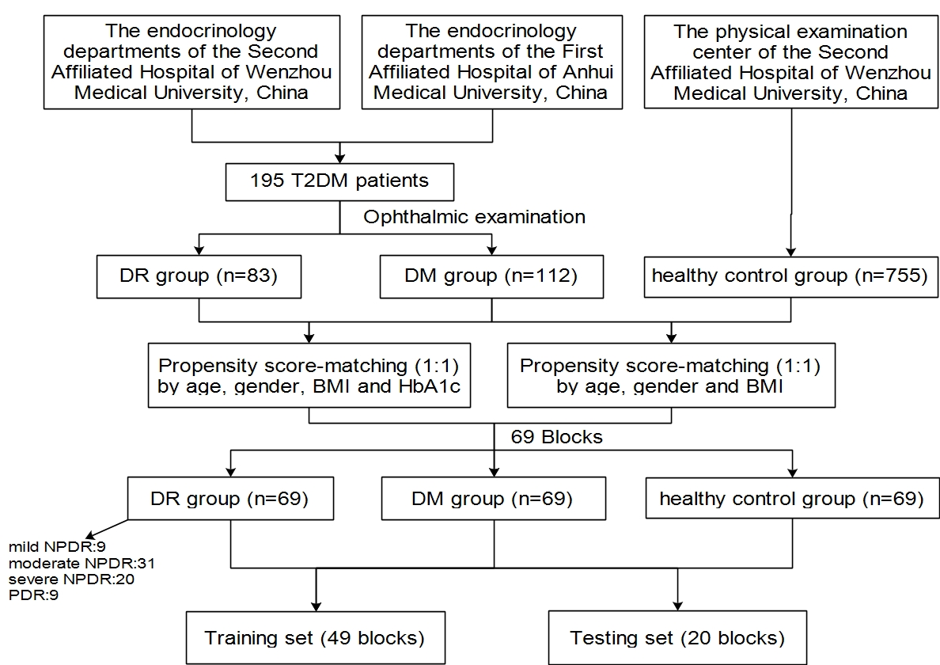
Fig S1. Study flowchart of the propensity score-matched participants

Abbreviations: T2DM, Type 2 diabetes; DR, diabetic retinopathy; DM, diabetes mellitus without DR; NPDR, non-proliferative diabetic retinopathy; PDR, proliferative diabetic retinopathy.

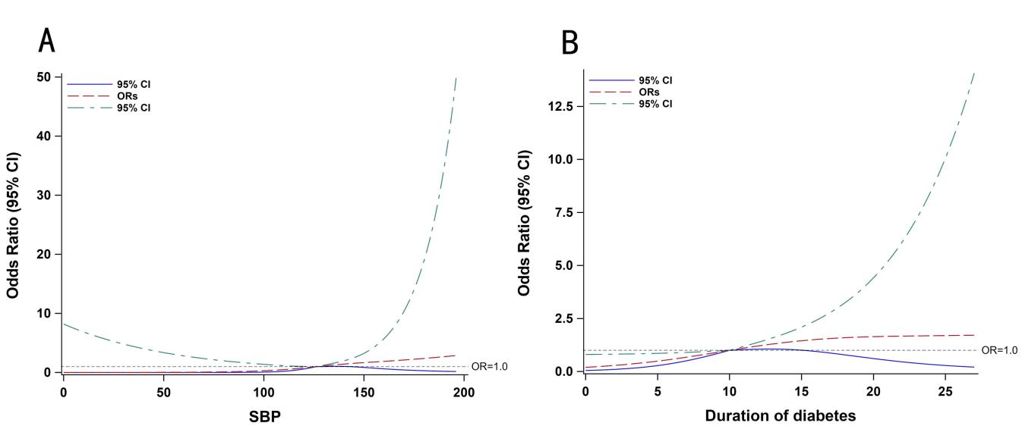
Fig S2. The relation of SBP (A) and duration (B) with the risk of DR

Fig S3. Calibration curves of the DR incidence risk nomogram prediction in the array

Notes: The x-axis represents the predicted incidence risk. The y-axis represents the actual diagnosed DR. The diagonal dotted line represents a perfect prediction by an ideal model. The solid line represents the performance of the nomogram; a closer fit to the diagonal dotted line represents a better prediction.
Fig S4. Sensitivity analysis of patients with DM and mild/moderate/severe DR: the ROC curve of the nomogram model in the training set (A, C, E) and testing set (B, D, F)

Notes: mile, A and B; moderate, C and D; severe, E and F.
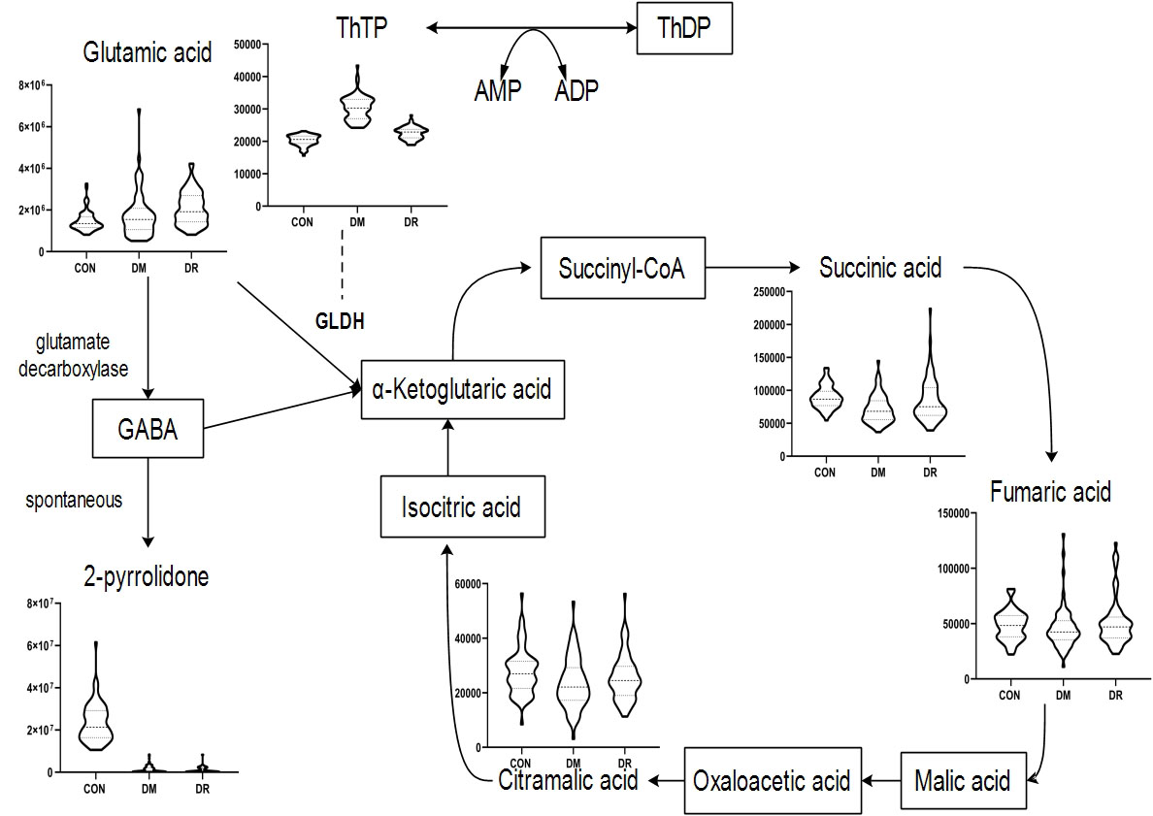
Fig S5. A schematic diagram of a proposed metabolic pathway

Abbreviations: ThTP, thiamine triphosphate; ThDP, thiamine diphosphate; AMP, adenosine monophosphate, ADP, adenosine diphosphate; CON, healthy control group; DR, diabetic retinopathy group; DM, diabetes mellitus without DR group; GABA, γ-aminobutyric acid; GLDH, glutamate dehydrogenase.

