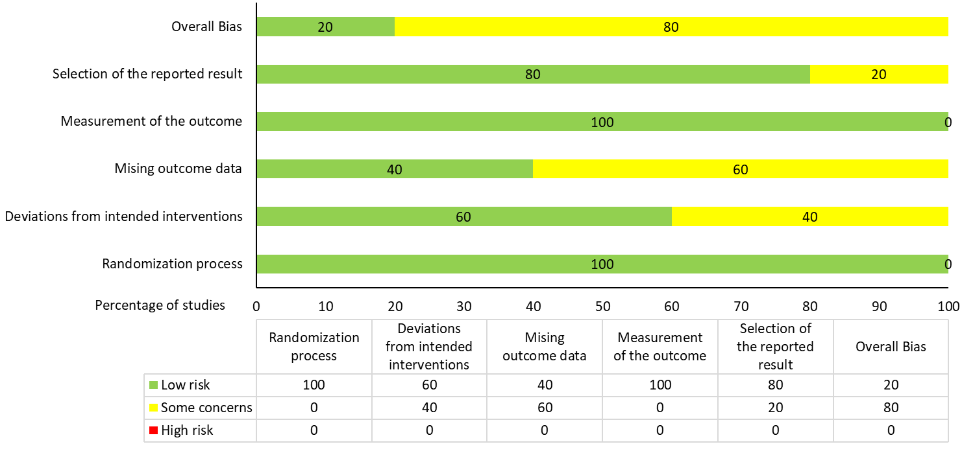
Supplementary Figure 1: Risk of bias assessment for RCTs using Cochrane’s Risk of Bias (ROB) tool -2

Supplementary Table 1: Risk of bias assessment for case-control and cohort studies using Newcastle-ottawa scale of star scoring: low risk (6-9/10), some concerns (3-5), high risk (0-2)

Case control studies | Selection |  |  |  | Comparability | Exposure
 | 1* | 2* | 3* | 4* | 1** | 1* | 2* | 3*
Asadi et al 2019 | * | * | * | * | ** |  | * | *
Chen et al 2019 | * | * | * | * | ** |  | * | *
Chen et al 2020 | * | * | * | * | ** |  | * | *
Shivappa et al 2019 | * | * | * | * | ** |  | * | *
Cohort studies | Selection |  |  |  | Comparability | Outcome
Cohort (PA based) studies | 1* | 2* | 3* | 4* | 1** | 1* | 2* | 3**
Currie et al 2014 | * | * |  | * | ** | * | * | *
Dempsey et al 2004 | * | * |  | * | ** | * | * | *
Oken et al 2006 | * | * |  | * | ** | * | * | *
Zhang et al 2006 | * | * |  | * | ** | * | * | *
Zhang et al 2014 | * | * |  | * | ** | * | * | *
Cohort (Diet based) studies | 1* | 2* | 3* | 4* | 1** | 1* | 2* | 3*
Amelia et al 2017B | * | * |  | * | ** | * | * | *
Bao et al 2014 | * | * |  | * | ** | * | * | *
Bao et al 2015 | * | * |  | * | ** | * | * | *
Bao et al 2018 | * | * |  | * | ** | * | * | *
Chen et al 2009 | * | * |  | * | ** | * | * | *
Li et al 2019 | * | * |  | * | ** | * | * | *
Looman et al 2018 | * | * |  | * | ** | * | * | *
Lynn et al 2020 | * | * |  | * | ** | * | * | *
Mikel et al 2017 | * | * |  | * | ** | * | * | *
Mikel et al 2018 | * | * |  | * | ** | * | * | *
Mikel et al 2019 | * | * |  | * | ** | * | * | *
Schoenaker et al 2015 | * | * |  | * | ** | * | * | *
Tobias et al 2012 | * | * |  | * | ** | * | * | *
Zhang et al 2014 | * | * |  | * | ** | * | * | *
Zhang et al (2), 2006 | * | * |  | * | ** | * | * | *
Zhang et al (3), 2006 | * | * |  | * | ** | * | * | *

Supplementary Figure 2: Funnel plots for
- RCTs (n=5)
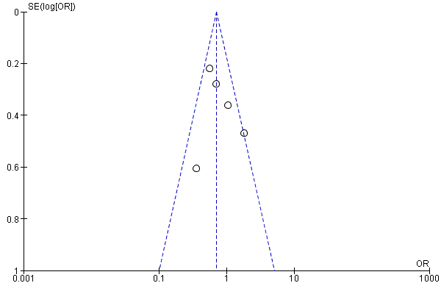

- Case-control studies (n=4)
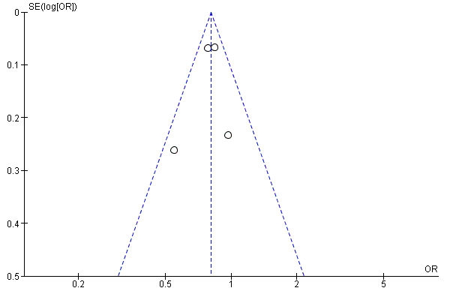

- Cohort studies based on Physical activity (n=5)

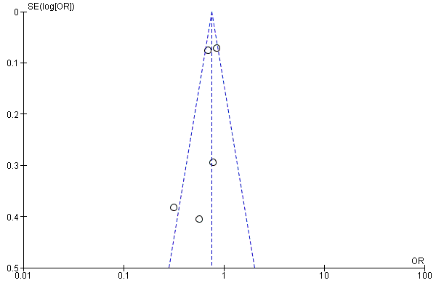

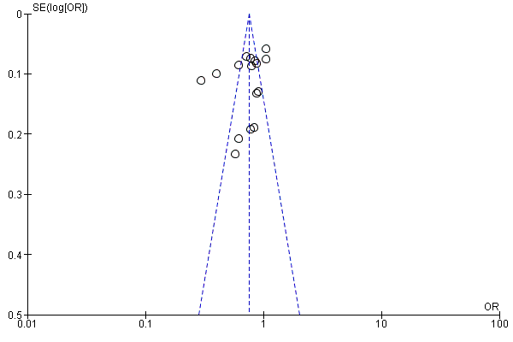
- Cohort studies based on Diet (n=16)

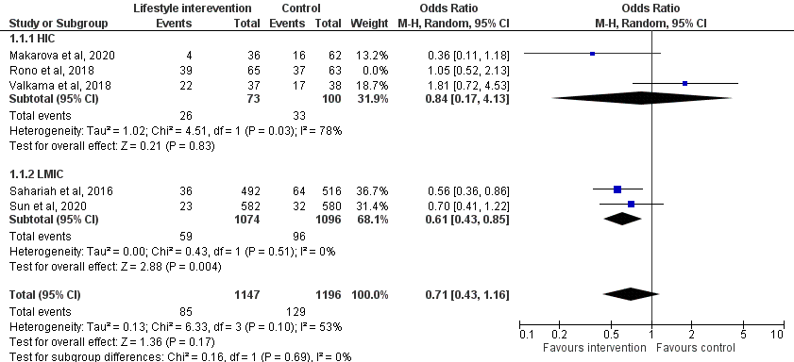
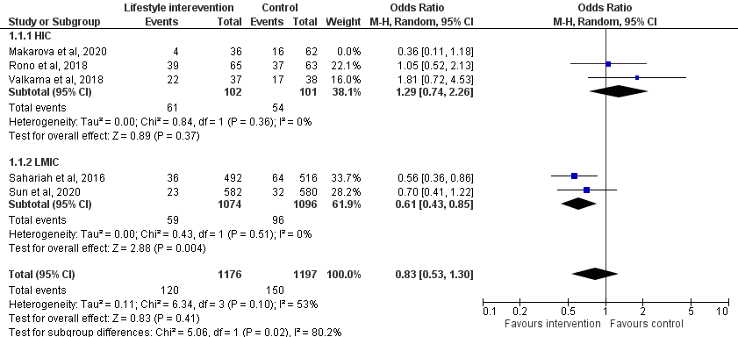
Supplementary figure 3a) Leave one out plots for RCTs
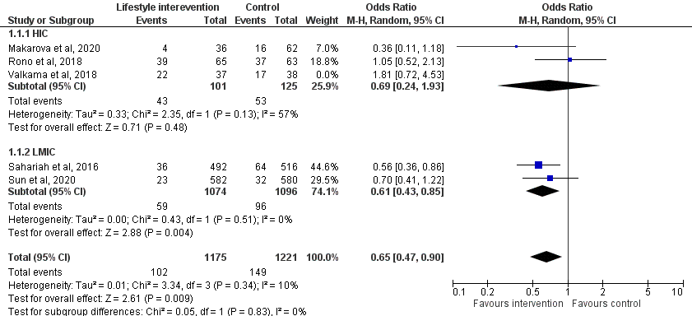
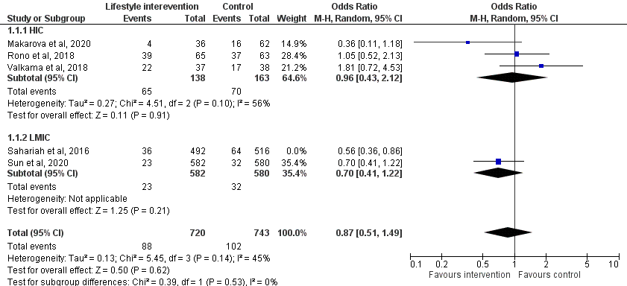

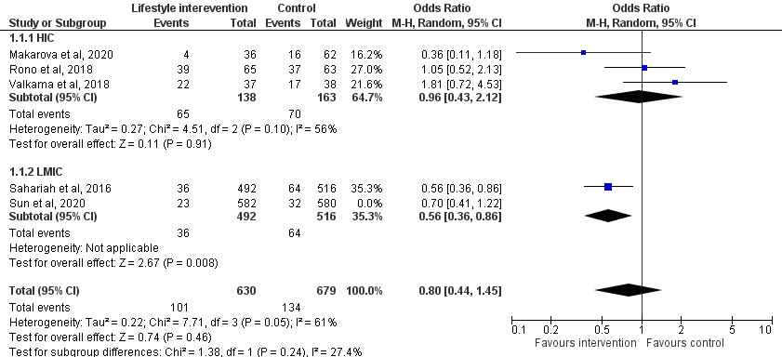
Supplementary figure 3b) Leave one out plots for cohort studies based on Physical activity
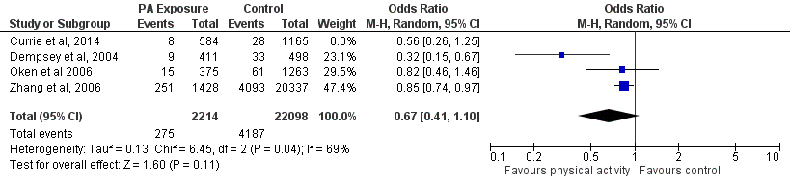
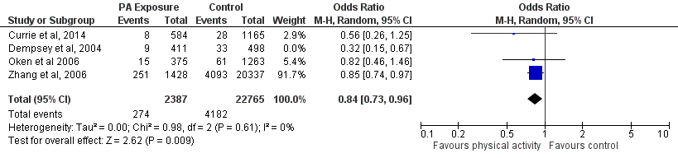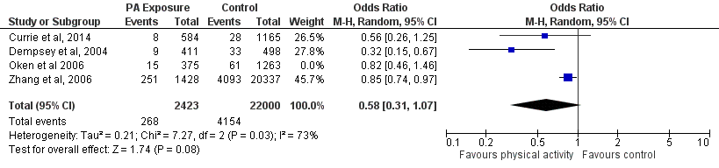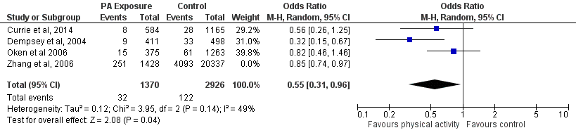

Supplementary figure 3c) Leave one out plots for cohort studies based on Low Carbohydrate/low sugar diet
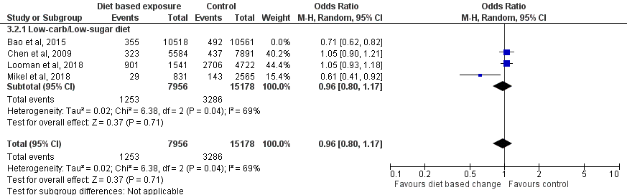
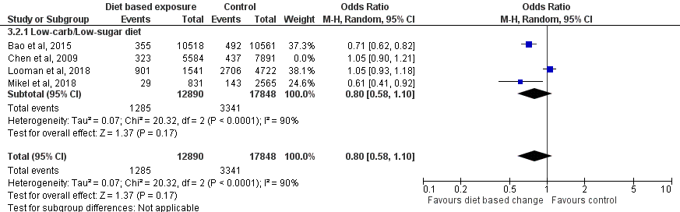
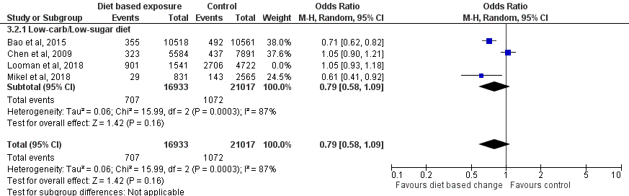
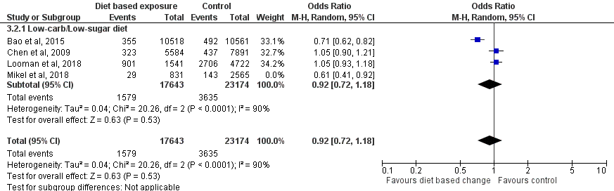

Supplementary figure 3d) Leave one out plots for cohort studies based on Diet Scores
