Folic acid Supplementation on Inflammation and Homocysteine in Type 2 Diabetes Mellitus: Systematic Review and Meta-analysis of Randomized Controlled Trials
Running title: Folic acid in type 2 diabetes mellitus

Kabelo Mokgalaboni^{1*}, Given. R Mashaba¹, Wendy N. Phoswa¹, Sogolo. L Lebelo¹

¹Department of Life and Consumer Science, College of Agriculture and Environmental Sciences, University of South Africa, Florida Campus, Roodepoort, 1710, South Africa.

*Corresponding author
Mr Mokgalaboni Kabelo
Emails: mokgak@unisa.ac.za;
Department of Life and Consumer Sciences
University of South Africa
Calabash Building Office no 02-047
Florida, 1710

Table legends
Table 1S: Search strategies used on database.
Table 2S: Sensitivity analysis results on homocysteine
Table 3S: Sensitivity analysis results on CRP
Table 4S: Sensitivity analysis results on TNF-α
Table 5S: Sensitivity analysis results on IL-6
Table 6S: GRADE results on the effect of folate on homocysteine and inflammation

Figure legends
Figure 1S: Subgroup analysis on homocysteine based on sample size and dosage. A. Subgroup analysis based on sample size; B. subgroup based on the dosage of folic acid
Figure 2S: Subgroup analysis on homocysteine based on gender and duration of intervention.
Figure 3S: Subgroup analysis on CRP in type 2 diabetes mellitus

Table 1S: Search strategies used on database.

PubMed
MESH TERMS | HITS
Folate | 42,187
Folic acid | 42,137
Folacin | 42,187
Vitamin B9 | 42,187
Homocysteine | 17,037
Inflammation | 421,584
Type 2 diabetes mellitus | 174,205
((((((Folate[MeSH Terms]) OR (Folic acid[MeSH Terms])) OR (folacin[MeSH Terms])) OR (vitamin b9[MeSH Terms])) AND (homocysteine[MeSH Terms])) AND (Inflammation[MeSH Terms])) AND (type 2 diabetes mellitus[MeSH Terms]) | 2
Scopus
(TITLE-ABS-KEY ( folate ) OR TITLE-ABS-KEY ( folic AND acid ) OR TITLE-ABS-KEY ( vitamin AND b9 ) OR TITLE-ABS-KEY ( folacin ) AND TITLE-ABS-KEY ( homocysteine ) AND TITLE-ABS-KEY ( inflammation ) AND TITLE-ABS-KEY ( type 2 diabetes AND mellitus ) | 20
Cochrane Library
MESH descriptor [Folic acid] AND MESH descriptor [type 2 diabetes] | 26

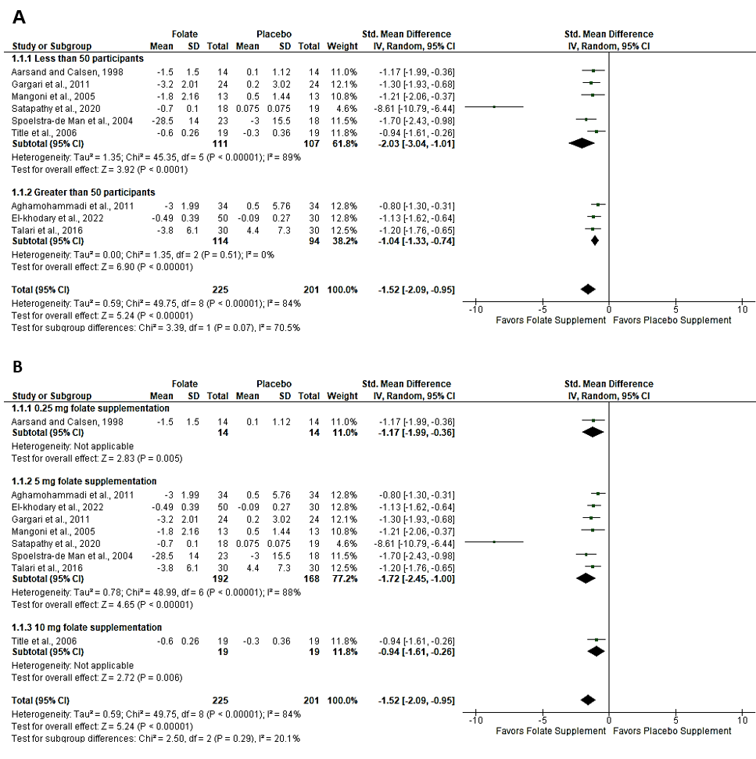
Figure 1S: Subgroup analysis on homocysteine based on sample size and dosage. A. Subgroup analysis based on sample size; B. subgroup based on the dosage of folate

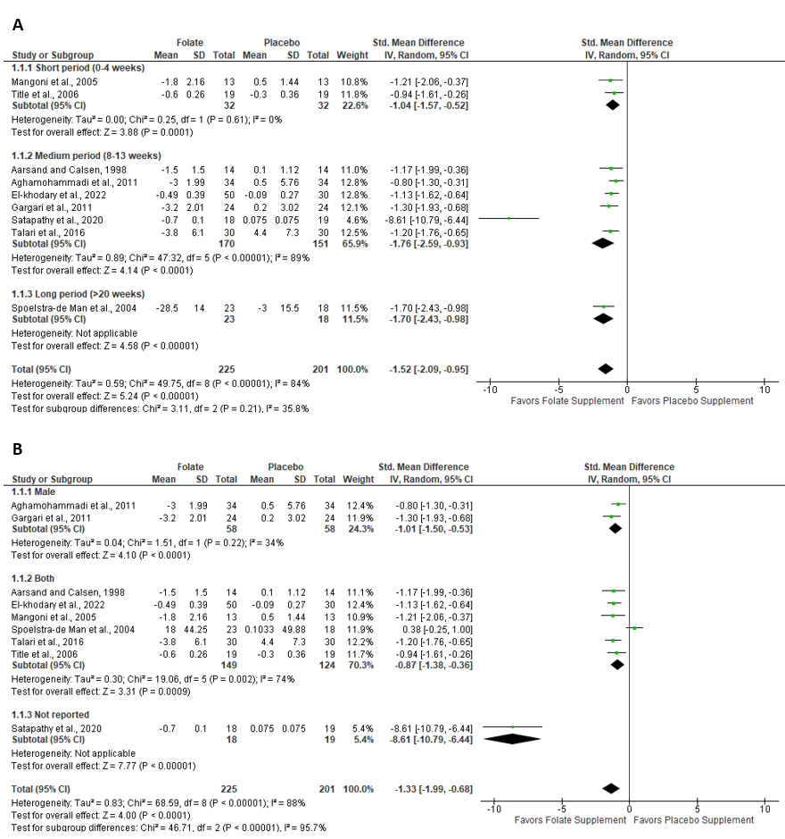
Figure 2S: Subgroup analysis on homocysteine based on gender and duration of intervention.

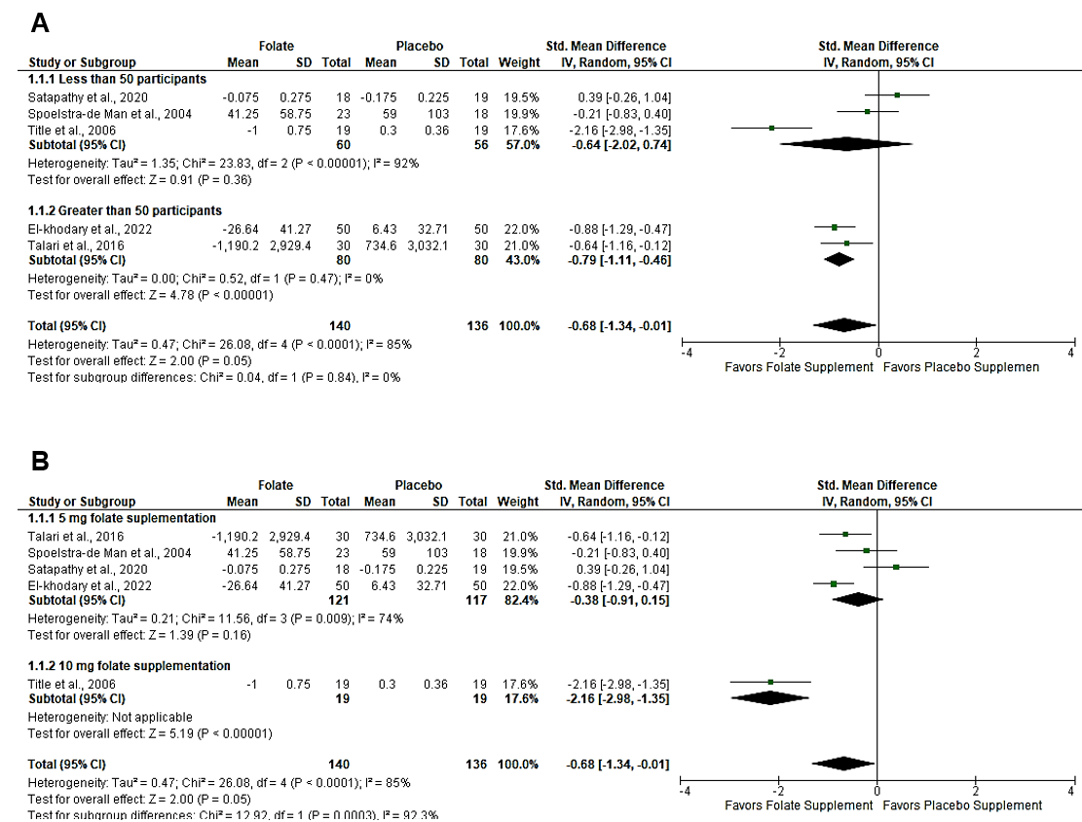
Figure 3S: Subgroup analysis on CRP in type 2 diabetes mellitus

Table 2S: Sensitivity analysis for results on homocysteine
Deleted Study | Effect Size | Lower CI | Upper CI | P Value | I Square
Aarsand and Calsen, 1998 | -1.9790 | -3.5810 | -0.3771 | 0.0155 | 97.9422
Aghamohammadi et al., 2011 | -2.0262 | -3.6117 | -0.4406 | 0.0123 | 97.5890
El-khodary et al., 2022 | -1.9866 | -3.5909 | -0.3823 | 0.0152 | 97.6297
Gargari et al., 2011 | -1.9646 | -3.5739 | -0.3552 | 0.0167 | 97.8366
Mangoni et al., 2005 | -1.9739 | -3.5769 | -0.3710 | 0.0158 | 97.9605
Satapathy et al., 2020 | -1.1403 | -1.3566 | -0.9239 | 0.0000 | 0.0000
Spoelstra-de Man et al., 2004 | -1.9142 | -3.5296 | -0.2987 | 0.0202 | 97.9305
Talari et al., 2016 | -1.9774 | -3.5840 | -0.3707 | 0.0159 | 97.7421
Title et al., 2006 | -2.0088 | -3.6010 | -0.4166 | 0.0134 | 97.8319

Table 3S: Sensitivity analysis results on CRP
Deleted Study | Effect Size | Lower CI | Upper CI | P Value | I Square
Title et al., 2006 | -0.3886 | -0.8736 | 0.0963 | 0.0998 | 65.9574
Talari et al., 2016 | -0.6963 | -1.6270 | 0.2345 | 0.1245 | 88.6113
Spoelstra-de Man et al., 2004 | -0.7986 | -1.6787 | 0.0814 | 0.0623 | 88.4689
Satapathy et al., 2020 | -0.9251 | -1.5893 | -0.2610 | 0.0042 | 80.1355
El-khodary et al., 2022 | -0.6302 | -1.5594 | 0.2991 | 0.1637 | 87.1244

Table 4S: Sensitivity analysis results on TNF-α
Deleted Study | Effect Size | Lower CI | Upper CI | P Value | I Square
Satapathy et al., 2020 | 0.1952 | -0.2709 | 0.6612 | 0.3897 | 0.0000
Spoelstra-de Man et al., 2004 | -1.5052 | -3.7515 | 0.7411 | 0.1688 | 92.8380
Title et al., 2006 | -1.3176 | -3.8417 | 1.2066 | 0.2837 | 94.4002

Table 5S: Sensitivity analysis results on IL-6
Deleted Study | Effect Size | Lower CI | Upper CI | P Value | I Square
Satapathy et al., 2020 | 0.4940 | -0.1320 | 1.1200 | 0.1219 | 0.0000
Spoelstra-de Man et al., 2004 | -0.5753 | -1.2332 | 0.0825 | 0.0865 | 0.0000

Table 6S: GRADE results on the effect of folate on homocysteine and inflammation

Outcomes | № of participants  (studies)  Follow-up | Certainty of the evidence  (GRADE) | Relative effect  (95% CI) | Anticipated absolute effects
 |  |  |  | Risk with placebo | Risk difference with folate and placebo
Homocysteine  assessed with: µmol/L | 426  (9 RCTs) | ⨁⨁⨁◯  Moderate^{a,b,c} | - | - | SMD 1.52 SD lower  (2.09 lower to 0.95 lower)
C-Reactive Protein (CRP) | 276  (5 RCTs) | ⨁⨁⨁◯  Moderate^{d,e,f,g} | - | - | SMD 0.68 SD lower  (1.34 lower to 0.01 lower)
Tumor Necrosis Factor-Alpha (TNF-α) | 116  (3 RCTs) | ⨁⨁⨁◯  Moderate^{b,d,e,h} | - | - | SMD 0.86 SD lower  (2.65 lower to 0.93 higher)
Interleukin-6 (IL-6) | 78  (2 RCTs) | ⨁◯◯◯  Very low^{b,d,i,j} | - | - | SMD 0.04 SD lower  (1.08 lower to 1.01 higher)
*The risk in the intervention group (and its 95% confidence interval) is based on the assumed risk in the comparison group and the relative effect of the intervention (and its 95% CI).
CI: confidence interval; SMD: standardised mean difference
GRADE Working Group grades of evidence
High certainty: we are very confident that the true effect lies close to that of the estimate of the effect.
Moderate certainty: we are moderately confident in the effect estimate: the true effect is likely to be close to the estimate of the effect, but there is a possibility that it is substantially different.
Low certainty: our confidence in the effect estimate is limited: the true effect may be substantially different from the estimate of the effect.
Very low certainty: we have very little confidence in the effect estimate: the true effect is likely to be substantially different from the estimate of effect.

Explanations
a. Two trials analyzed were judged as some concern of bias in two domains
b. evidence of publication bias was observed graphically through funnel plot and statistically through Eggers regression test (p value less than 0.05)
c. The effect size was large, with SMD of 1.52 which is large effect according to Cohens d
d. All trials analyzed showed no risk of bias and thus were judged as low risk of bias according to Cochrane risk of bias
e. Small sample size
f. The funnel plot and Eggers regression test showed no evidence of publication bias
g. The effect size is ranging from small to medium, with SMD of 0.68 which is medium effect according to Cohens d
h. Large effect size, with SMD of 0.86 which is large according to Cohens d
i. Very small sample size (78) participants
j. Small effect size, with SMD of 0.04 according to Cohens d

