Supplementary Materials
Supplementary Table 1. The search queries used for each database and the search results

Query |  | Results (No.)  24 April 2024
PubMed
#1 | (“TyG” OR “triglyceride glucose” OR “triglyceride-glucose” OR “triglyceride-glucose index”) | 1,755
#2 | ("Peripheral Arterial Disease"[Mesh] OR "Peripheral Vascular Diseases"[MeSH] OR "Peripheral Arterial Disease" OR "Peripheral Arterial Diseases" OR "Peripheral Artery Disease" OR "Peripheral Artery Diseases" OR "Peripheral Arterial Occlusive Disease" OR "Peripheral Arterial Occlusive Diseases" OR "Peripheral Vascular Disease" OR "Peripheral Vascular Diseases" OR "Intermittent Claudication" OR "Critical Limb Ischemia" OR "Aortic Occlusive Disease" OR "Aortic Occlusive Diseases" OR "Aortic Artery Disease" OR "Aortic Artery Diseases" OR "Aortic Arterial Disease" OR "Aortic Arterial Diseases" OR "Iliac Occlusive Disease" OR "Iliac Occlusive Diseases" OR "Iliac Artery Disease" OR "Iliac Artery Diseases" OR "Iliac Arterial Disease" OR "Iliac Arterial Diseases" OR "Femoral Occlusive Disease" OR "Femoral Occlusive Diseases" OR "Femoral Artery Disease" OR "Femoral Artery Diseases" OR "Femoral Arterial Disease" OR "Femoral Arterial Diseases" OR "Popliteal Occlusive Disease" OR "Popliteal Occlusive Diseases" OR "Popliteal Artery Disease" OR "Popliteal Artery Diseases" OR "Popliteal Arterial Disease" OR "Popliteal Arterial Diseases" OR "Femoropopliteal Occlusive Disease" OR "Femoropopliteal Occlusive Diseases" OR "Femoropopliteal Artery Disease" OR "Femoropopliteal Artery Diseases" OR "Femoropopliteal Arterial Disease" OR "Femoropopliteal Arterial Diseases" OR “ankle brachial” OR “ankle-brachial” OR “pulse wave velocit*”) | 102,548
#3 | #1 AND #2 | 51
Embase
#1 | (“TyG”:ti,ab,kw OR “triglyceride glucose”:ti,ab,kw OR “triglyceride-glucose”:ti,ab,kw OR “triglyceride-glucose index”:ti,ab,kw) | 2,265
#2 | ("Peripheral Arter*”:ti,ab,kw OR "Peripheral Arterial Disease":ti,ab,kw OR "Peripheral Arterial Diseases":ti,ab,kw OR "Peripheral Artery Disease":ti,ab,kw OR "Peripheral Artery Diseases":ti,ab,kw OR "Peripheral Arterial Occlusive Disease":ti,ab,kw OR "Peripheral Arterial Occlusive Diseases":ti,ab,kw OR "Peripheral Vascular Disease":ti,ab,kw OR "Peripheral Vascular Diseases":ti,ab,kw OR "Intermittent Claudication":ti,ab,kw OR "Critical Limb Ischemia":ti,ab,kw OR "Aortic Occlusive Disease":ti,ab,kw OR "Aortic Occlusive Diseases":ti,ab,kw OR "Aortic Artery Disease":ti,ab,kw OR "Aortic Artery Diseases":ti,ab,kw OR "Aortic Arterial Disease":ti,ab,kw OR "Aortic Arterial Diseases":ti,ab,kw OR "Iliac Occlusive Disease":ti,ab,kw OR "Iliac Occlusive Diseases":ti,ab,kw OR "Iliac Artery Disease":ti,ab,kw OR "Iliac Artery Diseases":ti,ab,kw OR "Iliac Arterial Disease":ti,ab,kw OR "Iliac Arterial Diseases":ti,ab,kw OR "Femoral Occlusive Disease":ti,ab,kw OR "Femoral Occlusive Diseases":ti,ab,kw OR "Femoral Artery Disease":ti,ab,kw OR "Femoral Artery Diseases":ti,ab,kw OR "Femoral Arterial Disease":ti,ab,kw OR "Femoral Arterial Diseases":ti,ab,kw OR "Popliteal Occlusive Disease":ti,ab,kw OR "Popliteal Occlusive Diseases":ti,ab,kw OR "Popliteal Artery Disease":ti,ab,kw OR "Popliteal Artery Diseases":ti,ab,kw OR "Popliteal Arterial Disease":ti,ab,kw OR "Popliteal Arterial Diseases":ti,ab,kw OR "Femoropopliteal Occlusive Disease":ti,ab,kw OR "Femoropopliteal Occlusive Diseases":ti,ab,kw OR "Femoropopliteal Artery Disease":ti,ab,kw OR "Femoropopliteal Artery Diseases":ti,ab,kw OR "Femoropopliteal Arterial Disease":ti,ab,kw OR "Femoropopliteal Arterial Diseases":ti,ab,kw OR “ankle brachial”:ti,ab,kw OR “ankle-brachial”:ti,ab,kw OR “pulse wave velocit*”:ti,ab,kw) | 103,006
#3 | #1 AND #2 | 62
Web of Science
#1 | TS=(“TyG” OR “triglyceride glucose” OR “triglyceride-glucose” OR “triglyceride-glucose index”) | 1,882
#2 | TS=("Peripheral Arter*" OR "Peripheral Vascular Diseases" OR "Peripheral Arterial Disease" OR "Peripheral Arterial Diseases" OR "Peripheral Artery Disease" OR "Peripheral Artery Diseases" OR "Peripheral Arterial Occlusive Disease" OR "Peripheral Arterial Occlusive Diseases" OR "Peripheral Vascular Disease" OR "Peripheral Vascular Diseases" OR "Intermittent Claudication" OR "Critical Limb Ischemia" OR "Aortic Occlusive Disease" OR "Aortic Occlusive Diseases" OR "Aortic Artery Disease" OR "Aortic Artery Diseases" OR "Aortic Arterial Disease" OR "Aortic Arterial Diseases" OR "Iliac Occlusive Disease" OR "Iliac Occlusive Diseases" OR "Iliac Artery Disease" OR "Iliac Artery Diseases" OR "Iliac Arterial Disease" OR "Iliac Arterial Diseases" OR "Femoral Occlusive Disease" OR "Femoral Occlusive Diseases" OR "Femoral Artery Disease" OR "Femoral Artery Diseases" OR "Femoral Arterial Disease" OR "Femoral Arterial Diseases" OR "Popliteal Occlusive Disease" OR "Popliteal Occlusive Diseases" OR "Popliteal Artery Disease" OR "Popliteal Artery Diseases" OR "Popliteal Arterial Disease" OR "Popliteal Arterial Diseases" OR "Femoropopliteal Occlusive Disease" OR "Femoropopliteal Occlusive Diseases" OR "Femoropopliteal Artery Disease" OR "Femoropopliteal Artery Diseases" OR "Femoropopliteal Arterial Disease" OR "Femoropopliteal Arterial Diseases" OR “ankle brachial” OR “ankle-brachial” OR “pulse wave velocit*”) | 69,374
#3 | #1 AND #2 | 53
SCOPUS
#1 | TITLE-ABS-KEY(“TyG” OR “triglyceride glucose” OR “triglyceride-glucose” OR “triglyceride-glucose index”) | 2,943
#2 | TITLE-ABS-KEY("Peripheral Arter*" OR "Peripheral Vascular Diseases" OR "Peripheral Arterial Disease" OR "Peripheral Arterial Diseases" OR "Peripheral Artery Disease" OR "Peripheral Artery Diseases" OR "Peripheral Arterial Occlusive Disease" OR "Peripheral Arterial Occlusive Diseases" OR "Peripheral Vascular Disease" OR "Peripheral Vascular Diseases" OR "Intermittent Claudication" OR "Critical Limb Ischemia" OR "Aortic Occlusive Disease" OR "Aortic Occlusive Diseases" OR "Aortic Artery Disease" OR "Aortic Artery Diseases" OR "Aortic Arterial Disease" OR "Aortic Arterial Diseases" OR "Iliac Occlusive Disease" OR "Iliac Occlusive Diseases" OR "Iliac Artery Disease" OR "Iliac Artery Diseases" OR "Iliac Arterial Disease" OR "Iliac Arterial Diseases" OR "Femoral Occlusive Disease" OR "Femoral Occlusive Diseases" OR "Femoral Artery Disease" OR "Femoral Artery Diseases" OR "Femoral Arterial Disease" OR "Femoral Arterial Diseases" OR "Popliteal Occlusive Disease" OR "Popliteal Occlusive Diseases" OR "Popliteal Artery Disease" OR "Popliteal Artery Diseases" OR "Popliteal Arterial Disease" OR "Popliteal Arterial Diseases" OR "Femoropopliteal Occlusive Disease" OR "Femoropopliteal Occlusive Diseases" OR "Femoropopliteal Artery Disease" OR "Femoropopliteal Artery Diseases" OR "Femoropopliteal Arterial Disease" OR "Femoropopliteal Arterial Diseases" OR “ankle brachial” OR “ankle-brachial” OR “pulse wave velocit*”) | 108,750
#3 | #1 AND #2 | 81
TOTAL RECORDS |  | 247
TOTAL RECORDS AFTER REMOVING DUPLICATES |  | 106

Supplementary Table 2. Quality Assessment of Included Studies Based on Newcastle-Ottawa Scale (NOS)

Study | Selection |  |  |  | Comparability | Outcome |  | Overall  Score
Study | Representation | Sample size | Non-Respondents | Exposure | Comparability | Outcome | Statistical test | Overall  Score
Caliskan et al. (2023) | * | * | * | ** | - | ** | * | 8
Chiu et al. (2020) | * | * | * | ** | - | ** | * | 8
Çora et al. (2021) | * | * | * | ** | - | ** | * | 8
Gao et al. (2021) | * | * | * | ** | - | ** | * | 8
Guo et al. (2021) | * | * | * | ** | - | ** | * | 8
Ji et al. (2022) | * | * | * | ** | - | ** | * | 8
Karaduman et al. (2020) | * | * | * | ** | - | ** | * | 8
Lee et al. (2018) | * | * | * | ** | - | ** | * | 8
Li et al. (2020) | * | * | * | ** | - | ** | * | 8
Liu et al. (2022) | * | * | * | ** | - | ** | * | 8
Nakagomi et al. (2019) | * | * | * | ** | - | ** | * | 8
Ning et al. (2024) | * | * | * | ** | - | ** | * | 8
Pala et al. (2021) | * | * | * | ** | - | ** | * | 8
Pan et al. (2021) | * | * | * | ** | - | ** | * | 8
Su et al. (2021) | * | * | * | ** | - | ** | * | 8
Wang et al. (2021) | * | * | * | ** | - | ** | * | 8
Wu et al. (2021) | * | * | * | ** | - | ** | * | 8
Wu et al. (2021) | * | * | * | ** | - | ** | * | 8
Yan et al. (2022) | * | * | * | ** | - | ** | * | 8
Yang et al. (2022) | * | * | * | ** | - | ** | * | 8
Zhang et al. (2024) | * | * | * | ** | - | ** | * | 8
Zhao et al. (2019) | * | * | * | ** | - | ** | * | 8

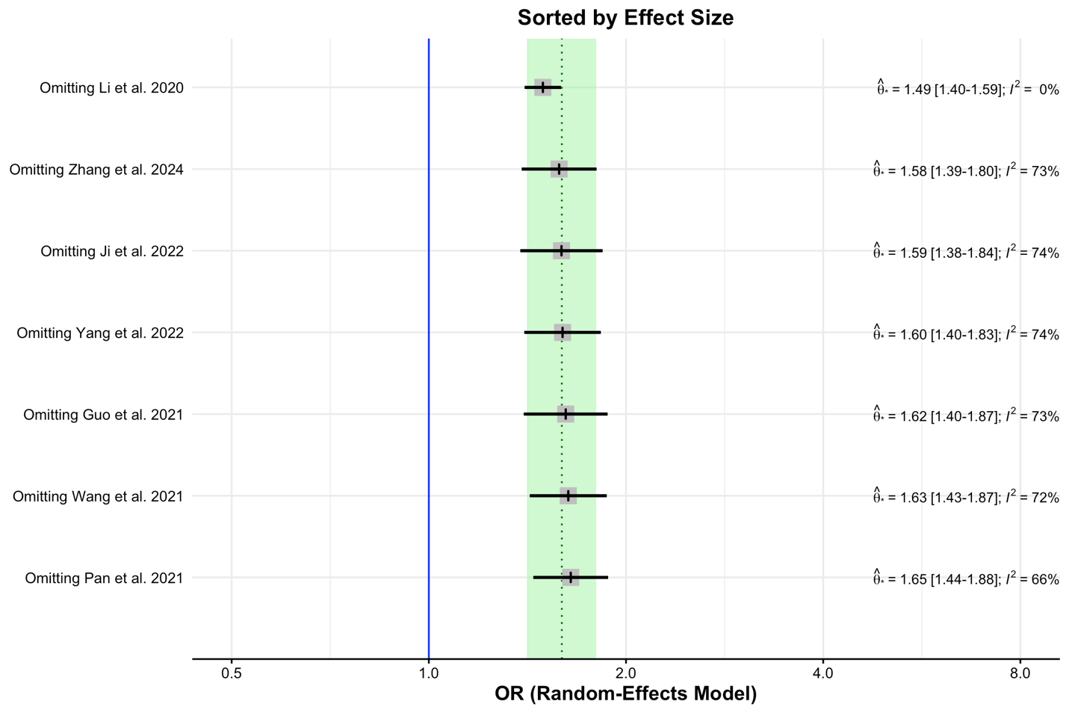
Supplementary Figure 1. Sensitivity analysis by leave-one-out method for meta-analysis of one unit increase in TyG association with high baPWV

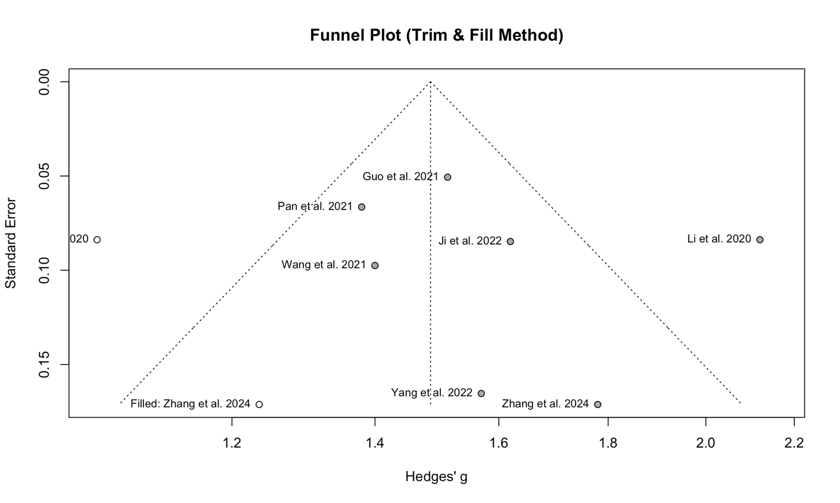
Supplementary Figure 2. Funnel plot by trim-and-fill method for meta-analysis of one unit increase in TyG association with high baPWV

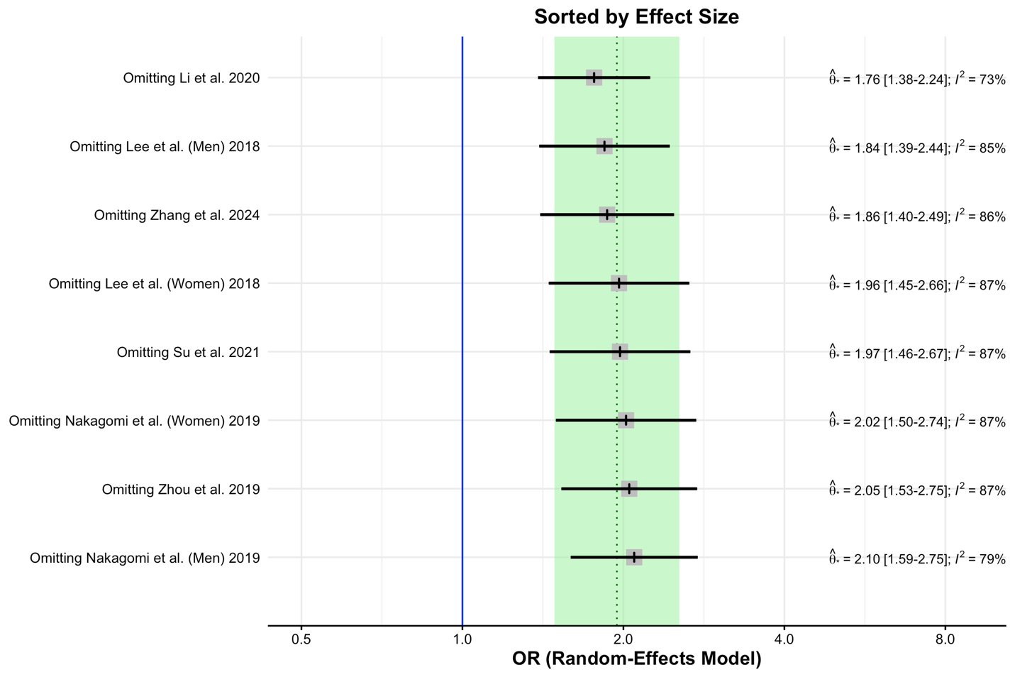
Supplementary Figure 3. Sensitivity analysis by leave-one-out method for meta-analysis of odds ratios for Q4 to Q1 of TyG association with high baPWV

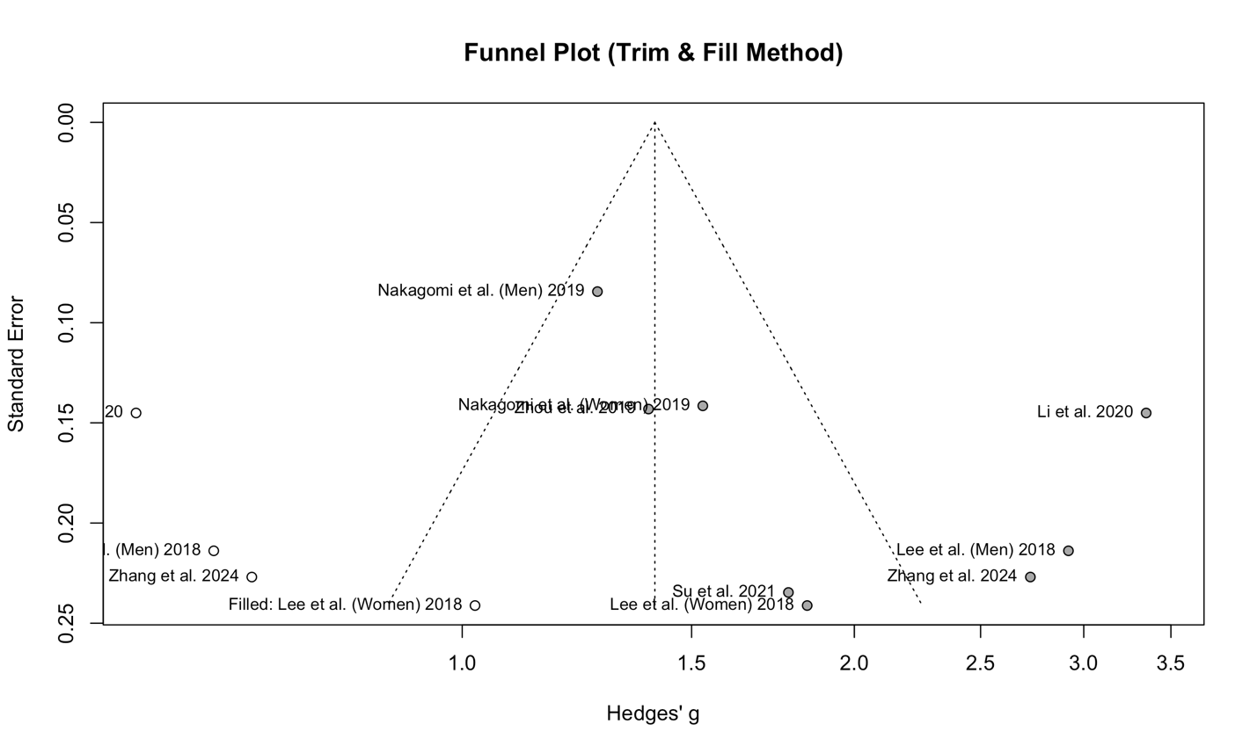
Supplementary Figure 4. Funnel plot by trim-and-fill method for meta-analysis of odds ratios for Q4 to Q1 of TyG association with high baPWV

