Supplementary Information
Table A-1. Model Parameters for the US Nonfarm Industries
Model Input | Parameter | Source
Employment (millions) | 158.0 | BLS (2023)¹
Obesity prevalence | 30% | NHIS analysis
Overweight prevalence | 34% | NHIS analysis
Increased medical costs per person
Obesity impact on worker medical costs | $1514 | MEPS analysis
Overweight impact on worker medical costs | $380 | MEPS analysis
Obesity impact on dependent medical costs | $1514 | Assumption based on MEPS analysis
Overweight impact on dependent medical costs | $380 | Assumption based on MEPS analysis
Medical insurance and payment inputs
Health insurance take-up rate (industry average) | 59% | KFF (2023)²
Health insurance take-up rate (for organizations with 500+ employees) | 81% | Calculated from KFF (2023)²
Employer % total medical costs (industry average) | 60% | Calculated from BLS (2023)³ and MEPS analysis
Employer % total medical costs (for organizations with 500+ employees) | 63% | Calculated from BLS (2023)³ and MEPS analysis
Percent of covered employees with adult dependent | 44% | Calculated from 62% of adults are married or have a partner⁴, and 29% of partners have separate coverage⁵
Other costs to employers
Higher disability costs: Obesity | $664 | Calculated from Shinde et al. (2023) and NHIS and MEPS analysis⁶
Higher workers’ compensation payments: Obesity | $112 | Calculated from Shinde et al. (2023) and NHIS and MEPS analysis⁶
Productivity
Health-related work absenteeism: Obesity | $1755 | Calculated from Shinde et al. (2023)⁶, Strömberg (2017)⁷, and NHIS and MEPS analysis
Health-related presenteeism: Obesity | $2427 | Calculated from Strömberg (2017)⁷ and NHIS and CPS analysis
Health-related presenteeism: Overweight | $864 | Calculated from Strömberg (2017)⁷ and NHIS and CPS analysis
Notes: BLS=Bureau of Labor Statistics; CPS=Current Population Survey, KFF=Kaiser Family Foundation, MEPS=Medical Expenditure Panel Survey, NHIS=National Health Interview Survey.

Table A-2. Injury Risk and Obesity-associated Costs for Workers’ Compensation and Disability
Industry | % injuries associated with obesity-related cause | Higher injury worker compensation | Higher disability costs (short-term and long-term) | Injury and disability-related expense per worker
Construction | 27% | $ 268 | $ 1589 | $1857
Education & Health Services | 30% | $ 33 | $ 966 | $1129
Financial Activities | 38% | $ 17 | $ 101 | $118
Government | 32% | $ 154 | $ 913 | $1067
Manufacturing | 29% | $ 228 | $ 1352 | $1580
Professional & Business Services | 31% | $ 33 | $ 196 | $229
Transportation & Utilities | 32% | $ 204 | $ 1209 | $1413
All industries | 31% | $ 112 | $ 664 | $776

Figure A-1. Estimated Clinical Outcomes from Weight Loss
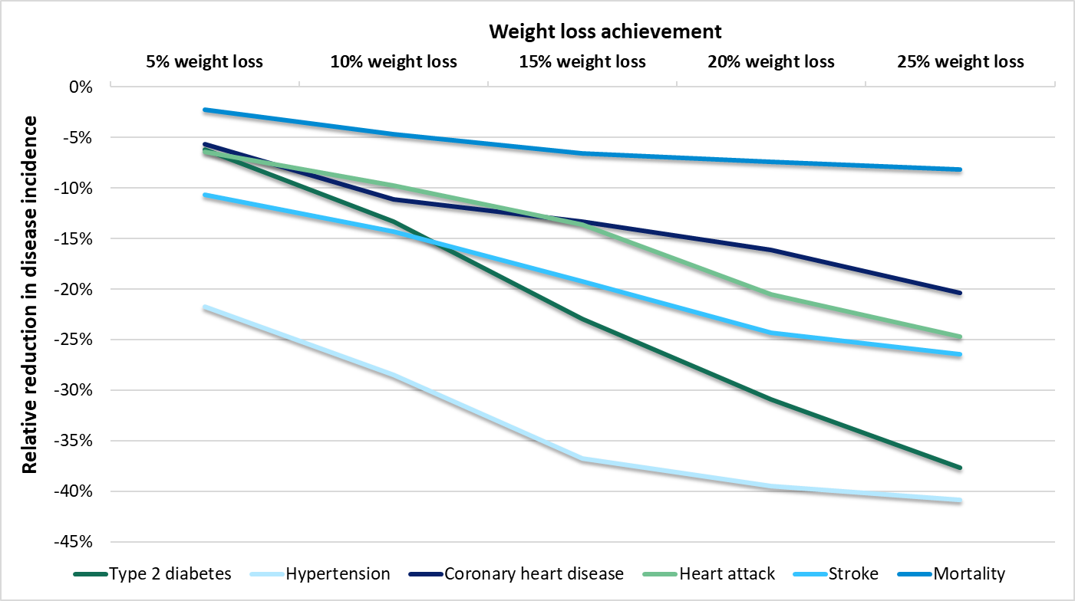

Table A-3. Average 5-year Medical Cost Saving per Person with Obesity Treatment
Industry/Weight Loss Scenario | 5% | 10% | 15% | 20% | 25%
Construction | $2110 | $3030 | $3900 | $4510 | $4760
Education & Health Services | $1940 | $2960 | $4210 | $4660 | $4890
Financial Activities | $2060 | $2870 | $3640 | $4290 | $4380
Government | $1940 | $2960 | $4210 | $4660 | $4890
Manufacturing | $1950 | $2960 | $3810 | $4300 | $4600
Professional & Business Services | $1870 | $2330 | $3580 | $4330 | $4620
Transportation & Utilities | $2230 | $3460 | $4000 | $5180 | $5310
All Industries | $2270 | $3170 | $3840 | $4490 | $4830

Brief Overview of DPTMM
The Disease Prevention and Treatment Microsimulation Model (DPTMM) is an analytical tool developed by GlobalData to help decision-makers evaluate the health and economic impacts of disease interventions across populations. By simulating individual characteristics and health risk factors, the model projects outcomes such as disease incidence, healthcare costs, and quality of life under various intervention scenarios. For the current analysis, the DPTMM simulated individual health changes over time, using a Markov Chain approach, incorporating the impact of weight loss on various clinical and economic outcomes, such as reductions in disease risks and healthcare costs. The model compared baseline and intervention scenarios, allowing projections of potential benefits over a 10-year period to reflect the potential benefits of obesity treatment.
For more details, please refer to the full model description available here: https://www.globaldata.com/health-economics/pharmaceuticals/DPTMM-Documentation.pdf

References
1. U.S. Bureau of Labor Statistics. Table B-1. Employees on nonfarm payrolls by industry sector and selected industry detail - 2023 M10 Results. November 3, 2023. Accessed November 8, 2023. https://www.bls.gov/news.release/empsit.t17.htm
2. Kaiser Family Foundation. 2023 Employer Health Benefits Survey. KFF; 2023. Accessed November 14, 2023. https://www.kff.org/report-section/ehbs-2023-section-3-employee-coverage-eligibility-and-participation/
3. U.S. Bureau of Labor Statistics. Table 3. Medical Plans: Share of Premiums Paid by Employer and Employee for Single Coverage. September 21, 2023. Accessed November 14, 2023. https://www.bls.gov/news.release/empsit.t17.htm
4. Fry R, Parker K. Rising Share of U.S. Adults Are Living Without a Spouse or Partner. Pew Research Center’s Social & Demographic Trends Project. October 5, 2021. Accessed November 14, 2023. https://www.pewresearch.org/social-trends/2021/10/05/rising-share-of-u-s-adults-are-living-without-a-spouse-or-partner/
5. Leonhardt M. 29% of Couples Have Separate Health Insurance. CNBC. November 8, 2019. Accessed November 14, 2023. https://www.cnbc.com/2019/11/08/29-percent-of-couples-have-separate-health-insurance.html
6. Shinde S, Tran AT, Jerry M, Lee CJ. Work loss among privately insured employees with overweight and obesity in the United States. Obesity Science & Practice. 2024;10(4):e775. doi:10.1002/osp4.775
7. Strömberg C, Aboagye E, Hagberg J, Bergström G, Lohela-Karlsson M. Estimating the Effect and Economic Impact of Absenteeism, Presenteeism, and Work Environment–Related Problems on Reductions in Productivity from a Managerial Perspective. Value in Health. 2017;20(8):1058-1064. doi:10.1016/j.jval.2017.05.008

