Supplemental Material
Supplemental tables
Table S1 Characteristics between the GDM population in this study and the total GDM population.
Variables | GDM (n = 200) | Total GDM (n = 1547) | P value
Maternal age (years) | 30.24 ± 3.44 | 30.40 ± 3.82 | 0.517
Ethnicity |  |  | 0.883
Han | 188 (94.0) | 1428 (94.3)
Others | 12 (6.0) | 87 (5.7)
Maternal education level |  |  | 0.224
High school or below | 36 (18.0) | 259 (22.1)
Collage or above | 164 (82.0) | 929 (77.9)
Pre-pregnant BMI (kg/m2) |  |  | 0.907
< 18.5 | 11 (5.5) | 84 (5.4)
18.5–23.9 | 111 (55.5) | 834 (53.9)
≥ 24.0 | 78 (39.0) | 628 (40.6)
Gravidity |  |  | 0.452
1 | 83 (41.5) | 685 (41.1)
≥ 2 | 117 (58.5) | 861 (58.9)
Parity |  |  | 0.168
0 | 128 (64.0) | 902 (58.9)
≥ 1 | 72 (36.0) | 629 (41.1)
Fetal sex |  |  | 0.868
Male | 104 (53.1) | 815 (53.7)
Female | 92 (46.9) | 703 (46.3)
Abbreviation: BMI, body mass index; GDM, gestational diabetes mellitus.
Values are mean ± standard deviation, numbers (percentage).

Table S2 Characteristics between the control population in this study and the total control population.
Variables | Control (n = 200) | Total Control (n = 3879) | P value
Maternal age (years) | 30.24 ± 3.44 | 30.11 ± 3.70 | 0.626
Ethnicity |  |  | 0.882
Han | 188 (94.0) | 3069 (93.7)
Others | 12 (6.0) | 205 (6.3)
Maternal education level |  |  | 0.257
High school or below | 49 (24.5) | 633 (21.1)
Collage or above | 151 (75.5) | 2366 (78.9)
Pre-pregnant BMI (kg/m2) |  |  | 0.112
< 18.5 | 17 (8.5) | 424 (10.9)
18.5–23.9 | 125 (62.5) | 2559 (66.1)
≥ 24.0 | 58 (29.0) | 890 (23.0)
Gravidity |  |  | 0.402
1 | 87 (43.5) | 1381 (43.0)
≥ 2 | 113 (56.5) | 1834 (57.0)
Parity |  |  | 0.175
0 | 114 (57.0) | 2063 (61.8)
≥ 1 | 86 (43.0) | 1275 (38.2)
Fetal sex |  |  | 0.880
Male | 93 (47.9) | 1668 (50.6)
Female | 101 (52.1) | 1626 (49.4)
Abbreviation: BMI, body mass index.
Values are mean ± standard deviation, numbers (percentage).

Table S3 Associations between serum essential trace element levels and the risk of GDM in conditional logistics regression.
Metals | Unadjusted OR (95% CI) | P for trend | Adjusted OR (95% CI) ª | P for trend
Cu
Continuous | 0.99 (0.38, 2.59) |  | 1.12 (0.40, 3.12)
T1 | 1 |  | 1
T2 | 1.42 (0.85, 2.37) |  | 1.47 (0.85, 2.53)
T3 | 1.14 (0.65, 1.99) |  | 1.21 (0.67, 2.20)
 |  | 0.792 |  | 0.654
Zn
Continuous | 0.29 (0.06, 1.40) |  | 0.21 (0.04, 1.13)
T1 | 1 |  | 1
T2 | 1.06 (0.67, 1.68) |  | 1.23 (0.74, 2.04)
T3 | 0.62 (0.37, 1.04) |  | 0.55 (0.31, 0.96) *
 |  | 0.066 |  | 0.037*
Se
Continuous | 0.60 (0.16, 2.30) |  | 0.74 (0.21, 2.63)
T1 | 1 |  | 1
T2 | 1.06 (0.63, 1.78) |  | 1.04 (0.59, 1.85)
T3 | 0.83 (0.49, 1.43) |  | 0.80 (0.45, 1.41)
 |  | 0.480 |  | 0.411
Cr
Continuous | 1.19 (0.64, 2.21) |  | 1.34 (0.69, 2.62)
T1 | 1 |  | 1
T2 | 0.94 (0.57, 1.53) |  | 1.05 (0.61, 1.82)
T3 | 1.15 (0.68, 1.92) |  | 1.07 (0.60, 1.90)
 |  | 0.326 |  | 0.318
Mo
Continuous | 1.87 (0.63, 5.54) |  | 2.33 (0.72, 7.56)
T1 | 1 |  | 1
T2 | 1.17 (0.68, 2.02) |  | 1.14 (0.63, 2.06)
T3 | 1.21 (0.67, 2.20) |  | 1.23 (0.65, 2.32)
 |  | 0.552 |  | 0.530
Co
Continuous | 0.49 (0.26, 0.95) * |  | 0.46 (0.22, 0.93) *
T1 | 1 |  | 1
T2 | 0.65 (0.38, 1.09) |  | 0.57 (0.32, 1.00)
T3 | 0.46 (0.26, 0.82) * |  | 0.41 (0.22, 0.77) *
 |  | 0.011* |  | 0.008*
ª Adjusted variables included ethnicity, annual household income, maternal education level, pre-pregnancy BMI, gravidity, parity, fetal sex, dietary energy, physical activity in early pregnancy.
*P value < 0.05. Abbreviation: T1, tertile 1; T2, tertile 2; T3, tertile 3.

Table S4 Associations between serum essential trace element levels and glucose levels at each time point ª
 | Fasting blood glucose |  | 1-hour blood glucose |  | 2-hour blood glucose
 | β (95% CI) | P value | β (95% CI) | P value | β (95% CI) | P value
Cu
T1 | Ref |  | Ref |  | Ref
T2 | 0.018 (-0.002, 0.039) | 0.075 | 0.035 (-0.020, 0.089) | 0.208 | 0.009 (-0.038,0.056) | 0.701
T3 | 0.009 (-0.012, 0.031) | 0.382 | 0.012 (-0.044, 0.069) | 0.667 | -0.002 (-0.050, 0.047) | 0.949
Zn
T1 | Ref |  | Ref |  | Ref
T2 | 0.008 (-0.012, 0.028) | 0.422 | 0.049 (-0.003, 0.102) | 0.067 | 0.011 (-0.034, 0.056) | 0.629
T3 | -0.008 (-0.029, 0.013) | 0.460 | 0.002 (-0.054, 0.058) | 0.949 | -0.029 (-0.077, 0.019) | 0.234
Se
T1 | Ref |  | Ref |  | Ref
T2 | 0.010 (-0.010, 0.031) | 0.333 | -0.011 (-0.066, 0.044) | 0.687 | 0.011 (-0.036, 0.058) | 0.637
T3 | 0.008 (-0.013, 0.028) | 0.477 | -0.018 (-0.074, 0.037) | 0.518 | 0.019 (-0.028, 0.067) | 0.430
Cr
T1 | Ref |  | Ref |  | Ref
T2 | 0.005 (-0.015, 0.026) | 0.610 | 0.015 (-0.040, 0.070) | 0.595 | 0.012 (-0.036, 0.059) | 0.630
T3 | 0.005 (-0.016, 0.025) | 0.654 | 0.046 (-0.009, 0.101) | 0.102 | 0.037 (-0.010, 0.084) | 0.122
Mo
T1 | Ref |  | Ref |  | Ref
T2 | 0015 (-0.006, 0.035) | 0.160 | 0.000 (-0.056, 0.055) | 0.994 | -0.018 (-0.065, 0.029) | 0.458
T3 | 0.004 (-0.016, 0.024) | 0.700 | 0.010 (-0.045, 0.065) | 0.712 | 0.002 (-0.045, 0.049) | 0.939
Co
T1 | Ref |  | Ref |  | Ref
T2 | -0.005 (-0.025, 0.015) | 0.623 | -0.038 (-0.091, 0.015) | 0.156 | -0.025 (-0.070, 0.020) | 0.278
T3 | -0.023 (-0.043, -0.003) | 0.026* | -0.030 (-0.084, 0.024) | 0.279 | -0.034 (-0.081, 0.012) | 0.149
ª Adjusted variables included ethnicity, annual household income, maternal education level, pre-pregnancy BMI, gravidity, parity, fetal sex, dietary energy, physical activity in early pregnancy.
*P value < 0.05. Abbreviation: T1, tertile 1; T2, tertile 2; T3, tertile 3.

Table S5 Posterior inclusion probabilities (PIPs) in the BKMR model.
Metals | PIPs
Cu | 0.439
Zn | 0.586
Mo | 0.553
Cr | 0.448
Se | 0.490
Co | 0.673

Table S6 Summary of previous epidemiologic studies on serum cobalt concentrations in pregnant women.
Reference | Region | Co levels (ng/ml) | Sample size
Yin et al, 2020 | Beijing (2010-2019) | OFC: 1.109 (0.849, 1.396)  Control: 1.176 (0.977, 1.518) | Case:130  Control: 260
Zhao et al, 2023 | Nanjing  (2006-2011) | 0.72 (0.22, 1.29) | Case: 292  Control: 292
Li et al, 2019 | Ma’anshan  (2013-2014) | First trimester: 0.170 (0.130, 0.234)  Second trimester: 0.391 (0.280, 0.535)  Cord serum: 0.301 (0.238, 0.377) | First trimester: 2951 Second trimester:3080  Cord serum: 2698
Hou et al, 2019 | Guangxi  (2015.07-09) | LBW:0.33 (0.13, 0.62)  Control: 0.40 (0.21, 0.74) | Case: 246  Control: 409
Liu et al, 2017 | China  (2010-2012) | Total: 0.338 (P_{2.5}: 0.057, P_{97.5}: 1.130) | 1400
Silberstein et al, 2015 | Israel | 0.74 (0.47, 1.23)
Awan et al, 2023 | Pakistan | CPW: 90 ± 60  NCPW: 30 ± 20 | CPW: 200  NCPW: 200
Our study | Beijing  2018.06-2019.02 | Total: 0.951 (0.761, 1.268)  GDM: 0.920 (0.733, 1.216)  Control: 0.973 (0.788, 1.367) | Case: 200  Control: 200

Supplemental figures
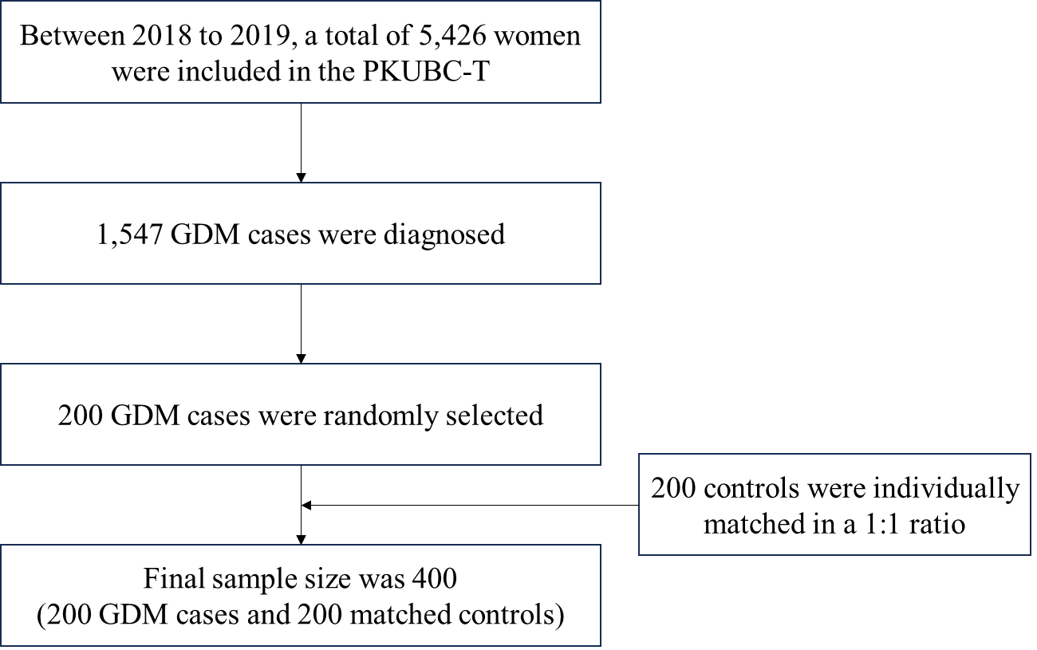
Figure S1 Flowchart of participant selection
Figure S2 Spearman correlations between concentrations of individual maternal serum essential trace elements.

Figure S3 Restricted cubic spline models for serum essential trace elements and the risk of GDM. Knots were placed at the 10th, 50th, and 90th percentiles of serum levels. Models were adjusted for ethnicity, annual household income, maternal education level, pre-pregnancy BMI, gravidity, parity, fetal sex, dietary energy, physical activity in early pregnancy.

Figure S4 Univariate exposure-response functions (95% CIs) between ETEs and the risk of GDM while fixing other chemicals at their 50th percentiles.

Figure S5 Bivariate exposure–response functions for each of the ETE1 when ETE2 were at their 25th, 50th, and 75th levels, with other chemicals fixed at median concentrations.

