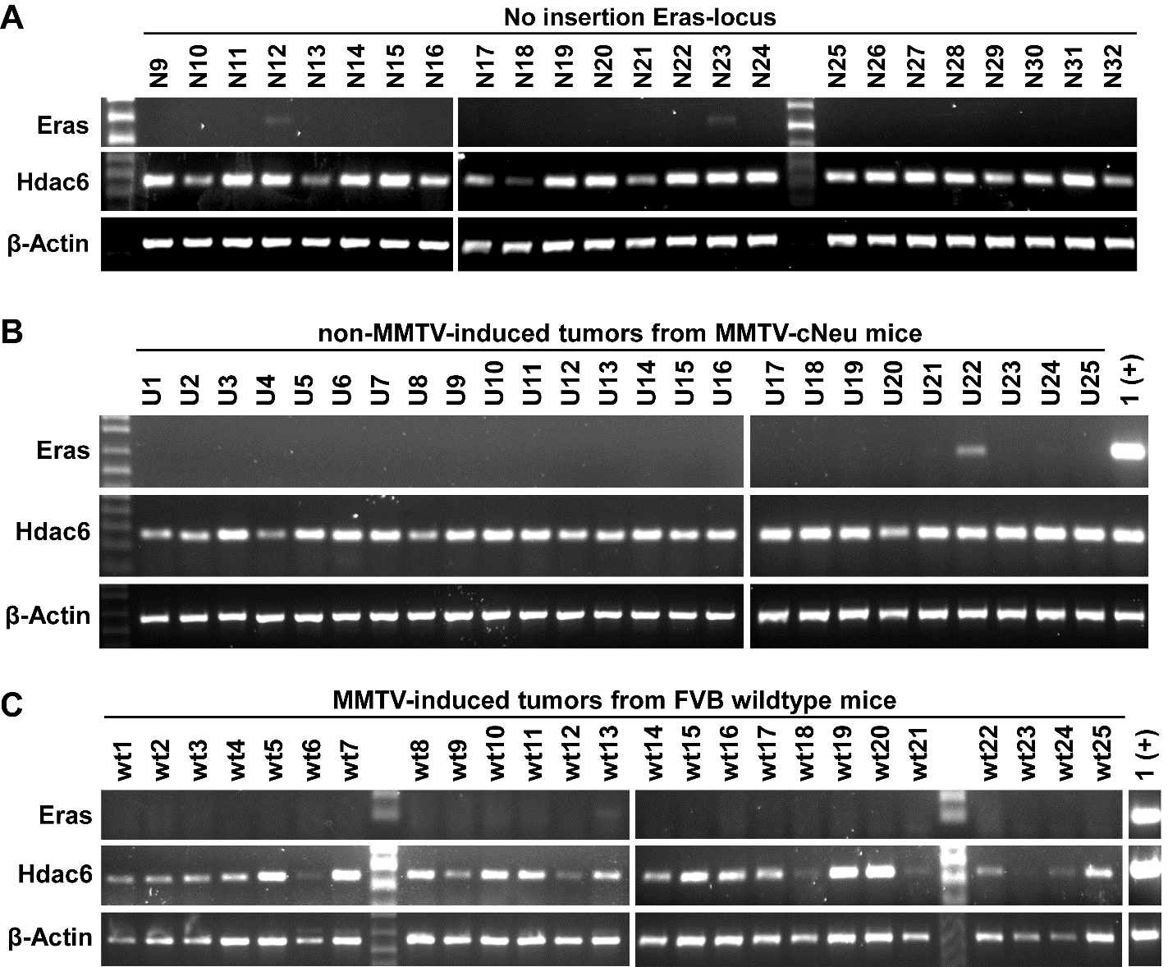

Supplementary Figure S1.
Eras-expression is associated with MMTV-proviral integration in Pcsk1n/Eras/Hdac6-locus.
(A) Additional part of RT-PCR expression analysis of Eras and Hdac6 in random tumors without integrations in Pcsk1n/Eras/Hdac6-locus shown in Figure 2D. PCR-products for β-actin were used as controls for RNA integrity.
(B,C) RT-PCR expression analysis of Eras and Hdac6 in random tumors of non-MMTV-infected ErbB2 transgenic mice (B) and random tumors of MMTV-induced mammary tumors from FVB wildtype mice without integrations in Pcsk1n/Eras/Hdac6-locus. PCR-products for β-actin were used as controls for RNA integrity.
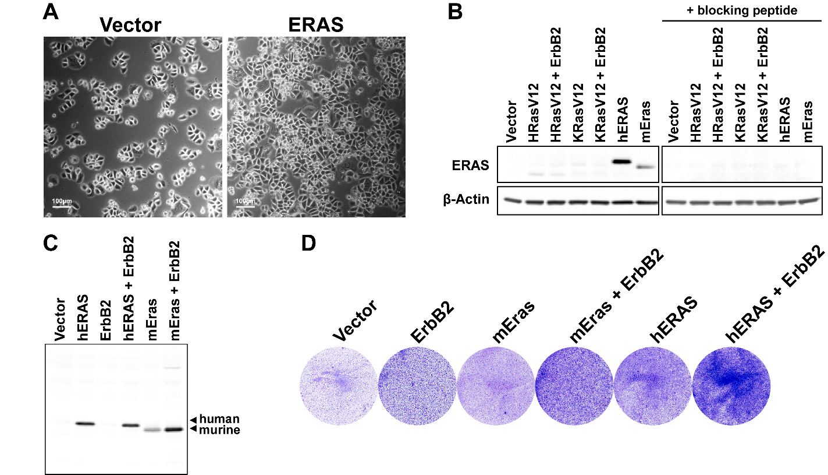

Supplementary Figure S2.
ERAS in various mammary cell cultures.
(A) Micrograph of SKBR3 vector controls or SKBR3 cells ectopically expressing ERAS, at day 9 of Figure 3A. Scale bar = 100 µm.
(B) Western blot showing human and murine ERAS in NMuMG cells, stably transduced with human or murine ERAS (hERAS or mEras, respectively) and HRasV12 and KRasV12 alone or co-expressed with ErbB2, compared to vector control cells. The ERAS signal was abolished when the blocking peptide was added with the antibody. β-actin was used as loading control.
(C) Western blot analysis of Figure 3B, using a different ERAS-specific antibody.
(D) Crystal Violet staining of MCF10A cells, stably transduced with murine or human ERAS (mEras or hERAS, respectively) alone or co-expressed with ErbB2, compared to vector control cells. 200,000 Cells per well (6-wells plate) were allowed to grow for 4 days in low serum conditions (0.5%).
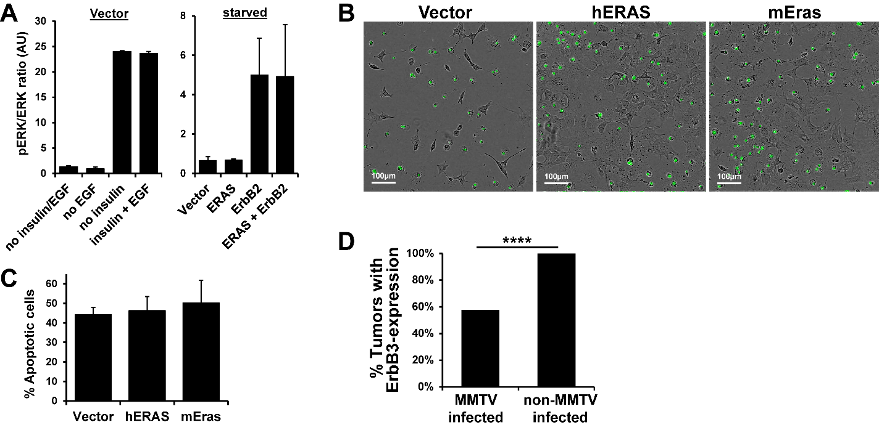

Supplementary Figure S3.
ERAS and ERBB2 activate complementary signaling pathways.
(A) Ratios phosphorylated over total ERK, plotted as mean + SD (n = 3) and quantified from the blots as in Figure 4C.
(B) Representative micrographs showing apoptosis in green (fluorescent caspase-3/7 reagent) of 7-day starved NMuMG cells, stably transduced with human or murine ERAS (hERAS or mEras, respectively), compared to vector control cells (scale bar = 100 µm) (3,000 cells per well, 384-wells plate).
(C) Quantification of percentages apoptotic cells of experiment in (B), showing mean + SD (n = 4-7). Welch's t-test shows no significant differences (p > 0.05).
(D) Percentage of ErbB3-expression positive tumors that developed in ErbB2-transgenic mice that were (n = 33) or were not infected by MMTV (n = 27), showing a statistically significant difference with p-value = 8.652·10⁻⁵ (****), determined by a Fisher's exact test.
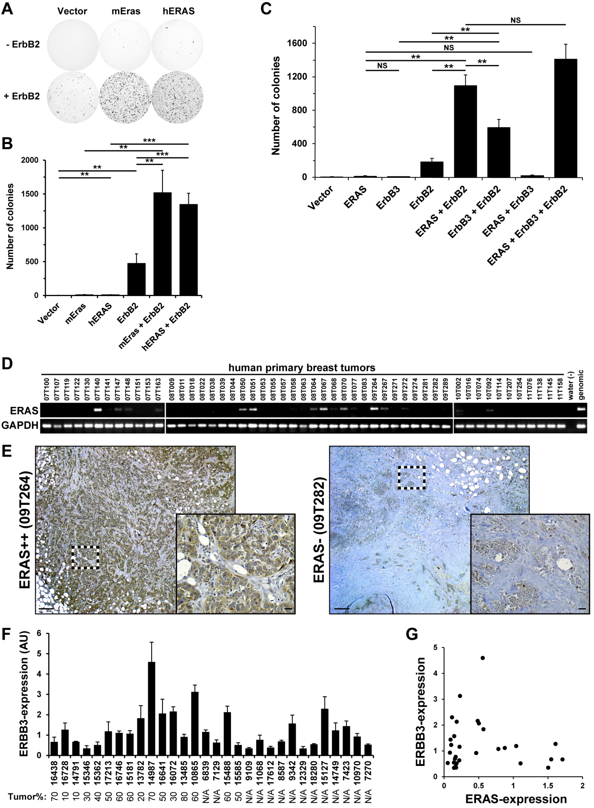
Supplementary Figure S4.
ERAS can functionally replace ERBB3 in collaboration with ERBB2.
(A) Representative whole well scans of MCF10A-cells, stably transduced with murine or human ERAS (mEras or hERAS, respectively) compared to vector controls, alone or co-expressed with ErbB2 and allowed to grow in soft agar for four weeks (20,000 cells per well, 6-wells plates).
(B) Quantification of soft agar growth of (A), plotted as mean + SD (n = 4). Statistical significance of differences in relevant comparisons was determined by a Welch's t-test and p-values are shown as **p < 0.01; ***p < 0.001.
(C) Quantification of anchorage independent colony formation of MCF10A cells, stably transduced with ERAS, ErbB3 and/or ErbB2, allowed to grow in soft agar for two weeks (40,000 cells per well, 6-wells plates). Data are presented as mean + SD (n = 3). Statistical analysis of relevant comparisons was performed using the Welch's t-test: **p < 0.01; NS = not significant.
(D) RT-PCR expression analysis of ERAS in 51 random human primary breast carcinomas. PCR-products for GAPDH were used as controls for RNA integrity. Pathological and clinical characteristics of these samples are provided in Supplementary Table S1.
(E) Representative micrographs of immunostaining for ERAS (brown) of human primary breast carcinomas with (left) and without (right) ERAS-expression, as determined in (D) and Supplementary Table S1. Inserts represent enlargements of the framed areas. Scale bar low magnification 200 µm and insert 10 µm.
(F) Quantitative RT-PCR of ERBB3 mRNA-expression in 30 HER2-positive primary breast carcinomas, presented in the same order as Figure 5E. The estimated tumor percentages are indicated below each sample: N/A, not available.
(G) Scatter plot of ERAS-expression versus ERBB3-expression of the 30 HER2-positive primary breast carcinomas as shown in Figure 5E and Supplementary Figure S4F, respectively. None of the samples show combined high expression of both genes.
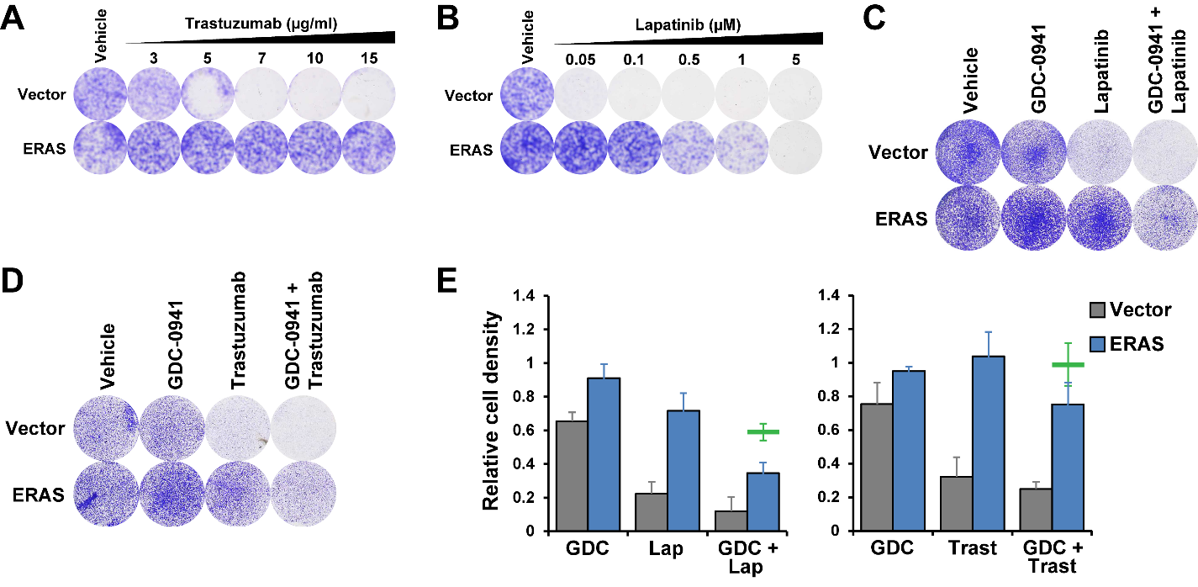

Supplementary Figure S5.
ERAS induces Trastuzumab and Lapatinib resistance via PI3K/AKT-pathway hyperactivation.
(A,B) Crystal Violet staining of SKBR3 vector controls or SKBR3 cells stably transduced with ERAS, allowed to grow for 11 or 14 days in medium supplemented with the indicated concentrations Trastuzumab (A) or Lapatinib (B), respectively (at T = 0, 12,500 cells per well were seeded, 24-wells plates).
(C,D) Representative Crystal Violet staining of SKBR3 vector controls or SKBR3 cells stably transduced with ERAS, grown in presence of 50 nM Lapatinib (grown 11 days) (C), 10 μg/ml Trastuzumab (grown 7 days) (D) and/or 50 nM PI3K-inhibitor GDC-0941, or equal volumes of DMSO (vehicle) (at T = 0, 50,000 cells per well were seeded, 12-wells plates).
(E) Quantification of (C) and (D), showing cell proliferation rate in the presence of the inhibitors relative to vehicle controls. Data plotted as mean + SD (n = 3). A projection of the combined (additive) single agent effects of GDC-0941 (GDC) and Lapatinib (Lap) or Trastuzumab (Trast) is shown in green.
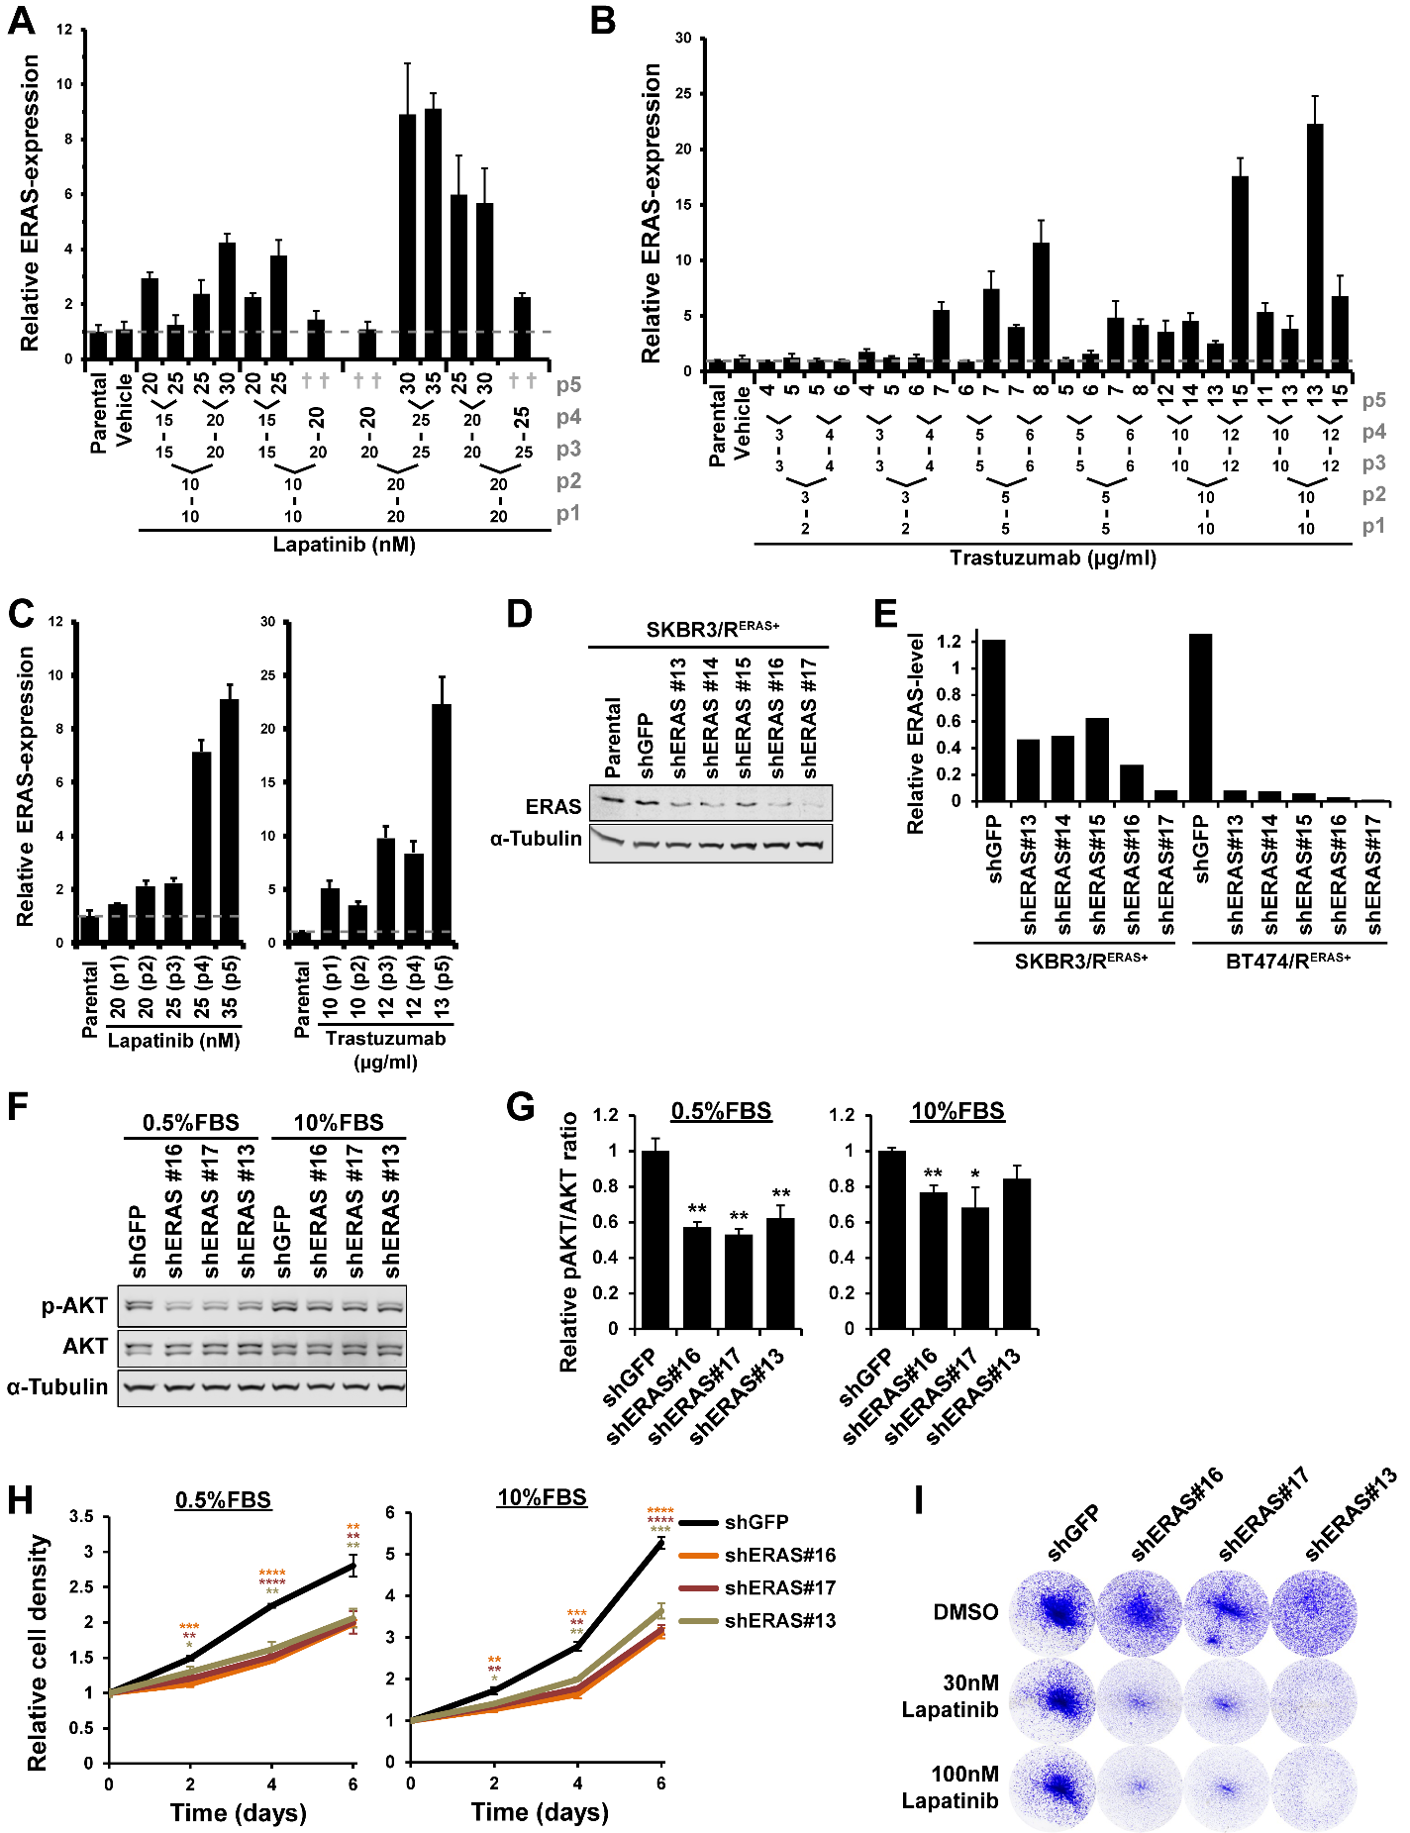

Supplementary Figure S6.
HER2-targeted treatment selects for ERAS+ cells.
(A,B) ERAS-mRNA expression levels in SKBR3 cells (Parental), cultured for five passages in presence of vehicle (this level is also indicated by grey dashed line for clarity) or the indicated concentrations Lapatinib (A) or Trastuzumab (B). Expression data, as determined by quantitative RT-PCR, are represented as mean + SD of triplicates and are shown relative to ERAS-levels in vehicle controls. Lapatinib (A) or Trastuzumab (B) concentrations during each passage are shown below and passage numbers (p) are depicted in grey on the right.
(C) Relative ERAS-expression levels at each passage in the cultures that obtained the highest ERAS-levels under Lapatinib or Trastuzumab selection depicted in (A) and (B), respectively.
(D) Western blot, showing ERAS knockdown efficiency in the Trastuzumab-treated SKBR3 cell culture of (C) (designated: SKBR3/R^{ERAS+}). α-Tubulin was used as loading control.
(E) Quantification of ERAS protein levels in the SKBR3/R^{ERAS+} and BT474/R^{ERAS+} cells from the blots in (D) and Figure 7D, respectively. Levels were corrected to the loading controls of each lane (α-tubulin).
(F) Representative Western blots showing phosphorylated (p-) and total protein of AKT in a selection of cell cultures from (D). α-Tubulin was used as loading control.
(G) Ratios phosphorylated over total AKT, relative to shGFP controls, quantified from the blots as in (F). Data represented as mean + SD (n = 3) and statistically significant differences in PI3K/AKT-pathway activation between shGFP controls and shERAS are indicated as *p < 0.05; **p < 0.01 (Welch's t-test).
(H) Growth curves of the SKBR3/R^{ERAS+} cells as in (G) in medium supplemented with 10% FBS or 0.5% FBS, based on Crystal Violet staining (30,000 cells per well, 24-wells plates). Plotted values are mean ± SD, relative to day 0 (n = 3). Statistical significance of differences in cell proliferation between shGFP controls and shERAS was determined by a Welch's t-test and p-values are shown as *p < 0.05; **p < 0.01; ***p < 0.001; ****p < 1·10⁻⁴.
(I) Representative Crystal Violet staining (n = 3) of the SKBR3/R^{ERAS+} cells as in (G), allowed to grow for 6 days in the presence of 30 nM or 100 nM Lapatinib or equal volumes of vehicle (DMSO) (30,000 cells per well were seeded at T = 0, 24-wells plates).
Supplementary Table S1.
Pathological and clinical characteristics.
tumor sample | ERAS expression* | ER | PR | HER2 | p53 | grade | type | metastasis | patient age
07T100 | - | pos | 50-100% | 1+ | 1% | II | ductal | - | 83
07T107 | - | pos | 20% | 0 | 10% | II | ductal | - | 80
07T119 | - | pos | 10% | 0 | 50% | II | ductal | reg LN | 46
07T122 | - | pos | pos | 1+ | neg | II | ductal | - | 56
07T130 | - | pos | 10% | 2+ | neg | II | lobular | reg LN | 76
07T140 | ++ | neg | neg | 0 | 100% | III | ductal | - | 64
07T141 | - | pos | 30% | 1+ | 5% | III | ductal | reg LN | 64
07T147 | +/- | pos | 10-50% | 0 | 10% | II | ductal | reg LN | 57
07T148 | +/- | pos | pos | 0 | 10% | II | ductal | - | 76
07T151 | - | pos | pos | 1+ | neg | I | N/A | - | 49
07T153 | - | N/A | N/A | N/A | N/A | N/A | N/A | N/A | N/A
07T163 | +/- | pos | 60% | 0 | 30% | II | ductal | reg LN | 58
08T009 | - | N/A | N/A | N/A | N/A | N/A | N/A | N/A | 48
08T011 | - | N/A | N/A | N/A | N/A | N/A | N/A | N/A | 64
08T018 | - | N/A | N/A | N/A | N/A | N/A | N/A | N/A | 73
08T022 | - | neg | neg | 1+ | 100% | III | ductal | - | 75
08T038 | - | pos | pos | 1+ | 10% | II | ductal | - | 50
08T039 | - | pos | neg | 0 | 80% | II | ductal | - | 53
08T044 | - | pos | neg | 3+ | 50% | III | ductal | - | 82
08T050 | ++ | N/A | N/A | N/A | N/A | N/A | N/A | N/A | 38
08T051 | ++ | N/A | N/A | N/A | N/A | N/A | N/A | N/A | 59
08T053 | - | N/A | N/A | N/A | N/A | N/A | N/A | N/A | 94
08T055 | - | neg | neg | 2+ | >90% | III | ductal | reg LN | 90
08T057 | - | N/A | N/A | N/A | N/A | N/A | N/A | N/A | 57
08T058 | - | pos | 70% | 1+ | <2% | III | ductal | - | 81
08T063 | - | pos | 10% | 1+ | 90% | I | ductal | - | 66
08T064 | +/- | pos | pos | 0 | 20% | I | ductal | - | 47
08T067 | ++ | pos | 80% | 0 | 10% | I | ductal | - | 51
08T068 | +/-- | pos | 10% | 3+ | 20% | I | ductal | - | 41
08T070 | + | pos | pos | 1+ | <5% | III | ductal | - | 58
08T077 | - | pos | pos | 0 | 10% | II | ductal | - | 55
08T083 | - | neg | neg | 2+ | <10% | III | ductal | reg LN | 75
09T264 | ++ | neg | neg | 0 | 0% | III | ductal | - | 30
09T267 | +/- | N/A | N/A | N/A | N/A | N/A | N/A | N/A | 51
09T271 | - | N/A | N/A | N/A | N/A | N/A | N/A | reg LN | N/A
09T272 | +/-- | N/A | N/A | N/A | N/A | N/A | N/A | N/A | N/A
09T274 | - | neg | neg | 1+ | 1% | III | ductal | - | 41
09T281 | - | pos | pos | 2+ | 15% | I | ductal | - | 48
09T282 | - | neg | neg | 0 | 100% | III | ductal | - | 49
09T289 | - | 25% | neg | 3+ | 80% | III | ductal | - | 60
10T002 | +/-- | pos | N/A | N/A | N/A | N/A | N/A | N/A | N/A
10T016 | - | N/A | N/A | N/A | N/A | N/A | N/A | N/A | N/A
10T074 | - | N/A | N/A | N/A | N/A | N/A | N/A | N/A | N/A
10T092 | +/- | N/A | N/A | N/A | N/A | N/A | N/A | N/A | N/A
10T114 | - | N/A | N/A | N/A | N/A | N/A | N/A | N/A | N/A
10T207 | - | N/A | N/A | N/A | N/A | N/A | N/A | N/A | N/A
10T254 | - | N/A | N/A | N/A | N/A | N/A | N/A | N/A | N/A
11T076 | - | N/A | N/A | N/A | N/A | N/A | N/A | N/A | N/A
11T138 | - | N/A | N/A | N/A | N/A | N/A | N/A | N/A | N/A
11T145 | - | N/A | N/A | N/A | N/A | N/A | N/A | N/A | N/A
11T158 | - | N/A | N/A | N/A | N/A | N/A | N/A | N/A | N/A
*Scored ERAS-expression from Supplementary Figure S4D, shown as ++ (highly positive), + (positive), +/- (weak), +/-- (very weak), - (negative); ER = estrogen receptor; PR = progesterone receptor; HER2 = human epidermal growth factor receptor 2; reg LN = regional lymph node metastasis; N/A = no data available. ER, PR and p53 status are determined by a IHC-test and are shown as % positive staining or positive/negative (pos/neg), scored by a pathologist; HER2 status is determined by a IHC-test and is shown as: 0 (negative), 1+ (negative), 2+ (borderline), 3+ (positive: HER2 protein overexpression).

Supplementary Table S2
CIS-enrichment in cNeu-transgenic vs FVB wildtype mice.
Locus | ins_  FVBwt | ins_  cNeu | freq_  FVBwt | freq_  cNeu | pref_  cNeu | pVal
Eras | 5 | 11 | 0.0099 | 0.1410 | 13.1% | 3.08·10⁻⁷
Gm26870 (lincRNA) / Mir101c | 2 | 6 | 0.0039 | 0.0769 | 7.3% | 1.06·10⁻⁴
Lrfn5 | 2 | 4 | 0.0039 | 0.0513 | 4.7% | 3.57·10⁻³
Gm10800 / Gm10801 | 13 | 5 | 0.0256 | 0.0641 | 3.8% | 0.078
Metrnl / Ptchd3 | 5 | 3 | 0.0099 | 0.0385 | 2.9% | 0.078
Irs4 | 10 | 4 | 0.0197 | 0.0513 | 3.2% | 0.103
Pdgfrb | 5 | 2 | 0.0099 | 0.0256 | 1.6% | 0.237
Sfi1 | 3 | 2 | 0.0059 | 0.0256 | 2.0% | 0.134
Map3k8 | 15 | 3 | 0.0296 | 0.0385 | 0.9% | 0.721
Rspo1 | 4 | 1 | 0.0079 | 0.0128 | 0.5% | 0.512
Igf2 / Igf2as | 7 | 0 | 0.0138 | 0 | -1.4% | 0.602
Hbegf | 6 | 0 | 0.0118 | 0 | -1.2% | 1
Sfmbt2 / miRNA-cluster | 6 | 0 | 0.0118 | 0 | -1.2% | 1
Fgfr3 | 4 | 0 | 0.0079 | 0 | -0.8% | 1
Fgfr1 | 18 | 1 | 0.0355 | 0.0128 | -2.3% | 0.493
Wnt3a | 36 | 4 | 0.0710 | 0.0513 | -2.0% | 0.636
Pdgfra | 10 | 0 | 0.0197 | 0 | -2.0% | 0.373
Wnt3 | 29 | 3 | 0.0572 | 0.0385 | -1.9% | 0.788
Rspo3 | 8 | 0 | 0.0158 | 0 | -1.6% | 0.606
Rspo2 | 16 | 0 | 0.0316 | 0 | -3.2% | 0.147
Fgfr2 | 28 | 2 | 0.0552 | 0.0256 | -3.0% | 0.408
Fgf3 / Fgf4 | 72 | 9 | 0.1420 | 0.1154 | -2.7% | 0.601
Wnt1 / Wnt10b | 126 | 14 | 0.2485 | 0.1795 | -6.9% | 0.202
Fgf8 | 77 | 4 | 0.1519 | 0.0513 | -10.1% | 0.013
TOTAL | 507 | 78 | 1 | 1 | 0.0%
Fgf/Fgfr family | 199 | 16 | 0.3925 | 0.2051 | -18.7% | 1.48·10⁻³
Wnt family | 191 | 21 | 0.3767 | 0.2692 | -10.7% | 7.64·10⁻³
Rspo family | 28 | 1 | 0.0552 | 0.0128 | -4.2% | 0.158
Pdgfr family | 15 | 2 | 0.0296 | 0.0256 | -0.4% | 1
Locus = Potential target gene symbols of the MMTV-proviral insertions; ins_FVBwt and ins_cNeu = the number of independent tumors with insertion in this locus in the FVB wildtype mice and MMTV-cNeu mice; freq_FVBwt and freq_cNeu = their respective frequencies calculated over each total of independent tumors; pref_cNeu = the percentage of insertion frequency enriched in MMTV-cNeu compared to FVB wildtypes; pVal = the associated p-values calculated using a Fisher's exact test for count data.

Supplementary Table S3
Sequences of used primers.
Target | Forward primer (5' → 3') | Reverse primer (5' → 3')
murine Eras | CCCTCATCAGACTGCTACTCCTGG | TCCTGCCCAGATGTATCCAGAACA
murine Hdac6 | AACCCTGAGACAAGAGTGCC | GAAGCTCCCCTTCATTCATG
murine Pcsk1n | GACGAGACTCCTGACGTGGA | TCCTCAGTAGGACAGCCACT
murine Pcsk1n (alternative) | CCGGCCCCCAGTGTATGATGAT | GGTGAGACCCGCAAAGTCCA
murine Actb | TGAGACCTTCAACACCCCAG | GAGCCAGAGCAGTAATCTCC
human ERAS | GAAGGAGCCCATGGCAAGGT | GGCCTGGGGAAAGGTCTACA
human ERAS (alternative) | CATCCAGCTGAACCACCAGT | GTTTTGGCCGAGGTCTCC
human GAPDH | GCCAAGGTCATCCATGACAACT | GAGGGGCCATCCACAGTCTT
human ACTB | CCAACCGCGAGAAGATGA | CCAGAGGCGTACAGGGATAG

Supplementary Table S4
Sources and dilutions of used antibodies.
Target | Dilution | Manufacturer | Catalog nr.
ERAS¹ | 1:500 | Abgent | #AP1470a  (blocking peptide: #BP1470a)
p-AKT S473 | 1:1000 | Cell Signaling | #4060
total AKT | 1:1000 | Santa Cruz | #sc-8312
p-MEK S217/221 | 1:2000 | Cell Signaling | #9154
total MEK | 1:1000 | Cell Signaling | #4694
p-MAPK (p-ERK) T202/Y204 | 1:2000 | Cell Signaling | #9106
total MAPK (ERK) | 1:1000 | Cell Signaling | #9102
p-S6 S235/236 | 1:2000 | Cell Signaling | #4858
total S6 | 1:1000 | Cell Signaling | #2217
p-4EBP1 T37/46 | 1:1000 | Cell Signaling | #2855
total 4EBP1 | 1:1000 | Cell Signaling | #9644
PARP | 1:1000 | Cell Signaling | #9542
cleaved caspase-3 | 1:1000 | Cell Signaling | #9661
β-actin | 1:5000 | GeneTex | #GTX26276
α-Tubulin | 1:5000 | Sigma-Aldrich | #T9026

¹) The specificity of this purified anti-Eras polyclonal antibodies is provided by the supplier (http://www.abgent.com) and further validated in our own lab by western blotting of ERAS transduced and non-transduced parental cell lysates showing that the antibody is solely reactive with a single protein of the correct size and only present in Eras transduced cells. Immunohistochemically the antibody only stained tumors derived from subcutaneously injected NMuMG-cells ectopically expressing Eras, whereas control tumors did not react (see Fig 5D). Adding a blocking peptide, BP1470a (obtained from Abgent), to the incubation mixture abolished all reactivity. Furthermore, in semi-serial sections of the aforementioned tumors the same regions positive by immunohistochemistry also stained positive by RNA in situ hybridization using an ERAS specific probe (employing the RNA-scope assay from Advanced Cell Diagnostics, Newark, CA, USA), further proving the specificity of the Eras-antibodies.

