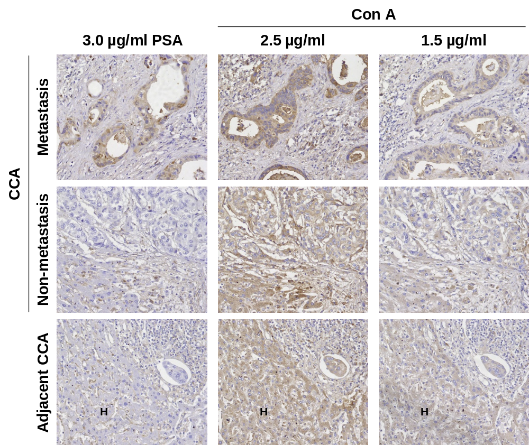

Supplementary Figure S1. The immunohistochemistry using PSA vs. Con A in tumor tissues from CCA patients were compared. PSA could differentiate CCA tissues with non-metastatic vs. metastatic stages. PSA reacted strongly with metastatic stage CCA, weaker with non-metastatic stage CCA; and negative with hepatocytes (H). Con A, in contrast, reacted strongly with both metastatic and non-metastatic CCA, as well as hepatocytes.

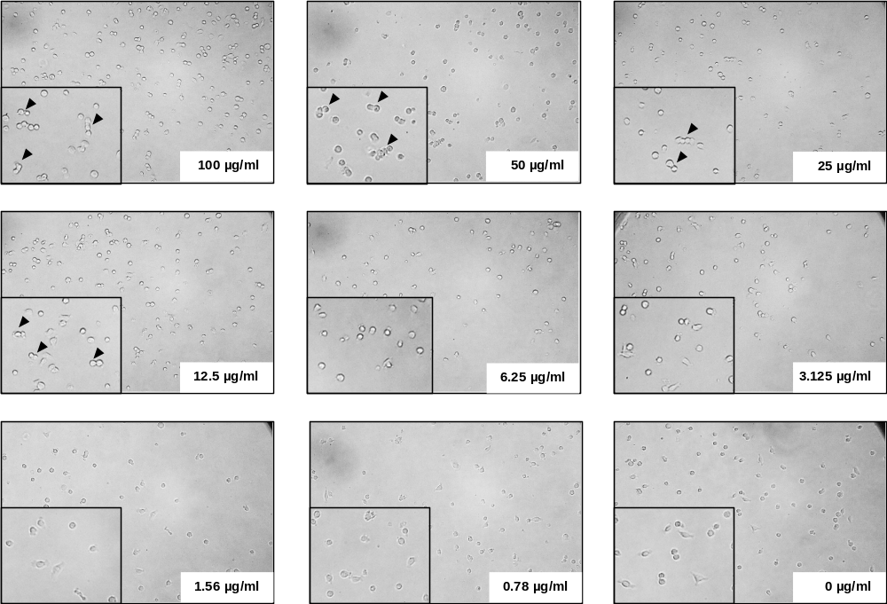

Supplementary Figure S2. Cell aggregation test. To select the Pisum Sativum Agglutinin (PSA) concentration, cell aggregation test were performed by various PSA concentrations (0.78 – 100 µg/ml). KKU-213, 4 x 10⁴ cells, were incubated with PSA in 48-well plate for 1 h and the aggregated cells were observed under the microscope.

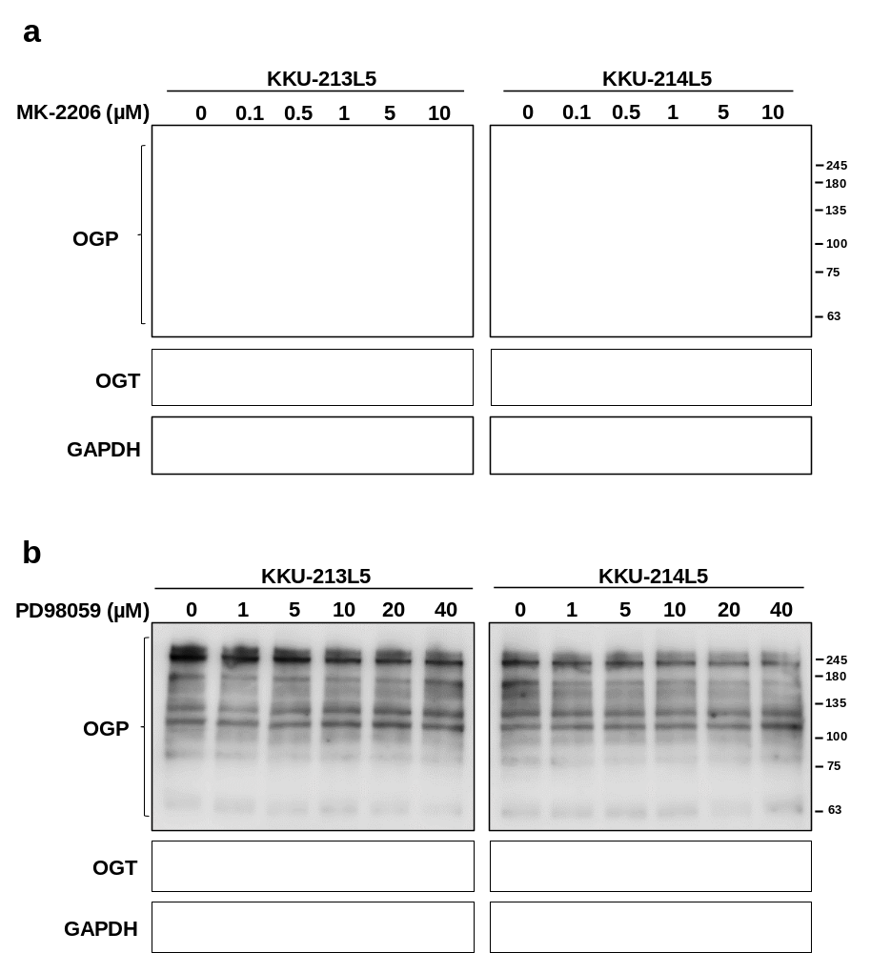

Supplementary Figure S3. Inhibited Akt and Erk activation had no effect on O-GlcNAcylation status in CCA cells. The levels of OGP and OGT were determined in (a) Akt inhibitor, MK-2206, and (b) Erk inhibitor, PD98059, treated cells using western blot analysis.

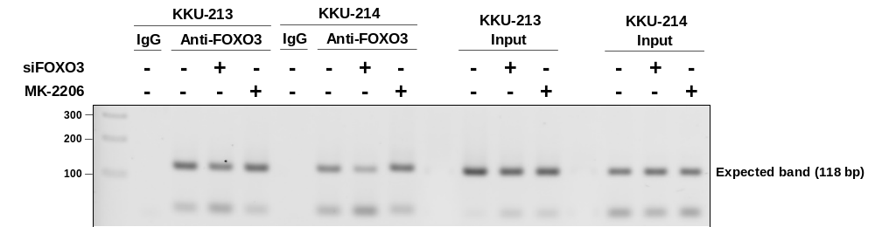

Supplementary Figure S4. The PCR products from the real-time PCR of chromatin immunoprecipitation (ChIP) assay were run in the 2% agarose gel electrophoresis. The expected band is 118 base pairs. All of the ChIP samples that immunoprecipitated with anti-FOXO3 showed the single band between 100-200 base pairs. The specific binding of anti-FOXO3 was confirmed by adding IgG isotype control. The band of PCR product could not be detected in the ChIP with IgG isotype control.

