Table S1. Clinicopathological characteristics of 15 hepatocarcinomapatients.
Pathological  lD | Gender | Age | Tumor size  (cm*cm*cm) | Procedure | Edmondson  grade | TNM Stage | Cirrhosis | HBV
436097 | Male | 56 | 5*5*8 | surgery | Ⅰ | T2 N0 M0 | Yes | Positive
436436 | Male | 62 | 6*3*1.5 | surgery | Ⅱ | T2 N0 M0 | No | Positive
436648 | Male | 45 | 4*3*5 | surgery | Ⅰ | T2 N0 M0 | Yes | Positive
440257 | Male | 39 | 2*3*2 | surgery | Ⅱ | T2 N0 M0 | No | Positive
447092 | Male | 62 | 4.5*5*3 | surgery | Ⅰ | T2 N0 M0 | No | Positive
448544 | Female | 43 | 4*2*2 | surgery | Ⅰ | T2 N0 M0 | No | Negative
457926 | Male | 43 | 5*1.5*3 | surgery | Ⅱ | T2 N0 M0 | No | Positive
436473 | Male | 65 | 3*3.5*4 | surgery | Ⅰ | T2 N0 M0 | Yes | Negative
449753 | Female | 49 | 5*5*6 | surgery | Ⅱ | T2 N0 M0 | No | Negative
458663 | Female | 51 | 2.5*2.5*3 | surgery | Ⅱ | T2 N0 M0 | Yes | Positive
464032 | Male | 61 | 6*5*2 | surgery | Ⅰ | T2 N0 M0 | Yes | Negative
468953 | Male | 46 | 3*5*2.5 | surgery | Ⅱ | T2 N0 M0 | No | Negative
463094 | Male | 58 | 3*1.5*2 | surgery | Ⅱ | T2 N0 M0 | No | Negative
475699 | Male | 60 | 4*2*2 | surgery | Ⅱ | T2 N0 M0 | Yes | Positive
476377 | Female | 54 | 3*6*3 | surgery | Ⅱ | T2 N0 M0 | Yes | Negative

Table S2. The primers of gene sequences list
GENE | PCR primer
BCLAF1 |  | F 5′- TCTGGAATAGAAGGCACTCTAGG-3′  R 5′- ACCCTCGTCTTTTAGAAACAGGA-3′
HIF1A (post-spliced) |  | F 5′- CAAGAACCTACTGCTAATGC-3′  R 5′- GTCTGGCTGCTGTAATAATG-3
HIF1A (pre-spliced) |  | F 5′- CAGCTATTTGCGTGTGAGGA-3′  R 5′- AACATTGCGACCACCTTCTAA-3′
HIF1A (P1) |  | F 5′- ATTATCCGAGTGTGGTGGTG-3′  R 5′- GAGGTGTGAGGCTGGAGAAG-3′
HIF1A (P2) |  | F 5′- CTTCTCCAGCCTCACACCTC-3′  R 5′- CCTAACCATGGGTCAATGTCA-3′
HIF1A (P3) |  | F 5′- TGACATTGACCCATGGTTAGG-3′  R 5′- CTGTGCACTGAGGAGCTGAG-3′
β-actin |  | F 5′-CATGTACGTTGCTATCCAGGC-3′  R 5′-CTCCTTAATGTCACGCACGAT-3′
VEGFA
  R 5′- AACCATGAACTTTCTGCTGT-3′
  R 5′- GGCTTGAAGATGTACTCGAT-3′
EPO
  R 5′- ATGTGGATAAAGCCGTCAG-3′
  R 5′- ATTGGAGTAGACTCGGAAGA-3′
TGFB
  R 5′- TATTTAAGGACACCCGTGC-3′
  R 5′- CAATGACACAGAGATCCGC-3′
c-MYC |  | F 5′-TGGAACTTACAACACCCG-3′
 |  | R 5′-CCTCGTCGCAGTAGAAAT-3′

Table S3. The amplification curves and melting peaks of primer pairs.
BCLAF1
β-actin
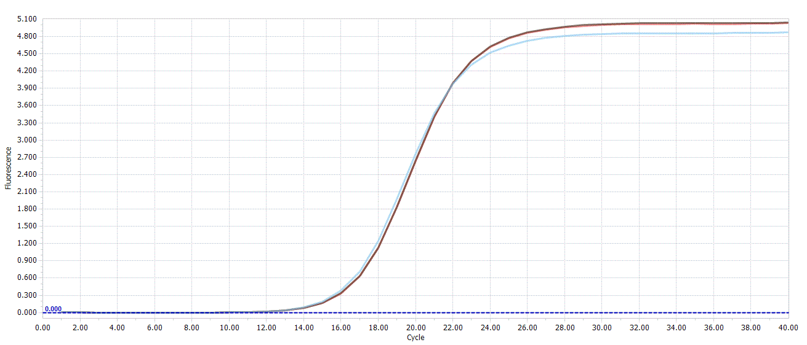
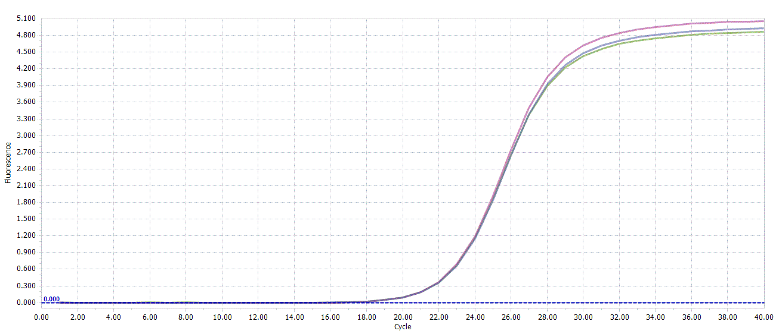
Amplification Curves

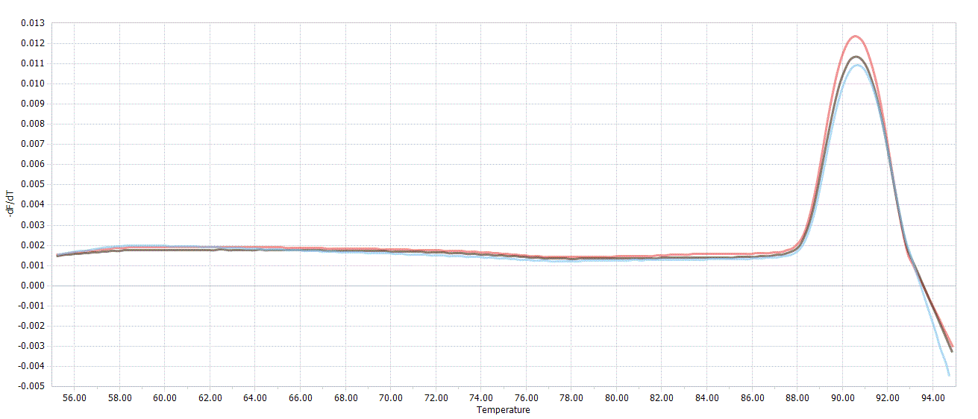
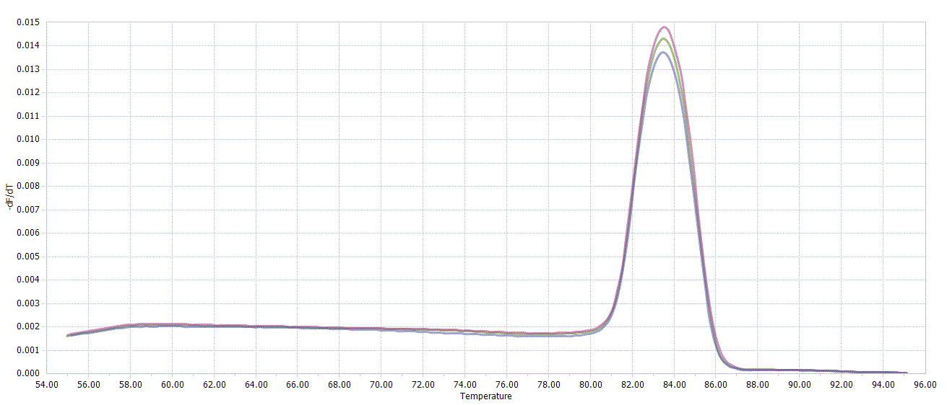
Melting Peaks

HIF1A (pre-spliced)
HIF1A (post-spliced)
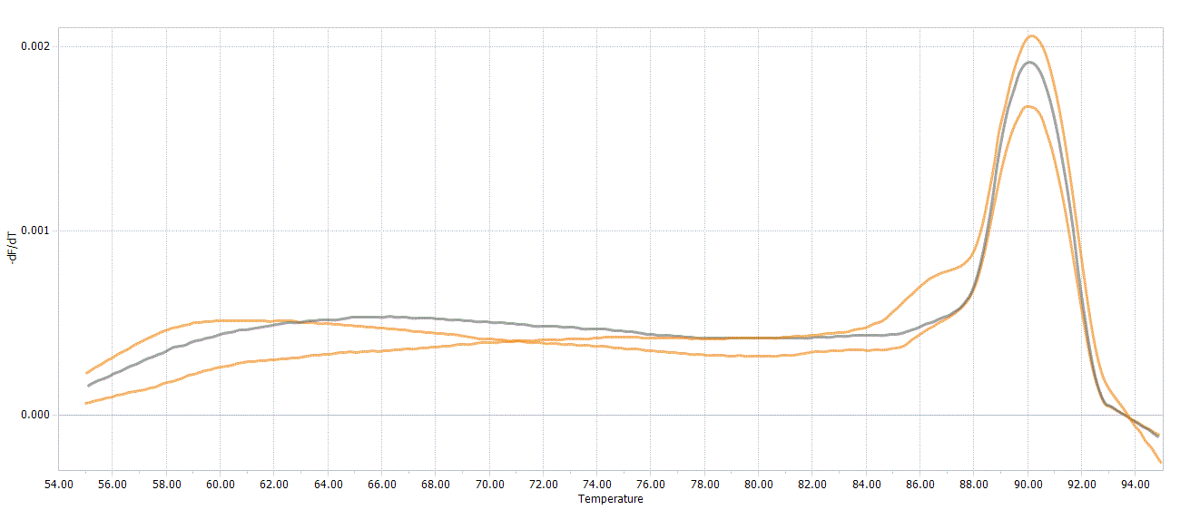
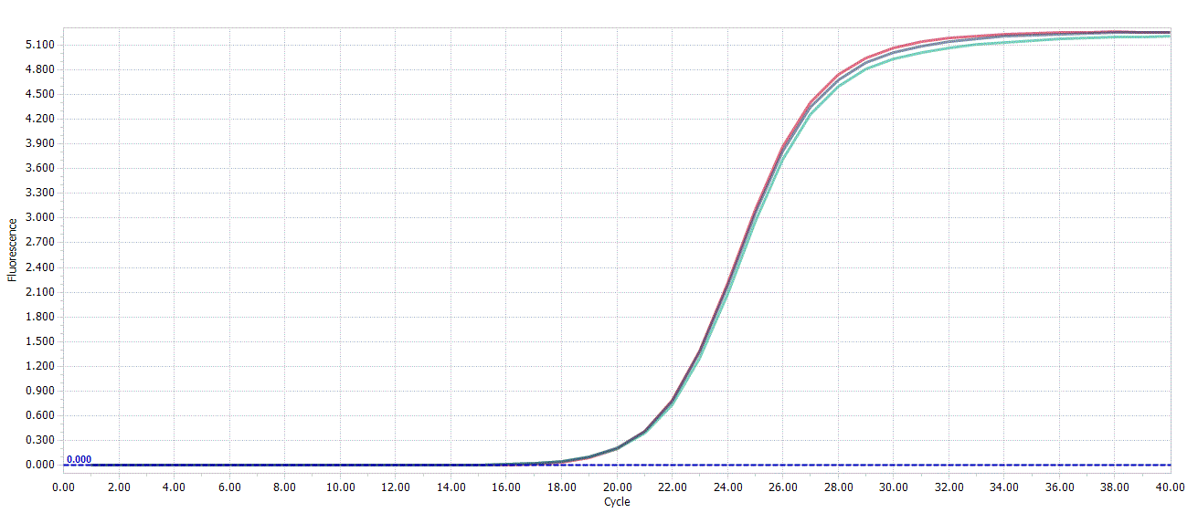
Amplification Curves

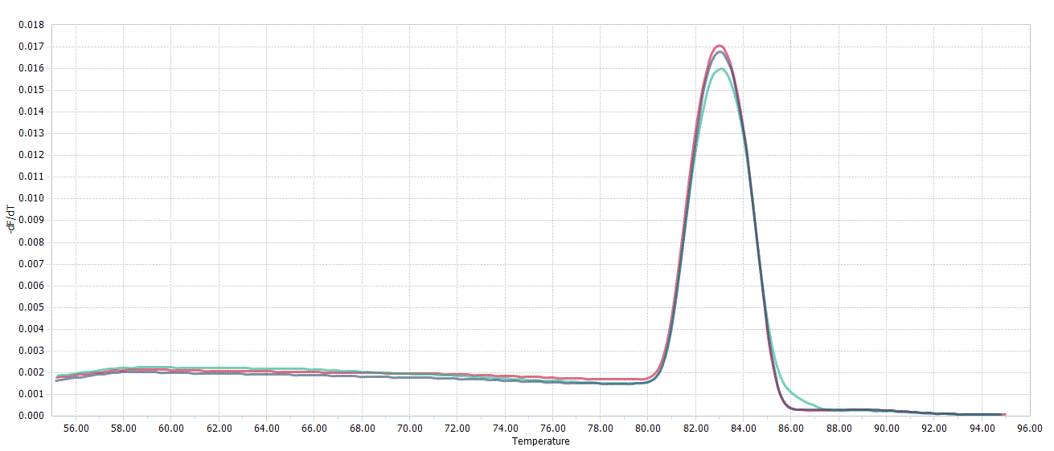
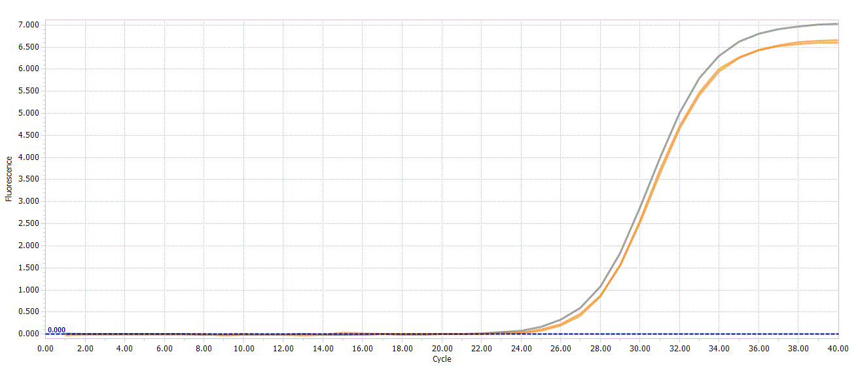
Melting Peaks

HIF1A (P1)
HIF1A (P2)
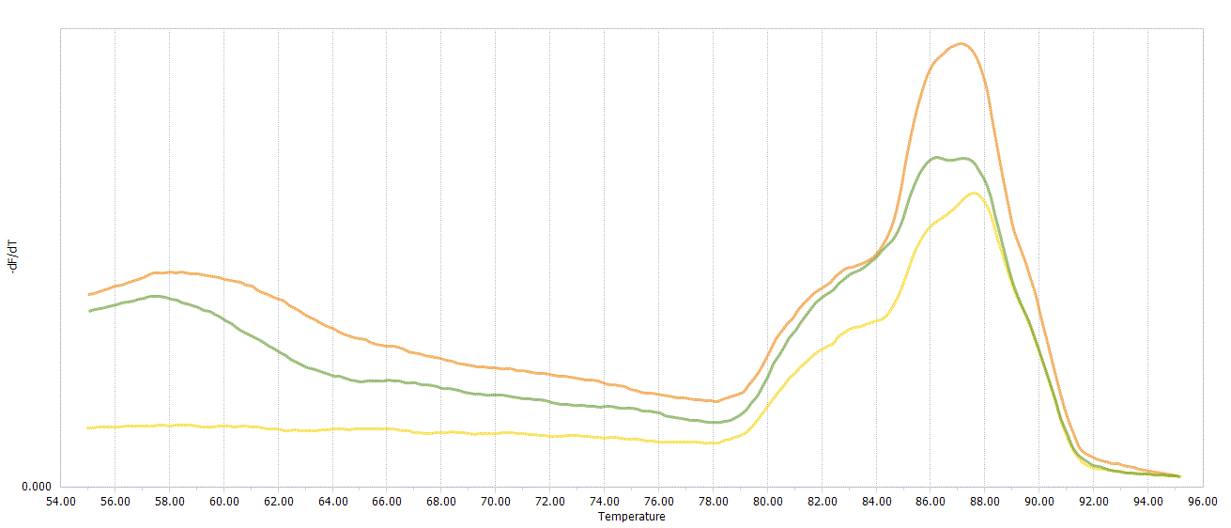
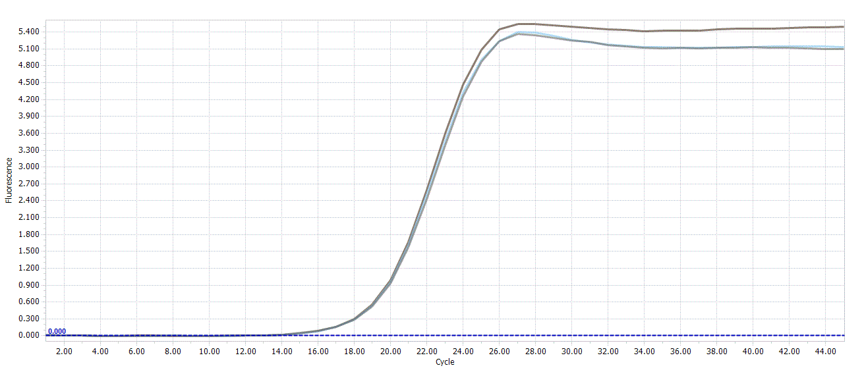
Amplification Curves

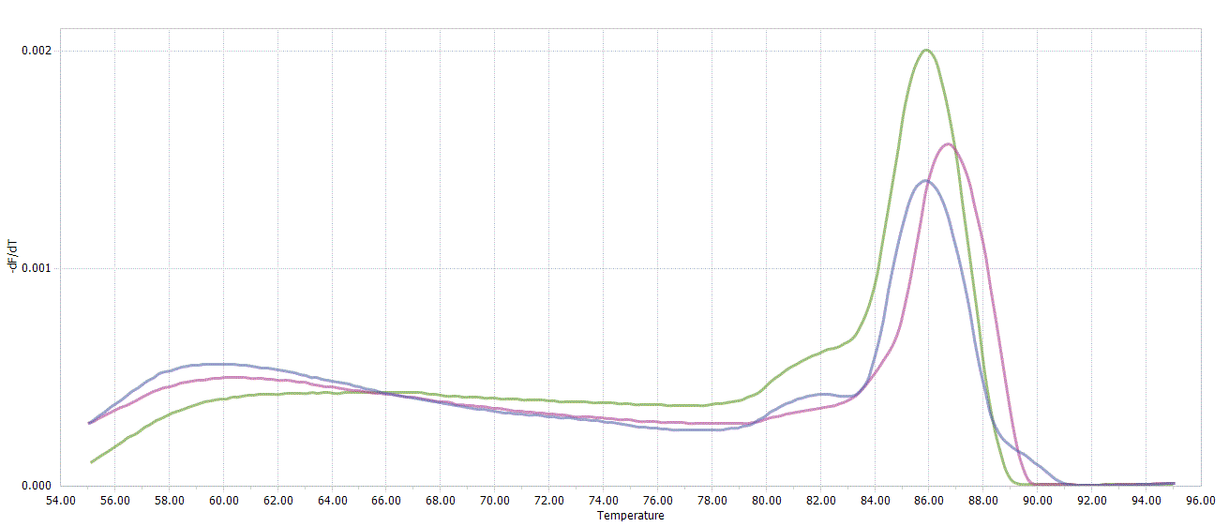
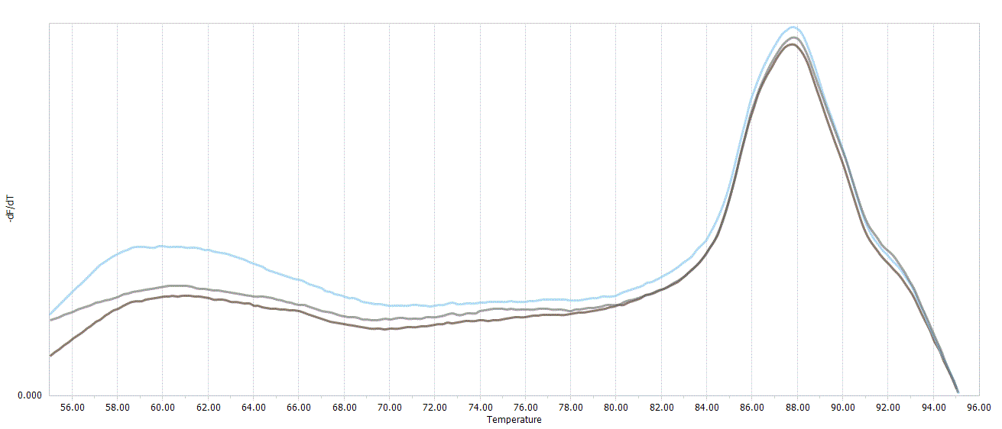
Melting Peaks

VEGF
HIF1A (P3)
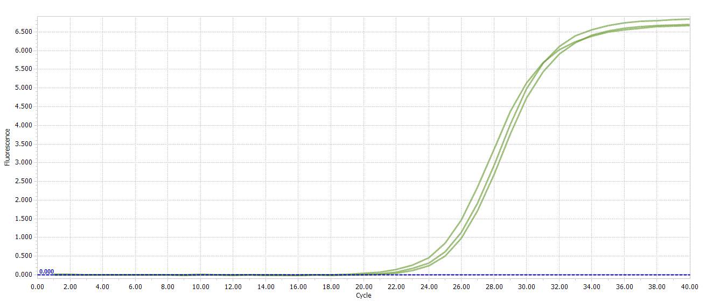
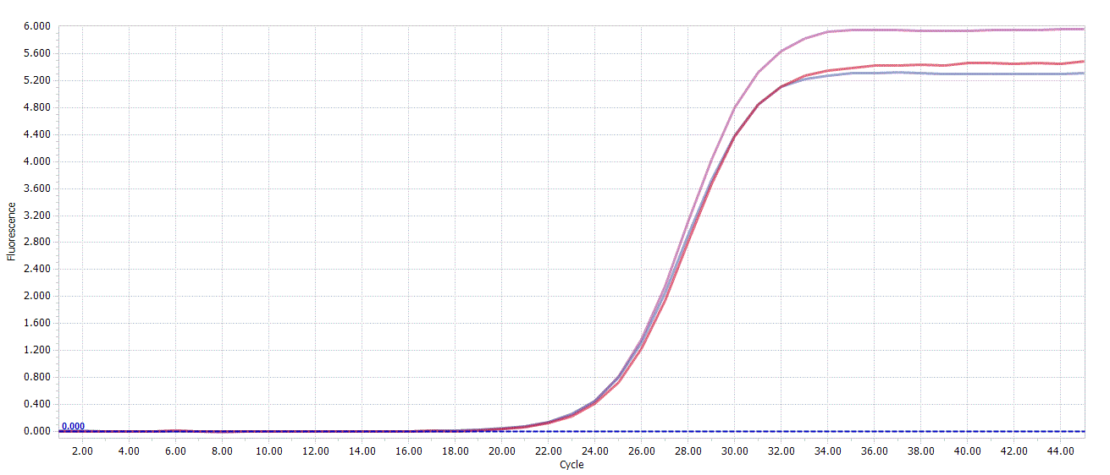
Amplification Curves

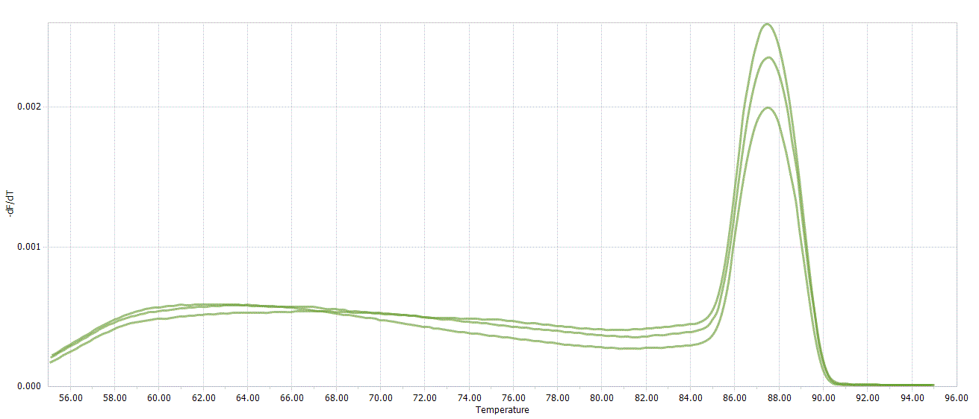
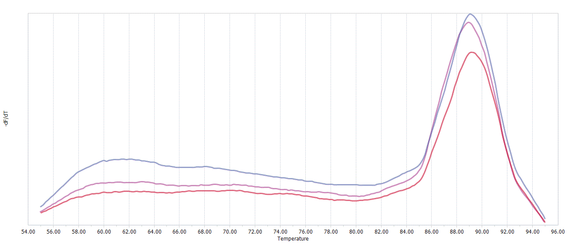
Melting Peaks

TGFB
EPO
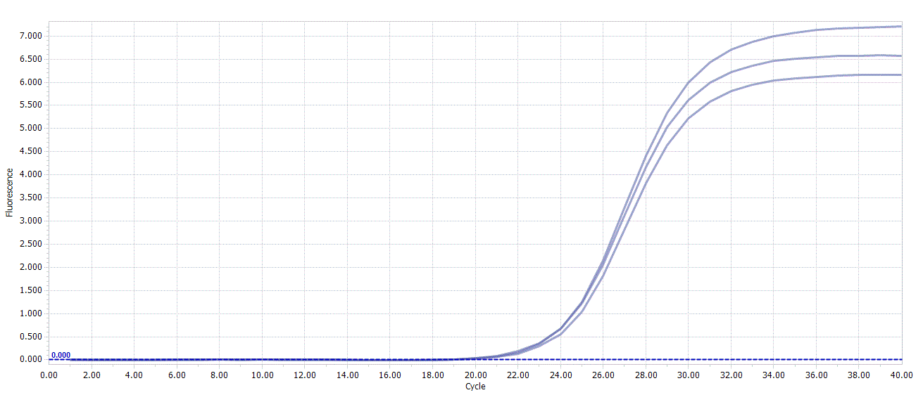
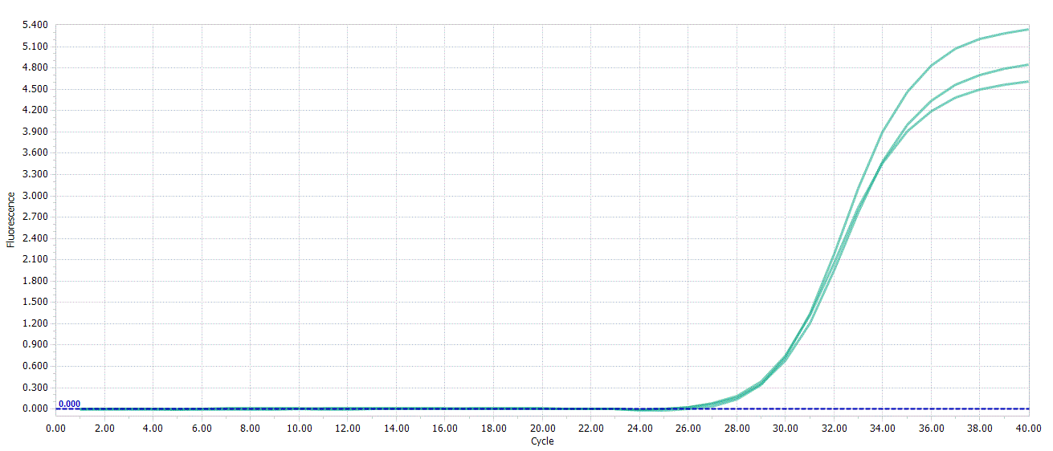
Amplification Curves

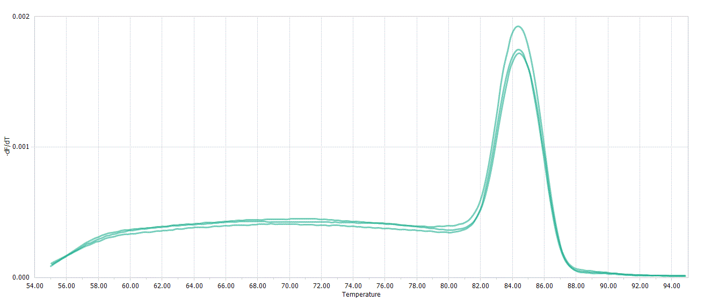
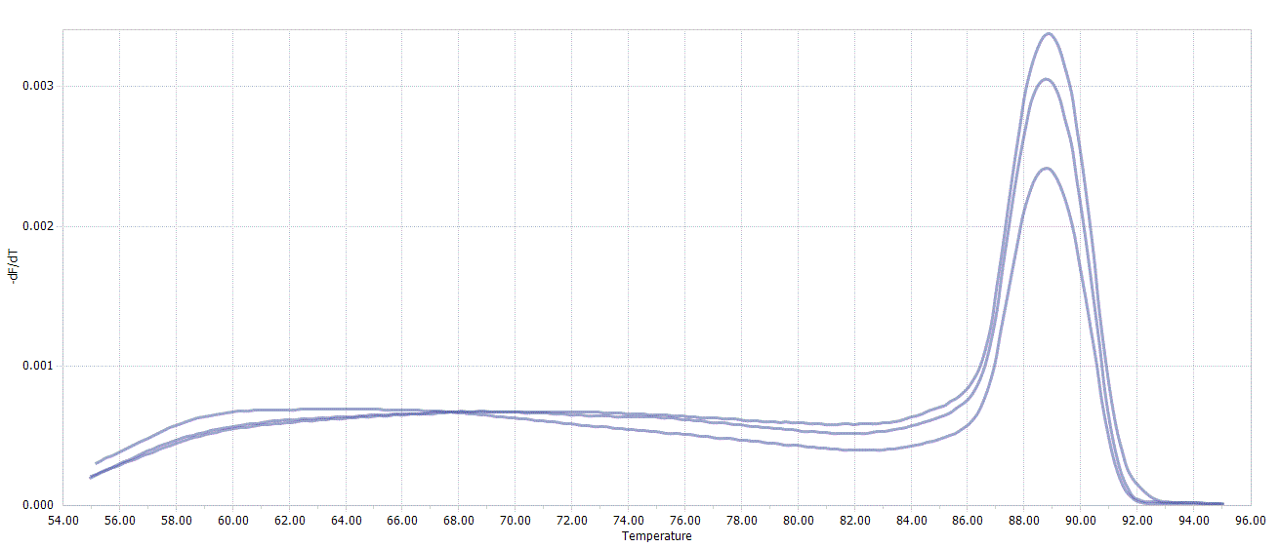
Melting Peaks

c-MYC
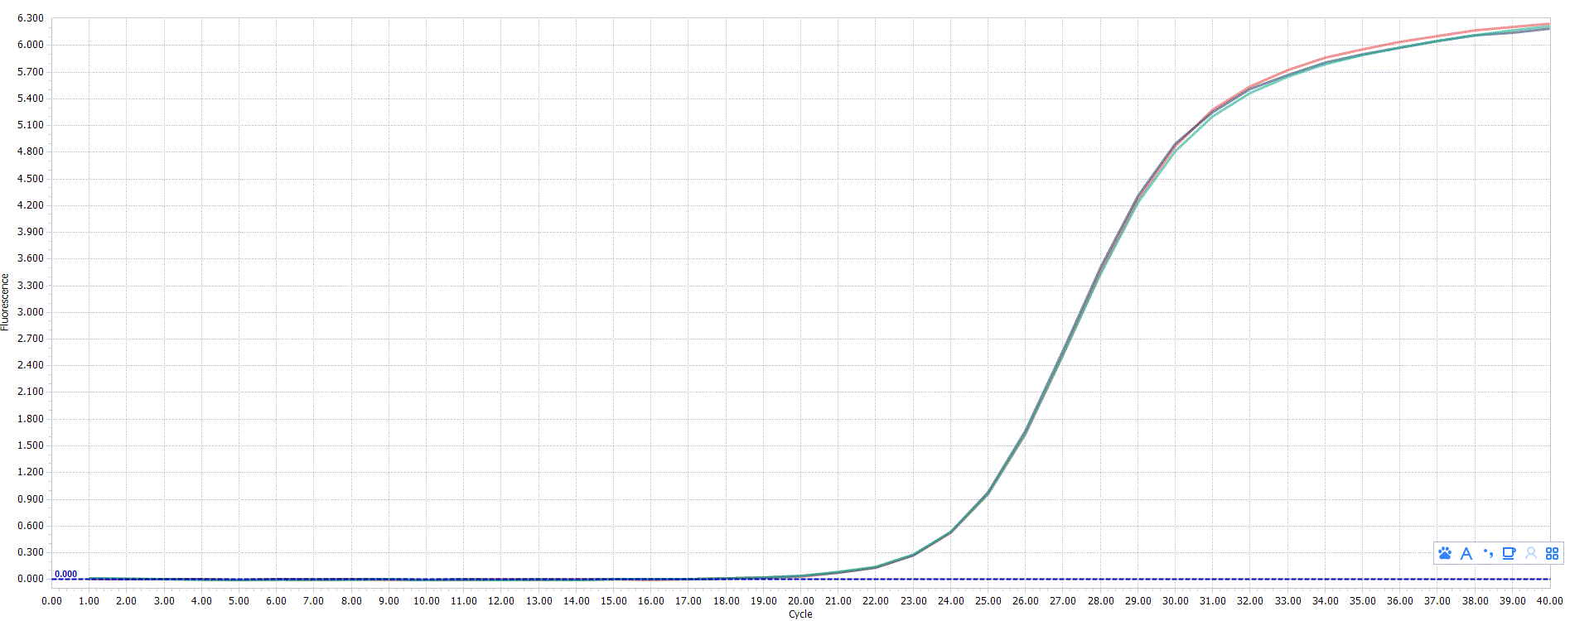
Amplification Curves

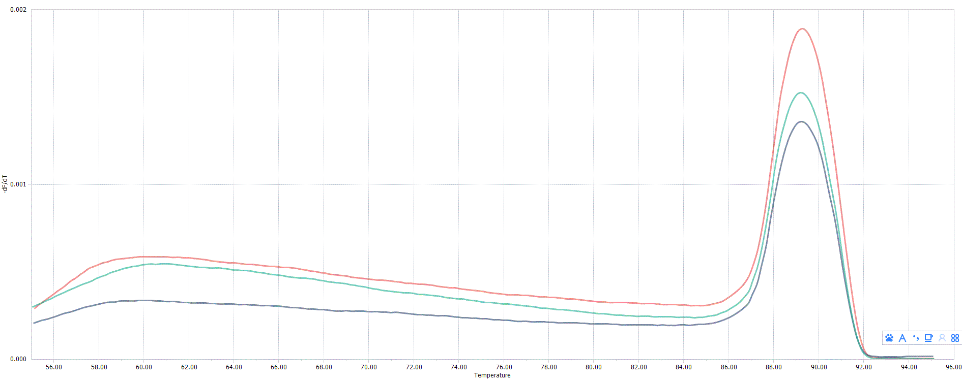
Melting Peaks

