Supplementary Methods
Further cell culture methods
Established bladder cancer cell lines sourced from ATCC/ECACC were tested and free of Mycoplasma spp. and were authenticated by short tandem repeat profiling using the PowerPlex16 System (Promega) within 5 passages of use in this study; all cell lines were a perfect match to the ATCC/ECACC genotype records. Cell lines were all cultured for this study in DMEM:RPMI 1640 (v:v) with 5% fetal bovine serum.

Reverse Transcribed - quantitative Polymerase Chain Reaction (RT-qPCR)
The following forward and reverse primers (all 5’-3’) were used in RT-qPCR reactions to amplify LT-Ag (GAGTAGCTCAGAGGTGCCAACC and CATCACTGGCAAACATATCTTCATGGC [1]), VP1 (CTTTGCTGTAGGTGGAGAACCC and CTCCTGTGAAAGTCCCAAAATAC [2]) and GAPDH (CAAGGTCATCCATGACAACTTTG and GGGCCATCCACAGTCTTCTG). Primers were optimised to give a linear response over a 1,000 fold dilution range and a single product as characterised by a single peak in the dissociation curve. Amplification was monitored using SYBR Green dye on a QuantStudio™ 3 Real-Time PCR System machine (ThermoFisher). All measurements were performed in triplicate and calculated using the ΔΔct method relative to GAPDH expression.

Indirect Immunofluoresence Antibodies
The primary antibodies used were anti-SV40 LT-Ag (1:200, mouse monoclonal “Pab 108”, Santa Cruz Biotechnology, sc-148), anti-VP1 (1:100, mouse “pab597”, kind gift from Chris Buck at the National Institute of Health, Bethesda), anti-Rad51 (1:1,000, rabbit “EPR4030(3)”, Abcam #ab133534), anti-Ki67 (1:400, mouse, “MM1”, Leica, NCL-L-Ki67-MM1), anti-MCM2 (1:500, rabbit, “D7G11”, Cell Signalling #3619), anti-Phospho-pRb Serine 608/807/811 (1:500, rabbit, Cell Signalling #9308), anti-p53 (1:40, mouse, “D01”, Cell Signalling #18032), anti-ZO3 (1:800, rabbit, Cell Signalling #3704) and anti-APOBEC3A/B/G (1:100 rabbit monoclonal, clone 5210-87-13 [3]).

Western Blotting Antibodies
The test antibodies used were anti-SV40 LT-Ag (1:250, mouse monoclonal “Pab 108”, Santa Cruz Biotechnology, sc-148), anti-VP1 (1:250, mouse “pab597”, kind gift from Chris Buck at the National Institute of Health, Bethesda), anti-MCM2 (1:1,000, rabbit, “D7G11”, Cell Signalling #3619), anti-Phospho-pRb Serine 608/807/811 (1:1,000, rabbit, Cell Signalling #9308), anti-EZH2 (1:1,000, rabbit “D2C9”, Cell Signalling #5246), anti-p53 (1:1,000, mouse, “D01”, Cell Signalling #18032), anti-Rad51 (1:10,000, rabbit “EPR4030(3)”, Abcam #ab133534), anti-APOBEC3A/B/G (1:800 rabbit monoclonal, clone 5210-87-13[3]). Homogeneous loading and transfer were evaluated using β-actin antibodies (Sigma, Clone AC15, Mouse, 1:10,000 dilution).

Deaminase Activity Assay Probes
A positive TUU probe and negative control (TCA probe without lysate) were included to aid experimental interpretation.
The ssDNA substrates used in these assays were:
- Linear RTCA
/5IRDye700/A*T*A*ATAATAATAATAATAATAATATCAATAATAATAATAATAATA*A*T*A
- Linear TUU positive control probe
/5IRDye700/A*T*A*ATAATAATAATAATAATAATATUUATAATAATAATAATAATA*A*T*A
- Hairpin YTCA (as previously described “oTM-814” [4] to be selective for APOBEC3A-mediated deamination in the presence of exogenous RNA)
/5IRD700/TTTTATTTTGCAATTGTTCAATTGCAAAATTT*G*T*T
Asterisks in the DNA probes denote phosphorothioate modifications, which confer resistance to both endo- and exonucleases, providing increased oligo stability. A graphical description of the method is provided as Supplementary Fig. 31.

Supplementary Figures
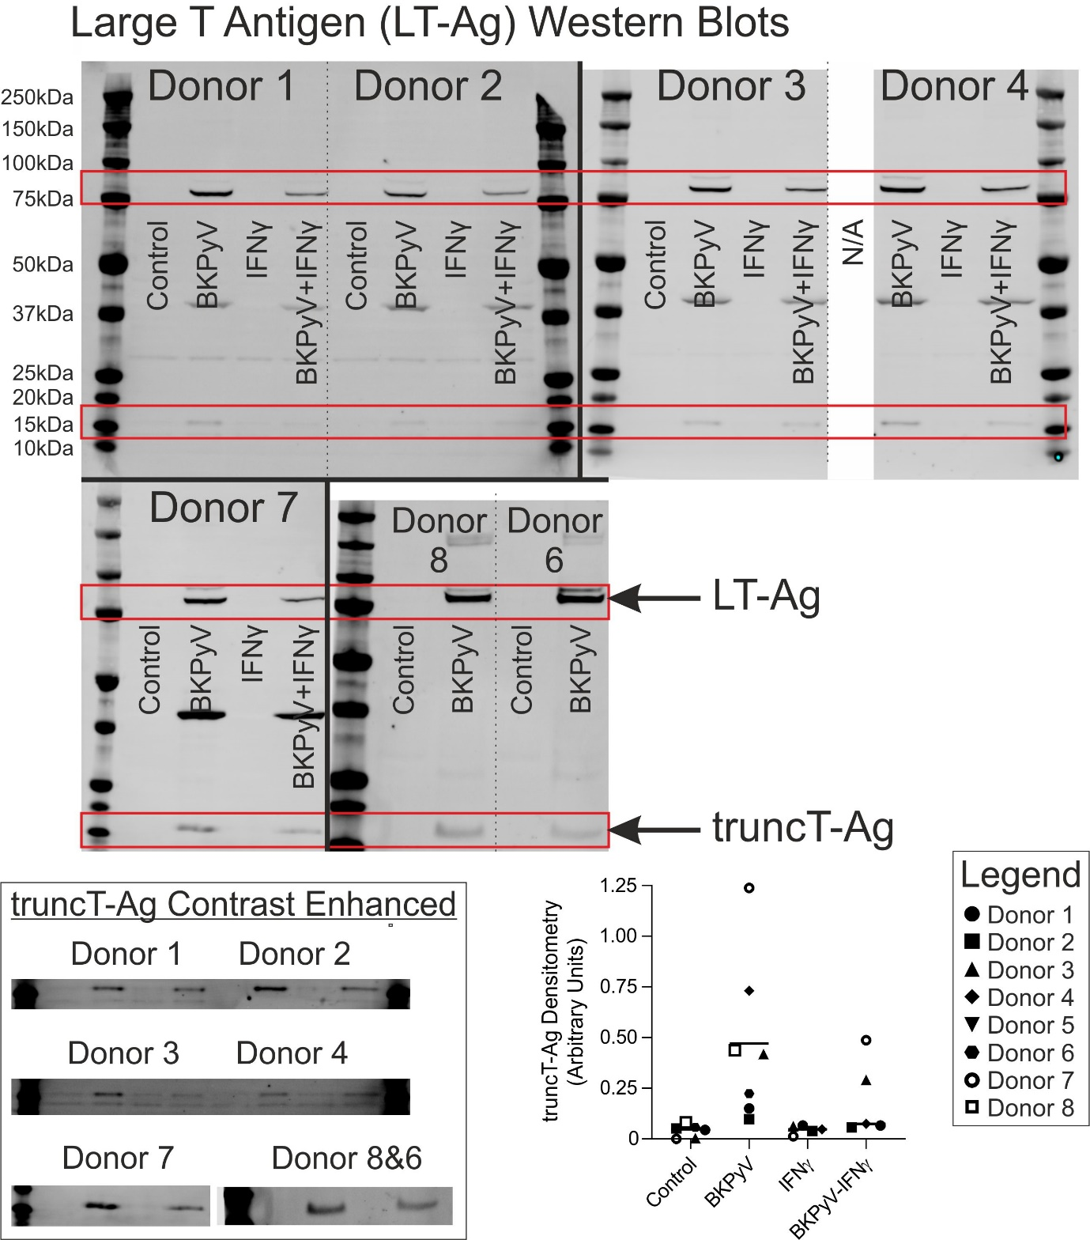
Supplementary Fig. 1 – Full anti-LT-Ag Western blots used for densitometry in Fig. 2d. Predicted molecular weight for BKPyV large T antigen is 80.5kDa (UniProtKB - P03071). Lower 40kDa band visible on some blots is retained VP1 from previous probing of the Western blot shown in Supplementary Fig. 3. The band at 17-20 kDa is the truncated of T-antigen[5] which is expressed to a lesser extent than full length LT-Ag. The box shows contrast enhancement of the truncT-Ag band on all blots and the dot plot shows densitometry for the truncT-Ag band. Like LT-Ag, truncT-Ag expression was reduced by IFNγ. The control cells for Donor 4 were lost to an infection during culture and were therefore not available (N/A) for analysis. β-actin loading controls are shown in Supplementary Fig. 2.
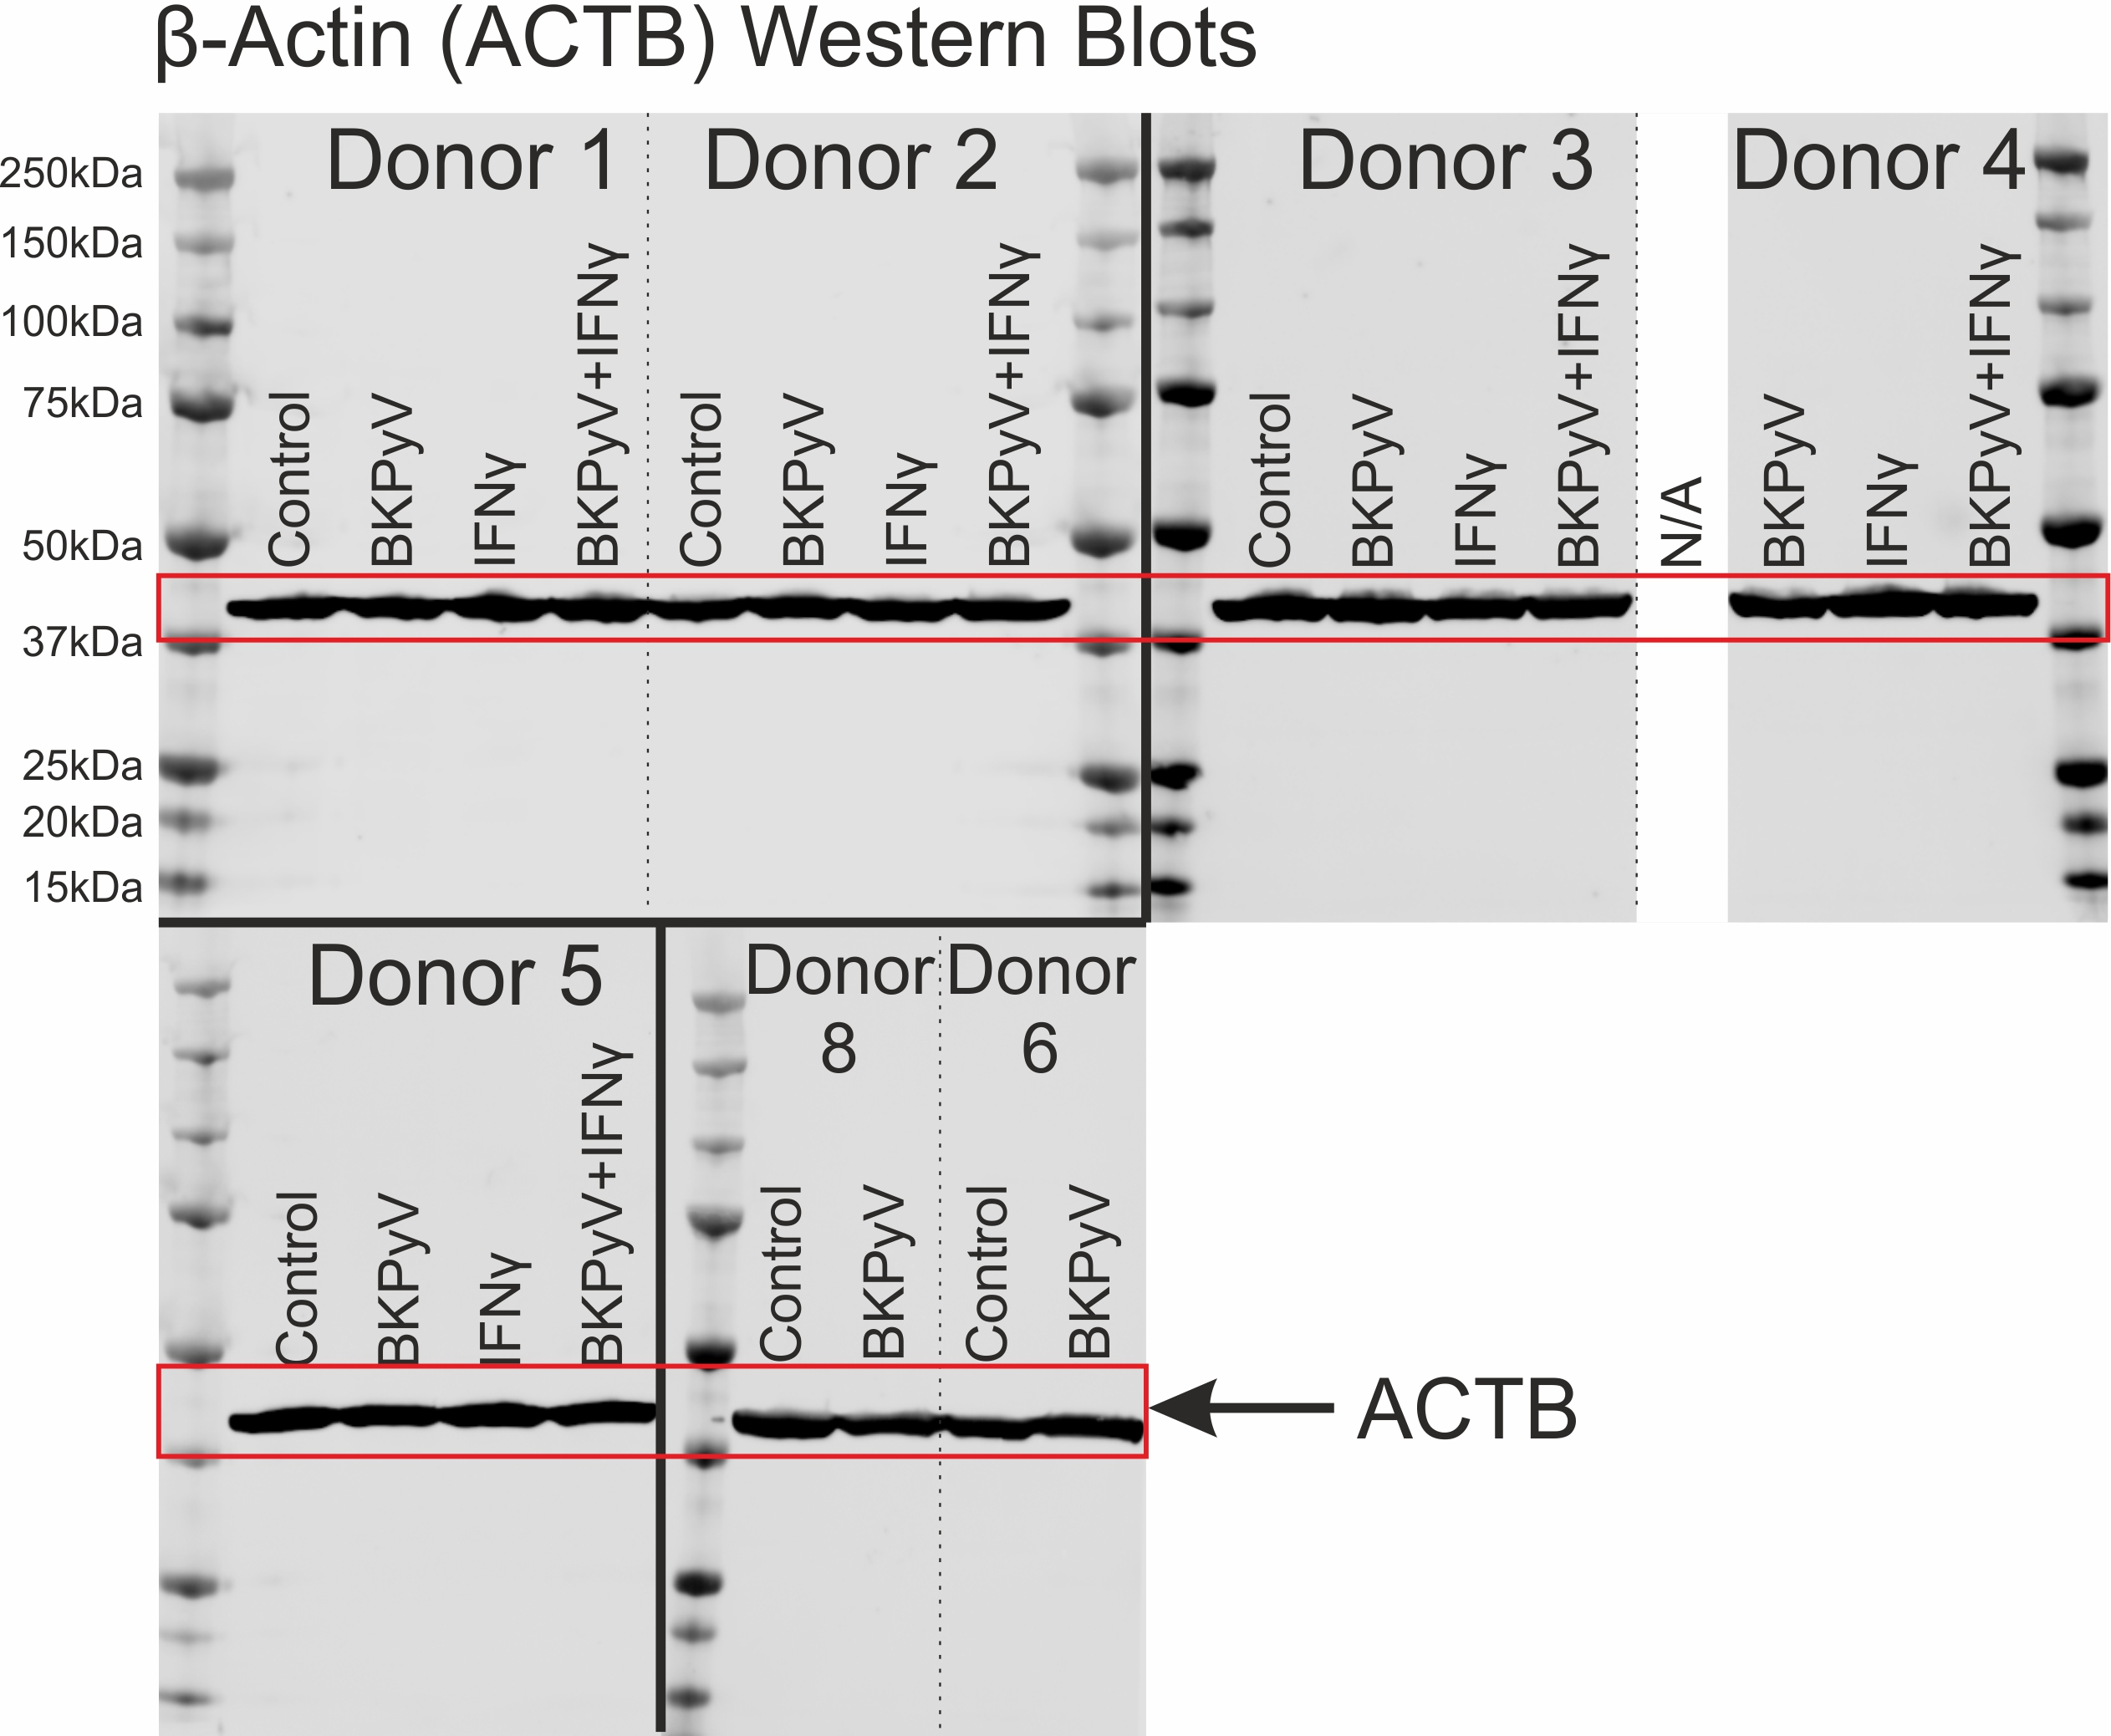
Supplementary Fig. 2 – The loading of Western blots was normalised by running the same amount of protein per lane (50μg). Here we show, Western blotting of β–actin (as a housekeeping protein not expected to change in abundance) as additional evidence, supporting equal loading and transfer of protein using this method. The control cells for Donor 4 were lost to an infection during culture and were therefore not available (N/A) for analysis.
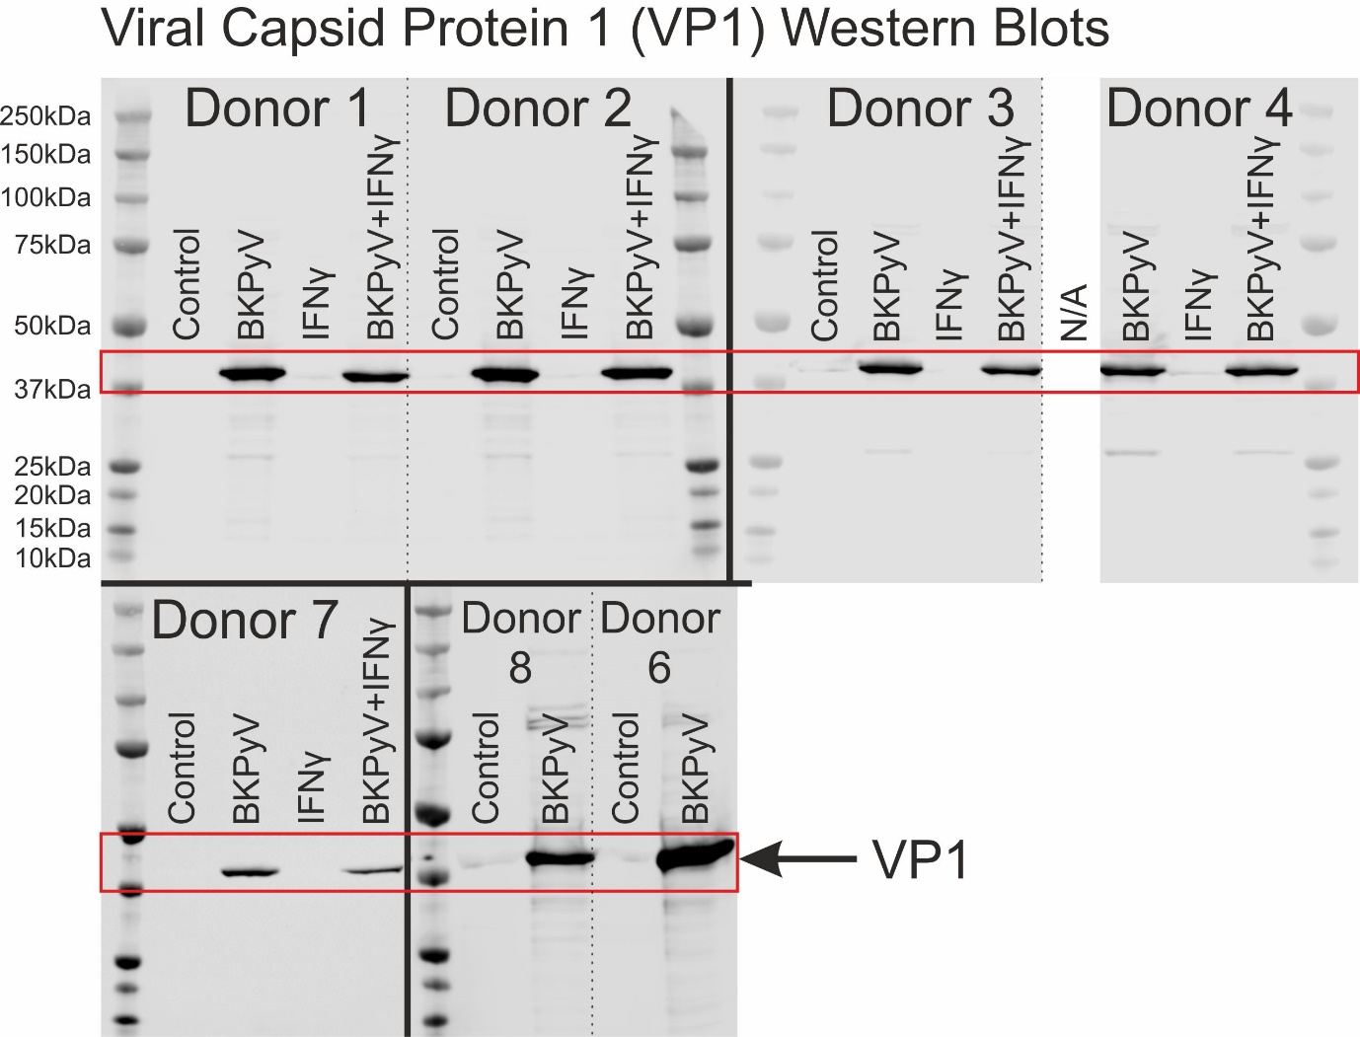
Supplementary Fig. 3 – Full anti-VP1 Western blots used for densitometry in Fig. 2e. Predicted molecular weight for BKPyV VP1 capsid protein is 40.1kDa (UniProtKB - P03088). The control cells for Donor 4 were lost to an infection during culture and were therefore not available (N/A) for analysis. β-actin loading controls are shown in Supplementary Fig. 2.

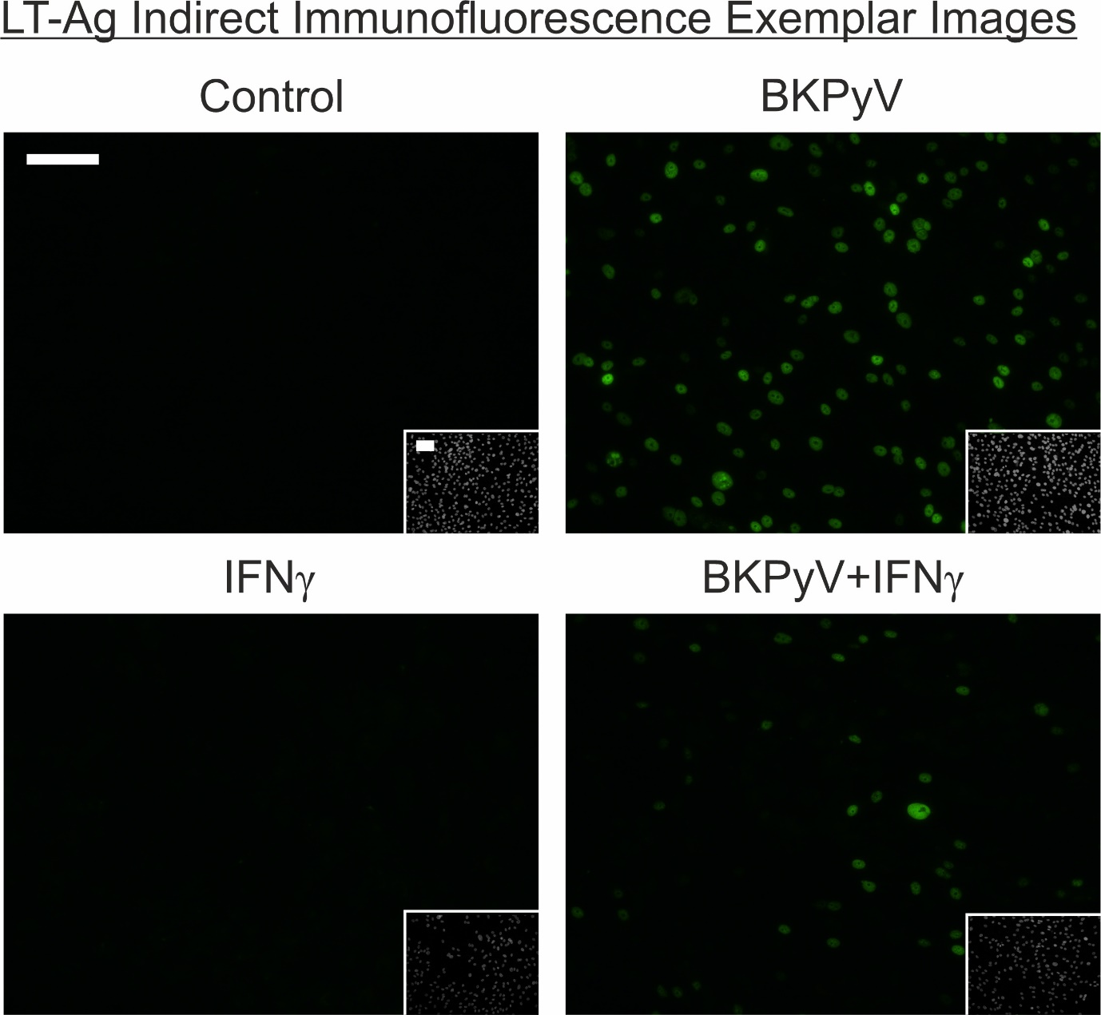
Supplementary Fig. 4 – Indirect immunofluorescence labelling of Large T antigen (LT-Ag) in NHU cell cultures. Inset shows all nuclei present stained with Hoechst 33258. These representative images are of Donor 3 cells and further evidence of LT-Ag immunolabelling in the four conditions from separate experiments can be found in Supplementary Figures 9 and 12. White scale bar in control main panel and inset denotes 100 μm.

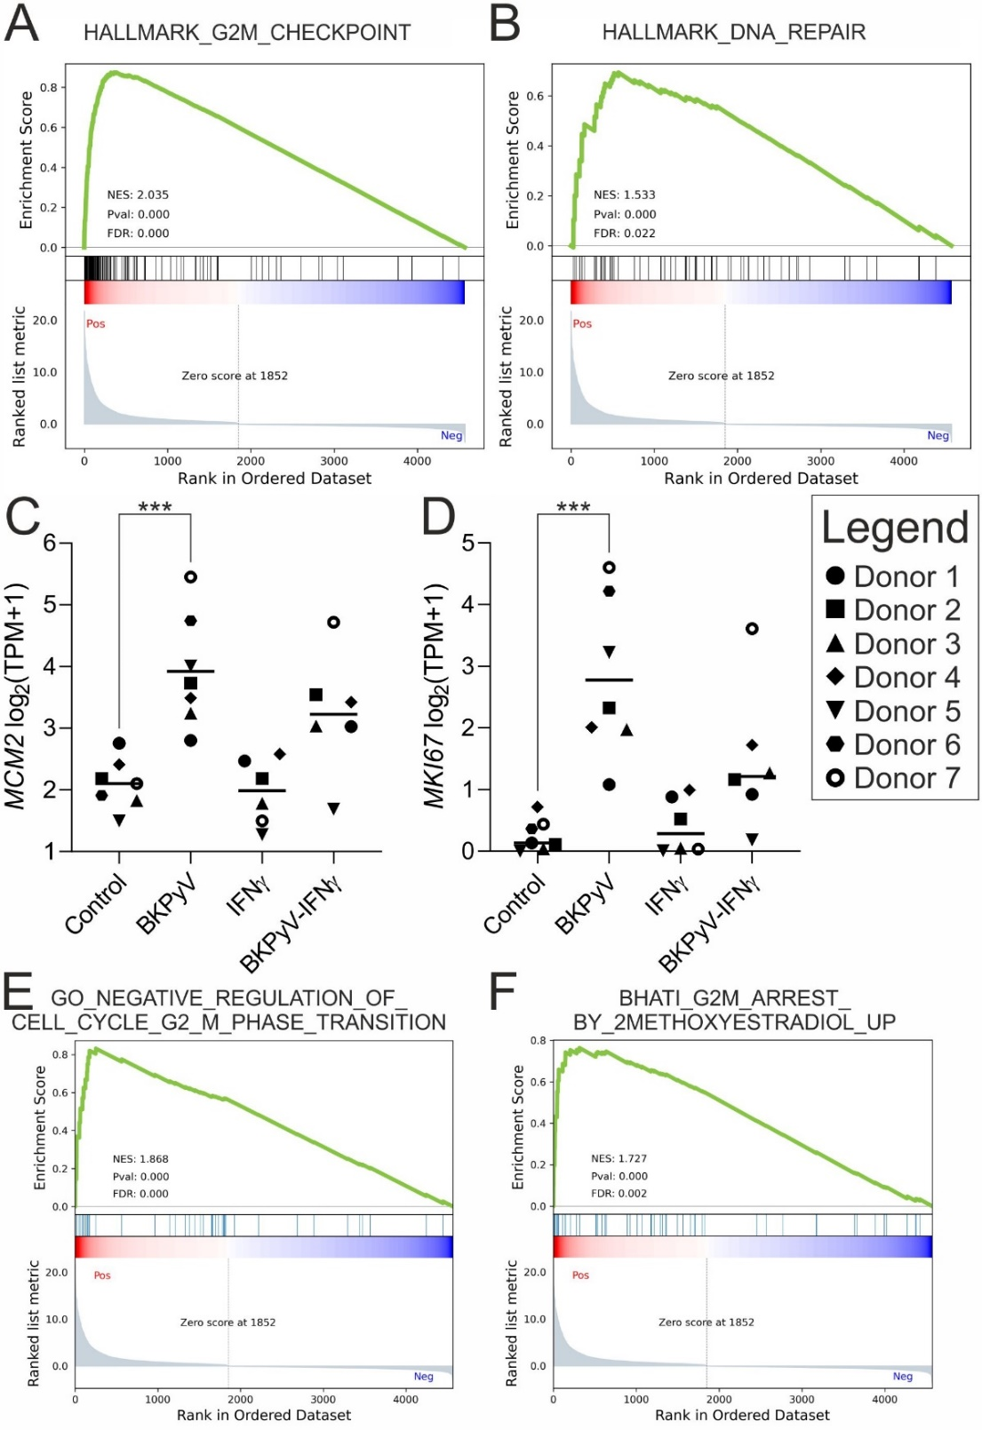
Supplementary Fig. 5 – Gene-set enrichment analysis (GSEA) of mRNAseq π-values for the control vs BKPyV comparison revealed increased expression related to the G2/M checkpoint of the cell cycle (A; Systematic Name = M5901) and DNA repair processes (B; Systematic Name = M5898). mRNAseq data for the proliferation markers (C) MCM2 (D) MKI67. MCM2 transcript expression is not completely lost in quiescent cultures as was observed at the protein level (Fig. 3c). MKI67 is traditionally used as a marker for cells in active cell cycle and is lost as cells exit the cycle into G0. Both MCM2 and MKI67 transcript expression was significantly (p<0.001) induced by BKPyV infection (C&D). Interferon-γ exposure reduced MCM2 and MKI67 transcript expression in BKPyV-infected cultures from all donors tested compared with infection alone; however, the variance in reduction made this change not statistically significant (C&D). GSEA of mRNAseq π-values for the control vs BKPyV comparison also revealed increased expression associated with negative regulation of the G2 to M transition (E; GO:1902750) and experimentally-induced G2-arrest by 2-methoxyestradiol (F; [6]).
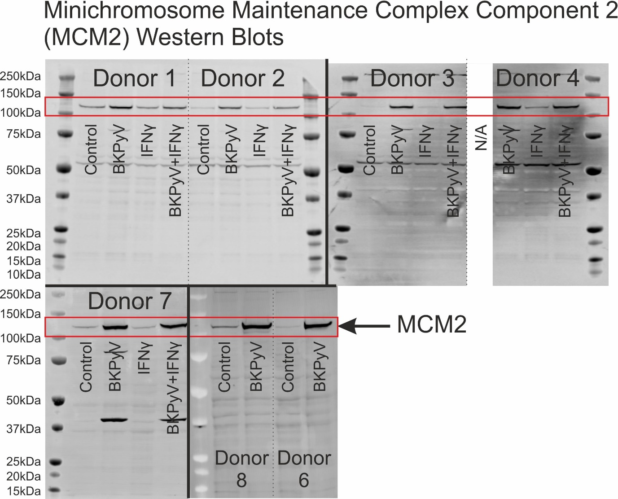
Supplementary Fig. 6 – Full anti-MCM2 Western blots used for densitometry in Fig. 3c. Predicted molecular weight for DNA replication licensing factor MCM2 is 101.9kDa (UniProtKB - P49736). The lower ~55kDa band (Donor 1-4) was considered non-specific and the 40kDa band on the Donor 5 blot is residual antibody from prior probing for VP1. The control cells for Donor 4 were lost to an infection during culture and were therefore not available (N/A) for analysis. β-actin loading controls are shown in Supplementary Fig. 2.
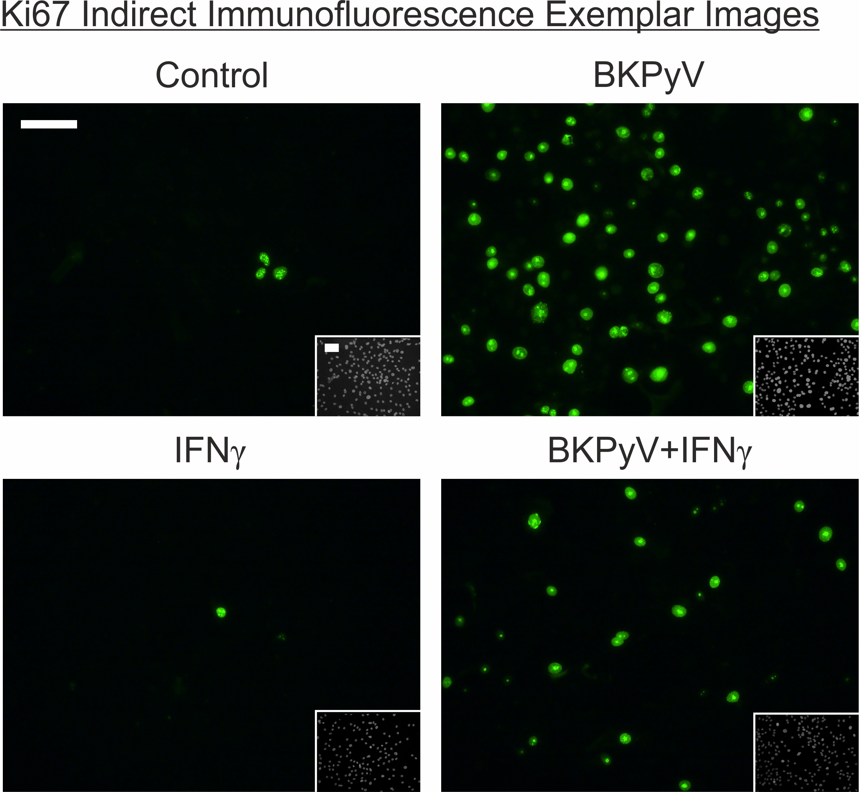
Supplementary Fig. 7 – Indirect immunofluorescence labelling of Ki67 in NHU cell cultures. Ki67 positive nuclei in the control cultures show the many small speckles characteristic of the G1 cell cycle stage. By contrast, Ki67 positive nuclei in the BKPyV infected cultures display the few larger nucleolar granules of labelling that identifies the G2 stage of the cell cycle. Inset shows all nuclei present stained with Hoechst 33258. White scale bar in control main panel and inset denotes 100 μm.
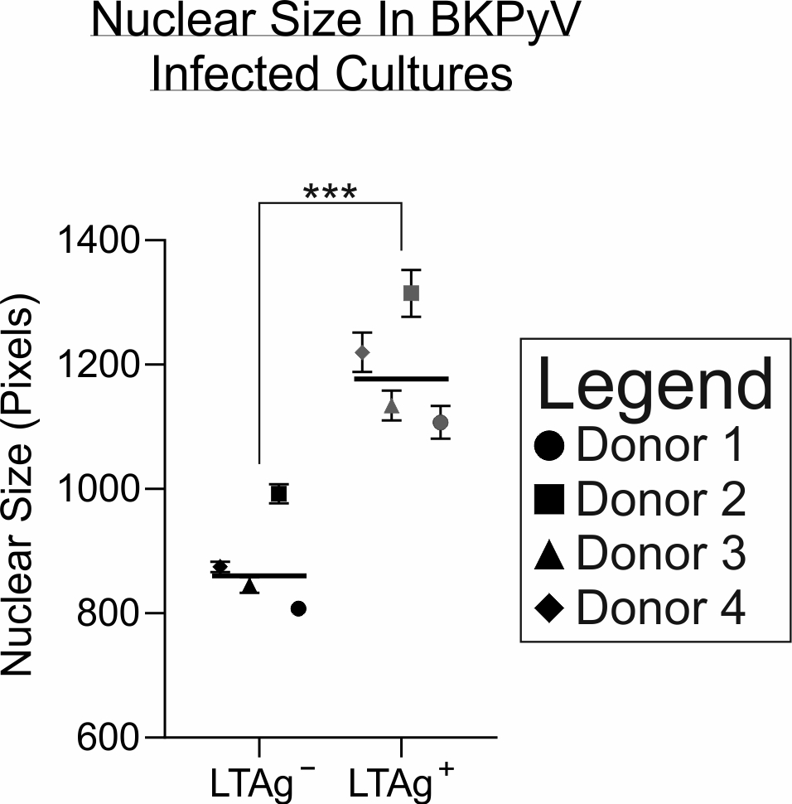
Supplementary Fig. 8 – Hoechst 33258 staining of urothelial cells in BKPyV infected cultures, showed a significant (p=0.0001) increase in the size of nuclei for LT-Ag labelling positive cells as measured by pixel area (line indicates the mean nuclear size in n=4 independent donors with >1,000 cells analysed in each condition).
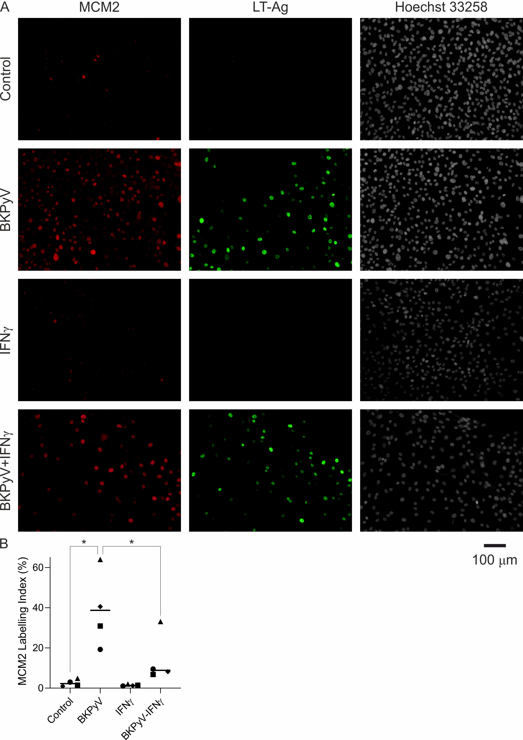
Supplementary Fig. 9 – (A) Indirect Immunofluorescence labelling for MCM2 (red) is shown alongside LT-Ag (green) labelling of the same cells. Hoechst 33258 DNA staining is included in grayscale. In BKPyV-infected cells there was MCM2 positivity in the absence of LT-Ag labelling. (B) MCM2 labelling indices showed a significant increase in positive cells in BKPyV infected cultures. In addition, the number of MCM2 positive cells in BKPyV-infected cultures was significantly lower when IFNγ was added to the culture (line indicates the mean nuclear size in n=4 independent donors with >1,000 cells analysed in each condition).
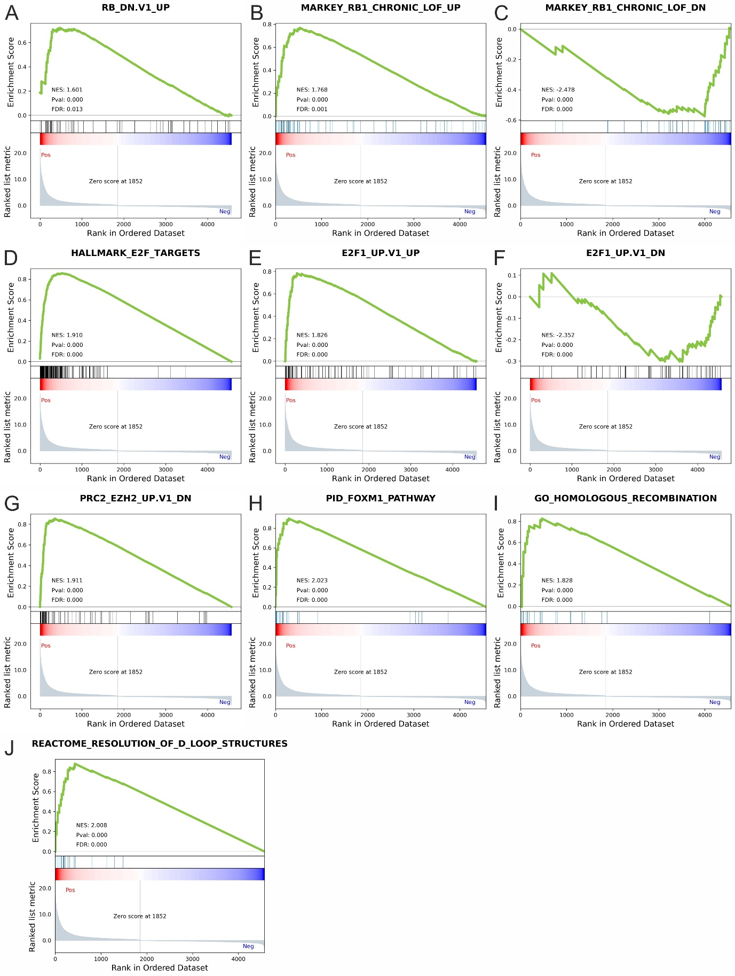
Supplementary Fig. 10 – Gene-set enrichment analysis (GSEA) of mRNAseq π-values for the control vs BKPyV comparison.
(A) RB_DN.V1_UP = gene set derived from epidermal-specific ablation of Rb gene [7].
(B) MARKEY_RB1_CHRONIC_LOF_UP = Genes up-regulated in mouse embryonic fibroblasts isolated from RB1 knockout mice: chronic loss of function (LOF) of RB1 [8].
(C) MARKEY_RB1_CHRONIC_LOF_DN = Genes down-regulated in mouse embryonic fibroblasts isolated from RB1 knockout mice leading to chronic loss of function (LOF) of RB1 [8].
(D) HALLMARK_E2F_TARGETS = Genes encoding cell cycle related targets of E2F transcription factors. Systematic Name = M5925.
(E) E2F1_UP.V1_UP = Genes up-regulated in mouse fibroblasts over-expressing E2F1 [10].
(F) E2F1_UP.V1_DN = Genes down-regulated in mouse fibroblasts over-expressing E2F1 [10].
(G) PRC2_EZH2_UP.V1_DN = Genes down-regulated in TIG3 cells (fibroblasts) upon knockdown of EZH2 gene. BKPyV infection increased EZH2 transcript and protein (Fig. 3D&E). Thus genes that went down when EZH2 was knocked down in fibroblasts, also go up when EZH2 expression goes up in BKPyV infection [9].
(H) PID_FOXM1_PATHWAY = Pathway Interaction Database (NCI, NIH and Nature Publishing Group) FOXM1 transcription factor network [11].
(I) GO_HOMOLOGOUS_RECOMBINATION = Gene Ontology Consortium contributed gene set associated with a DNA recombination process that results in the equal exchange of genetic material between the recombining DNA molecules.
(J) REACTOME_RESOLUTION_OF_D_LOOP_STRUCTURES = Reactome contributed list of genes associated with resolution of D-loop Structures through Synthesis-Dependent Strand Annealing (SDSA). Systematic Name = M27583.

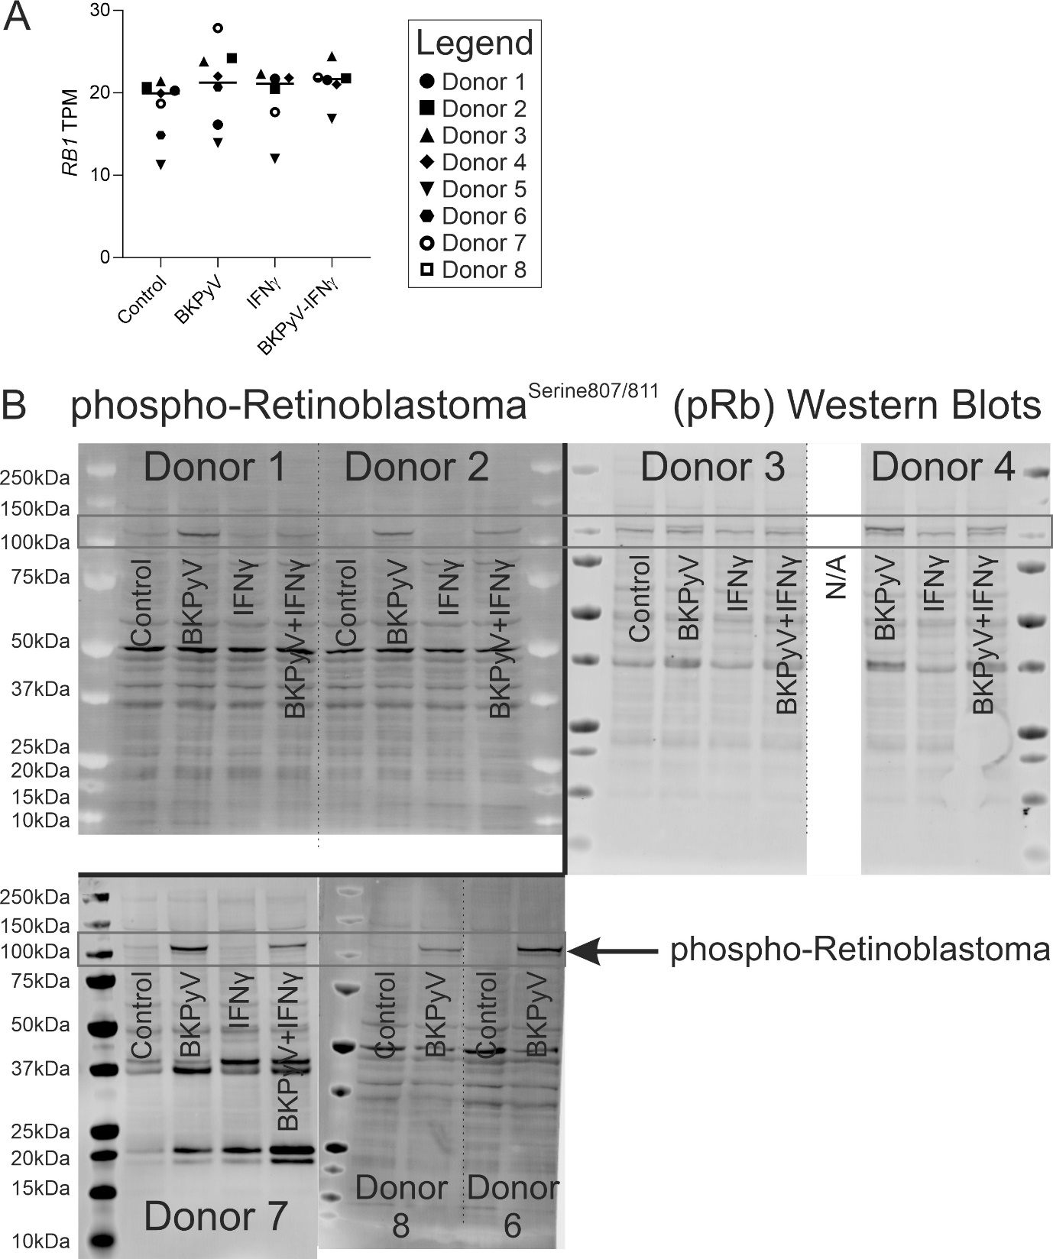
Supplementary Fig. 11 – (A) mRNAseq data for the RB1 gene which encodes the Retinoblastoma protein showing no changes between treatments. (B) Full anti-phosphorylated-Retinoblastoma (p-pRb) Western blots used for densitometry in Fig. 4b. Predicted molecular weight for pRb is 106.2kDa (UniProtKB – P06400). This antibody recognises Retinoblastoma when phosphorylated at serine 807 or serine 811 and this is reflected in the presence of a doublet band. The lower band reflects single phosphorylation at serine 807/811 and the higher band represents phosphorylation at both sites. The control cells for Donor 4 were lost to an infection during culture and were therefore not available (N/A) for analysis. β-actin loading controls are shown in Supplementary Fig. 2.
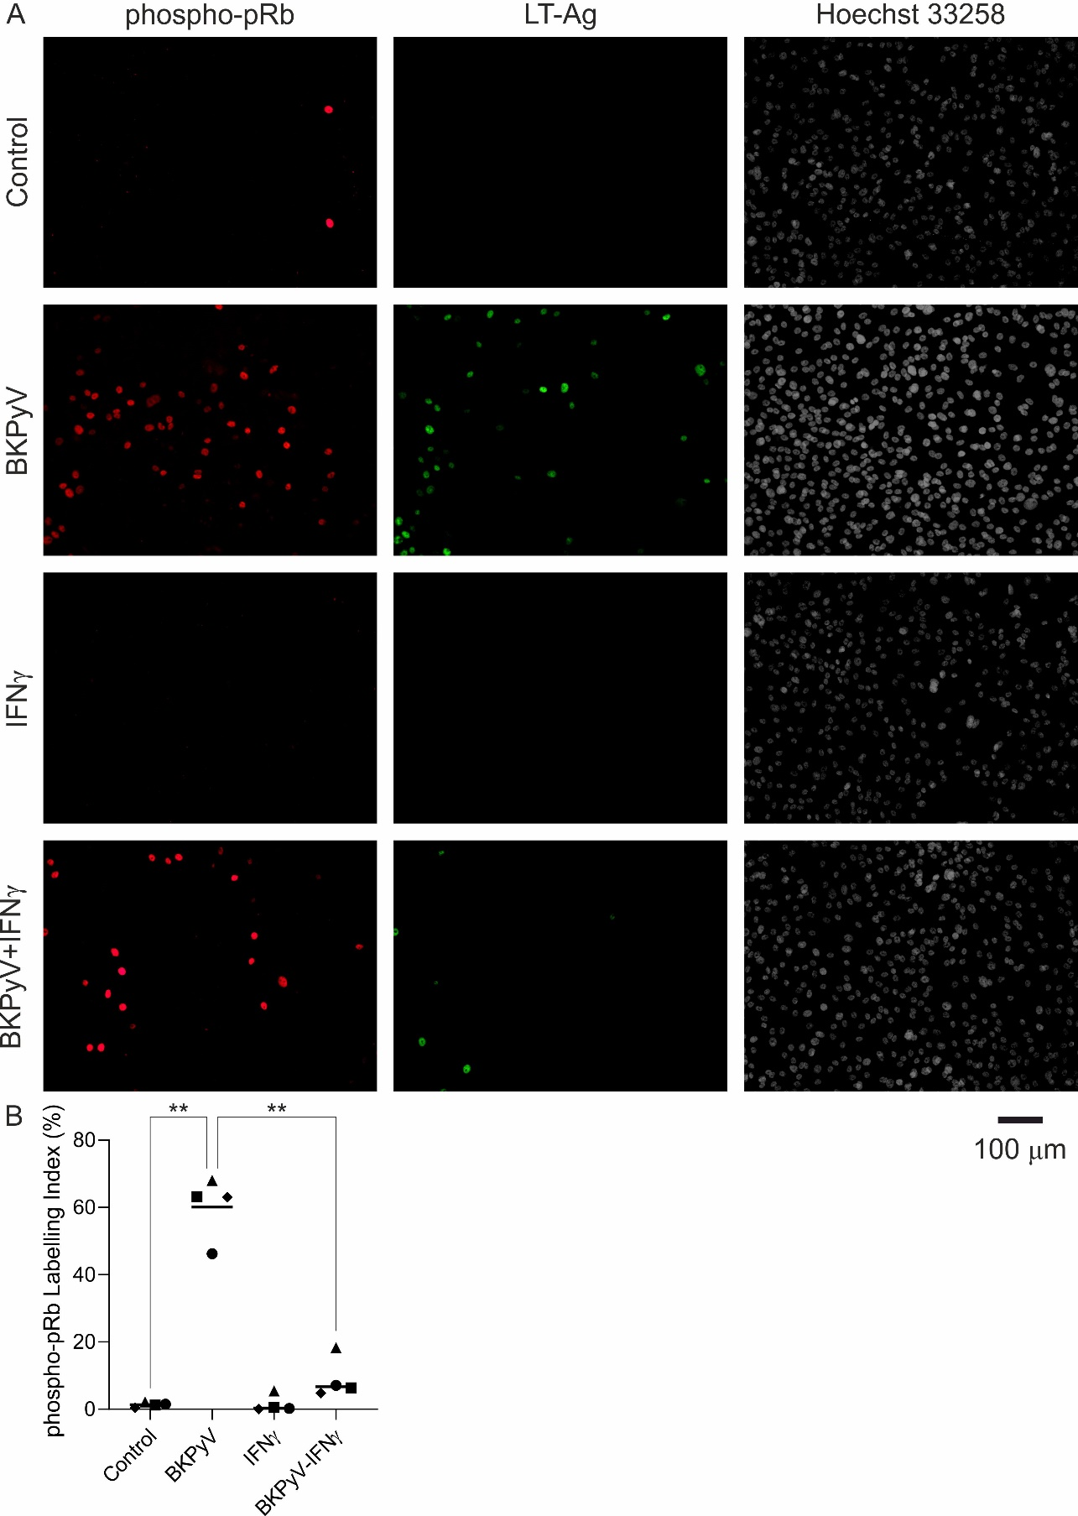
Supplementary Fig. 12 – (A) Indirect Immunofluorescence labelling for phosphorylated-Retinoblastoma (phospho-pRb; red) is shown alongside LT-Ag (green) labelling of the same cells. In BKPyV-infected cells there was frequent phospho-pRb positivity in the absence of LT-Ag labelling. (B) phospho-pRb labelling indices showed a significant increase in positive cells in BKPyV infected cultures. In addition, the number of phospho-pRb positive cells in BKPyV-infected cultures was significantly lower when IFNγ was added to the culture (line indicates the mean nuclear size in n=4 independent donors with >1,000 cells analysed in each condition).
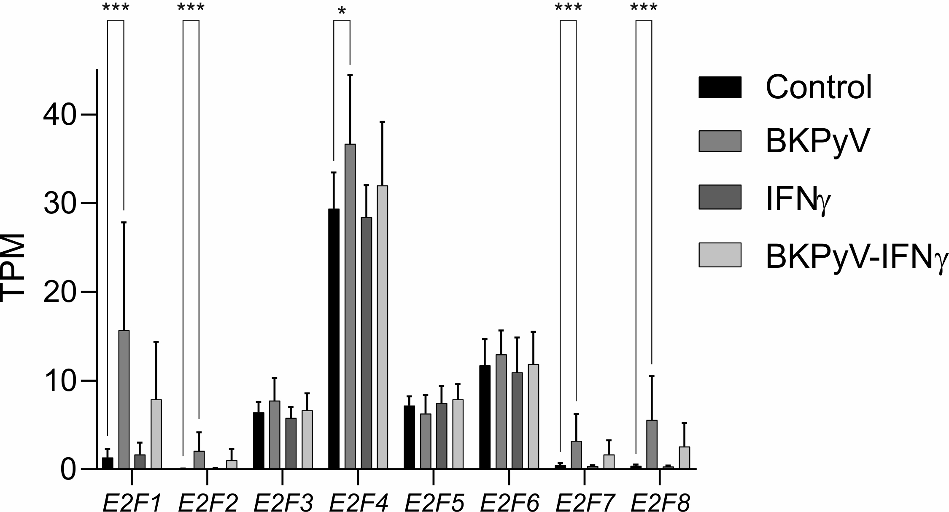

Supplementary Fig. 13 – mRNAseq data for the E2F family of transcription factors. The E2F1 transcription showed the greatest fold change (mean log₂ fold change (TPM+1) = 2.40; p<0.001). However, E2F2 (mean log₂ fold change (TPM+1) = 1.03; p<0.001), E2F4 (mean log₂ fold change (TPM+1) = 0.30; p=0.014), E2F7 (mean log₂ fold change (TPM+1) = 1.07; p<0.001) and E2F8 (mean log₂ fold change (TPM+1) = 1.64; p<0.001) were all induced significantly too.
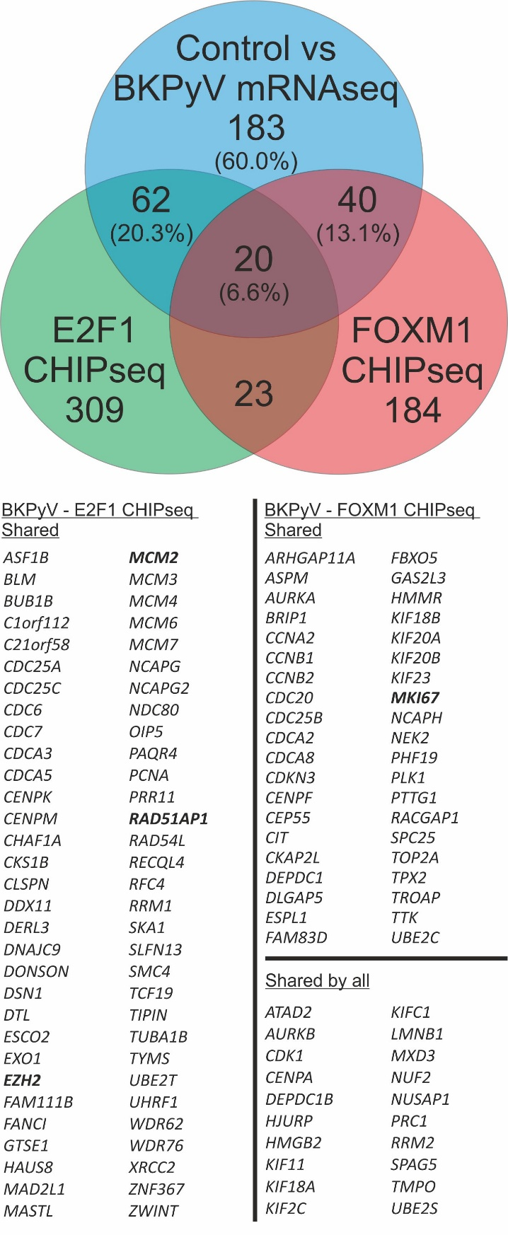
Supplementary Fig. 14 – Comparison of genes significantly induced by >2-fold following BKPyV infection with published CHIPseq peaks for E2F1 in MM1.S cells [12] and FOXM1 in U20S cells [13] reveals significant overlap. E2F1 and FOXM1 CHIPseq peaks [12, 13] were found near 33.6% and 29.5% of BKPyV-induced genes, respectively. The significance of the overlap was tested by calculating their exact hypergeometric probability. For FOXM1: representation factor = 40.3 and p < 2.70e-78. For E2F1: representation factor = 35.6 and p < 9.88e-103.
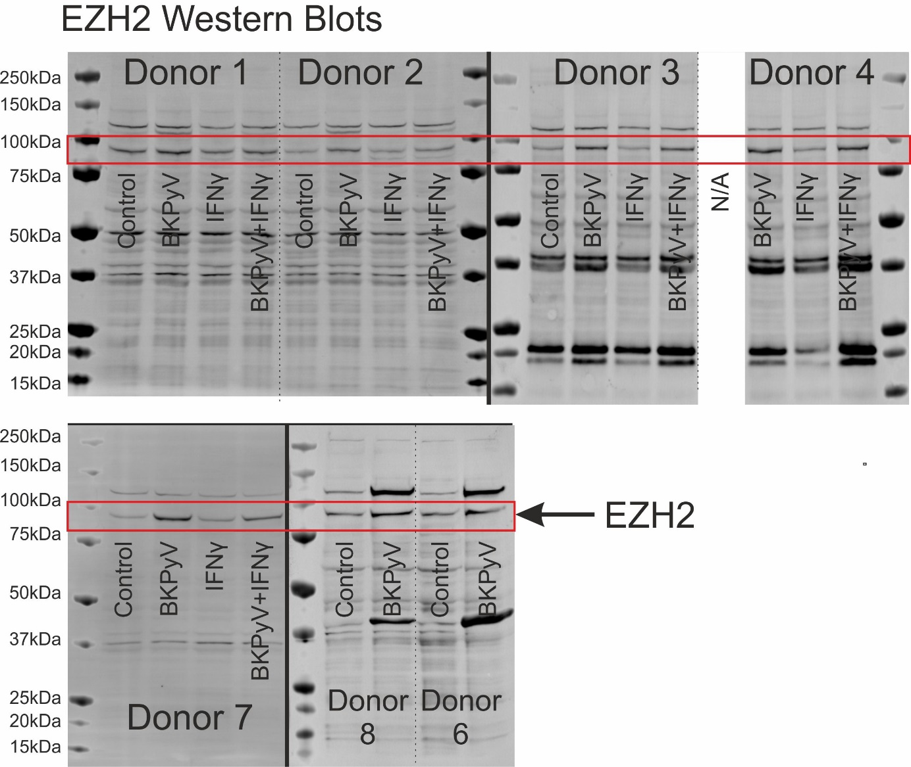
Supplementary Fig. 15 – Full EZH2 Western blots used for densitometry in Fig. 4g. Predicted molecular weight for EZH2 is 85.4kDa (UniProtKB – Q15910). The control cells for Donor 4 were lost to an infection during culture and were therefore not available (N/A) for analysis. β-actin loading controls are shown in Supplementary Fig. 2.
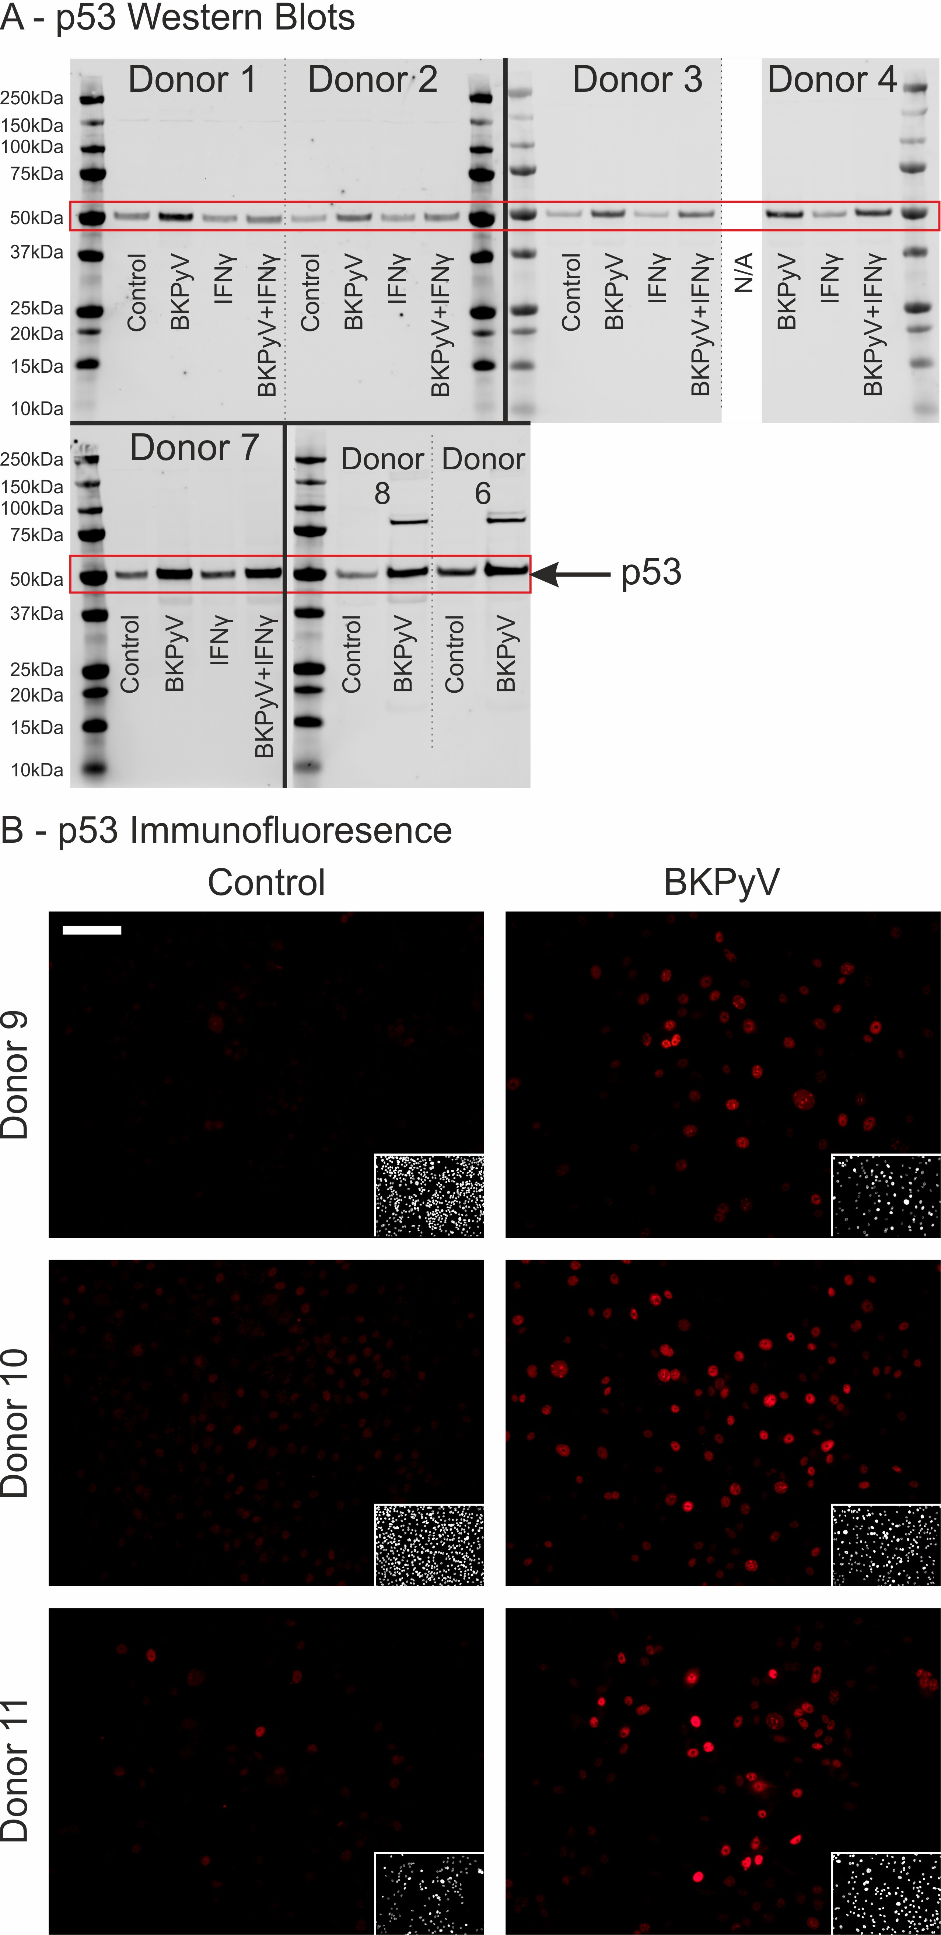
Supplementary Fig. 16 – (A) Full p53 Western blots used for densitometry in Fig. 5a. Predicted molecular weight for p53 is 53kDa (UniProtKB – P04637). The higher bands on the blots for Donor 8 and 6 reflect a previous probing of the membrane for LT-Ag (see Supplementary Fig. 1). The control cells for Donor 4 were lost to an infection during culture and were therefore not available (N/A) for analysis. β-actin loading controls are shown in Supplementary Fig. 2.
(B) Indirect immunofluorescence for p53 found stabilised p53 protein was localised to the nuclei of BKPyV infected urothelial cells (n=3 independent donors). Scale bar in Donor 9 control main panel indicates 100 μm.
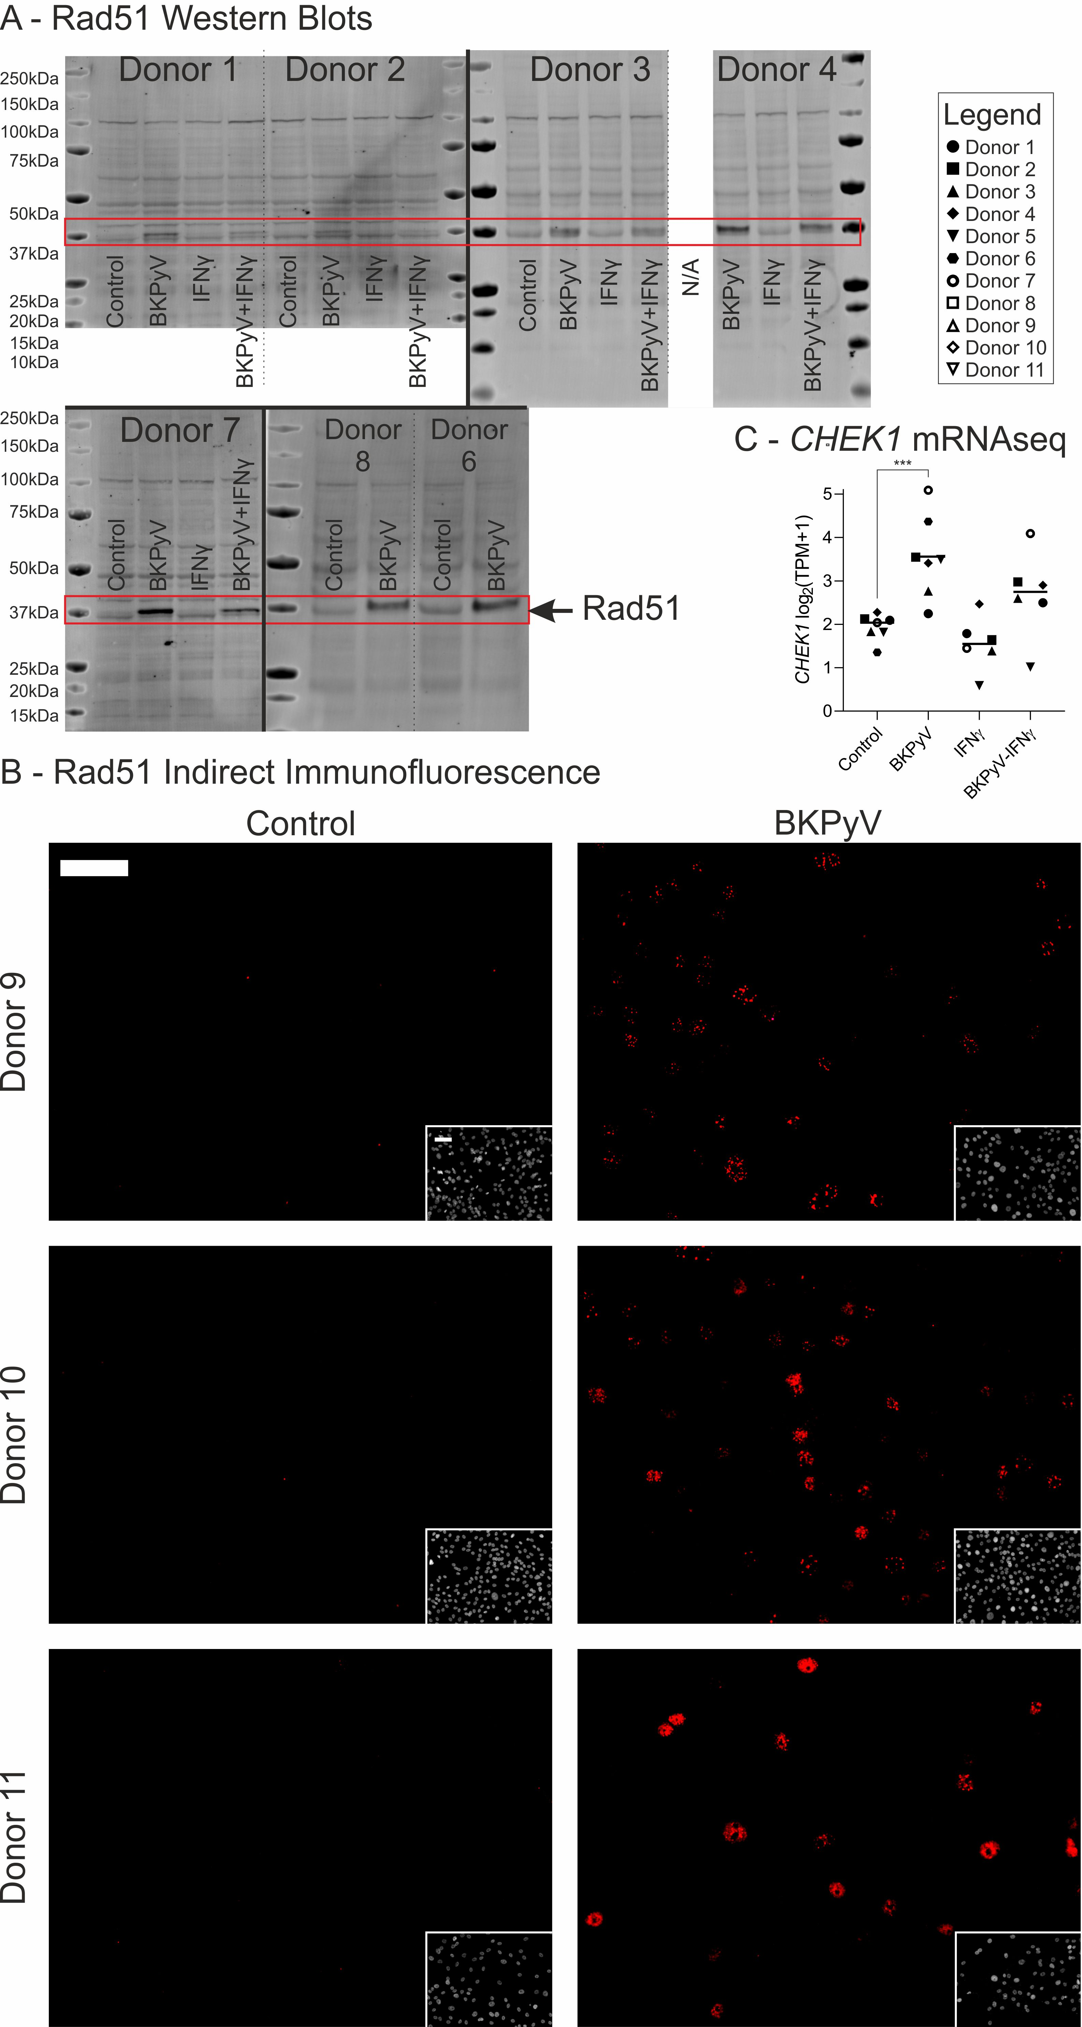
Supplementary Fig. 17 – (A) Full RAD51 Western blots used for densitometry in Fig. 5e. Predicted molecular weight for RAD51 is 37.0kDa (UniProtKB – Q06609). The slight increase in molecular weight observed from control to BKPyV-infected lysates likely reflects phosphorylation of the Rad51 protein, which has previously been associated with activity. The control cells for Donor 4 were lost to an infection during culture and were therefore not available (N/A) for analysis. β-actin loading controls are shown in Supplementary Fig. 2. (B) Indirect immunofluorescence for Rad51 showed speckles within the nuclei of BKPyV infected urothelial cells (n=3 independent donors). Scale bars in the top left corner of donor 9 Control main image and inset Hoechst 33258 stain both denote 100μm. (C) Chk1 kinase performs activating phosphorylation of Rad51. Expression of the CHEK1 gene was significantly (p=0.0001) induced by BKPyV infection.
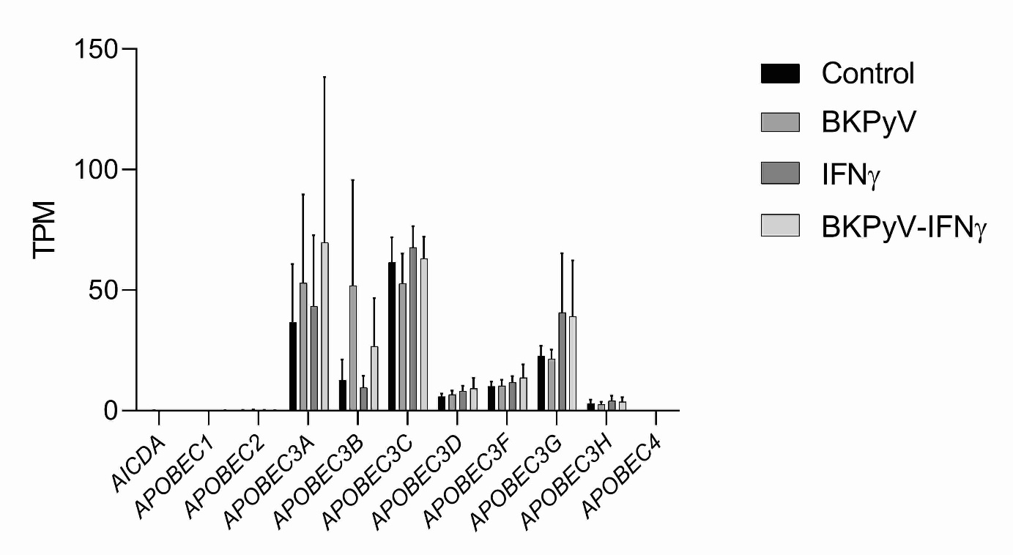
Supplementary Fig. 18 – Analysis of cytosine deaminase gene transcription by cultures of differentiated normal human urothelial (NHU) cells (cell lines developed from n=7 independent donors, positive error bars denote standard deviation).
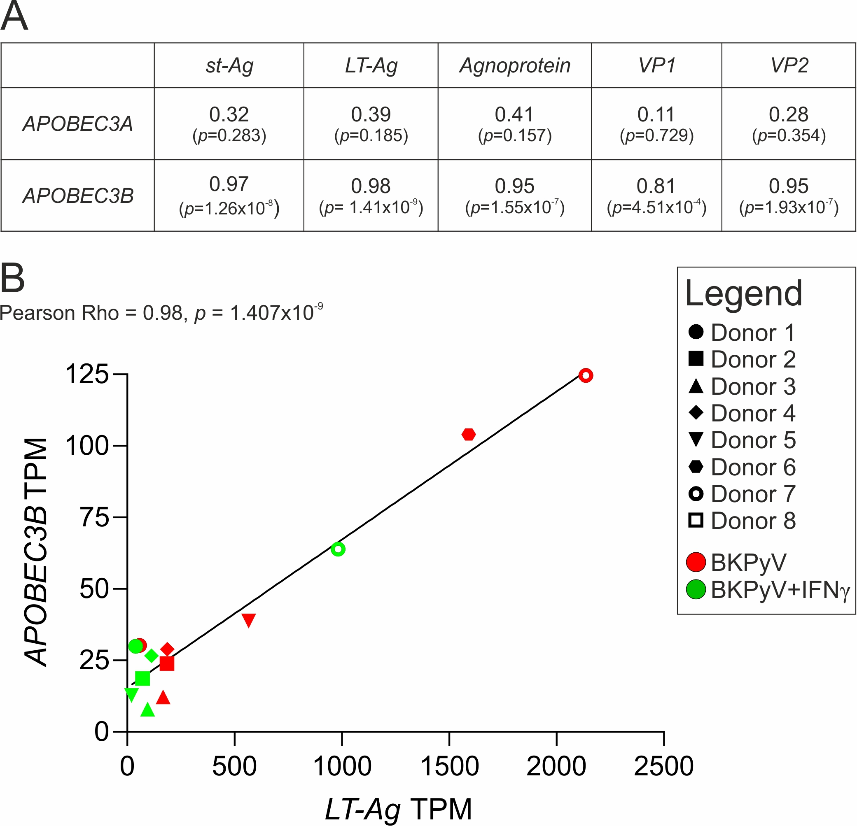
Supplementary Fig. 19 – (A) Table of Pearson correlation Rho values (and significance p values) for comparison of APOBEC3A and APOBEC3B TPMs with viral transcript relative TPMs. (B) Linear regression analysis of the relationship between BKPyV LT-Ag TPM and APOBEC3B TPM.

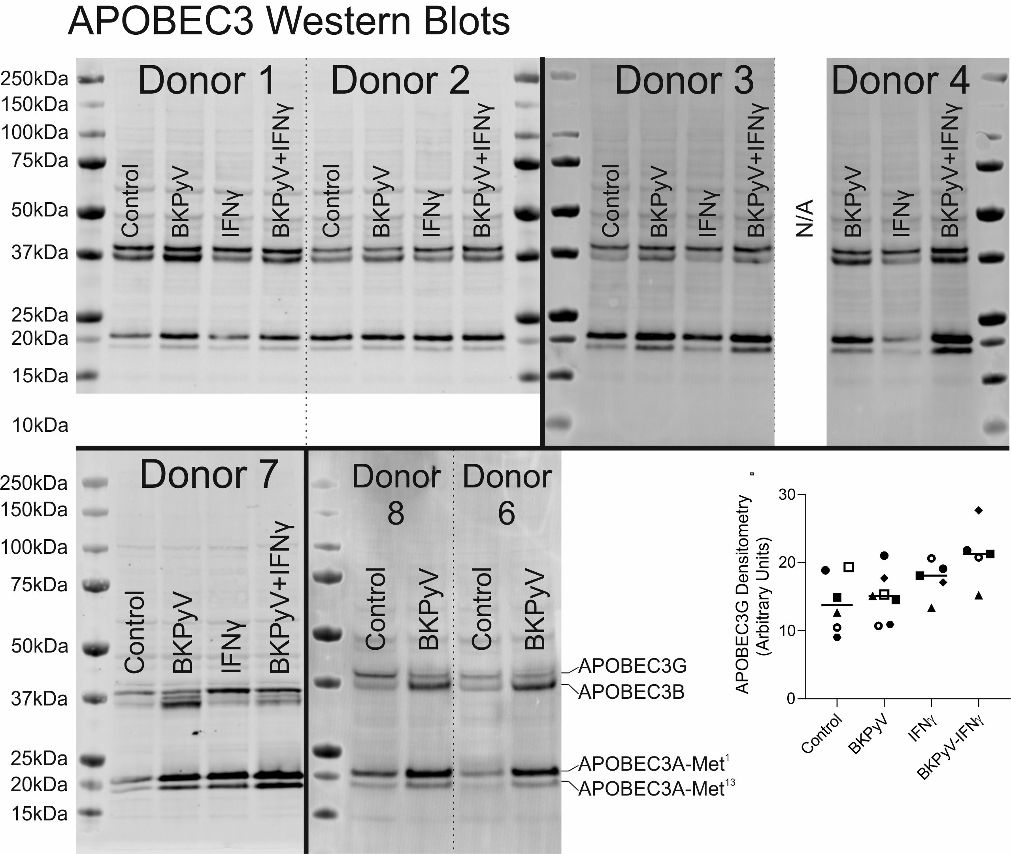
Supplementary Fig. 20 – Full anti-APOBEC3 Western blots used for densitometry in Fig. 6c-d. The anti-APOBEC3A/B/G rabbit monoclonal (clone 5210-87-13) antibody was developed in the laboratory of Reuben Harris [3]. A detailed characterisation demonstrating the reactivity of this antibody against all APOBEC3 isoforms was recently published showing it detects APOBEC3A, APOBEC3B and APOBEC3G which are readily distinguished by molecular weight [15]. The predicted molecular weight for APOBEC3A (UniProtKB – P31941) is 23kDa (Met¹) and a smaller 21.8kDa enzymatically-active variant is generated by internal translation initiation at a methionine at position 13 (Met¹³) [14]. The predicted molecular weight for APOBEC3B is 45.9kDa (UniProtKB - Q9UH17). The predicted molecular weight for APOBEC3G is 46.4kDa (UniProtKB - Q9HC16). However, the running of APOBEC3B and APOBEC3G around the 37kDa marker in Western blots is consistent with previous reports [15]. The control cells for Donor 4 were lost to an infection during culture and were therefore not available (N/A) for analysis.
Densitometry analysis for the APOBEC3G band is also included here but showed no significant changes in spite of apparent IFNγ-mediated induction at the transcript level (Supplementary Fig. 18).
β-actin loading controls are shown in Supplementary Fig. 2.
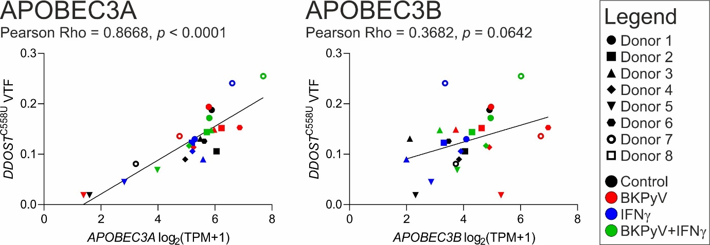
Supplementary Fig. 21 – Correlation analysis of the relationship between APOBEC3 enzyme transcript expression and DDOST C558U variant transcript abundance.

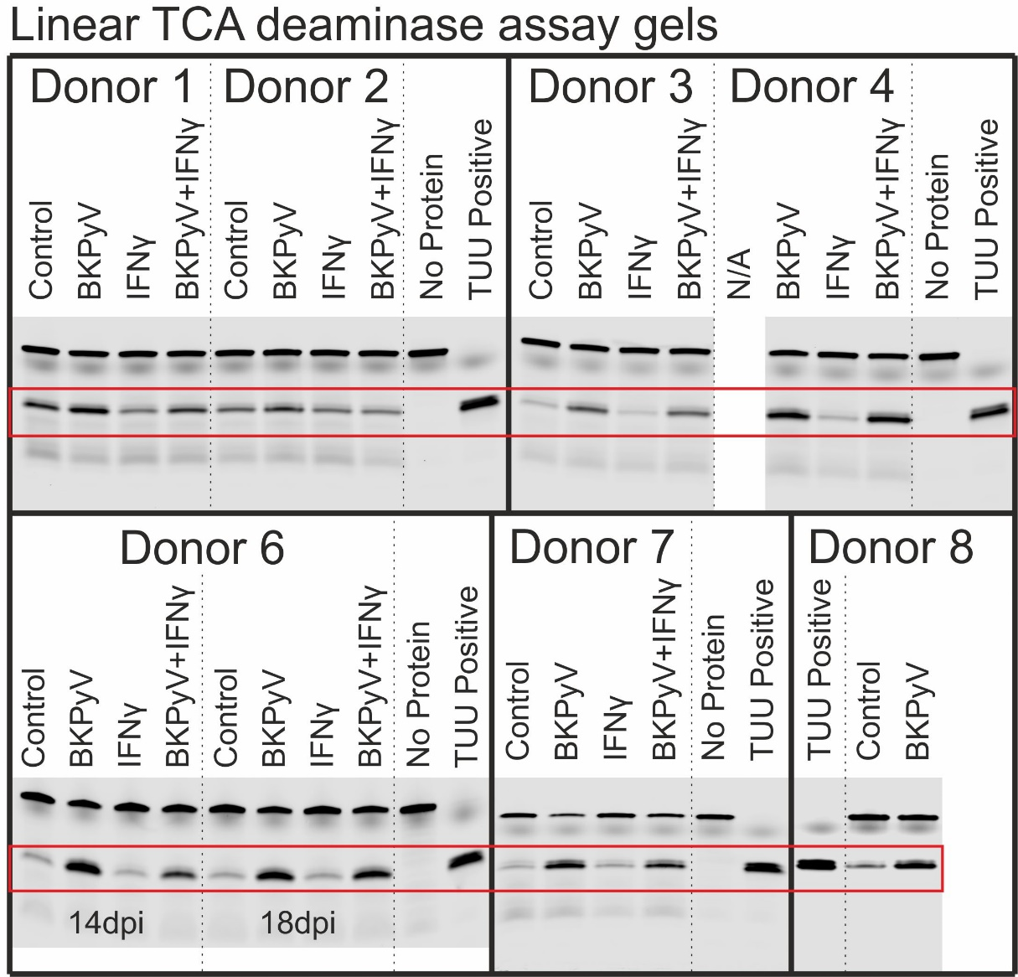
Supplementary Fig. 22 – Deaminase assays performed with a linear RTCA probe preferential for APOBEC3B. The red box shows the band for the cleaved probe which was analysed by densitometry for panel Fig. 6f. These assays were all performed on lysates from 14 dpi except for the Donor 6 18 dpi assays (shown above) which were not included in the densitometry shown in Fig. 6f.
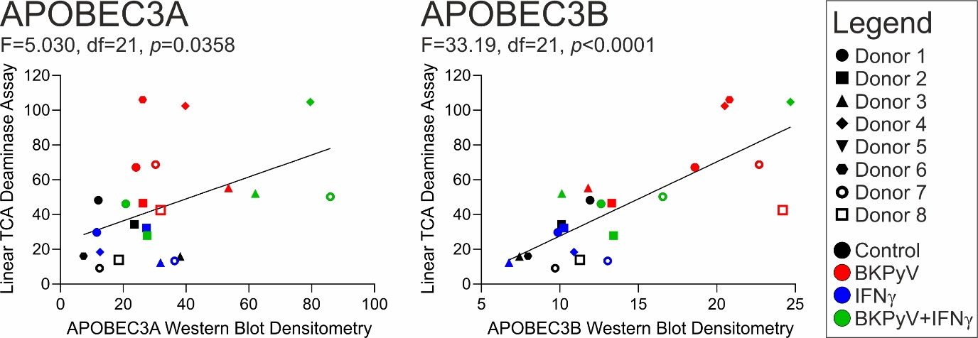
Supplementary Fig. 23 – Linear regression analysis of the relationship between linear TCA deaminase assays and APOBEC3A and APOBEC3B protein abundance (assessed by Western blot in Fig. 6c-d).

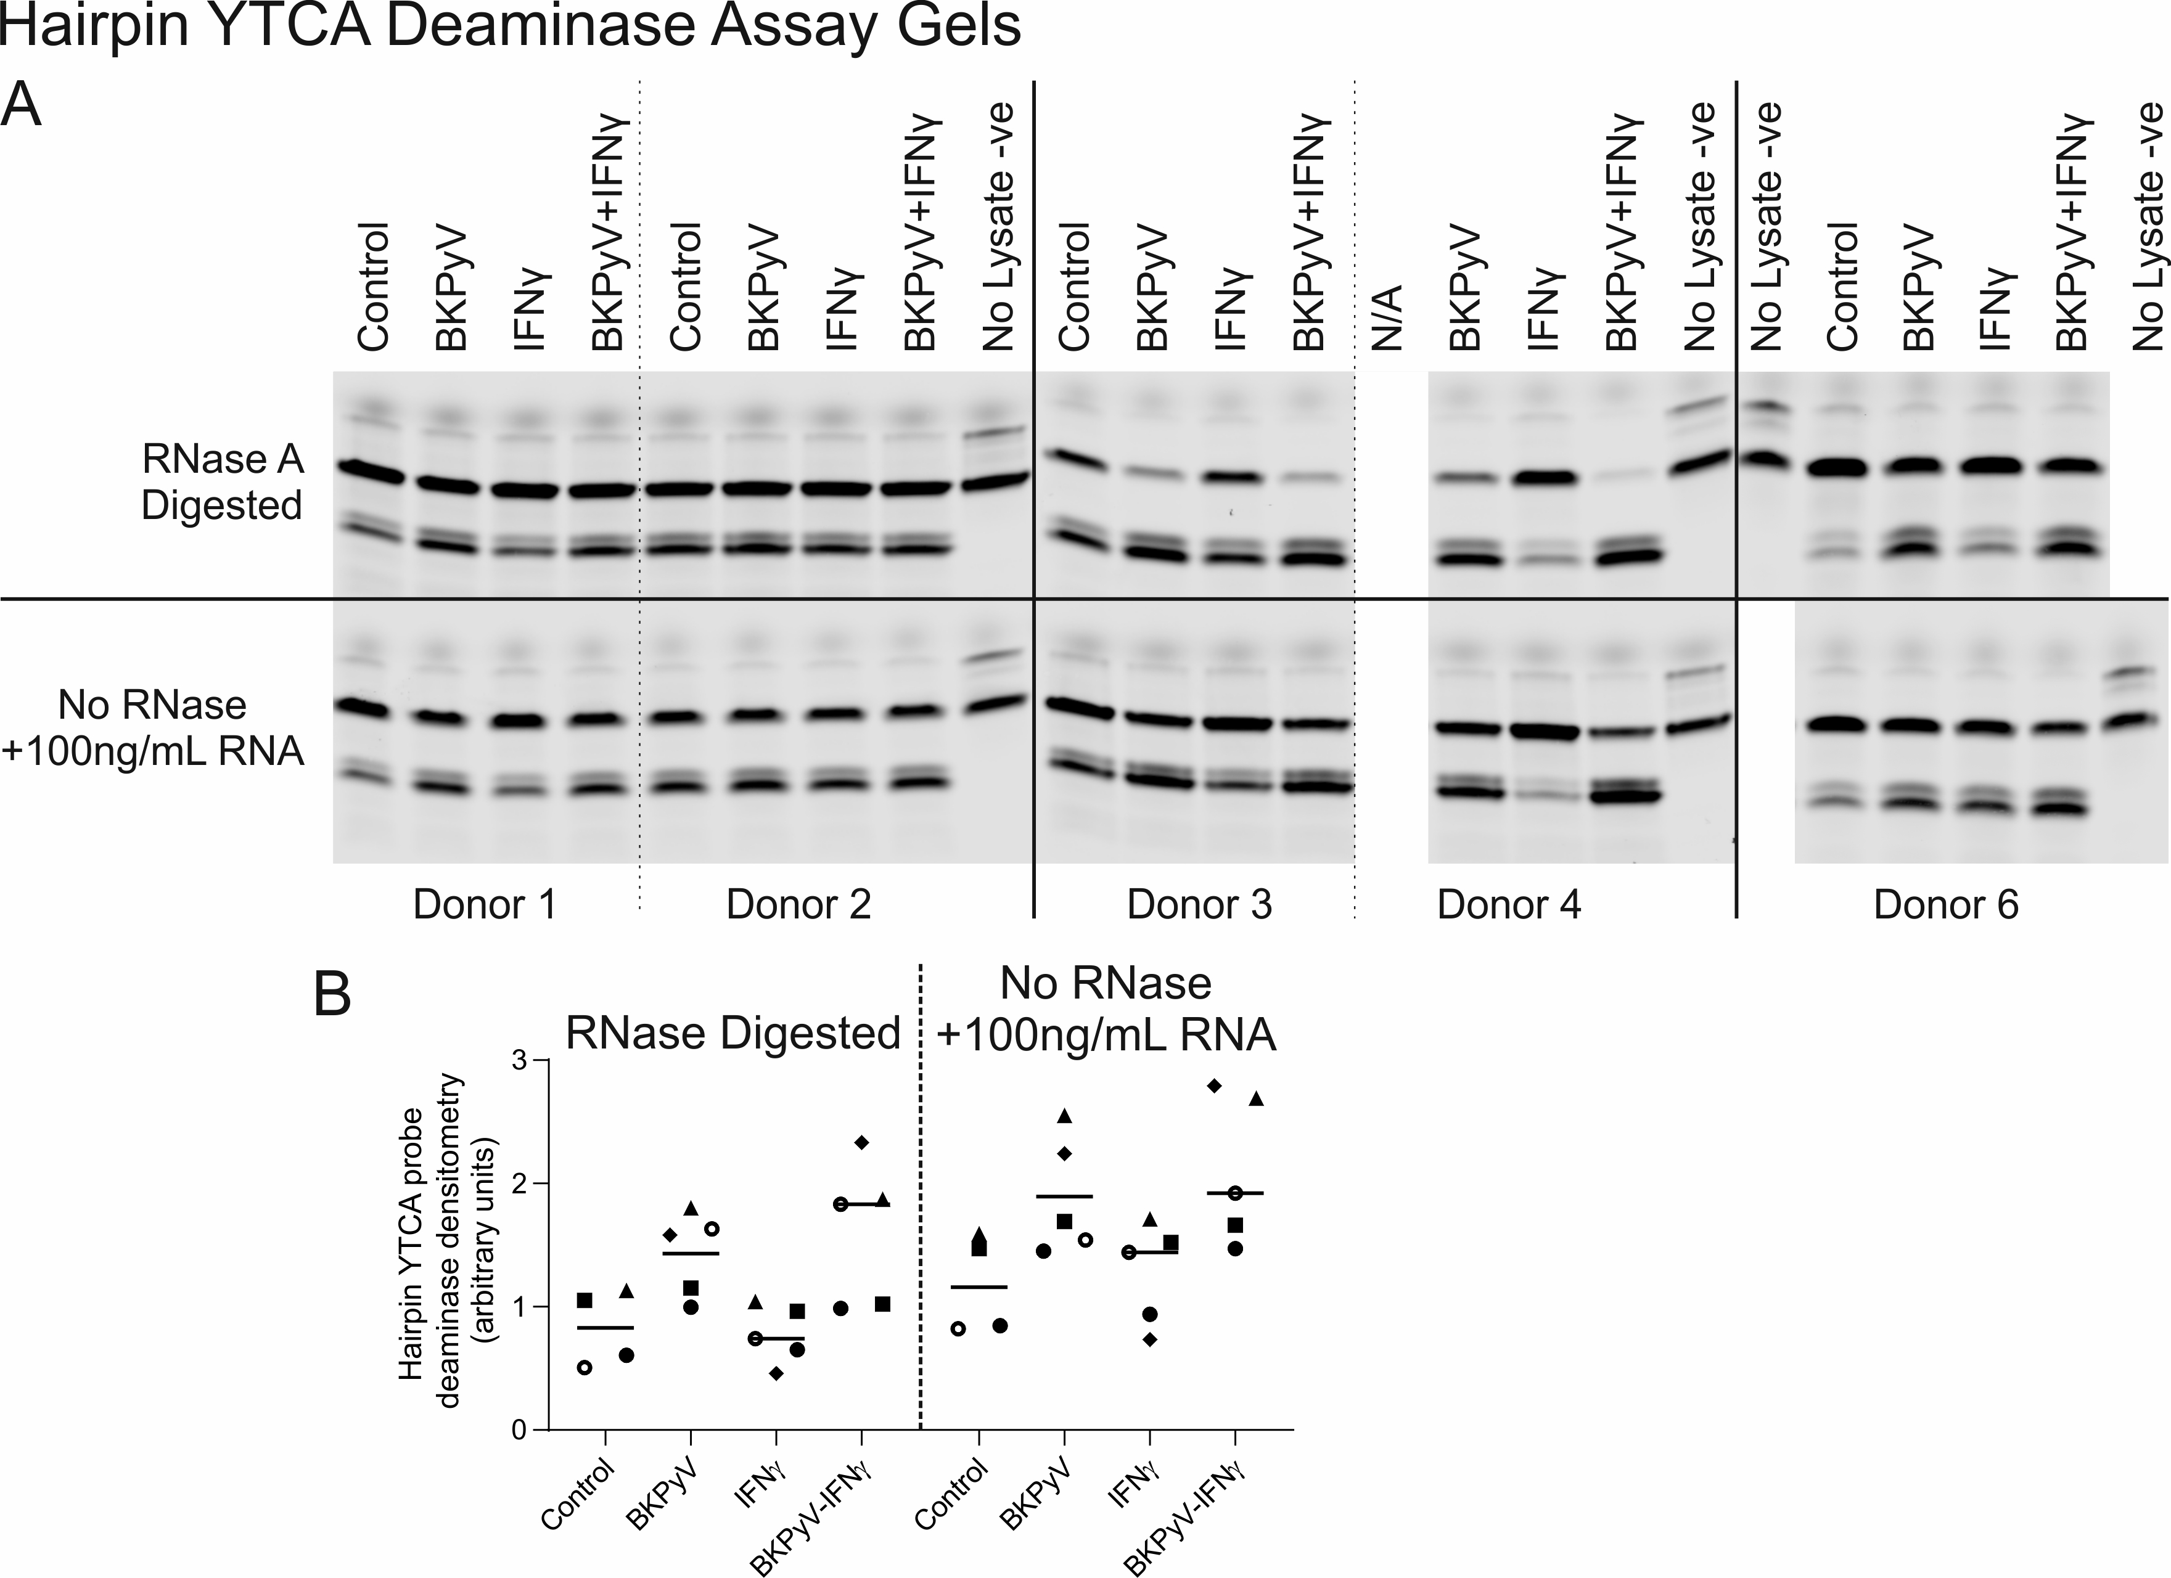
Supplementary Fig. 24 – (A) Full gel scans for deaminase assays performed with a hairpin YTCA probe previously reported to be preferential for APOBEC3A in the presence of exogenous RNA [4]. The presence of RNA was previously shown to inhibit APOBEC3B giving this assay APOBEC3A specificity [4]. (B) Densitometry for the deaminase assays performed with a hairpin YTCA probe, found the addition of exogenous RNA had no effect on deaminase activity in BKPyV-infected urothelial cell lysates.

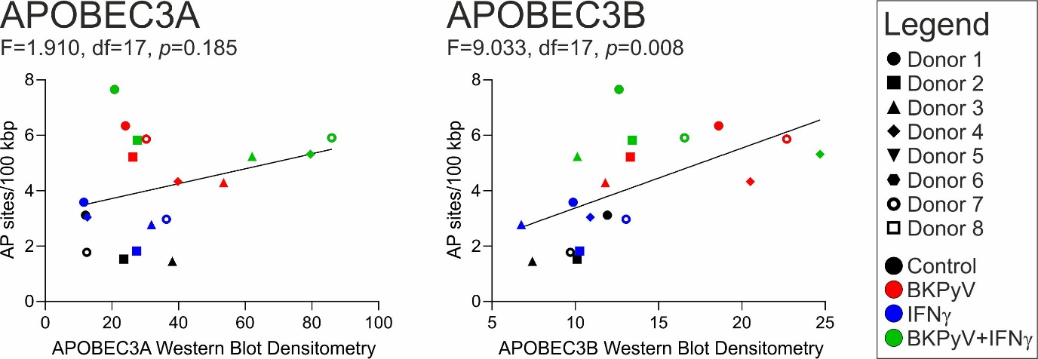
Supplementary Fig. 25 – Linear regression analysis of the relationship between the formation of apurinic/apyrimidinic (AP) sites in the host urothelial genome and APOBEC3A and APOBEC3B protein abundance (assessed by Western blot in Fig. 6c-d).
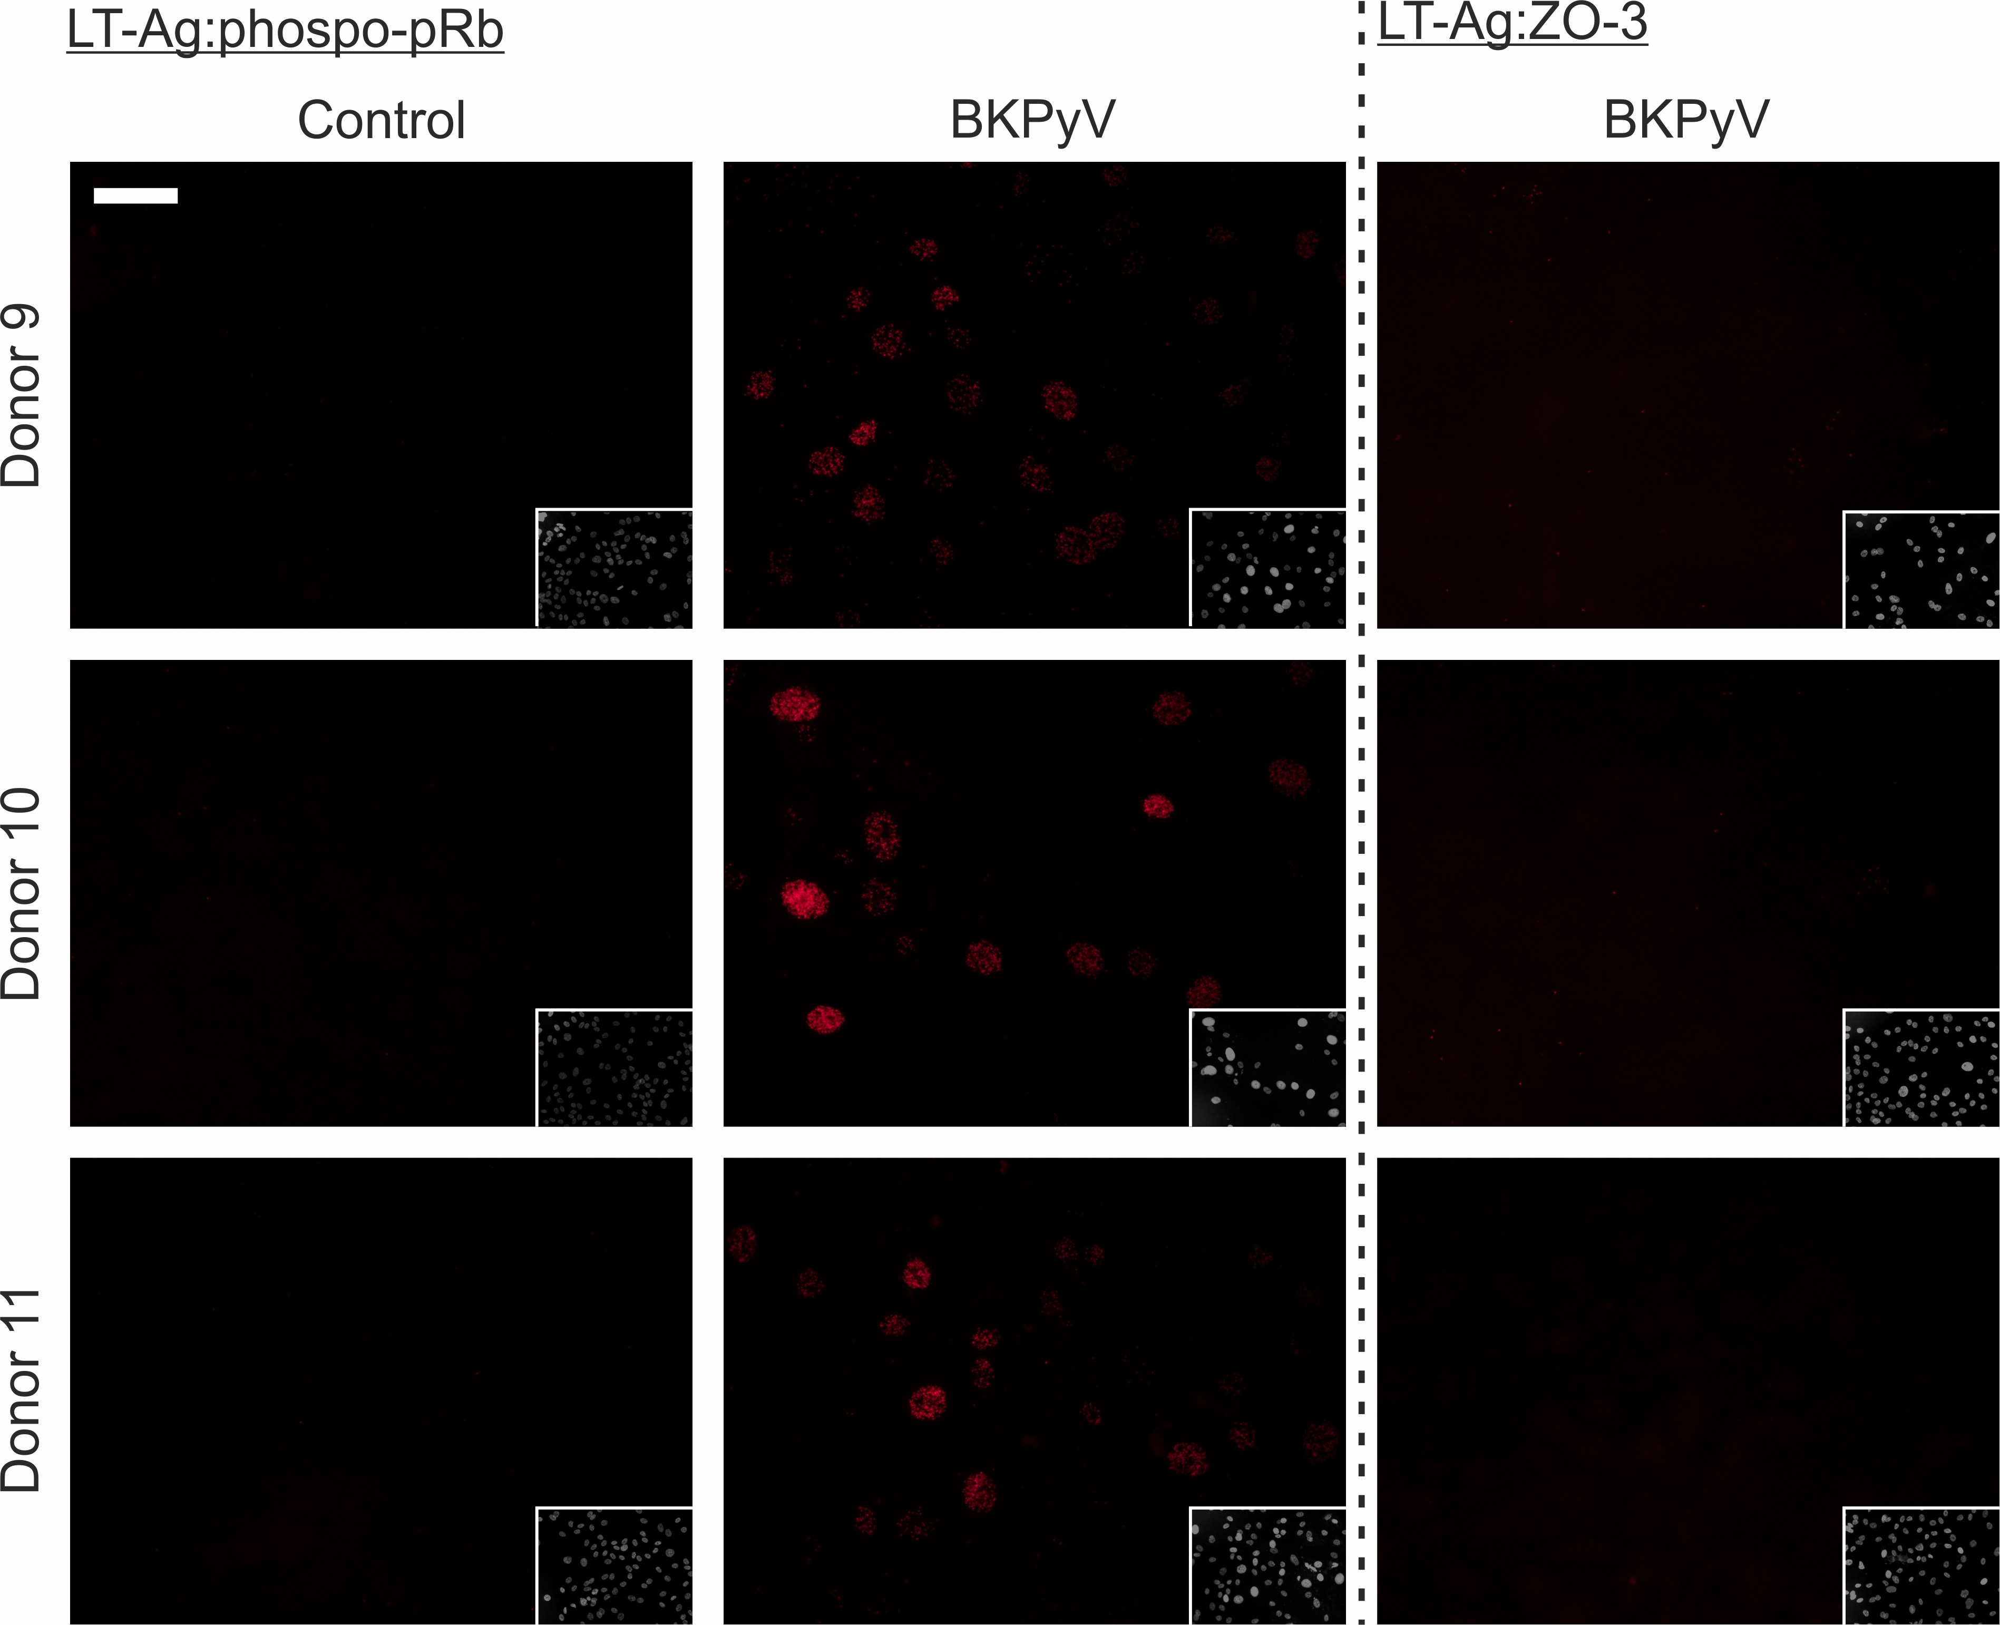
Supplementary Fig. 26 – Proximity ligation controls.
Direct binding of Large T antigen (LT-Ag) and Retinoblastoma protein (pRb) has previously been reported [16]. The LT-Ag:pRb interaction was therefore included as a positive control for the assay. LT-Ag interactions were always negative in uninfected controls.
ZO3 is a tight junction protein that localises to the plasma membrane and was therefore unlikely to interact with the predominantly nuclear LT-Ag. LT-Ag:ZO-3 was included as an irrelevant (negative) control antibody pair.
Images of DAPI stained nuclei are inset. White scale bar in the main panel of Donor 9 Control indicates 50 μm.
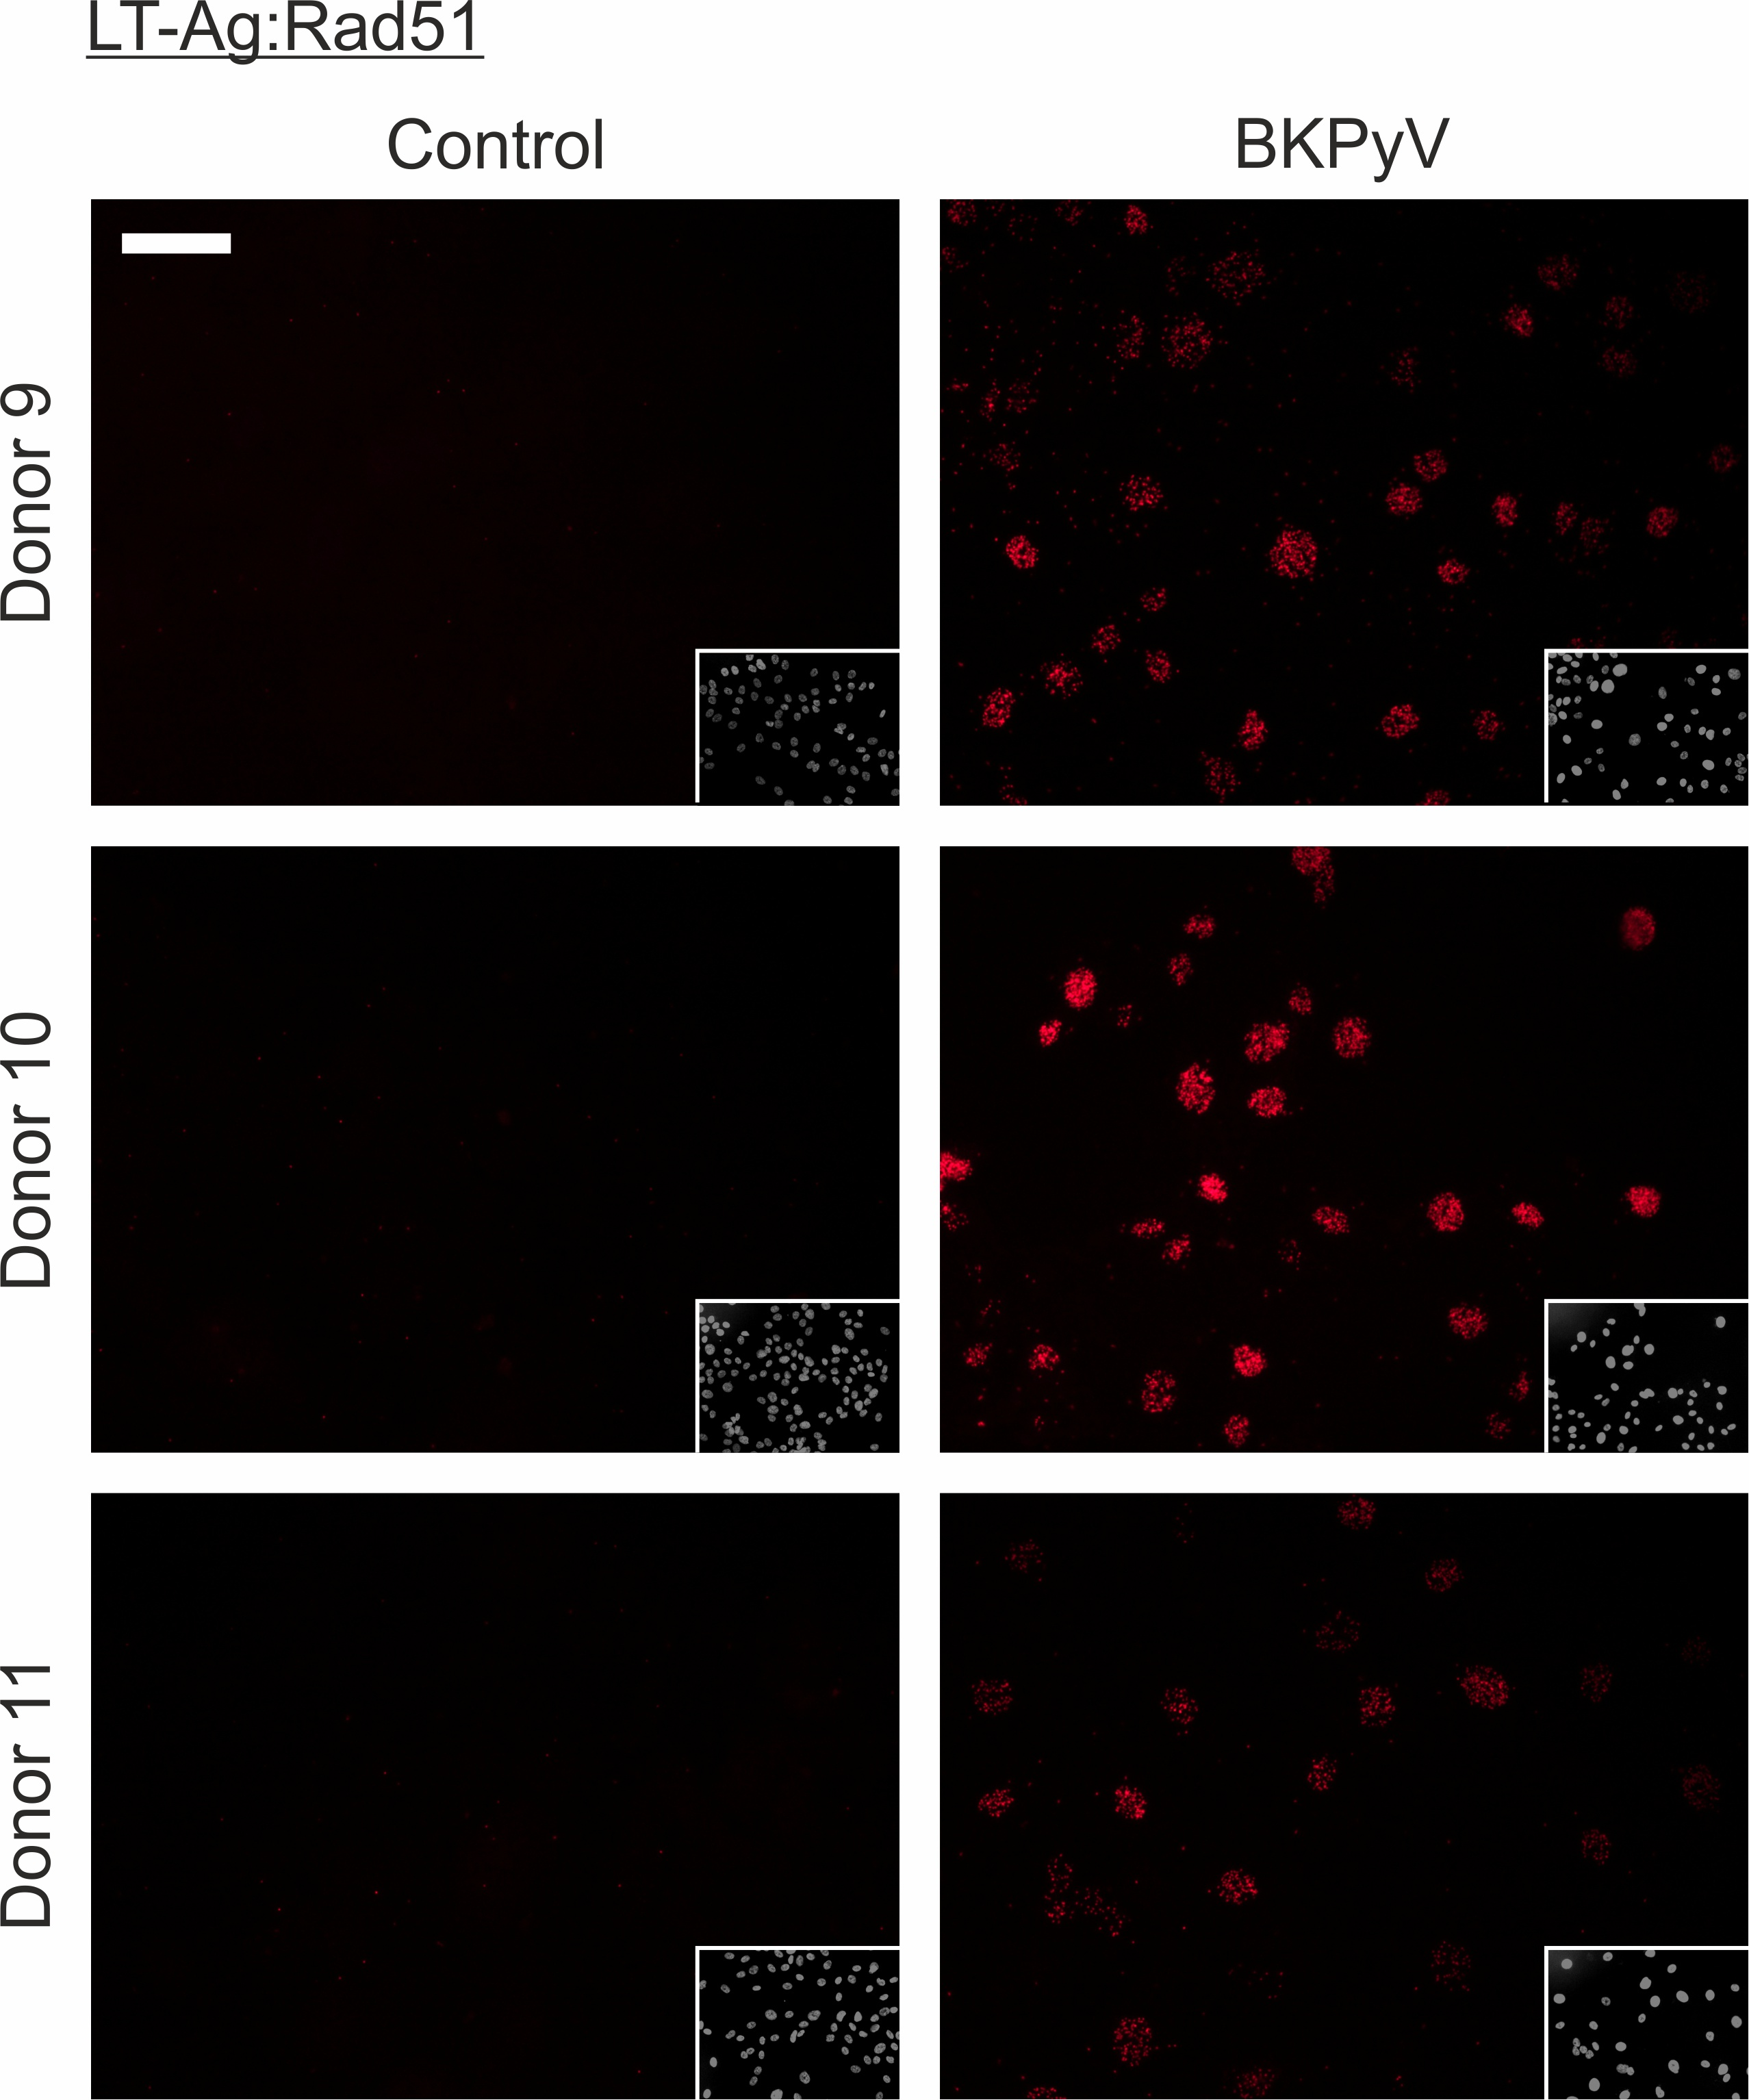
Supplementary Fig. 27 – Proximity ligation of Large T antigen (LT-Ag) and Rad51 was negative in non-infected control NHU cells but showed nuclear speckles in BKPyV-infected cells. Images of DAPI stained nuclei are inset. White scale bar in the main panel of Donor 9 Control indicates 50 μm.
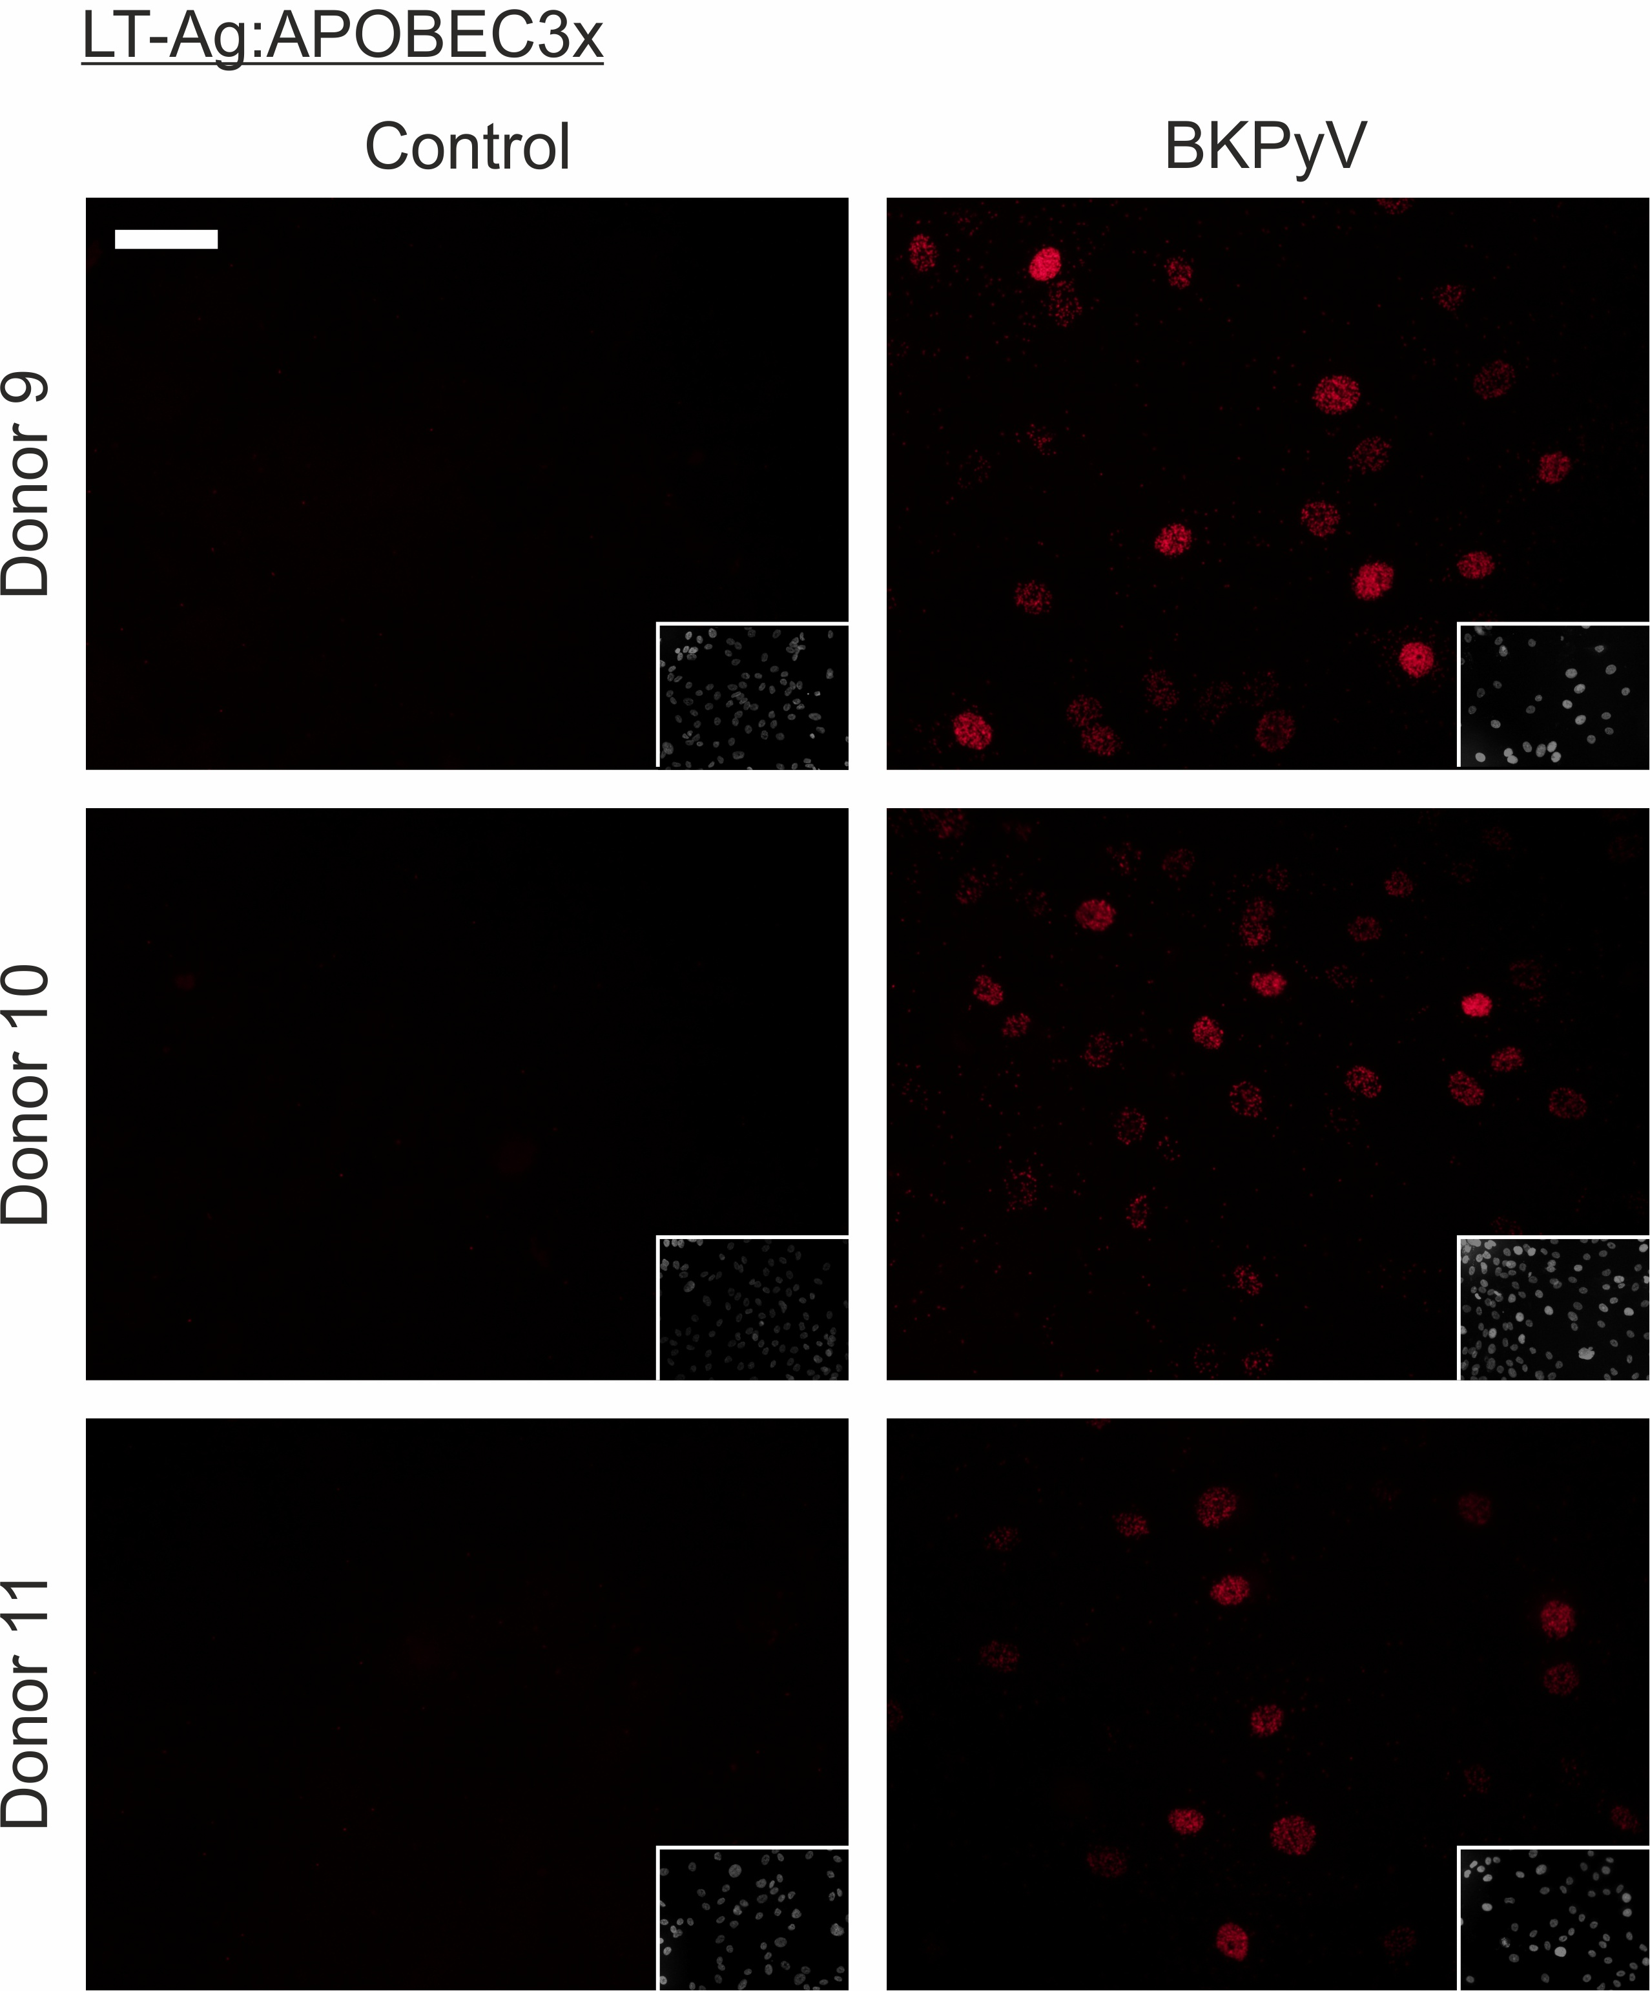
Supplementary Fig. 28 – Proximity ligation of Large T antigen (LT-Ag) and the APOBEC3A/B/G antibody [3] was negative in non-infected control normal human urothelial cells but showed nuclear speckles in BKPyV-infected cells. Images of DAPI stained nuclei are inset. White scale bar in the main panel of Donor 9 Control indicates 50 μm.

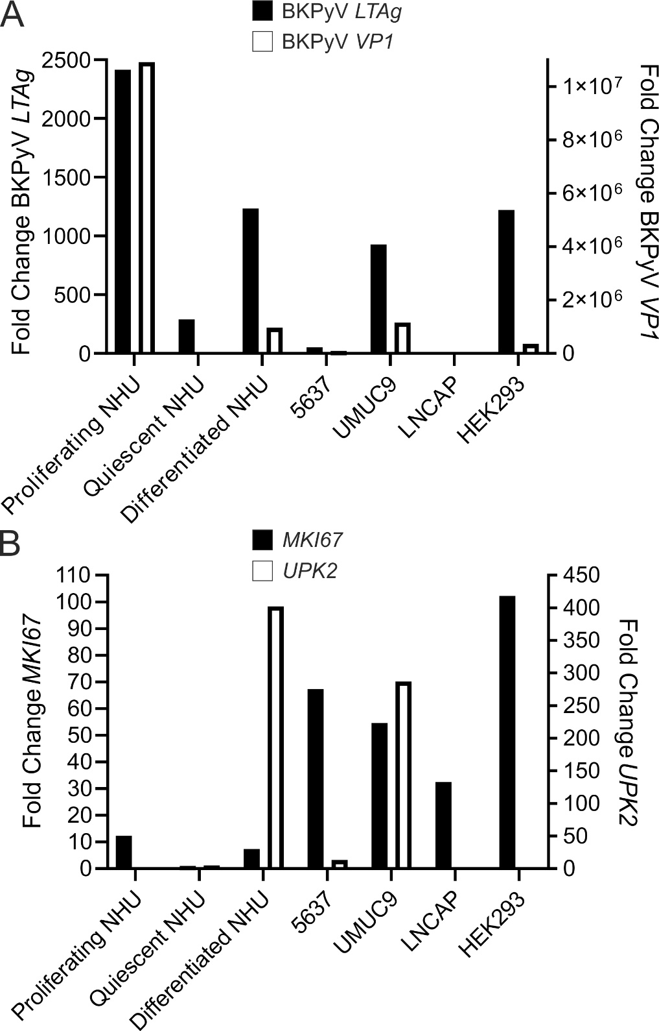
Supplementary Fig. 29 – Total mRNA was collected from cells at 3 dpi with a MOI = 1 and RT-qPCR was performed for the early (LT-Ag) and late (VP1) BKPyV transcripts (Panel A); and MKI67 and UPK2 host transcripts (Panel B). BKPyV preferentially infected differentiated urothelium (indicated by uroplakin 2/UPK2 expression; panel B) whether normal or neoplastic. BKPyV readily infected undifferentiated proliferating NHU cells where the viral life cycle proceeded to late promoter driven VP1 transcript expression at 3dpi. Differentiated NHU cells are mitotically quiescent and were therefore compared with undifferentiated “quiescent NHU” cells, where quiescence was achieved by contact inhibition. 5637 and UMUC9 were respectively chosen as poorly-differentiated and well-differentiated models of urothelial carcinoma (based on UPK2 expression). LNCAP and HEK293 cells were included as negative and positive control models for BKPyV infection, respectively.
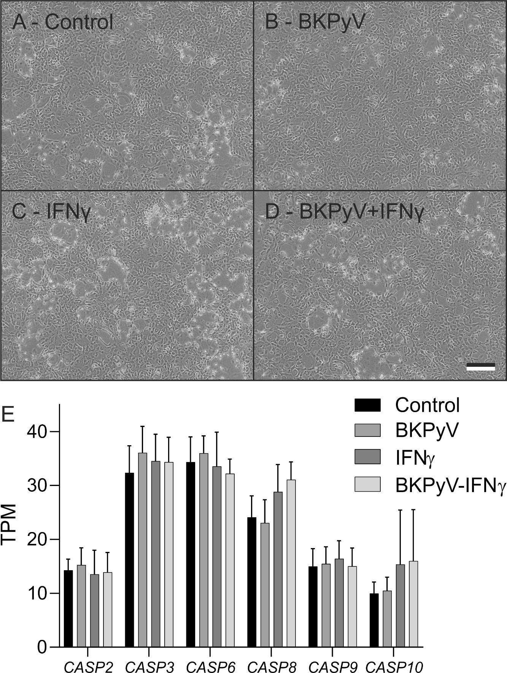
Supplementary Fig. 30 – (A-D) Example phase contrast images of one donor line of the studied differentiated normal human urothelial (NHU) cells at 14dpi showing no signs of apoptosis or cell loss in the cultures. The cultures are 100% confluent but stratification of the urothelium into multi-layered tissues takes them out of the plane of focus in some areas, giving the appearance of bare plastic. Scale bar in panel D denotes 200μm. (E) Transcriptomic analysis of the pro-apoptotic caspases found the maximum mean increase in expression was 12% (CASP3; n=6/7).

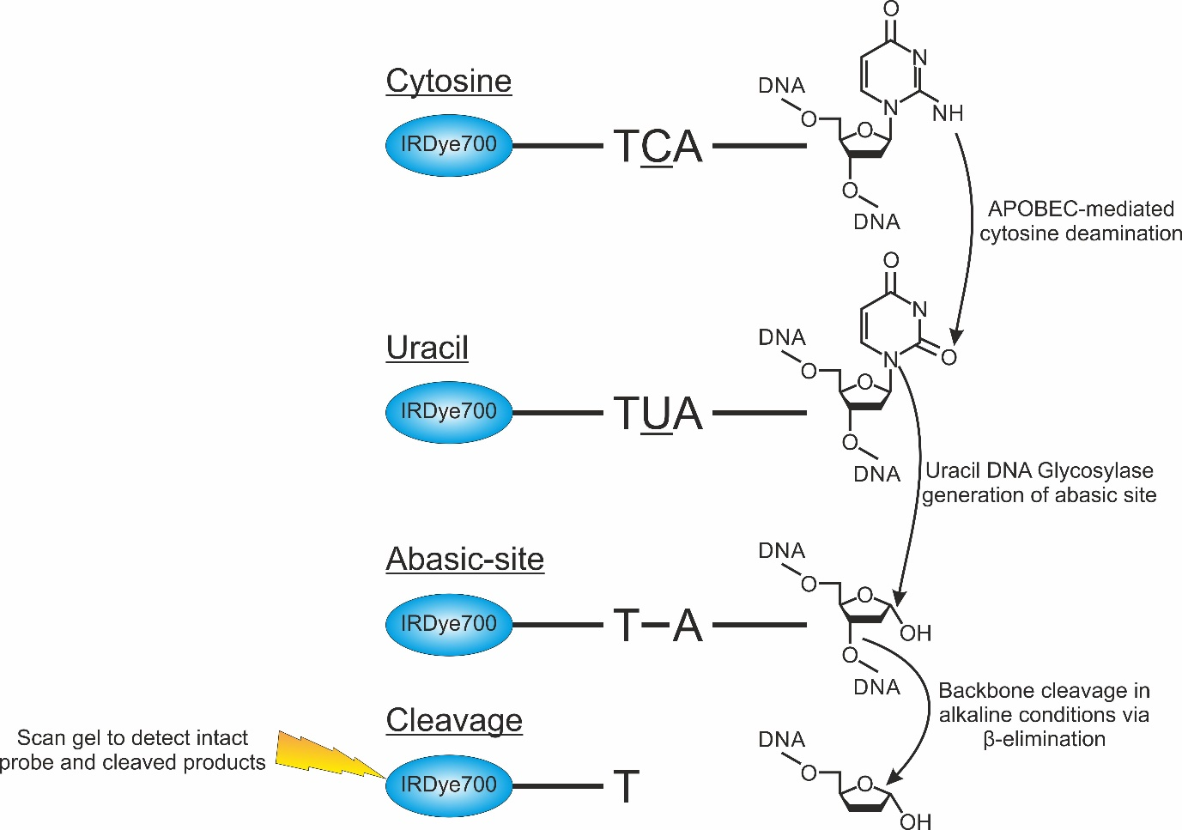
Supplementary Fig. 31 – Schematic describing the deaminase assay method principle. Fluorescently labelled ssDNA probes containing either a RTCA or YTCA motif were exposed to the APOBEC enzymes present in NHU cell lysates. APOBECs deaminate the cytosine bases in a TCA context to uracil. Exposure to uracil DNA glycosylase (UDG) cleaves off the uracil leaving an abasic site. The reaction buffer is then turned alkaline by the addition of NaOH which leads to cleavage of the DNA backbone by β–elimination. The intact probe and the cleaved DNA attached to the probe can then be run on a gel and detected.

Supplementary References
[1] An P, Saenz Robles MT, Duray AM, Cantalupo PG, Pipas JM. Human polyomavirus BKV infection of endothelial cells results in interferon pathway induction and persistence. PLoS Pathog. 2019;15:e1007505.
[2] Johannessen M, Myhre MR, Dragset M, Tummler C, Moens U. Phosphorylation of human polyomavirus BK agnoprotein at Ser-11 is mediated by PKC and has an important regulative function. Virology. 2008;379:97-109.
[3] Brown WL, Law EK, Argyris PP, et al. A Rabbit Monoclonal Antibody against the Antiviral and Cancer Genomic DNA Mutating Enzyme APOBEC3B. Antibodies (Basel). 2019;8.
[4] Cortez LM, Brown AL, Dennis MA, et al. APOBEC3A is a prominent cytidine deaminase in breast cancer. PLoS Genet. 2019;15:e1008545.
[5] Abend JR, Joseph AE, Das D, Campbell-Cecen DB, Imperiale MJ. A truncated T antigen expressed from an alternatively spliced BK virus early mRNA. J Gen Virol. 2009;90:1238-45.
[6] Bhati R, Gokmen-Polar Y, Sledge GW, Jr., et al. 2-methoxyestradiol inhibits the anaphase-promoting complex and protein translation in human breast cancer cells. Cancer Res. 2007;67:702-8.
[7] Lara MF, Garcia-Escudero R, Ruiz S, et al. Gene profiling approaches help to define the specific functions of retinoblastoma family in epidermis. Mol Carcinog. 2008;47:209-21.
[8] Markey MP, Bergseid J, Bosco EE, et al. Loss of the retinoblastoma tumor suppressor: differential action on transcriptional programs related to cell cycle control and immune function. Oncogene. 2007;26:6307-18.
[9] Bracken AP, Dietrich N, Pasini D, Hansen KH, Helin K. Genome-wide mapping of Polycomb target genes unravels their roles in cell fate transitions. Genes Dev. 2006;20:1123-36.
[10] Ma Y, Croxton R, Moorer RL, Jr., Cress WD. Identification of novel E2F1-regulated genes by microarray. Arch Biochem Biophys. 2002;399:212-24.
[11] Schaefer CF, Anthony K, Krupa S, et al. PID: the Pathway Interaction Database. Nucleic Acids Res. 2009;37:D674-9.
[12] Fulciniti M, Lin CY, Samur MK, et al. Non-overlapping Control of Transcriptome by Promoter- and Super-Enhancer-Associated Dependencies in Multiple Myeloma. Cell Rep. 2018;25:3693-705 e6.
[13] Chen X, Muller GA, Quaas M, et al. The forkhead transcription factor FOXM1 controls cell cycle-dependent gene expression through an atypical chromatin binding mechanism. Mol Cell Biol. 2013;33:227-36.
[14] Thielen BK, McNevin JP, McElrath MJ, Hunt BV, Klein KC, Lingappa JR. Innate immune signaling induces high levels of TC-specific deaminase activity in primary monocyte-derived cells through expression of APOBEC3A isoforms. J Biol Chem. 2010;285:27753-66.
[15] Starrett GJ, Serebrenik AA, Roelofs PA, et al. Polyomavirus T Antigen Induces APOBEC3B Expression Using an LXCXE-Dependent and TP53-Independent Mechanism. mBio. 2019;10.
[16] Kim HY, Ahn BY, Cho Y. Structural basis for the inactivation of retinoblastoma tumor suppressor by SV40 large T antigen. EMBO J. 2001;20:295-304.

