Supplementary Figure 1. (A) Hesperadin induced polyploidy in Miapaca-2 and BxPC-3 cells after 48 h of treatment, as assessed via confocal microscopy. (B) Immunofluorescence staining of γ-H2AX in Miapaca-2 and BxPC-3 cells after treatment with Hesperadin (0, 25, 50, or 100 nM) for 48 h. DAPI was used for nucleus staining.
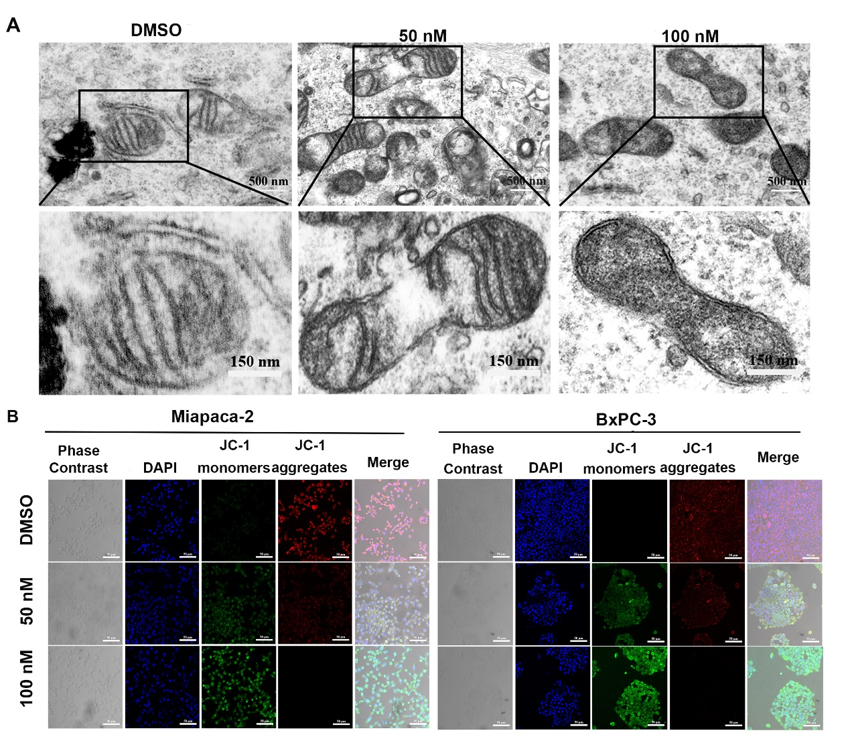
Supplementary Figure 2. (A) TEM of BxPC-3 after Hesperadin treatment (50, 100 nM). (B) MMP of Miapaca-2 and BxPC-3 cells was detected by JC-1 staining after 48 h of Hesperadin treatment.
Supplementary Figure 3. (A) Effect of Hesperadin treatment (50, 100 nM) on ER structure in BxPC-3. (B) Miapaca-2 and BxPC-3 cells were treated with Hesperadin. The protein levels of IRE1α and ATF6 were analyzed by western blot assay. (C) Expression of the ATF4 protein in PC cells treated with ATF4 siRNA was assessed by western blot analysis.

Supplementary Figure 4. (A) The promoter regions of GADD45A contained six binding sites of ATF4. (B) Expression of the GADD45A protein in PC cells treated with GADD45A siRNA was assessed by western blot analysis.

Supplementary Figure 5. (A) Flowchart of tissue acquisition by endoscopic ultrasound-guided fine needle biopsy. (B) Phase-contrast microscopy of pancreatic normal epithelial organoids from three patients treated with Hesperadin.

