Supplementary data

Supplementary figure

Supplementary figure 1

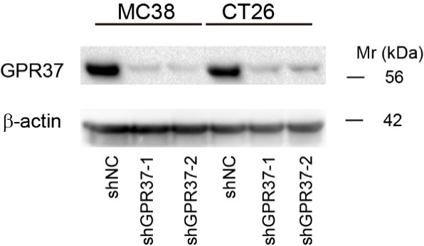

Supplementary figure 1 The western blots of control and GPR37 knockdown MC38 and CT26 cells.

Supplementary figure 2
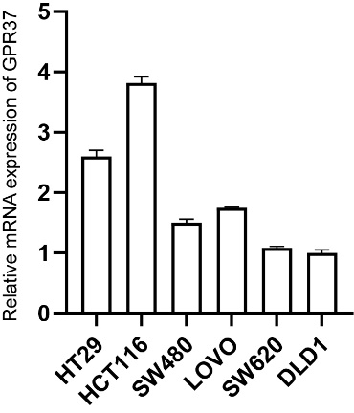
Supplementary figure 2. The mRNA expression level of CRC cell lines

Supplementary figure 3
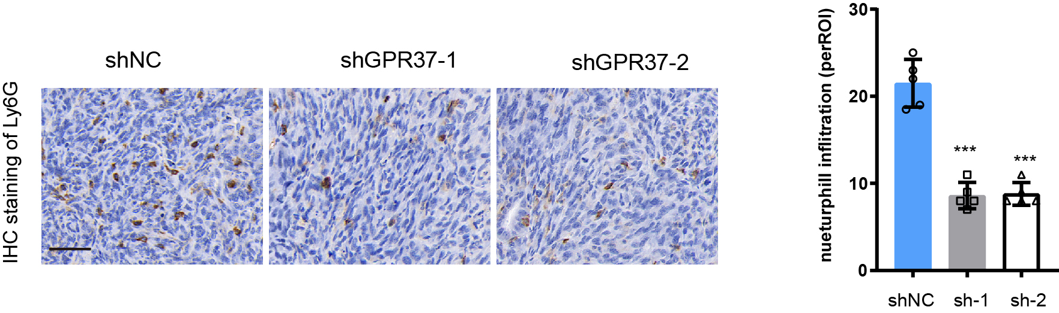
Supplementary figure 3. The IHC staining of Ly6G in the liver metastasis derived from MC38 cells.
Supplementary figure 4

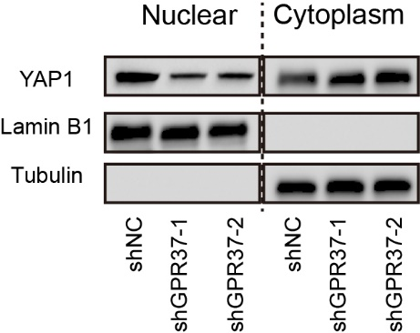
Supplementary figure 4. The localization of YAP1 by nuclear and cytoplasm isolation

Supplementary figure 5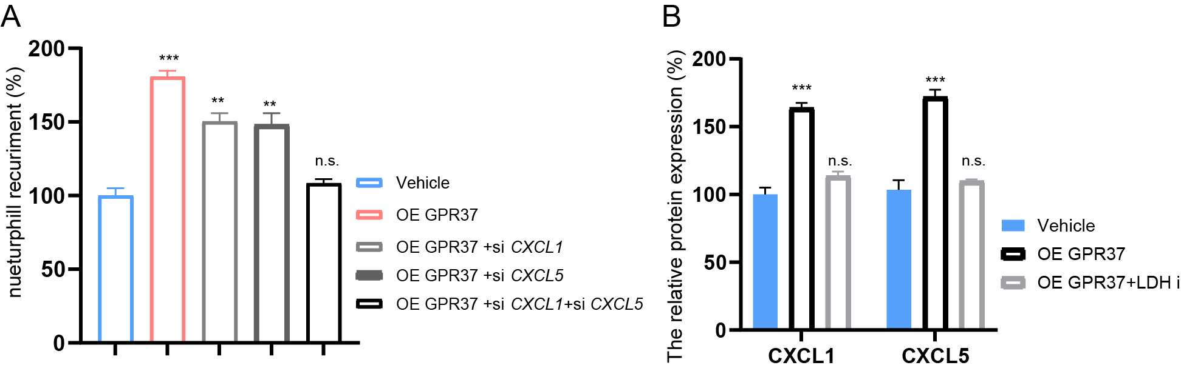

Supplementary figure 5. A. neutrophil recruitment assay of control or GPR37 overexpression cells, with CXCL1 and CXCL5 knockdown respectively or both. B. CXCL1 and CXCL5 protein expression level in the control and GPR37 overexpression cells treat with LDH inhibitor galloflavin.

Supplementary figure 6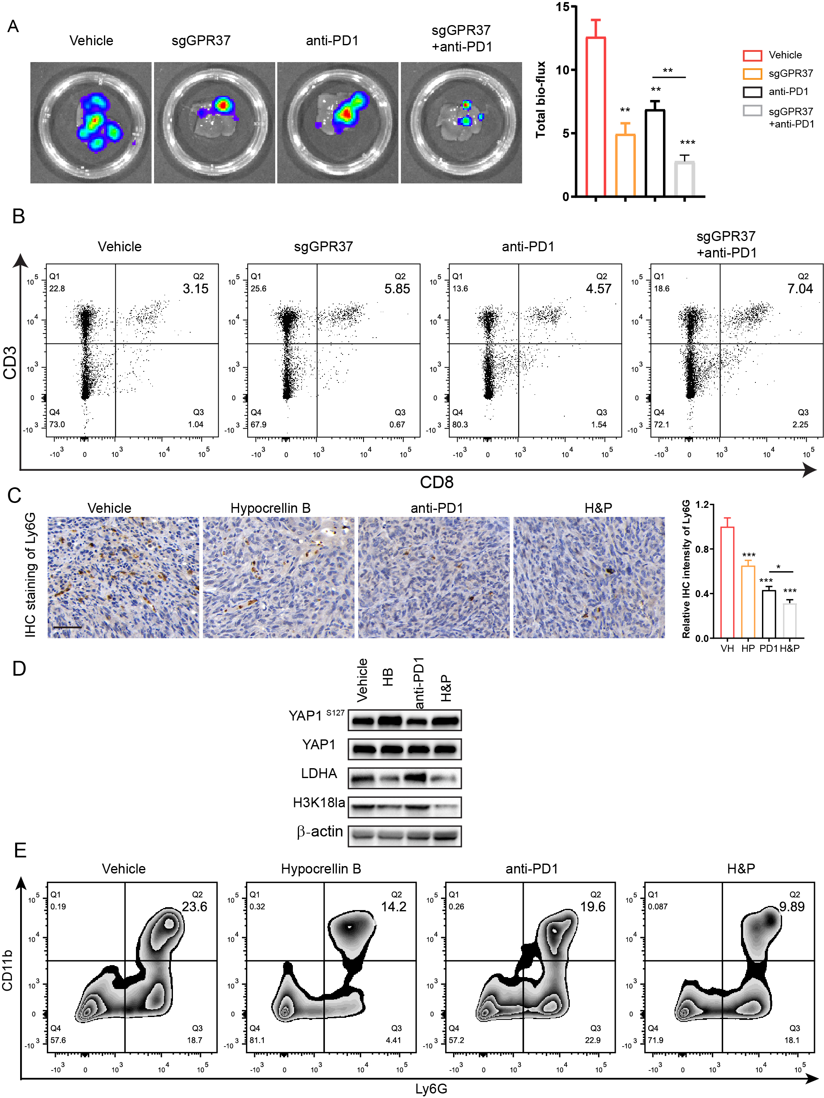Supplementary figure 6.
A. The represented IVIS bioluminescence imaging of liver resected from Vehicel (VH), sgGPR37, anti-PD1 or sgGPR37 plus anti-PD1(H&P) group mice. B. Flow cytometry analysis of CD8+ T cells in the metastasis liver derived from different group mice. C. The IHC staining of Ly6G and statistical results of liver metastasis from Vehicel (VH), Hypocrellin B(HB), anti-PD1(PD1) or Hypocrellin B plus anti-PD1(H&P) group mice. D. The western bolts of YAP1 ^{S127} , LDHA, H3K18la in the liver metastasis from Vehicel (VH), Hypocrellin B(HB), anti-PD1(PD1) or Hypocrellin B plus anti-PD1(H&P) group mice. E. Flow cytometry analysis of neutrophil in the liver metastasis tumor microenvironment.
Supplementary Table 1. The clinicopathological characteristics of patients
Characteristic | GPR37 High  (n = 63) | GPR37 low  (n = 63) | P
Age, years | 56.14 ± 2.56 | 54.16 ± 1.38 | 0.345
Gender, % |  |  | 0.762
Male | 39 (61.90%) | 45 (71.14%)
Female | 24 (38.10%) | 18 (28.56%)
Liver metastasis, % |  |  | 1.000
Synchronous | 9 (69.23%) | 52 (70.27%)
Metachronous | 4 (30.77%) | 22 (29.73%)
Extrahepatic disease, % |  |  | 0.434
Yes | 38 (61.54%) | 42 (66.67%)
No | 25 (38.46%) | 21 (33.33%)
Preoperative CEA level, ng/ml | 12.30 (6.56-22.28) | 8.88 (4.10-35.25) | 0.536
Liver metastasis distribution, % |  |  | 0.523
Unilobar | 22 (35.38%) | 18 (28.38%)
Bilobar | 41 (65.62%) | 45 (71.62%)
Number of liver metastasis ≥3 |  |  | 0.006
Yes | 36 (57.14%) | 13 (64.86%)
No | 27 (42.86%) | 48 (35.14%)
Number of liver metastasis | 6.50 (3.00-25.00) | 4.00 (2.00-7.00) | 0.233
Size of largest liver metastasis, cm | 3.50 (2.63-5.38) | 3.50 (2.00-5.75) | 0.756
Primary tumor site, % |  |  | 0.325
Left-sided | 42 (66.67%) | 47 (74.60%)
Right-sided | 21 (33.33%) | 16 (25.39%)
Primary T stage, % |  |  | 0.001
T2/3 | 20 (31.74%) | 53 (76.81%)
T4 | 43 (68.26%) | 16 (23.19%)
Primary N stage, % |  |  | 0.011
N0 | 26 (41.26%) | 22 (34.92%)
N1/2 | 37(58.73%) | 41 (65.08%)

