Supplementary Materials

A targeted inhibition of SCF^{SKP2} has anti-tumor activities that result in a survival benefit in osteosarcoma

Jichuan Wang^{1,2#}, Alexander Ferrena^{1,3#}, Ranxin Zhang^{1#}, Swapnil Singh¹, Valentina Viscarret¹, Waleed Al-Harden¹, Osama Aldahamsheh¹, Hasibagan Borjihan¹, Amit Singla¹, Simon Yaguare¹, Janet Tingling¹, Xiaolin Zi⁴, Yungtai Lo⁵, Richard Gorlick⁶, Edward L. Schwartz⁷, Hongling Zhao⁸, Rui Yang¹, David S. Geller¹, Deyou Zheng^{9*} and Bang H. Hoang^{1*}

¹Department of Orthopedic Surgery, Montefiore Medical Center, Albert Einstein College of Medicine, Bronx, NY.
²Musculoskleletal Tumor Center, Beijing Key Laboratory for Musculoskeletal Tumors, Peking University People's Hospital, Beijing, China
³Institute for Clinical and Translational Research, Departments of Genetics, Albert Einstein College of Medicine, Bronx, NY.

⁴Department of Urology, University of California, Irvine Medical Center, Orange, CA.
⁵Department of Epidemiology & Population Health, Albert Einstein College of Medicine, Bronx, NY.
⁶Division of Pediatrics, University of Texas MD Anderson Cancer Center, Houston, TX.
⁷ Departments of Oncology, Molecular Pharmacology, and Medicine, Albert Einstein College of Medicine, Bronx, NY.
⁸ Department of Developmental and Molecular Biology, Albert Einstein College of Medicine, Bronx, NY.
⁹ Departments of Genetics, Neurology and Neuroscience. Albert Einstein College of Medicine, Bronx, NY.

# Authors contributed equally.
*Corresponding author. Bang H. Hoang, Department of Orthopedic Surgery, Montefiore Medical Center, Albert Einstein College of Medicine, Bronx, NY.
E-mail address: bahoang@montefiore.org.
Deyou Zheng, Departments of Genetics, Neurology and Neuroscience. Albert Einstein College of Medicine, Bronx, NY.
E-mail address: deyou.zheng@einsteinmed.edu

Supplementary Tables
Table S1 Genotyping primers used for identification of Skp2 knockout transgenic mice
Table S2 qPCR primers used in this study
Table S3 Table showing results of survival analysis of the Reactome Apoptosis gene signature in the NCI TARGET OS cohort

Supplementary Figures
Figure S1
Genotyping results using agarose gel electrophoresis. (A) Genotyping results of Trp53 wild type(p53^{(+/+)} )(288bp), p53-lox heterozygotes (p53^{(lox/+)} ) (288bp and 370bp) and p53-lox homozygotes (p53^{(lox/lox)} ) (370bp). (B) Genotyping results of Osterix1-Cre (Osx-Cre(+)) (198bp) and coresponding internal positive control（Osx-Cre(+) Ctrl) (253bp). (C) Genotyping results of Rb1 wild type (Rb1 ^{(+/+)} )(250bp), Rb1-lox heterozygotes (Rb1 ^{(lox/+)} ) (250bp and 310bp) and Rb1-lox homozygotes (Rb1 ^{(lox/lox)} ) (310bp). (D) Genotyping results of recombined Trp53 and Rb1 after deletion mediated by Osterix-Cre. (～500 bp). (E) Genotyping results of wild type p27 (250bp), p27 T187A heterozygotes (p27^{(T187A/+)}) (250bp and 284bp) and T187A homozygotes (p27^{(T187A/T187A)} ) (284bp). (F) Genotyping results of wild type Skp2 (Skp2^{(wt/wt)}) (500bp only) and Skp2 knockout homozygotes (Skp2^{(-/-)} ) (430bp only).

Figure S2
Sashimi plots showing splicing RNA-seq reads mapped to the Trp53 (A), RB1 (B) and Skp2 loci(C). The numbers above the arch lines indicate the numbers of reads for individual splicing patterns. (C) Summary of RNA-seq reads mapped to the T187A mutation sites in the DKO (top) and DKOAA (bottom), confirming mutation in DKOAA samples.

Figure S3
Kaplan-Meier survival analysis comparing the DKO, DKOAA and TKO cohorts of mice undergoing tumorigenesis exclude maxillofacial tumor. P-value is by a log-rank test and indicated in the figure.

Figure S4
Graph showing the tumor anatomical distribution of each genotype.

Figure S5
Mouse body weight during daily treatment of 40 days with either C1 or Pevonedistat as indicated. Statistical significance is indicated by *P < .05,**P < .01, ***P < .001. Column: mean; Error bars are SEM.

Table S1 Genotyping primers used for identification of Skp2 knockout transgenic mice

Wildtype allele | KN3 | 5′- AGAGTGGAAGAACCCAGGCAGGAC-3’
 | KN4 | 5′- CCCGTGGAGGGAAAAAGAGGGACG-3’
Knockout allele | KN13 | 5′- GCATCGCCTTCTATCGCCTTCTTG-3’
 | KN38 | 5′- TTCCCACCCCCACATCCAGTCATT-3’

Table S2 qPCR primers used in this study

CDKN1B | sense | 5′-GCGGTGCCTTTAATTGGGTCT
 | antisense | 5′-GGCTTCTTGGGCGTCTGC T
p73 | sense | 5′-AACGCCGAGCATCAATCC
 | antisense | 5′-AGCCCAGACTCTGAGCACTT
Skp2 | sense | 5′-AGCAGCCGCTGGGTGAAAGC
 | antisense | 5′-ATCACTGAGTTCGACAGGTCCAT
E2f1 | sense | 5′-TCACTAAATCTGACCACCAAACG
 | antisense | 5′-TTGGACTTCTTGGCAATGAGC
Bbc3(Puma) | sense | 5′-GGTCCAGACTGTGAATCCTGTG
 | antisense | 5′-TCCTCCCTCTTCTGAGACTTCC
Bid | sense | 5′-ACGGAATGCAAAGAACAACTC
 | antisense | 5′-CAACGCTTGAGGATACAGTGAG
Bcl2l11(Bim) | sense | 5′-ATCTTGTTGGGCTTACTTGTG
 | antisense | 5′-GTCCTGCCTGGTCTTGAAAT
Casp3 | sense | 5′-CGCGCACAAGCTAGAATTTATG
 | antisense | 5′-GGACACAATACACGGGATCTG
Prominin1 | sense | 5′- TCTGCTGACATTTGCCTCTAC
 | antisense | 5′- GCTGGTGGATGGCTCTTATATT
ALDH1A1 | sense | 5′- GAGAGTGGGAAGAAAGAAGGAG
 | antisense | 5′- CTCATCAGTCACGTTGGAGAA
ALDH2 | sense | 5′- CATCTTGGTACCTGGGATCTTG
 | antisense | 5′- TGTAGCTGCAGCCAAGAATAG
ALDH7A1 | sense | 5′- CTCAGTACCACCACAACAAAGA
 | antisense | 5′- CAAGAACGAAGGTCTGTCTACC
CD117(Kit) | sense | 5′- AGGAGAACTGAGGCTGTTTG
 | antisense | 5′- TAACTTGTGCTCCCTGCTATG
GAPDH | sense | 5′- GGTTGTCTCCTGCGACTTCA
 | antisense | 5′-GGTGGTCCAGGGTTTCTTAC

Table S3.
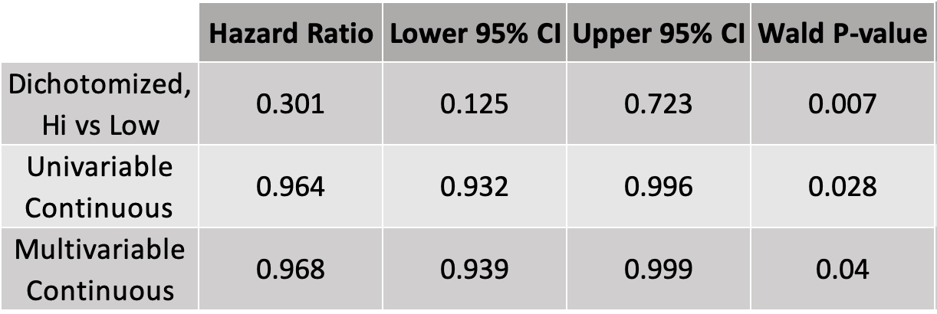

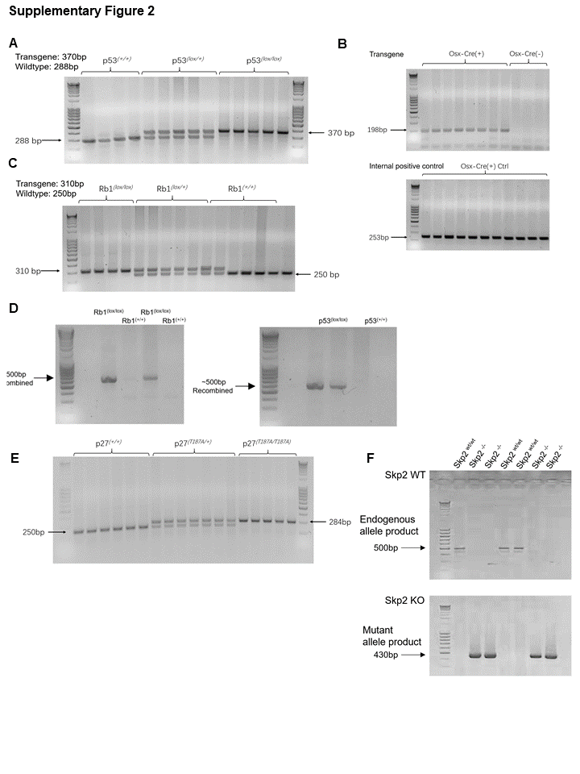
Figure S1

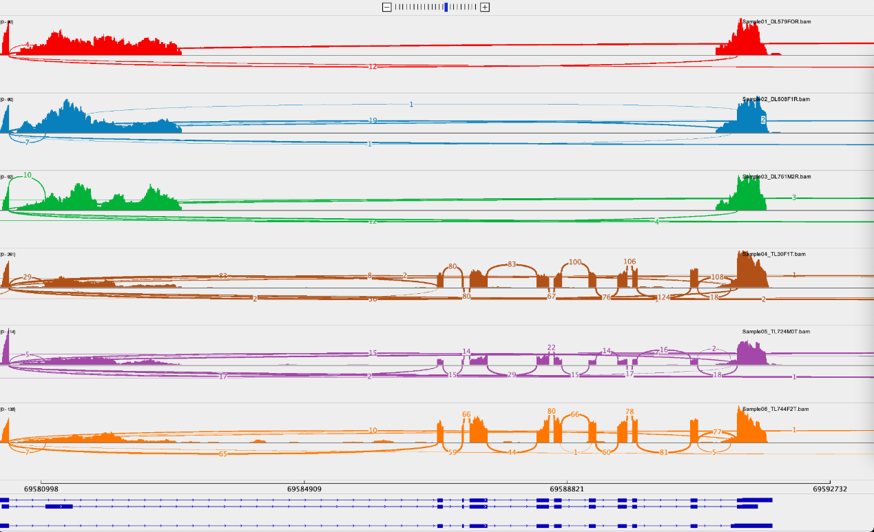
Figure S2
A) Splicing reads at exons 2-10 excision of Trp53, DKO (up) and TKO (down)
B) Splicing reads at exons 3 excision of RB1, DKO (up) and TKO (down).

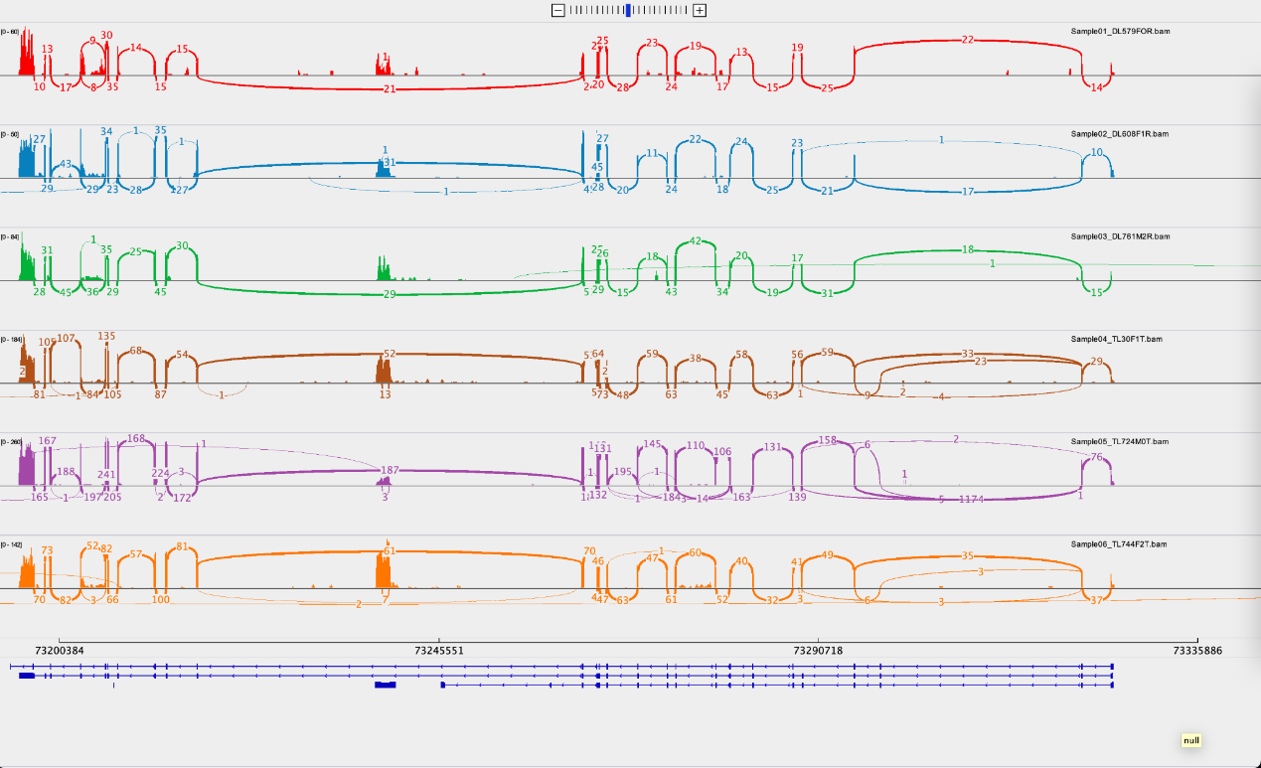

C) Splicing reads showing deletion of Skp2, DKO (up), and TKO (down).
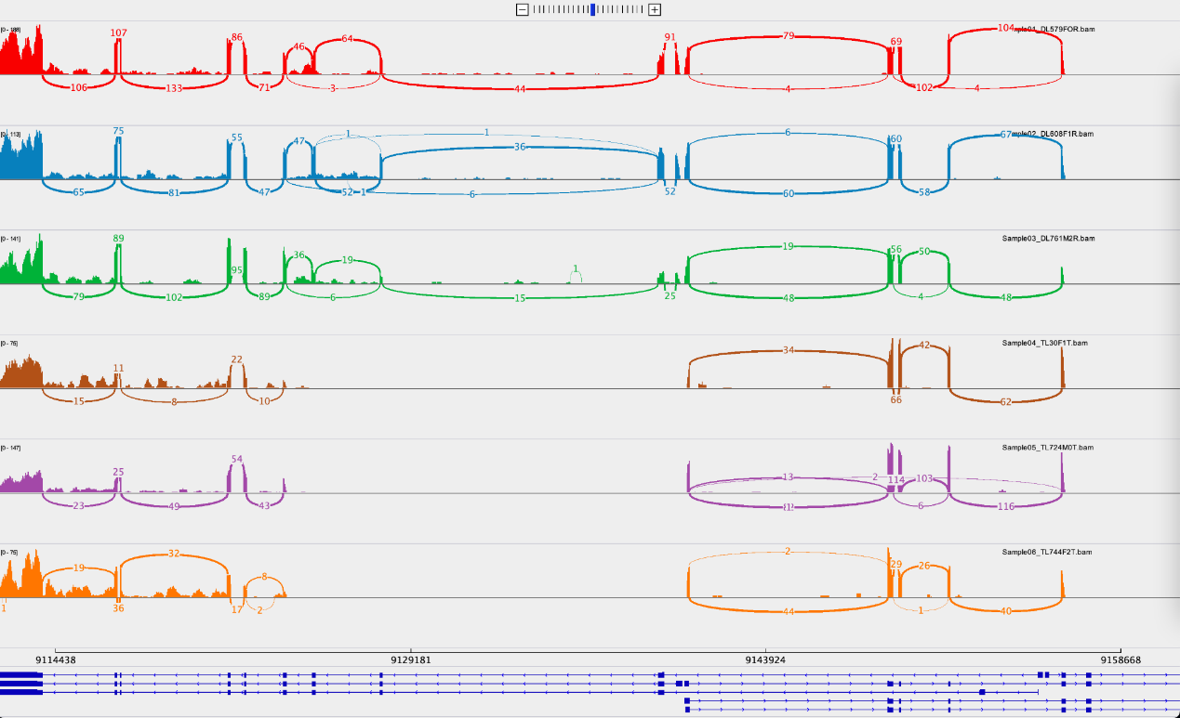

Figure S3
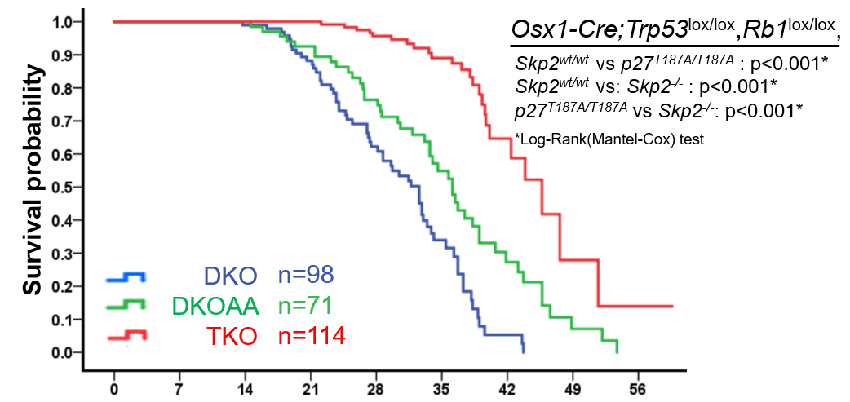

Figure S4
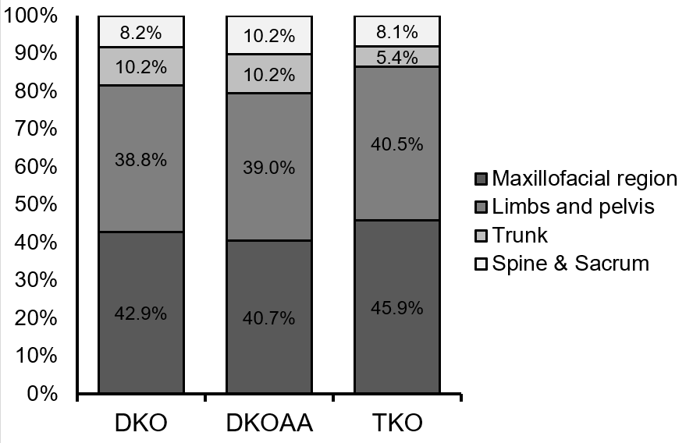

Figure S5

