Supplementary materials

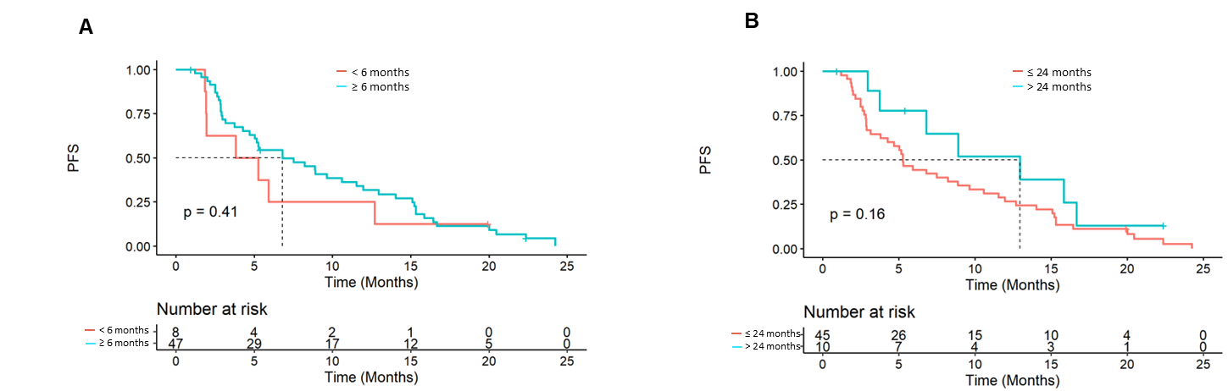

Supplementary figure 1. PFS according to median PFS of palbociclib: < 6 months (A) or > 24 months (B).
PFS: progression-free survival.

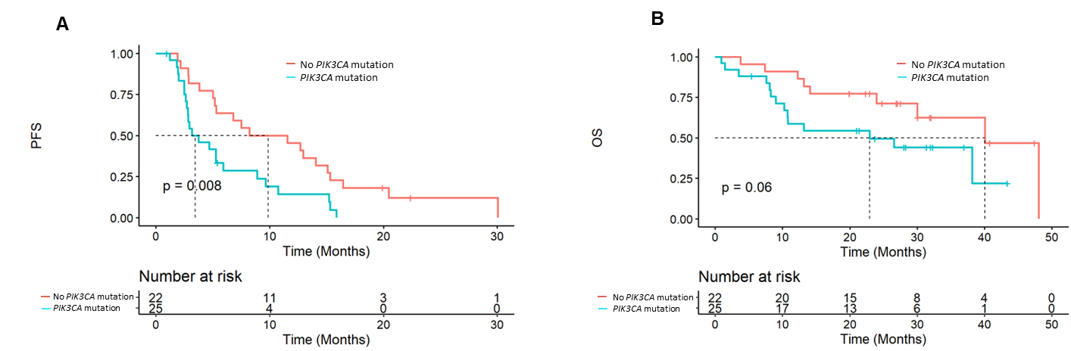

Supplementary figure 2. Progression-free survival (A) and overall survival (B) according to PIK3CA mutation.
PFS: progression-free survival; OS: overall survival.

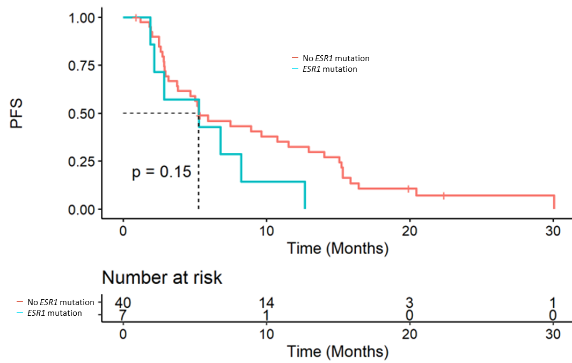
Supplementary figure 3. Progression-free survival according to ESR1 mutation.
PFS: progression-free survival.

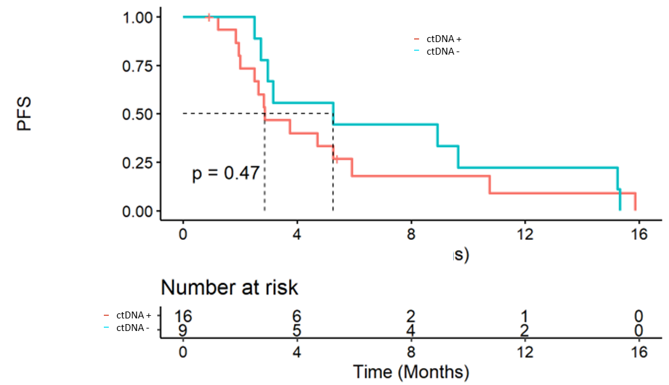

Supplementary figure 4. Progression-free survival among patients with PIK3CA mutation according to ctDNA positive or negative.
PFS: progression-free survival.

Supplementary table 1. ddPCR assays.
Mutation targeted by ddPCR | Provider | Reference number | LOB | Ta | Minumum droplet
AKT1 : c.49G>A | Biorad | dHsaMDV2010031 | 0.036 | 55 | >3
APC : c.1786T>C | Biorad | dHsaMDS702205622 | 0.000 | 55 | >1
ATM : c.866_868del | Biorad | dHsaMDS531312748 | 0.000 | 55 | >1
CUX1: c.3556C>T | Biorad | dHsaMDS846834797 | 0.000 | 55 | >1
ESR1 : c.1610A>C | Biorad | dHsaMDS975379796 | 0.000 | 55 | >1
ESR1 : c.1613A>G | Biorad | dHsaMDS460485301 | 0.006 | 55 | >2
ESR1: c.1605_161del | Biorad | dMDS140108909 | 0.000 | 55 | >1
GATA3 : c.1220dup | Biorad | dHsaMDS804009364 | 0.000 | 55 | >1
GATA3 : c.998delinsGT | Biorad | dHsaMDS404204051 | 0.006 | 55 | >2
KRAS: c.35G>T | Biorad | dHsaMDV2510592 | 0.000 | 55 | >1
PI3KCA: c.2597T>G | Biorad | dHsaMDS319038639 | 0.000 | 55 | >1
PIK3CA : c.1035T>A | Biorad | dHsaMDS2516778 | 0.000 | 55 | >1
PIK3CA : c.1633_1634delinsAG | Biorad | dHsaMDS372838164 | 0.000 | 55 | >1
PIK3CA : c.1633G>A | Biorad | dHsaMDV2010075 | 0.033 | 55 | >3
PIK3CA : c.1634A>G | Biorad | dHsaMDS175985942 | 0.022 | 55 | >2
PIK3CA : c.3140A>G | Thermofisher |  | 0.014 | 60 | >2
PIK3CA : c.3193_3202delinsTT | Biorad | dHsaMDS487937044 | 0.000 | 55 | >1
PIK3CA: c.1268C>T | Biorad | dHsaMDS122023940 | 0.017 | 55 | >2
PIK3CA: c.197C>T | Biorad | dHsaMDS503667651 | 0.017 | 55 | >2
PIK3CA: c.1357G>C | Biorad | dHsaMDS256883370 | 0.000 | 55 | >1
PIK3CA: c.3140A>T | Biorad | dHsaMDV2010123 | 0.000 | 55 | >1
PTEN: c.955_958del | Biorad | dHsaMDS417315727 | 0.000 | 55 | >1
RET: c.2731 G>A | Biorad | dHsaMDS887659414 | 0.000 | 55 | >1
TP53 : c.216del | Biorad | dMDS858067005 | 0.014 | 55 | >1
TP53 : c.488A>G | Biorad | dHsaMDV2010099 | 0.000 | 55 | >1
TP53 : c.517G>A | Biorad | dHsaMDV2510514 | 0.000 | 55 | >1
TP53 : c.637C>T | SAGA | ATR1100P53A004 | 0.018 | 72 and 48 | >2
TRRAP : c.6883C>T | Biorad | dMDS436062977 | 0.010 | 55 | >2

PIK3CA : c.3140A>G | Sequence
Primer F | GGCTTTGGAGTATTTCATGAAACA
Primer R | GAAGATCCAATCCATTTTTGTTGTC
Probe1 (FAM - MGB) | TGATGCACGTCATGGT (mut)
Probe 2 (VIC - MGB) | ATGATGCACATCATGGT (WT)

Supplementary table 2. Tumor response with everolimus plus fulvestrant.
Response | Number  of patients  N=47 | %
Best overall response
Complete response | 0 | 0
Partial response | 15 | 31.9
Stable disease $≥$ 6 months | 11 | 23.4
Progressive disease | 21 | 44.7
6 months clinical benefit rate | 26 | 55.3

Supplementary table 4. Univariate analysis for progression-free survival and overall survival.
Cox univariate analysis
 | Progression-free survival |  | Overall survival
Variable | HR (95%CI) | p value | HR (95%CI) | p value
Age | 1.00 (0.98-1.00) | 0.83 | 1.00 (1.00-1.10) | 0.03
Tumor grade | 0.71 (0.33-1.50) | 0.38 | 0.71 (0.24-2.10) | 0.54
Synchronous metastases | 1.30 (0.72-2.20) | 0.42 | 1.30 (0.61-3.00) | 0.47
Neo/adjuvant chemotherapy | 0.74 (0.42-1.30) | 0.30 | 1.20 (0.54-2.60) | 0.68
Number of metastatic sites | 1.60 (0.90-2.80) | 0.11 | 1.30 (0.57-2.80) | 0.56
Only bone metastases | 0.55 (0.28-1.10) | 0.08 | 0.96 (0.38-2.50) | 0.93
Visceral metastases | 1.30 (0.71-2.20) | 0.44 | 0.77 (0.35-1.70) | 0.53
Performance status | 1.00 (0.53-1.90) | 0.98 | 2.90 (1.20-6.90) | 0.02
Prior number of lines | 0.89 (0.43-1.80) | 0.74 | 1.40 (0.50-3.70) | 0.54
Palbociclib treatment duration | 0.83 (0.47-1.40) | 0.50 | 0.84 (0.37-1.90) | 0.68
PIK3CA mutation | 2.30 (1.20-4.40) | 0.01 | 2.20 (0.92-5.40) | 0.07
Baseline ctDNA detection | 2.04 (1.20-3.45) | 0.008 | 3.85 (1.39-10.99) | 0.01
3-5 weeks ctDNA detection | 2.38 (1.33-4.17) | 0.004 | 3.45 (1.52-7.69) | 0.003
Clearance of ctDNA at 3-5 weeks | 0.36 (0.13-0.99) | 0.05 | 0.31 (0.09-1.10) | 0.08
ctDNA decrease at 3-5 weeks | 0.15 (0.06-0.41) | 0.0002 | 0.27 (0.09-0.79) | 0.02
F ctDNA level (high or low) * | 1.40 (0.69-3.00) | 0.33 | 0.62 (0.25-1.50) | 0.30
HR: hazard ratio; CI: confidence interval; vs: versus. * Only in patients with ctDNA detection and median copy number used as a threshold.

