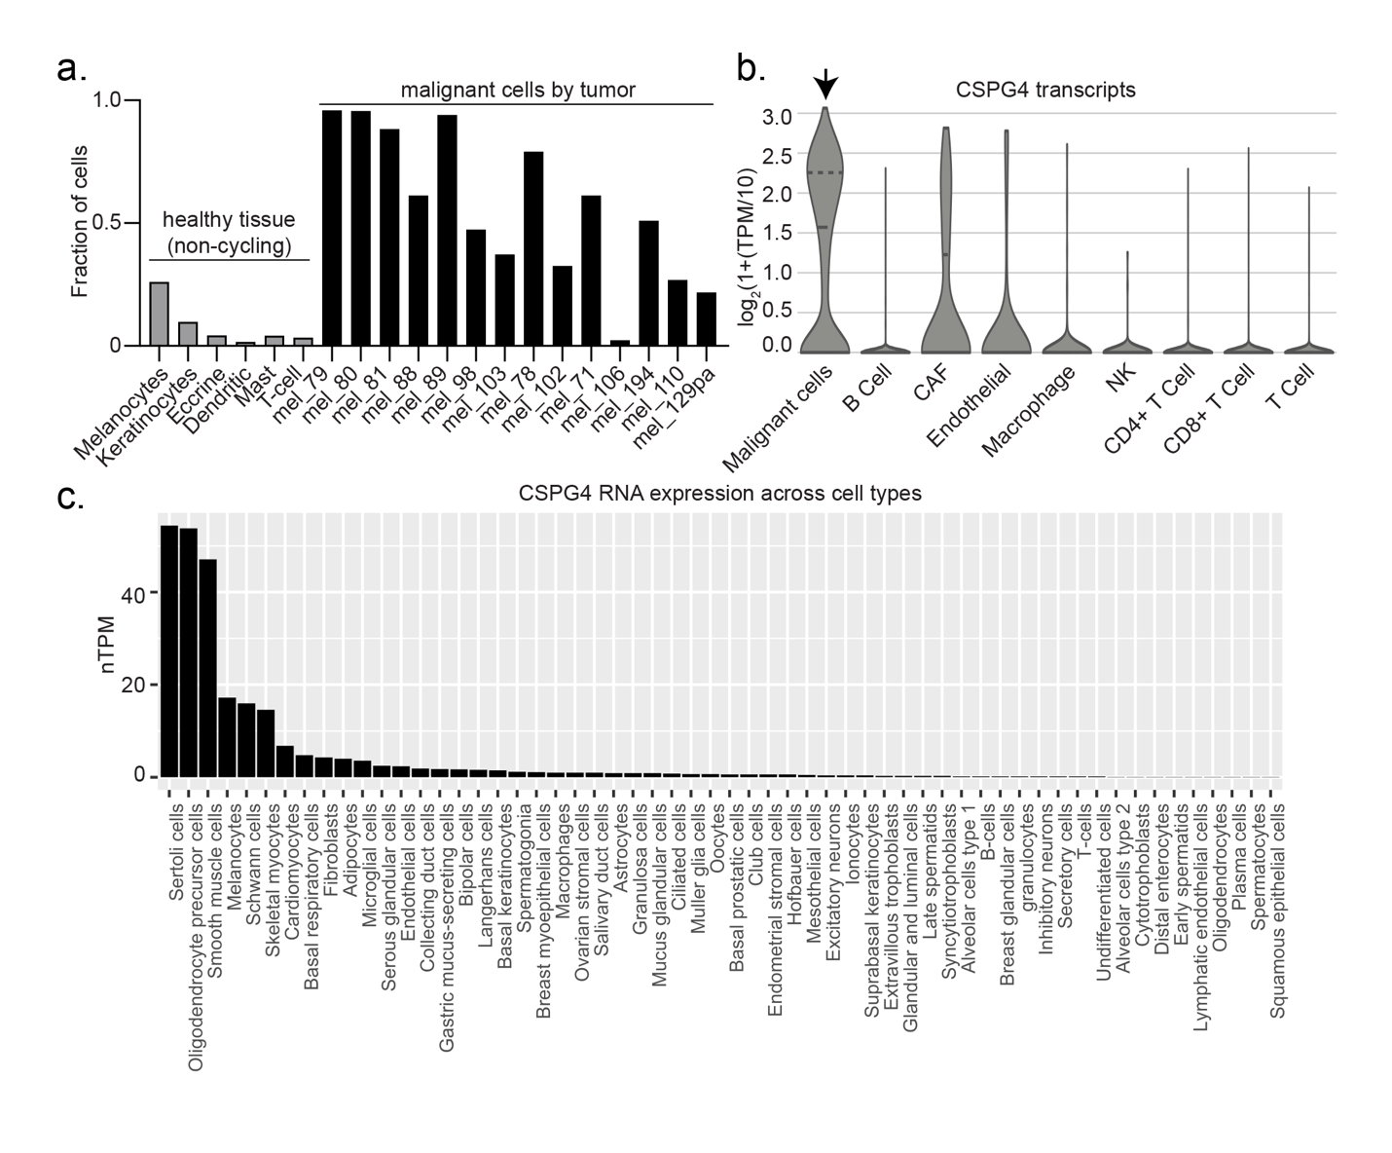
Supplemental Figure 1| CSPG4 expression is overexpressed and specific to melanoma. a) Fraction of cells expressing CSPG4 in single-cell RNA sequencing analysis of healthy (non-cycling, gray) tissue vs melanoma tumors (black) rank mean normalized from Figure 1A. b) Violin plot of CSPG4 transcript levels by single-cell RNA sequencing analysis of malignant cells (arrow) in tumors compared to non-malignant cells within the tumor. Quartiles are demarcated on the violin plots. c) CSPG4 transcript counts in normal cell types (Human Protein Atlas).
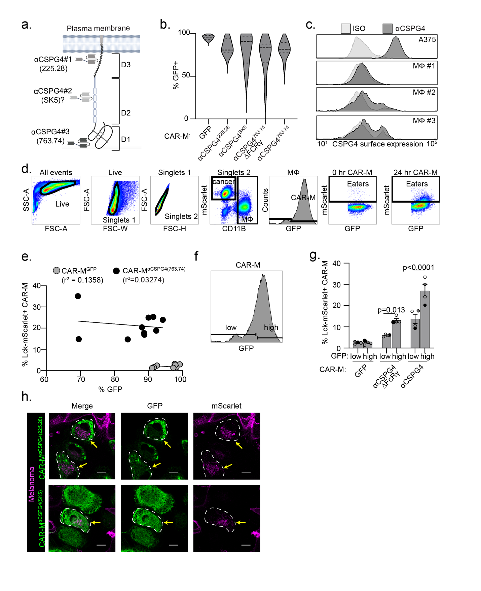Supplemental Figure 2| Engulfment gating strategy and CAR-M transduction efficiencies. a) Schematic (created with Biorender.com) of CSPG4 scFvs showing predicted (SK5) and validated (225.28, 763.74) domain binding. b) Violin plot of percentage of primary macrophages expressing each CAR-M construct (N: GFP = 12, 763.74 = 12, SK5 = 4, 225.28 = 3). c) CSPG4 surface expression by flow cytometry of A375 cells compared to primary macrophages (n=3 PBMC donors denoted as MΦ #1-3). d) Gating strategy for quantifying CAR-M transduction and CAR-M-mediated engulfment of A375-Lck-mScarlet cells based on 0-hour coculture. e) Comparison of CAR-M^{αCSPG4(763.74)} and CAR-M^{GFP} engulfment of Lck-mScarlet fragments and CAR expression from flow cytometry experiments with line of best fit (slope - CAR-M^{GFP}: 0.086 and CAR-M^{αCSPG4}: -0.13) and correlation. f) Gating strategy for segregating high vs low CAR expression on GFP control and CSPG4-targeting CAR-Ms. g) Quantification of CAR-M-mediated engulfment of A375-Lck-mScarlet cells by CAR-Ms with low or high CAR expression. h) Representative single z-plane images of CAR-M^{αCSPG4(SK5)} or CAR-M^{αCSPG4(225.28)} (green) and A375-Lck-mScarlet cells (magenta). The white dashed line outlines CAR-M^{αCSPG4} cell boundary, and the yellow arrows highlight engulfment events. Images acquired with a 63X objective on an LSM 880 microscope. Scale bar is 10 microns. g) Mean +/- SEM, 2-way AVOVA with Sidak’s multiple comparisons test. Non-significant comparisons are not indicated on the graphs.
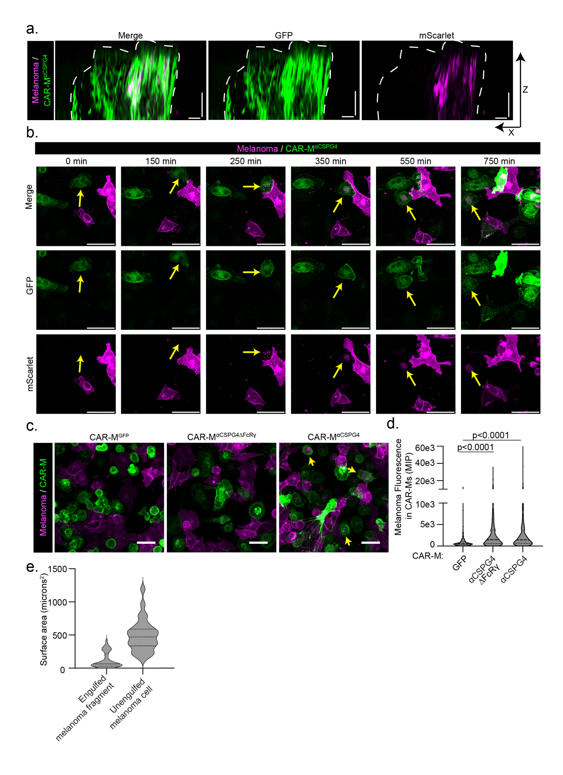
Supplemental Figure 3| Melanoma particles are fully internalized within CSPG4-targeting CAR-Ms. a) Representative X-Z plane images of engulfed Lck-mScarlet fragments inside of CAR-M^{αCSPG4} cells shown in Fig. 1g. Images acquired with a 63X objective on an LSM 880 microscope. Scale bars on both x and z axis represent 5 microns. b) Representative still images from timelapse recording (Supplemental Video 2) of CAR-M^{αCSPG4} (green) engulfment of Lck-mScarlet fragments (magenta). Yellow arrows highlight engulfment events. Scale bar is 50 microns. c) Representative images of A375-Lck-mScarlet cells cocultured with CAR-M^{αCSPG4} or CAR-M^{GFP} for 24 hours, images taken at 20X, yellow arrows indicate CAR-M eating events, scale bar is 40 microns. d) Violin plot, with quartiles, of quantification of Lck-mScarlet signal overlapping with GFP+ CAR-Ms in (c) from a maximum intensity projection (n=3 PBMC donors (biological replicates)). Mean +/- SEM, 1-way ANOVA with Tukey’s multiple comparisons test. e) Violin plot, with quartiles, of internalized Lck-mScarlet fragment area in CAR-M^{αCSPG4} (N= 34 engulfments, median = 64.69 microns²) or unengulfed A375-Lck-mScarlet cells (N = 28 cells, median = 473.19 microns²).
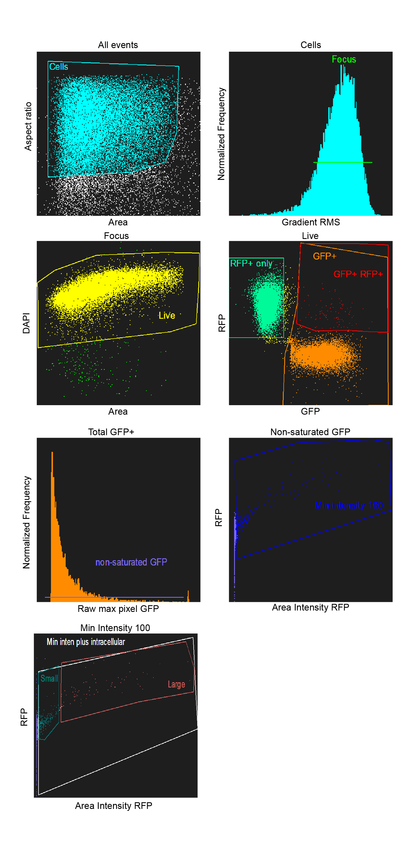
Supplemental Figure 4| Imagestream gating strategy for engulfment events. Imagestream gating strategy for identification of internalized Lck-mScarlet+ melanoma cell fragments in GFP+ CAR-M cells (data in Figure 3).
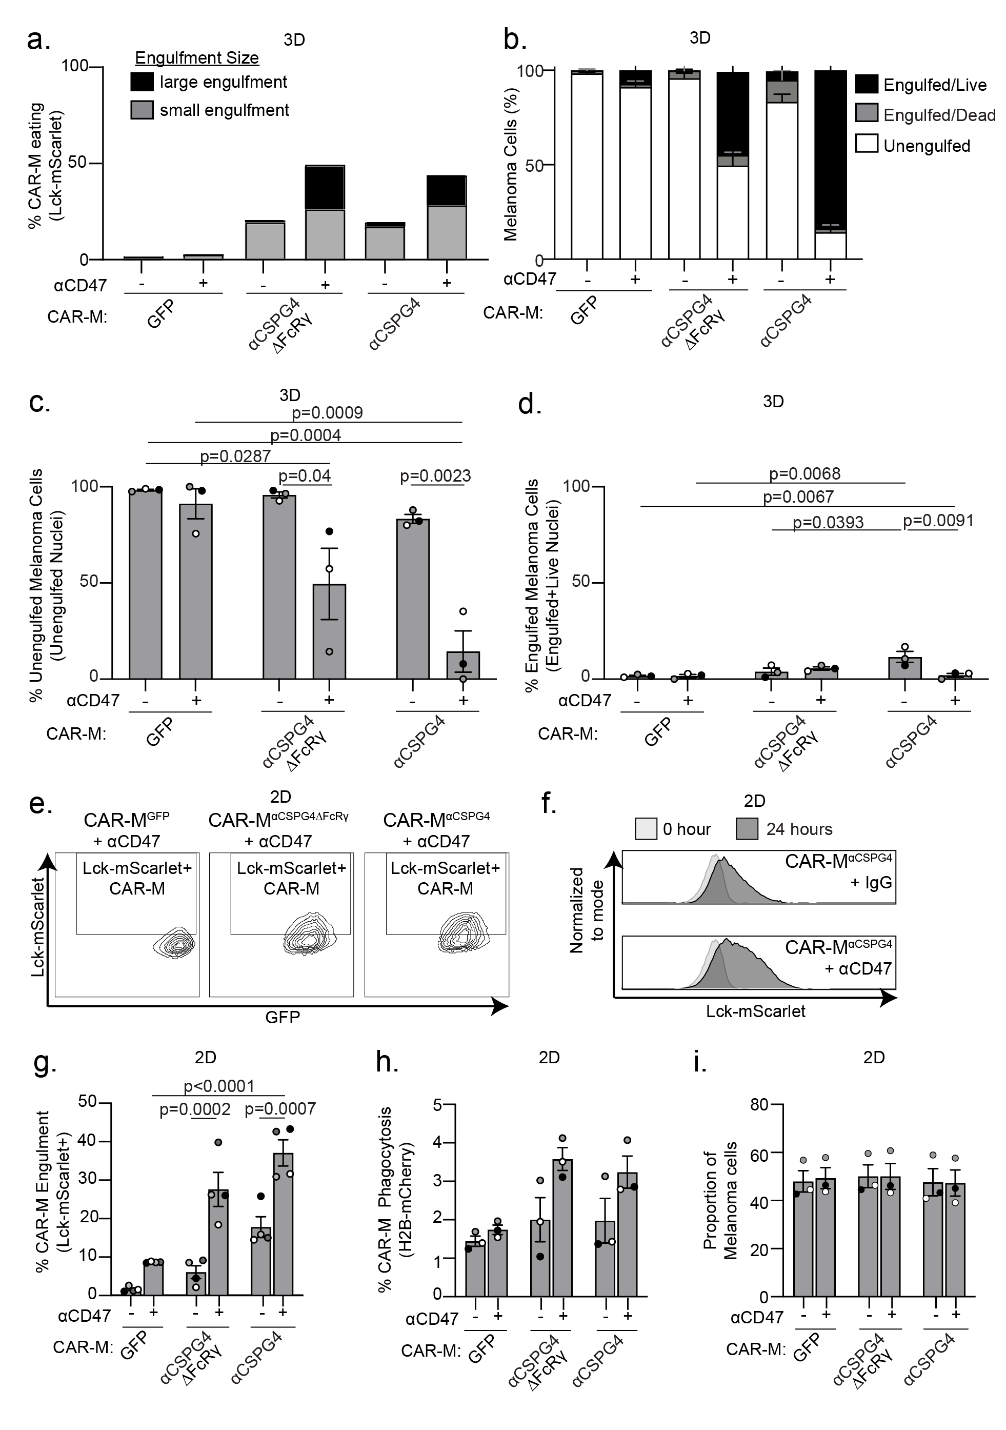
Supplemental Figure 5| αCD47 treatment increases CSPG4-CAR-M-mediated melanoma cell death in 3D, but not in 2D. a) Imagestream quantification of fully internalized A375 Lck-mScarlet punctae in GFP+ CAR-M cells upon treatment with 10 µg/mL αCD47 (+) or IgG isotype control (-) for 24 hours in 3D spheroids after 24 hours; images acquired with a 40X objective lens on an Imagestream. b) Classification of melanoma cells (live or dead) after 3 days of coculture with CAR-Ms as co-formed spheroids from Figure 4d. c) Quantification of unengulfed nuclei as percent of total melanoma cells after 72 hours of coculture in b. d) Quantification of engulfed nuclei as percent of total melanoma cells after 72 hours of coculture in b. e) Representative flow cytometry contour plots of CAR-M-mediated engulfment of melanoma fragments upon treatment with 10 µg/mL αCD47 (+) or IgG isotype control (-) for 24 hours in 2D culture. f) A normalized to mode histogram of Lck-mScarlet fluorescence in CAR-Ms at 0 and 24 hours in CAR-M^{αCSPG4} with 10 µg/mL αCD47 (+) or IgG isotype control (-) in 2D culture. g) Quantification of CAR-M-mediated engulfment of melanoma fragments upon treatment with αCD47 (+) or isotype control antibody (-) in (e, f). h) Quantification of CAR-M whole-cell phagocytosis of A375-H2B-mCherry cells treated with 10 µg/mL IgG isotype control (-) or αCD47 (+) in 2D culture. i) Proportion of target A375-H2B-mCherry cells remaining in coculture after 24 hours of coculture with CAR-Ms from (h). Each dot is a PBMC donor (biological replicate), as shades of gray. c, d, g, h, i) Mean +/- SEM, 2-way AVOVA with Tukey’s multiple comparisons test. Non-significant comparisons are not indicated on the graphs.
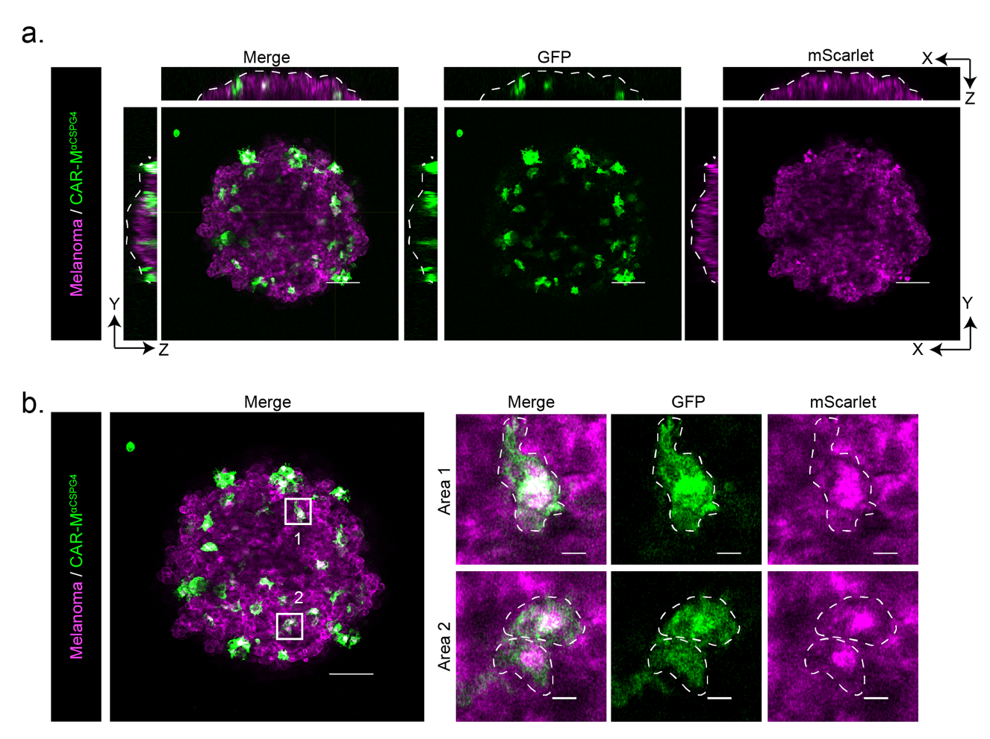
Supplemental Figure 6| CSPG4 CAR-Ms infiltrate melanoma spheroids and engulf melanoma cells. a) Representative still images with orthogonal x-z, and y-z slices of CAR-M^{αCSPG4} (green) inside A375-Lck-mScarlet spheroids (magenta) after 72 hours of coculture. Spheroid boundary is marked by white dashed line. Scale bar is 100 microns. Images acquired with a 10X objective. b) Representative maximum intensity projection of 3 slices indicating CAR-M (green) engulfment of mScarlet+ fragments. Two areas of the spheroid (boxes) are magnified to the right as Area 1 and Area 2, with CAR-Ms outlined in white hatched lines. Scale bar of main image is 100 microns; scale bar of inset is 10 microns.

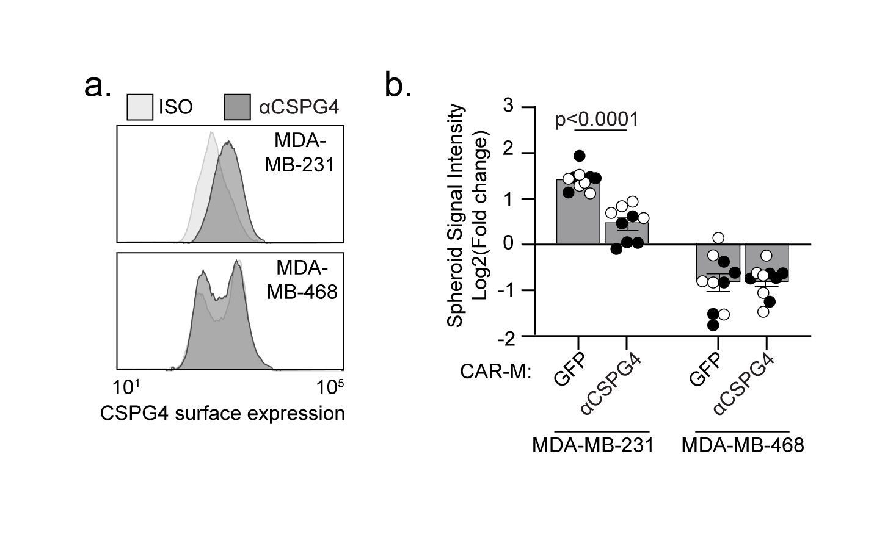
Supplemental Figure 7| CSPG4 CAR-Ms inhibit CSPG4+ breast cancer spheroid growth. a) Representative flow histograms of CSPG4 expression in MDA-MB-231 (CSPG4+) and MDA-MB-468 (CSPG4-) compared to isotype controls (ISO). b) Quantification of breast cancer spheroid growth as measured by log₂ fold change in mCherry intensity after 12 days of coculture with CAR-M^{GFP} or CAR-M^{αCSPG4}. Data shown as log₂(fold change from time zero). Mean +/- SEM, 2-way ANOVA with Sidak’s multiple comparisons test. N=2 PBMC donors (biological replicates) as black or white dots, with each dot as a technical replicate. Non-significant comparisons are not indicated on the graphs.
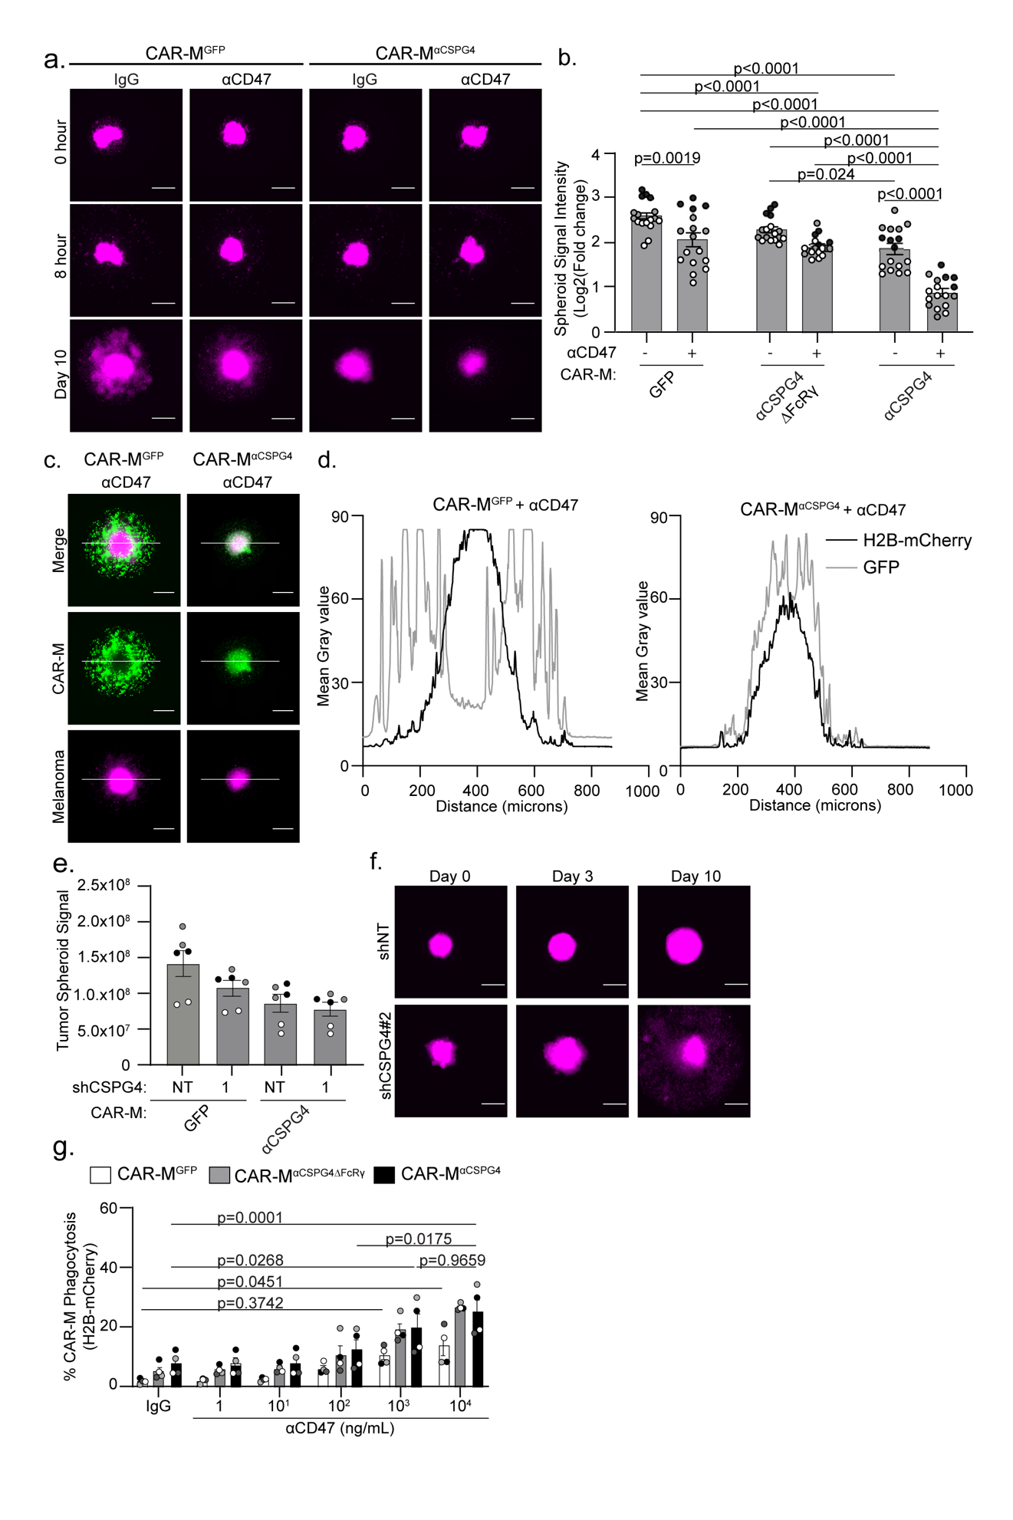
Supplemental Figure 8| Combining CSPG4-targeting CAR-Ms with αCD47 approaches leads to whole-cell melanoma phagocytosis in 3D. a) Representative images of pre-formed A375-H2B-mCherry spheroids (magenta) at day 0 (before CAR-Ms), 8 hours after CAR-M addition, and 10 days after CAR-M addition with 10 µg/mL αCD47 or IgG isotype control. Scale bar is 200 microns. b) Quantification of A375 spheroid growth as measured by total mCherry integrated intensity at day 10 across conditions (N = 17 spheroids across N=3 PBMC donors (biological replicates)). Data shown as log₂(fold change from time zero). Mean +/- SEM, 2-way ANOVA with Tukey’s multiple comparisons test. c) Representative images of pre-formed A375-H2B-mCherry spheroids (magenta) and CAR-Ms (green) on day 10; white line indicates line scan measurements in (d). Scale bar is 200 microns. d) Line scan signal intensity from representative spheroid images in (c). e) Quantification of mScarlet integrated density of A375-Lck-mScarlet tumor spheroids after 10 days. A375-Lck-mScarlet cells were either treated with shNT or shCSPG4 RNA. f) Representative images of shNT and shCSPG4 #2 clones at day 0, day 3 (first media change), and day 10. Scale bar is 200 microns. g) Flow cytometry quantification of CAR-M-mediated whole-cell phagocytosis of A375-H2B-mCherry cells after 72 hours of 3D coculture with decreasing concentrations of αCD47 or IgG isotype control antibody. g) Mean +/- SEM, 2-way ANOVA with Tukey’s multiple comparisons test. N=4 PBMC donors (biological replicates). Non-significant comparisons are not indicated on the graphs, with the exception of on (g).
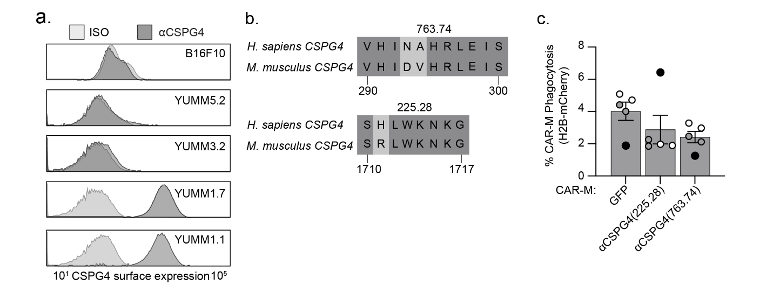
Supplemental Figure 9| CSPG4-targeting CAR-Ms using the 225.28 scFv do not efficiently phagocytose murine melanoma cells. a) Representative flow cytometry histograms of CSPG4 surface expression across a panel of murine melanoma cell lines. b) UniProt alignment of human vs mouse CSPG4 amino acid sequences for epitopes identified for 763.74 and 225.28 scFvs. c) Quantification of CSPG4^{αCSPG4(225.28)} whole-cell phagocytosis of YUMM1.7 H2B-mCherry murine melanoma cells compared to CAR-M^{GFP} and CAR-M^{αCSPG4(763.74)} by flow cytometry. N=3 PBMC donors (biological replicates) as shades of gray, and each dot as a technical replicate. 1-way ANOVA with Tukey’s multiple comparisons test, non-significant comparisons are not indicated on the graph.
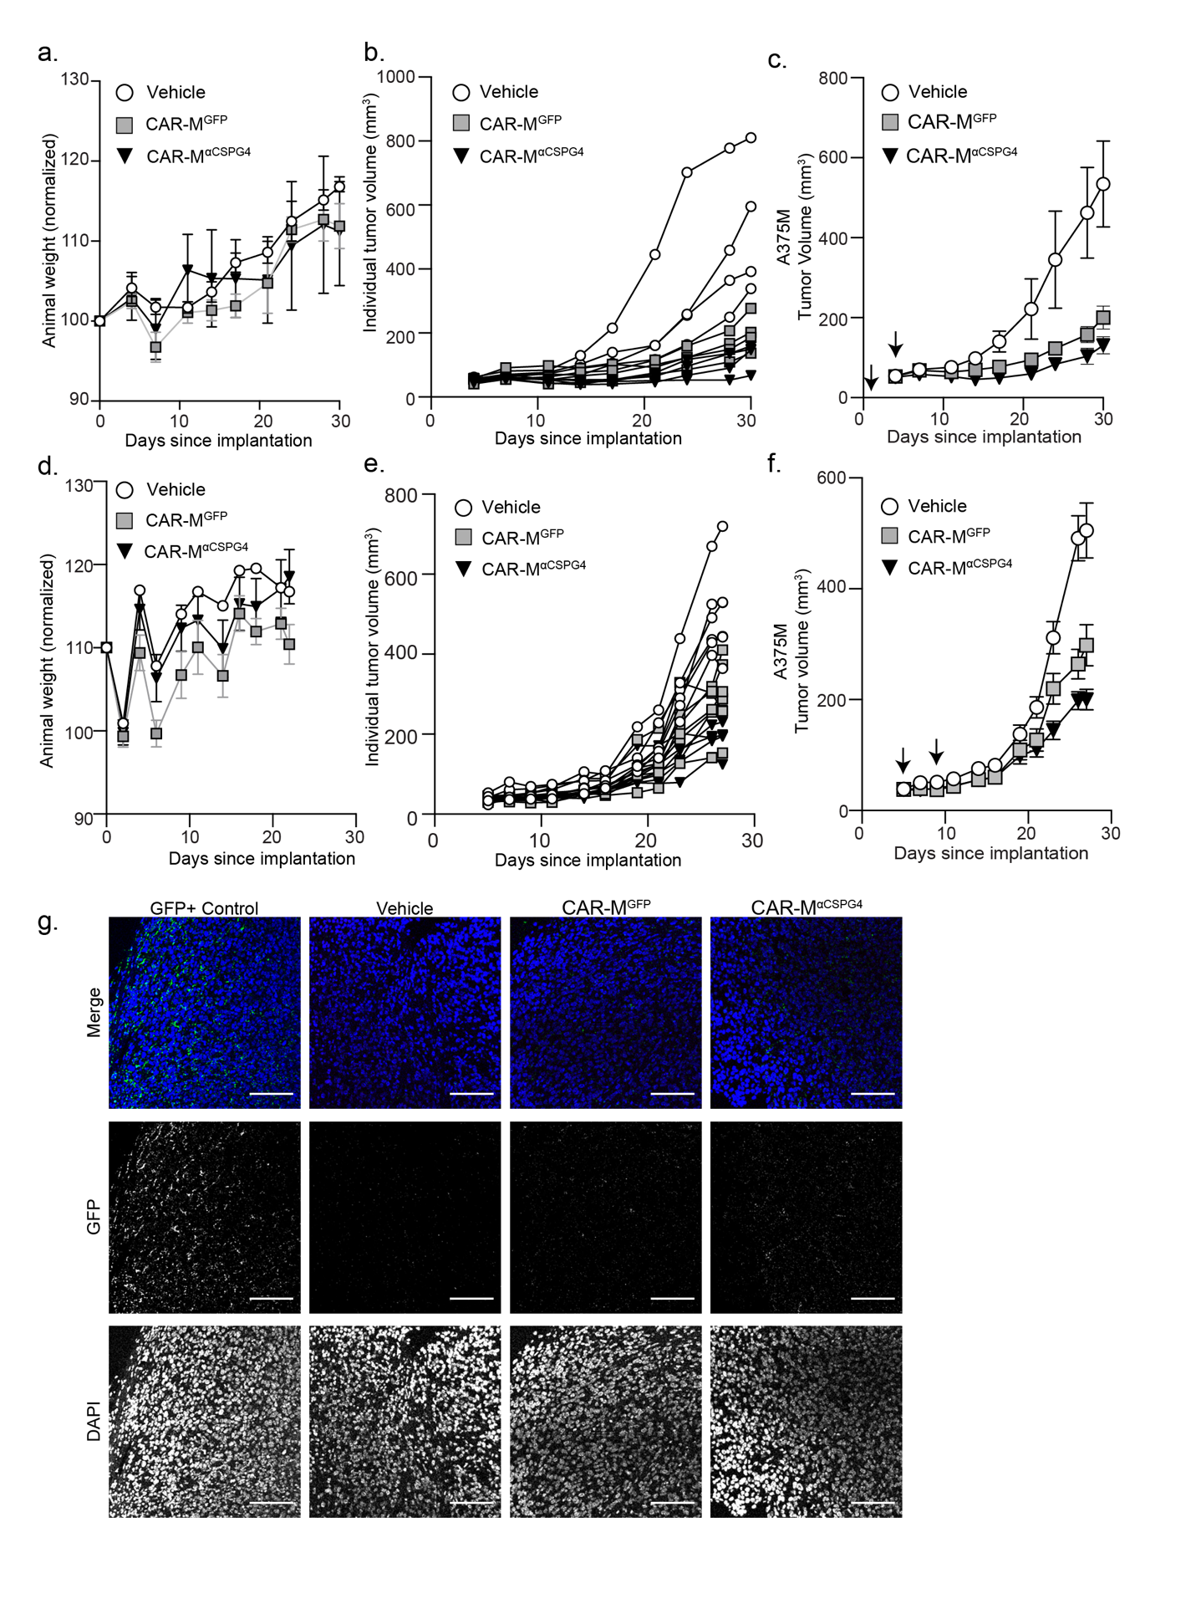
Supplemental Figure 10| CSPG4-targeting CAR-Ms do not affect mouse weight and do not persist in tumors 5 days after last peritumoral injection. a-c) Animal weights (a), individual mouse tumor volumes (b), grouped mouse tumor volumes including vehicle (c) from Figure 6d. d-f) Animal weights (d), individual mouse tumor volumes (e), and grouped mouse tumor volumes including vehicle (f) from Figure 6g. g) Representative 40X images of immunofluorescent staining for GFP and DAPI of tumors from Figure 6g. As a positive control for GFP staining, a tumor isolated from a GFP+ mouse was used. c, f) Mean +/- SEM. Arrows indicate CAR-M injections.
Supplemental Video Legends

Supplemental Video 1| CSPG4-targeting CAR-Ms fully engulf melanoma cell fragments in 3D. Video of sequential z-planes from confocal images of Fig. 1g – CAR-M^{αCSPG4(763.74)} (green) with internalized A375 cells tagged with Lck-mScarlet (magenta).

Supplemental Video 2| CSPG4-targeting CAR-Ms trogocytose melanoma cells in 2D. Timelapse video (maximum intensity projection) of CAR-M^{αCSPG4(763.74)} (green) interacting and trogocytosing/nibbling A375 cells tagged with Lck-mScarlet (magenta). Yellow arrows highlight CAR-M^{αCSPG4(763.74)} actively trogocytosing A375-Lck-mScarlet cell. Images taken every 10 minutes for 18 hours; 7 fps.

Supplemental Video 3| CAR-M ^{αCSPG4} infiltrate A375-Lck-mScarlet spheroids. Video of a Z-stack showing GFP+ CAR-M^{αCSPG4} (green) inside an A375-Lck-mScarlet spheroid (magenta).

Supplemental Video 4| CSPG4-targeting CAR-Ms exhibit increased infiltration of melanoma spheroids compared to control CAR-Ms. Timelapse video of CAR-M^{GFP} (green) that remain on the exterior of A375-H2B-mCherry spheroids (left side) compared to CAR-M^{αCSPG4} which infiltrate A375-H2B-mCherry spheroids (right side). Images taken every 8 hours for 10 days; 7 fps.

