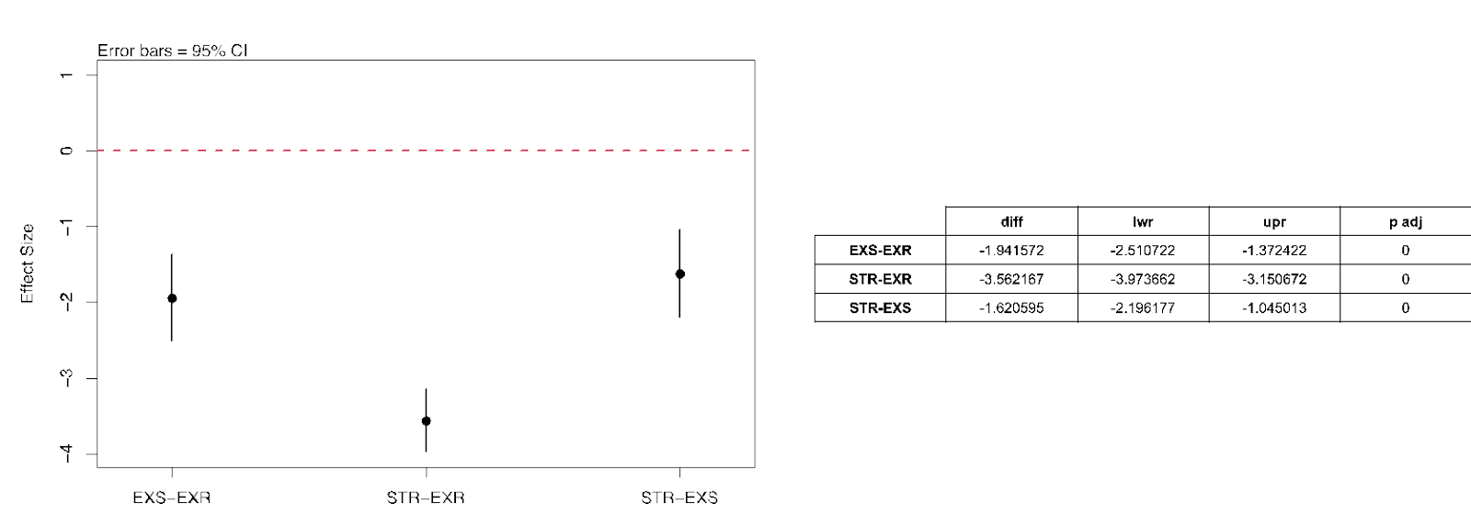
Figure S1. Tukey comparisons of centromeric CN means between ExR, ExS and STR.
Post hoc ANOVA test (Tukey) performed using R (V4.2.0) and R packages rstatix, AICcmodavg, ggplot2, ggpubr, tidyverse, broom and multcompView.

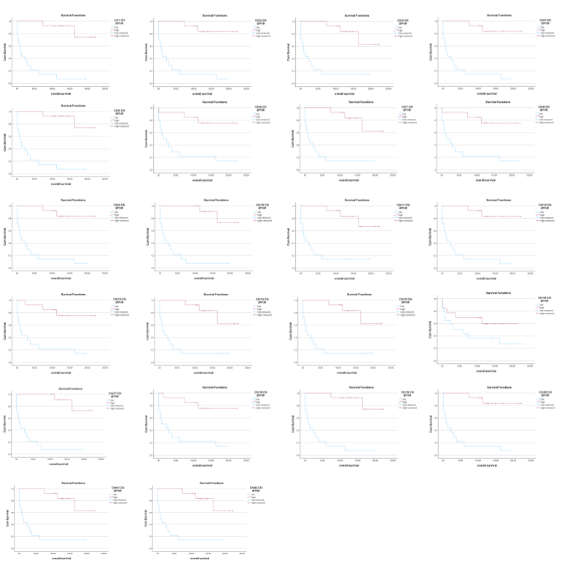

Figure S2. Kaplan Meier curves of overall survival in ExR, ExS, and STR patients divided by centromeric copy number. Patients were divided into a low or high CCN group based on the median CCN.

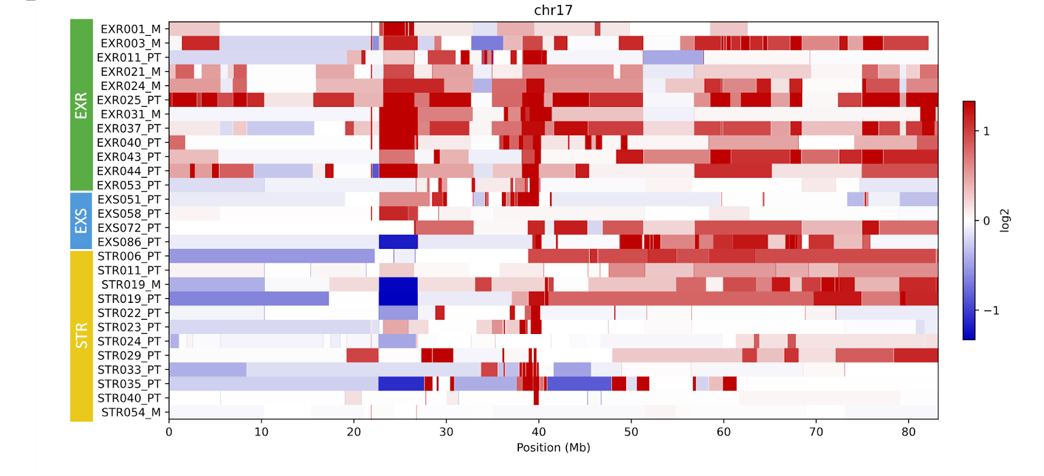
Figure S3. Copy number aberration profiles of chromosomes 17.
Heatmap of the log2 normalized CNA profiles of the whole genome of the 12 EXR, 4 EXS and 11 STR samples. Red color indicates a gain of copy, blue indicates a loss of copy and white indicates a normal copy number (2 copies)

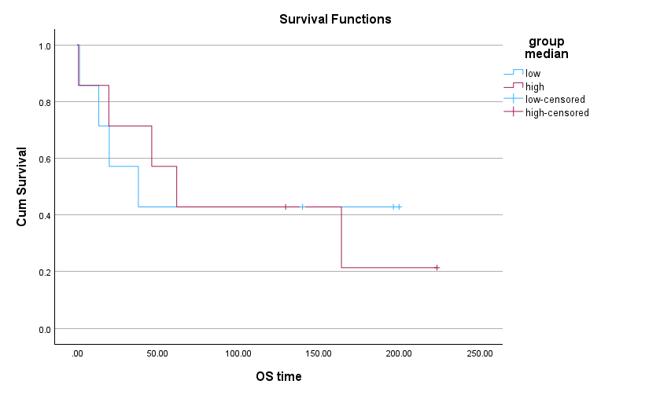
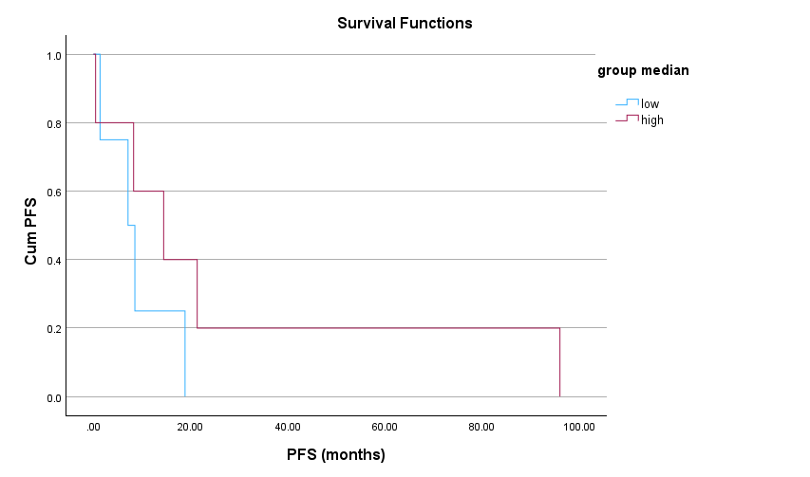
Figure S4. Kaplan Meier curves of overall survival and progression-free survival in ExR, ExS, and STR patients grouped by D4Z1 copy number.
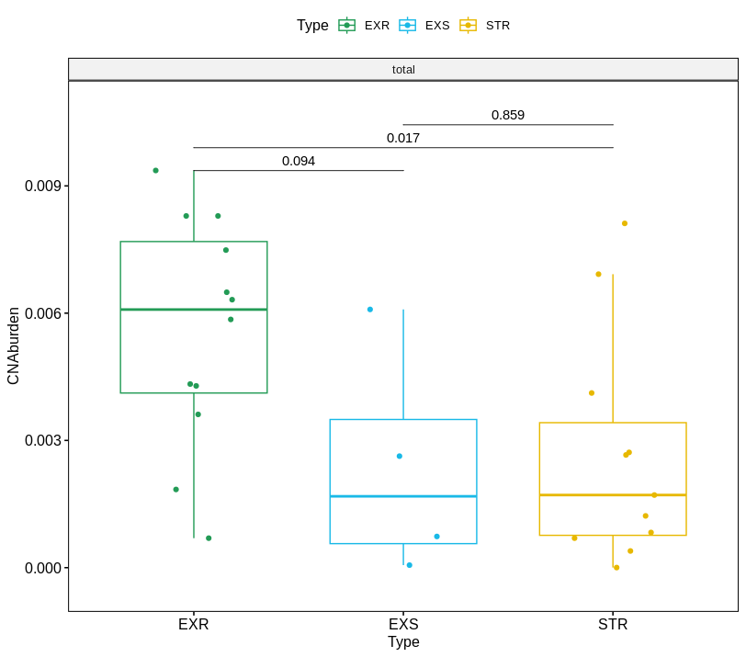

Figure S5. CNA burden of the coding regions.
Fractions of the genome altered by CNA in terms of loss and gain (total) for the EXR, EXS and STR groups.

Table S1. Coordinates of the selected centromeric regions (hg38).
Coordinates used to estimate the copy-number status of the centromeric regions.

chromosome | start | end
chr1 | 122500000 | 124000000
chr2 | 93000000 | 94000000
chr3 | 91551000 | 93400000
chr4 | 49650000 | 49700000
chr5 | 47251000 | 48600000
chr6 | 58451000 | 58600000
chr7 | 59851000 | 60000000
chr8 | 44100000 | 44500000
chr9 | 44900000 | 45400000
chr10 | 39700000 | 39900000
chr11 | 53951000 | 54300000
chr12 | 35400000 | 37200000
chr13 | 17500000 | 18000000
chr14 | 17651000 | 18200000
chr15 | 18400000 | 19700000
chr16 | 36110000 | 36210000
chr17 | 25950000 | 26500000
chr18 | 20610000 | 20800000
chr19 | 26300000 | 26900000
chr20 | 26551000 | 28000000
chr21 | 12310000 | 12400000
chr22 | 14500000 | 15000000

Table S2. dPCR primers
Gene | primer | Assay ID
D4Z1 | FW 5’ CTG TAG TAT CTG GAA GTG GAC ATT 3’ | ThermoFisher
D4Z1 | RV 5’ GGT TCA ACT GTG TTC GTT TAG G 3’ | ThermoFisher
RHOT1 | FW 5’ CGT AGC TGC AAA GTC AGA CC 3’ | Hs.PT.58.40542312.g, Integrated DNA technologies, Coralville, IA USA
RHOT1 | RV 5’ GTC AAT TTA ACA AAG AA TCC TTA CTG G 3’
MED19 | FW 5 GAT TGA TCT GCC TGG TTC CC 3’ | Hs.PT.58.26606431.g, Integrated DNA technologies, Coralville, IA USA
MED19 | RV 5’ CAG TGT GGA GGC GGA AG 3’

Supplemental Table S3. Clinical characteristics of the HER2-positive MBC cohort.
 | ExR | ExS | STR
 | (n=29) | (n=54) | (n=160)
Median age (range) at first anti-HER2 line, years | 50 (range 30-77) | 54 (range 25-79) | 63 (range 26-88)
Median survival, months
OS | 148 (range 95-238) | 113 (range 60.2-278) | 21 (<60)
PFS | NA | 34.4 (4-170) | 10.9 (<60)
de novo metastasis
yes | 18 (62%) | 19 (35%) | 53 (33.1%)
no | 11 (38%) | 35 (65%) | 103 (64.4%)
unknown | 0 (0%) | 0 (0%) | 4 (2.5%)
ER/PR status (primary tumor or metastases)
positive | 15 (51.7%) | 23 (43%) | 55 (34.375%)
negative | 12 (41.3%) | 25 (45%) | 76 (47.5%)
unknown | 2 (7.0%) | 6 (12%) | 29 (18.125%)
Number of metastatic sites
1 | 21 (71.0%) | 25 (46.1%) | 53 (33.1%)
2 | 4 (16.1%) | 20 (38.5%) | 68 (42.5%)
3 or more | 4 (12.9%) | 9 (15.4%) | 36 (22.5%)
unknown | 0 (0%) | 0 (0%) | 3 (1.9%)
Location of metastases
lung | 5 | 13 | 54
lymph nodes | 16 | 24 | 59
brain | 0 | 3 | 18
liver | 8 | 15 | 67
bone | 7 | 29 | 91
chest wall recurrence | 2 | 3 | 10
Best treatment response
complete response (CR) | 22 (75.9%) | 15 (27.8%) | 7 (4.4%)
partial response (PR) | 4 (13.8%) | 29 (53.7%) | 54 (33.8%)
stable disease (SD) | 2 (6.9%) | 7 (13.0%) | 37 (23.1%)
progression of disease (POD) | 0 (0%) | 2 (3.7%) | 41 (25.6%)
unknown | 1 (3.4%) | 1 (1.8%) | 21 (13.1%)
Drug category regimen
single agent trastuzumab | 0 (0%) | 1 (1.8%) | 18 (11.25%)
trastuzumab with chemotherapy | 28 (96.6%) | 46 (85.2%) | 115 (71.875%)
trastuzumab with hormonal therapy | 0 (0%) | 4 (7.4%) | 13 (8.125%)
unknown | 1 (3.4%) | 3 (5.6%) | 14 (8.75%)

Table S4. PFS and OS statistics. Kaplan Meier survival analysis performed using R (V4.2.0) and R packages survival and survminer.
 | EXR | EXS | STR
 | (n=29) | (n=54) | (n=160)
Progression-Free Survival
records | 29 | 54 | 159
events | 0 | 54 | 156
mean, months | NA | 46.5 | 15.1
median, months | NA | 34.4 | 10.9
0.95 LCL, months | NA | 27.7 | 8.54
0.95 UCL, months | NA | 43.4 | 12.7
Overall Survival
records | 29 | 54 | 159
events | 3 | 36 | 154
mean, months | 157 | 139 | 23.8
median, months | 148 | 113 | 21.1
0.95 LCL, months | NA | 91.5 | 19.3
0.95 UCL, months | NA | 152 | 26.4

Table S5. D4Z1 copy number as measured by dPCR and associated PFS and OS.
ID | D4Z1_avg | OS | PFS | WGS
EXR004 | 665.88 | 199.69 | NA | N
EXR021 | 602.49 | 139.79 | NA | Y
EXR024 | 1557.74 | 129.31 | NA | Y
EXR043 | 4405.96 | 223.28 | NA | Y
EXS051 | 2917.61 | 163.94 | 95.97 | Y
EXR053 | 874.31 | 196.17 | NA | Y
EXS085 | 66885.45 | 61.7 | 21.36 | N
STR005 | 899.56 | 13.31 | 7.13 | N
STR023 | 2711.97 | 0.72 | 0.46 | Y
STR024 | 1170.8 | 1.38 | 1.38 | Y
STR049 | 3459.9 | 19.55 | 8.28 | N
STR052 | 555.08 | 19.81 | 8.54 | N
STR053 | 2092.07 | 46.19 | 14.46 | N
STR054 | 523.73 | 37.88 | 18.86 | Y

