Figure S1. UNC5B is highly expressed by PDAC cells, and its expression promotes metastasis in pancreatic cancer. A) In situ hybridization images showing Unc5b expression across KPCU groups. KPCU^{+/+} tumors exhibit high levels of Unc5b expression, whereas KPCU^{-/-} tumors show a complete loss of Unc5b signal. B) In situ hybridization analysis of primary pancreatic tumors from KPCU^{-/-} mice that developed overt liver metastases. Despite Cre-LoxP introduction, these tumors showed persistent Unc5b expression, indicating incomplete recombination in the lesions that subsequently metastasized. C) Immunocytochemistry (ICC) analysis of Ki67 in Met38 pancreatic cancer cells demonstrated that UNC5B knockdown (KD) resulted in reduced Ki67 expression compared to wild-type controls. D) schematic illustration of pancreas orthotopic models. Western Blot analysis confirms Unc5b KD in murine Met38 cell line. In an orthotopic pancreatic cancer model, stable Unc5b KD in murine PDAC cells (Met38 line) resulted in a marked reduction in metastatic burden. Mice (n=12/group) were injected orthotopically with either Unc5b wild-type or Unc5b KD cells, followed by primary tumor resection at almost 2 weeks post-injection and followed up. Subsequent analysis of distant organs showed that all mice in the Unc5b wild-type group developed overt metastases. In contrast, mice in the Unc5b KD group displayed no detectable metastases (****P < 0.0001, unpaired two-tailed t-test). E) UNC5B expression landscape across 176 human pancreatic cancer samples from the TCGA cohort, illustrating the distribution and variability of UNC5B transcription in patient tumors. Blue dots represent alive individual (n=92) and red dots indicates dead individual (n=84); on the right, Box-and-whisker plot showing UNC5B expression levels in human PDAC tumors with average pTPM of 20.2. F) RNA-seq data from a cohort of 289 PDAC patients (GSE205154) demonstrated that UNC5B expression is elevated in both primary and metastatic tumor cells. Statistical analysis was performed using unpaired t-tests between groups. G) Analysis of 45 matched pairs of human PDAC tumors and adjacent non-tumor pancreatic tissues (GDS4336) revealed significantly higher UNC5B expression in PDAC tumor cells compared with normal pancreas (non-tumor tissues). In the tissue-type annotation, dark green indicates PDAC tumor tissue, whereas light green represents adjacent non-tumor pancreatic tissue. In disease state annotation, dark, medium, and light purple represents cancer death NA, 1, and 0, respectively. H) representative Image of In situ hybridization showing robust Unc5b expression in a primary pancreatic tumor from a KPCU^{+/+} mouse (n=10), with no detectable Unc5b signal in normal mouse pancreas (n=4).
Supp Figure S2. UNC5B Drives Mesenchymal Transition and Regulates EMT in PDAC. A) MAK EMT scores, based on a 77-gene signature, were calculated from RNA-seq data of primary tumors from KPCU^{+/+} (wild-type), KPCU^{+/-}, and KPCU^{-/-} mice. KPCU^{-/-} tumors exhibited a lower EMT scores compared to wild-type tumors (P=0.0976), suggesting a shift toward a more epithelial-like, less aggressive phenotype. B), Representative double immunohistochemistry (IHC) staining for E-cadherin (epithelial marker) and Vimentin (mesenchymal marker) in primary tumors from KPCU mice (n=8 per group). KPCU^{-/-} tumors exhibited strong E-cadherin expression with minimal Vimentin staining, consistent with an epithelial phenotype. In contrast, KPCU^{+/+} and KPCU^{+/-} tumors displayed heterogeneous staining patterns, comprising both E-cadherin-positive and Vimentin-positive cell populations, with KPCU^{+/+} tumors showing a predominance of Vimentin-positive cells indicative of enhanced mesenchymal features. C) Western blot analysis confirms UNC5B overexpression and depletion in KP4 pancreatic cancer cells. UNC5B overexpression reduced E-cadherin expression, whereas UNC5B depletion increased E-cadherin levels. Immunocytochemistry and Western blot analyses demonstrated a marked upregulation of vimentin expression in KP4 cells overexpressing UNC5B compared with empty vector-transduced controls, indicating an enhanced acquisition of mesenchymal characteristics upon UNC5B overexpression. D) Western blot analyses indicate moderate UNC5B knockdown in human MIA PaCa-2 cells. Widefield light microscopy shows UNC5B KD led to epithelial-like morphology in MIA PaCa-2 cells. CRISPR activation-mediated endogenous overexpression of UNC5B enhanced the mesenchymal phenotype of MIA PaCa-2 cells, as indicated by EMT and PAMG scoring systems. E) Conversely, UNC5B knockdown in murine Met38 cells reduced mesenchymal scoring (higher PAMG score), indicating an epithelial shift. Western blot analyses indicate that Unc5b knockdown in murine Met38 cell line reduces the vimetin expression F) Gene set enrichment and pathway analysis were performed to identify biological processes and signaling pathways modulated by receptor expression across the indicated comparisons, UNC5B overexpression (UNC5B OE) and UNC5B depletion using Degron construct (UNC5B DP). The bubble plot depicts significantly enriched Gene Ontology (GO) terms and MSigDB/KEGG pathways, ranked by combined enrichment score. Bubble size corresponds to the adjusted p-value, and colors indicate the comparison groups. Statistical comparisons between groups were conducted using unpaired two-tailed Student’s t-tests and p-values < 0.05 were considered statistically significant.
Figure S3. UNC5B Facilitates Epithelial-Mesenchymal Transition Through SRC/ZEB1 Regulation. A) UNC5B KD in MIA PaCa2 cells led to a significant decrease in ZEB1 levels, as measured by western blot, with no significant changes observed in other canonical EMT-inducing transcription factors (e.g., SNAIL1, SLUG, TWIST1). B) Exogenous UNC5B overexpression significantly increased ZEB1 level, without affecting the expression of other EMT-inducing transcription factors. ZEB1 protein levels were further validated by immunocytochemistry (ICC) in the same cells, confirming increased nuclear ZEB1 expression upon UNC5B overexpression. C) Acute degradation of UNC5B reduces ZEB1 expression in human pancreatic cancer cells. UNC5B expression was modulated using a protein degrader (Degron) system in human BxPC-3 cells stably overexpressing UNC5B fused to the FKBP^{12^F36V} degron tag. Acute degradation of UNC5B upon dTAG^{V}-1 treatment resulted in a no significant reduction of canonical EMT-inducing transcription factors, including SNAIL1 and SLUG, with undetectable level of TWIST1 remained unchanged. Gene expression was assessed by qPCR. D) Western blot analysis shows UNC5B OE elevated the ZEB1 expression and acute depletion of UNC5B using dTAG^{V}-1 compound reverted ZEB1 level to the baseline. Statistical significance was determined using an unpaired t-test. p < 0.05 was considered significant. E) Western blot analysis confirms UNC5B overexpression in human AsPC-1 and PANC-1 pancreatic cancer cell lines. F) Western Blot analysis showing the modulation of PTEN in human BxPC3 pancreatic cell line with UNC5B overexpression and depletion models.

Supplementary Figure 1
B
A
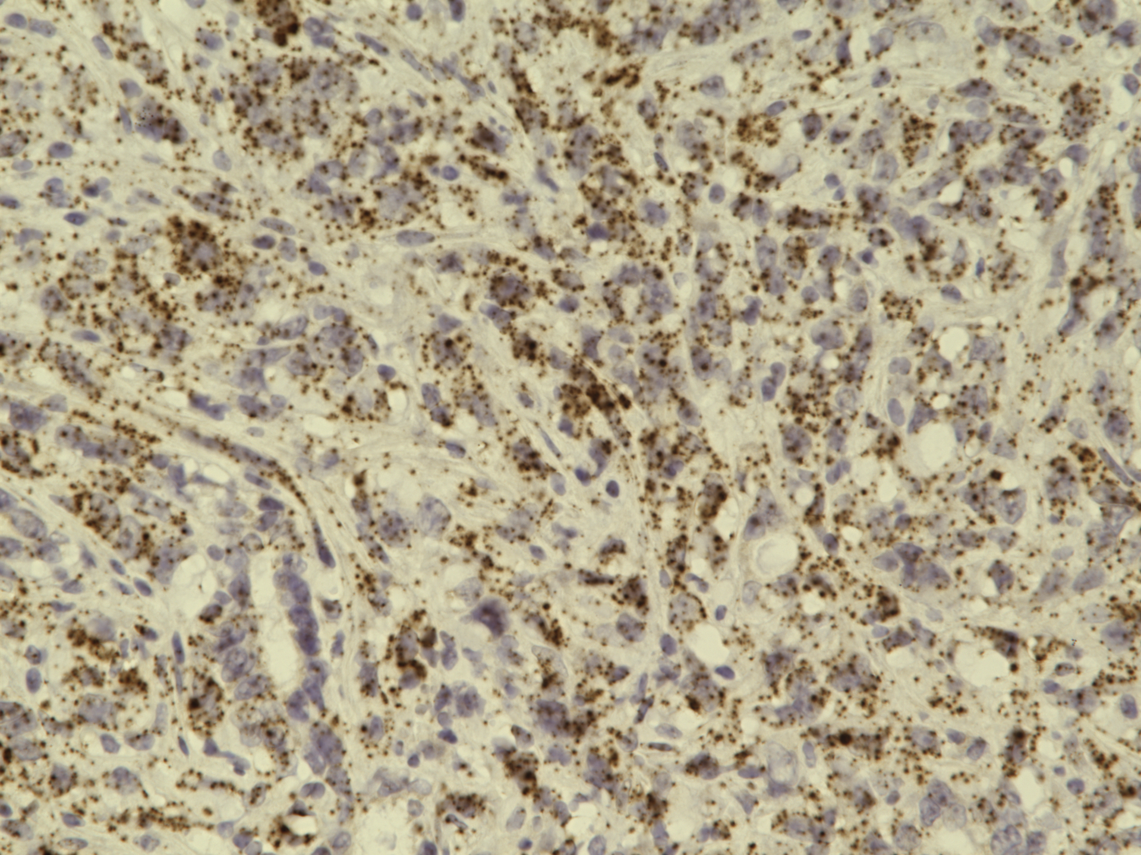
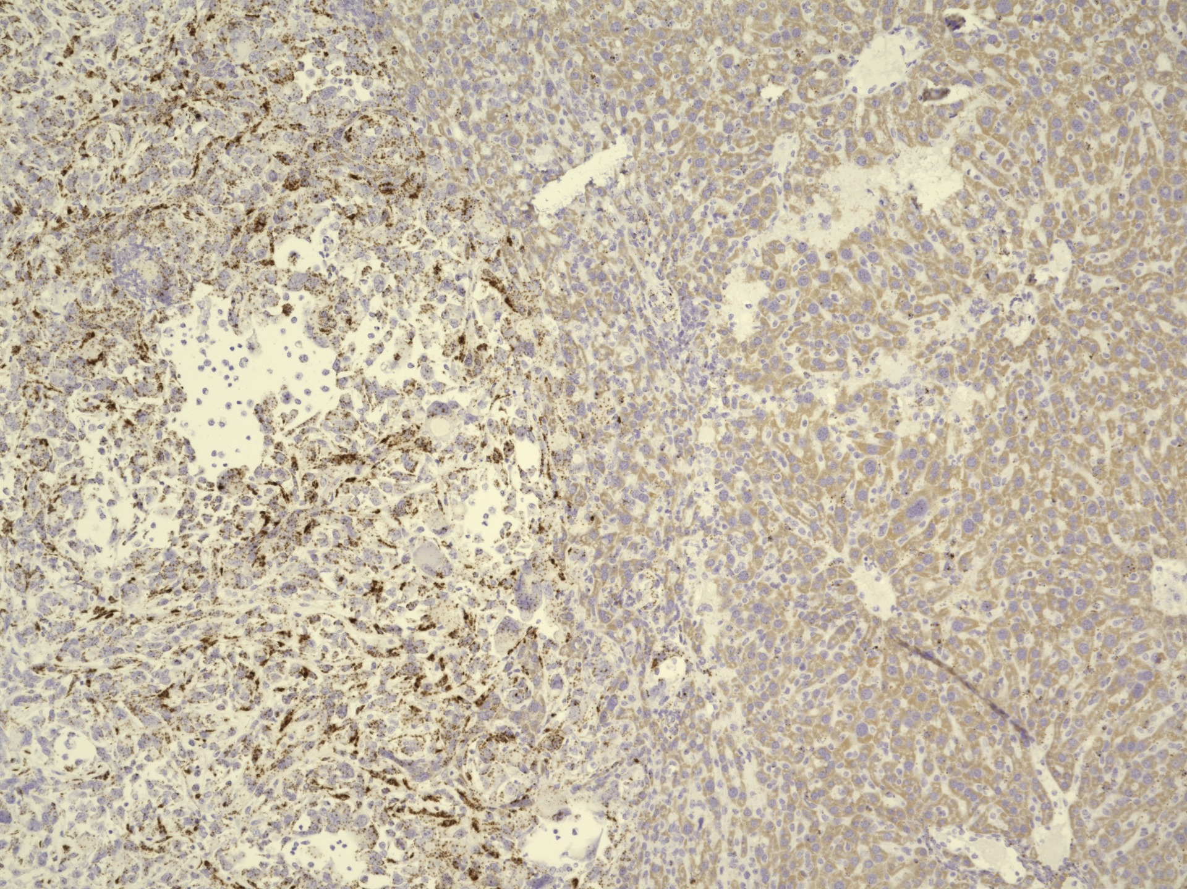
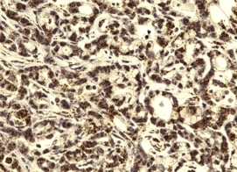
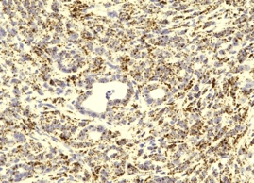

Liver Mets
KPCU-/-
KPCU-/-
KPCU+/-
KPCU+/+
C
UNC5B KD
Wild Met38
Merged
Ki67
DAPI,

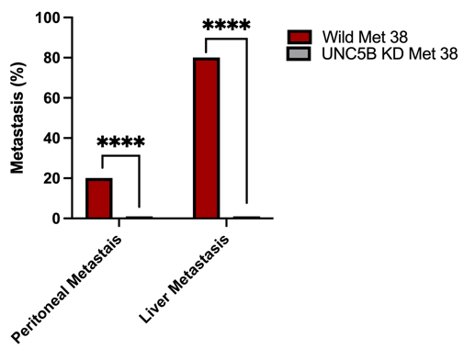
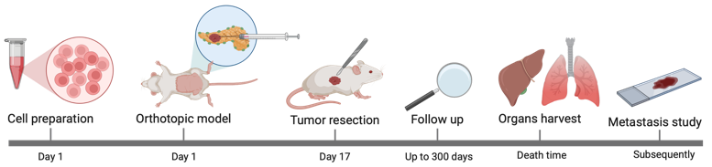
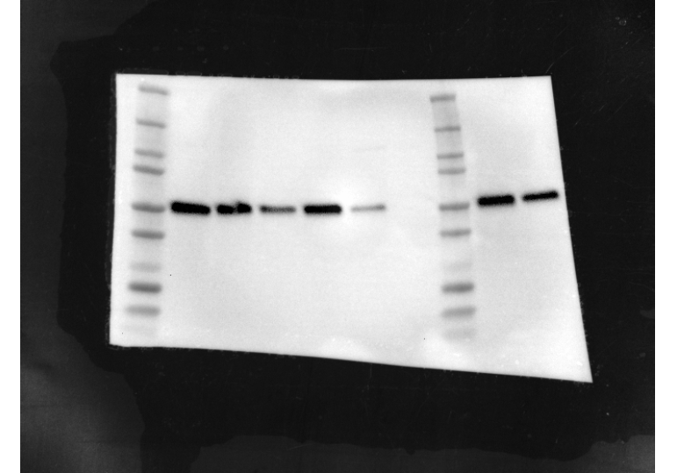
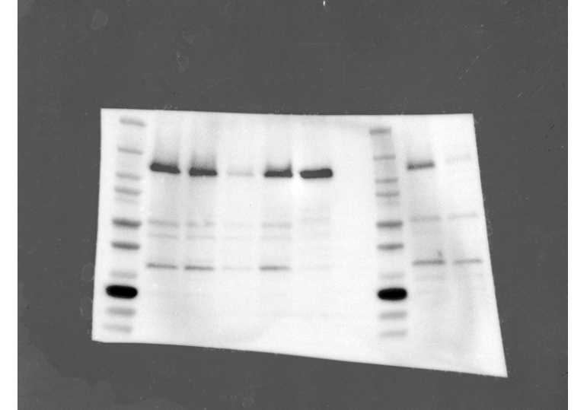
Unc5b KD
Beta-Tubulin
Unc5b
Wild Met 38
130 kDa
D

55 kDa

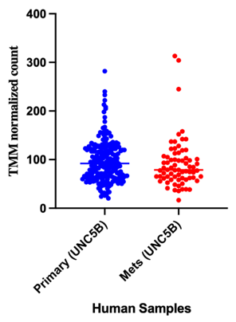
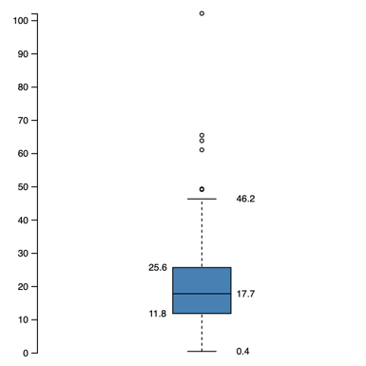
F
E
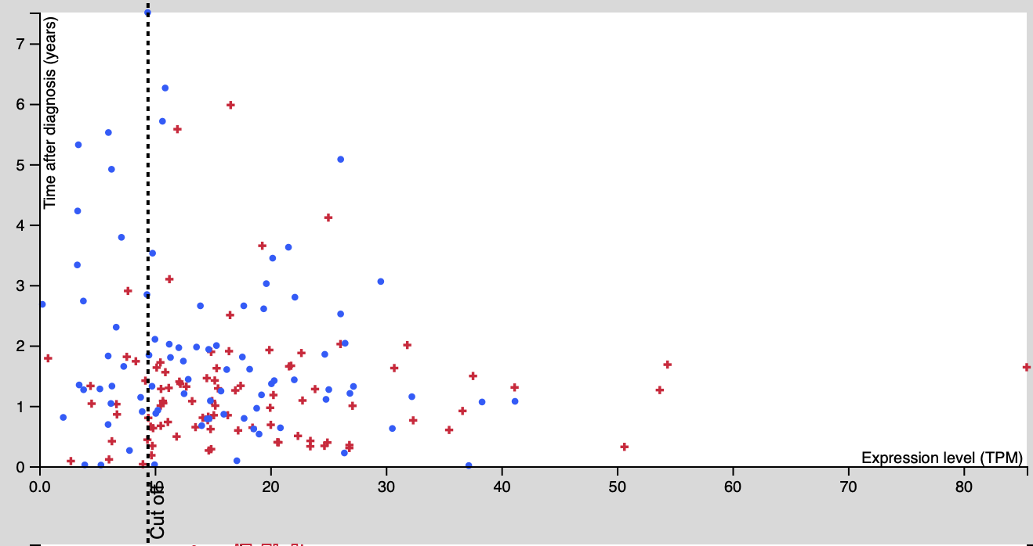
N=176
UNC5B expression

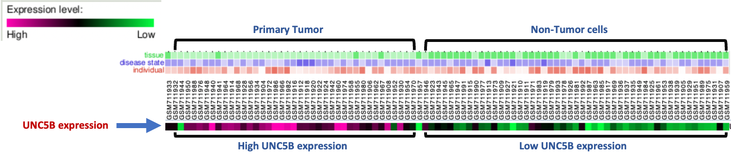
G
Representative colors
Tissue type


Disease State




H
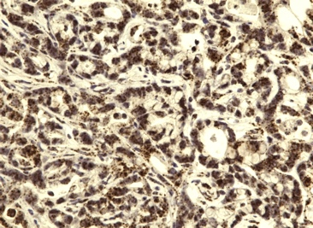

Mouse Normal Pancreas
Mouse PDAC Primary Tumor

Supplemental Figure 2
A
B
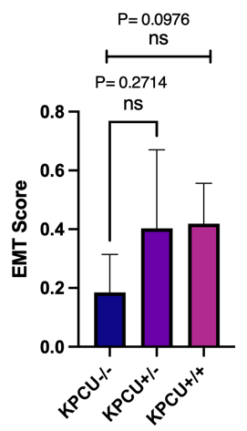
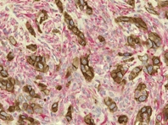
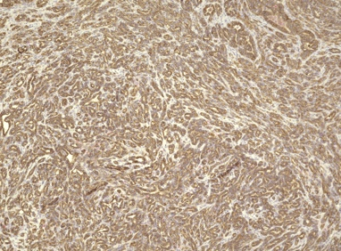
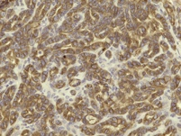
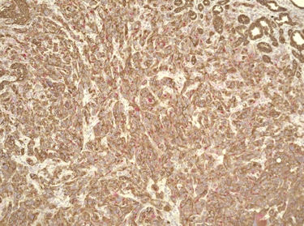
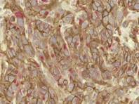
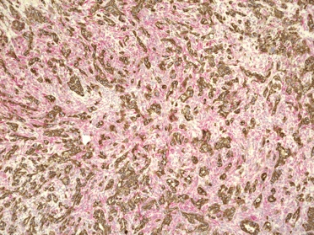
40X
40X
40X
E-cadherin, Vimentin

KPCU-/-
KPCU+/-
KPCU+/+
10X
10X
10X

C
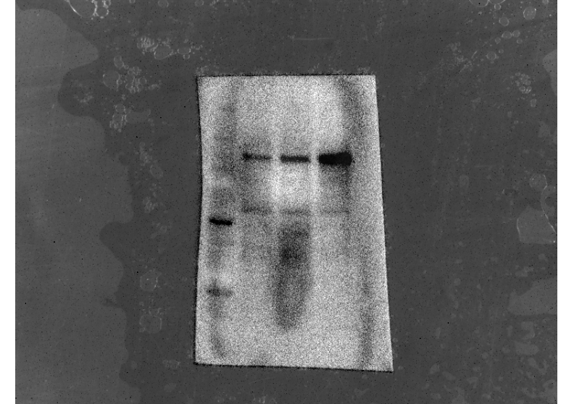
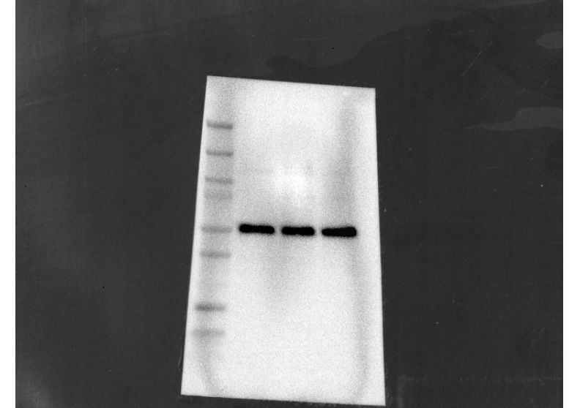
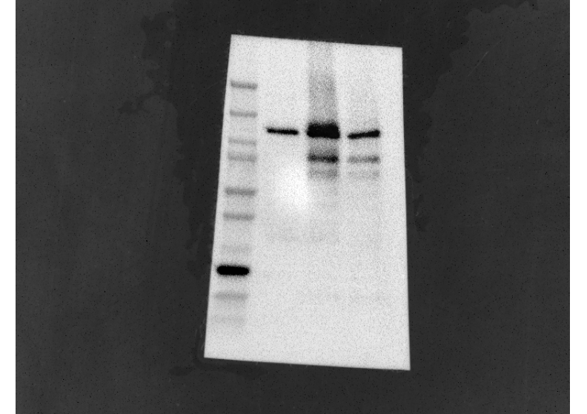
55kDa
Beta tubulin
E-Cadherin
135 kDa
150kDa
120kDa
Exo UNC5B
UNC5B OE/DP
KP4 UNC5B OE
Endo UNC5B
Endo UNC5B
Exo UNC5B
UNC5B OE
Beta tubulin
120kDa
55kDa
150kDa
KP4 EV

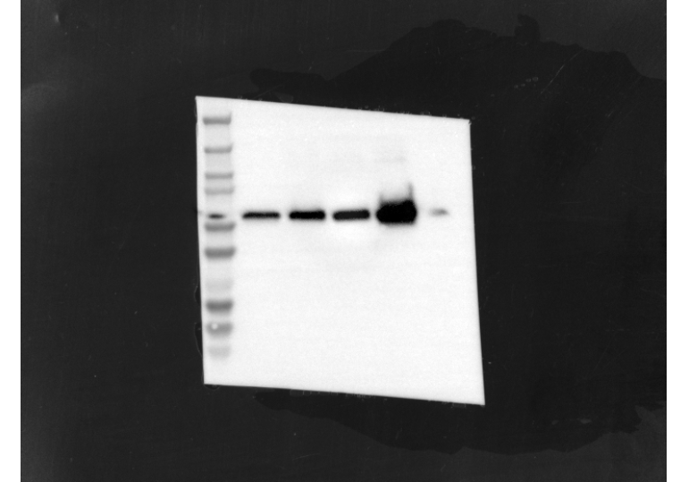
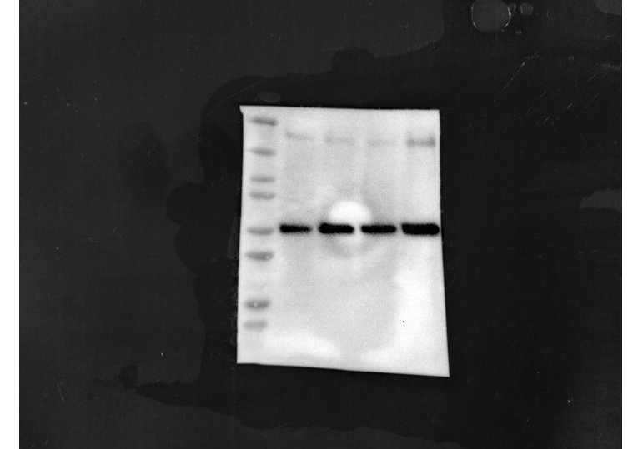
KP4 EV
UNC5B OE
Vimentin
Beta Tubulin
57 KDa
55 KDa
Vimentin
Merged
DAPI
KP4 EV
UNC5B OE

Merged
DAPI
Vimentin

D
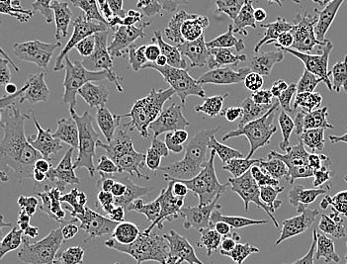
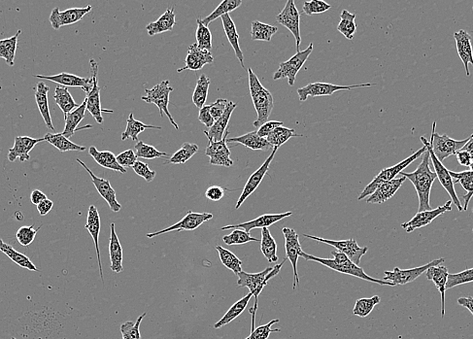
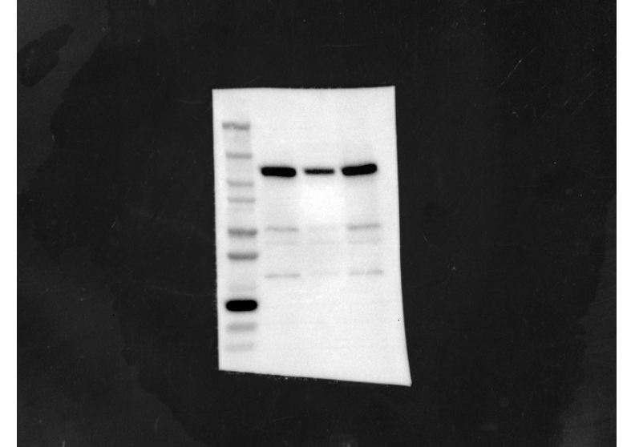
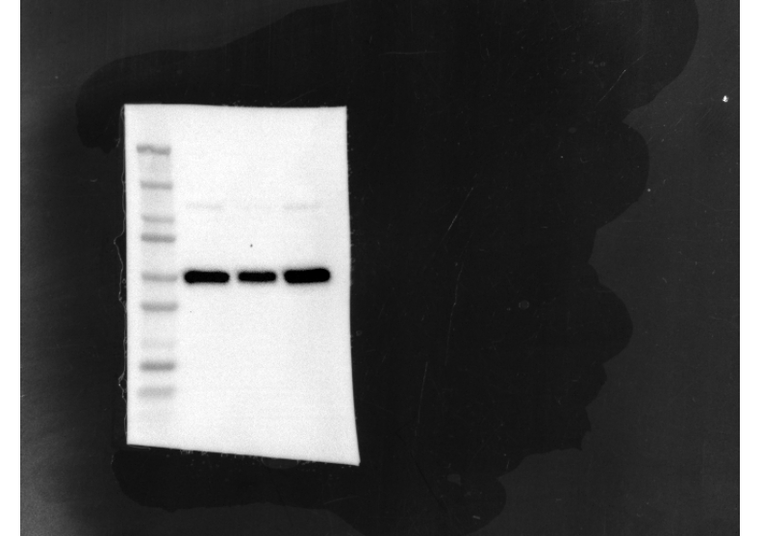
MIA-PACA2 EV
UNC5B
55 KDa
UNC5B KD
120 KDa
Beta Tubulin
MIA PACA-2 EV
UNC5B KD
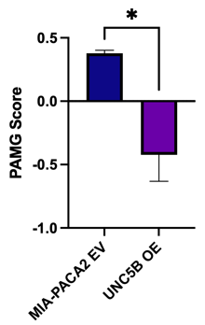
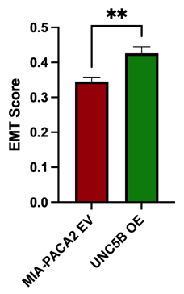

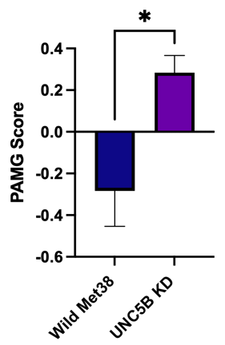
Wild Met 38
Unc5b KD
E

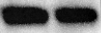
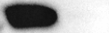
57 KDa
55 KDa
Vimentin
Beta tubulin

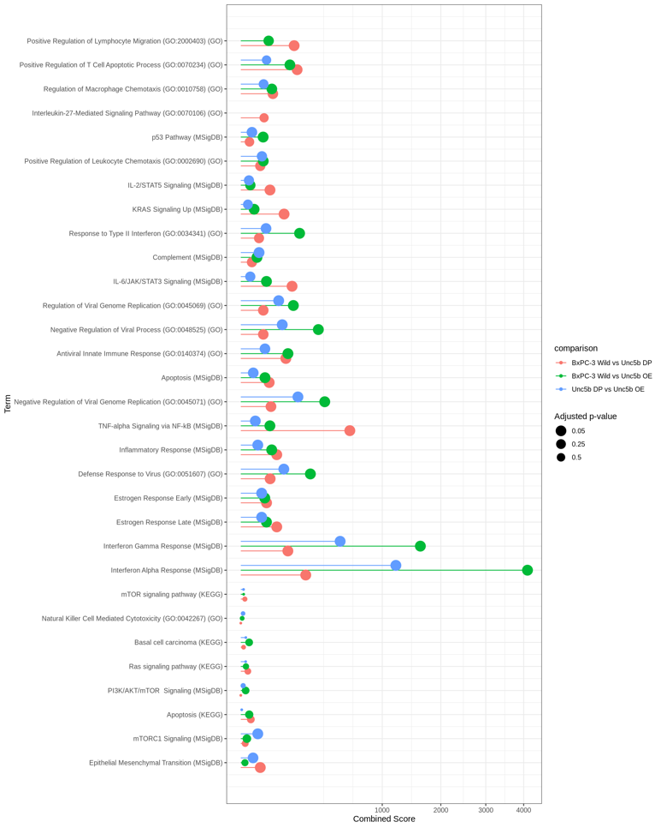
F
KEGG and MSigDB hallmarks UP
KEGG and MSigDB hallmarks Down
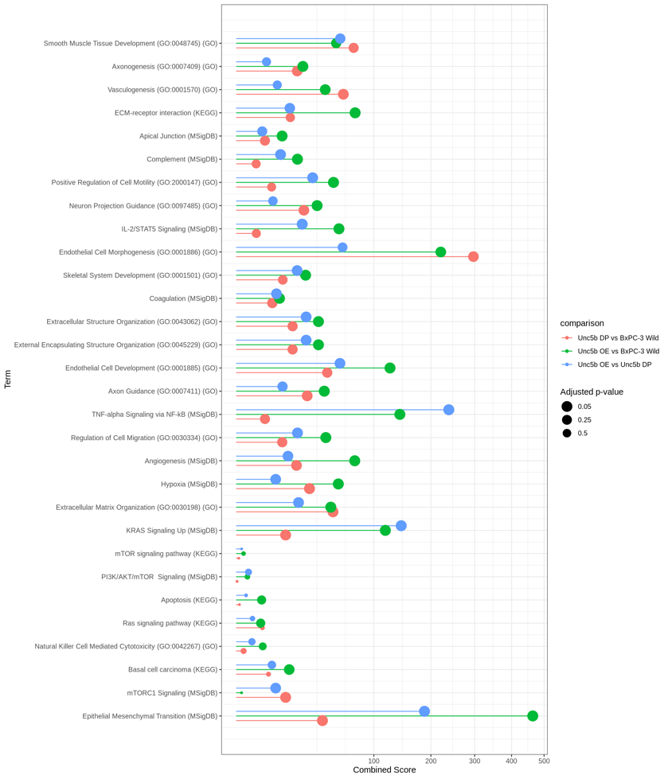

Supplemental Figure 3
A
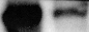
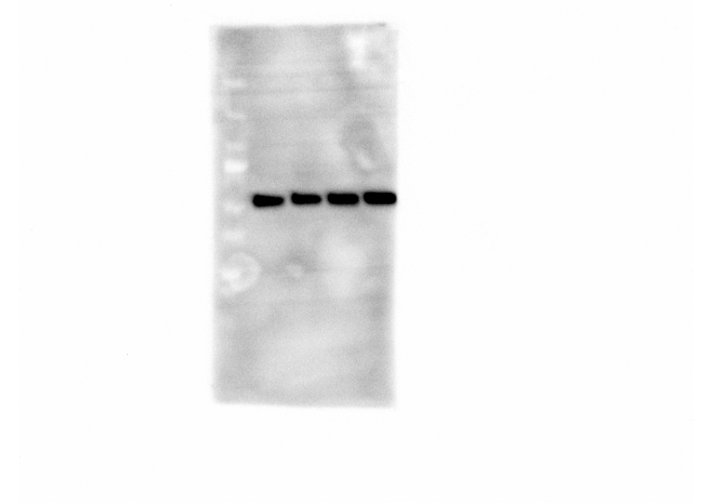
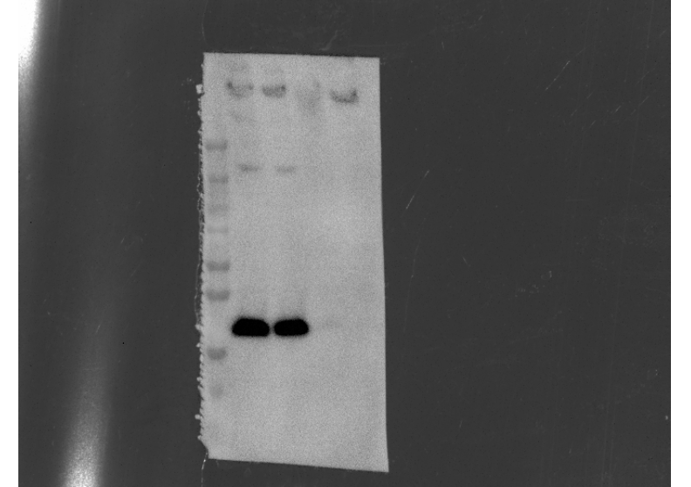
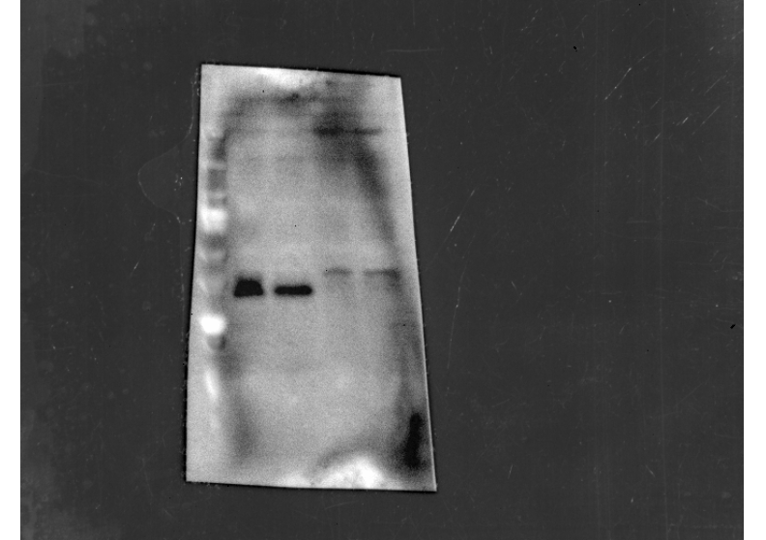
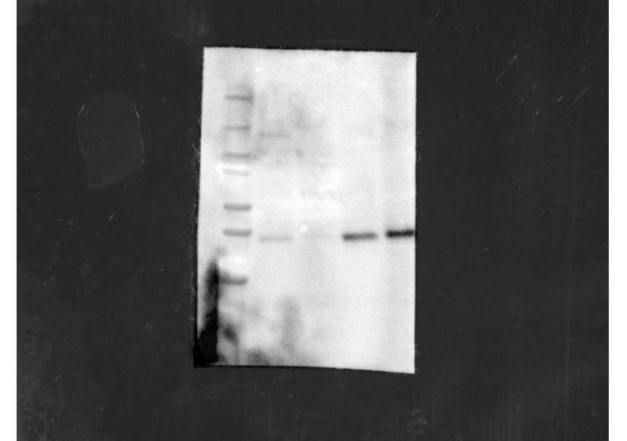
55 kDa
200 kDa
ZEB1
Beta Tubulin
29 kDa
26 kDa
Wild MIA-PACA
UNC5B KD
30 kDa

SNAIL
SLUG
TWIST1

B
C
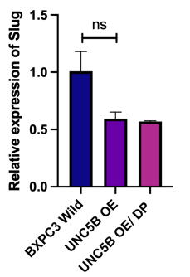
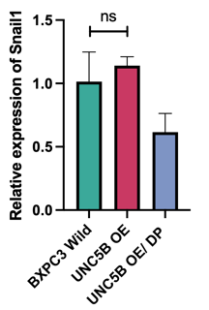
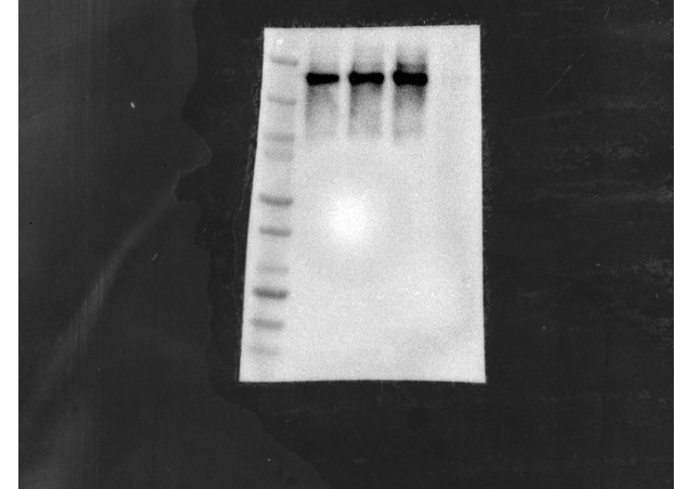
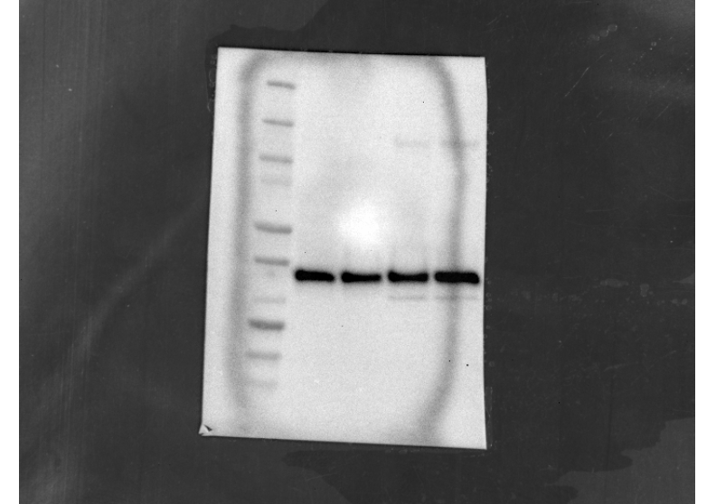
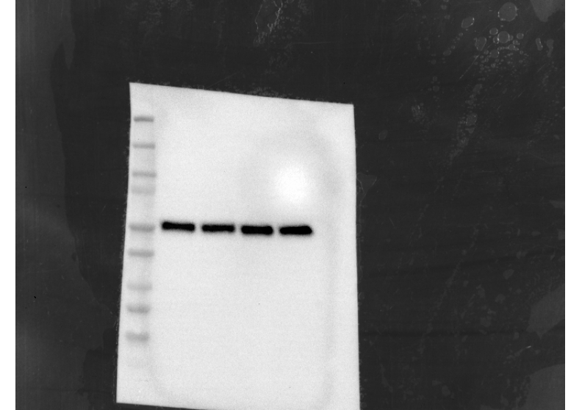
KP4 EV
UNC5B OE
Merged
DAPI
ZEB1
Merged
DAPI
UNC5B OE
Wild KP4
SNAIL
ZEB1
29 kDa
200 kDa
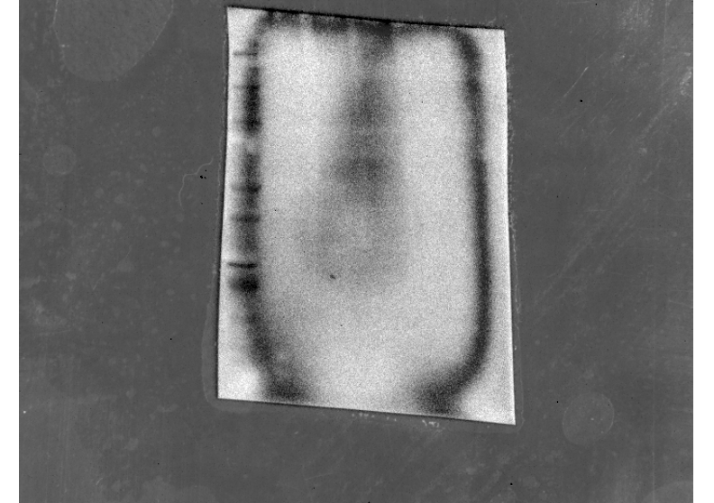
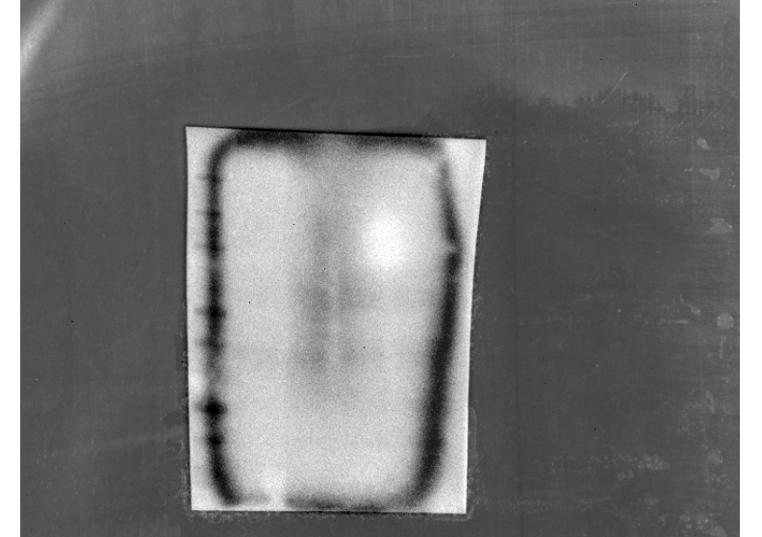
TWIST1
30 kDa
SLUG
26 kDa
ZEB1
Beta Tubulin
55 kDa

D
KP4 EV
UNC5B OE/ DP
UNC5B OE
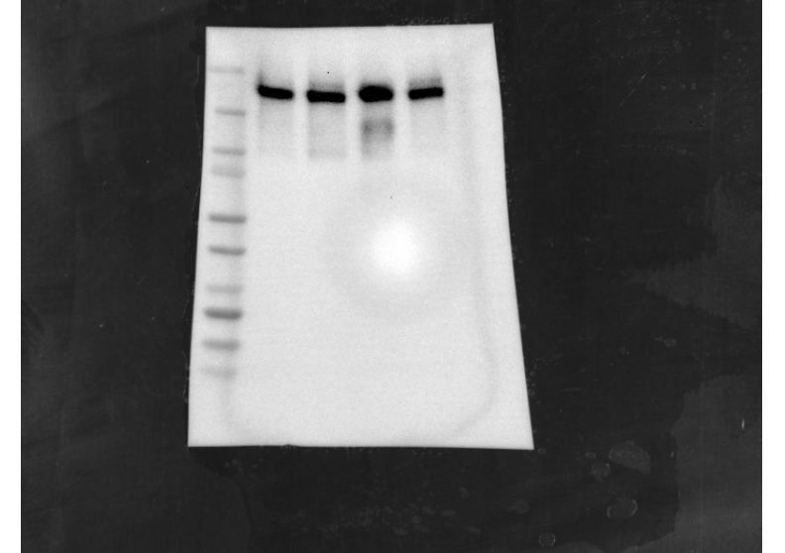
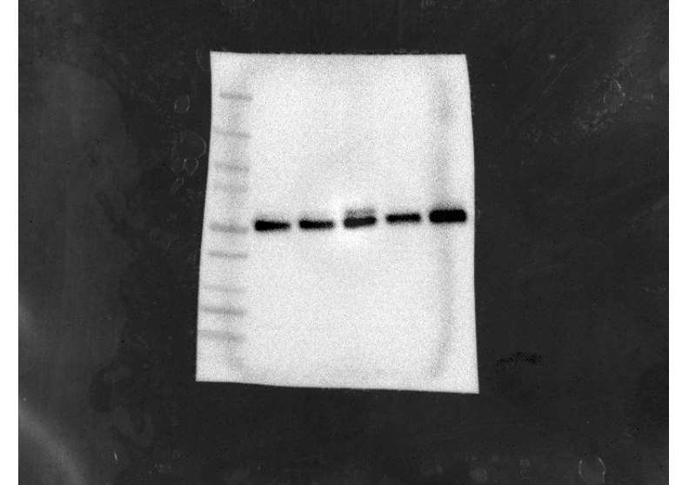
200 kDa
ZEB1
55 kDa
Beta Tubulin

E
UNC5B OE
Wild PANC1
UNC5B OE
Wild ASPC2
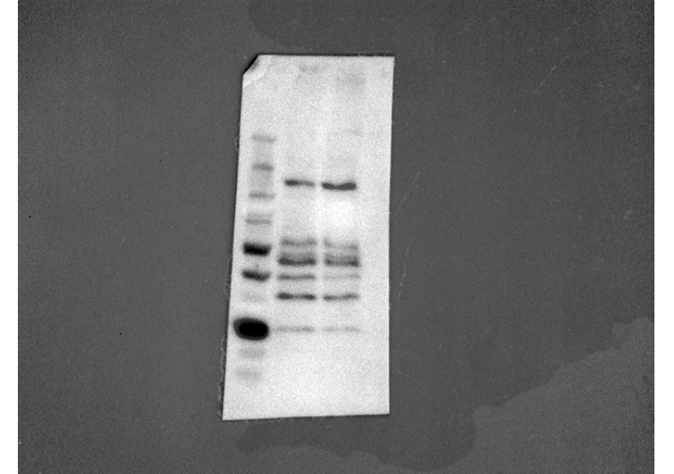
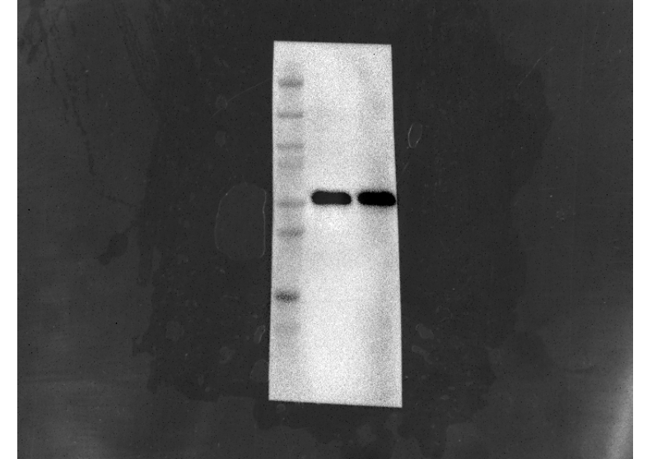
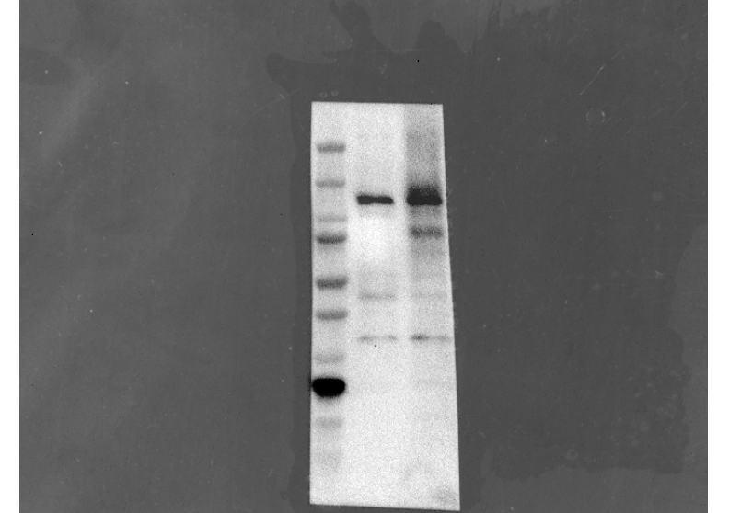
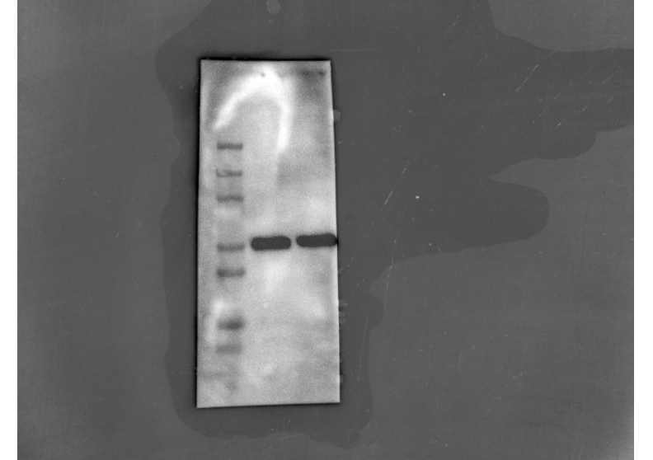
120kDa
55kDa
55kDa
120kDa
Beta Tubulin
UNC5B

F
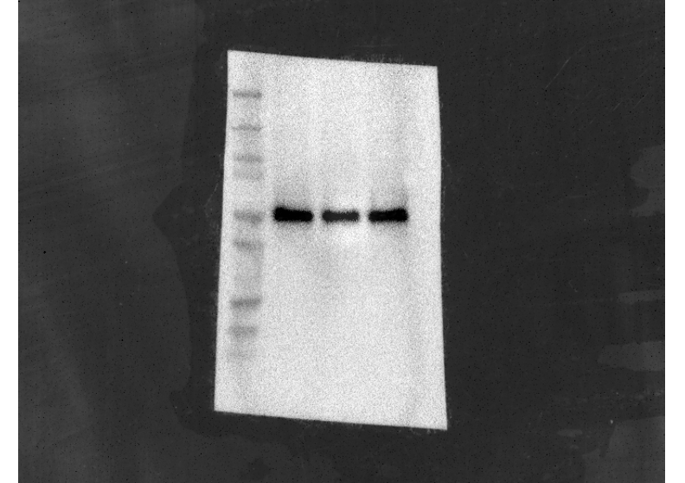
Wild BXPC3
UNC5B OE
UNC5B OE/DP
PTEN
Beta Tubulin

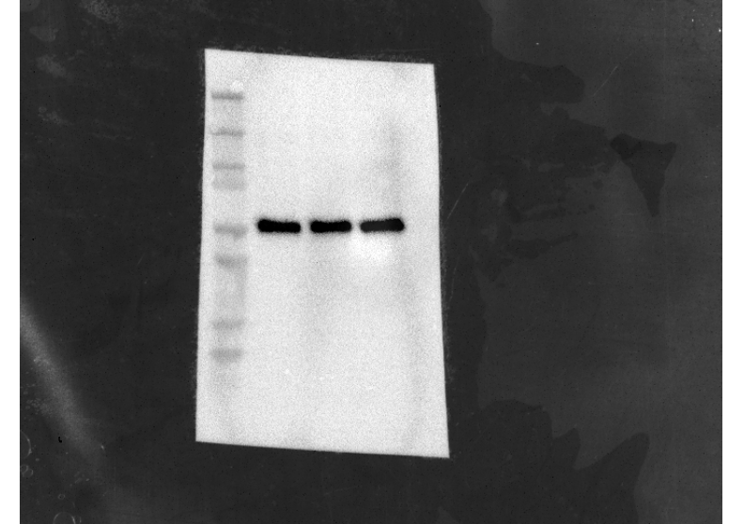
55kDa
54kDa

