Supplementary Information for

JNK Acts as a Molecular Brake of the CDC73 Positive Feedback Loop to Modulate Osteosarcoma Malignant Progression Via UBR5
Dingji Li¹, Xinchen Wang¹，Huigen Luo¹, Hua Tu ¹, Lili Hao ¹, IoHong Lei¹, Renjie Hu¹, Pengchao Zheng¹, Yuhan Shi¹, Jianbo Sun², Minying Zhu², Chengnong Guan³, Baoshan Xu*¹

This file contains the following contents:
Supplementary Figures and Figure Legends
Supplementary Tables
Supplementary Figures and Figure Legends
Figure Legends: Supplementary Figure S1. CDC73 protein expression levels after knockdown in 143B(A) and LM8(B) cells (Western blot)
Figure Legends: Supplementary Figure S2 A Clustering analysis of differential metabolites in supernatant of CDC73-knockdown LM8 cells. B KEGG pathway enrichment analysis of sh#1 and sh#2 CDC73-knockdown 143B cells.
Figure Legends: Supplementary Figure S3. Correlation between CDC73 expression and osteosarcoma patient survival in the GSE16091(P=0.057), GSE39055 (P=0.09) and the Target-OS dataset (P=0.533)
Figure Legends: Supplementary Figure S4 A-F CDC73 mRNA (qRT-PCR) and protein (Western blot) levels, and UBR5-GFP rescue effect (Western blot) in UBR5 KO 143B and U2OS cells. Data were shown as mean ± SEM for triplicates; ns not significant; ns: not significant; *p< 0.05; **p < 0.01; ***p < 0.001; ****p < 0.0001.
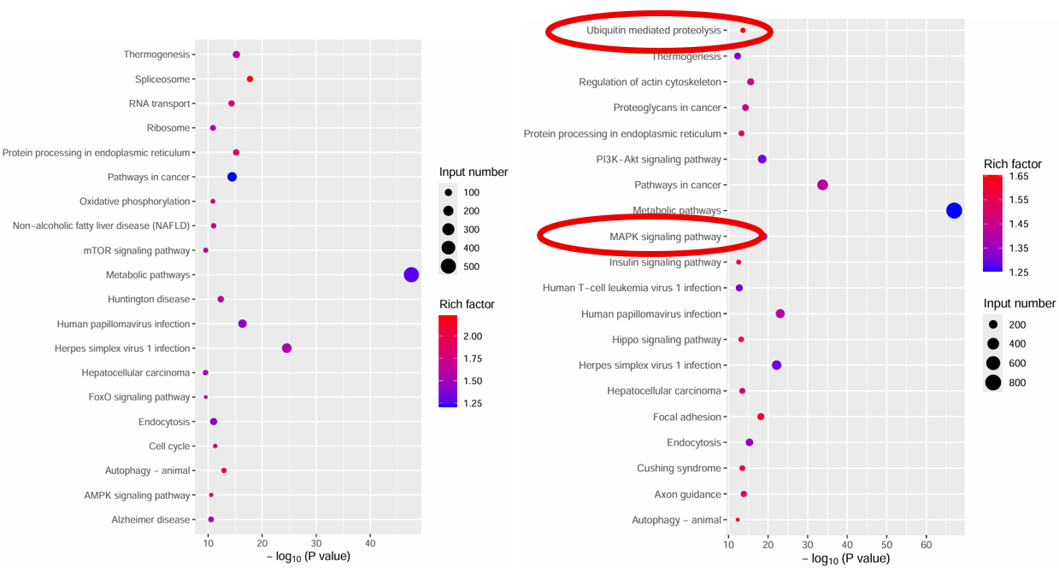
Figure Legends: Supplementary Figure S5. Kegg analysis on differentially expressed genes (DEGs) in LM8 WT cells and in LM8 ubr5⁻ cells
Figure Legends: Supplementary Figure S6 A Genomic functional region distribution of ATAC-seq peaks in 143B WT and ubr5⁻ cells. B Genome-wide TSS chromatin accessibility in 143B WT and ubr5⁻ cells (ATAC-seq). C 1961 upregulated and 3554 downregulated CDC73 binding peaks in ubr5⁻ cells. D-E GO and KEGG enrichment of UBR5 KO-specific peaks. F Differential Analysis of Transcription Factor Binding Motifs in the CDC73 Promoter Region Between Groups (Cross-species false-positive annotations excluded). G Family classification of CDC73-regulatory TFs specific to 143B UBR5⁻ cells. H Functional clustering of the 35 TFs into 5 categories
Figure Legends: Supplementary Figure S7 A Genomic functional region distribution of CUTTAG peaks in 143B WT and ubr5⁻ cells. B Genome-wide TSS chromatin accessibility in 143B WT and ubr5⁻ cells （CUTTAG). C KEGG analysis showing specific enrichment of protein kinase binding and mRNA splicing in 143B ubr5- cells. D 625 upregulated and 1080 downregulated CDC73 binding peaks in ubr5⁻ cells. E GO Enrichment Analysis of Genes Corresponding to Specific Peaks in 143B ubr5⁻ Cells

Figure Legends: Supplementary Figure S8 The CCK-8 assay was performed in 143B and U2OS osteosarcoma cells with UBR5/CDC73 knockdown or non-knockdown.
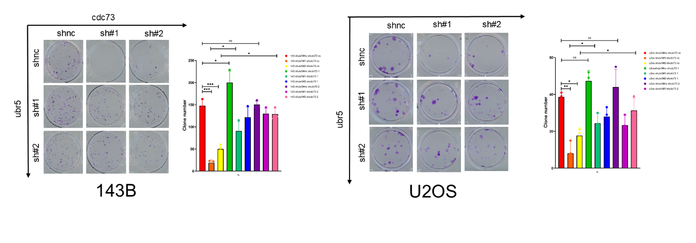
Figure Legends: Supplementary Figure S9. The Colony Formation assay was performed in 143B and U2OS osteosarcoma cells with UBR5/CDC73 knockdown or non-knockdown.
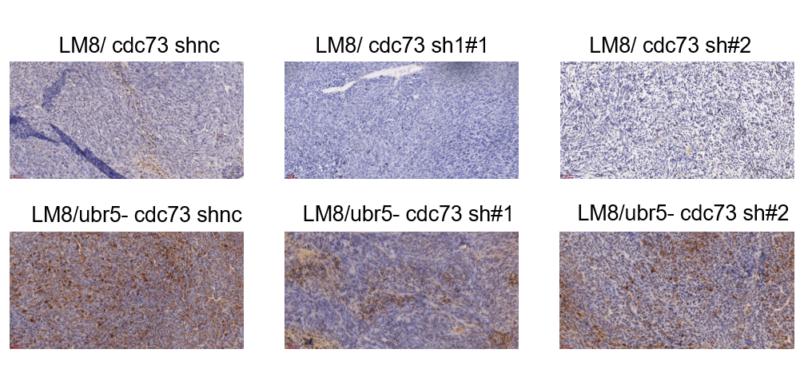
Figure Legends: Supplementary Figure S10. The expression of cleaved caspase-3 was examined by IHC staining
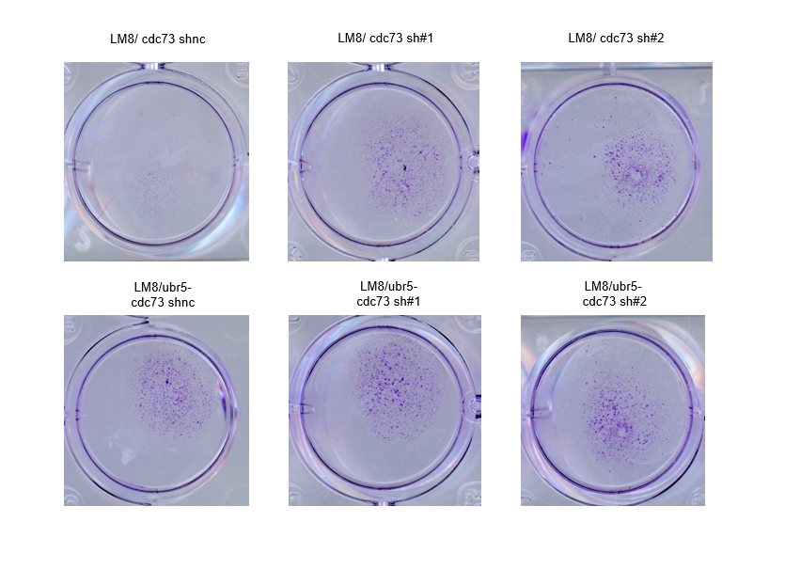

Figure Legends: Supplementary Figure S11. Lung tissues bearing tumor nodules derived from cells with different gene knockout or knockdown were cultured in the presence of 500 nM G418 for 7 days, stained with 1% crystal violet staining solution, and then imaged using a scanner.
Figure Legends: Supplementary Figure S12 A Representative bioluminescence images of orthotopic tibial tumors in nude mice (left) and quantitative analysis of total photon flux from the tumor-bearing tibiae (right). Tumor-bearing mice were injected with UBR5‑knockout, CDC73‑knockdown, or control cells. Normalization was based on the mean fluorescence of the reference region, calculated as: [target total intensity / target mean intensity] × (target mean intensity – reference mean intensity). B TUNEL staining of tumor sections from the tibial injection sites (left) and quantification of TUNEL-positive cells (right). Scale bar, 50 μm. C Representative gross images of lungs harvested from each group. No visible tumor nodules were observed in any of the groups. D H&E staining of lung sections. Scale bar, 100 μm. E Flow cytometric quantification of fluorescent-positive cells in lung tissues. Single-cell suspensions were prepared from digested lungs, and the percentages of GFP-positive (or luciferase-positive) cells were quantified as a measure of metastatic tumor burden. $n=4$ mice per group. *$p<0.05$, **$p<0.01$. **$p<0.001.$N.S., not significant.
Figure Legends: Supplementary Figure S13. JNK-regulated UBR5 mediates proteasomal degradation of CDC73
A Western blot analysis of CDC73 expression in 143B wild-type (WT) and UBR5 KO cells treated with 50 μg/ml cycloheximide (CHX). B CDC73 protein levels in 143B WT/UBR5 KO cells treated with proteasome inhibitors MG-132 (10μM, 8h). C CDC73 levels in the 143B WT/UBR5 KO cells treated with 100nM broad-spectrum kinase inhibitor staurosporine (STS, 8h). D CDC73 and LC3B levels in cells treated with 20μM autophagy inhibitor chloroquine (CQ, 8h) to verify autophagy inhibition efficacy. E CDC73 levels in 143B WT/UBR5 KO cells treated with 0, 20, 50nM siJNK for 30h. F GAPDH and JNK were detected separately on the same membrane with figure 7H. G CDC73 degradation in cells treated with CC-401(10uM,12h), alone or combined with MG-132(10uM,12h). H Ubiquitination assay of CDC73 in GFP-UBR5-transfected 143B cells pre-treated with 50 nM siJNK for 20 h, followed by treatment with or without 10 μM MG-132 for an additional 10 h.
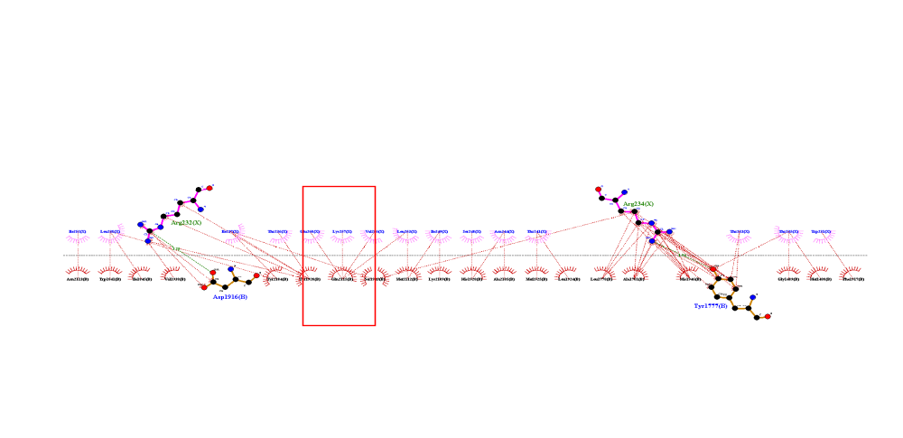
Figure Legends: Supplementary Figure S14. 2D results of molecular docking showed that CDC73 Lys257 interacts with UBR5 via hydrophobic bonds and is the only lysine residue in this region.

