Nuclear Cathepsin L induces DNA damage by regulating of DNA repair factors in ovarian cancer

Prabhu Thirusangu¹*, Upasana Ray¹*, Ling Jin¹*, Biswajit Das², Christopher L Pathoulas^{1,3}, Julie Staub¹, Ann L Oberg⁴, Xiaonan Hou⁴, Jamison L VanBlaricom⁴, Nagarajan Kannan¹, John Weroha⁴, Jamie N Bakkum-Gamez⁴ and Viji Shridhar¹**

¹Department of Experimental Pathology and Medicine, Mayo Clinic, Rochester, MN, USA
²Department of Molecular, Cell, and Developmental Biology, University of California, Santa Cruz, CA, USA
³University of Connecticut Health Center-Medical School, Farmington, CT, USA
⁴Department of Oncology, Mayo Clinic, Rochester, MN, USA

*These authors contributed equally
** Corresponding author: Viji Shridhar (shridhar.vijayalakshmi@mayo.edu)

Supplementary Materials
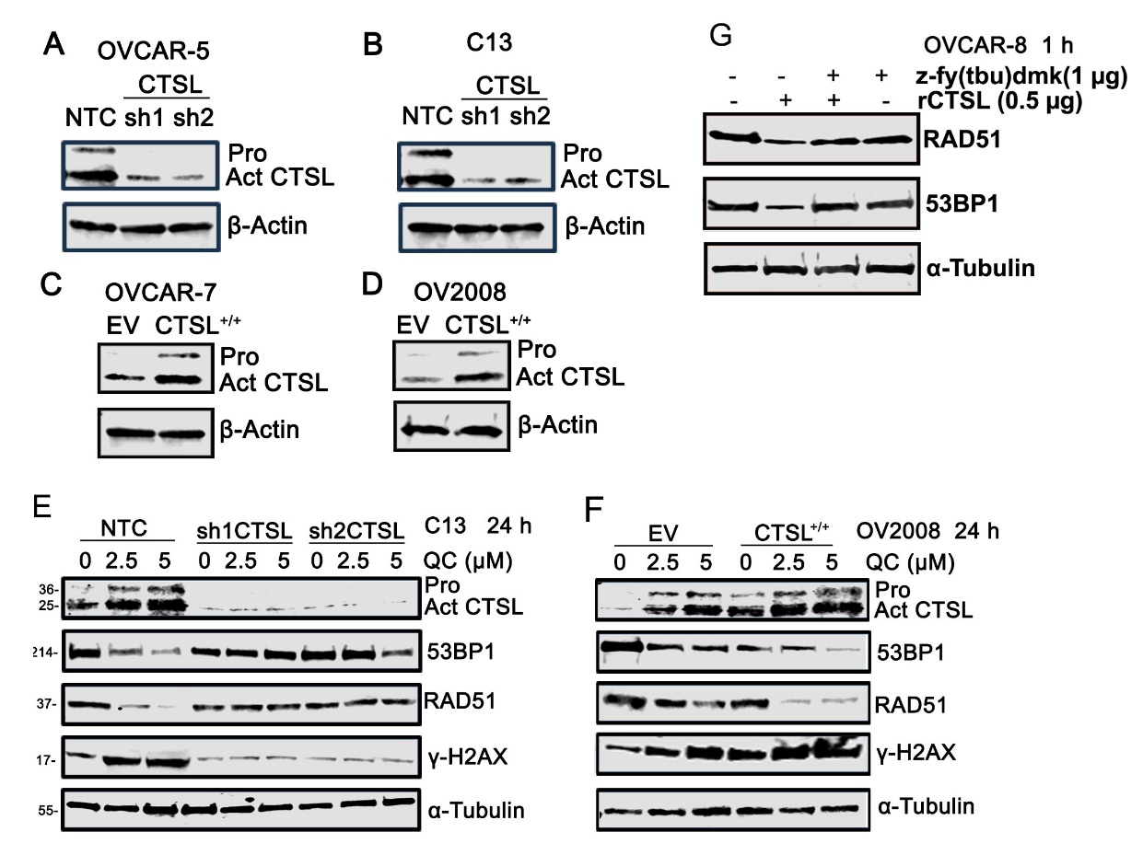

Supplementary figure 1: (A and B) Western blot showing confirmation of genetic knockdown of CTSL in OVCAR5 and C13 respectively. (C and D) Immunoblot analysis of confirmation of ectopic expression of CTSL in OVCAR7 and OV2008 respectively. (E) Western blot analysis of 53BP1, RAD51 and y-H2AX protein levels in C13- CTSL knockdown cells treated with QC at specified concentrations. (F) Western analysis of above-mentioned proteins in CTSL overexpressed cervical cancer OV2008 (EV, CTSL^{+/+}) cells. (G) Western blot showing RAD51 and 53BP1 levels after OVCAR 8 lysates incubated with rCTSL in plus or minus CTSL inhibitor at indicated concentration. β-actin and α-Tubulin were used as loading control.

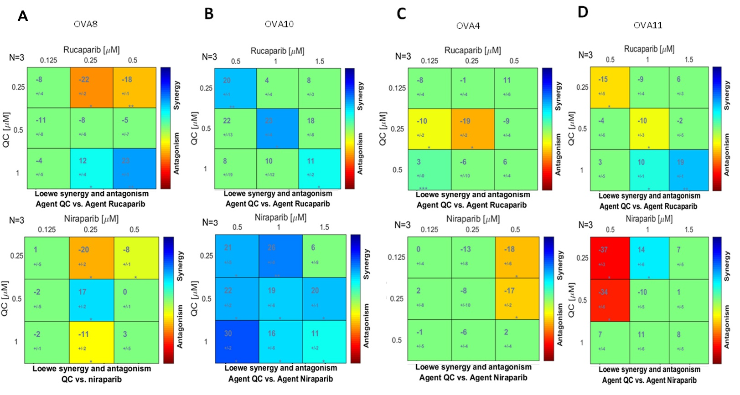
Supplementary Figure 2: (A, B, C, D) Dual drug response assays for QC + rucaparib and QC + niraparib were performed in OVAs (OVA-8, 10, 4, 11) cells ex vivo. Each assay included three technical replicates, repeated independently three times (N=3), and was analyzed using the Loewe synergy and antagonism matrix model with Combenefit software. Statistical significances were expressed as *p < 0.05, **p < 0.01 and ***p < 0.001.
A B
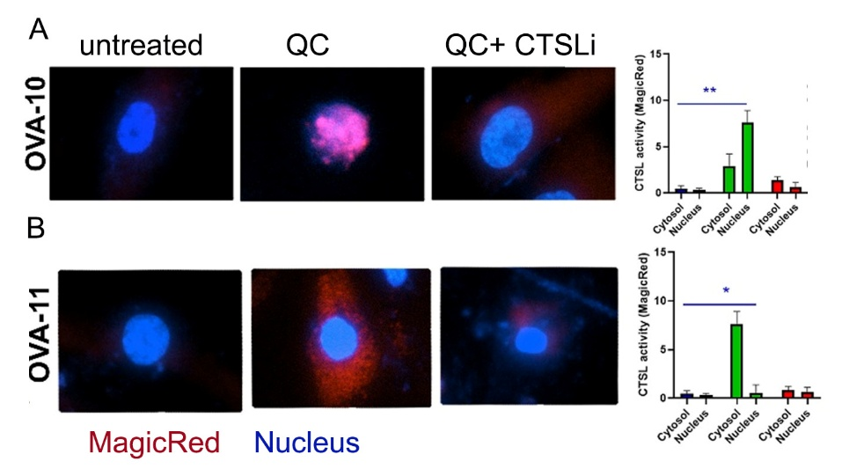
Supplementary figure 3: (A and B) Detection of intracellular CTSL activity upon treating with QC (5µM) and Z-FY-(tBU)-DMK (5 µM) in OVA-10 and OVA-11 by MagicRed live cell imaging and Respective bar graphs show quantification of number of cells with active CTSL in cytosol vs nucleus ((n/100 cells counted/field X 3). Statistics were analyzed by student’s t-test and statistical significances were expressed as *p < 0.05, **p < 0.01 and ***p < 0.001.

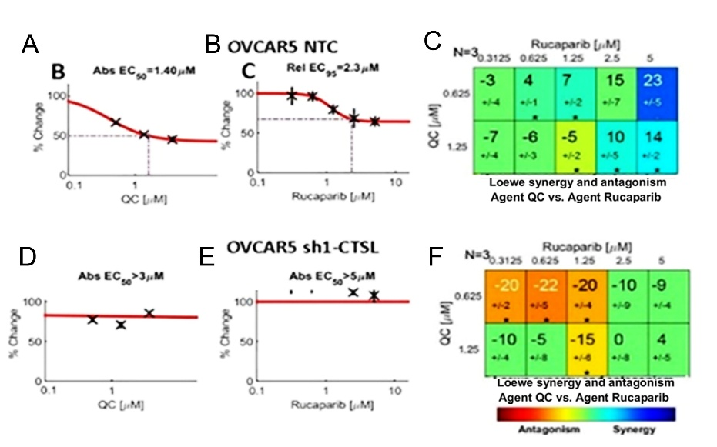

Supplementary Figure 4: (A, B, D, E) Growth curve of OVCAR5 NTC and shCTSL cells upon treatment with QC or rucaparib, and CTSL KD cells are resistant to QC or rucaparib treatments. (C and F) Dual drug response assays for QC + rucaparib were performed in OVCAR5 NTC and shCTSL cells respectively. Each assay included three technical replicates, repeated independently three times (N=3), and was analyzed using the Loewe synergy and antagonism matrix model with Combenefit software.

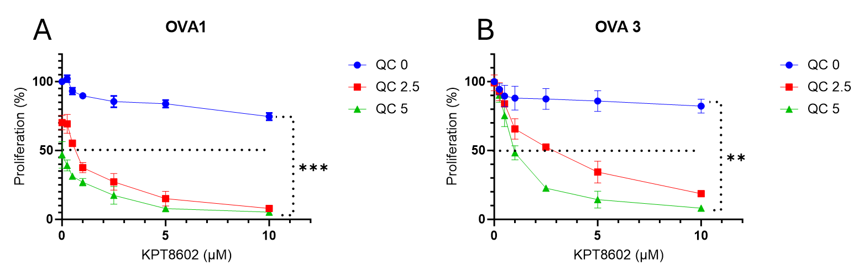
Supplementary Figure 5: Proliferation of OVA1 (A) and OVA3 (B) cells following treatment with QC and KPT-8602 combinations at the indicated concentrations was assessed using the CCK-8 assay. Each experiment was performed with three technical replicates and independently repeated three times (N=3). Data was analyzed using GraphPad Prism, and statistical significance was determined by Student’s t-test. Significance levels are indicated as **p < 0.01 and ***p < 0.001.

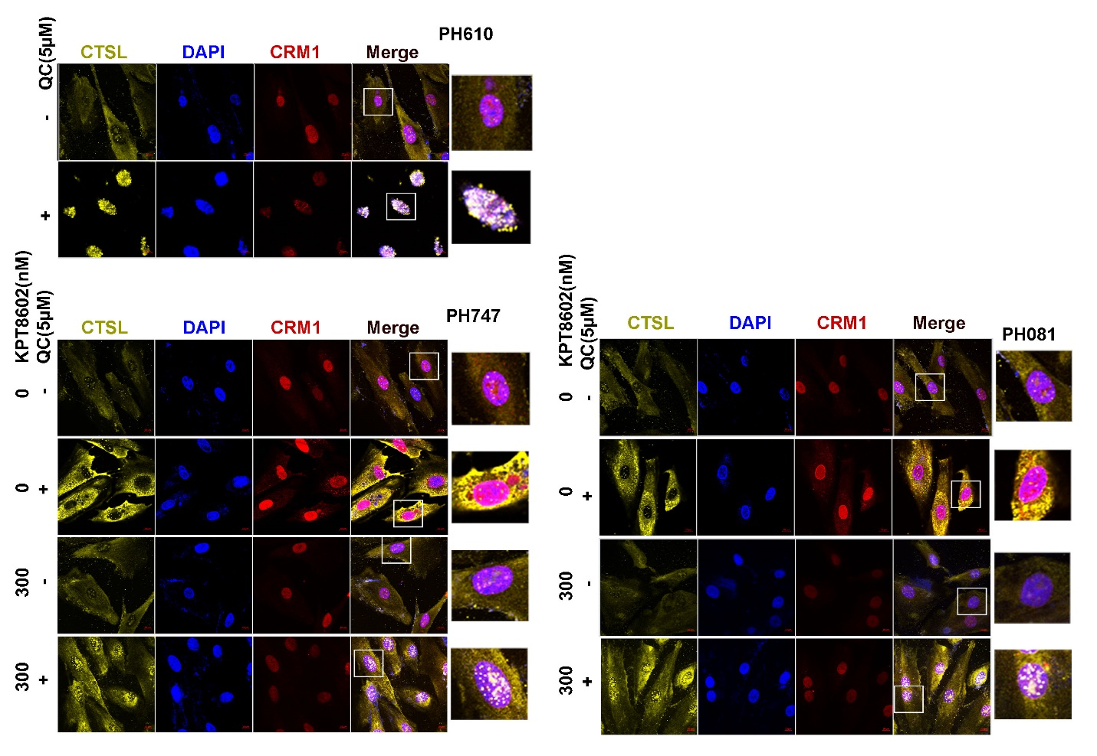
Supplementary figure 6: Representative immunofluorescence images of CTSL (yellow) and CRM1 (red) in (A)PDX-PH610, (B)PH747 and (C)PH081 cells following 24-hour treatment with the indicated inhibitors are shown (40X magnification, scale bar: 5 μm). DAPI was used to stain the nucleus.

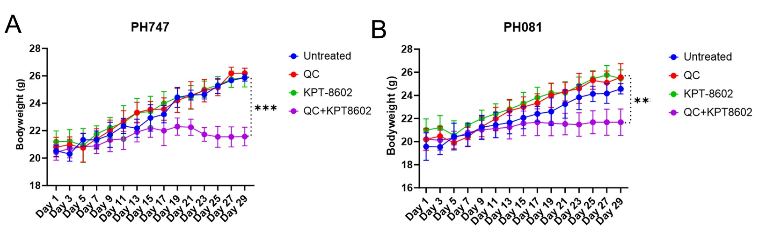
Supplementary Figure 7: (A and B) Graphs showing tumor growth curves of untreated, QC (50 mg/kg daily) and KPT-8602 (5 mg/kg 5 days/week) combinations by oral gavage for 28 days, measured by body weight. Statistics were assessed by Student’s t-test and statistical significances were expressed as **p < 0.01 and ***p < 0.001 vs control).

Supplementary table 1: source of materials used
Sl no | Name of the chemicals/reagent/plasmid | Catalog number | Manufacturer
1 | Quinacrine | Q3251 | Sigma Aldrich
2 | Eltanexor (KPT-8602) | S8397 | Selleckchem (Houston, TX USA)
3 | Niraparib | MK4827 | Chemietek, Indianapolis, Indiana)
4 | Rucaparib |  | Clovis Oncology (Boulder, CO)
5 | Z-FY(tBU)-DMK | sc-222423 | Santa Cruz Biotechnology Inc.
6 | Z-DEVD-FMK | #14414 | Cayman Chemicals
Sl no | Name of the Antibodies/Plasmid/Kits | Catalog number | Manufacturer
1 | Anti-CRM1 | sc-28359 | Santa Cruz Biotechnology Inc.
3 | anti-GAPDH | sc-47724 | Santa Cruz Biotechnology Inc.
4 | anti-C9 tag | sc-390000 | Santa Cruz Biotechnology Inc.
5 | anti-KPNB1 | sc-137016 | Santa Cruz Biotechnology Inc.
7 | anti-β actin | SC-47778 | Santa Cruz Biotechnology Inc.
8 | anti- α tubulin | sc-5286 | Santa Cruz Biotechnology Inc.
9 | Anti-CRM1 | #46249S | Cell Signaling Technology
10 | anti- PARP | #9541S | Cell Signaling Technology
11 | anti-53BP1 | #11940 | Cell Signaling Technology
12 | cell lysis buffer | #9803S. | Cell Signaling Technology
13 | anti- RAD51 | #ab133534 | Abcam
14 | Anti-CTSL | #10486-R221 | Sino Biological
15 | IRDye 680 LT goat anti mouse IgG, red | 926-68020 | Li-Cor, Lincoln, NE, U.S.A.
15 | IRDye 800CW Donkey anti-Mouse IgG, green | 926-32212 | Li-Cor, Lincoln, NE, U.S.A.
15 | IRDye 800 goat anti rabbit IgG, green, | 926-32211 | Li-Cor, Lincoln, NE, U.S.A.
15 | IRDye 680RD Donkey anti-Rabbit IgG, red | 926-68073 | Li-Cor, Lincoln, NE, U.S.A.
16 | Pacific Blue™ Annexin V | #11 858 777 | Roche, Basel, Switzerland
17 | shCTSL -TRC1.5 plasmid | SHCLNG-NM_001912 | Sigma Aldrich
18 | anti- RAD51 | #ab133534 | Abcam
19 | pcDNA3.1-hCathepsin L construct | #11250 | Addgene
20 | recombinant human CTSL (rCTSL) protein | 952-CY | R&D Systems
21 | recombinant human CTSB (rCTSB) protein | 10483-H08H | Sino Biological
22 | NE-PER nuclear and CE-PER | #78833 | Life Technologies
23 | Magic Red® Cathepsin L Assay | #942 | ImmunoChemistry Technologies LLC

