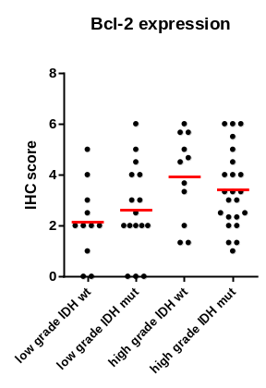
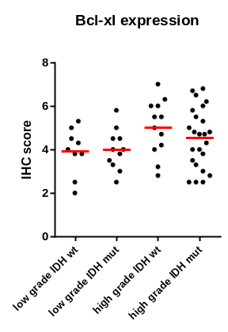
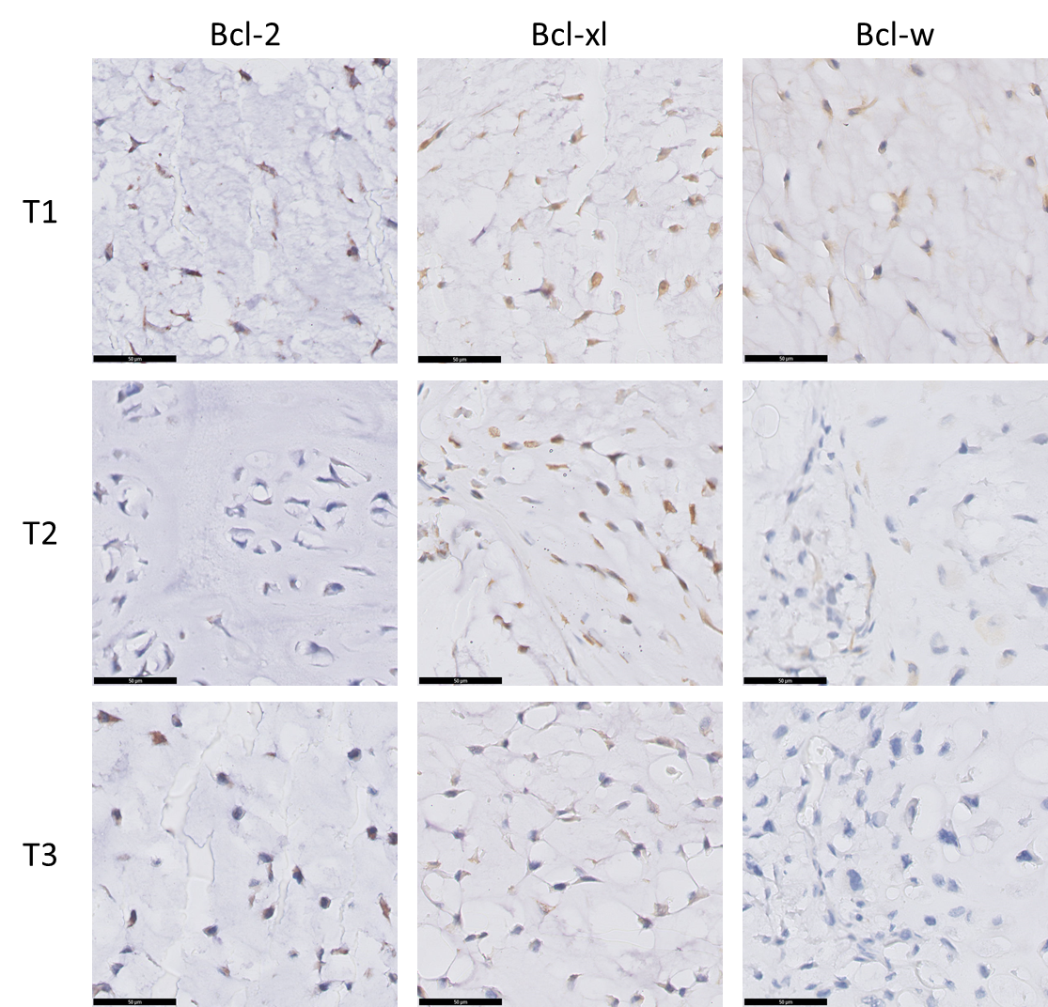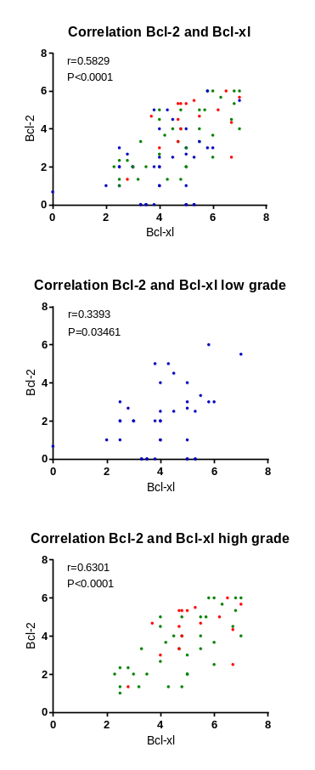
C
B
A
Supplementary figure 1.
A. Immunohistochemical staining results of three different cases of high grade chondrosarcoma tumor samples showing different staining patterns for Bcl-2, Bcl-xl and Bcl-w. B. A positive correlation is observed between Bcl-2 and Bcl-xl expression in chondrosarcoma patient tissue samples (r=0.5829, P<0.0001). Blue = Grade I , Green = Grade II, Red = Grade III. Higher grade chondrosarcomas show a stronger correlation (r=0.6301, P<0.0001) compared to low grade chondrosarcomas (r=0.03393, P=0.03461) Correlation is determined using the spearman correlation test. C. Bcl-2 and Bcl-xl expression are not correlated towards IDH mutation status

