

Supplementary Information for

Hypoxia induces an endometrial cancer stem-like cell phenotype via HIF-dependent demethylation of SOX2 mRNA
Guofang Chen^{1, #, *}, Binya Liu^{2, #}, Shasha Yin¹, Shuangdi Li², Yu’e Guo¹, Mengfei Wang¹, Kai Wang^{1, *}, Xiaoping Wan^{2, *}

# Guofang Chen and Binya Liu contributed equally to this work.
* To whom correspondence should be addressed.
E-mail: chenguofang@tongji.edu.cn (Guofang Chen), kaiwangcn@yahoo.com (Kai Wang), wanxiaoping@tongji.edu.cn (Xiaoping Wan)

This file includes:

Figures S1 to S4 and Supplementary figure legends
Table S1 to S2 and Supplementary table legends

S Figure legends

Figure S1. Stemness gene expression levels during ECSC expansion.
(A) qRT-PCR analysis of stemness genes of ECSCs isolated from the EC cell lines ECC-1, RL95-2 and HEC-1A. Mean ± SEM; *P < 0.05, **P < 0.01, and ***P < 0.001.

Figure S2. Characterization of the self-renewal and pluripotency of ECSCs.
(A) Western blot analysis of pluripotency and lineage-specific markers of ECSC^{isk} after differentiation from days 1-20. (B, C) Immunofluorescence staining of pluripotency markers (NANOG and SOX2) in ECSC^{isk} (B) and ECSC^{ecc} (C). (D) A total of 1×10⁶ ISK cells or 1×10⁴ ECSC^{isk} were injected into female BALB/c nu/nu mice, and after 4 weeks, tumour formation in both groups was analysed (scale bar = 25 μm).

Figure S3. The effect of SOX2 on the maintenance of ECSCs.
(A, B) The number of primary (A) and secondary (B) mammospheres of ECSC^{isk} after SOX2 inhibition under hypoxic or normoxic conditions for 72 h was determined. (C) FACS analysis of the percentages of CD133-positive cells in tumours from SOX2 knockdown ECSCisk that were subjected to 2% or 21% O2 for 72 h. (D) Immunohistochemical staining of HIF1α and SOX2 in three different EC samples (EC sample #1, #2, #3) (scale bar = 25 μm). Mean ± SEM (N = 3). **/## P < 0.01, and ***/### P < 0.001.

Figure S4. Knockdown of HIF-1α or HIF-2α represses the self-renewal of ECSCs.
(A, B) qPCR (A) and Western blot (B) analysis of the expression of HIF-1α or HIF-2α following treatment with shRNAs. (C) The morphology of ECSC^{isk} after HIF-1α or HIF-2α inhibition under hypoxic or normoxic conditions for 2 days (scale bar = 25 μm). Mean ± SEM (N = 3). **P < 0.01.

Figure S1
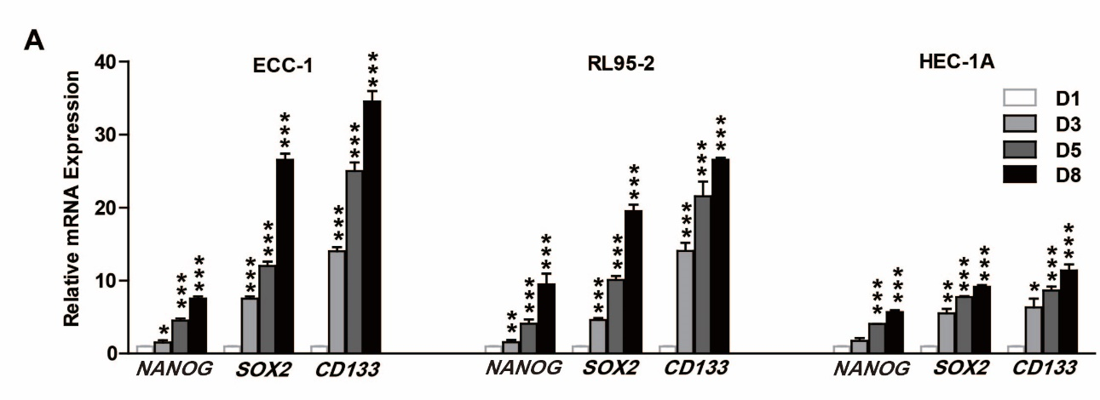

Figure S2
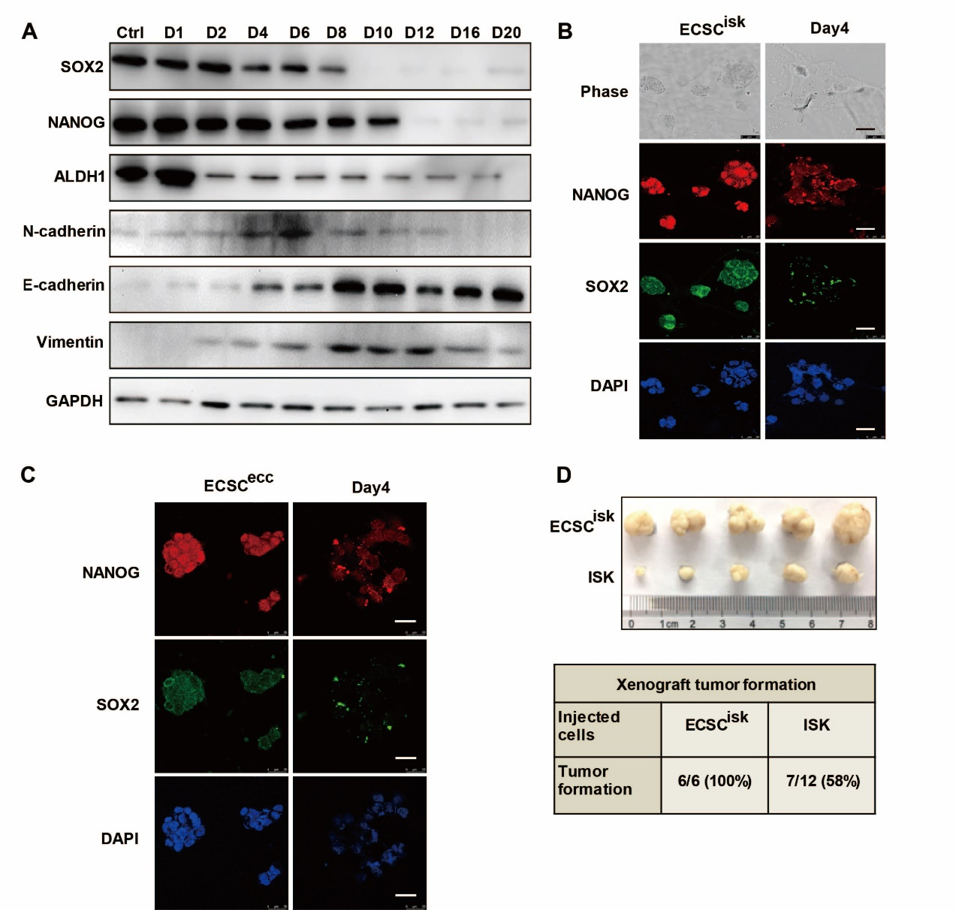

Figure S3
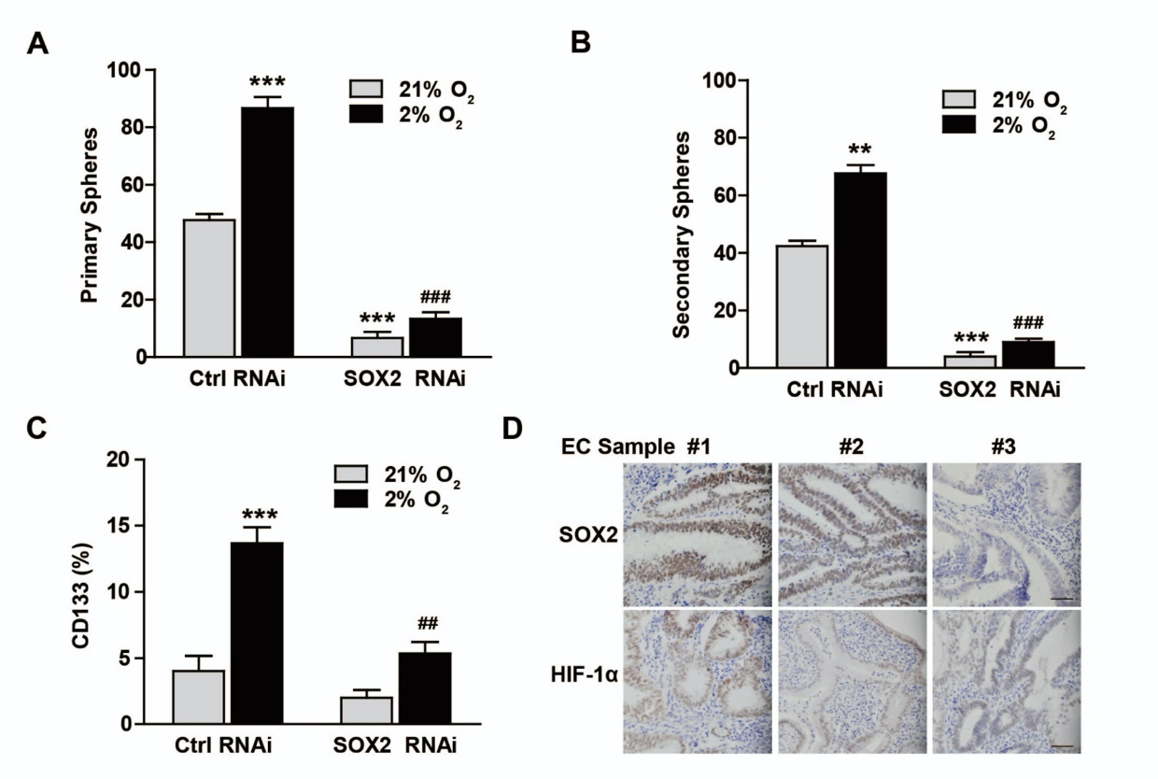

Figure S4
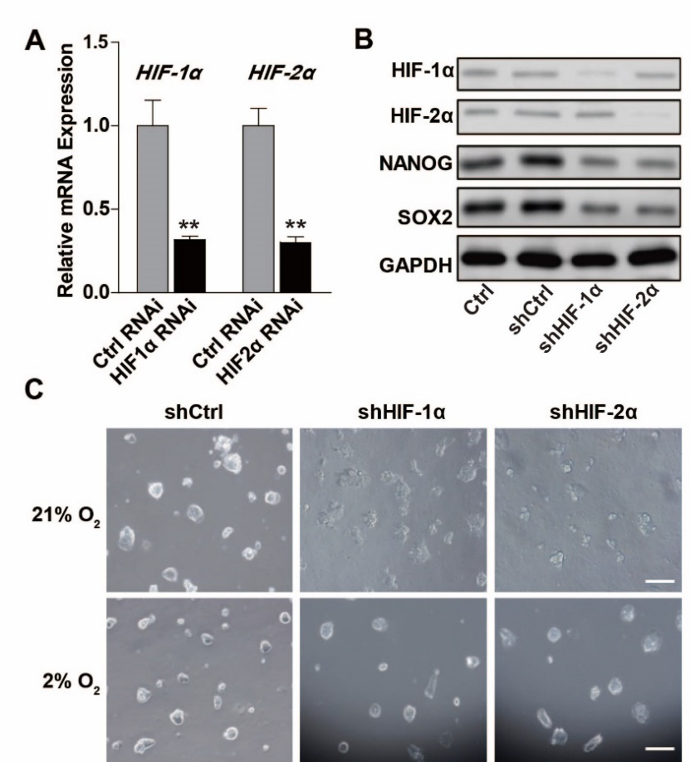

S Table legends

Table S1. The correlation between the expression of SOX2 and HIF-1α with clinical features.

Table S2. Primers sequences used for qRT-PCR analysis

Table S1
Characteristic | Total | SOX2 expression |  | HIF-1α expression
 |  | Low (N = 2) | High (N = 26) | Low (N = 7) | High (N = 21)
Age (years) | 28
≤ 34 | 1 | 0 | 1 | 0 | 1
35-49 | 7 | 2 | 5 | 3 | 4
≥ 50 | 20 | 0 | 20 | 4 | 16
Histological differentiation
Well/Moderate | 18 | 2 | 16 | 7 | 11
Poor | 10 | 0 | 10 | 0 | 10
TNM stage
I | 15 | 2 | 13 | 7 | 8
II/III | 13 | 0 | 13 | 0 | 13
Based on mode
Curettage | 14 | 1 | 13 | 6 | 8
Panhysterectomy | 14 | 1 | 13 | 1 | 13

Table S2

 | Primer sequence |  | Primer sequence
HIF-1α | Forward 5’- ACCTATGACCTGCTTGGTGC -3’  Reverse 5’- GGCTGTGTCGACTGAGGAAA -3’ | OCT4 | Forward 5’- GGTATTCAGCCAAACGACCA -3’  Reverse 5’- CACACTCGGACCACATCCTT -3’
HIF-2α | Forward 5’- CATGCGCTAGACTCCGAGAACA -3’  Reverse 5’- GCTTTGCGAGCATCCGGT -3’ | NANOG | Forward 5’- TTTGTGGGCCTGAAGAAAACT -3’  Reverse 5’- AGGGCTGTCCTGAATAAGCAG -3’
ALKBH5 | Forward 5’- CGGCGAAGGCTACACTTACG -3’  Reverse 5’- CCACCAGCTTTTGGATCACCA -3’ | MeTTL3 | Forward 5’- TTGTCTCCAACCTTCCGTAGT -3’  Reverse 5’- CCAGATCAGAGAGGTGGTGTAG -3’
FTO | Forward 5’- GCTGCTTATTTCGGGACCTG -3’  Reverse 5’- AGCCTGGATTACCAATGAGGA -3’ | MeTTL14 | Forward 5’- TTTCTCTGGTGTGGTTCTGG -3’  Reverse 5’- AAGTCTTAGTCTTCCCAGGATTG -3’
CD133 | Forward 5’- CAGAAGGCATATGAATCCAAAA -3’  Reverse 5’- ATAAACAGCAGCCCCAGGAC -3’ | E-cadherin | Forward5’- ATTTTTCCCTCGACACCCGAT -3’  Reverse5’- TCCCAGGCGTAGACCAAGA -3’
SOX2 | Forward 5’- GACAGTTACGCGCACATGAA -3’  Reverse 5’- TAGGTCTGCGAGCTGGTCAT -3’ | EpCAM | Forward5’- TGATCCTGACTGCGATGAGAG -3’  Reverse5’- CTTGTCTGTTCTTCTGACCCC -3’

 | Primer sequence |  | Primer sequence
Ocln | Forward 5’- ACAAGCGGTTTTATCCAGAGTC -3’  Reverse 5’- GTCATCCACAGGCGAAGTTAAT -3’ | ALDH1 | Forward 5’- GCTCCATCATCTATCACCCGT -3’  Reverse 5’- ATCTCCGTGAATGAGGGTCCA -3’
Cldn3 | Forward 5’- AACACCATTATCCGGGACTTCT -3’  Reverse 5’- GCGGAGTAGACGACCTTGG -3’ | Cytokeratin8 | Forward 5’- CTGGTGGAGGACTTCAAGAAC -3’  Reverse 5’- GACCTCAGCAATGATGCTGTC -3’
N-cadherin | Forward 5’- AGCCAACCTTAACTGAGGAGT -3’  Reverse 5’- GGCAAGTTGATTGGAGGGATG -3’ | α-SMA | Forward 5’- GACGAAGCACAGAGCAAAAGAG -3’  Reverse 5’- TGGTGATGATGCCATGTTCTATCG -3’
Snail | Forward 5’- ACTGCAACAAGGAATACCTCAG -3’  Reverse 5’- GCACTGGTACTTCTTGACATCTG -3’ | Vimentin | Forward 5’- TGGCACGTCTTGACCTTGAA -3’  Reverse 5’- GGTCATCGTGATGCTGAGAA -3’
FN | Forward 5’- AGGAAGCCGAGGTTTTAACTG -3’  Reverse 5’- AGGACGCTCATAAGTGTCACC -3’ | m⁶A+ SOX2 | Forward 5’- TAATACGACTCACTATAGGGAGAAGTGAGGGAGCTCAT  AGGCCG -3’  Reverse 5’-CAGAATCAAAATTCAGCAAGAAGCCTCTCCT -3’
Slug | Forward 5’- TGTGACAAGGAATATGTGAGCC -3’  Reverse 5’- TGAGCCCTCAGATTTGACCTG -3’

