All co-authors’ email responses are included as follow.
Contributing author # 1: Luojiao Liang
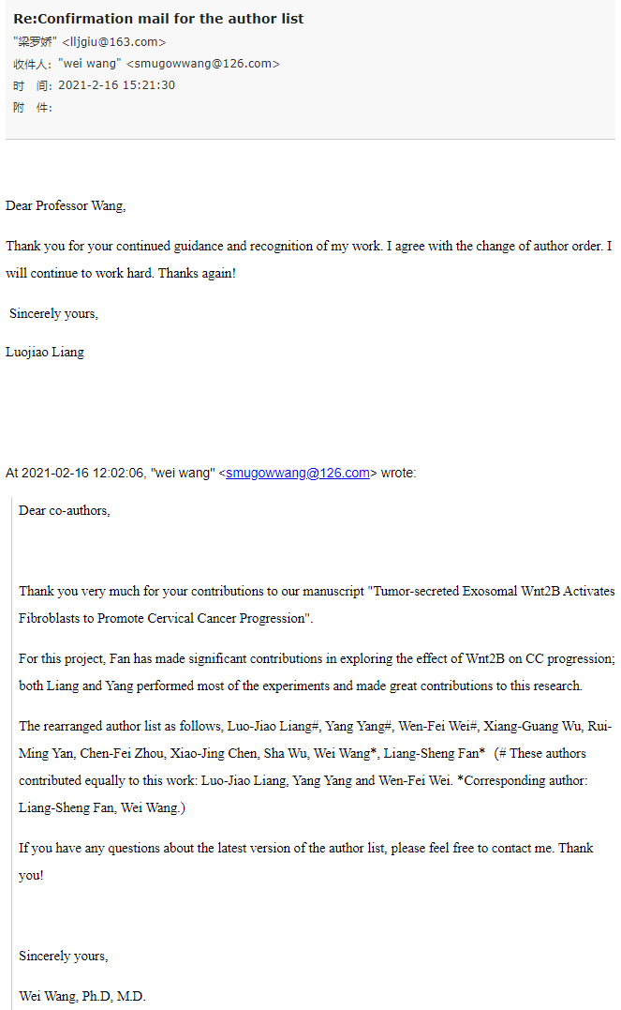

Contributing author # 2: Yang Yang
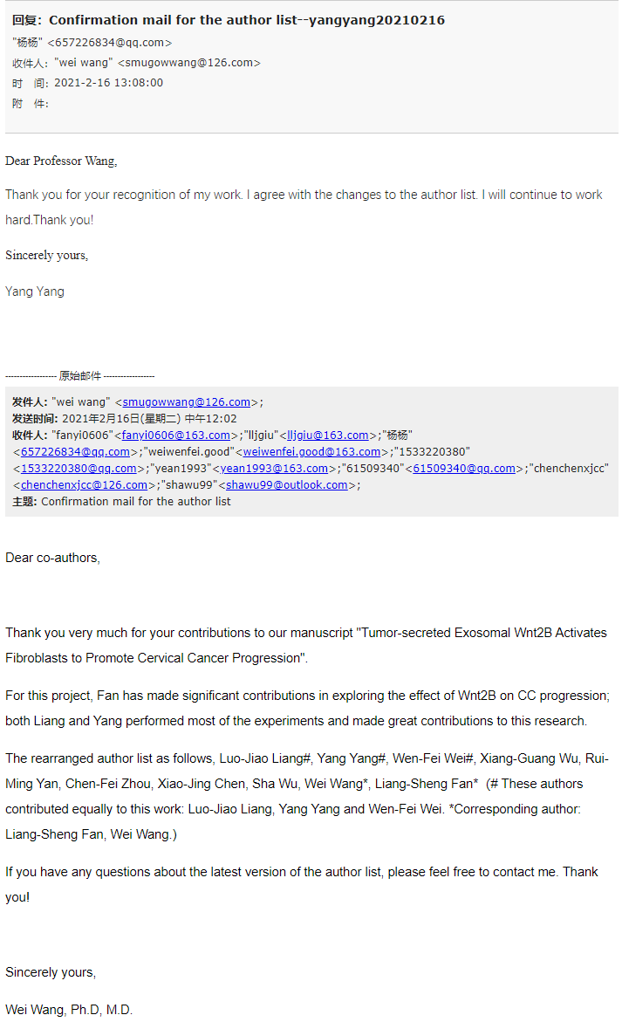

Contributing author # 3: Wenfei Wei
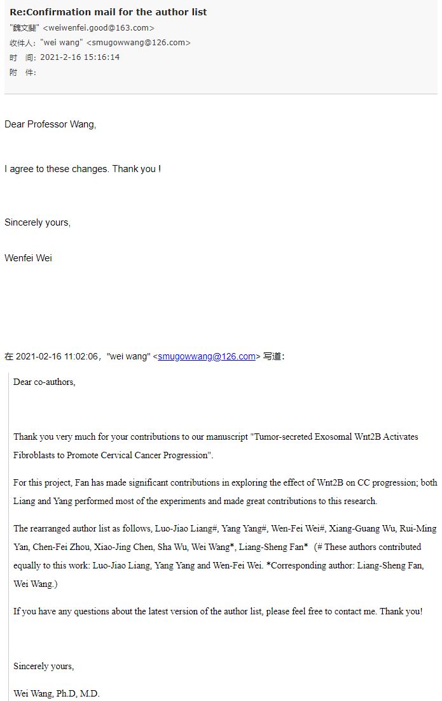

Contributing author # 4: Xiangguang Wu
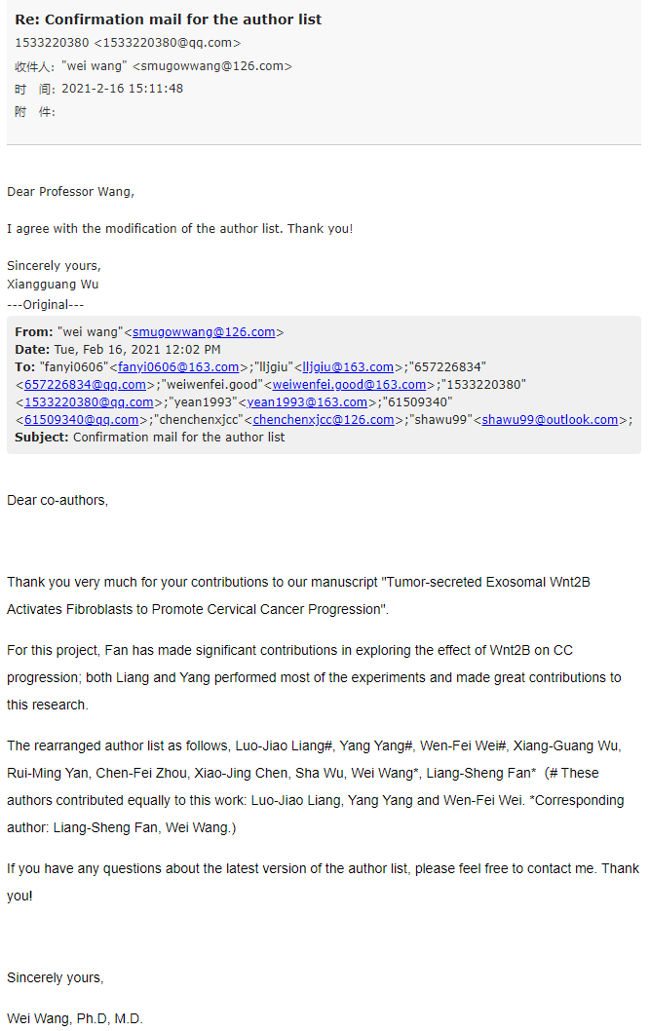

Contributing author # 5: Ruiming Yan
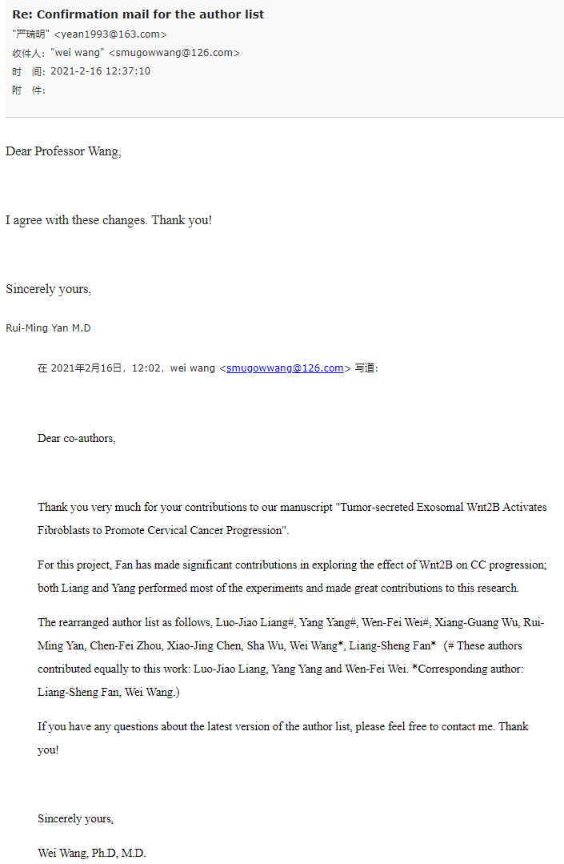

Contributing author # 6: Chenfei Zhou
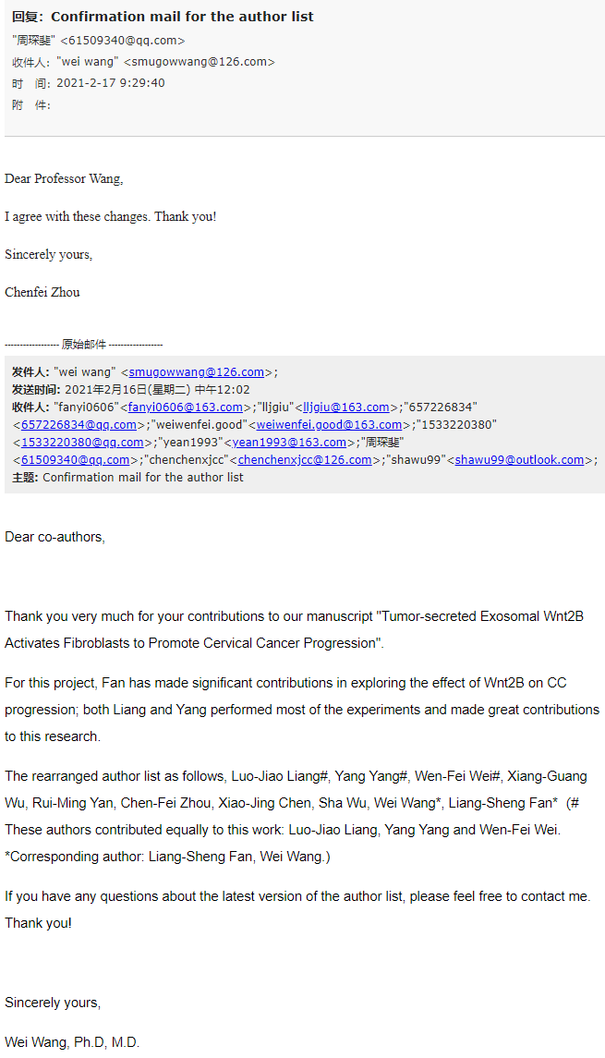

Contributing author # 7: Xiaojing Chen
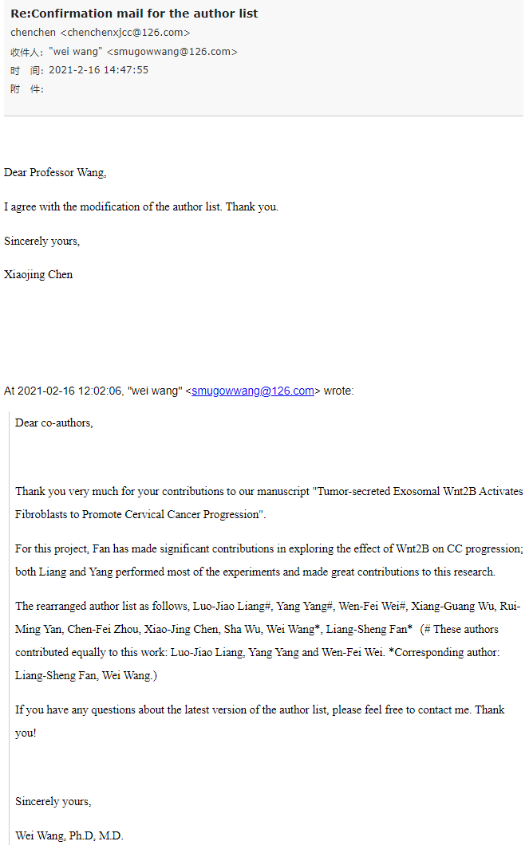

Contributing author # 8: Wu Sha
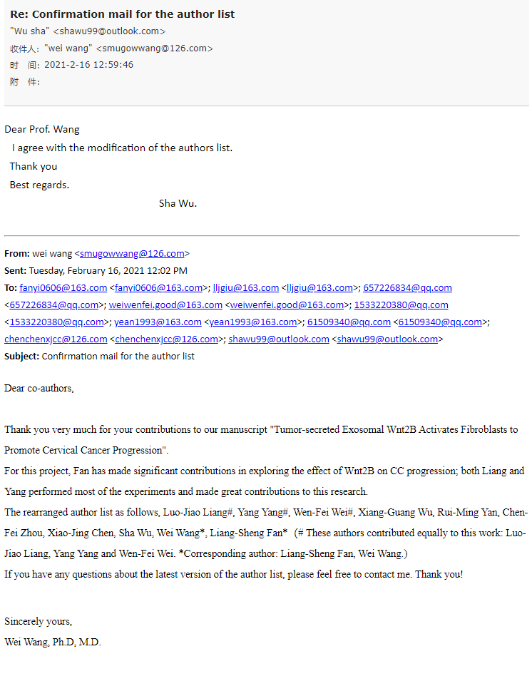

Contributing author # 9: Liangsheng Fang
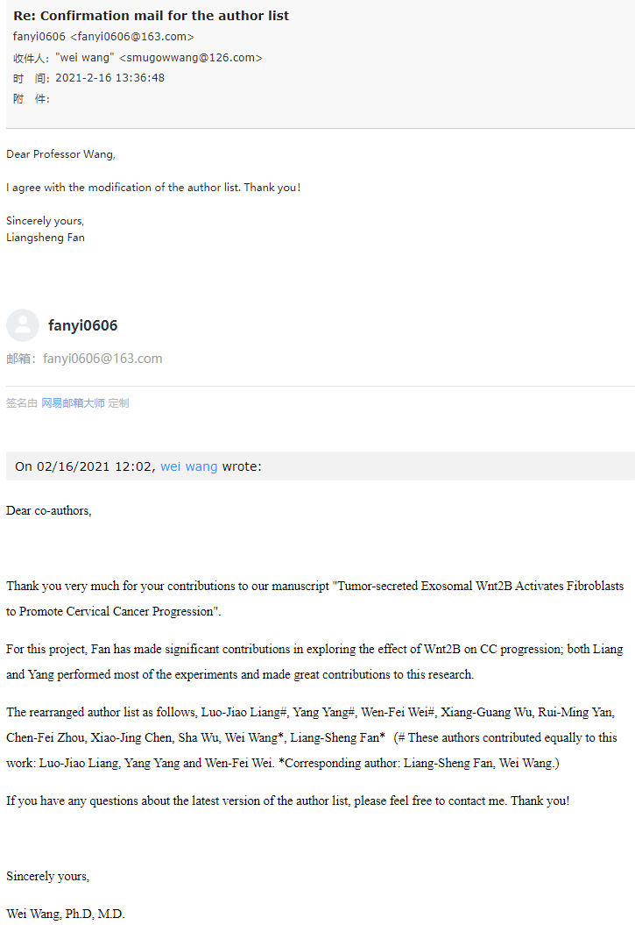

The following document is a signed letter from all authors for the confirmation of the author list.