Supplementary Information
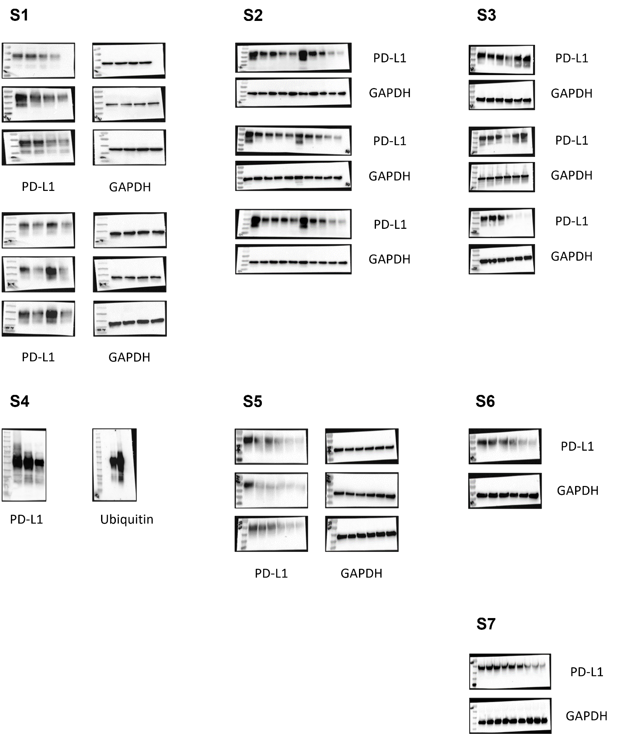
Supplementary Figure. This figure presents the original, uncropped Western blot images corresponding to the data shown in the main figures. The blots displayed in panels S1, S2, S3, S4, S5, S6, and S7 correspond to those presented in Figure 1B, D, Figure 2A, Figure 2B, Figure 2C, Figure 3C, Figure 6C, and Figure 7F, respectively.

