Supplemental Methods
Cell Lines and Culture
HCT116, SW480, RKO, and NIH-3T3 cell lines were purchased from the Cell Bank of the Chinese Academy of Sciences (Shanghai, CN). Cell lines were routinely tested for Mycoplasma contamination by PCR and cultured in DMEM (#C11995500BT, Gibco) containing 10% fetal bovine serum (FBS; #10099141C, Gibco) and 1X penicillin-streptomycin solution (#SV30010, Cytiva) at 37 °C in a humidified 5% CO₂ incubator.

Plasmid Extraction and Amplification
Transformed E. coli DH5α competent cells (#CD201-01, TransGen Biotech) were streaked onto LB/ampicillin plates and incubated at 37 °C for 16 h. Individual colonies were transferred into 200 ml LB/ampicillin broth, followed by incubation with shaking at 37 °C (220 rpm) for 16 h. Plasmid DNA extraction was performed using the EndoFree Plasmid Maxi Kit (#DP117, TIANGEN). A NanoDrop 2000 spectrophotometer (Thermo Scientific) was used to measure DNA purity and concentration (Thermo Scientific).

Plasmid transfection
Human SPOCK1 sequence fused to a C-terminal GST tag was cloned into pcDNA3.1 vector under the control of the CMV promoter to generate the oeSPOCK1 plasmid. A control plasmid (oeCtrl) containing only the GST tag was constructed similarly. For SPOCK1 knockdown, two shRNA sequences (sh#2: CCACGGCAATTTCCTAGACAA; sh#3: CGGTGTAATGAGGAGGGCTAT) were designed and inserted into pLVX vector under the U6 promoter. ZsGreen reporter was inserted under the control of CMV promoter in all shRNA constructs (sh#2, sh#3 and shCtrl) to confirm transfection. All plasmids were purchased from Fenghui Biotechnology (Changsha, Hunan, CN) and validated by Sanger sequencing. HCT116 and SW480 cells were transiently transfected using Lipofectamine 3000 reagent (L3000015, Thermo Scientific) according to the manufacturer’s protocol and effective overexpression or knockdown was confirmed by immunoblotting.

TOPFlash Reporter Assay
CRC cells were transfected for 48 h with SuperTopFlash or SuperFopFlash plasmid (D2505/D2507, Beyotime) along with the oeCtrl, oeSPOCK1, shCtrl or shSPOCK1 plasmid (sh#2/sh#3) at 50% confluence. Renilla luciferase plasmid (pRL) (D2760, Beyotime) was used as an internal control. Lysates were collected using a Dual Luciferase Reporter Gene Assay Kit (RG027, Beyotime). Luminescence values were measured using a Tecan Spark plate reader. Values were reported as the relative fold change for TOP/FOP (TOP/pRL $÷$ FOP/pRL).

Colony Formation Assay
Following transfection with oeCtrl/oeSPOCK1 (24 h) or knockdown with shCtrl/sh#2/sh#3 (48 h), CRC cells were seeded into 12-well plates (2000 cells per well). Colony formation was observed daily and cultured was continued for 7-10 days until the colony size was approximately 50 cells. Colonies were then washed with PBS, fixed in 10% neutral buffered formalin (#G2161, Solarbio) for 15 min, and stained with 0.1% crystal violet solution (#G1062, Solarbio) for 15 min. After staining, the plates were washed 2-3 times with tap water and air-dried. Colonies were subsequently photographed and counted under a microscope.

3D Spheroid Formation Assay
Cells (see Colony Formation Assay for transfection times) were suspended at a 2:3 ratio in Reduced Growth Factor Matrigel (#356234, Corning) and plated in pre-warmed 48-well plates at densities of 1500 cells/well for HCT116 or 2000 cells/well for SW480. After polymerization, spheroids were cultured in DMEM with 0.5% FBS. The culture medium was replaced every 48 h. Spheroids were fixed when control groups formed mature structures (7–10 days), imaged using a 4X objective lens, and quantified.

Nuclear Fractionation
HCT116 and SW480 cells were transfected for 48 h with oeSPOCK1 or shSPOCK1 plasmids along with their corresponding controls. Subsequently, nuclear and cytoplasmic proteins were separated using the Ne-PER Nuclear and Cytoplasmic Extraction Kit (78833, Thermo Scientific), denatured by heating (100 °C for 5 min) in 5X SDS loading buffer, and subjected to Western blot.

Western Blot
Proteins were extracted with M-PER (78501, Thermo Scientific) with protease inhibitors (HY-K0010, MCE) and PMSF (KGP610, Keygen). Protein concentrations were determined using the BCA assay (PC0001-10, Solarbio). Equal amounts of proteins were separated by SDS-PAGE and transferred onto PVDF membranes. The membranes were incubated with 1X blocking buffer (ab126587, Abcam) for 1.5 h at room temperature, then incubated with primary antibodies at 4 °C overnight. The primary antibodies used were as follows: Testican-1 (sc-390789 1:500, Santa Cruz Biotechnology), CD133 (66666-1-Ig 1:2000, Proteintech), LGR5 (bs-20747R 1:1000, Bioss), c-Myc (10828-1-AP 1:1000, Proteintech), Cyclin D1 (2978 1:2000, Cell Signaling Technology), β-catenin (ab32572 1:2000, Abcam), AXIN2 (YM8789 1:2000, Immunoway), non-phospho (active) β-catenin (#8814 1:100, Cell Signaling Technologies), GAPDH (60004-1-lg 1:2000, Proteintech), TBP (22006-1AP 1:2000, Proteintech) and β-actin (66009-1-lg 1:2000, Proteintech). Next, the membrane was washed three times with TBST and incubated with secondary antibody (1:5000, #RS0001 for mouse/RS0002 for rabbit, Immunoway) for 2 h at room temperature. Proteins were detected using ECL reagent and a Cytiva ImageQuant™ 800 chemiluminescence system.

Immunofluorescence (IF) staining
Cells were seeded onto UV-sterilized microscope cover slips in a 6-well plate and subjected to their respective treatments. After treatment, cells were washed three times with PBS and fixed with 4% paraformaldehyde for 15 min. After another 3 PBS washes, the fixed cells were permeabilized with 0.05% Triton X-100 at room temperature for 20 min. The coverslips were rinsed three times with PBS, and residual liquid was removed. 1% BSA was incubated on the coverslips at room temperature for 30 min for blocking. The blocking solution was then removed, and each coverslip was incubated with a sufficient amount of diluted primary antibody (β-catenin (ab32572 1:250, Abcam), alpha-Smooth Muscle Actin (YM8040 1:200, Immunoway)) and placed in a dark, humidified chamber at 4 °C overnight. Next, coverslips were rinsed 3 times with PBST before incubation with diluted fluorescent secondary antibodies (RGAR005/RGAM002 1:200, Proteintech) and/or FITC-phalloidin (YS0016, Immunoway) for 1 h in the dark. After washing three times with PBST, nuclei were counterstained with DAPI (1005, Beyotime). Finally, excess DAPI was removed with a PBST wash. Staining was observed and imaged under the STELLARIS 8 confocal microscope (100X) and ImageJ was used to merge the color channels.

Wnt Inhibitor Treatment
Wnt inhibitors LGK-974 (HY-17545), MSAB (HY-120697), and iCRT3 (HY-103705) were purchased from MedChemExpress (Monmouth Junction, NJ, USA). For TOPFlash assays, LGK-974 (100 nM), MSAB (10 μM), or iCRT3 (25 μM) were added to cells 8 h post-transfection and assays were completed 16 h later (24 h post-transfection). For Western blot and immunofluorescence assays, cells were transfected for 24 h, followed by 24 h of treatment with inhibitor.

Fibroblast Co-Culture Assay
NIH-3T3 fibroblasts (1×10⁴ cells/well) were seeded in the lower chambers of 6-well plates. Concurrently, SW480 cells (4×10⁵ cells/well) were seeded into 6-well transwell inserts (0.4 μm pore size, Corning, CLS3450). The following day, SW480 cells were transfected with either oeCtrl or oeSPOCK1 plasmids using Lipofectamine 3000. Eight hours post-transfection, the inserts containing the transfected SW480 cells were transferred onto the plates containing the NIH-3T3 fibroblasts. After 48 hours of co-culture, the NIH-3T3 cells in the lower chambers were fixed with 4% paraformaldehyde and processed for IF staining. To quantitatively assess stress fiber elongation, multichannel confocal IF images were imported into QuPath v0.6, alpha-smooth muscle actin positive fibers (red) or background were annotated manually, and an artificial neural network-multilayer perceptron (ANN-MLP) pixel classifier was trained on the annotations. The settings were as follows: high resolution, red channel, scales = 1.0 with local mean subtraction only and a local normalization scale of 8. The selected features for classification were Gaussian, Laplacian of Gaussian, Structure Tensor Max Eigenvalue, and Hessian Max Eigenvalue. After obtaining the total length of the stress fibers in each image, the length was normalized to the number of DAPI+ nuclei present in the image. Finally, the data were averaged based on the oeCtrl treatment and recalculated to represent fold change.

Conditioned Medium and rTestican-1 Characterization and TOPFlash Assay
To evaluate the extracellular activity of Testican-1, conditioned media (CM) and recombinant protein (rTestican-1) treatments were performed in conjunction with dual-luciferase reporter assays. oeSPOCK1 and oeCtrl CM were generated by transfecting HCT116, SW480, and RKO cells with oeCtrl or oeSPOCK1 plasmids for 24 hours. Following transfection, cells were washed twice with sterile PBS to eliminate residual serum and incubated in serum-free DMEM for an additional 48 hours. The resulting supernatant was collected, centrifuged at 1,000 rpm for 3 minutes to remove cellular debris, and filtered through a 0.22 μm PE membrane. After collection, the CM was concentrated by centrifugation using an Amicon-15 10 kDa cutoff filter (UFC901096, Millipore), to achieve a volume of 250 μl for each group. Successful, CM preparation was confirmed using a Testican-1 ELISA assay kit (EK6578, SAB) with a minimum sensitivity of 0.156 ng/ml according to the manufacturer instructions. Recombinant Testican-1 (10644-H08B, Sino Biological) was confirmed by Coomassie blue (P0004S, Beyotime) staining and immunoblotting with anti-Testican-1.

For the signaling assays, cells were seeded to 50% confluence and co-transfected with TOPFlash or FOPFlash plasmids, using a pRL Renilla luciferase plasmid (D2760, Beyotime) as an internal normalization control. The treatment timeline was standardized across all groups. After 8 h transfection, the culture media was replaced with either the prepared oeCtrl/oeSPOCK1 CM or complete medium containing purified rTestican-1 protein. After a 16-hour incubation period, pathway inhibitors (LGK-974, MSAB, iCRT3) were added for an additional 24 hours until the experimental endpoint.

Lentiviral Infection of CRC Cell Lines
Lentiviruses for SPOCK1 overexpression and vector control were purchased from GeneChem (Shanghai, CN) and cloned into the GV492 vector with a Flag tag. SW480 cells were digested with 0.2% trypsin-EDTA and then seeded into 6-well plates. When the cell confluence reached 50%, lentivirus was transduced (MOI: 1 × 10⁷ TU). After infection, the medium was refreshed with puromycin (HY-B1743; 4 μg/ml, MCE)-supplemented complete medium. Puromycin selection was maintained until stable overexpression of Testican-1 was confirmed by Western blot.

CCK8 Assay
SW480 cells stably overexpressing Testican-1 were seeded in 96-well plates (5×10³ cells/ well). Every 24 h, 10 μL/well of CCK-8 reagent (K1018-100, Apex bio) was added, followed by incubation at 37° C for 2-4 h. Finally, a multifunctional microplate reader was used to detect absorbance values at an optical density of 460 nm.

CRC PDO Immunofluorescence (IF) staining
PDOs were collected with a cell scraper from 24-well plates and prepared as formalin-fixed, paraffin-embedded (FFPE) samples following standard procedures. Sections were prepared with a microtome, deparaffinized, and subjected to antigen retrieval with Tris-EDTA buffer. Next, slides were blocked using 1% BSA for 30 min, washed twice with PBST, then incubated with Testican-1 (sc-390789 1:200, Santa Cruz Biotechnology) or β-catenin (ab32572 1:500, Abcam) primary antibodies and placed in a dark, humidified chamber at 4 °C overnight. After three PBST washes diluted fluorescent secondary antibodies (647-Goat-Anti-Rb/488-Goat-Anti-Ms 1:200, Proteintech) were applied in the dark for 1 h. After incubation, slides were rinsed 3 times with PBST and counterstained with DAPI (1005, Beyotime). Finally, excess DAPI was removed with PBST washing. Staining was observed and imaged under the STELLARIS 8 confocal microscope (100X) and ImageJ was used to merge the color channels.

Immunofluorescent Quantitative Analysis
Immunofluorescence quantification was performed in CellProfiler (version 4.2.8). Images were first converted to grayscale. The IdentifyPrimaryObjects module was then applied to segment nuclei using carefully defined thresholds and segmentation parameters to ensure accurate identification. For analysis of cytoplasmic fluorescence, the IdentifySecondaryObjects module was used to segment the cell cytoplasm by nuclear exclusion. The MeasureObjectIntensity module was then used to measure the cell cytoplasm or nuclear fluorescence intensity.

For line profile analysis, confocal images were imported into ImageJ and converted into RGB stack format. The line tool (width 10) was used to draw a line from the edge of the cell, across the nucleus, and to the far edge of the cell. Plot profile measurements were then taken in the blue (DAPI) and red (β-catenin) channels and values were normalized based on the maximum DAPI intensity.

Tumor Xenograft Model
All animal experiments were approved by the Institutional Animal Care and Use Committee of Fujian Provincial Hospital, Fuzhou University (Approval No. IACUC-FPH-SL-20251107[1134]). A xenograft model was established using SW480 cells stably overexpressing Testican-1 or control vector (n=9 per group). Cells were counted (1x10⁶/50 μL) and mixed 1:1 with reduced growth factor Matrigel. Cells were delivered subcutaneously into the right flanks of athymic nude mice (6 weeks old). Tumor growth was observed daily, and calipers were used tumor volume was measured every two days. On the 12th day, mice were killed, and xenograft tumors were surgically excised. Final volume and weight of the excised tissue were measured with a caliper and electronic scale, and the tissue was processed for hematoxylin-eosin staining (H&E) and immunohistochemistry (IHC).

Hematoxylin-Eosin Staining
FFPE samples were cut into 4 μm thick sections, mounted on slides, and dried at 60 °C for 1.5 h. Sections were dewaxed using xylene and rehydrated using graded ethanol and distilled water. A Hematoxylin-Eosin Staining Kit (G1120, Solarbio) was used for staining. First, hematoxylin was incubated for 2 min to stain the nucleus. After washing away the excess hematoxylin stain with distilled water, slides were incubated in Differentiation Solution for 30 s, then rinsed in tap water twice for 5 min each time. Next Eosin Y solution was added dropwise and excess dye solution was removed. Finally, slides were mounted with neutral balsam (MB9899, Meilunbio). For quantitative assessment of eosin staining intensity, images of stained slides were loaded into CellProfiler, colors were deconvoluted with UnmixColors to separate the eosin layer, thresholding (Threshold) was performed to remove empty space, and intensity was measured from the mask (ConvertImageToObjects) prepared in the previous step using MeasureImageIntensity.

Immunohistochemistry (IHC)
The use of human CRC surgical biopsies was granted approval by the Ethics Board of the Second Affiliated Hospital of the Fujian University of Traditional Chinese Medicine (SPHFJP-T2022001-01). Serial sectioned, deidentified FFPE CRC tissue microarray slides containing 48 matched tumor and adjacent pairs were purchased (ZL-ColRecA961, Shanghai Weiao Biotechnology). Tissue samples were fixed in 4% paraformaldehyde (BL539A, Biosharp) solution for 48 h and subsequently stored in 70% ethanol until processing. Following dehydration, FFPE samples were prepared, cut, and processed as described for H&E. Antigen retrieval was carried out with a pressure cooker (2200W, 3 min) using Tris-EDTA buffer, followed by a 30 min incubation until pressure was safe to release. Detection was conducted on processed FFPE samples and the tissue microarray slides using a mouse/rabbit HRP/DAB IHC detection kit (ab236466, Abcam). Primary antibodies included Testican-1 (sc-390789 1:50, Santa Cruz Biotechnology) or β-catenin (ab32572 1:200, Abcam). The Goat anti-rabbit HRP-conjugate included in the kit was used as the secondary antibody. After immunohistochemical staining, hematoxylin counterstain (G1140, Solarbio) was applied for 2 min and then washed in tap water. Finally, slides were mounted with neutral balsam (MB9899, Meilunbio) and photos imaged using a Nikon DS-Ri2 microscope.

For quantification of immunohistochemistry from the CRC and matched paracancer/adjacent normal tissue microarray, whole-slide scans were de-arrayed to 2 mm cores using QuPath (v0.6.0). For mouse xenograft immunohistochemistry and human tissue microarrays, cell segmentation and intensity classification were determined using the built-in Positive Cell Detection function, with a 15 µm background radius to account for heterogeneity of staining. For β-catenin expression, quantification was restricted to the nuclear compartment. For Testican-1 expression, quantification was performed on a whole cell level. Intensity classification for both markers was determined using DAB optical density mean thresholds: 0 (Negative, <0.1), 1+ (Weak, 0.1-0.2), 2+ (Moderate, 0.2-0.35), and 3+ (Strong > 0.35). A final H-score was calculated for each core according the formula below and results were manually verified for accuracy:
$H\text{-}score =$ (1 $×$ $\%$1+ cells) $+$ (2 $×$ $\%$2+ cells) $+$ (3 $×$ $\%$3+ cells)

RNA-Sequencing
Cells were carefully washed with PBS, suspended in 1.5 ml of TRIzol (15596018, Invitrogen) reagent per 1 x 10⁷ cells, and transferred to an RNase-free 15 ml centrifuge tube, snap frozen in liquid nitrogen, and transported on dry ice to GeneChem (Shanghai, CN). RNA quality was assessed by electrophoresis and the Agilent 2100 bioanalyzer (Agilent Technologies). RNA libraries were constructed with a NEBNext® Ultra™ RNA Library Prep Kit (Illumina). Following construction, libraries underwent preliminary quantification using a Qubit 2.0 Fluorometer and dilution to 1.5 ng/μL. The libraries' insert size was confirmed with the Agilent 2100 bioanalyzer; successful libraries were pooled based on their concentration and required amounts of target data for off-machine processing, followed by Illumina sequencing, resulting in 150 bp paired-end reads. CASAVA base calling was used to determine sequences. HISAT2 v2.0.5 was used to prepare the reference genome, and paired-end clean reads were aligned. Mapped reads were quantified using featureCounts (v1.5.0-p3). Finally, the FPKM (Fragments Per Kilobase of transcript per Million mapped reads) of each gene was calculated based on its length and the total mapped reads.

Astral DlA Proteomics Analysis
oeCtrl and oeSPOCK1 xenograft tumor samples (n = 4 per group) were sectioned and transported on dry ice to Sanshu Biotechnology Co. (Nantong, Jiangsu, CN). Protein lysates were measured using BCA assay and protein quality was checked by Coomassie blue staining. Following denaturation and reduction-alkylation, proteins were digested with trypsin at 37 °C for 2 h. Supernatant desalting was performed with a C18 column and concentrated at 45 °C. Chromatographic separation was performed using a Vanquish Neo UHPLC system (Thermo Scientific) equipped with a Trap Column (PepMap Neo 5 µm C18 300 µm x 5 mm, Thermo Scientific) and a chromatographic analysis column (μPAC Neo High Throughput column, Thermo Scientific). Peptides were eluted with a formic acid/acetonitrile gradient and analyzed by data-independent acquisition (DIA) on an Orbitrap Astral Mass Spectrometer (Thermo Scientific).

DIA raw data files were analyzed using DIA-NN (v1.9) against the Proteome Reference Database. Protein quantification information was extracted from the raw data using two spectral libraries: one predicted by DIA-NN's deep learning algorithm and another generated using the Match-Between-Runs (MBR) function. Final results were then filtered at a 1% FDR at both the parent ion and protein levels. Discrete sample separation was confirmed by partial least squares discriminative analysis (PLS-DA) from the R mixOmics package, achieving a high classification accuracy with a Balanced Error Rate (BER) of 0.1375 (86.25% accuracy) using two components (Mahalanobis distance). Pathway enrichment analysis for oeSPOCK1 compared to oeCtrl proteomes was performed using Protein Set Enrichment Analysis (PSEA) to determine altered biological pathways. Briefly, the t-statistic derived from the limma R package’s differential expression model was used to rank all quantified proteins. PSEA was then performed with the fgsea package in R using the MSigDB Hallmark³, KEGG², Reactome⁴, WikiPathways¹, and the Pathway Interaction Database (PID)⁵ gene sets. Results were plotted using the ggplot2 and EnhancedVolcano R packages.

References
1 Diamant I, Clarke DJB, Evangelista JE, Lingam N, Ma'ayan A (2025). Harmonizome 3.0: integrated knowledge about genes and proteins from diverse multi-omics resources. Nucleic Acids Res 53: D1016-D1028.

2 Kanehisa M, Furumichi M, Sato Y, Matsuura Y, Ishiguro-Watanabe M (2025). KEGG: biological systems database as a model of the real world. Nucleic Acids Res 53: D672-D677.

3 Liberzon A, Birger C, Thorvaldsdottir H, Ghandi M, Mesirov JP, Tamayo P (2015). The Molecular Signatures Database (MSigDB) hallmark gene set collection. Cell Syst 1: 417-425.

4 Milacic M, Beavers D, Conley P, Gong C, Gillespie M, Griss J et al (2024). The Reactome Pathway Knowledgebase 2024. Nucleic Acids Res 52: D672-D678.

5 Schaefer CF, Anthony K, Krupa S, Buchoff J, Day M, Hannay T et al (2009). PID: the Pathway Interaction Database. Nucleic Acids Research 37: D674-D679.

Supplemental Data
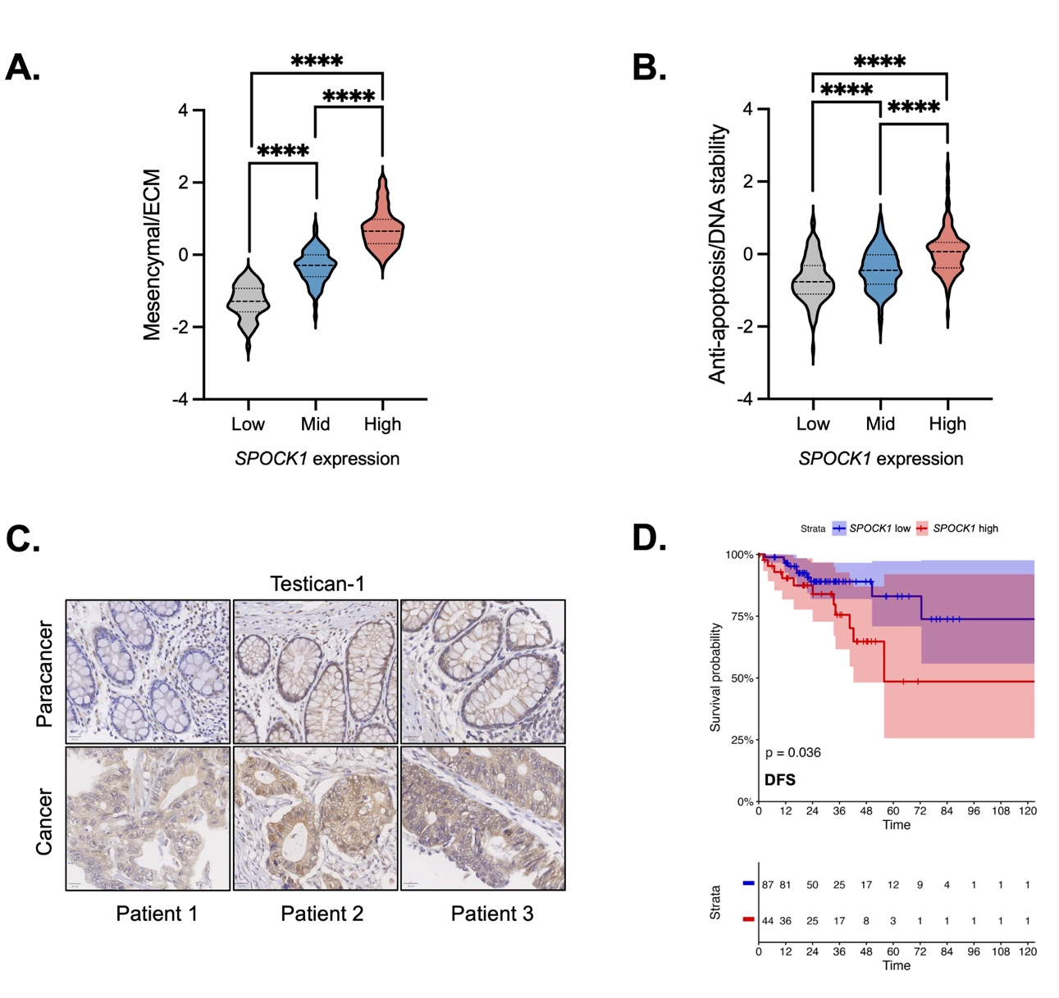
Supplemental Figure 1
Figure S1. A-B. Mesenchymal/ECM and Anti-apoptosis/DNA stability gene signatures are associated with SPOCK1 expression in TCGA’s colon adenocarcinoma dataset ((Wilcoxon Rank-Sum, P<0.0001). C. Representative immunohistochemistry demonstrating that Testican-1 is upregulated in CRC patient tumor compared to paracancer tissues. D. Data from TCGA’s COADREAD dataset reveal that high expression of SPOCK1 predicts reduced DFS in the total patient dataset (Log-Rank, P<0.05).

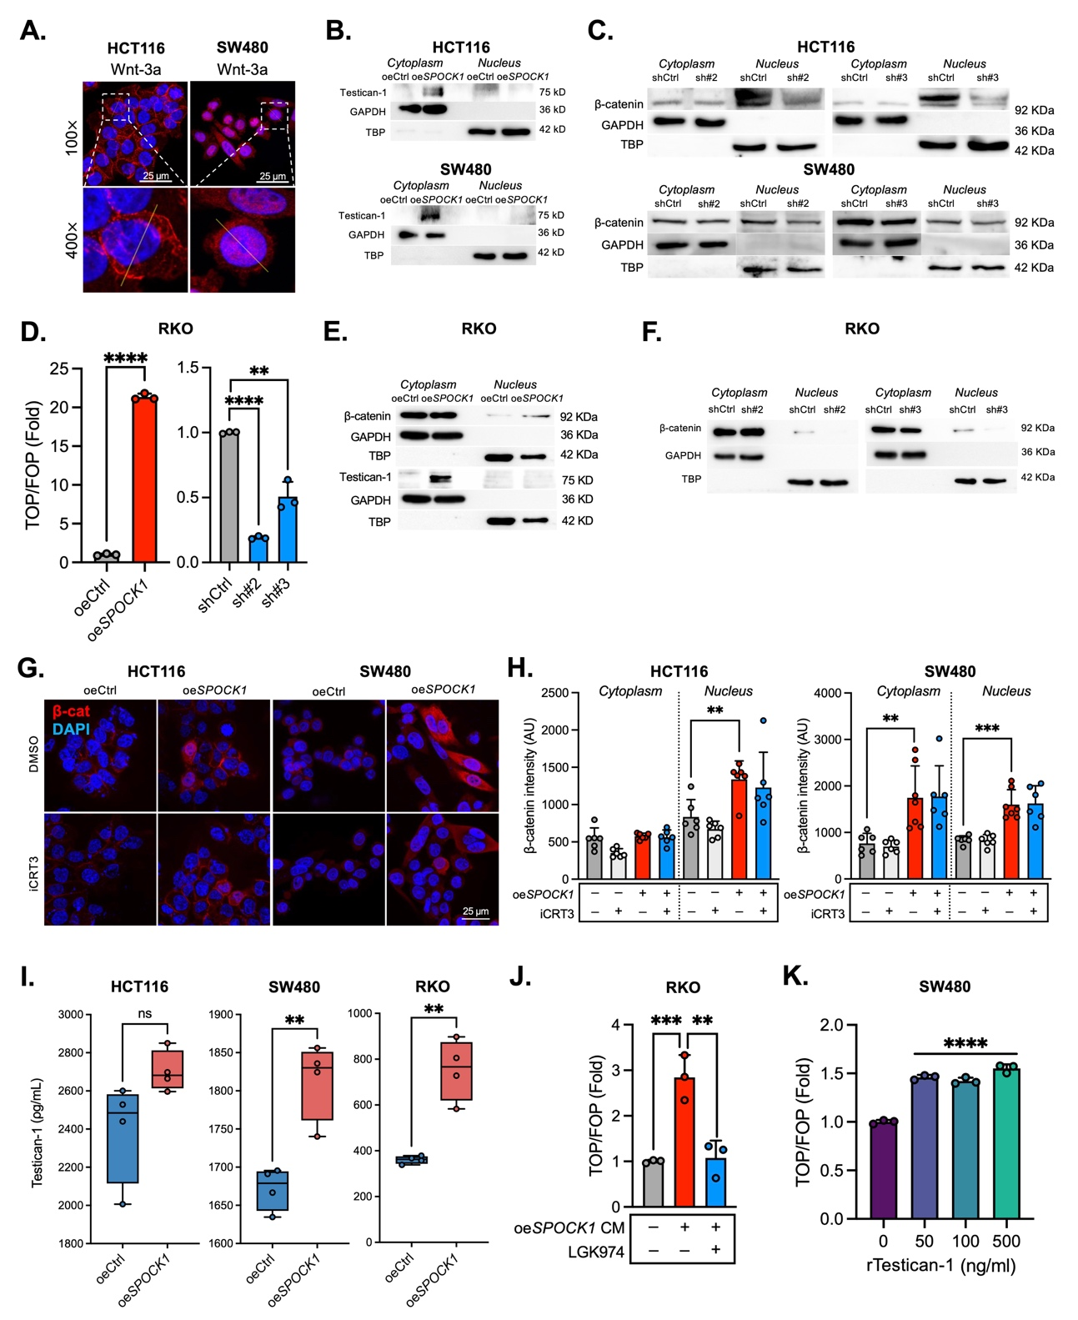
Supplemental Figure 2
Figure S2. A. Immunofluorescence images showing nuclear translocation of β-catenin in Wnt-3a treated HCT116 and SW480 cells. B. Nuclear fractionation results showing confirmed Testican-1 overexpression in the cytoplasm of HCT116 and SW480 cells. C. Nuclear fractionation results of β-catenin for HCT116 and SW480 cell lines treated with 2 distinct shRNAs targeting Testican-1. D. TOPFlash assay results for RKO cells after Testican-1 overexpression or knockdown, revealing a significant increase and decrease in TOPFlash activation respectively. E. Nuclear fractionation results of β-catenin for RKO cells overexpressing Testican-1. F. Nuclear fractionation results of β-catenin for RKO cells treated with 2 distinct shRNAs targeting Testican-1. G. Representative immunofluorescence images of HCT116 and SW480 cells transfected with oeCtrl or oeSPOCK1 plasmids for 24 h with or without iCRT3 treatment (16 h). H. Immunofluorescence quantification demonstrating that after Testican-1 overexpression, iCRT3 does not significantly alter β-catenin localization. I. ELISA assay results for oeSPOCK1 compared to oeCtrl-conditioned medium (CM), revealing increased secretion of Testican-1 from HCT116, SW480, and RKO cells. J. TOPFlash assay results demonstrating that oeSPOCK1 CM-mediated TCF/LEF transcriptional activity is reversible by Wnt ligand inhibitor LGK-974. K. TOPFlash assay results demonstrating that recombinant Testican-1 (rTestican-1) is capable of inducing TCF/LEF transcriptional activity in SW480 at concentrations from 50-500 ng/ml. Unpaired Student’s t-test: *P<0.05, **P<0.01, ***P<0.001, ****P<0.0001. Note: Nuclear fractionation results were obtained from a single membrane for each experiment.

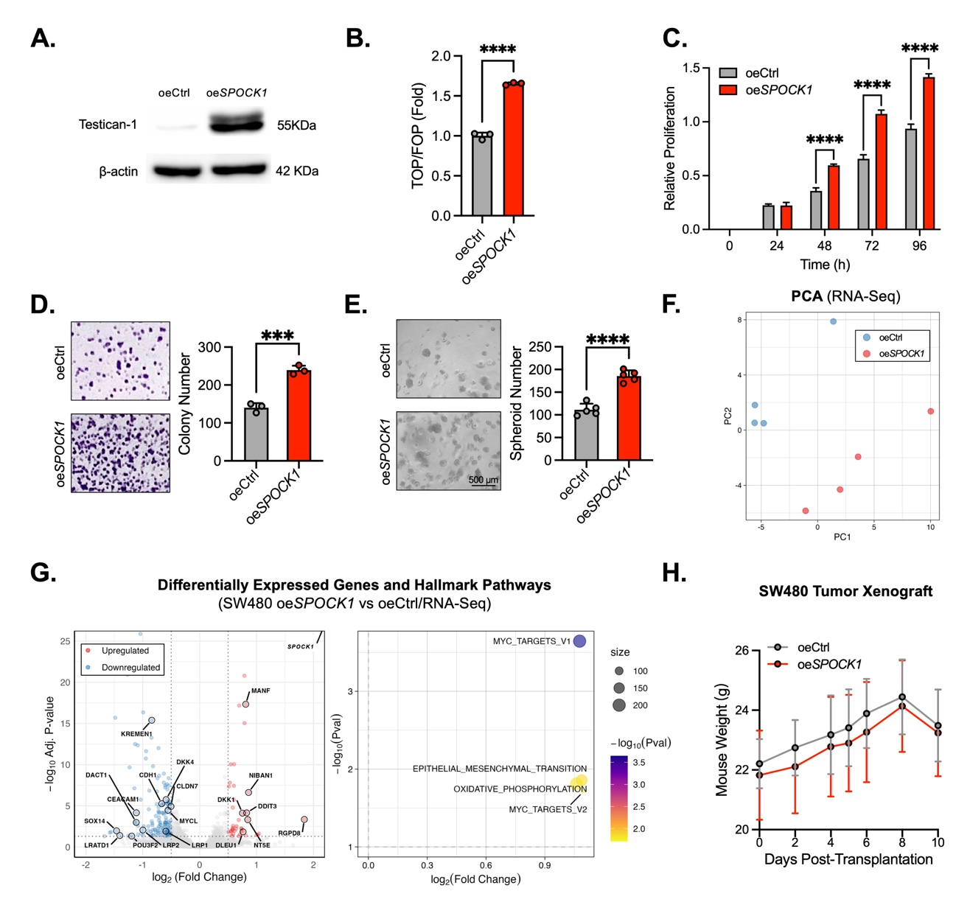
Supplemental Figure 3
Figure S3. A. The ovexpression of Testican-1 was confirmed by Western blot. B. Relative luminescent reporter activation for TCF/LEF binding sites (TOPFlash) demonstrating that TCF/LEF-mediated transcription is increased in SW480 (P<0.01) after Testican-1 stable overexpression. C. Cell growth curves showing that stable oeSPOCK1 group has a higher proliferation rate compared to stable oeCtrl group (Two-Way ANOVA, P<0.0001). Data points represent the mean relative proliferation at each timepoint, with error bars indicating the standard deviation (SD). Šídák's multiple comparisons test was performed to determine statistical significance at individual time points. D. Representative images and quantification of colony formation assays showing that stable oeSPOCK1 demonstrate a significant increase in colony number in SW480 cell lines (P<0.001). E. 3D spheroid assays and the quantification showing that stable Testican-1 overexpression can promote CRC stemness in SW480 cells (P<0.0001). F-G. RNA-seq was conducted using the stable cell line. Principal component analysis (PCA) revealed discrete distribution for oeCtrl and oeSPOCK1 cells, and the volcano plot of significantly expressed genes showed that SPOCK1 was the most highly expressed, and confirmed significant dysregulation of Wnt (LRP1/2, DKK1/4, DACT1, and KREMEN1) and MYC-associated genes (NIBAN1, MANF). Gene Set Enrichment Analysis (GSEA) using the Hallmark database revealed significant enrichment of c-Myc targets (MYC_V1/2), epithelial-mesenchymal transition (EMT), and oxidative phosphorylation pathways in oeSPOCK1 cells. H. Mouse body weight monitoring throughout the xenograft experiment showed no significant change between experimental groups. *P<0.05, **P<0.01, ***P<0.001, ****P<0.0001. For B and D-E, the unpaired Student’s t-test was used to determine statistical significance.

