Supplementary Material

Appendix 1: Search strategy

CENTRAL via CRS Web
- MeSH descriptor: [Risk Assessment] explode all trees
- MeSH descriptor: [Models, Statistical] explode all trees
- (((predict* or multicomponent or multivariable) near model*) or (predict* near (outcome* or risk* or model*)) or ((history or variable* or criteria or scor* or characteristic* or finding* or factor* or value*) near (predict* or model* or decision* or identif* or prognos*)) or (decision* near (model* or clinical* or logistic model*)) or (prognostic near (history or variable* or criteria or scor* or characteristic* or finding* or factor* or model*)) or (observ* near (variation or model*)))
- (#1 or #2 or #3) not pain
- MeSH descriptor: [Bronchopulmonary Dysplasia] explode all trees
- bronchopulmonary dysplasia or BPD or chronic lung disease or CLD
- #5 or #6
- MESH DESCRIPTOR Infant, Newborn EXPLODE ALL AND CENTRAL:TARGET
- infant or infants or infant's or "infant s" or infantile or infancy or newborn* or "new born" or "new borns" or "newly born" or neonat* or baby* or babies or premature or prematures or prematurity or preterm or preterms or "pre term" or premies or "low birth weight" or "low birthweight" or VLBW or LBW or ELBW or NICU AND CENTRAL:TARGET
- #8 or #9
- #4 and #7 and #10

Medline via Ovid - Ovid MEDLINE(R) and Epub Ahead of Print, In-Process & Other Non-Indexed Citations, Daily and Versions(R):
- (Risk Assessment/ or Models, Statistical/ or (predict* or validat* or rule* or scor*).ti,ab. or ((predict* or multicomponent or multivariable) adj3 model*).mp. or (predict* adj5 (outcome* or risk* or model*)).ti,ab. or ((history or variable* or criteria or scor* or characteristic* or finding* or factor* or value*) adj5 (predict* or model* or decision* or identif* or prognos*)).ti,ab. or (decision* adj5 (model* or clinical* or logistic model*)).ti,ab. or (prognostic adj5 (history or variable* or criteria or scor* or characteristic* or finding* or factor* or model*)).ti,ab. or (observ* adj3 (variation or model*)).ti,ab.) not pain.mp.
- bronchopulmonary dysplasia or BPD or chronic lung disease or CLD
- #1 and #2
- exp infant, newborn/
- (newborn* or new born or new borns or newly born or baby* or babies or premature or prematurity or preterm or pre term or low birth weight or low birthweight or VLBW or LBW or infant or infants or 'infant s' or infant's or infantile or infancy or neonat*).ti,ab.
- #4 or #5
- #3 and #6

Cumulative Index to Nursing and Allied Health Literature (CINAHL) via EBSCOhost
- ((MM “Risk Assessment”) OR (MM “Models, Statistical”) or TI ((predict* or validat* or rule* or scor*) or ((predict* or multicomponent or multivariable) N3 model*) or (predict* N3 (outcome* or risk* or model*)) or ((history or variable* or criteria or scor* or characteristic* or finding* or factor* or value*) N3 (predict* or model* or decision* or identif* or prognos*)) or (decision* N3 (model* or clinical* or logistic model*)) or (prognostic N3 (history or variable* or criteria or scor* or characteristic* or finding* or factor* or model*)) or (observ* N3 (variation or model*))) or AB ((predict* or validat* or rule* or scor*) or ((predict* or multicomponent or multivariable) N3 model*) or (predict* N3 (outcome* or risk* or model*)) or ((history or variable* or criteria or scor* or characteristic* or finding* or factor* or value*) N3 (predict* or model* or decision* or identif* or prognos*)) or (decision* N3 (model* or clinical* or logistic model*)) or (prognostic N3 (history or variable* or criteria or scor* or characteristic* or finding* or factor* or model*)) or (observ* N3 (variation or model*)))) NOT TX pain
- MM "Bronchopulmonary Dysplasia" OR (bronchopulmonary dysplasia or BPD or chronic lung disease or CLD)
- #1 AND #2
- infant or infants or infant's or infantile or infancy or newborn* or "new born" or "new borns" or "newly born" or neonat* or baby* or babies or premature or prematures or prematurity or preterm or preterms or "pre term" or premies or "low birth weight" or "low birthweight" or VLBW or LBW
- #3 AND #4

Searching other resources
Reference lists of included studies and previous reviews were examined alongside proceedings of annual meetings of the Paediatric American Societies (from 1993 onwards), the European Society for Paediatric Research (from 1995 onwards), the Royal College of Paediatrics and Child Health (from 2000 onwards), and the Perinatal Society of Australia and New Zealand (from 2000 onwards). Studies reported as abstracts were included if sufficient information was obtained.

Appendix 2: Preliminary study selection, data extraction and risk of bias forms

2a Data extraction spreadsheet (adapted from the CHARMS checklist¹ and Cochrane exemplar by Pace et al²)
Author ID: |  | Date of extraction:
Domain | Key items | Extracted Data | Reported on page number
Study citation | Authors, journal name, year, volume, pages
Source of data | e.g. cohort (prospective or retrospective), case-control, randomised trial participants
Participants | Participant eligibility and recruitment method (e.g. consecutive participants, location(s) / country(s), number of centres, setting)
 | Inclusion criteria
 | Exclusion criteria
 | Study dates/period of data collection
 | Participant characteristics
 | Gestational age at birth
 | Birthweight
 | Sex
 | Ethnicity
 | Antenatal corticosteroids use
 | Surfactant
 | Number of non-ventilated infants
 | Duration of invasive ventilation
 | Postnatal corticosteroids
Outcome(s) to be predicted | Definition of BPD used (e.g. respiratory support requirement at 28 days old or 36 weeks CGA)
 | Was the physiological challenge of oxygen withdrawal performed?
 | Was the same BPD definition and method of assessment used for all participants?
 | Type of outcome (e.g. BPD or composite BPD and death before discharge from neonatal units)
 | Was the outcome assessed without knowledge of candidate predictors (i.e. blinded)?
 | Was candidate predictors part of the outcome?
Candidate predictors | Number of predictors
 | Definition and method of measurement for each candidate predictors
 | Age of infants/timing of predictor measurement
 | Were predictors assessed blinded for the outcome, and for each other (if relevant)?
 | Handling of continuous predictors in the modelling (e.g. linear, non-linear transformation categorised)
Sample size | Number of participants
 | Number of events
 | Number of events per number of candidate predictor
Missing data | Number of participants with any missing value (including predictors and outcomes)
 | Number of participants with missing data for outcome
 | Number of participants with missing data for each predictor
 | Handling of missing data (e.g. complete case analysis, imputation)
Model development | Modelling method (e.g. logistic regression, neural network) and statistical software used
 | Modelling assumptions satisfied
 | Method for selection of predictors for inclusion in multivariable modelling (e.g. all candidate predictors, pre-selection based on unadjusted association with the outcome)
 | Method for selection of predictors during multivariable modelling (e.g. full model approach, backward or forward selection) and criteria used (e.g. p-value, Akaike Information Criteria)
 | Shrinkage of predictor weights or regression coefficients (e.g. no shrinkage, uniform shrinkage, penalised estimation)
Model performance | Discrimination measure (C-statistics) with confidence interval or standard error
 | Calibration measure (O:E ratio, calibration plot or slope, Hosmer-Lemeshow test) with confidence interval or standard error
 | Classification measure (e.g. net benefit analysis, sensitivity, specificity, positive predictive value, negative predictive value) and whether a priori cut-offs were used
Model evaluation | Method used for testing model performance: (a) Developmental dataset only (random split, re-sampling methods (e.g. bootstrap), (b) Separate external validation (e.g. temporal, geographical)
 | If poor validation, was model adjusted or updated (e.g. intercept re-calibrated, predictor effects adjusted, new predictors added)?
Results | Final model presented including predictor weights
 | Alternative presentation of the model (e.g. nomogram, score chart)
 | Comparison of the distribution of predictors (including missing data) for development and validation datasets
Interpretation and discussion | Interpretation of model (e.g. confirmatory - model useful for practice; exploratory - more research needed)
 | Comparison with other studies (e.g. generalisability, strengths and limitations)
 | Ease of use of the model
Author correspondence | Contact details of the corresponding author
References | Reference of relevant studies cited in the reference list

Reference
1 Moons, K. G. et al. Critical Appraisal and Data Extraction for Systematic Reviews of Prediction Modelling Studies: The Charms Checklist. PLoS Med 11, e1001744 (2014).
2 Pace, N. et al. Prediction models for the risk of postoperative nausea and vomiting. Cochrane Database of Systematic Reviews (2014).

2b PROBAST tool (adapted from Wolff et al¹³ and Moons et al¹⁴)
Step 1: Specify your systematic review question
Criteria | Specify your systematic review question
Intended use of the model: | Prognostic model to predict the occurrence of bronchopulmonary dysplasia at 28 days of age or 36 weeks of corrected gestational age.
Participants including selection criteria and setting: | Very preterm infants born below 32 weeks of gestational age
Predictors (used in prediction modelling), including types of predictors (e.g. history, clinical examination, biochemical markers, imaging tests), time of measurement, specific measurement issues (e.g., any requirements/ prohibitions for specialised equipment): | Universally accessible predictors that are available within the first two weeks of age are included.  Non-universally accessible predictors, such as pulmonary function testing, ultrasonography and biomarkers, are excluded.
Outcome to be predicted: | Bronchopulmonary dysplasia at 28 days of age or 36 weeks of corrected gestational age

Step 2: Classify the type of prediction model evaluation
Classify the evaluation based on its aim
Type of prediction study | PROBAST boxes to complete | Tick as appropriate | Definition for the type of prediction model study
Development only | Development |  | Prediction model development without external validation. These studies may include internal validation methods, such as bootstrapping and cross-validation techniques.
Development and validation | Development and validation |  | Prediction model development combined with external validation in other participants in the same article.
Validation only | Validation |  | External validation of existing (previously developed) model in other participants.

This table should be completed once for each publication being assessed and for each relevant outcome in your review.
Publication reference
Models of interest
Outcome of interest

Step 3: Assess the risk of bias and applicability
PROBAST is structured into four key domains. Each domain is judged for risk of bias (low, high or unclear) and includes signalling questions to help make judgements. Signalling questions are rated as yes (Y), probably yes (PY), probably no (PN), no (N) or no information (NI). All signalling questions are phrased so that "yes" indicates the absence of bias. Any signalling question rated as "no" or "probably no" flags the potential for bias; you will need to use your judgement to determine whether the domain should be rated as "high", "low" or "unclear" risk of bias. The guidance document contains further instructions and examples on rating signalling questions and risk of bias for each domain.
The first three domains are also rated for concerns regarding applicability (low/ high/ unclear) to your review question defined above.
Complete all domains separately for each evaluation of a distinct model. Shaded boxes indicate where signalling questions do not apply and should not be answered.

DOMAIN 1: Participants
A. Risk of Bias
Describe the sources of data and criteria for participant selection:

 |  | Dev | Val
  - Were appropriate data sources used, e.g. cohort, RCT or nested case-control study data?
  - Were all inclusions and exclusions of participants appropriate?
Risk of bias introduced by the selection of participants | RISK:  (low/ high/ unclear)
Rationale of bias rating:
B. Applicability
Describe included participants, setting and dates:

Concern that the included participants and setting do not match the review question | CONCERN:  (low/ high/ unclear)
Rationale of applicability rating:

DOMAIN 2: Predictors
A. Risk of Bias
List and describe predictors included in the final model, e.g. definition and timing of assessment:

 |  | Dev | Val
  - Were predictors defined and assessed in a similar way for all participants?
  - Were predictor assessments made without knowledge of outcome data?
  - Are all predictors available at the time the model is intended to be used?
Risk of bias introduced by predictors or their assessment | RISK:  (low/ high/ unclear)
Rationale of bias rating:

B. Applicability
Concern that the definition, assessment or timing of predictors in the model do not match the review question | CONCERN:  (low/ high/ unclear)
Rationale of applicability rating:

DOMAIN 3: Outcome
A. Risk of Bias
Describe the outcome, how it was defined and determined, and the time interval between predictor assessment and outcome determination:
 |  |  | Dev |  | Val
  - Was the outcome determined appropriately?
  - Was a pre-specified or standard outcome definition used?
  - Were predictors excluded from the outcome definition?
  - Was the outcome defined and determined in a similar way for all participants?
  - Was the outcome determined without knowledge of predictor information?
  - Was the time interval between predictor assessment and outcome determination appropriate?
Risk of bias introduced by the outcome or its determination | RISK:  (low/ high/ unclear)
Rationale of bias rating:

B. Applicability
At what time point was the outcome determined:

If a composite outcome was used, describe the relative frequency/distribution of each contributing outcome:

Concern that the outcome, its definition, timing or determination do not match the review question |  | CONCERN:  (low/ high/ unclear)
Rationale of applicability rating:

DOMAIN 4: Analysis
Risk of Bias
Describe numbers of participants, number of candidate predictors, outcome events and events per candidate predictor:

Describe how the model was developed (for example in regards to modelling technique (e.g. survival or logistic modelling), predictor selection, and risk group definition):

Describe whether and how the model was validated, either internally (e.g. bootstrapping, cross-validation, random split sample) or externally (e.g. temporal validation, geographical validation, different setting, different type of participants):

Describe the performance measures of the model, e.g. (re)calibration, discrimination, (re)classification, net benefit, and whether they were adjusted for optimism:

Describe any participants who were excluded from the analysis:

Describe missing data on predictors and outcomes as well as methods used for missing data:

 |  | Dev | Val
  - Were there a reasonable number of participants with the outcome?
  - Were continuous and categorical predictors handled appropriately?
  - Were all enrolled participants included in the analysis?
  - Were participants with missing data handled appropriately?
  - Was the selection of predictors based on univariable analysis avoided?
  - Were complexities in the data (e.g. censoring, competing risks, sampling of controls) accounted for appropriately?
  - Were relevant model performance measures evaluated appropriately?
  - Were model overfitting and optimism in model performance accounted for?
  - Do predictors and their assigned weights in the final model correspond to the results from the multivariable analysis?
Risk of bias introduced by the analysis | RISK:  (low/ high/ unclear)
Rationale of bias rating:

Step 4: Overall assessment
Use the following tables to reach overall judgements about risk of bias and concerns regarding the applicability of the prediction model evaluation (development and/or validation) across all assessed domains. Complete for each evaluation of a distinct model.

Reaching an overall judgement about the risk of bias of the prediction model evaluation
Low risk of bias | If all domains were rated low risk of bias.  If a prediction model was developed without any external validation, and it was rated as low risk of bias for all domains, consider downgrading to high risk of bias. Such a model can only be considered as low risk of bias, if the development was based on a very large data set and included some form of internal validation.
High risk of bias | If at least one domain is judged to be at high risk of bias.
Unclear risk of bias | If an unclear risk of bias was noted in at least one domain and it was low risk for all other domains.

Reaching an overall judgement about the applicability of the prediction model evaluation
Low concerns regarding applicability | If low concerns regarding applicability for all domains, the prediction model evaluation is judged to have low concerns regarding applicability.
High concerns regarding applicability | If high concerns regarding applicability for at least one domain, the prediction model evaluation is judged to have high concerns regarding applicability.
Unclear concerns regarding applicability | If unclear concerns (but no "high concern") regarding applicability for at least one domain, the prediction model evaluation is judged to have unclear concerns regarding applicability overall.

Overall judgement about risk of bias and applicability of the prediction model evaluation
Overall judgement of risk of bias | RISK:  (low/ high/ unclear)
Summary of sources of potential bias:

Overall judgement of applicability | CONCERN:  (low/ high/ unclear)
Summary of applicability concerns:

Appendix 3: Definition of predictor and outcome in the external validation cohort study
BPD was defined as respiratory support or oxygen requirement over a three-day period at 36 weeks of corrected gestational age (CGA). Respiratory support at discharge was used if infants were discharged from neonatal units before 36 weeks CGA. Information on room air challenge test was not available. A composite secondary outcome of BPD and death before 36 weeks CGA was also used.

Birthweight centile was calculated using the UK WHO growth chart, with small for gestational age defined as below the 10th birthweight centile. Antenatal steroids were defined as any antenatal steroids received by the mother. Respiratory distress syndrome, maternal hypertension, prolonged rupture of membrane and chorioamnionitis were defined based on the diagnosis entered on admission or discharge.

Appendix 4: Reference list of included full-text articles
1 Cohen, A. & Taeusch Jr, H. W. Prediction of Risk of Bronchopulmonary Dysplasia. American Journal of Perinatology 1, 21-22 (1983).
2 Palta, M. et al. Development and Validation of an Index for Scoring Baseline Respiratory Disease in the Very Low Birth Weight Neonate. Pediatrics 86, 714-721 (1990).
3 Parker, R. A., Lindstrom, D. P. & Cotton, R. B. Improved Survival Accounts for Most, but Not All, of the Increase in Bronchopulmonary Dysplasia. Pediatrics 90, 663-668 (1992).
4 Corcoran, J. D., Patterson, C. C., Thomas, P. S. & Halliday, H. L. Reduction in the Risk of Bronchopulmonary Dysplasia from 1980-1990: Results of a Multivariate Logistic Regression Analysis. European Journal of Pediatrics 152, 677-681 (1993).
5 Ryan, S. W., Wild, N. J., Arthur, R. J. & Shaw, B. N. Prediction of Chronic Neonatal Lung Disease in Very Low Birthweight Neonates Using Clinical and Radiological Variables. Arch Dis Child Fetal Neonatal Ed 71, F36-39 (1994).
6 Gortner, L., Schroeder, P., Schaible, T., Moller, J. & Teichert, H. M. Bronchopulmonary Dysplasia in Preterm Infants. An Eight Year Retrospective and Analysis of Risk Factors. Monatsschrift Kinderheilkunde 144, 895-900 (1996).
7 Rozycki, H. J. & Narla, L. Early Versus Late Identification of Infants at High Risk of Developing Moderate to Severe Bronchopulmonary Dysplasia. Pediatric Pulmonology 21, 345-352 (1996).
8 Ryan, S. W., Nycyk, J. & Shaw, B. N. Prediction of Chronic Neonatal Lung Disease on Day 4 of Life. European Journal of Pediatrics 155, 668-671 (1996).
9 Fowlie, P. W., Gould, C. R., Tarnow-Mordi, W. O. & Strang, D. Measurement Properties of the Clinical Risk Index for Babies - Reliability, Validity Beyond the First 12 Hours, and Responsiveness over 7 Days. Critical Care Medicine 26, 163-168 (1998).
10 Hentschel, J., Friedel, C., Maier, R. E., Bassir, C. & Obladen, M. Predicting Chronic Lung Disease in Very Low Birthweight Infants: Comparison of 3 Scores. Journal of Perinatal Medicine 26, 378-383 (1998).
11 Romagnoli, C., Zecca, E., Tortorolo, L., Vento, G. & Tortorolo, G. A Scoring System to Predict the Evolution of Respiratory Distress Syndrome into Chronic Lung Disease in Preterm Infants. Intensive Care Medicine 24, 476-480 (1998).
12 Schroeder, P. & Gortner, L. Predicting Bronchopulmonary Dysplasia. Intensive Care Medicine 25, 241-242 (1999).
13 Yoder, B. A., Anwar, M. U. & Clark, R. H. Early Prediction of Neonatal Chronic Lung Disease: A Comparison of Three Scoring Methods. Pediatric Pulmonology 27, 388-394 (1999).
14 Chien, L. Y. et al. Snap-Ii Predicts Severe Intraventricular Hemorrhage and Chronic Lung Disease in the Neonatal Intensive Care Unit. Journal of Perinatology 22, 26-30 (2002).
15 Srisuparp, P., Marks, J. D., Khoshnood, B. & Schreiber, M. D. Predictive Power of Initial Severity of Pulmonary Disease for Subsequent Development of Bronchopulmonary Dysplasia. Biology of the Neonate 84, 31-36 (2003).
16 Groves, A. M., Briggs, K. A., Kuschel, C. A. & Harding, J. E. Predictors of Chronic Lung Disease in the ‘Cpap Era’. Journal of paediatrics and child health 40, 290-294 (2004).
17 Cunha, G. S., Mezzacappa-Filho, F. & Ribeiro, J. D. Risk Factors for Bronchopulmonary Dysplasia in Very Low Birth Weight Newborns Treated with Mechanical Ventilation in the First Week of Life. J Trop Pediatr 51, 334-340 (2005).
18 Kim, Y. D., Kim, E. A. R., Kim, K. S., Pi, S. Y. & Kang, W. C. Scoring Method for Early Prediction of Neonatal Chronic Lung Disease Using Modified Respiratory Parameters. Journal of Korean Medical Science 20, 397-401 (2005).
19 Choi, E. N., Ramgung, R. & Koo, H. K. in Paediatric Academic Society.
20 Henderson-Smart, D. J. et al. Prenatal Predictors of Chronic Lung Disease in Very Preterm Infants. Archives of Disease in Childhood -- Fetal & Neonatal Edition 91, F40-45 (2006).
21 Bhering, C. A., Mochdece, C. C., Moreira, M. E. L., Rocco, J. R. & Sant'Anna, G. M. Bronchopulmonary Dysplasia Prediction Model for 7-Day-Old Infants. Jornal De Pediatria 83, 163-170 (2007).
22 May, C., Kavvadia, V., Dimitriou, G. & Greenough, A. A Scoring System to Predict Chronic Oxygen Dependency. Eur J Pediatr 166, 235-240 (2007).
23 Ambalavanan, N. et al. Predictors of Death or Bronchopulmonary Dysplasia in Preterm Infants with Respiratory Failure. Journal of Perinatology 28, 420-426 (2008).
24 Thowfique, I., Agarwal, P., Bhavani, S. & Rajadurai, V. S. Clinical Risk Index of Babies (Crib) Score and Neonatal Outcome in Very Low Birthweight (Vlbw) Infants. Proceedings of Singapore Healthcare 19, S104 (2010).
25 Carvalho, P. R. N., Moreira, M. E. L., Sá, R. A. M. & Lopes, L. M. Snappe-Ii Application in Newborns with Very Low Birth Weight: Evaluation of Adverse Outcomes in Severe Placental Dysfunction. Journal of Perinatal Medicine 39, 343-347 (2011).
26 Laughon, M. M. et al. Prediction of Bronchopulmonary Dysplasia by Postnatal Age in Extremely Premature Infants. American Journal of Respiratory & Critical Care Medicine 183, 1715-1722 (2011).
27 Gottipati, V., McCoy, M., Anderson, M. & Sekar, K. A Predictive Model for Describing Bronchopulmonary Dysplasia Outcome in Infants Requiring Intubation and Surfactant. Journal of Investigative Medicine 60, 421-422 (2012).
28 Roth-Kleiner, M., Chnayna, J., Giannoni, E. & Faouzi, M. 596 Early Prediction of Bronchopulmonary Dysplasia (Bpd) by an Easily Available Risk Score. Archives of Disease in Childhood 97, A173-A173 (2012).
29 Gursoy, T., Derin, H., Hayran, M. & Ovali, F. A Clinical Scoring System to Predict the Development of Bronchopulmonary Dysplasia in Very Low Birth Weight Infants. Journal of Perinatal Medicine 41 (2013).
30 Ozcan, B. et al. Snappe-Ii and Risk of Neonatal Morbidities in Very Low Birth Weight Preterm Infants. Intensive Care Medicine 39, S69-S70 (2013).
31 Onland, W. et al. Clinical Prediction Models for Bronchopulmonary Dysplasia: A Systematic Review and External Validation Study. BMC Pediatr 13, 207 (2013).
32 Li, Y. H. et al. Addition of Snap to Perinatal Risk Factors Improves the Prediction of Bronchopulmonary Dysplasia or Death in Critically Ill Preterm Infants. Bmc Pediatrics 13, 9 (2013).
33 Gursoy, T., Hayran, M., Derin, H. & Ovali, F. A Clinical Scoring System to Predict the Development of Bronchopulmonary Dysplasia. American Journal of Perinatology 32, 659-665 (2014).
34 Gursoy, T., Hayran, M., Derin, H. & Ovali, F. Prediction of the Development of Bronchopulmonary Dysplasia Preterm Infants: A New Scoring System and Prospective Validation. Journal of Maternal-Fetal and Neonatal Medicine 27, 210-211 (2014).
35 Chock, V. Y. et al. Predictors of Bronchopulmonary Dysplasia or Death in Premature Infants with a Patent Ductus Arteriosus. Pediatr Res 75, 570-575 (2014).
36 Truog, W. E. et al. Infants Born at <29 Weeks: Pulmonary Outcomes from a Hybrid Perinatal System. Journal of perinatology : official journal of the California Perinatal Association 34, 59-63 (2014).
37 Yang, J. Y., Cha, J., Shim, S. Y., Cho, S. J. & Park, E. A. The Relationship between Eosinophilia and Bronchopulmonary Dysplasia in Premature Infants at Less Than 34 Weeks' Gestation. Korean Journal of Pediatrics 57, 171-177 (2014).
38 Anand, V., Schneeberger, D. & Piedimonte, G. A Probabilistic Model for Prediction of Bronchopulmonary Dysplasia in Pre-Term and Term Babies Admitted to the Nicu. American Journal of Respiratory and Critical Care Medicine 191 (2015).
39 Jang, J. H., Jung, Y. H., Kimn, H. S., Kim, E. K. & Shin, S. H. The Effectiveness of Respiratory Severity Score for Prediction of Severe Bronchopulmonary Dysplasia or Mortality in Preterm Infants. European Journal of Pediatrics 175, 1463 (2016).
40 Ochab, M. & Wajs, W. Expert System Supporting an Early Prediction of the Bronchopulmonary Dysplasia. Computers in Biology & Medicine 69, 236-244 (2016).
41 Sullivan, B. A. et al. Early Heart Rate Characteristics Predict Death and Morbidities in Preterm Infants. Journal of Pediatrics 174, 57-62 (2016).
42 Wai, K., Kohn, M. A., Ballard, R., Black, D. & Keller, R. L. Early Cumulative Supplemental Oxygen (O2) Exposure Predicts Bronchopulmonary Dysplasia (Bpd) in Extremely Low Gestational Age Newborns (Elgan). Journal of Investigative Medicine 64, 336 (2016).
43 Kim, H. R. et al. Interstitial Pneumonia Pattern on Day 7 Chest Radiograph Predicts Bronchopulmonary Dysplasia in Preterm Infants. BMC Pediatrics 17, 125 (2017).
44 Ozcan, B. et al. Snappe-Ii and Risk of Neonatal Morbidities in Very Low Birth Weight Preterm Infants. Turkish Journal of Pediatrics 59, 105-112 (2017).
45 Boghossian, N. S., Geraci, M., Edwards, E. M. & Horbar, J. D. Neonatal and Fetal Growth Charts to Identify Preterm Infants <30 Weeks Gestation at Risk of Adverse Outcomes. American Journal of Obstetrics and Gynecology 219, 195 (2018).
46 Gulliver, K. & Yoder, B. A. Bronchopulmonary Dysplasia: Effect of Altitude Correction and Role for the Neonatal Research Network Prediction Algorithm. Journal of Perinatology 38, 1046-1050 (2018).
47 Hunt, K. A., Dassios, T., Ali, K. & Greenough, A. Prediction of Bronchopulmonary Dysplasia Development. Archives of Disease in Childhood-Fetal and Neonatal Edition 103, F598-+ (2018).
48 Sullivan, B. A. et al. Early Pulse Oximetry Data Improves Prediction of Death and Adverse Outcomes in a Two-Center Cohort of Very Low Birth Weight Infants. American Journal of Perinatology 35, 1331-1338 (2018).
49 Vasquez, P., Romero Diaz, H. A., Gomez Gomez, M. J., Leal, L. & Yejas Navarro, L. M. Bronchopulmonary Dysplasia Predictor Scale Validation in Preterm Newborns in Two Neonatal Units at 2600m above Sea Level. Infant Behavior & Development 52, 1-8 (2018).
50 Baker, E. K. & Davis, P. G. Bpd Outcome Estimator: Applicability in Preterm Infants 2018. Journal of Paediatrics and Child Health 55, 7 (2019).
51 Gulliver, K. & Yoder, B. Does the Nrn Bpd Prediction Algorithm Correctly Identify Bpd Risk Using Different Bpd Definitions at Altitude? Journal of Investigative Medicine 67, 121 (2019).
52 Beltempo, M. et al. Snap-Ii for Prediction of Mortality and Morbidity in Extremely Preterm Infants. J Matern Fetal Neonatal Med 32, 2694-2701 (2019).
53 Fairchild, K. D., Nagraj, V. P., Sullivan, B. A., Moorman, J. R. & Lake, D. E. Oxygen Desaturations in the Early Neonatal Period Predict Development of Bronchopulmonary Dysplasia. Pediatr Res 85, 987-993 (2019).
54 Jung, Y. H. et al. Respiratory Severity Score as a Predictive Factor for Severe Bronchopulmonary Dysplasia or Death in Extremely Preterm Infants. BMC Pediatr 19, 121 (2019).
55 Lee, S. M., Lee, M. H. & Chang, Y. S. The Clinical Risk Index for Babies Ii for Prediction of Time-Dependent Mortality and Short-Term Morbidities in Very Low Birth Weight Infants. Neonatology 116, 244-251 (2019).
56 Sun, Y. Y. et al. High Neutrophil-to-Lymphocyte Ratio Is an Early Predictor of Bronchopulmonary Dysplasia. Frontiers in Pediatrics 7, 9 (2019).
57 Valenzuela-Stutman, D. et al. Bronchopulmonary Dysplasia: Risk Prediction Models for Very-Low- Birth-Weight Infants. J Perinatol 39, 1275-1281 (2019).
58 Baker, E. K. & Davis, P. G. Bronchopulmonary Dysplasia Outcome Estimator in Current Neonatal Practice. Acta Paediatr (2020).
59 Bhattacharjee, I., Das, A., Collin, M. & Aly, H. Predicting Outcomes of Mechanically Ventilated Premature Infants Using Respiratory Severity Score. Journal of Maternal-Fetal and Neonatal Medicine (2020).
60 Mistry, A. E. & De Waal, K. Respiratory Severity Score: Predicting Bronchopulmonary Dysplasia in Preterm Infants. Journal of Paediatrics and Child Health 56, 105 (2020).
61 Pillow Jane J, J., Benjamin, S., Harshad, P., Jane, C. & Pillow Jane, J. Bronchopulmonary Dysplasia Can Be Predicted by Early Assessment of Shift of the Spo2 Vs. Pio2 Curve in Extremely Preterm Infants. Journal of Paediatrics and Child Health 56, 46-47 (2020).
62 Shah, S. I., Aboudi, D., La Gamma, E. F. & Brumberg, H. L. Respiratory Severity Score Greater Than or Equal to 2 at Birth Is Associated with An increased Risk of Mortality in Infants with Birth Weights less Than or Equal to 1250 G. Pediatric Pulmonology 55, 3304-3311 (2020).
63 Vaid, A., Padilla, L. & Rehan, V. Prediction of Bronchopulmonary Dysplasia on Postnatal Day One by Gradient Boosting, an Ensemble Machine Learning Algorithm. Journal of Investigative Medicine 68, A121 (2020).
64 Dylag, A. M. et al. Early Neonatal Oxygen Exposure Predicts Pulmonary Morbidity and Functional Deficits at 1 Year. Journal of Pediatrics 223, 20-+ (2020).
65 Sharma, A., Xin, Y. M., Chen, X. G. & Sood, B. G. Early Prediction of Moderate to Severe Bronchopulmonary Dysplasia in Extremely Premature Infants. Pediatrics and Neonatology 61, 290-299 (2020).
66 Sotodate, G. et al. Predictive Ability of Neonatal Illness Severity Scores for Early Death in Extremely Premature Infants. Journal of Maternal-Fetal & Neonatal Medicine, 1-6 (2020).
67 Baud, O., Laughon, M. & Lehert, P. Survival without Bronchopulmonary Dysplasia of Extremely Preterm Infants: A Predictive Model at Birth. Neonatology, 1-9 (2021).
68 Imai, K. et al. Antenatal Prediction Models for Short- and Medium-Term Outcomes in Preterm Infants. Acta Obstetricia et Gynecologica Scandinavica 100, 1089-1096 (2021).
69 Rysavy, M. A. et al. Should Vitamin a Injections to Prevent Bronchopulmonary Dysplasia or Death Be Reserved for High-Risk Infants?: Reanalysis of the Nichd Neonatal Research Network Randomized Trial. Journal of pediatrics (2021).
70 Rysavy, M., Li, L. & Bell, E. Estimating the Effect of Vitamin a Therapy to Prevent Bronchopulmonary Dysplasia or Death to Very Low Birth Weight Infants Born Two Decades after a Clinical Trial. Paediatric and Perinatal Epidemiology 35, 32-33 (2021).
71 Shim, S. Y., Yun, J. Y., Cho, S. J., Kim, M. H. & Park, E. A. The Prediction of Bronchopulmonary Dysplasia in Very Low Birth Weight Infants through Clinical Indicators within 1 Hour of Delivery. Journal of Korean Medical Science 36, 12 (2021).
72 Sucasas Alonso, A., Pertega Diaz, S., Saez Soto, R. & Avila-Alvarez, A. [Epidemiology and Risk Factors for Bronchopulmonary Dysplasia in Prematures Infants Born at or Less Than 32 Weeks of Gestation]. Epidemiologia y factores de riesgo asociados a displasia broncopulmonar en prematuros menores de 32 semanas de edad gestacional (2021).

Appendix 5: Characteristics of 53 BPD prediction models included. * refers to prediction models externally validated in our study. BMI = Body mass index. PROM = Prolonged rupture of membrane. RDS = Respiratory distress syndrome. PIE = Pulmonary interstitial emphysema. IVH = Intraventricular haemorrhage. FiO2 = Fraction of inspired oxygen. PaO2 = Arterial partial pressure of oxygen. PaCO2 = Arterial partial pressure of carbon dioxide. A-a DO2 = Alveolar-arterial partial pressure of oxygen difference. CC = Clinical consensus. NR = Not recorded. D = Day. H = Hour. M = Minutes. EXT = Extubation. DUR = Duration. T = Trend. DESAT = Desaturation. SIG = Significant. HFOV = High frequency oscillation ventilation. CUM = cumulative. EOS = Eosinophil. NUT = Neutrophil.

Study | Cohen 1983 |  | Palta 1990 |  | Parker 1992 |  | Corcoran 1993 |  |  |  | Ryan 1994 |  | Gortner 1996 |  |  | Rozycki 1996 |  |  |  |  |  | Ryan 1996 |  |  |  |  |  | Romagnoli 1998 |  |  | Yoder 1999 |  |  | Chien 2002 |  | Groves 2004 |  |  | Cunha 2005 |  | Kim 2005 |  |  | Choi 2006 |  |  | Henderson-Smart 2006* |  |  |  |  | Bhering 2007 |  |  | May 2007 |  |  | Ambalavanan 2008
 |  |  |  |  |  |  |  |  |  |  |  |  |  |  |  |  |  |  |  |  |  | BPD 28d |  |  | BPD 36w
No predictors considered | CC |  | CC |  | 10 |  | 17 |  |  |  | 12 |  | 27 |  |  | 16 |  |  |  | 19 |  | 9 |  |  | 9 |  |  | 10 |  |  | 7 |  |  | NR |  | 6 |  |  | 16 |  | 27 |  |  | 16 |  |  | 21 |  |  |  |  | 66 |  |  | NR |  |  | 26
No predictors used | 2 |  | 9 |  | 7 |  | 7 |  |  |  | 4 |  | 8 |  |  | 5 |  |  |  | 3 |  | 3 |  |  | 3 |  |  | 10 |  |  | 6 |  |  | 11 |  | 1 |  |  | 4 |  | 8 |  |  | 3 |  |  | 3 |  |  |  |  | 4 |  |  | 2 |  |  | 6
Age at prediction | 2d |  | 2-3d |  | 1d |  | 3d |  |  |  | 7d |  | 7d |  |  | 8h |  |  |  | 14d |  | 4d |  |  | 4d |  |  | 3, 5d |  |  | 12h, 3d |  |  | 12h |  | 14d |  |  | 7d |  | 4, 7, 10d |  |  | 7d |  |  | birth |  |  |  |  | 7d |  |  | 2, 7d |  |  | 1d
Gestational age |  |  |  |  | ✓ |  | ✓ |  |  |  | ✓ |  | ✓ |  |  | ✓ |  |  |  |  |  |  |  |  |  |  |  | ✓ |  |  | ✓ |  |  | ✓ |  |  |  |  | ✓ |  | ✓ |  |  | ✓ |  |  | ✓ |  |  |  |  | ✓
Birthweight | ✓ |  | ✓ |  | ✓ |  | ✓ |  |  |  |  |  | ✓ |  |  |  |  |  |  |  |  | ✓ |  |  | ✓ |  |  | ✓ |  |  | ✓ |  |  |  |  |  |  |  |  |  | ✓ |  |  |  |  |  | ✓ |  |  |  |  |  |  |  |  |  |  | ✓
Small for gestational age |  |  |  |  |  |  |  |  |  |  |  |  |  |  |  |  |  |  |  |  |  |  |  |  |  |  |  |  |  |  |  |  |  | ✓
Sex |  |  |  |  | ✓ |  | ✓ |  |  |  |  |  | ✓ |  |  |  |  |  |  |  |  |  |  |  |  |  |  |  |  |  |  |  |  | ✓ |  |  |  |  |  |  |  |  |  |  |  |  | ✓ |  |  |  |  |  |  |  |  |  |  | ✓
Maternal age
Maternal BMI
Maternal hypertension
Multiple gestation
Chorioamnionitis
PROM
Race |  |  |  |  | ✓
Apgar |  |  | ✓5m |  | ✓5m |  |  |  |  |  |  |  |  |  |  | ✓5m |  |  |  |  |  |  |  |  |  |  |  |  |  |  |  |  |  | ✓5m |  |  |  |  |  |  | ✓5m
Outborn |  |  |  |  | ✓ |  |  |  |  |  |  |  |  |  |  |  |  |  |  |  |  |  |  |  |  |  |  |  |  |  |  |  |  | ✓ |  |  |  |  |  |  |  |  |  |  |  |  |  |  |  |  |  |  |  |  |  |  |  | ✓
Delivery mode |  |  |  |  |  |  |  |  |  |  |  |  | ✓
Antenatal steroids
Surfactant |  |  |  |  |  |  |  |  |  |  |  |  | ✓ |  |  |  |  |  |  |  |  |  |  |  |  |  |  |  |  |  |  |  |  |  |  |  |  |  |  |  |  |  |  |  |  |  |  |  |  |  |  |  |  |  |  |  |  | ✓
Mean blood pressure |  |  |  |  |  |  |  |  |  |  |  |  |  |  |  |  |  |  |  |  |  |  |  |  |  |  |  |  |  |  |  |  |  | ✓
Mean oxygen saturation
Heart rate
Lowest temperature |  |  |  |  |  |  |  |  |  |  |  |  |  |  |  |  |  |  |  |  |  |  |  |  |  |  |  |  |  |  |  |  |  | ✓
Urine output |  |  |  |  |  |  |  |  |  |  |  |  |  |  |  |  |  |  |  |  |  |  |  |  |  |  |  |  |  |  |  |  |  | ✓
Weight loss |  |  |  |  |  |  |  |  |  |  |  |  | ✓ |  |  |  |  |  |  |  |  |  |  |  |  |  |  |  |  |  |  |  |  |  |  |  |  |  |  |  |  |  |  |  |  |  |  |  |  |  |  | ✓
Fluid intake |  |  |  |  |  |  |  |  |  |  |  |  | ✓ |  |  |  |  |  |  |  |  |  |  |  |  |  |  |  |  |  |  |  |  |  |  |  |  |  | ✓
RDS |  |  |  |  | ✓ |  |  |  |  |  |  |  |  |  |  |  |  |  |  |  |  |  |  |  |  |  |  | ✓
Pneumonia |  |  |  |  |  |  | ✓
Pneumothorax |  |  | ✓
Pulmonary haemorrhage |  |  | ✓
PIE |  |  | ✓ |  |  |  |  |  |  |  |  |  |  |  |  |  |  |  |  |  |  |  |  |  |  |  |  | ✓
Patent ductus arteriosus |  |  |  |  |  |  |  |  |  |  | ✓ |  |  |  |  |  |  |  |  |  |  | ✓ |  |  |  |  |  | ✓ |  |  |  |  |  |  |  |  |  |  | ✓ |  |  |  |  |  |  |  |  |  |  |  |  | ✓
Sepsis |  |  |  |  |  |  |  |  |  |  |  |  |  |  |  |  |  |  |  | ✓ |  |  |  |  |  |  |  | ✓
Seizure |  |  |  |  |  |  |  |  |  |  |  |  |  |  |  |  |  |  |  |  |  |  |  |  |  |  |  |  |  |  |  |  |  | ✓
IVH |  |  |  |  |  |  |  |  |  |  |  |  |  |  |  |  |  |  |  |  |  |  |  |  |  |  |  | ✓
Congenital anomaly
Diuretics
Postnatal steroids
Centre effect
Chest X ray |  |  | ✓
Ventilator settings
Modality |  |  |  |  |  |  |  |  |  |  |  |  |  |  |  |  |  |  |  |  |  |  |  |  |  |  |  |  |  |  |  |  |  |  |  |  |  |  |  |  | ✓ |  |  |  |  |  |  |  |  |  |  |  |  |  | ✓
Invasive ventilation | ✓ |  |  |  |  |  | ✓AGE |  |  |  | ✓ |  |  |  |  |  |  |  |  |  |  | ✓ |  |  | ✓ |  |  | ✓ |  |  |  |  |  |  |  |  |  |  |  |  |  |  |  |  |  |  |  |  |  |  |  | ✓>2D
Delivery room intubation
Mean F_{i}O₂ | ✓≥0.6 |  | ✓MAX |  |  |  | ✓≥0.6 |  |  |  | ✓MAX |  | ✓MAX |  |  |  |  | ✓ |  |  |  |  |  |  |  |  |  | ✓ |  |  | ✓ |  |  | ✓ |  | ✓ |  |  |  |  | ✓ |  |  | ✓MAX |  |  |  |  |  |  |  |  |  |  | ✓ |  |  | ✓
Peak inspiratory pressure |  |  | ✓ |  |  |  | ✓>25 |  |  |  |  |  |  |  |  | ✓ |  | ✓ |  |  |  |  |  |  | ✓ |  |  | ✓ |  |  | ✓ |  |  |  |  |  |  |  | ✓ |  | ✓
Peak expiratory pressure |  |  |  |  |  |  |  |  |  |  |  |  |  |  |  | ✓ |  | ✓
Mean airway pressure |  |  |  |  |  |  |  |  |  |  |  |  |  |  |  |  |  |  |  |  |  |  |  |  |  |  |  |  |  |  | ✓ |  |  |  |  |  |  |  |  |  | ✓ |  |  | ✓MAX
Rate |  |  |  |  |  |  |  |  |  |  |  |  |  |  |  | ✓ |  | ✓ |  |  |  |  |  |  |  |  |  |  |  |  | ✓
Bloods
pH |  |  |  |  |  |  |  |  |  |  |  |  |  |  |  |  |  |  |  |  |  |  |  |  |  |  |  |  |  |  |  |  |  | ✓
p_{a}O₂ |  |  | ✓ |  |  |  |  |  |  |  |  |  |  |  |  |  |  |  |  |  |  |  |  |  |  |  |  |  |  |  |  |  |  | ✓ |  |  |  |  |  |  | ✓ |  |  |  |  |  |  |  |  |  |  |  |  |  |  |  |  | ✓
p_{a}CO₂ |  |  |  |  |  |  |  |  |  |  |  |  |  |  |  | ✓ |  | ✓
A-a DO₂
Base Excess
White blood cell
Study | Laughon 2011 |  | Gottipati 2012 |  |  | Roth-Kleiner  2012 |  |  | Gursoy 2014 |  |  | Yang 2014 |  |  | Anand 2015 |  | Ochab 2016 |  |  |  |  |  |  | Wai 2016 |  |  | Kim 2017 |  | Beltempo 2018 |  |  | Boghossian 2018 |  |  | Hunt 2018 |  | Sullivan 2018 |  |  | Fairchild 2019 |  |  | Sun 2019 |  | Valenzuela–Stutman 2019* |  |  |  |  |  |  |  |  | Dylag 2020 |  |  | Mistry 2020 |  |  | Shah 2020
 |  |  |  |  |  |  |  |  |  |  |  |  |  |  |  |  | LR |  |  |  | SVM
No predictors considered | 11 |  | 16 |  |  | NR |  |  | 31 |  |  | 1 |  |  | NR |  | 14 |  |  |  | 14 |  |  | 14 |  |  | 14 |  | 10 |  |  | 2 |  |  | 1 |  | 23 |  |  | 13 |  |  | 2 |  | 12 |  |  | 17 |  | 18 |  |  | 21 | NR |  |  | 13 |  |  | NR
No predictors used | 6 |  | 6 |  |  | 5 |  |  | 7 |  |  | 1 |  |  | 5 |  | 5 |  |  |  | 9 |  |  | 6 |  |  | 6 |  | 10 |  |  | 2 |  |  | 1 |  | 23 |  |  | 5 |  |  | 1 |  | NR (top 5) |  |  |  |  |  |  |  |  | 1 |  |  | 11 |  |  | 5
Age at prediction | 1, 3, 7, 14d |  | NR |  |  | 7d |  |  | 3d |  |  | 8-11d |  |  | birth |  | 7d |  |  |  | 7d |  |  | 14d |  |  | 7d |  | 12h |  |  | birth |  |  | 7d |  | 7d |  |  | 7d |  |  | 3d |  | birth |  |  | 3d |  | 7d |  |  | 14d | 14d |  |  | 14d |  |  | 1d
Gestational age | ✓ |  | ✓ |  |  | ✓ |  |  | ✓ |  |  |  |  |  | ✓ |  | ✓ |  |  |  | ✓ |  |  |  |  |  | ✓ |  | ✓ |  |  | ✓ |  |  |  |  | ✓ |  |  | ✓ |  |  |  |  | ✓ |  |  |  |  |  |  |  |  |  |  |  | ✓ |  |  | ✓
Birthweight | ✓ |  |  |  |  | ✓ |  |  | ✓ |  |  |  |  |  | ✓ |  |  |  |  |  |  |  |  |  |  |  | ✓ |  | ✓ |  |  |  |  |  |  |  | ✓ |  |  | ✓ |  |  |  |  | ✓ |  |  | ✓ |  | ✓ |  |  |  |  |  |  | ✓
Small for gestational age |  |  |  |  |  |  |  |  |  |  |  |  |  |  |  |  |  |  |  |  |  |  |  |  |  |  |  |  |  |  |  | ✓ |  |  |  |  |  |  |  |  |  |  |  |  |  |  |  |  |  |  |  |  | ✓
Sex | ✓ |  |  |  |  |  |  |  | ✓ |  |  |  |  |  | ✓ |  |  |  |  |  |  |  |  |  |  |  |  |  | ✓ |  |  |  |  |  |  |  | ✓ |  |  |  |  |  |  |  | ✓ |  |  | ✓ |  | ✓ |  |  | ✓ |  |  |  | ✓ |  |  | ✓
Maternal age |  |  |  |  |  |  |  |  |  |  |  |  |  |  | ✓
Maternal BMI |  |  |  |  |  |  |  |  |  |  |  |  |  |  | ✓
Maternal hypertension |  |  |  |  |  |  |  |  |  |  |  |  |  |  |  |  |  |  |  |  |  |  |  |  |  |  |  |  |  |  |  |  |  |  |  |  |  |  |  |  |  |  |  |  |  |  |  | ✓ |  |  |  |  |  |  |  |  |  |  |  | ✓
Multiple gestation
Chorioamnionitis
PROM
Race | ✓
Apgar |  |  |  |  |  |  |  |  |  |  |  |  |  |  |  |  |  |  |  |  |  |  |  |  |  |  |  |  |  |  |  |  |  |  |  |  | ✓1/5m |  |  |  |  |  |  |  | ✓1m
Outborn
Delivery mode
Antenatal steroids |  |  |  |  |  |  |  |  |  |  |  |  |  |  |  |  |  |  |  |  |  |  |  |  |  |  |  |  |  |  |  |  |  |  |  |  | ✓ |  |  |  |  |  |  |  |  |  |  |  |  |  |  |  |  |  |  |  | ✓
Surfactant |  |  | ✓ |  |  |  |  |  |  |  |  |  |  |  |  |  |  |  |  |  |  |  |  |  |  |  |  |  |  |  |  |  |  |  |  |  |  |  |  |  |  |  |  |  |  |  |  |  |  |  |  |  |  |  |  |  | ✓
Mean blood pressure |  |  |  |  |  |  |  |  | ✓ |  |  |  |  |  |  |  | ✓&T |  |  |  | ✓&T |  |  |  |  |  |  |  | ✓
Mean oxygen saturation |  |  |  |  |  |  |  |  |  |  |  |  |  |  |  |  | ✓85 |  |  |  | ✓&T/85/95 |  |  |  |  |  |  |  |  |  |  |  |  |  |  |  | ✓T |  |  | ✓DESAT
Heart rate |  |  |  |  |  |  |  |  |  |  |  |  |  |  |  |  |  |  |  |  |  |  |  |  |  |  |  |  |  |  |  |  |  |  |  |  | ✓T
Lowest temperature |  |  |  |  |  |  |  |  |  |  |  |  |  |  |  |  |  |  |  |  |  |  |  |  |  |  |  |  | ✓
Urine output |  |  |  |  |  |  |  |  |  |  |  |  |  |  |  |  |  |  |  |  |  |  |  |  |  |  |  |  | ✓
Weight loss
Fluid intake
RDS |  |  |  |  |  |  |  |  | ✓ |  |  |  |  |  |  |  |  |  |  |  |  |  |  |  |  |  | ✓ |  |  |  |  |  |  |  |  |  |  |  |  |  |  |  |  |  |  |  |  | ✓ |  | ✓ |  |  | ✓
Pneumonia |  |  |  |  |  |  |  |  |  |  |  |  |  |  |  |  |  |  |  |  |  |  |  |  |  |  | ✓
Pneumothorax
Pulmonary haemorrhage
PIE
Patent ductus arteriosus |  |  | ✓ |  |  |  |  |  | ✓SIG |  |  |  |  |  |  |  | ✓ |  |  |  | ✓ |  |  |  |  |  | ✓SIG |  |  |  |  |  |  |  |  |  |  |  |  |  |  |  |  |  |  |  |  |  |  | ✓ |  |  |  |  |  |  | ✓SIG
Sepsis |  |  | ✓ |  |  | ✓ |  |  |  |  |  |  |  |  |  |  |  |  |  |  |  |  |  |  |  |  |  |  |  |  |  |  |  |  |  |  |  |  |  |  |  |  |  |  |  |  |  |  |  |  |  |  |  |  |  |  | ✓
Seizure |  |  |  |  |  |  |  |  |  |  |  |  |  |  |  |  |  |  |  |  |  |  |  |  |  |  |  |  | ✓
IVH |  |  |  |  |  |  |  |  | ✓
Congenital anomaly
Diuretics |  |  |  |  |  |  |  |  |  |  |  |  |  |  |  |  |  |  |  |  |  |  |  |  |  |  |  |  |  |  |  |  |  |  |  |  |  |  |  |  |  |  |  |  |  |  |  |  |  |  |  |  |  |  |  |  | ✓
Postnatal steroids |  |  |  |  |  |  |  |  |  |  |  |  |  |  |  |  |  |  |  |  |  |  |  |  |  |  |  |  |  |  |  |  |  |  |  |  |  |  |  |  |  |  |  |  |  |  |  |  |  |  |  |  |  |  |  |  | ✓
Centre effect
Chest X ray
Ventilator settings
Modality | ✓ |  | ✓EXT |  |  |  |  |  |  |  |  |  |  |  |  |  |  |  |  |  |  |  |  |  |  |  |  |  |  |  |  |  |  |  |  |  |  |  |  | ✓
Invasive ventilation |  |  | ✓EXT |  |  | ✓DUR |  |  |  |  |  |  |  |  |  |  |  |  |  |  |  |  |  |  |  |  | ✓ |  |  |  |  |  |  |  | ✓ |  |  |  |  | ✓DUR |  |  |  |  |  |  |  | ✓ |  | ✓ |  |  | ✓7D
Delivery room intubation |  |  |  |  |  | ✓ |  |  |  |  |  |  |  |  |  |  |  |  |  |  |  |  |  |  |  |  |  |  |  |  |  |  |  |  |  |  |  |  |  |  |  |  |  |  | ✓
Mean F_{i}O₂ | ✓ |  |  |  |  |  |  |  |  |  |  |  |  |  |  |  |  |  |  |  |  |  |  | ✓CUM |  |  |  |  | ✓ |  |  |  |  |  |  |  |  |  |  | ✓ |  |  |  |  |  |  |  |  |  |  |  |  | ✓14D | ✓CUM |  |  | ✓ |  |  | ✓
Peak inspiratory pressure
Peak expiratory pressure
Mean airway pressure |  |  |  |  |  |  |  |  |  |  |  |  |  |  |  |  |  |  |  |  |  |  |  | ✓CUM |  |  |  |  |  |  |  |  |  |  |  |  |  |  |  |  |  |  |  |  |  |  |  |  |  |  |  |  |  |  |  |  | ✓ |  |  | ✓
Rate
Bloods
pH |  |  |  |  |  |  |  |  |  |  |  |  |  |  |  |  |  |  |  |  |  |  |  |  |  |  |  |  | ✓
p_{a}O₂ |  |  |  |  |  |  |  |  |  |  |  |  |  |  |  |  |  |  |  |  |  |  |  |  |  |  |  |  | ✓
p_{a}CO₂
A-a DO₂ |  |  |  |  |  |  |  |  |  |  |  |  |  |  |  |  |  |  |  |  | ✓
Base Excess
White blood cell |  |  |  |  |  |  |  |  |  |  |  | ✓EOS |  |  |  |  |  |  |  |  |  |  |  |  |  |  |  |  |  |  |  |  |  |  |  |  |  |  |  |  |  |  | ✓NUT
Study |  | Sharma 2020 |  | Vaid 2020 |  |  |  | Baud 2021 |  | Shim 2021* |  |  |  |  |  |  |  |  | Ushida 2021* |  |  |  | CRIB I |  |  | Sinkin 1990 |  |  |  | Respiratory Severity Score |  |  | Berlin Admission Score |  |  |  |  | SNAP II |  |  |  | SNAPPE II |  |  |  | CRIB II |  |  | HRC index |  | Srisuparp 2003 |  |  |  |  | SpO₂ / P_{i}O₂ shift |  |  | Total  (n (%))
 |  |  |  |  |  |  |  |  |  | BPD 28d |  |  |  | BPD 36w
No predictors considered |  | 9 |  | 60 |  |  |  | 13 |  | 13 |  |  |  | 13 |  |  |  |  | 12 |  |  |  | NA |  |  | NA |  |  |  | NA |  |  | NA |  |  |  |  | NA |  |  |  | NA |  |  |  | NA |  |  | NA |  | NA |  |  |  |  | NA
No predictors used |  | 2 |  | 3 |  |  |  | 6 |  | 5 |  |  |  | 7 |  |  |  |  | 8 |  |  |  | 6 |  |  | 4 |  |  |  | 2 |  |  | 5 |  |  |  |  | 7 |  |  |  | 9 |  |  |  | 5 |  |  | 3 |  | 3 |  |  |  |  | 2
Age at prediction |  | 14d |  | 1d |  |  |  | 1d |  | 1h |  |  |  | 1h |  |  |  |  | birth |  |  |  | 12h |  |  | 12h |  |  |  | Variable |  |  | Admission |  |  |  |  | 12h |  |  |  | 12h |  |  |  | 1h |  |  | 1, 7d |  | 1d |  |  |  |  | 7d
Gestational age |  |  |  |  |  |  |  | ✓ |  | ✓ |  |  |  | ✓ |  |  |  |  | ✓ |  |  |  | ✓ |  |  | ✓ |  |  |  |  |  |  |  |  |  |  |  |  |  |  |  |  |  |  |  | ✓ |  |  |  |  |  |  |  |  |  |  |  |  | 37 (69)
Birthweight |  |  |  |  |  |  |  | ✓ |  | ✓ |  |  |  | ✓ |  |  |  |  | ✓ |  |  |  | ✓ |  |  | ✓ |  |  |  |  |  |  | ✓ |  |  |  |  |  |  |  |  | ✓ |  |  |  | ✓ |  |  |  |  |  |  |  |  |  |  |  |  | 33 (61)
Small for gestational age |  |  |  |  |  |  |  |  |  |  |  |  |  |  |  |  |  |  |  |  |  |  |  |  |  |  |  |  |  |  |  |  |  |  |  |  |  |  |  |  |  | ✓ |  |  |  |  |  |  |  |  |  |  |  |  |  |  |  |  | 4 (7)
Sex |  |  |  |  |  |  |  | ✓ |  | ✓ |  |  |  | ✓ |  |  |  |  | ✓ |  |  |  |  |  |  |  |  |  |  |  |  |  |  |  |  |  |  |  |  |  |  |  |  |  |  | ✓ |  |  |  |  |  |  |  |  |  |  |  |  | 22 (41)
Maternal age |  |  |  |  |  |  |  |  |  |  |  |  |  |  |  |  |  |  |  |  |  |  |  |  |  |  |  |  |  |  |  |  |  |  |  |  |  |  |  |  |  |  |  |  |  |  |  |  |  |  |  |  |  |  |  |  |  |  | 1 (2)
Maternal BMI |  |  |  |  |  |  |  |  |  |  |  |  |  |  |  |  |  |  |  |  |  |  |  |  |  |  |  |  |  |  |  |  |  |  |  |  |  |  |  |  |  |  |  |  |  |  |  |  |  |  |  |  |  |  |  |  |  |  | 1 (2)
Maternal hypertension |  |  |  |  |  |  |  |  |  |  |  |  |  | ✓ |  |  |  |  |  |  |  |  |  |  |  |  |  |  |  |  |  |  |  |  |  |  |  |  |  |  |  |  |  |  |  |  |  |  |  |  |  |  |  |  |  |  |  |  | 3 (6)
Multiple gestation |  |  |  |  |  |  |  | ✓ |  |  |  |  |  |  |  |  |  |  | ✓ |  |  |  |  |  |  |  |  |  |  |  |  |  |  |  |  |  |  |  |  |  |  |  |  |  |  |  |  |  |  |  |  |  |  |  |  |  |  |  | 2 (4)
Chorioamnionitis |  |  |  |  |  |  |  |  |  |  |  |  |  |  |  |  |  |  | ✓ |  |  |  |  |  |  |  |  |  |  |  |  |  |  |  |  |  |  |  |  |  |  |  |  |  |  |  |  |  |  |  |  |  |  |  |  |  |  |  | 1 (2)
PROM |  |  |  |  |  |  |  |  |  |  |  |  |  |  |  |  |  |  | ✓ |  |  |  |  |  |  |  |  |  |  |  |  |  |  |  |  |  |  |  |  |  |  |  |  |  |  |  |  |  |  |  |  |  |  |  |  |  |  |  | 1 (2)
Race |  |  |  |  |  |  |  |  |  |  |  |  |  |  |  |  |  |  |  |  |  |  |  |  |  |  |  |  |  |  |  |  |  |  |  |  |  |  |  |  |  |  |  |  |  |  |  |  |  |  |  |  |  |  |  |  |  |  | 2 (4)
Apgar |  |  |  |  |  |  |  |  |  | ✓5m |  |  |  | ✓5m |  |  |  |  |  |  |  |  |  |  |  | ✓5m |  |  |  |  |  |  | ✓5m |  |  |  |  |  |  |  |  | ✓5m |  |  |  |  |  |  |  |  |  |  |  |  |  |  |  |  | 12 (22)
Outborn |  |  |  |  |  |  |  |  |  |  |  |  |  |  |  |  |  |  |  |  |  |  |  |  |  |  |  |  |  |  |  |  |  |  |  |  |  |  |  |  |  |  |  |  |  |  |  |  |  |  |  |  |  |  |  |  |  |  | 3 (6)
Delivery mode |  |  |  |  |  |  |  |  |  |  |  |  |  |  |  |  |  |  | ✓ |  |  |  |  |  |  |  |  |  |  |  |  |  |  |  |  |  |  |  |  |  |  |  |  |  |  |  |  |  |  |  |  |  |  |  |  |  |  |  | 2 (4)
Antenatal steroids |  |  |  |  |  |  |  |  |  |  |  |  |  |  |  |  |  |  | ✓ |  |  |  |  |  |  |  |  |  |  |  |  |  |  |  |  |  |  |  |  |  |  |  |  |  |  |  |  |  |  |  |  |  |  |  |  |  |  |  | 3 (6)
Surfactant |  |  |  | ✓ |  |  |  |  |  | ✓ |  |  |  |  |  |  |  |  |  |  |  |  |  |  |  |  |  |  |  |  |  |  |  |  |  |  |  |  |  |  |  |  |  |  |  |  |  |  |  |  |  |  |  |  |  |  |  |  | 6 (11)
Mean blood pressure |  |  |  |  |  |  |  |  |  |  |  |  |  |  |  |  |  |  |  |  |  |  |  |  |  |  |  |  |  |  |  |  |  |  |  |  |  | ✓ |  |  |  | ✓ |  |  |  |  |  |  |  |  |  |  |  |  |  |  |  |  | 5 (9)
Mean oxygen saturation |  |  |  |  |  |  |  |  |  |  |  |  |  |  |  |  |  |  |  |  |  |  |  |  |  |  |  |  |  |  |  |  |  |  |  |  |  |  |  |  |  |  |  |  |  |  |  |  |  |  |  |  |  |  |  | ✓ |  |  | 5 (9)
Heart rate |  |  |  |  |  |  |  |  |  |  |  |  |  |  |  |  |  |  |  |  |  |  |  |  |  |  |  |  |  |  |  |  |  |  |  |  |  |  |  |  |  |  |  |  |  |  |  |  | ✓T |  |  |  |  |  |  |  |  |  | 2 (4)
Lowest temperature |  |  |  |  |  |  |  |  |  |  |  |  |  | ✓ |  |  |  |  |  |  |  |  |  |  |  |  |  |  |  |  |  |  |  |  |  |  |  | ✓ |  |  |  | ✓ |  |  |  | ✓ |  |  |  |  |  |  |  |  |  |  |  |  | 6 (11)
Urine output |  |  |  |  |  |  |  |  |  |  |  |  |  |  |  |  |  |  |  |  |  |  |  |  |  |  |  |  |  |  |  |  |  |  |  |  |  | ✓ |  |  |  | ✓ |  |  |  |  |  |  |  |  |  |  |  |  |  |  |  |  | 4 (7)
Weight loss |  |  |  |  |  |  |  |  |  |  |  |  |  |  |  |  |  |  |  |  |  |  |  |  |  |  |  |  |  |  |  |  |  |  |  |  |  |  |  |  |  |  |  |  |  |  |  |  |  |  |  |  |  |  |  |  |  |  | 2 (4)
Fluid intake |  |  |  |  |  |  |  |  |  |  |  |  |  |  |  |  |  |  |  |  |  |  |  |  |  |  |  |  |  |  |  |  |  |  |  |  |  |  |  |  |  |  |  |  |  |  |  |  |  |  |  |  |  |  |  |  |  |  | 2 (4)
RDS |  |  |  |  |  |  |  |  |  |  |  |  |  | ✓ |  |  |  |  |  |  |  |  |  |  |  |  |  |  |  |  |  |  | ✓ |  |  |  |  |  |  |  |  |  |  |  |  |  |  |  |  |  |  |  |  |  |  |  |  |  | 9 (17)
Pneumonia |  |  |  |  |  |  |  |  |  |  |  |  |  |  |  |  |  |  |  |  |  |  |  |  |  |  |  |  |  |  |  |  |  |  |  |  |  |  |  |  |  |  |  |  |  |  |  |  |  |  |  |  |  |  |  |  |  |  | 2 (4)
Pneumothorax |  |  |  |  |  |  |  |  |  |  |  |  |  |  |  |  |  |  |  |  |  |  |  |  |  |  |  |  |  |  |  |  |  |  |  |  |  |  |  |  |  |  |  |  |  |  |  |  |  |  |  |  |  |  |  |  |  |  | 1 (2)
Pulmonary haemorrhage |  |  |  |  |  |  |  |  |  |  |  |  |  |  |  |  |  |  |  |  |  |  |  |  |  |  |  |  |  |  |  |  |  |  |  |  |  |  |  |  |  |  |  |  |  |  |  |  |  |  |  |  |  |  |  |  |  |  | 1 (2)
PIE |  |  |  |  |  |  |  |  |  |  |  |  |  |  |  |  |  |  |  |  |  |  |  |  |  |  |  |  |  |  |  |  |  |  |  |  |  |  |  |  |  |  |  |  |  |  |  |  |  |  |  |  |  |  |  |  |  |  | 2 (4)
Patent ductus arteriosus |  |  |  |  |  |  |  |  |  |  |  |  |  |  |  |  |  |  |  |  |  |  |  |  |  |  |  |  |  |  |  |  |  |  |  |  |  |  |  |  |  |  |  |  |  |  |  |  |  |  |  |  |  |  |  |  |  |  | 13 (24)
Sepsis |  |  |  |  |  |  |  |  |  |  |  |  |  |  |  |  |  |  |  |  |  |  |  |  |  |  |  |  |  |  |  |  |  |  |  |  |  |  |  |  |  |  |  |  |  |  |  |  |  |  |  |  |  |  |  |  |  |  | 5 (9)
Seizure |  |  |  |  |  |  |  |  |  |  |  |  |  |  |  |  |  |  |  |  |  |  |  |  |  |  |  |  |  |  |  |  |  |  |  |  |  | ✓ |  |  |  | ✓ |  |  |  |  |  |  |  |  |  |  |  |  |  |  |  |  | 4 (7)
IVH |  |  |  |  |  |  |  |  |  |  |  |  |  |  |  |  |  |  |  |  |  |  |  |  |  |  |  |  |  |  |  |  |  |  |  |  |  |  |  |  |  |  |  |  |  |  |  |  |  |  |  |  |  |  |  |  |  |  | 2 (4)
Congenital malformation |  |  |  |  |  |  |  |  |  |  |  |  |  |  |  |  |  |  |  |  |  |  | ✓ |  |  |  |  |  |  |  |  |  |  |  |  |  |  |  |  |  |  |  |  |  |  |  |  |  |  |  |  |  |  |  |  |  |  |  | 1 (2)
Diuretics |  |  |  |  |  |  |  |  |  |  |  |  |  |  |  |  |  |  |  |  |  |  |  |  |  |  |  |  |  |  |  |  |  |  |  |  |  |  |  |  |  |  |  |  |  |  |  |  |  |  |  |  |  |  |  |  |  |  | 1 (2)
Postnatal steroids |  |  |  | ✓ |  |  |  |  |  |  |  |  |  |  |  |  |  |  |  |  |  |  |  |  |  |  |  |  |  |  |  |  |  |  |  |  |  |  |  |  |  |  |  |  |  |  |  |  |  |  |  |  |  |  |  |  |  |  | 2 (4)
Centre effect |  |  |  |  |  |  |  | ✓ |  |  |  |  |  |  |  |  |  |  |  |  |  |  |  |  |  |  |  |  |  |  |  |  |  |  |  |  |  |  |  |  |  |  |  |  |  |  |  |  |  |  |  |  |  |  |  |  |  |  | 1 (2)
Chest X ray |  |  |  |  |  |  |  |  |  |  |  |  |  |  |  |  |  |  |  |  |  |  |  |  |  |  |  |  |  |  |  |  |  |  |  |  |  |  |  |  |  |  |  |  |  |  |  |  |  |  |  |  |  |  |  |  |  |  | 1 (2)
Ventilator settings
Modality |  |  |  |  |  |  |  | ✓ |  |  |  |  |  |  |  |  |  |  |  |  |  |  |  |  |  |  |  |  |  |  |  |  |  |  |  |  |  |  |  |  |  |  |  |  |  |  |  |  |  |  |  |  |  |  |  |  |  |  | 6 (11)
Invasive ventilation |  | ✓DUR |  |  |  |  |  |  |  |  |  |  |  |  |  |  |  |  |  |  |  |  |  |  |  |  |  |  |  |  |  |  | ✓ |  |  |  |  |  |  |  |  |  |  |  |  |  |  |  |  |  |  |  |  |  |  |  |  |  | 17 (33)
Delivery room intubation |  |  |  | ✓HFOV |  |  |  |  |  |  |  |  |  |  |  |  |  |  |  |  |  |  |  |  |  |  |  |  |  |  |  |  |  |  |  |  |  |  |  |  |  |  |  |  |  |  |  |  |  |  |  |  |  |  |  |  |  |  | 3 (6)
Mean F_{i}O₂ |  | ✓DUR |  |  |  |  |  |  |  |  |  |  |  |  |  |  |  |  |  |  |  |  | ✓MIN/MAX |  |  |  |  |  |  | ✓ |  |  |  |  |  |  |  | ✓ |  |  |  | ✓ |  |  |  |  |  |  |  |  |  |  |  |  |  | ✓ |  |  | 28 (52)
Peak inspiratory pressure |  |  |  |  |  |  |  |  |  |  |  |  |  |  |  |  |  |  |  |  |  |  |  |  |  | ✓ |  |  |  |  |  |  |  |  |  |  |  |  |  |  |  |  |  |  |  |  |  |  |  |  |  |  |  |  |  |  |  |  | 9 (17)
Peak expiratory pressure |  |  |  |  |  |  |  |  |  |  |  |  |  |  |  |  |  |  |  |  |  |  |  |  |  |  |  |  |  |  |  |  |  |  |  |  |  |  |  |  |  |  |  |  |  |  |  |  |  |  |  |  |  |  |  |  |  |  | 2 (4)
Mean airway pressure |  |  |  |  |  |  |  |  |  |  |  |  |  |  |  |  |  |  |  |  |  |  |  |  |  |  |  |  |  | ✓ |  |  |  |  |  |  |  |  |  |  |  |  |  |  |  |  |  |  |  |  | ✓ |  |  |  |  |  |  |  | 8 (15)
Rate |  |  |  |  |  |  |  |  |  |  |  |  |  |  |  |  |  |  |  |  |  |  |  |  |  |  |  |  |  |  |  |  |  |  |  |  |  |  |  |  |  |  |  |  |  |  |  |  |  |  |  |  |  |  |  |  |  |  | 3 (6)
Bloods
pH |  |  |  |  |  |  |  |  |  |  |  |  |  |  |  |  |  |  |  |  |  |  |  |  |  |  |  |  |  |  |  |  |  |  |  |  |  | ✓ |  |  |  | ✓ |  |  |  |  |  |  |  |  |  |  |  |  |  |  |  |  | 4 (7)
p_{a}O₂ |  |  |  |  |  |  |  |  |  |  |  |  |  |  |  |  |  |  |  |  |  |  |  |  |  |  |  |  |  |  |  |  |  |  |  |  |  | ✓ |  |  |  | ✓ |  |  |  |  |  |  |  |  | ✓ |  |  |  |  |  |  |  | 8 (15)
p_{a}CO₂ |  |  |  |  |  |  |  |  |  |  |  |  |  |  |  |  |  |  |  |  |  |  |  |  |  |  |  |  |  |  |  |  |  |  |  |  |  |  |  |  |  |  |  |  |  |  |  |  |  |  |  |  |  |  |  |  |  |  | 2 (4)
A-a DO₂ |  |  |  |  |  |  |  |  |  |  |  |  |  |  |  |  |  |  |  |  |  |  |  |  |  |  |  |  |  |  |  |  |  |  |  |  |  |  |  |  |  |  |  |  |  |  |  |  |  |  | ✓ |  |  |  |  |  |  |  | 2 (4)
Base Excess |  |  |  |  |  |  |  |  |  |  |  |  |  |  |  |  |  |  |  |  |  |  | ✓ |  |  |  |  |  |  |  |  |  | ✓ |  |  |  |  |  |  |  |  |  |  |  |  | ✓ |  |  |  |  |  |  |  |  |  |  |  |  | 3 (6)
White blood cell |  |  |  |  |  |  |  |  |  |  |  |  |  |  |  |  |  |  |  |  |  |  |  |  |  |  |  |  |  |  |  |  |  |  |  |  |  |  |  |  |  |  |  |  |  |  |  |  |  |  |  |  |  |  |  |  |  |  | 2 (4)

Appendix 6: Risk of bias assessments for included studies based on the PROBAST tool¹³
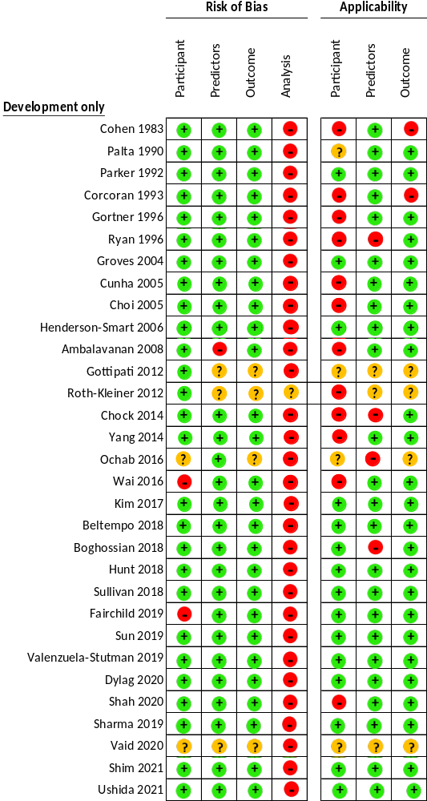
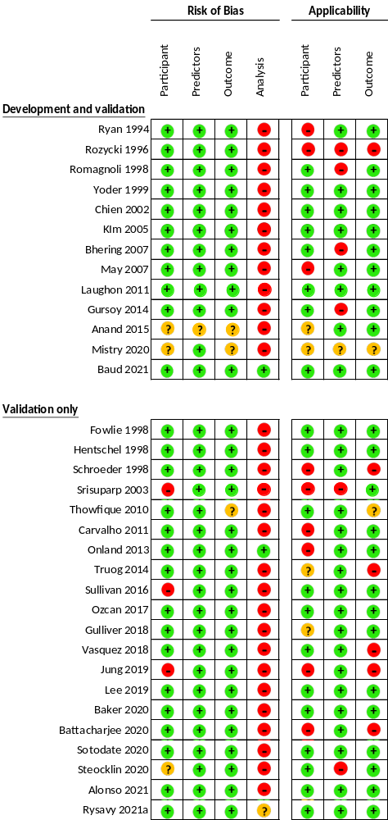

Appendix 7: Forest plot of C-statistics in external validation studies of included prediction models for (A) bronchopulmonary dysplasia (BPD) outcome as well as (B) composite outcome of BPD and death.
The figure below shows the meta-analysis of the C-statistics obtained from external validation studies for each of the prediction models for (A) BPD and (B) composite outcome of BPD and death. This was split by the age of the infant when the prediction was made in the external validation studies (≤1 day, 2 – 6 days and ≥7 days old). The meta-analysis and the reported confidence intervals are shown in bold after each prediction model if it was externally validated by more than two external validation studies. BPD was defined as respiratory support requirement at 36 weeks of corrected gestational age in most of the external validation studies except for those labelled ¹.

Bronchopulmonary dysplasia
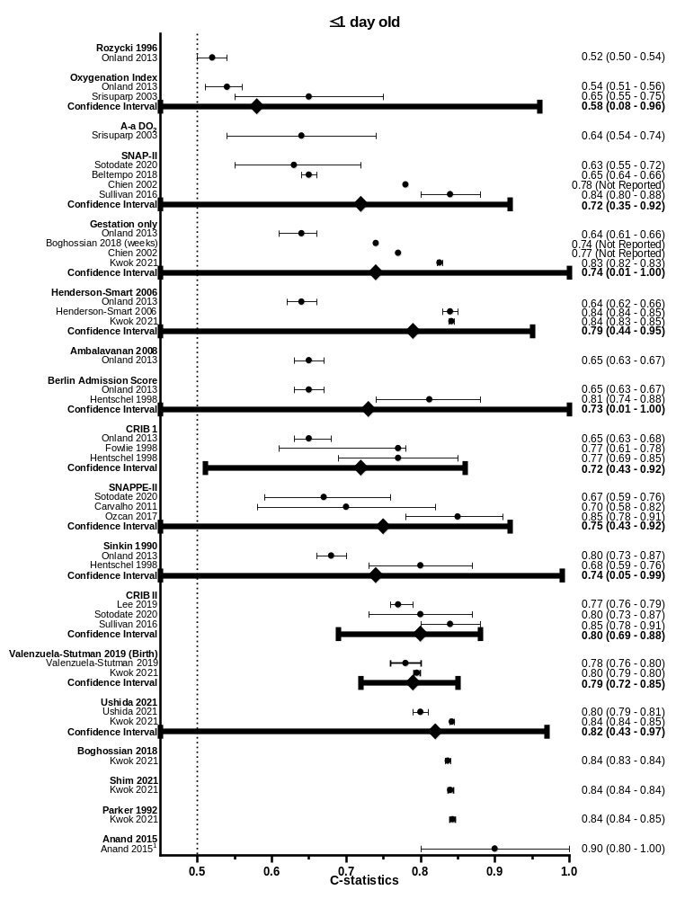
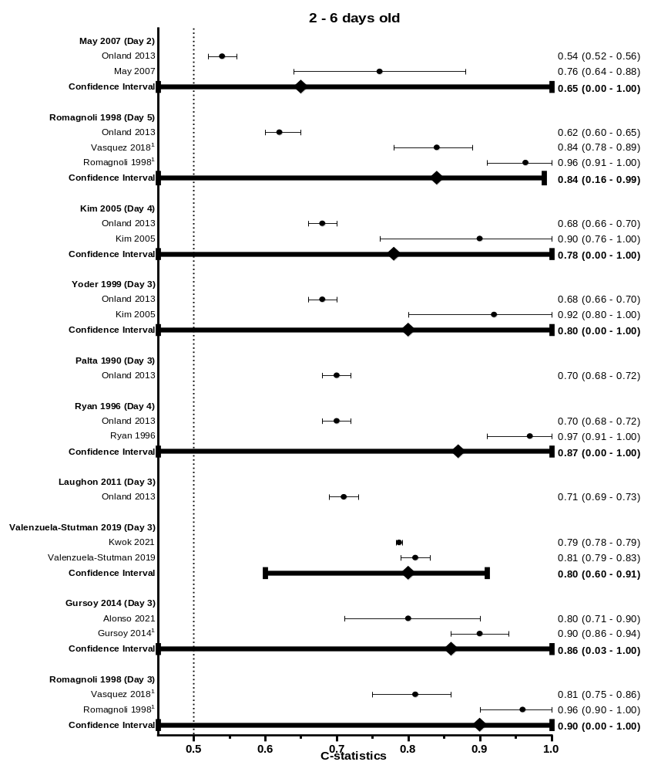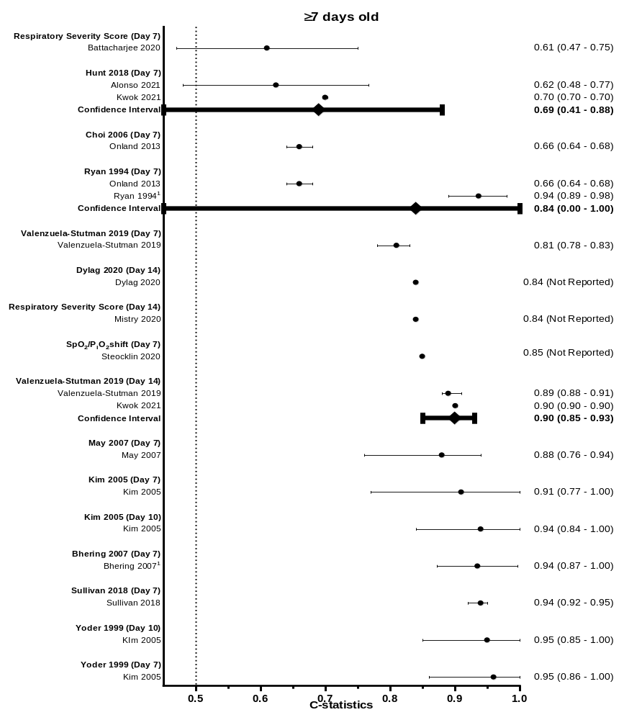

(B) Composite outcome of bronchopulmonary dysplasia and death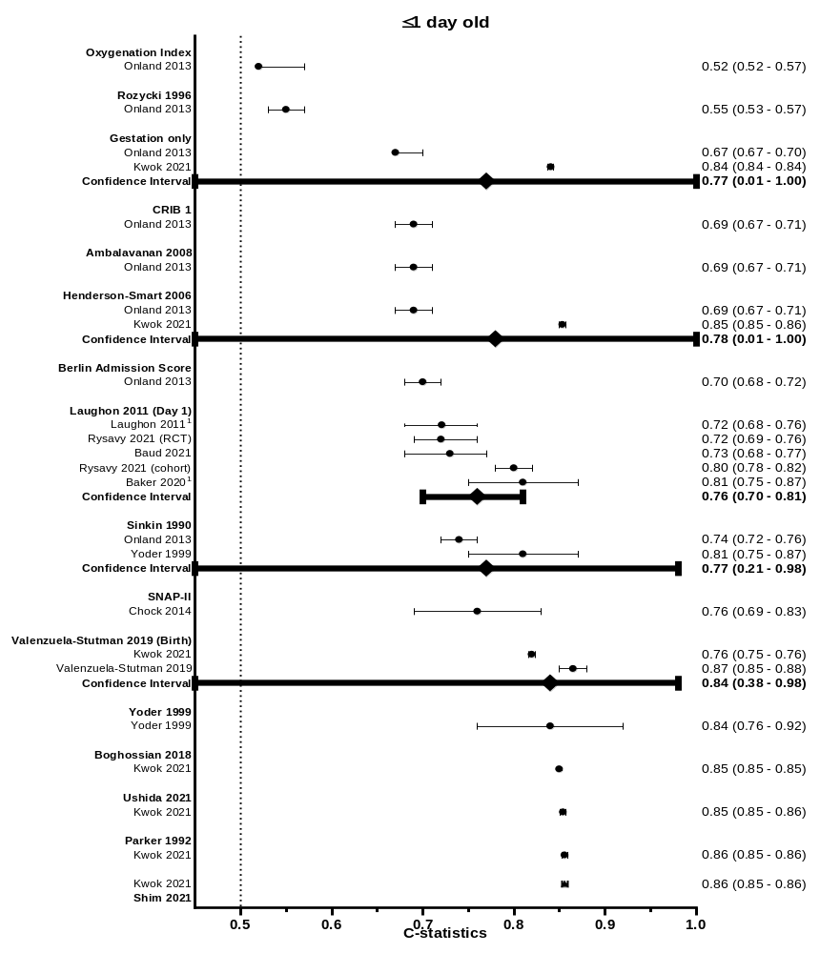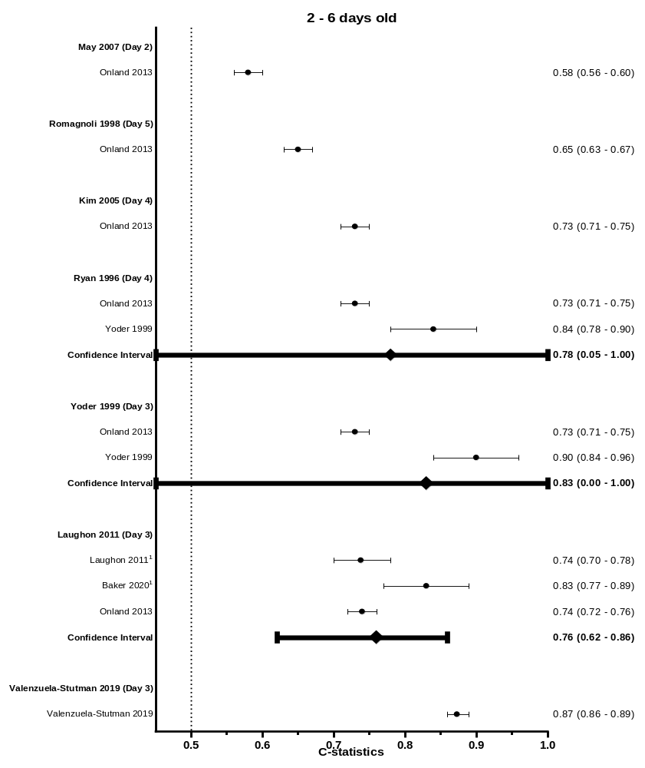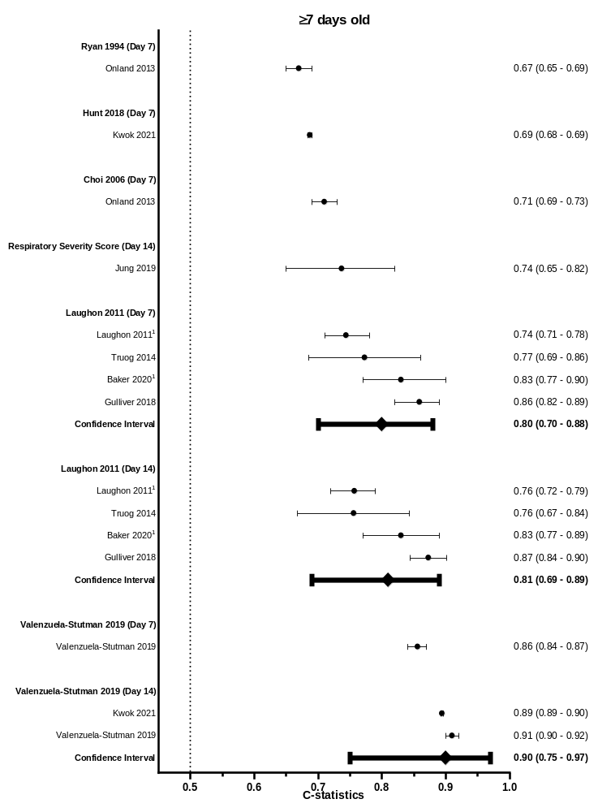

Appendix 8: Forest plot of observed : expected ratio (O:E ratio) in external validation studies of included prediction models for (A) bronchopulmonary dysplasia (BPD) outcome as well as (B) composite outcome of BPD and death
The figure below shows the meta-analysis of the O:E ratio obtained from external validation studies for each of the prediction models for (A) BPD and (B) composite outcome of BPD and death. The meta-analysis and the reported confidence intervals are shown in bold after each prediction model if it was externally validated by more than two external validation studies.
¹ Observed and expected risk were obtained from the observed incidence table stratified by estimated risk group.
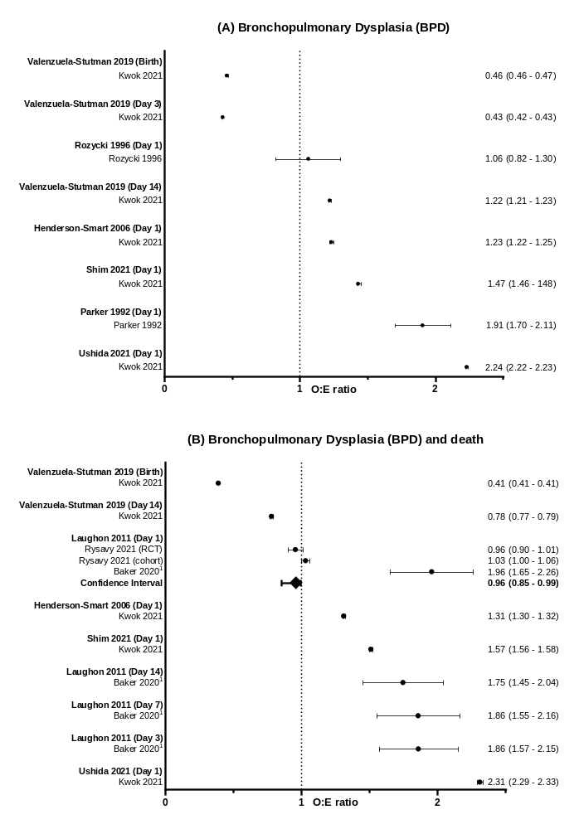

Appendix 9: Calibration plots of prediction models with two or more external validation studies.
¹ Observed and expected risk were obtained from the observed incidence table stratified by estimated risk group.
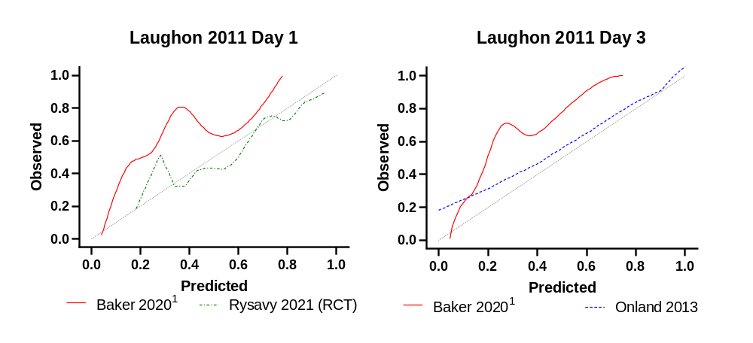

Appendix 10: Flow diagram depicting the retrospective patient cohort for the external validation study
Resp = Respiratory. BPD = bronchopulmonary dysplasia
n = 62,937
- Born <32 weeks of gestational age
- Born in January 2010 to December 2017
- Admitted to neonatal unit in England & Wales

n = 62,864
Missing data
- Ethnicity – 11.8% (n=7,444)
- Apgar at 5 minute – 10.8% (n=6,796)
- Apgar at 1 minute – 10.3% (n=6,498)
- Mode of delivery – 6.1% (n=3,809)
- Antenatal steroids – 5.6% (n=3,522)
- Admission temperature – 1.3% (n=803)
- Resp support day 3 – 0.8% (n=474)
- Resp support day 7 – 0.7% (n=453)
- Resp support day 14 – 0.7% (n=425)
- Birthweight z score – 0.2% (n=150)
- BPD – 0.6% (n=383)
- Sex – 0.07% (n=43)
- Outborn/inborn status – 0.04% (n=24)
- Multiple pregnancy – 0.02% (n=14)
Exclusions
- Birthweight z score above 4 or below -4 (n = 73)

Appendix 11: Infant characteristics of the retrospective patient cohort for the external validation study
¹ Percentage of bronchopulmonary dysplasia was calculated based on babies who survived till 36 weeks of corrected gestational age.
Clinical characteristics | All infants (n = 62,864)
Gestation at birth (weeks), median (IQR) | 29+3 (27+2 – 30+6)
Birthweight (g), median (IQR) | 1200 (900 – 1490)
Birthweight z score, median (IQR) | -0.25 (-0.87 – 0.26)
Small for gestational age (%) | 9,229 (15)
Sex (n (%))
Male | 34,276 (55)
Ethnicity (n (%))
White  South Asian  Black  Others/Mix | 27,830 (70)  5,138 (13)  3,167 (8)  3,380 (9)
Complete antenatal steroid course (n (%)) | 42,647 (72)
Apgar at 1 minute median (IQR) | 6 (4 – 8)
Apgar at 5 minutes median (IQR) | 9 (7 – 9)
Apgar at 10 minutes median (IQR) | 9 (8 – 10)
Vaginal delivery (n (%)) | 24,902 (42)
Received surfactant (n (%)) | 38,938 (65)
Received invasive ventilation (n (%)) | 42,385 (67)
Duration of invasive ventilation (days), median (IQR) | 2 (1 – 7)
Bronchopulmonary dysplasia (n (%))¹ | 17,775 (31)
Composite outcome bronchopulmonary dysplasia and death (n (%)) | 23,095 (37)
Death (n (%)) | 5,718 (9)

Appendix 12: Decision curve analysis of prediction models using retrospective cohort.
The decision curve analysis below depicts the clinical “net benefit“ for using one or more of the prediction models in comparison to default strategies of treating all or no patients across a range of threshold probabilities. Further detailed explanation of the decision curve analysis can be found in Vickers et al 2019⁴².
HS = Henderson-Smart. VS = Valenzuela-Stutman
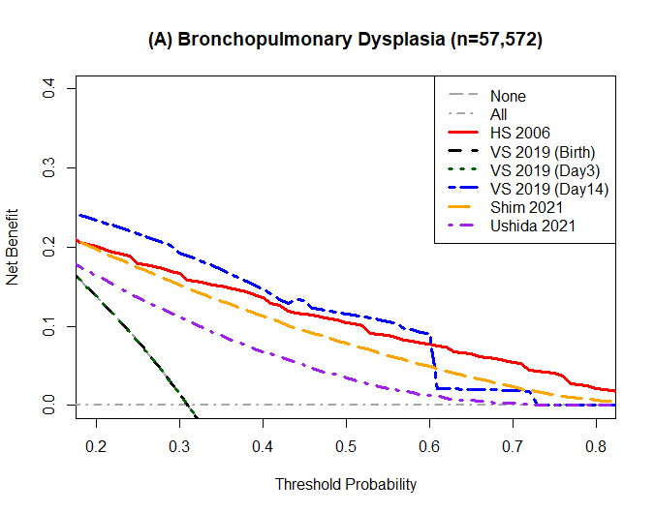
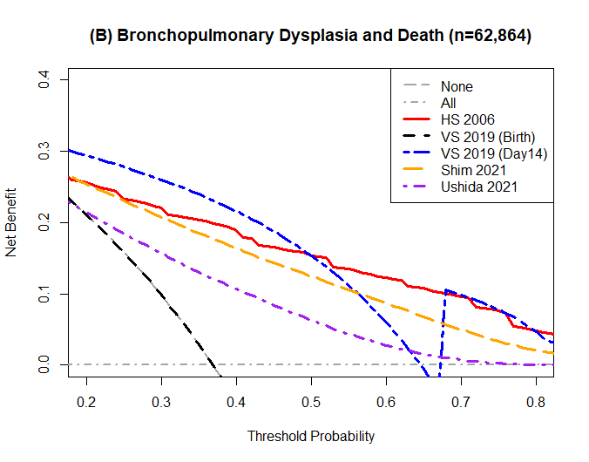

Appendix 13: List of participating institutions within the UK Neonatal Collaborative
Institution | Lead clinician
Airedale General Hospital | Dr Matthew Babirecki
Arrowe Park Hospital | Dr Anand Kamalanathan
Barnet Hospital | Dr Tim Wickham
Barnsley District General Hospital | Dr Kavi Aucharaz
Basildon Hospital | Dr Aashish Gupta
Basingstoke & North Hampshire Hospital | Dr Nicola Paul
Bassetlaw District General Hospital | Dr L M Wong
Bedford Hospital | Dr Anita Mittal
Birmingham City Hospital | Dr Lindsay Halpern
Birmingham Heartlands Hospital | Dr Pinki Surana
Birmingham Women's Hospital | Dr Matt Nash
Bradford Royal Infirmary | Dr Sam Wallis
Broomfield Hospital, Chelmsford | Dr Ahmed Hassan
Calderdale Royal Hospital | Dr Karin Schwarz
Chelsea & Westminster Hospital | Dr Shu-Ling Chuang
Chesterfield & North Derbyshire Royal Hospital | Dr Aiwyne Foo
Colchester General Hospital | Dr Jo Anderson
Conquest Hospital | Dr Graham Whincup
Countess of Chester Hospital | Dr Stephen Brearey
Croydon University Hospital | Dr Morris
Croydon University Hospital | Dr Srirambhatla
Cumberland Infirmary | Dr Yee Aung
Darent Valley Hospital | Dr Abdul Hasib
Darlington Memorial Hospital | Dr Mehdi Garbash
Derriford Hospital | Dr Alex Allwood
Diana Princess of Wales Hospital | Dr Pauline Adiotomre
Doncaster Royal Infirmary | Dr Nigel Brooke
Dorset County Hospital | Dr Abby Deketelaere
East Surrey Hospital | Dr Abdul Khader
Epsom General Hospital | Dr Sonia Spathis
Frimley Park Hospital | Dr Sanghavi Rekha
Furness General Hospital | Dr Anas Olabi
George Eliot Hospital | Dr Mukta Jain
Glan Clwyd Hospital | Dr Ian Barnard
Glangwili General Hospital | Dr Prem Pitchaikani
Gloucester Royal Hospital | Dr Jennifer Holman
Good Hope Hospital | Dr Pinki Surana
Great Western Hospital | Dr Stanley Zengeya
Guy's & St Thomas' Hospital | Dr Geraint Lee
Harrogate District Hospital | Dr Sobia Balal
Hereford County Hospital | Dr Cath Seagrave
Hillingdon Hospital | Dr Tristan Bate
Hinchingbrooke Hospital | Dr Hilary Dixon
Homerton Hospital | Dr Narendra Aladangady
Hull Royal infirmary | Dr Hassan Gaili
Ipswich Hospital | Dr Matthew James
James Cook University Hospital | Dr M Lal
James Paget Hospital | Dr Ambadkar
Kettering General Hospital | Dr Poornima Pandey
Kings College Hospital | Dr Ravindra Bhat
King's Mill Hospital | Dr Simon Rhodes
Kingston Hospital | Dr Jonathan Filkin
Lancashire Women and Newborn Centre | Dr Savi Sivashankar
Leeds Neonatal Service | Dr Lawrence Miall
Leicester General Hospital | Dr Jonathan Cusack
Leicester Royal Infirmary | Dr Venkatesh Kairamkonda
Leighton Hospital | Dr Michael Grosdenier
Lincoln County Hospital | Dr Ajay Reddy
Lister Hospital | Dr J Kefas
Liverpool Women's Hospital | Dr Christopher Dewhurst
Luton & Dunstable Hospital | Dr Jennifer Birch
Macclesfield District General Hospital | Dr Gail Whitehead
Manor Hospital | Dr Ashok Karupaiah
Medway Maritime Hospital | Dr Ghada Ramadan
Milton Keynes General Hospital | Dr I Misra
Musgrove Park Hospital | Dr Chris Knight
New Cross Hospital | Dr Matt Nash
Newham General Hospital | Dr Imdad Ali
Nobles Hospital | Dr Prakash Thiagarajan
Norfolk & Norwich University Hospital | Dr Muthukumar
North Devon District Hospital | Dr Michael Selter
North Manchester General Hospital | Dr Ajit Mahaveer
North Middlesex University Hospital | Dr Neeraj Jain
Northampton General Hospital | Dr Subodh Gupta
Northumbria Specialist Emergency Care Hospital | Jess Reynolds
Northwick Park Hospital | Dr Richard Nicholl
Nottingham City Hospital | Dr Steven Wardle
Nottingham University Hospital (QMC) | Dr Steven Wardle
Ormskirk District General Hospital | Dr Andreea Bontea
Oxford University Hospitals, John Radcliffe Hospital | Dr Eleri Adams
Peterborough City Hospital | Dr Katharine McDevitt
Pilgrim Hospital | Dr Ajay Reddy
Pinderfields General Hospital (Pontefract General Infirmary) | Dr David Gibson
Poole General Hospital | Prof Minesh Khashu
Prince Charles Hospital | Dr Iyad Al-Muzaffar
Princess Alexandra Hospital | Dr Chinnappa Reddy
Princess Anne Hospital | Dr Mark Johnson
Princess of Wales Hospital | Dr Kate Creese
Princess Royal Hospital | Dr P Amess
Princess Royal Hospital (previously Royal Shrewsbury Hospital) | Dr Deshpande
Princess Royal University Hospital | Dr Elizabeth Sleight
Queen Alexandra Hospital | Dr Charlotte Groves
Queen Charlotte's Hospital | Dr Lidia Tyszcuzk
Queen Elizabeth Hospital, Gateshead | Dr Anne Dale
Queen Elizabeth Hospital, King's Lynn | Dr Glynis Rewitzky
Queen Elizabeth Hospital, Woolwich - see notes | Dr Olutoyin Banjoko
Queen Elizabeth the Queen Mother Hospital | Dr Bushra Abdul-Malik
Queen's Hospital, Burton on Trent | Dr Dominic Muogbo
Queen's Hospital, Romford | Dr Khalid Mannan
Queen's Hospital, Romford 2 | Dr Khalid Mannan
Rosie Maternity Hospital, Addenbrookes | Dr Angela D'Amore
Rotherham District General Hospital | Dr Soma Sengupta
Royal Albert Edward Infirmary | Dr Christos Zipitis
Royal Berkshire Hospital | Dr Peter De Halpert
Royal Bolton Hospital | Dr Paul Settle
Royal Cornwall Hospital | Dr Paul Munyard
Royal Derby Hospital | Dr John McIntyre
Royal Devon & Exeter Hospital | Dr Chrissie Oliver
Royal Gwent Hospital | Dr Sunil Reddy
Royal Hampshire County Hospital | Dr Lucinda Winckworth
Royal Lancaster Infirmary | Dr Joanne Fedee
Royal Oldham Hospital | Dr Natasha Maddock
Royal Preston Hospital | Dr Richa Gupta
Royal Stoke University Hospital | Dr Jyoti Kapur
Royal Surrey County Hospital | Dr Ben Obi
Royal Sussex County Hospital | Dr P Amess
Royal United Hospital | Dr Stephen Jones
Royal Victoria Infirmary | Dr Naveen Athiraman
Russells Hall Hospital | Dr Chandan Gupta
Salisbury District Hospital | Dr Jim Baird
Scarborough General Hospital | Dr Kirsten Mack
Scunthorpe General Hospital | Dr Pauline Adiotomre
Singleton Hospital | Dr Arun Ramachandran
Southend Hospital | Dr Vineet Gupta
Southmead Hospital | Dr Faith Emery
St George's Hospital | Dr Charlotte Huddy
St Helier Hospital | Dr Ralf Hartung
St Mary's Hospital, IOW | Dr Akinsola Ogundiya
St Mary's Hospital, London | Dr Lidia Tyszcuzk
St Mary's Hospital, Manchester | Dr Ngozi Edi-Osagie
St Michael's Hospital | Dr Pamela Cairns
St Peter's Hospital | Dr Peter Martin
St Richard's Hospital | Dr Victoria Sharp
Stepping Hill Hospital | Dr Carrie Heal
Stoke Mandeville Hospital | Dr Sanjay Salgia
Sunderland Royal Hospital | Dr Majd Abu-Harb
Tameside General Hospital | Dr Jacqeline Birch
The Grange University Hospital | Dr Sunil Reddy
The Jessop Wing, Sheffield | Dr Porus Bastani
The Royal Free Hospital | Dr Marice Theron
The Royal London Hospital - Constance Green | Dr Vadivelam Murthy
Torbay Hospital | Dr Siba Paul
Tunbridge Wells Hospital | Dr Hamudi Kisat
University College Hospital | Dr Giles Kendall
University Hospital Coventry | Dr Puneet Nath
University Hospital Lewisham | Dr Ozioma Obi
University Hospital of North Durham | Dr Mehdi Garbash
University Hospital of North Tees | Dr Hari Kumar
University Hospital of Wales | Dr Nitin Goel
Victoria Hospital, Blackpool | Dr Chris Rawlingson
Warrington Hospital | Dr Delyth Webb
Warwick Hospital | Dr Bird
Watford General Hospital | Dr Sankara Narayanan
West Cumberland Hospital | Dr Yee Aung
West Middlesex University Hospital | Dr Eleanor Hulse
West Suffolk Hospital | Dr Ian Evans
Wexham Park Hospital | Dr Sanjay Jaisal
Whipps Cross University Hospital | Dr Caroline Sullivan
Whiston Hospital | Dr Ros Garr
Whittington Hospital | Dr Wynne Leith
William Harvey Hospital | Dr Vimal Vasu
Withybush Hospital | Dr Vishwa Narayan
Worcestershire Royal Hospital | Dr Liza Harry
Worthing Hospital | Dr Katia Vamvakiti
Wrexham Maelor Hospital | Dr Brendan Harrington
Wythenshawe Hospital | Dr Ngozi Edi-Osagie
Yeovil District Hospital | Dr Megan Eaton
York District Hospital | Dr Sundeep Sandhu
Ysbyty Gwynedd | Dr Mike Cronin
The list was accessed from https://www.imperial.ac.uk/neonatal-data-analysis-unit/neonatal-data-analysis-unit/list-of-national-neonatal-units/ on 06/01/2022.

