Supplement
Supplementary Table 1. Treatment sequence among patients with chemotherapy-naïve mCRPC prescribed abiraterone vs enzalutamide
Enzalutamide  (n = 1229) |  | Abiraterone  (n = 1945)
Treatment sequences | no. (%) | Treatment sequences | no. (%)
Enzalutamide irrespective of follow-up treatments | 1229 (100) | Abiraterone irrespective of follow-up treatments | 1945 (100)
Enzalutamide followed by abiraterone | 282 (23) | Abiraterone followed by enzalutamide | 504 (26)
Enzalutamide followed by chemotherapy* as second-line therapy | 77 (6) | Abiraterone followed by chemotherapy* as second-line therapy | 178 (9)
Enzalutamide only (one line of therapy) | 668 (54) | Abiraterone only (one line of therapy) | 889 (46)
Enzalutamide followed by other† | 202 (16) | Abiraterone followed by other† | 374 (19)
*Chemotherapy included docetaxel, cabazitaxel, and mitoxantrone hydrochloride. †Other = any sequential treatment sequence (excluding treatment sequences as defined in the above rows).
mCRPC metastatic castration-resistant prostate cancer.

Supplementary Table 2. Treatment sequence among patients with chemotherapy-naïve mCRPC prescribed abiraterone vs enzalutamide followed by “other” regimens (ie, aside from one line of therapy only, direct crossover to the other NHT only, or chemotherapy as second-line therapy)
Enzalutamide  (n = 1229) |  | Abiraterone  (n = 1945)
Treatment sequences | no. (%) | Treatment sequences | no. (%)
Enzalutamide followed by enzalutamide (e)* | 69 (5.61) | Abiraterone followed by enzalutamide (e), followed by chemotherapy (c) |  | 134 (6.89)
Enzalutamide followed by abiraterone (a), followed by chemotherapy (c) | 62 (5.04) | Abiraterone followed by abiraterone (a)* |  | 84 (4.32)
Enzalutamide followed by c, followed by a | 21 (1.71) | Abiraterone followed by c, followed by e |  | 55 (2.83)
Enzalutamide followed by a, followed by e | 16 (1.30) | Abiraterone followed by a, followed by e* |  | 27 (1.39)
Enzalutamide followed by e, followed by a | 13 (1.06) | Abiraterone followed by e, followed by e |  | 25 (1.29)
Enzalutamide followed by e, followed by e* | 12 (0.98) | Abiraterone followed by e, followed by a |  | 22 (1.13)
Other regimens† | 48 (3.91) | Abiraterone followed by c, followed by e, followed by c |  | 18 (0.93)
 |  | Abiraterone followed by e, followed by c, followed by a |  | 10 (0.51)
 |  | Other regimens† |  | 103 (5.30)
*A 90-day gap in prescription dispensing was used to identify treatment discontinuation. Thus patients who had such a discontinuation and restarted therapy even with the same medication are shown here.
†Sum of other regimens with <10 patients per sequence.
a abiraterone; e enzalutamide; c chemotherapy; NHT novel hormonal therapy.
Supplemental Fig. 1. Adjusted Kaplan-Meier curve for overall survival, enzalutamide followed by other vs abiraterone followed by other
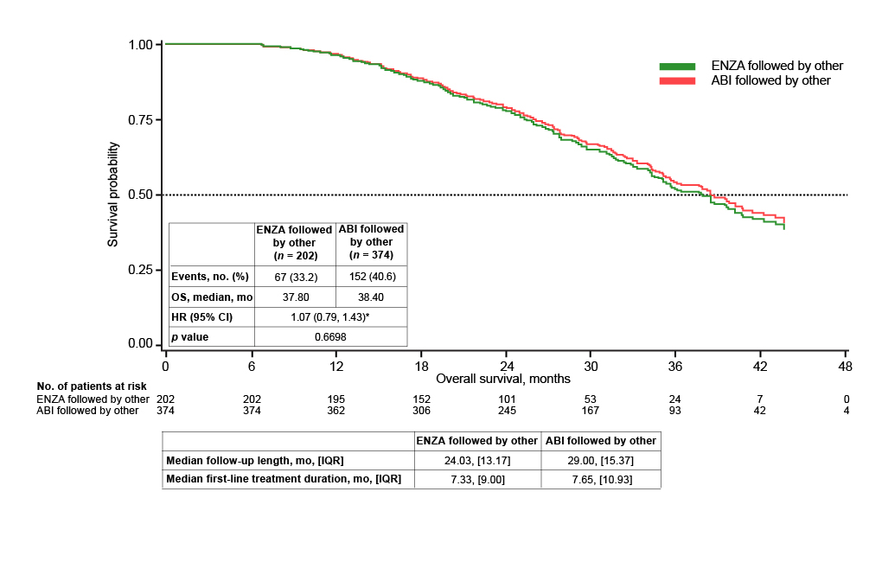

*Enzalutamide versus abiraterone.
ABI abiraterone; ENZA enzalutamide; HR hazard ratio; IQR interquartile range; OS overall survival.

