Supplemental Table 1: Breakdown of EPE by Laterality
 | N=601
Bilateral EPE | 72 (12%)
Dominant Side EPE | 206 (34%)
Non-Dominant Side EPE | 39 (6.5%)
No EPE | 284 (47%)

Supplemental Table 2: Univariable and multivariable analysis for overall EPE
 | Univariable Analysis |  | Multivariable Analysis
 | OR (95% CI) | P value | OR (95% CI) | P value
Age (years) | 1.03 (1.01,1.04) | 0.005 | 1.02 (0.99, 1.04) | 0.2
Black Race | 0.79 (0.45, 1.23) | 0.3
Insurance category |  | 0.09
Medicare | Ref
Medicaid | 0.88 (0.43, 1.81) | 0.7
Private | 0.68 (0.48, 0.96) | 0.03
BMI (kg/m²) | 1 (0.96, 1.04) | >0.9
Abnormal DRE | 0.88 (0.45, 1.74) | 0.7
Family Hx of Prostate Cancer | 0.88 (0.62, 1.27) | 0.5
PHI Category |  | <0.001
≥55 | Ref
0-26.9 | 0.23 (0.09, 0.56) | 0.002
27-35.9 | 0.33 (0.18, 0.58) | <0.001
36-54.9 | 0.27 (0.18, 0.41) | <0.001
PSAD Category |  | <0.001
≤ 0.10 | Ref
0.10-0.15 | 1.66 (1.03, 2.68) | 0.04
0.15-0.2 | 1.93 (1.18, 3.16) | 0.009
≥ 0.20 | 3.23 (2.12, 4.96) | <0.001
Log PSAD | 2.30 (1.74, 3.07) | <0.001 | 1.66 (1.23, 2.25) | 0.001
Max PIRADS |  | <0.001 |  | <0.001
3 | Ref |  | Ref
1 or 2 | 0.62 (0.09, 2.64) | 0.6 | 0.78 (0.11, 3.56) | 0.8
4 | 2.89 (1.60, 5.51) | <0.001 | 1.85 (0.97, 3.69) | 0.07
5 | 11.9 (6.22, 23.8) | <0.001 | 4.68 (2.29, 9.93) | <0.001
Max Gleason Grade |  | <0.001 |  | <0.001
2 | Ref |  | Ref
1 | 0.22 (0.06, 0.59) | 0.006 | 0.42 (0.12, 1.16) | 0.12
3 | 2.89 (1.97, 4.26) | <0.001 | 2.01 (1.32, 3.08) | 0.001
4 | 2.49 (1.43, 4.39) | 0.001 | 1.90 (1.03, 3.55) | 0.04
5 | 10.3 (4.92, 24.4) | <0.001 | 4.94 (2.18, 12.4) | <0.001
% Positive non-ROI Cores | 1.03 (1.02, 1.03) | <0.001
Total Cores Positive | 1.21 (1.15, 1.27) | <0.001 | 1.12 (1.05, 1.19) | <0.001
Total Cores Negative | 0.92 (0.89, 0.95) | <0.001 | 0.98 (0.95, 1.01) | 0.2
Prostate volume (cc) |  | 0.4
<30 | Ref
30-50 | 1.06 (0.72, 1.58) | 0.8
50-80 | 0.75 (0.48, 1.19) | 0.2
>80 | 0.8 (0.38, 1.67) | 0.6
Dominant Side GG |  | <0.001
2 | Ref
1 | 0.22 (0.06, 0.59) | 0.006
3 | 2.89 (1.97, 4.26) | <0.001
4 | 2.49 (1.43, 4.39) | 0.001
5 | 10.3 (4.92, 24.4) | <0.001
Non-Dominant Side GG |  | <0.001
2 | Ref
Negative | 0.86 (0.56, 1.31) | 0.5
1 | 0.62 (0.38, 1.02) | 0.06
3 | 4.86 (2.29, 11.3) | <0.001
4 | 5.93 (1.56, 38.9) | 0.02
5 | - | -
Dominant PIRADS |  | <0.001
3 | Ref
1 or 2 | 1.19 (0.48, 2.9) | 0.7
4 | 2.32 (1.28, 4.41) | 0.007
5 | 8.66 (4.55, 17.2) | <0.001
Non-Dominant PIRADS
3 | Ref
1 or 2 | 1.86 (1.14, 3.07) | 0.01
4 | 2.60 (1.50, 4.56) | <0.001
5 | 17 (6.09, 60.7) | <0.001
Dominant Abutment | 2.40 (1.63, 3.56) | <0.001
Non-Dominant Abutment | 1.72 (1.22, 2.42) | 0.002

Supplemental Table 3: Univariable and multivariable analysis for dominant side EPE

 | Univariable Analysis |  | Multivariable Analysis
 | OR (95% CI) | P value | OR (95% CI) | P value
Age (years) | 1.03 (1.01,1.06) | 0.003 | 1.02 (1.00, 1.05) | 0.1
Black Race | 0.68 (0.43, 1.08) | 0.11
Insurance category |  | 0.08
Medicare | Ref
Medicaid | 0.74 (0.36, 1.50) | 0.4
Private | 0.67 (0.48, 0.95) | 0.03
BMI (kg/m²) | 0.98 (0.94, 1.02) | 0.3
Abnormal DRE | 0.75 (0.37, 1.47) | 0.4
Family Hx of Prostate Cancer | 0.81 (0.56, 1.17) | 0.3
PHI Category |  | <0.001
≥55 | Ref
0-26.9 | 0.34 (0.13, 0.82) | 0.02
27-35.9 | 0.37 (0.21, 0.66) | <0.001
36-54.9 | 0.31 (0.20, 0.47) | <0.001
PSAD Category |  | <0.001
≤ 0.10 | Ref
0.10-0.15 | 1.53 (0.94, 2.49) | 0.09
0.15-0.2 | 1.60 (0.97, 2.64) | 0.06
≥ 0.20 | 2.66 (1.75, 4.08) | <0.001
Log PSAD |  |  | 1.45 (1.10, 1.94) | 0.01
Max PIRADS |  | <0.001
3 | Ref
1 or 2 | 0.82 (0.12, 3.59) | 0.8
4 | 2.74 (1.47, 5.55) | 0.003
5 | 10.7 (5.51, 22.5) | <0.001
Max Gleason Grade |  | <0.001
2 | Ref
1 | 0.31 (0.06, 0.81) | 0.03
3 | 2.82 (1.92, 4.17) | <0.001
4 | 2.66 (1.53, 4.67) | 0.001
5 | 7.12 (3.77, 14.2) | <0.001
% Positive non-ROI Cores | 1.02 (1.01, 1.03) | <0.001
Total Cores Positive |  |  | 1.12 (1.05, 1.20) | <0.001
Total Cores Negative |  |  | 1.01 (0.97, 1.04) | 0.7
Prostate volume (cc) |  | 0.6
<30 | Ref
30-50 | 1.13 (0.77, 1.68) | 0.5
50-80 | 0.85 (0.53, 1.34) | 0.5
>80 | 0.91 (0.43, 1.89) | 0.8
Dominant Side GG |  | <0.001 |  | 0.007
2 | Ref |  | Ref
1 | 0.31 (0.09, 0.81) | 0.03 | 0.52 (0.15, 1.47) | 0.3
3 | 2.82 (1.92, 4.17) | <0.001 | 1.91 (1.22, 3.00) | 0.005
4 | 2.66 (1.53, 4.67) | <0.001 | 1.89 (1.00, 3.58) | 0.051
5 | 7.12 (3.77, 14.2) | <0.001 | 2.67 (1.18, 6.29) | 0.02
Non-Dominant Side GG |  | <0.001 |  | 0.5
2 | Ref |  | Ref
Negative | 0.43 (0.24, 0.76) | 0.003 | 1.47 (0.83, 2.60) | 0.2
1 | 0.76 (0.46, 1.26) | 0.5 | 1.05 (0.58, 1.89) | 0.9
3 | 2.73 (1.44, 5.31) | 0.003 | 1.49 (0.71, 3.22) | 0.3
4 | 5.45 (1.64, 24.8) | 0.01 | 3.19 (0.68, 20) | 0.2
5 | 13.6 (2.50, 254) | 0.01 | 2.71 (0.38, 56) | 0.4
Dominant PIRADS |  | <0.001 |  | <0.001
3 | Ref |  | Ref
1 or 2 | 0.58 (0.17, 1.71) | 0.3 | 0.59 (0.16, 1.90) | 0.4
4 | 2.55 (1.34, 5.21) | 0.006 | 1.76 (0.87, 3.75) | 0.13
5 | 9.37 (4.76, 19.7) | <0.001 | 4.37 (2.06, 9.80) | <0.001
Non-Dominant PIRADS |  |  |  | 0.3
3 | Ref |  | Ref
1 or 2 | 2.05 (1.24, 3.48) | 0.006 | 1.67 (0.92, 3.10) | 0.1
4 | 2.05 (1.24, 3.48) | <0.001 | 1.21 (0.63, 2.37) | 0.6
5 | 2.06 (1.18, 3.68) | 0.01 | 1.65 (0.62, 4.52) | 0.3
Dominant Abutment | 2.81 (1.87, 4.30) | <0.001
Non-Dominant Abutment | 1.35 (0.96, 1.89) | 0.09

Supplemental Table 4: Univariable and multivariable analysis for non-dominant side EPE
 | Univariable Analysis |  | Multivariable Analysis
 | OR (95% CI) | P value | OR (95% CI) | P value
Age (years) | 1.03 (1.00, 1.06) | 0.04 | 1.04 (1.00, 1.07) | 0.04
Black Race | 1.20 (0.67, 2.05) | 0.5
Insurance category |  | 0.03
Medicare | Ref
Medicaid | 1.87 (0.84, 3.99) | 0.11
Private | 0.71 (0.46, 1.10) | 0.12
BMI (kg/m²) | 1.02 (0.97, 1.07) | 0.4
Abnormal DRE | 0.69 (0.23, 1.67) | 0.4
Family Hx of Prostate Cancer | 0.92 (0.56, 1.45) | 0.7
PHI Category |  | <0.001
≥55 | Ref
0-26.9 | - | -
27-35.9 | 0.31 (0.12, 0.68) | 0.006
36-54.9 | 0.36 (0.21, 0.61) | <0.001
PSAD Category |  | <0.001
≤ 0.10 | Ref
0.10-0.15 | 2.34 (1.12, 5.02) | 0.03
0.15-0.2 | 1.89 (0.86, 4.20) | 0.11
≥ 0.20 | 5.17 (2.82, 10.2) | <0.001
Log PSAD | 2.30 (1.74, 3.07) | <0.001 | 1.78 (1.26, 2.57) | 0.002
Max PIRADS |  | <0.001
3 | Ref
1 or 2 | 0.83 (0.04, 5.52) | 0.9
4 | 1.77 (0.78, 4.77) | 0.2
5 | 4.09 (1.79, 11.1) | 0.002
Max Gleason Grade |  | <0.001
2 | Ref
1 | 0.40 (0.06, 1.41) | 0.2
3 | 1.47 (0.89, 2.44) | 0.13
4 | 1.67 (0.81, 3.30) | 0.15
5 | 4.26 (2.25, 8.07) | <0.001
% Positive non-ROI Cores | 1.03 (1.02, 1.04) | <0.001
Total Cores Positive | 1.14 (1.08, 1.21) | <0.001 | 1.04 (0.97, 1.13) | 0.3
Total Cores Negative | 0.90 (0.86, 0.93) | <0.001 | 0.95 (0.90, 1.00) | 0.04
Prostate volume (cc) |  | >0.9
<30 | Ref
30-50 | 1.17 (0.71, 1.96) | 0.5
50-80 | 1.00 (0.55, 1.83) | >0.9
>80 | 0.97 (0.34, 2.42) | >0.9
Dominant Side GG |  | <0.001 |  | 0.9
2 | Ref |  | Ref
1 | 0.40 (0.06, 1.41) | 0.2 | 0.63 (0.10, 2.44) | 0.6
3 | 1.47 (0.89, 2.44) | 0.13 | 0.75 (0.40, 1.41) | 0.4
4 | 1.67 (0.81, 3.30) | 0.15 | 0.70 (0.27, 1.65) | 0.4
5 | 4.26 (2.25, 8.07) | <0.001 | 0.80 (0.31, 2.02) | 0.6
Non-Dominant Side GG |  | <0.001 |  | 0.049
2 | Ref |  | Ref
Negative | 0.43 (0.24, 0.76) | 0.003 | 0.89 (0.43, 1.87) | 0.7
1 | 0.43 (0.21, 0.84) | 0.02 | 0.64 (0.29, 1.35) | 0.2
3 | 2.53 (1.30, 4.96) | 0.006 | 1.79 (0.79, 4.06) | 0.2
4 | 5.22 (1.74, 16.8) | 0.004 | 4.52 (1.06, 20.7) | 0.04
5 | 9.29 (2.51, 44.5) | 0.002 | 4.90 (0.78, 35.3) | 0.10
Dominant PIRADS |  | <0.001 |  | 0.3
3 | Ref |  | Ref
1 or 2 | 2.65 (0.87, 8.60) | 0.09 | 2.1 (0.61, 7.56) | 0.2
4 | 1.50 (0.65, 4.07) | 0.4 | 0.95 (0.38, 2.72) | >0.9
5 | 3.33 (1.45, 9.06) | 0.009 | 0.77 (0.28, 2.32) | 0.6
Non-Dominant PIRADS |  | <0.001 |  | <0.001
3 | Ref |  | Ref
1 or 2 | 0.91 (0.44, 2.00) | 0.8 | 0.95 (0.43, 2.26) | >0.9
4 | 2.76 (1.34, 6.16) | 0.008 | 2.12 (0.96, 5.04) | 0.07
5 | 16.2 (6.6, 43) | <0.001 | 10.2 (3.49, 31.9) | <0.001
Dominant Abutment | 1.22 (0.75, 2.06) | 0.4
Non-Dominant Abutment | 3.70 (2.43, 5.68) | <0.001

Supplemental Table 5: Internal Validation with Leave One Out
 | AUC (95% CI)
Overall EPE | 0.772 (0.734-0.809)
Dominant Side EPE | 0.749 (0.71-0.788)
Non-Dominant Side EPE | 0.761 (0.71-0.816)

Supplemental Table 6: Calibration Curve Characteristics for Leave One Out Validation
 | Brier Score | Cox intercept | Cox Slope | Spiegelhalter Z statistic | Spiegelhalter Z p value
Overall EPE | 0.195 | 0.005 | 0.892 | 1.08 | 0.28
Dominant Side EPE | 0.202 | -0.02 | 0.89 | 1.02 | 0.31
Non-Dominant Side EPE | 0.122 | -0.18 | 0.86 | 0.85 | 0.39

Supplemental Figure 1: Distribution of EPE stratified by PIRADS and GG

A. Overall EPE stratified by max PIRADS B. Overall EPE stratified by max GG C. Dominant side EPE stratified by PIRADS D. Dominant side EPE stratified by GG E. Non-Dominant side EPE stratified by PIRADS F. Non-Dominant side EPE stratified by GG

A.
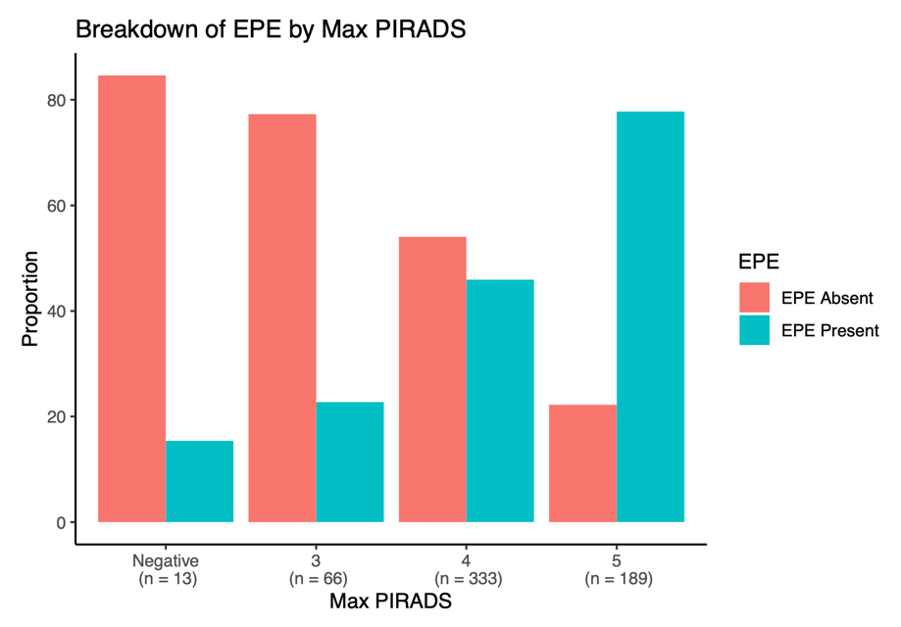
B.
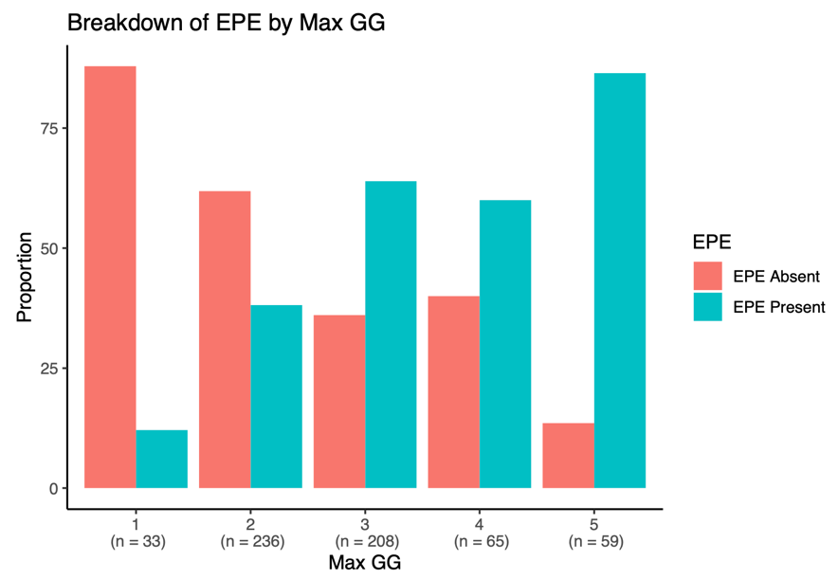

C.
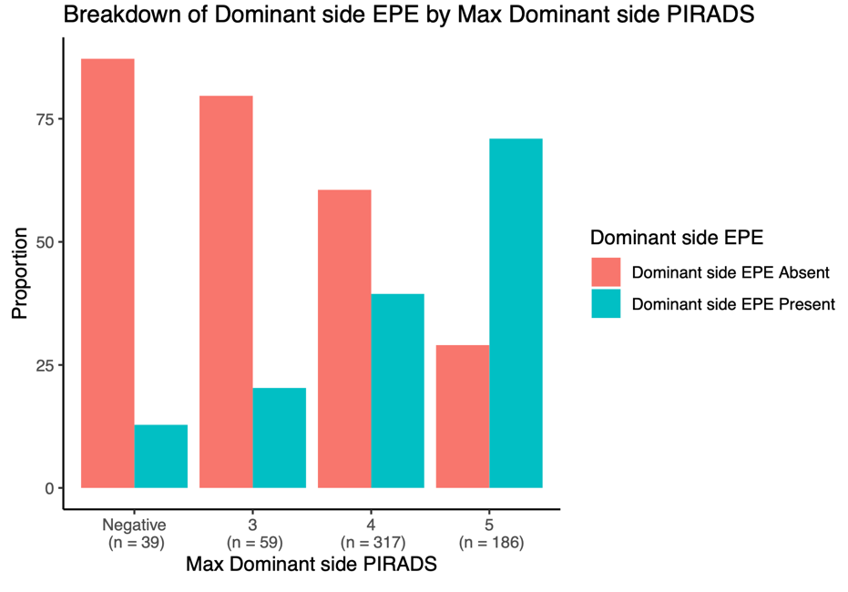
D.
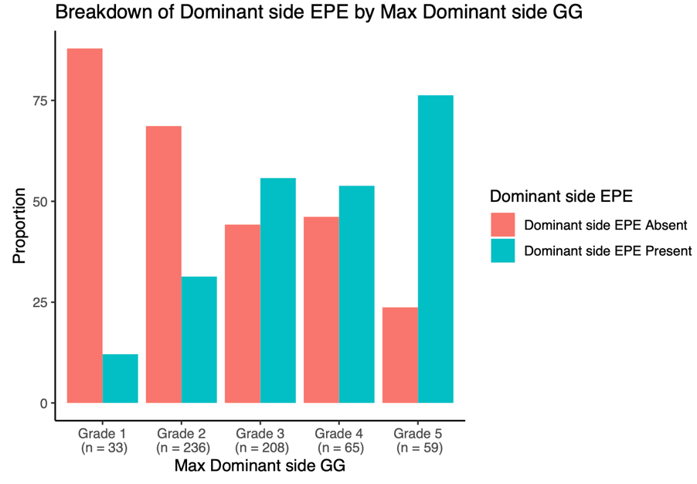

E.
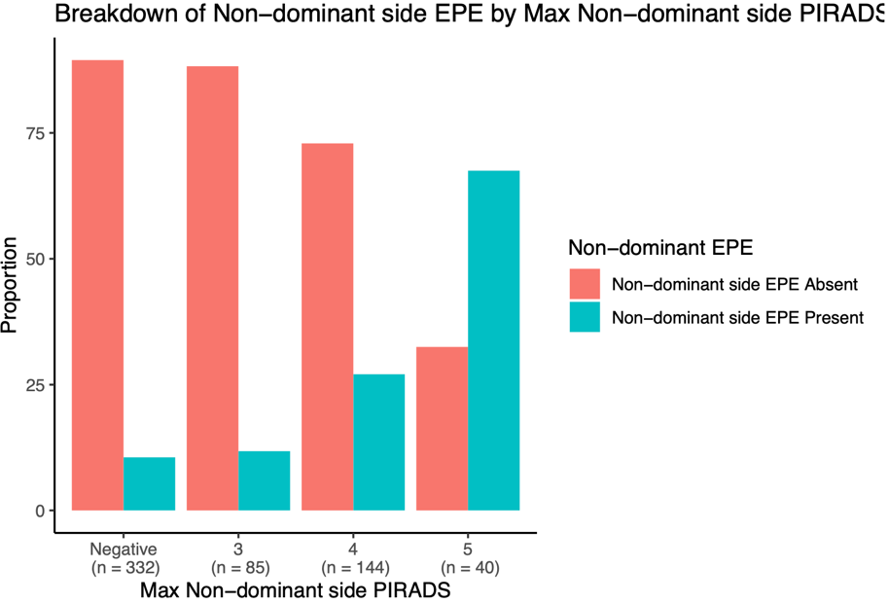

F.
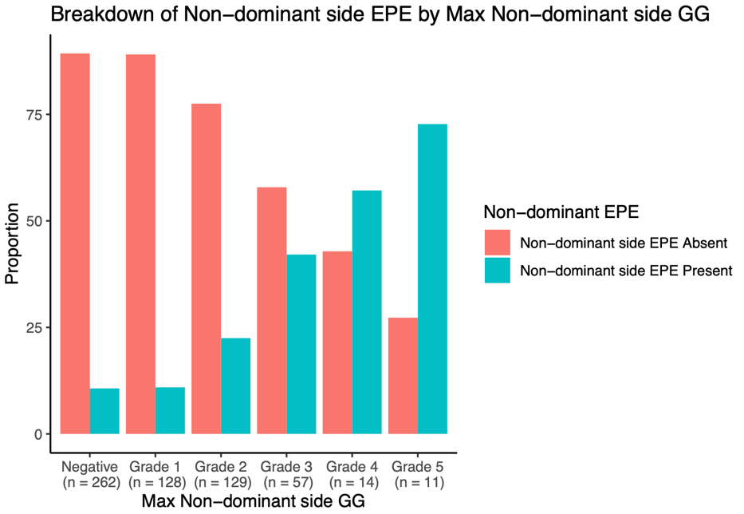
Supplemental Figure 2: Nomograms for A. Overall EPE, B. Dominant Side EPE, and C. Non-Dominant Side EPE

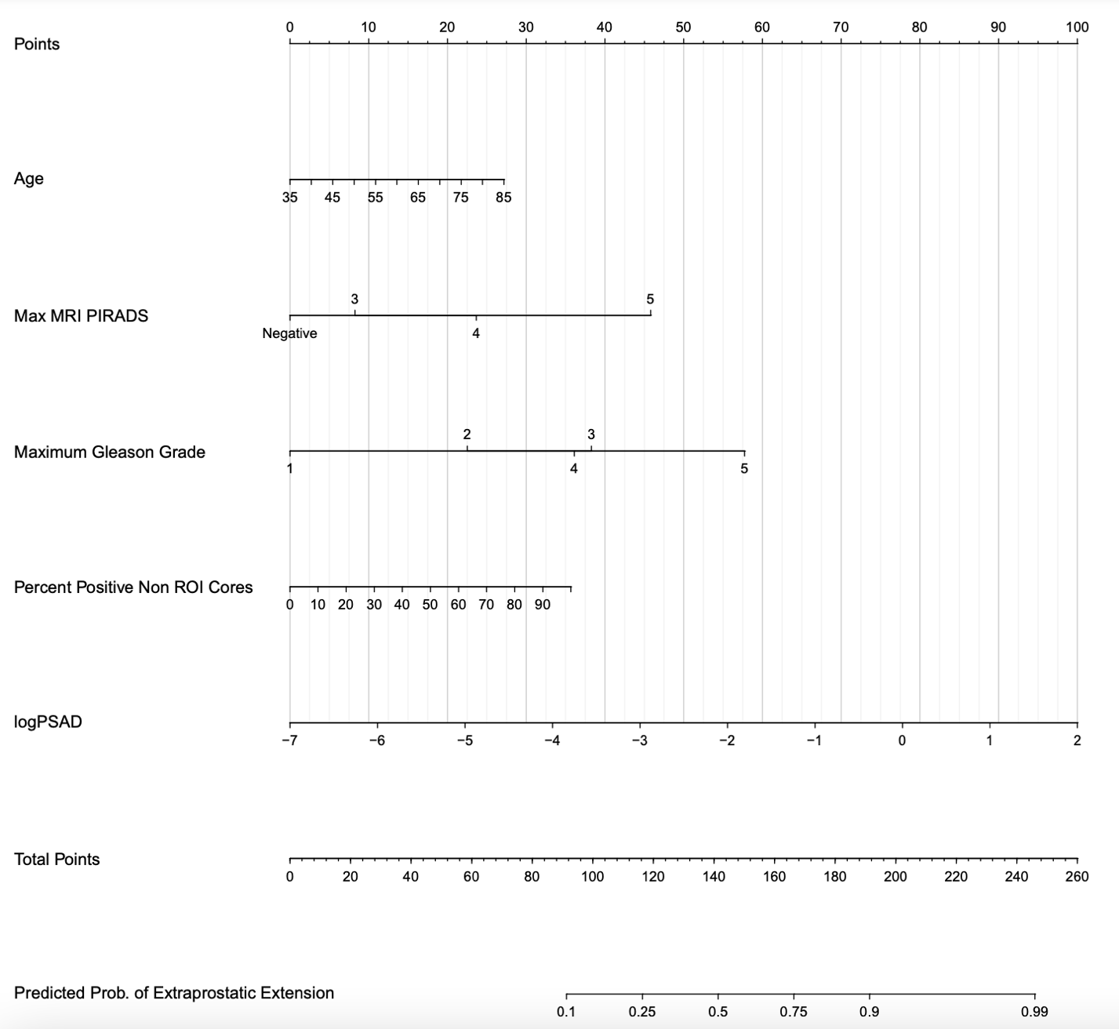

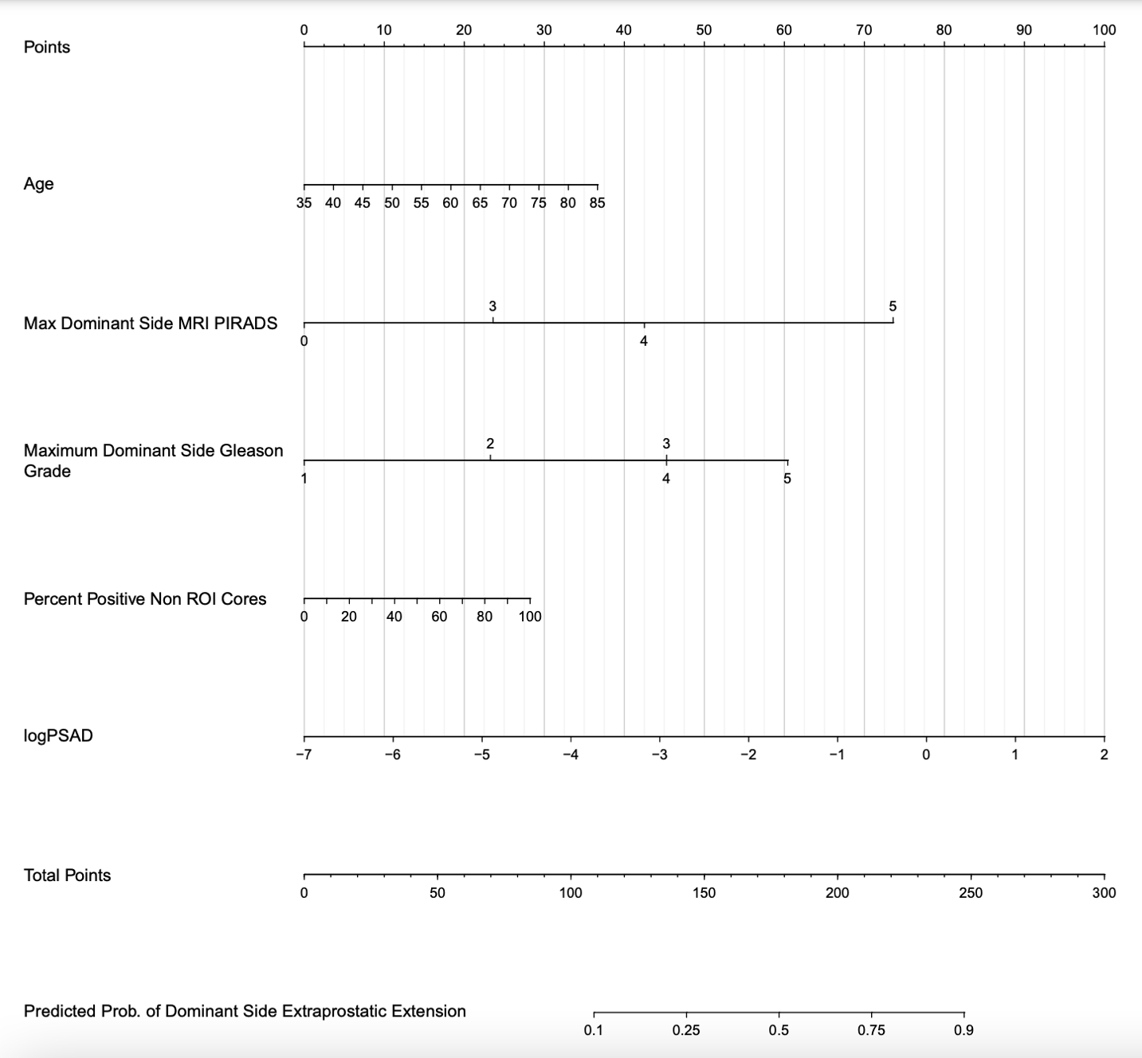

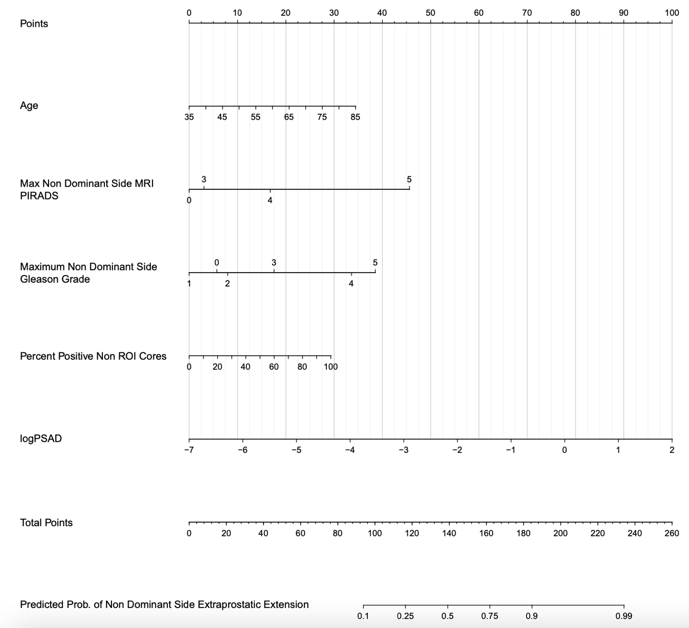

Supplemental Figure 3: Decision Curve Analyses for A. Overall EPE B. Dominant Side EPE and C. Non-Dominant Side EPE

- 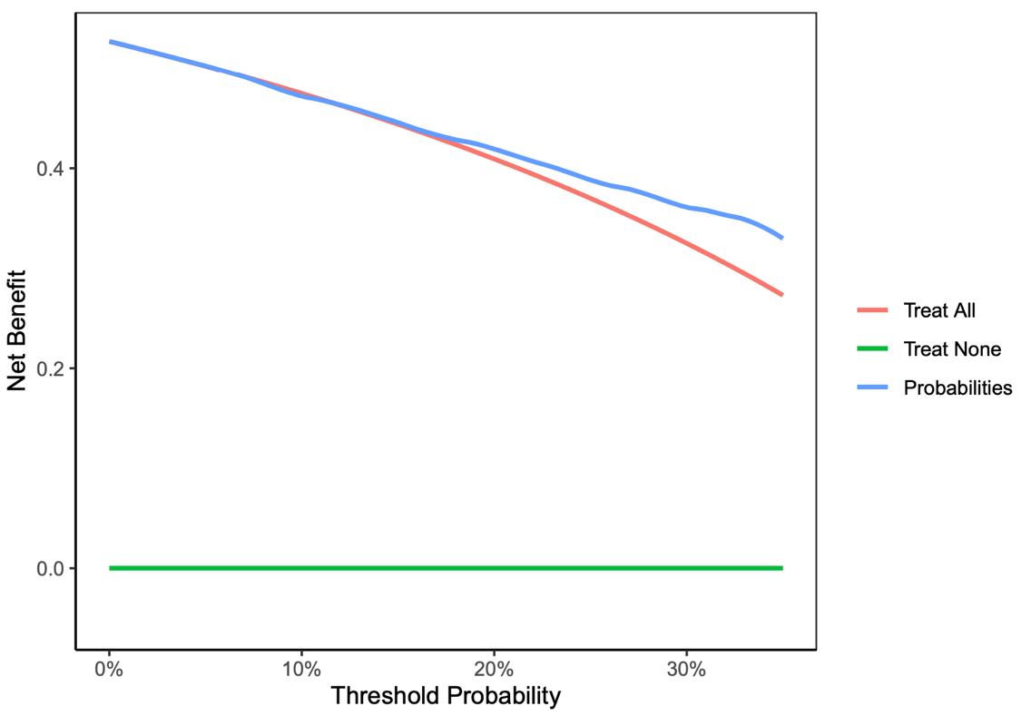

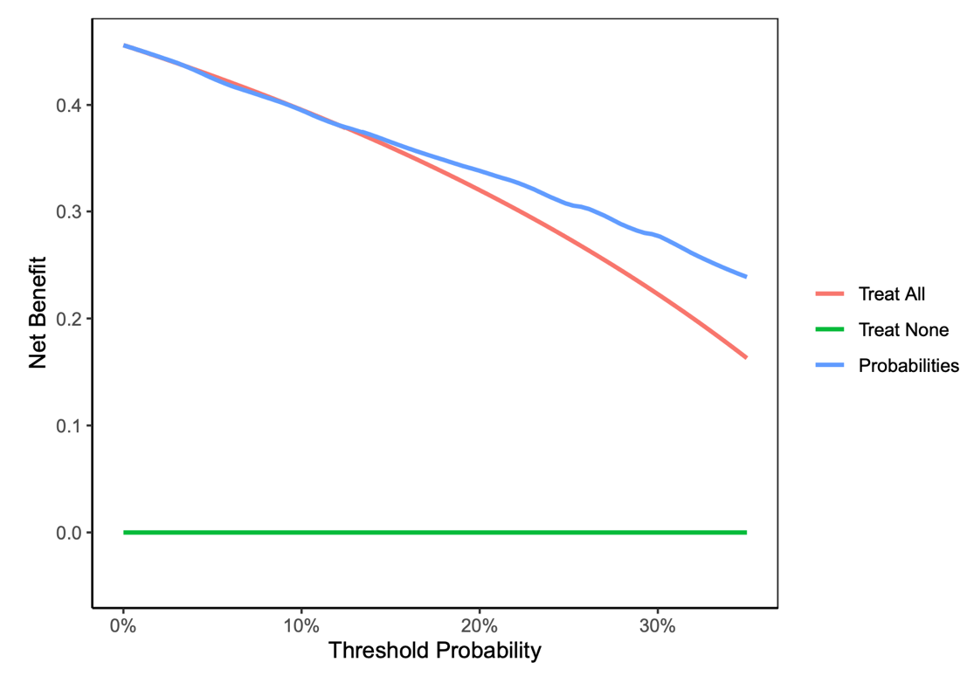

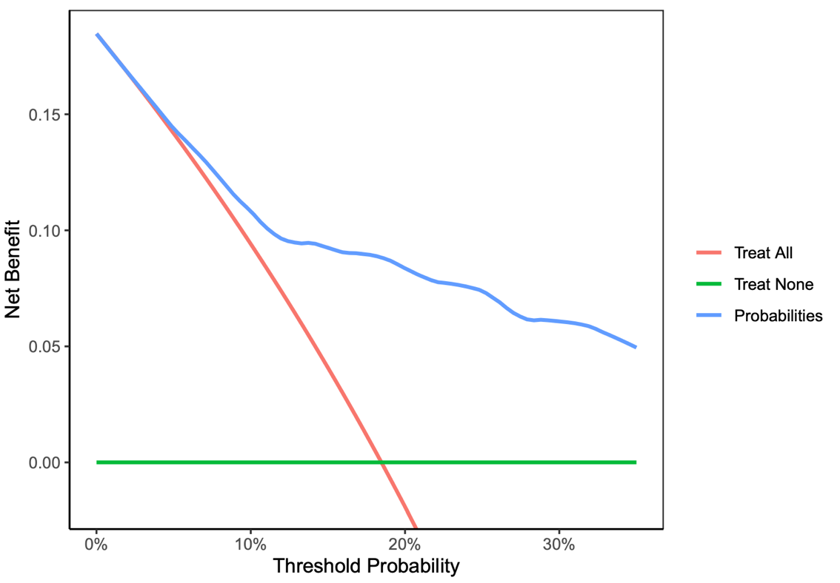

Supplemental Figure 4: Calibration curves for A. Overall EPE, B. Dominant Side EPE, C. Non-Dominant Side EPE

A.
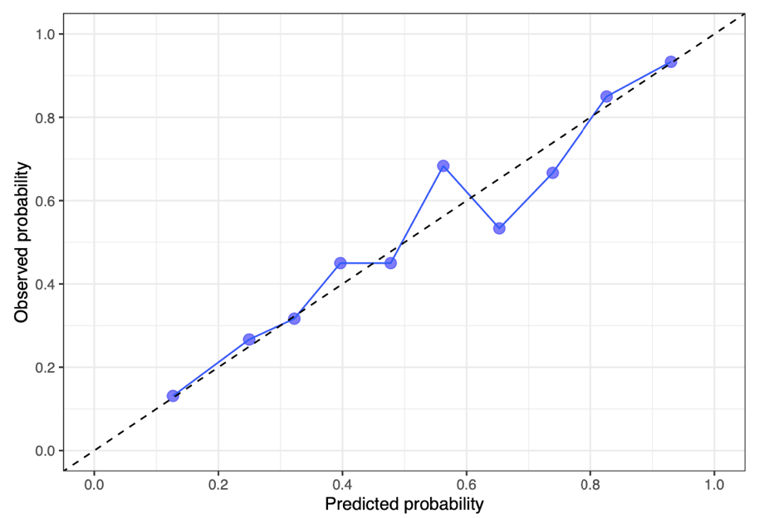

B.
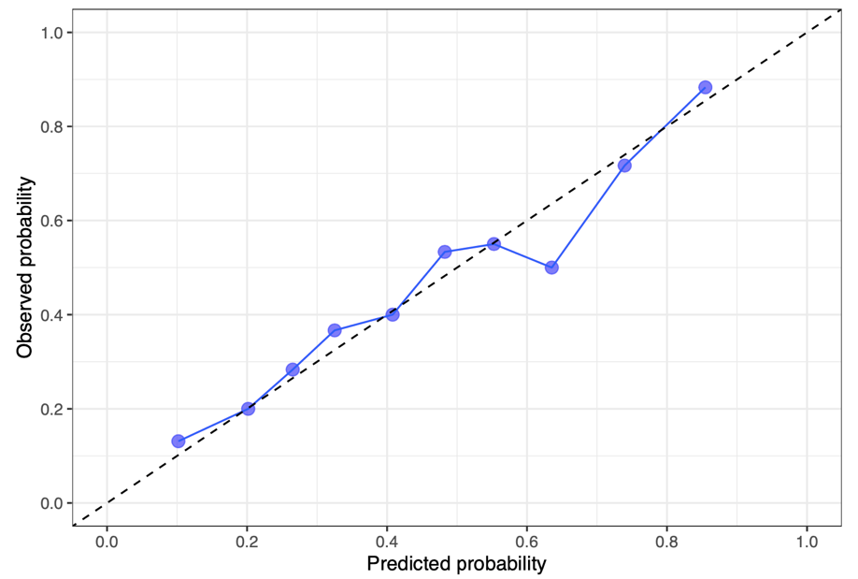

C.
