Supplementary Material:

Supplement to Garcia-Becerra CA, Arias-Gallardo MI, Juarez-Garcia JE, et al.
Head-to-Head Comparison of Diagnostic Test Accuracy Between Biparametric and Multiparametric MRI: An Updated Systematic Review and Bivariate Meta-Analysis

Content:
Tables:
Table S1 Research Question using PICOS approach (Population, Intervention, Comparator, outcome, Study design). 3
Table S2 Quality Assessment of Diagnostic Accuracy Studies – 2. Graph with the proportion of studies assessed by risk of bias and the proportion of studies assessed by concerns regarding its applicability as high, unclear, or low. 4
Table S3 Quality Assessment of Diagnostic Accuracy Studies – 2. Results regarding Risk of Bias. 5
Table S4 Quality Assessment of Diagnostic Accuracy Studies - 2. Results regarding applicability. 6

Figures:
Fig S1 Bp-MRI Diagnostic Odds Ratio Forest Plot 7
Fig S2 Bp-MRI Positive Likelihood Ratio Forest Plot 8
Fig S3 Bp-MRI Negative Likelihood Ratio Forest Plot 9
Fig S4 Mp-MRI Diagnostic Odds Ratio Forest plot 10
Fig S5 Mp-MRI Positive Likelihood Ratio Forest plot 11
Fig S6 Mp-MRI Negative Likelihood Ratio Forest plot 12

Table S1 Research Question using PICOS approach (Population, Intervention, Comparator, outcome, Study design).
Research Question: What are the differences in diagnostic precision and accuracy between Biparametric and Multiparametric MRI for Prostate Cancer screening?
Element | Focus
Population | Patients suspected of having prostate cancer who will undergo MRI (Biparametric or Multiparametric) assessment and subsequent prostate biopsy with image guidance.
Intervention | Biparametric Magnetic Resonance Imaging for Image-Guided Prostate Biopsy
Comparator | Multiparametric Magnetic Resonance Imaging for Image-Guided Prostate Biopsy
Outcomes | Variables that evaluate the diagnostic precision and accuracy of both diagnostic tools (True positives, False positives, True negatives, False Negatives, Sensitivity, Specificity, Positive predictive value, Negative predictive value), relevant patient-level and Study-level information.
Study design | Experimental or Quasi-Experimental with control group studies (preferably Randomized controlled Trials) and Observational studies that include a minimum of 10 patients

Table S2 Quality Assessment of Diagnostic Accuracy Studies – 2. Graph with the proportion of studies assessed by risk of bias and the proportion of studies assessed by concerns regarding its applicability as high, unclear, or low.
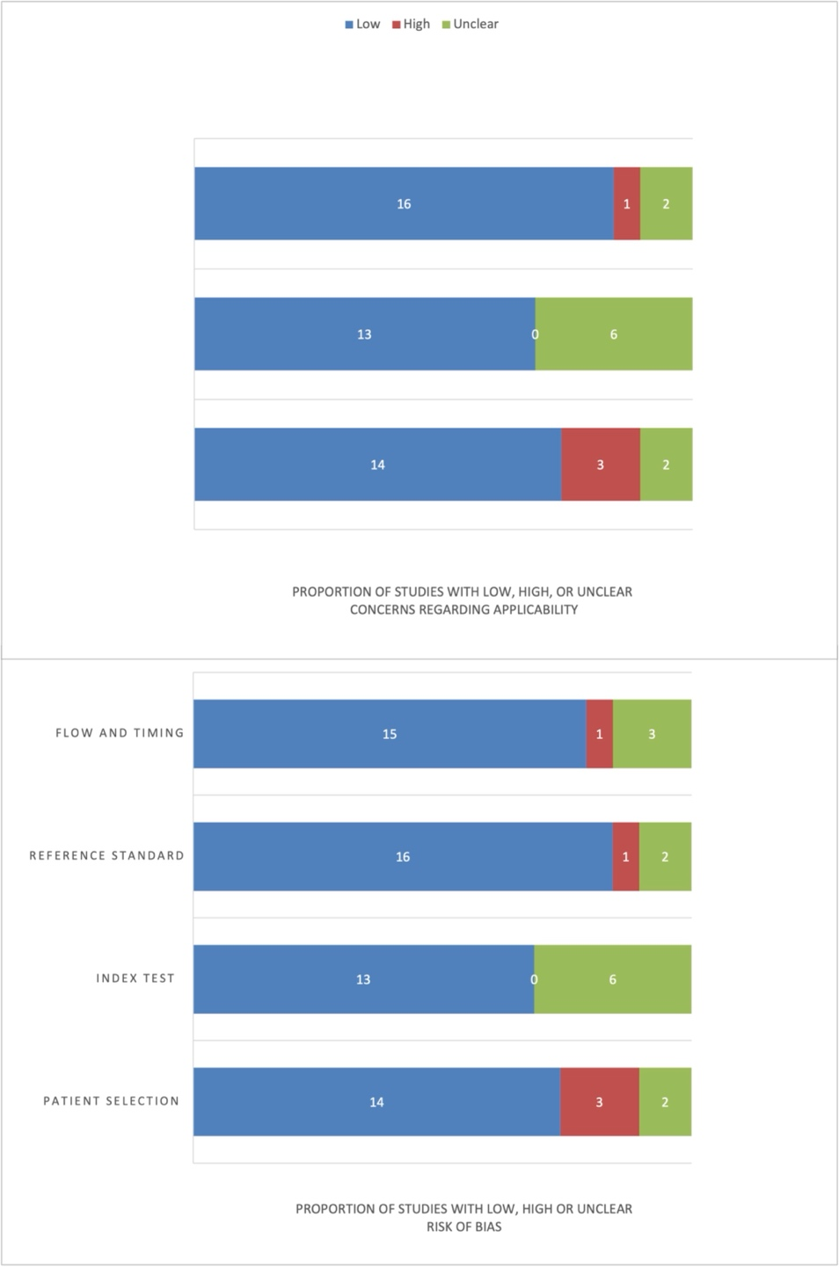

Table S3 Quality Assessment of Diagnostic Accuracy Studies – 2. Results regarding Risk of Bias.
 | PATIENT SELECTION | INDEX TEST | REFERENCE STANDARD | FLOW AND TIMING
Russo et al. | Low | Low | Low | Low
Thais et al. | Low | Low | Low | Low
kuhl et al. | Low | Low | Low | Low
Pesapane et al. | Low | Low | Low | Low
Der Leest et al. | Low | Low | Low | Low
Brembilla et al. | Low | Low | Low | Low
Xu et al. | Unclear | Low | High | Unclear
Zawaideh et al. | Low | Unclear | Low | Low
Thestrup et al. | Unclear | Unclear | Unclear | High
Zhang et al. | Low | Low | Low | Low
Majahan et al. | High | Unclear | Unclear | Unclear
Tamada et al. | High | Low | Low | Unclear
Bao et al. | Low | Low | Low | Low
Choi et al. | Low | Low | Low | Low
Gatti et al. | Low | Low | Low | Low
Barth et al. | Low | Unclear | Low | Low
Visschere et al. | Low | Unclear | Low | Low
Radtke et al. | High | Unclear | Low | Low
Nieuwenhove et al. | Low | Low | Low | Low

Table S4 Quality Assessment of Diagnostic Accuracy Studies - 2. Results regarding applicability.
 | PATIENT SELECTION | INDEX TEST | REFERENCE STANDARD
Russo et al. | Low | Low | Low
Thais et al. | Low | Low | Low
kuhl et al. | Low | Low | Low
Pesapane et al. | Low | Low | Low
Der Leest et al. | Low | Low | Low
Brembilla et al. | Low | Low | Low
Xu et al. | Unclear | Low | High
Zawaideh et al. | Low | Unclear | Low
Thestrup et al. | Unclear | Unclear | Unclear
Zhang et al. | Low | Low | Low
Majahan et al. | High | Unclear | Unclear
Tamada et al. | High | Low | Low
Bao et al. | Low | Low | Low
Choi et al. | Low | Low | Low
Gatti et al. | Low | Low | Low
Barth et al. | Low | Unclear | Low
Visschere et al. | Low | Unclear | Low
Radtke et al. | High | Unclear | Low
Nieuwenhove et al. | Low | Low | Low

Fig S1 Bp-MRI Diagnostic Odds Ratio Forest Plot
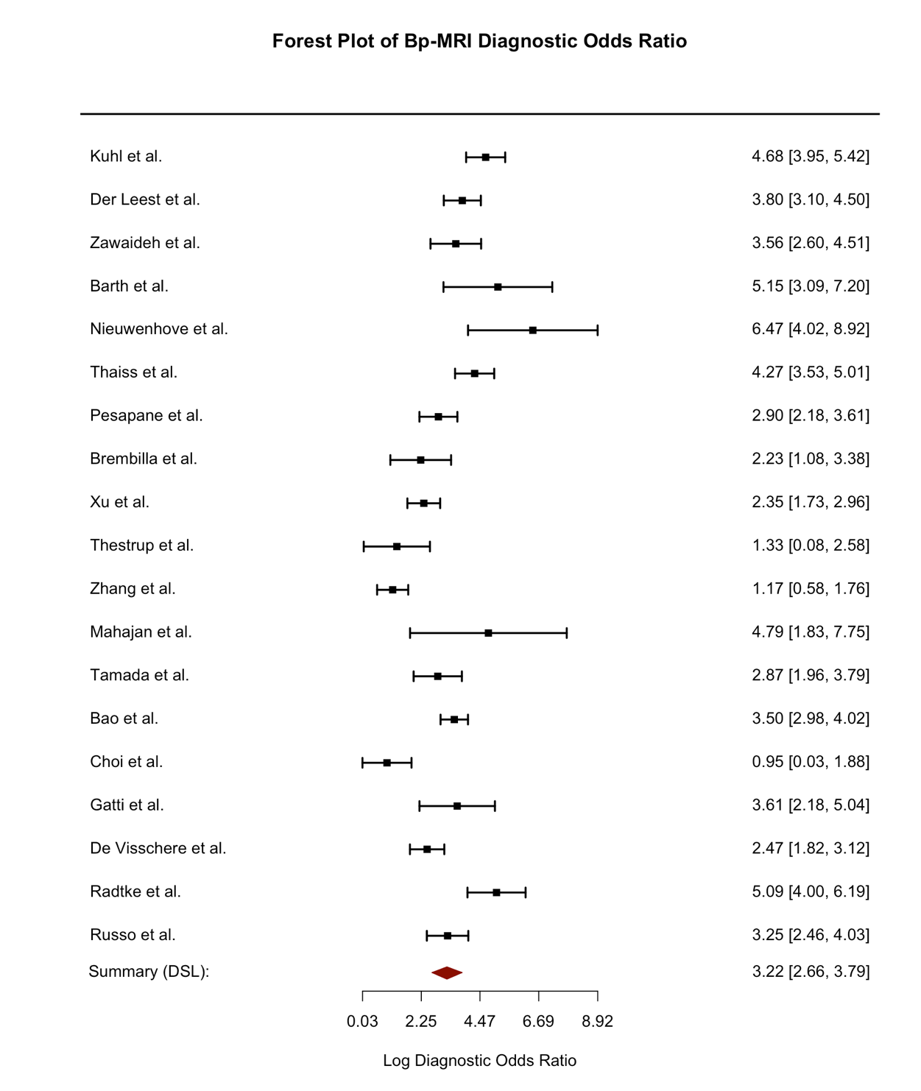

Fig S2 Bp-MRI Positive Likelihood Ratio Forest Plot
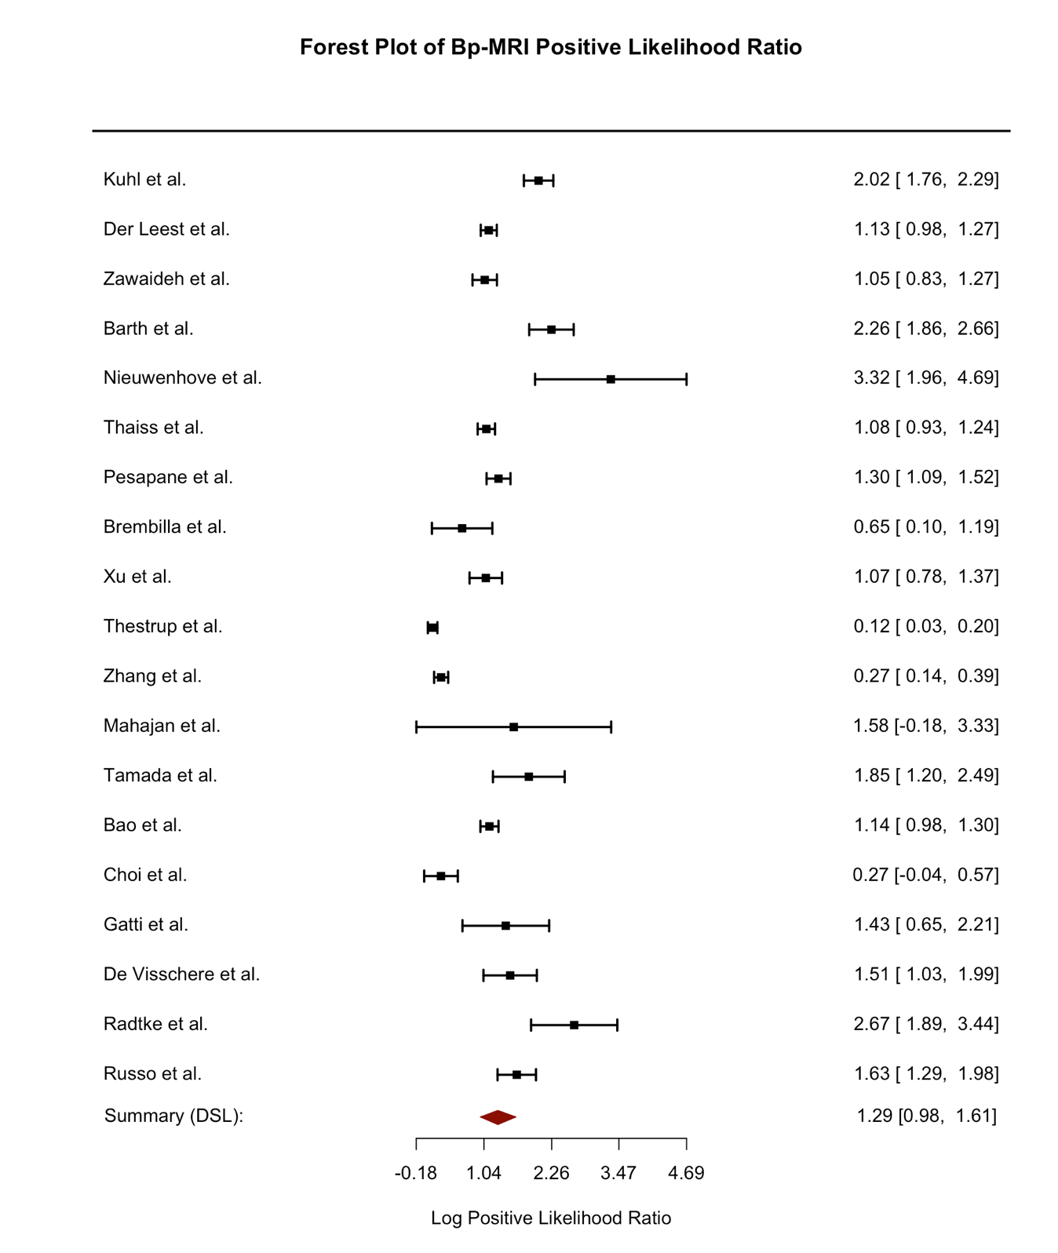

Fig S3 Bp-MRI Negative Likelihood Ratio Forest Plot
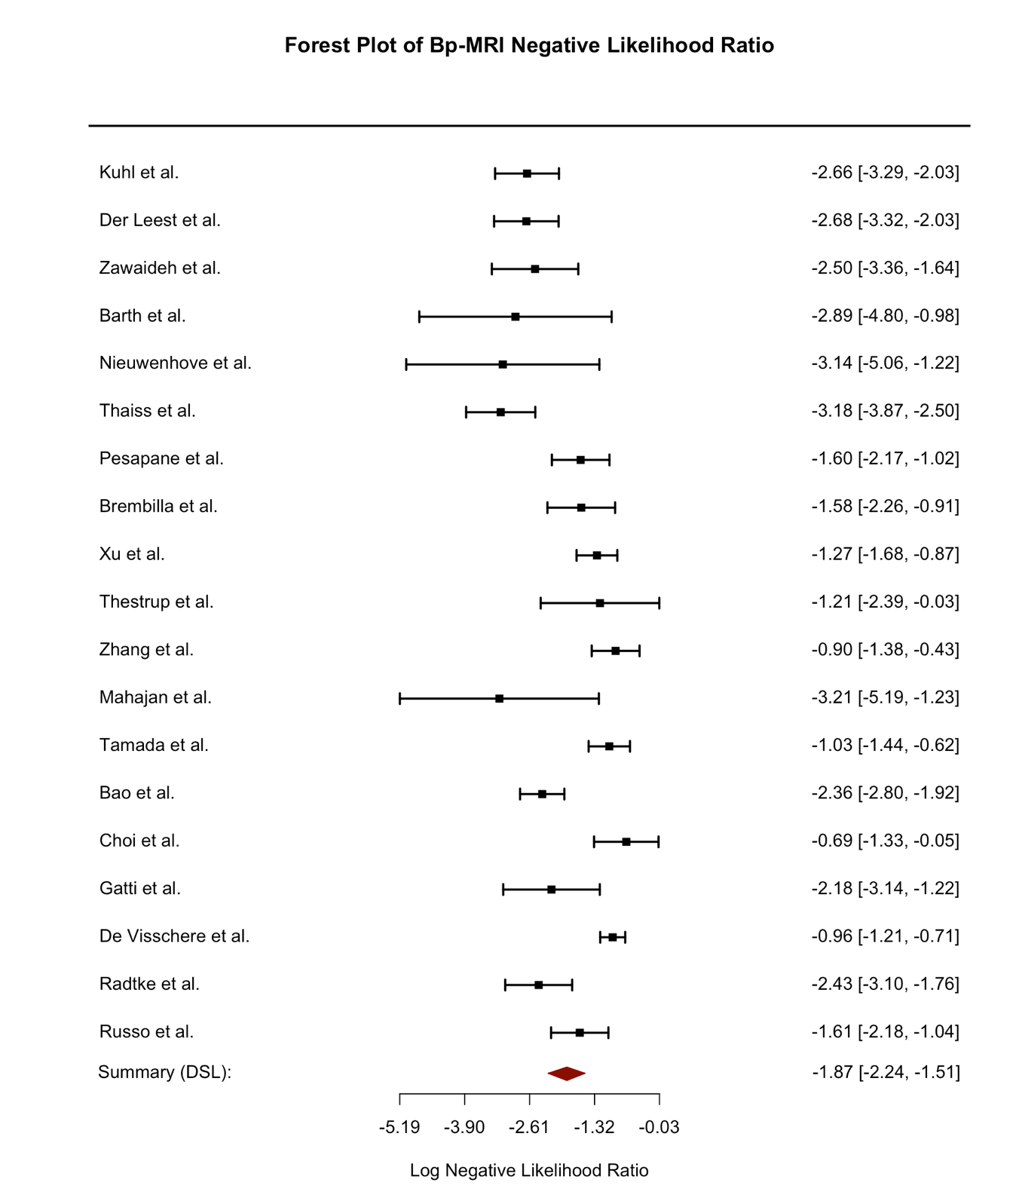

Fig S4 Mp-MRI Diagnostic Odds Ratio Forest plot
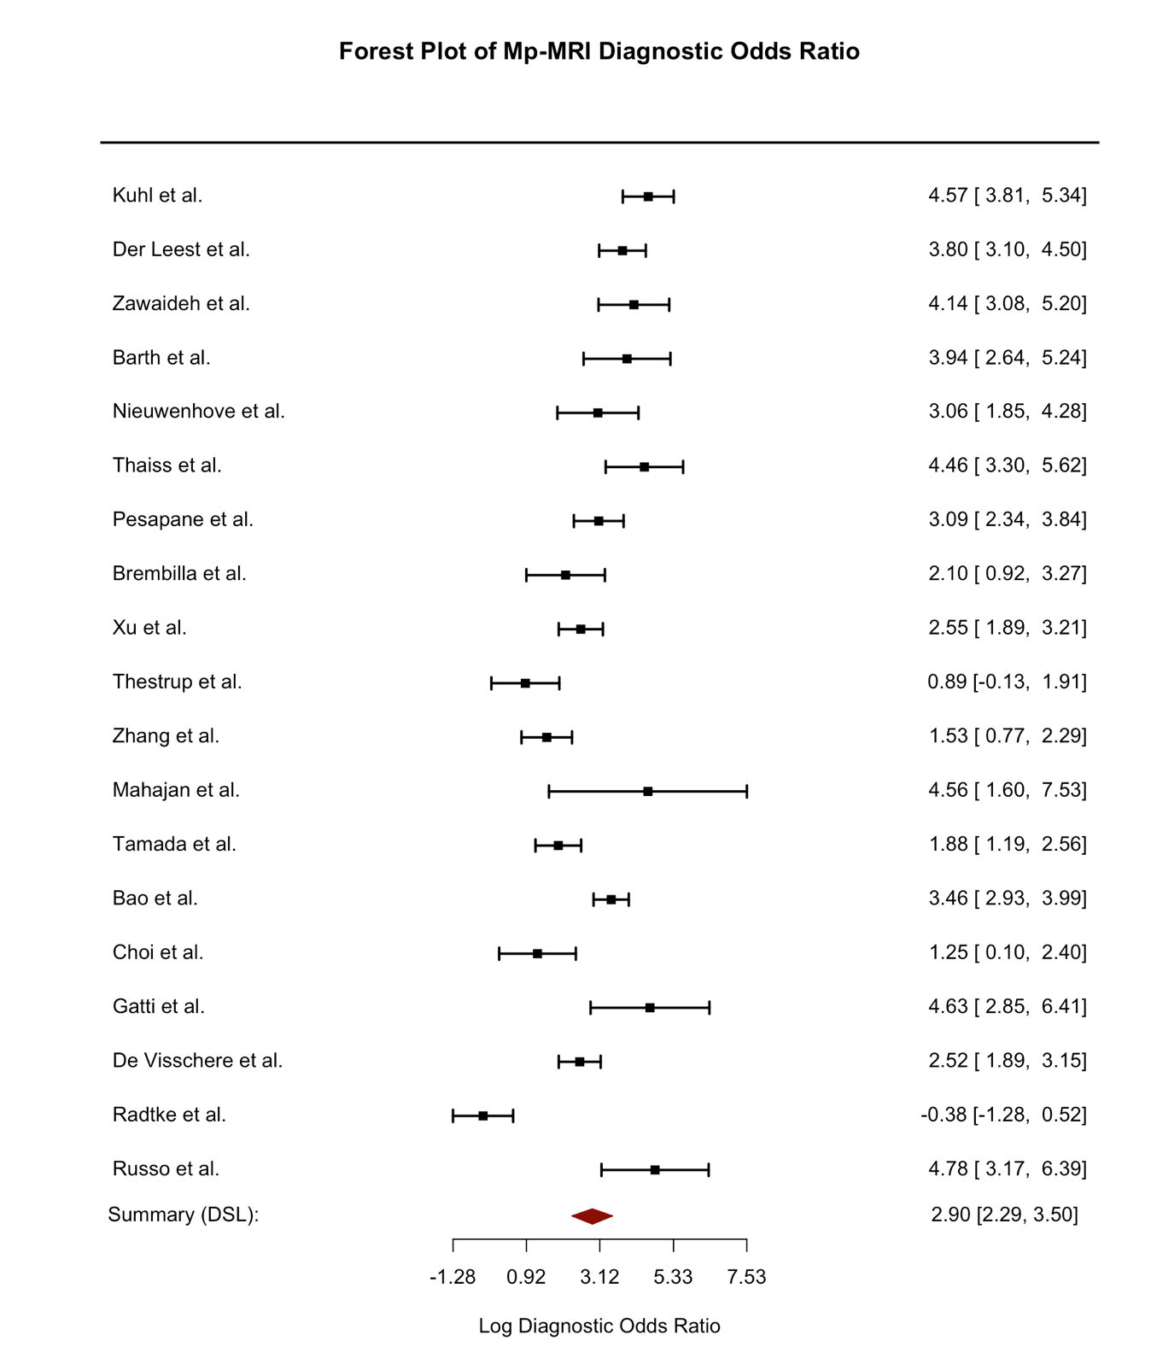

Fig S5 Mp-MRI Positive Likelihood Ratio Forest plot

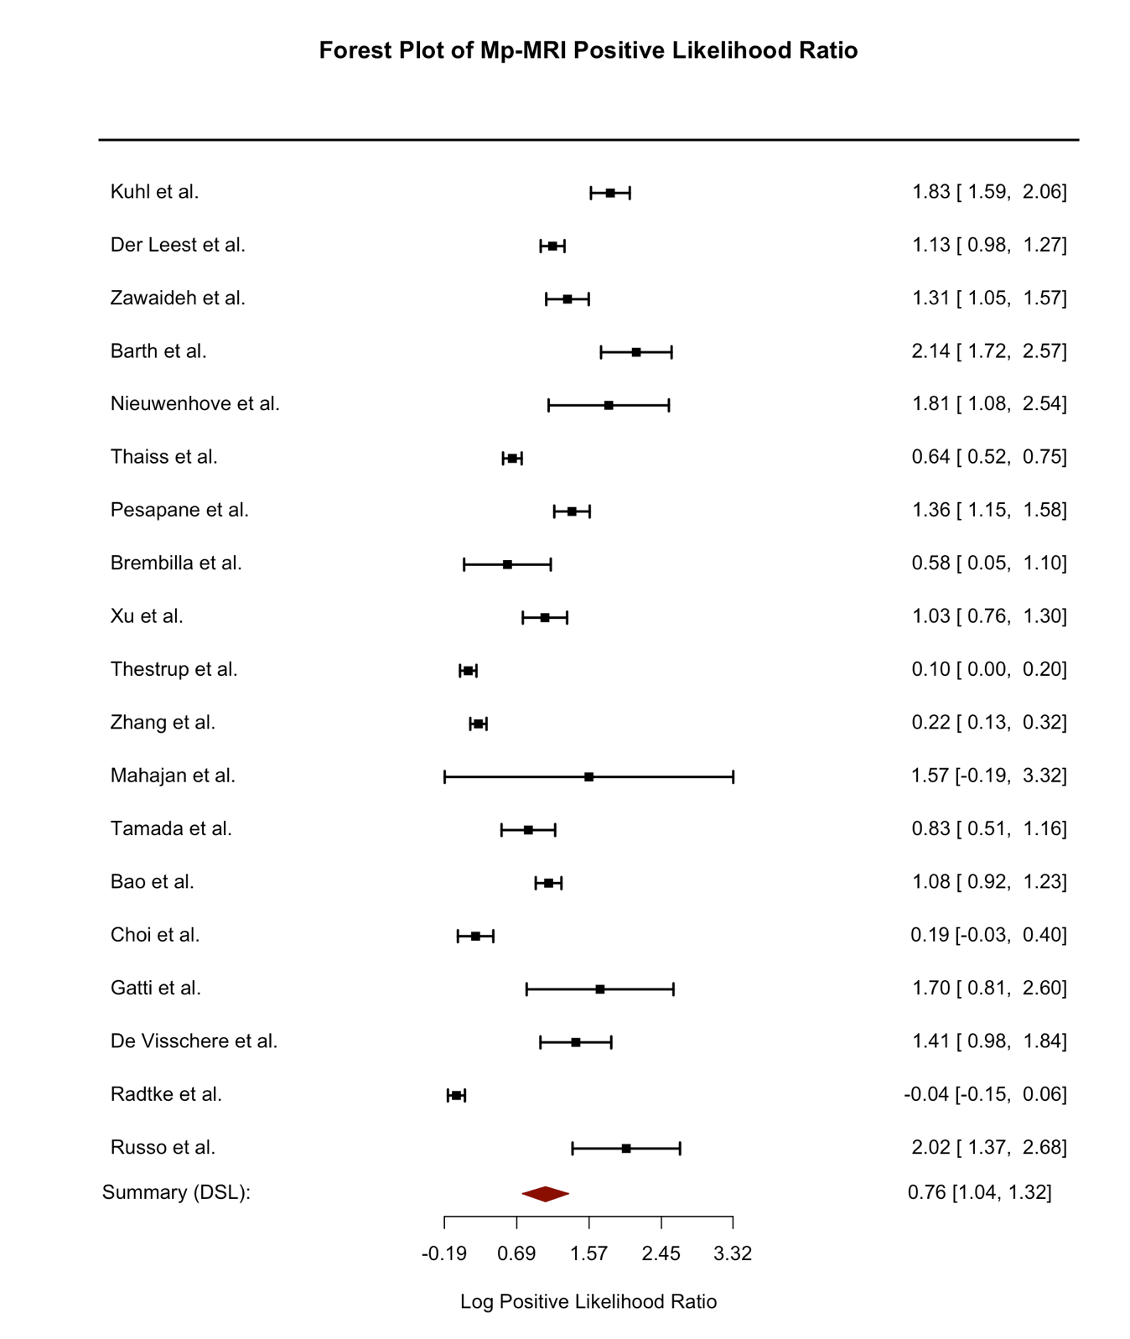

Fig S6 Mp-MRI Negative Likelihood Ratio Forest plot


