SUPPLEMENTAL MATERIAL

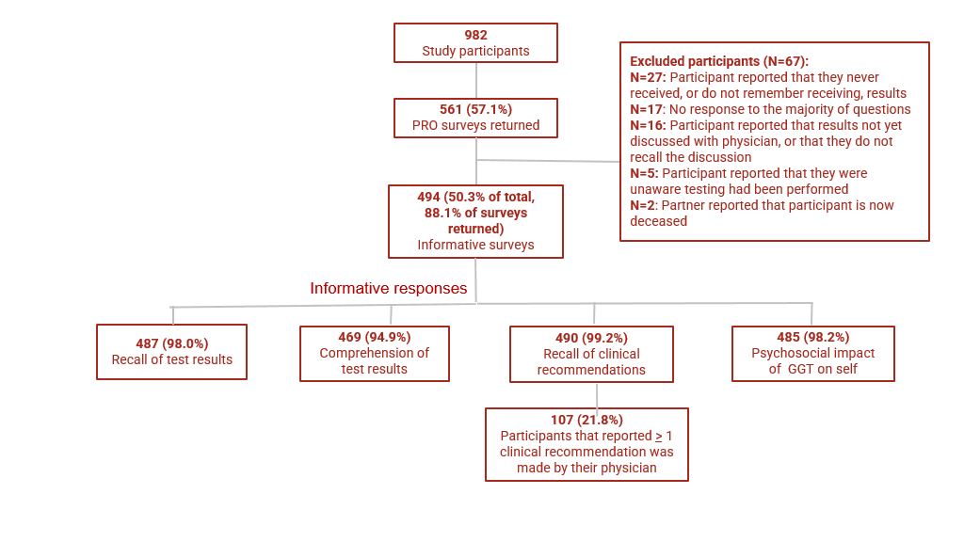
Figure S1. Flow chart showing the resulting informative surveys and responses from the 982 enrolled in the PROCLAIM trial.
In addition to the 485 individuals who provided informative responses to whether the return of GGT affected the patient’s feelings about their diagnosis, treatment and follow-up, 463 individuals provided informative responses about whether genetic counseling affected their feelings about their diagnosis, treatment and follow-up and 476 provided informative answers as to whether GGT and counseling affected their concerns for family members.

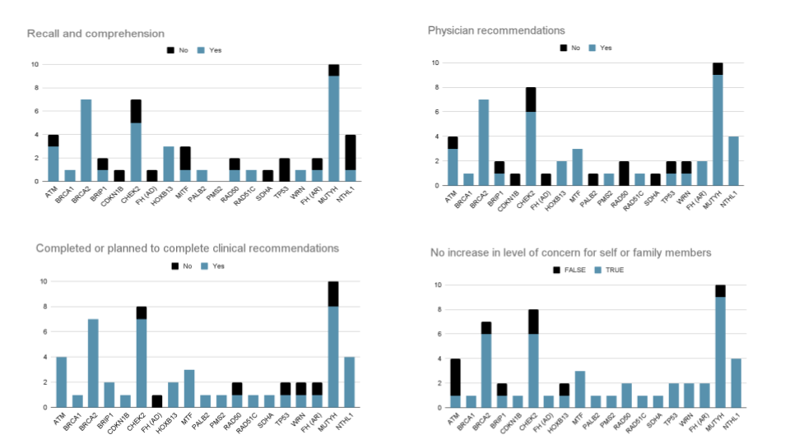

Figure S2. Rates of patient recall and comprehension of genetic test results, physician recommendations, patient uptake of recommendations and impact of genetic test results on patient concern by gene.
AR, autosomal recessive; AD, autosomal dominant
Two patients had PGVs in two genes: one with PGVs in BRCA2 and MUTYH and one with PGVs in both BRCA2 and HOXB13.
Both PGV in TP53 were classified as “possibly mosaic” (meaning that the variant is suspected to be present in some but not all cells in the body), which may have impacted patient comprehension and physician recommendations as management recommendations are not straightforward for these patients.
None of the factors differed significantly between patients with PGV in autosomal dominant genes (n=39) compared to carriers of autosomal recessive conditions (n=16)

Table S1. Patient survey on testing and clinical recommendations
Enter the Patient ID Number provided by your participating physician:
This number can also be found at the top of your email invitation to take this survey.
Did you get a copy of your genetic test result?
□ Yes
□ No
What was your genetic test result?
□ Negative
□ Positive
□ Uncertain or Variant of Unknown Significance
□ Unsure
Please describe your understanding of your test result. (Select all that apply)
□ My genetic test results show that I do NOT carry any genetic changes that are known to be linked to cancer
□ My genetic test results show that I DO have a genetic change(s) that is known to be linked to cancer
□ My genetic test results suggest members of my family should also be tested
□ My genetic test results suggest that I meet with another physician specialist to follow up on non prostate concerns
□ Unsure
Have you talked to a cancer genetic counselor about your test results?
□ Yes
□ No
□ Unsure
If not, do you plan to speak to a cancer genetic counselor?
□ Yes
□ No
□ Unsure
What were your physician’s recommendations for your care after testing? (Select all that apply)
□ No further recommendations
□ Meet with a genetic counselor for further counseling
□ Change my treatment plan
□ Change my follow up plan
□ Meet with another physician specialist to follow up on non-prostate concerns
□ Family members should be tested
□ Family members should visit a genetic counselor
□ Unsure
□ Other
If your physician made recommendations for your care, which ones have you already completed? (Select all that apply)
□ I met with a genetic counselor to further understand my test results
□ I am following a new treatment plan
□ I am participating in a new follow up plan
□ I met with another physician specialist to follow up on non prostate concerns
□ I recommended to family members that they should be tested
□ I recommended to family members that they should visit a genetic counselor
□ No additional recommendations were made by my physician
□ Other
Which of the recommendations made by your physician have you not done yet, but plan to do? (Select all that apply)
□ Meet with a genetic counselor to further understand my test results
□ Accept my new treatment plan
□ Accept the change to my follow up plan
□ Meet with another physician specialist to follow up on non prostate concerns
□ Recommend to family member/s that they should be tested
□ Recommend to family members that they should visit a genetic counselor
□ I do not plan to follow any of the recommendations
□ Other
How did the testing result impact how you feel about your prostate cancer diagnosis, treatment and follow up?
□ Reduced my concerns a lot
□ Reduced my concerns somewhat
□ No change
□ Increased my concerns somewhat
□ Increased my concerns a lot
Did the counseling/discussion with your physician after your testing impact how you feel about your prostate cancer diagnosis, treatment and follow up?
□ Reduced my concerns a lot
□ Reduced my concerns somewhat
□ No change
□ Increased my concerns somewhat
□ Increased my concerns a lot
Did the testing result and follow up counseling/discussion impact your concerns for your family and their hereditary risk of prostate or other cancers?
□ Reduced my concerns a lot
□ Reduced my concerns somewhat
□ No change
□ Increased my concerns somewhat
□ Increased my concerns a lot
Is there anything else you would like to share about your testing experience?

Table S2. Comparison of demographic data between patients who did and did not comprehend their germline genetic test results.
Characteristicª | No. (%) of patients who comprehended test results  [n=338] | No. (%) of patients who did not comprehend test results  [n=136] | Adjusted p-value
Race/ethnicity¹ |  |  | 1.000
Non-Hispanic White | 292 (86.4) | 117 (86.0)
Asian/Pacific Islander | 5 (1.5) | 1 (0.7)
Black/African American | 26 (7.7) | 14 (10.1)
Hispanic | 9 (2.7) | 3 (2.2)
Personal history of cancer² |  |  | 1.000
Other non-prostate cancers | 44 (13.0) | 16 (11.8)
No other non-prostate cancers | 268 (79.3) | 113 (83.0)
Family history of cancer |  |  | 1.000
Reported positive family history | 82 (24.3) | 33 (24.3)
No reported positive family history | 257 (76.0) | 103 (75.7)
Time of diagnosis² |  |  | 1.000
Recent (≤ 1 year) | 158 (46.7) | 62 (45.6)
Not recent (> 1 year) | 179 (53.0) | 73 (53.7)
Metastatic status at diagnosis |  |  | 1.000
Metastatic | 47 (13.9) | 22 (16.2)
Non-metastatic | 286 (84.6) | 114 (83.8)
Gleason (ISUP) Grade Group at diagnosis² |  |  | 1.000
4 or 5 | 83 (24.6) | 33 (23.7)
3 or lower | 232 (68.6) | 98(72.1)
Disease status at GGT² |  |  | 1.000
Stable | 189 (55.9) | 73 (53.7)
Progressing | 37 (10.9) | 16 (11.5)
2019 NCCN® criteria |  |  | 1.000
Met criteria for GGT | 163 (48.2) | 58 (42.6)
Did not meet criteria for GGT | 175 (51.8) | 78 (57.4)
Germline status |  |  | <0.001
Positive | 34 (10.1) | 17 (12.5)
VUS-only | 125 (37.0) | 89 (65.4)
Negative | 179 (53.0) | 30 (22.1)
¹excludes Mixed, Other, Unknown responses
²excludes Unknown responses

