Supplemental Online Content

Authors of “Quality of Life in Low-Risk Prostate Cancer under Active Surveillance or following Radical Treatments: The START cohort study”

eTable 1. Inclusion and Exclusion Criteria
eTable 2. Calendar of Controls During the First 5 Years of Patient Follow-Up
eTable 3. Criteria for Continuation of AS in the START Study
eTable 4. Patient-Reported Outcome Measure Domains and Instruments
eTable 5. Results of sensitivity analysis comparing Active Surveillance versus radical prostatectomy in relation to different domains of HRQoL measures in the 14 centres with the best response rate (higher than the median).
eFigure 1. Patient flow and number of compiled questionnaires (Q)
eFigure 2A. EORTC QLQ-C30: Physical Functioning
eFigure 2B. EORTC QLQ-C30: Role Functioning
eFigure 2C. EORTC QLQ-C30: Emotional Functioning
eFigure 2D. EORTC QLQ-C30: Social Functioning
eFigure 2E. EORTC QLQ-C30: Cognitive Functioning
Full list of members of the START COLLABORATIVE GROUP

This supplemental material has been provided by the authors to give readers additional information about their work.
eTable 1. Inclusion and exclusion criteria
Inclusion Criteria:
- Newly diagnosed low risk prostate cancer patients, defined according to the presence of all the following criteria:
o diagnosis of adenocarcinoma of the prostate
o prostate cancer clinical stage T1c or T2a
o PSA <=10ng/ml at diagnosis
o adequate biopsy sampling according to prostate volume
o maximum number of positive biopsy cores for prostate adenocarcinoma:
- 2, in case of biopsy with random sampling and less than 20 samples
- 3, in case of biopsy with random sampling and 20-26 samples
- 4, in case of biopsy with random sampling and more than 26 samples
- If a multi-parametric MRI of the prostate was performed at the time of diagnosis and multiple samples were taken from each target lesion, two or more positive samples from the same target lesion (regardless of the percentage of disease present in the samples) must also be considered as one positive core for the purpose of calculating the total number of positive cores. The number of positive biopsy cores will therefore be calculated as the sum of the positive target lesions + any positive random samples; the total number of samples will be calculated as the sum of the number of random samples and the number of biopsied target lesions.
o Gleason grade 3+3 (in patients aged>70 Gleason 3+4)
- Residence in Piemonte or Valle D'Aosta regions;
- Patients suitable for radical treatment (surgery or radiotherapy/HIFU);
- Age at diagnosis <= 75 years or >75 years if frailty assessment (measured with the G8 score)> = 14;
- Patients’ suitability for expressing a valid consent to participate in the study.

Exclusion Criteria:
- Patients previously treated for prostate cancer
- Patients not willing to undergo radical treatments
- Patients unable to give valid informed consent

eTable 2. Calendar of Controls During the First 5 Years of Patient Follow-Up (adapted from PRIAS). (For patients undergoing radical treatments, the monitoring schedule is indicative, but must be adhered to at least at six-monthly intervals during the first 5 years)

Year | 1 |  |  |  |  | 2 |  |  |  | 3 |  | 4 |  | 5
Month | 0* | 3 | 6 | 9 | 12 | 15 | 18 | 21 | 24 | 30 | 36 | 42 | 48 | 54 | 60
PSA test
DRE
Biopsy**
Clinical examination
QoL questionnaires

- Diagnosis
** For patients in active surveillance only: a biopsy could be repeated at 7 and 10 years, and every 5 years thereafter.
If PSA doubling time <=10 anni: repeat biopsy (if not performed within the last year); as an alternative to biopsy, multi-parametric MRI of the prostate, possibly followed by targeted biopsy of suspicious lesions

eTable 3. Criteria for Continuation of AS in the START Study (adapted from PRIAS)
The following criteria are a useful guide to re-evaluate the decision with the patient in AS during follow-up. For patients that are no more suitable for radical treatments (for age, comorbidity, or other reasons) consider and discuss the possibility of a de-escalation of the follow-up schedule towards a watchful waiting regimen.

      - Clinical:
        - Clinical stage < = T2a (reassess the patient's overall risk if clinical stage = T2b o T2c)
      - Istological (Gleason Score according to ISUP 2005):
        - Gleason-score 3+3=6 or less (Gleason score 3+4 allowed for patients aged >=70 years)
        - No more than one or two positive biopsy cores (considering specimens from the same mpMRI target lesion as a single core)
      - Biochemical:
        - A single altered PSA value should be repeated after a few weeks of treatment of possible infectious diseases or other non-neoplastic causes
        - PSA doubling time (PSA DT) > 10 years
        - If PSA DT <=10 years: repeat biopsy (if not performed within the last year); as an alternative to biopsy, multi-parametric MRI of the prostate, possibly followed by targeted biopsy of suspicious lesions
        - If PSA > 20 ng/ml: perform a bone scintigraphy.
      - Personal:
        - Patient satisfied to continue AS

eTable 4. Patient-Reported Outcome Measure Domains and Instruments.

Domain and instruments | Measures | Range | Meaning
Domain A: Health-related quality of life§ |  |  | Higher scores indicating higher functioning
Cancer-related quality of life: EORTC QLQ-C30. | - Global health status (mean)  - Physical functioning (mean)  - Role functioning (mean)  - Emotional functioning (mean)  - Social functioning (mean)  - Cognitive functioning (mean) | 0 to 100
Domain B: Anxiety and Depression° |  |  | Higher scores indicating worse conditions
Hospital Anxiety and Depression Scale (HADS). | - Anxiety scores (mean)  - Depression scores (mean) | 0 to 21
Domain C: Sexual function§ |  |  | Higher scores indicating higher functioning
Prostate cancer specific HRQoL - EORTC PR25. | - Sexual Functioning (mean)  - Sexual Activity (mean) | 0 to 100
International Index of Erectile Function (IIEF-5) | - Erectile Function (mean) | 0 to 25
Domain D: Urinary, prostatic and bowel symptoms |  |  | Presence of symptoms indicating worse conditions
Prostate cancer specific HRQoL EORTC PR25 | Presence of:  - Use of incontinent Aid (%)  - Bowel symptoms (%) | 0/1
International Prostatic Symptoms Score (IPSS) | - Severe prostatic symptoms (%) | 0/1

HRQoL: Health-related quality of life; °: higher scores indicating worse symptoms; §: higher scores indicating higher functioning

eTable 5. Results of sensitivity analysis comparing Active Surveillance versus local treatments (radical prostatectomy or radiotherapy) in relation to different domains of HRQoL measures in the 14 centres with the best response rate (higher than the median).

Domain A: General Health-related quality of life (HRQOL) § | β | 95%CI | p
EORTC QLQ-C30: Global health status | 3.09 | 0.81; 5.87 | 0.008
EORTC QLQ-C30: Physical Functioning | -1.10 | -3.12; 0. 92 | 0.285
EORTC QLQ-C30: Role Functioning | -1.96 | -3.93;0.01 | 0.051
EORTC QLQ-C30: Emotional Functioning | -2.81 | -4.76;-0.86 | 0.005
EORTC QLQ-C30: Social Functioning | 0.80 | -1.06;2.65 | 0.399
EORTC QLQ-C30: Cognitive Functioning | -0.92 | -2.33; 0.49 | 0.200
Domain B: Anxiety and depression§
HADS: Anxiety score | 0.40 | 0.13; 0.66 | 0.003
HADS: Depression score | 0.82 | 0.63; 1.01 | <0.001
Domain C: Sexual function§
PR25: Sexual functioning | 10.85 | 8.57; 13.13 | <0.001
PR25: Sexual activity | 10. 49 | 4.92; 16.06 | 0.0002
IIEF: Erectile function | 5.65 | 4.55; 6.76 | <0.001
Domain D: Urinary, prostatic and bowel symptoms° | OR | 95%CI | p
PR25-Use of incontinence aids | 0.09 | 0.04; 0.23 | <0.001
IPSS- Presence of moderate/severe prostatic symptoms | 8.52 | 3.39; 21.71 | <0.001
PR25- Presence of bowel symptoms | 1.26 | 0.46; 3.46 | 0.652

§: Regression coefficients (β)
°: Logistic regression odds ratios (OR)
All models are adjusted for age, education, presence of partner, PSA, Gleason score, tumor stage, Charlson comorbidity index and PROM values at baseline.

eFigure 1. Patient flow and number of compiled questionnaires (Q)

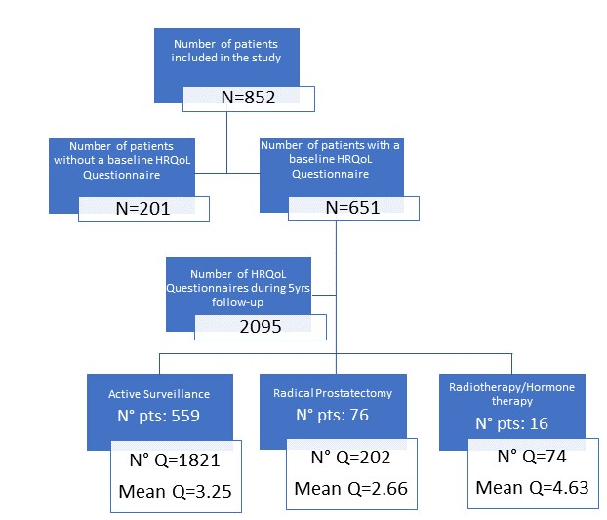
eFigure 2A. EORTC QLQ-C30: Physical Functioning

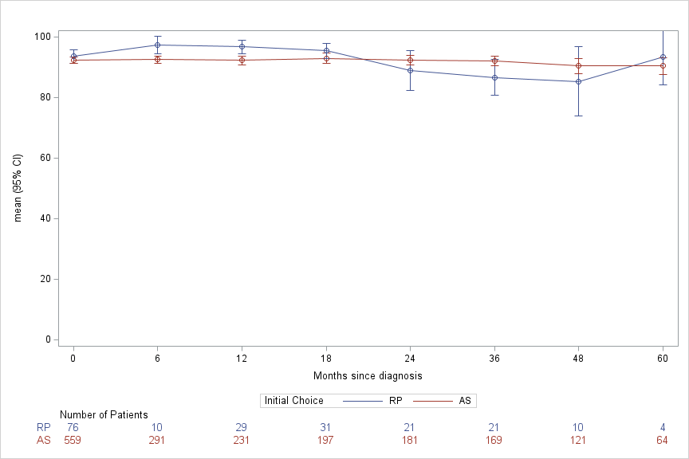

eFigure 2B. EORTC QLQ-C30: Role Functioning

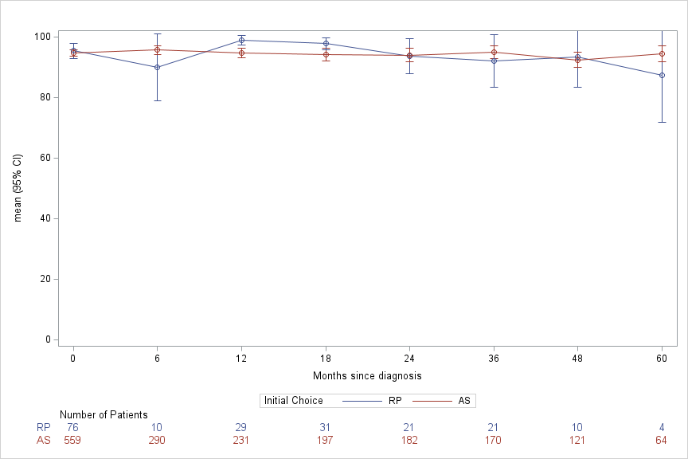

eFigure 2C. EORTC QLQ-C30: Emotional Functioning

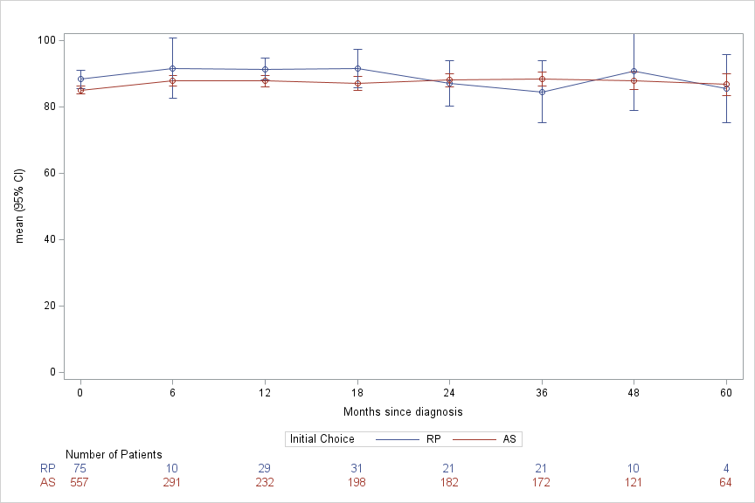

eFigure 2D. EORTC QLQ-C30: Social Functioning

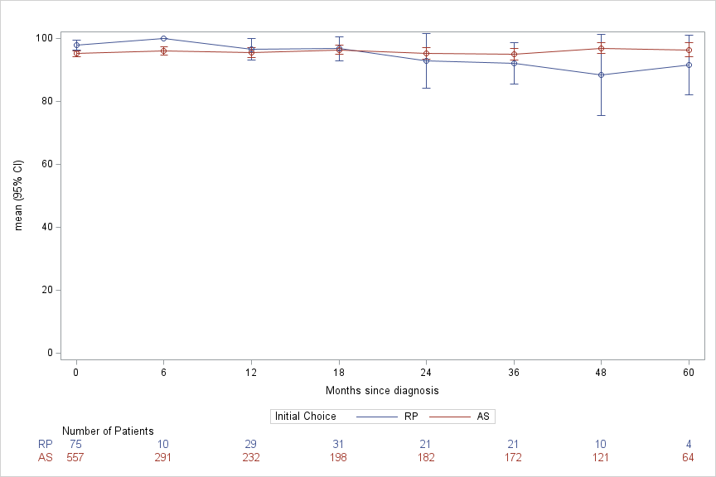

eFigure 2E. EORTC QLQ-C30: Cognitive Functioning

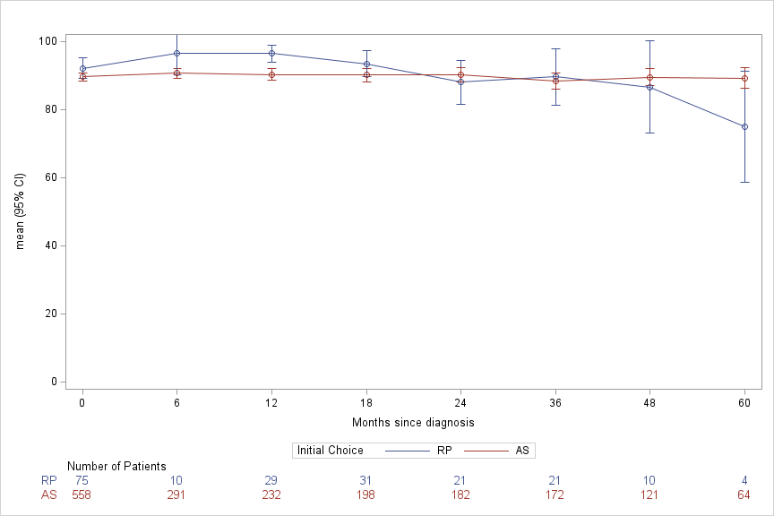

List of members of the START COLLABORATIVE GROUP
List of Author Collaborators
First name | Last name | Affiliation - City, Country
Rosalba | Rosato | 1. Epidemiologia Clinica e Valutativa, AOU Città della Salute e della Scienza di Torino e CPO Piemonte - Torino, Italy
 |  | 2. Dipartimento di Psicologia, Università di Torino – Torino, Italy
Stefano | De Luca | 3. Urologia, AOU San Luigi Gonzaga e Università di Torino – Orbassano (Torino), Italy
Andrea | Zitella | 4. Urologia, AOU Città della Salute e della Scienza e Università di Torino - Torino, Italy
Fernando | Munoz | 5. Radioterapia, PO Umberto Parini – Aosta, Italy
Carlo Giuliano | Baima | 6. Urologia, Ospedali Riuniti ASL TO4 – Ciriè (Torino), Italy
Maurizio | Barale | 7. Urologia, AO Ordine Mauriziano – Torino, Italy
Franco | Bardari | 8. Urologia, PO San Giovanni Bosco – Torino, Italy
Debora | Beldì | 9. Radioterapia, AOU Maggiore della Carità e Università del Piemonte Orientale - Novara, Italy
Luca | Bellei | 10. Urologia, Ospedali Riuniti ASL TO4 – Ivrea (Torino), Italy
Andrea Rocco | Bellissimo | 1. Epidemiologia Clinica e Valutativa, AOU Città della Salute e della Scienza di Torino e CPO Piemonte - Torino, Italy
 |  | 11. Rete Oncologica del Piemonte e Valle d’Aosta, AOU Città della Salute e della Scienza di Torino - Torino, Italy
Diego | Bernardi | 12. Urologia, AO Santa Croce e Carle – Cuneo, Italy
Giorgio | Biamino | 13. Urologia, PO Cardinal Massaia – Asti, Italy
Michele | Billia | 14. Urologia, AOU Maggiore della Carità e Università del Piemonte Orientale - Novara, Italy
Roberto | Borsa | 15. Urologia, PO SS Annunziata – Savigliano (Cuneo), Italy
Domenico | Cante | 16. Radioterapia, ASL TO4, Ospedale di Ivrea – Ivrea (Torino), Italy
Emanuele | Castelli | 17. Urologia, PO Umberto Parini – Aosta, Italy
Danilo | Centrella | 18. Urologia, PO San Biagio – Domodossola (VCO), Italy
Enrico | Checcucci | 19. Dipartimento di Chirurgia, Istituto di Candiolo - Fondazione del Piemonte per l'Oncologia (FPO), IRCCS – Candiolo (Torino), Italy
Devis | Collura | 20. Urologia, PO Humanitas Gradenigo – Torino, Italy
Pietro | Coppola | 15. Urologia, PO SS Annunziata – Savigliano (Cuneo), Italy
Ettore | Dalmasso | 12. Urologia, AO Santa Croce e Carle – Cuneo, Italy
Andrea | Di Stasio | 21. Urologia, AOU SS Antonio e Biagio e Cesare Arrigo – Alessandria, Italy
Michele | Fiorio | 8. Urologia, PO San Giovanni Bosco – Torino, Italy
Marco | Gatti | 22. Radioterapia, Istituto di Candiolo - Fondazione del Piemonte per l'Oncologia (FPO), IRCCS – Candiolo (Torino), Italy
Elisabetta | Garibaldi | 5. Radioterapia, PO Umberto Parini – Aosta, Italy
Giuseppe | Girelli | 23. Radioterapia, PO Nuovo Ospedale degli Infermi – Ponderano (Biella), Italy
Daniele | Griffa | 10. Urologia, Ospedali Riuniti ASL TO4 – Ivrea (Torino), Italy
Alessia | Guarneri | 22. Radioterapia, Istituto di Candiolo - Fondazione del Piemonte per l'Oncologia (FPO), IRCCS – Candiolo (Torino), Italy
Stefano | Guercio | 24. Urologia, PO Edoardo Agnelli – Pinerolo (Torino), Italy
Carlo Giuseppe | Iorio | 25. Radioterapia, AOU Città della Salute e della Scienza e Università di Torino - Torino, Italy
Roberto | Migliari | 7. Urologia, AO Ordine Mauriziano – Torino, Italy
Franco | Montefiore | 26. Urologia, PO San Giacomo - Novi Ligure (Alessandria), Italy
Maurizio | Moroni | 27. Urologia, PO Maria Vittoria – Torino, Italy
Giovanni | Muto | 28. Urologia, Ospedale Maria Pia – Torino (Italy)
Marco | Oderda | 4. Urologia, AOU Città della Salute e della Scienza e Università di Torino - Torino, Italy
Eva | Pagano | 1. Epidemiologia Clinica e Valutativa, AOU Città della Salute e della Scienza di Torino e CPO Piemonte - Torino, Italy
Massimo | Pasquale | 27. Urologia, PO Maria Vittoria – Torino, Italy
Francesca | Ponti di Sant’Angelo | 1. Epidemiologia Clinica e Valutativa, AOU Città della Salute e della Scienza di Torino e CPO Piemonte - Torino, Italy
 |  | 11. Rete Oncologica del Piemonte e Valle d’Aosta, AOU Città della Salute e della Scienza di Torino - Torino, Italy
Riccardo | Rossi | 15. Urologia, PO SS Annunziata – Savigliano (Cuneo), Italy
Luca | Ruggiero | 26. Urologia, PO San Giacomo - Novi Ligure (Alessandria), Italy
Omid | Sedigh | 20. Urologia, PO Humanitas Gradenigo – Torino, Italy
Armando | Serao | 21. Urologia, AOU SS Antonio e Biagio e Cesare Arrigo – Alessandria, Italy
Maria Sara | Squeo | 29. Urologia, PO Martini – Torino, Italy
Salvatore | Stancati | 30. Urologia, PO Rivoli – Rivoli (Torino), Italy
Francesco | Varvello | 31. Urologia, PO Michele e Pietro Ferrero – Verduno (Cuneo), Italy
Alessandro | Volpe | 14. Urologia, AOU Maggiore della Carità e Università del Piemonte Orientale - Novara, Italy
Stefano | Zaramella | 32. Urologia, PO Nuovo Ospedale degli Infermi – Ponderano (Biella), Italy
Giovanni | Zarrelli | 13. Urologia, PO Cardinal Massaia – Asti, Italy
Enrico | Bollito | 33. Anatomia Patologica, AOU San Luigi Gonzaga e Università di Torino – Orbassano, Italy
Paolo | Gontero | 4. Urologia, AOU Città della Salute e della Scienza e Università di Torino - Torino, Italy
Francesco | Porpiglia | 3. Urologia, AOU San Luigi Gonzaga e Università di Torino – Orbassano (Torino), Italy
Claudia | Galassi | 1. Epidemiologia Clinica e Valutativa, AOU Città della Salute e della Scienza di Torino e CPO Piemonte - Torino, Italy
Giovannino | Ciccone | 1. Epidemiologia Clinica e Valutativa, AOU Città della Salute e della Scienza di Torino e CPO Piemonte - Torino, Italy
List of Nonauthor Collaborators
First name | Last name | Affiliation - City, Country
Manuela | Alessio | 34. Oncologia, PO Michele e Pietro Ferrero – Verduno (Cuneo), Italy
Simona | Allis | 35. Radioterapia, AOU San Luigi Gonzaga – Orbassano (Torino), Italy
Scipio | Annoscia | 36. Urologia, Ospedali Riuniti ASL TO4 – Ivrea, Ciriè, Chivasso (Torino), Italy
Daniela | Antonini | 37. Anatomia Patologica, PO Martini – Torino, Italy
Emanuele | Baldassarre | 17. Urologia, PO Umberto Parini – Aosta, Italy
Sara | Bartoncini | 25. Radioterapia, AOU Città della Salute e della Scienza e Università di Torino - Torino, Italy
Gaetano | Belli | 22. Radioterapia, Istituto di Candiolo - Fondazione del Piemonte per l'Oncologia (FPO), IRCCS – Candiolo (Torino), Italy
Maurizio | Bellina | 30. Urologia, PO Rivoli – Rivoli (Torino), Italy
Donata | Bellis | 38. Anatomia Patologica, PO Nuovo Ospedale degli Infermi – Ponderano (Biella), Italy
Oscar | Bertetto | 11. Rete Oncologica del Piemonte e Valle d’Aosta, AOU Città della Salute e della Scienza di Torino - Torino, Italy
Fabio | Bonini | 26. Urologia, PO San Giacomo - Novi Ligure (Alessandria), Italy
Giulio | Bonvissuto | 30. Urologia, PO Rivoli – Rivoli (Torino), Italy
Martino | Bosco | 39. Anatomia Patologica, PO Michele e Pietro Ferrero – Verduno (Cuneo), Italy
Francesco | Bracco | 4. Urologia, AOU Città della Salute e della Scienza e Università di Torino - Torino, Italy
Rodolfo | Brizio | 40. Anatomia Patologica, AO Santa Croce e Carle – Cuneo, Italy
Francesco | Brunetti | 1. Epidemiologia Clinica e Valutativa, AOU Città della Salute e della Scienza di Torino e CPO Piemonte - Torino, Italy
Andrea | Buffardi | 8. Urologia, PO San Giovanni Bosco – Torino, Italy
Silvia | Cagnasso | 31. Urologia, PO Michele e Pietro Ferrero – Verduno (Cuneo), Italy
Eugenio | Cagnazzi | 30. Urologia, PO Rivoli – Rivoli (Torino), Italy
Giorgio | Calleris | 4. Urologia, AOU Città della Salute e della Scienza e Università di Torino - Torino, Italy
Laura | Caramanico | 41. Anatomia Patologica, PO Umberto Parini – Aosta, Italy
Mariateresa | Carchedi | 30. Urologia, PO Rivoli – Rivoli (Torino), Italy
Ugo | Casalone | 1. Epidemiologia Clinica e Valutativa, AOU Città della Salute e della Scienza di Torino e CPO Piemonte - Torino, Italy
Paola | Cassoni | 42. Anatomia Patologica 2, AOU Città della Salute e della Scienza e Università di Torino - Torino, Italy
Giovanni | Cattaneo | 3. Urologia, AOU San Luigi Gonzaga e Università di Torino – Orbassano (Torino), Italy
Manuela | Ceccarelli | 43. Direzione Sanitaria, AOU Città della Salute e della Scienza di Torino PO OIRM – Sant'Anna Direzione Sanitaria
Germano | Chiapello | 12. Urologia, AO Santa Croce e Carle – Cuneo, Italy
Elena | Cianini | 32. Urologia, PO Nuovo Ospedale degli Infermi – Ponderano (Biella), Italy
Francesca | Clot | 25. Radioterapia, AOU Città della Salute e della Scienza e Università di Torino - Torino, Italy
Nicola | Cruciano | 27. Urologia, PO Maria Vittoria – Torino, Italy
Michele | Cussotto | 13. Urologia, PO Cardinal Massaia – Asti, Italy
Paolo | De Angelis | 14. Urologia, AOU Maggiore della Carità e Università del Piemonte Orientale - Novara, Italy
Paolo | De Giuli | 39. Anatomia Patologica, PO Michele e Pietro Ferrero – Verduno (Cuneo), Italy
Elena | Delmastro | 22. Radioterapia, Istituto di Candiolo - Fondazione del Piemonte per l'Oncologia (FPO), IRCCS – Candiolo (Torino), Italy
Luisa | Delsedime | 42. Anatomia Patologica 2, AOU Città della Salute e della Scienza e Università di Torino - Torino, Italy
Jessica | Di Martino | 14. Urologia, AOU Maggiore della Carità e Università del Piemonte Orientale - Novara, Italy
Natalia | Dogliani | 39. Anatomia Patologica, PO Michele e Pietro Ferrero – Verduno (Cuneo), Italy
Chantal | Ducret | 17. Urologia, PO Umberto Parini – Aosta, Italy
Stefania | Erra | 44. Anatomia Patologica, PO Santo Spirito - Casale Monferrato (Alessandria)
Ubaldo | Familiari | 41. Anatomia Patologica, PO Umberto Parini – Aosta, Italy
Nicola | Faraone | 20. Urologia, PO Humanitas Gradenigo – Torino, Italy
Giuseppe | Fasolis | 31. Urologia, PO Michele e Pietro Ferrero – Verduno (Cuneo), Italy
Antonella | Ferro | 29. Urologia, PO Martini – Torino, Italy
Elda | Feyles | 45. Anatomia Patologica, PO Cardinal Massaia – Asti, Italy
Alessandro | Fornari | 33. Anatomia Patologica, AOU San Luigi Gonzaga e Università di Torino – Orbassano, Italy
Giuseppe | Forte | 40. Anatomia Patologica, AO Santa Croce e Carle – Cuneo, Italy
Flavio | Fraire | 39. Anatomia Patologica, PO Michele e Pietro Ferrero – Verduno (Cuneo), Italy
Alessia | Francese | 46. Infrastruttura Ricerca Formazione e Innovazione - AO SS Antonio e Biagio e Cesare Arrigo – Alessandria, Italy
Pietro | Gabriele | 22. Radioterapia, Istituto di Candiolo - Fondazione del Piemonte per l'Oncologia (FPO), IRCCS – Candiolo (Torino), Italy
Andrea | Galla | 22. Radioterapia, Istituto di Candiolo - Fondazione del Piemonte per l'Oncologia (FPO), IRCCS – Candiolo (Torino), Italy
Diletta | Garrou | 30. Urologia, PO Rivoli – Rivoli (Torino), Italy
Alessandro | Giacobbe | 7. Urologia, AO Ordine Mauriziano – Torino, Italy
Giuseppe | Giacomelli | 27. Urologia, PO Maria Vittoria – Torino, Italy
Andrea | Giordano | 4. Urologia, AOU Città della Salute e della Scienza e Università di Torino - Torino, Italy
Susanna | Grande | 30. Urologia, PO Rivoli – Rivoli (Torino), Italy
Sandro | Guglielmetti | 10. Urologia, Ospedali Riuniti ASL TO4 – Ivrea (Torino), Italy
Pamela Francesca | Guglielmini | 47. Oncologia, AO SS Antonio e Biagio e Cesare Arrigo – Alessandria, Italy
Paola | Ivaldi | 48. Epidemiologia dei tumori, AOU Città della Salute e della Scienza di Torino e CPO Piemonte - Torino, Italy
Marco | Krengli | 9. Radioterapia, AOU Maggiore della Carità e Università del Piemonte Orientale - Novara, Italy
Marisa | Kurti | 20. Urologia, PO Humanitas Gradenigo – Torino, Italy
Maria Rosa | La Porta | 16. Radioterapia, Ospedali Riuniti ASL TO4 – Ivrea (Torino), Italy
Giuliana | Leucci | 20. Urologia, PO Humanitas Gradenigo – Torino, Italy
Fabiola | Liberale | 32. Urologia, PO Nuovo Ospedale degli Infermi – Ponderano (Biella), Italy
Daniele | Lorenzo | 49. Anatomia Patologica, AO Ordine Mauriziano – Torino, Italy
Marco | Lucci Chiarissi | 31. Urologia, PO Michele e Pietro Ferrero – Verduno (Cuneo), Italy
Monica | Manassero | 31. Urologia, PO Michele e Pietro Ferrero – Verduno (Cuneo), Italy
Claudia | Manini | 37. Anatomia Patologica, PO Martini – Torino, Italy
Marco | Manzo | 20. Urologia, PO Humanitas Gradenigo – Torino, Italy
Giansilvio | Marchioro | 14. Urologia, AOU Maggiore della Carità e Università del Piemonte Orientale - Novara, Italy
Mauro | Mari | 30. Urologia, PO Rivoli – Rivoli (Torino), Italy
Gloria | Maso | 18. Urologia, PO San Biagio – Domodossola (VCO), Italy
Federica | Massa | 33. Anatomia Patologica, AOU San Luigi Gonzaga e Università di Torino – Orbassano, Italy
Massimo | Massarelli | 10. Urologia, Ospedali Riuniti ASL TO4 – Ivrea (Torino), Italy
Guglielmo | Melloni | 31. Urologia, PO Michele e Pietro Ferrero – Verduno (Cuneo), Italy
Luca | Molinaro | 50. Anatomia Patologica 1, AOU Città della Salute e della Scienza di Torino - Torino, Italy
Chiara | Monagheddu | 51. Medico di medicina generale, ASL Torino 3, Italy
Francesco | Morabito | 13. Urologia, PO Cardinal Massaia – Asti, Italy
Gregorio | Moro | 23. Radioterapia, PO Nuovo Ospedale degli Infermi – Ponderano (Biella), Italy
Ivano | Morra | 12. Urologia, AO Santa Croce e Carle – Cuneo, Italy
Carlo | Negro | 13. Urologia, PO Cardinal Massaia – Asti, Italy
Valerio | Olivieri | 10. Urologia, Ospedali Riuniti ASL TO4 – Ivrea (Torino), Italy
Renzo | Orlassino | 52. Anatomia Patologica, Ospedali Riuniti ASL TO4 – Ivrea, Ciriè e Chivasso (Torino), Italy
Cinzia | Ortega | 34. Oncologia, PO Michele e Pietro Ferrero – Verduno (Cuneo), Italy
Donatella | Pacchioni | 42. Anatomia Patologica 2, AOU Città della Salute e della Scienza e Università di Torino - Torino, Italy
Marco | Pagano | 39. Anatomia Patologica, PO Michele e Pietro Ferrero – Verduno (Cuneo), Italy
Mauro | Papotti | 50. Anatomia Patologica 1, AOU Città della Salute e della Scienza e Università di Torino - Torino, Italy
Roberta | Patetta | 41. Anatomia Patologica, PO Umberto Parini – Aosta, Italy
Valter | Pezzuto | 52. Anatomia Patologica, Ospedali Riuniti ASL TO4 – Ivrea, Ciriè e Chivasso (Torino), Italy
Donato | Randone | 20. Urologia, PO Humanitas Gradenigo – Torino, Italy
Umberto | Ricardi | 25. Radioterapia, AOU Città della Salute e della Scienza e Università di Torino - Torino, Italy
Cristina | Rossi | 26. Urologia, PO San Giacomo - Novi Ligure (Alessandria), Italy
Diego | Rosso | 15. Urologia, PO SS Annunziata – Savigliano (Cuneo), Italy
Maria Grazia | Ruo Redda | 53. Radioterapia, AO Ordine Mauriziano e Università di Torino – Torino, Italy
Fabio | Saccona | 1. Epidemiologia Clinica e Valutativa, AOU Città della Salute e della Scienza di Torino e CPO Piemonte - Torino, Italy
Domenico | Surleti | 7. Urologia, AO Ordine Mauriziano – Torino, Italy
Ezio | Talarico | 17. Urologia, PO Umberto Parini – Aosta, Italy
Matteo | Taurino | 14. Urologia, AOU Maggiore della Carità e Università del Piemonte Orientale - Novara, Italy
Salvatore | Treffiletti | 54. Urologia, Ospedali Riuniti ASL TO4 – Chivasso (Torino), Italy
Marcello | Tucci | 55. Oncologia, PO Cardinal Massaia – Asti, Italy
Marco | Volante | 33. Anatomia Patologica, AOU San Luigi Gonzaga e Università di Torino – Orbassano, Italy
Carla Angela | Zavattero | 56. Anatomia Patologica, PO SS Annunziata – Savigliano (Cuneo), Italy
Luisa | Zegna | 32. Urologia, PO Nuovo Ospedale degli Infermi – Ponderano (Biella), Italy

