Supplementary Table 1. Sample characteristics by Ethnicity

 | Overall | Hispanic | Non Hispanic | P
 | N=2042 | N=230 | N=1812
Race |  |  |  | <0.001
Black | 435 (21.3%) | 9 (3.91%) | 426 (23.5%)
White | 1445 (70.8%) | 162 (70.4%) | 1283 (70.8%)
Other | 162 (7.93%) | 59 (25.7%) | 103 (5.68%)
Age |  |  |  | 0.007
35-44 | 35 (1.72%) | 4 (1.78%) | 31 (1.71%)
45-54 | 169 (8.31%) | 21 (9.33%) | 148 (8.19%)
55-64 | 673 (33.1%) | 85 (37.8%) | 588 (32.5%)
65-74 | 811 (39.9%) | 96 (42.7%) | 715 (39.5%)
75-84 | 287 (14.1%) | 19 (8.44%) | 268 (14.8%)
85+ | 58 (2.85%) | 0 (0.00%) | 58 (3.21%)
Median (Q1, Q3) | 66 (58, 72) | 66 (59, 73) | 65 (57, 69)
Health Literacy |  |  |  | 0.2
Extremely | 1210 (59.3%) | 135 (58.7%) | 1075 (59.3%)
Quite a bit | 592 (29.0%) | 60 (26.1%) | 532 (29.4%)
Somewhat | 188 (9.21%) | 24 (10.4%) | 164 (9.05%)
A little bit | 32 (1.57%) | 6 (2.61%) | 26 (1.43%)
Not at all | 20 (0.98%) | 5 (2.17%) | 15 (0.83%)
Education |  |  |  | 0.3
Associate/Bachelors | 774 (37.9%) | 97 (42.2%) | 677 (37.4%)
Masters/Professional/Doctorate | 329 (16.1%) | 32 (13.9%) | 297 (16.4%)
Other | 939 (46.0%) | 101 (43.9%) | 838 (46.2%)
Income |  |  |  | 0.6
Less than $25,000 | 369 (18.1%) | 40 (17.4%) | 329 (18.2%)
$25,000 to $49,999 | 545 (26.7%) | 63 (27.4%) | 482 (26.6%)
$50,000 to $74,999 | 424 (20.8%) | 45 (19.6%) | 379 (20.9%)
$75,000 to $99,999 | 272 (13.3%) | 34 (14.8%) | 238 (13.1%)
$100,000 to $149,999 | 235 (11.5%) | 30 (13.0%) | 205 (11.3%)
$150,000 or more | 158 (7.74%) | 17 (7.39%) | 141 (7.78%)
Prefer not to answer | 39 (1.91%) | 1 (0.43%) | 38 (2.10%)
Marital Status |  |  |  | 0.003
Single, never married | 362 (17.7%) | 29 (12.6%) | 333 (18.4%)
Married or domestic partnership | 1183 (57.9%) | 145 (63.0%) | 1038 (57.3%)
Widowed | 133 (6.51%) | 7 (3.04%) | 126 (6.95%)
Divorced/Separated | 363 (17.8%) | 48 (20.9%) | 315 (17.4%)
Prefer not to answer | 1 (0.05%) | 1 (0.43%) | 0 (0.00%)
PCCI |  |  |  | 0.049
0 | 616 (30.2%) | 71 (30.9%) | 545 (30.1%)
1 | 468 (22.9%) | 70 (30.4%) | 398 (22.0%)
2 | 430 (21.1%) | 39 (17.0%) | 391 (21.6%)
3 | 218 (10.7%) | 24 (10.4%) | 194 (10.7%)
4 | 139 (6.81%) | 11 (4.78%) | 128 (7.06%)
5+ | 171 (8.37%) | 15 (6.52%) | 156 (8.61%)
Life Expectancy | 18.0 [15.0;20.0] | 18.0 [16.0;20.0] | 18.0 [15.0;20.0] | 0.09

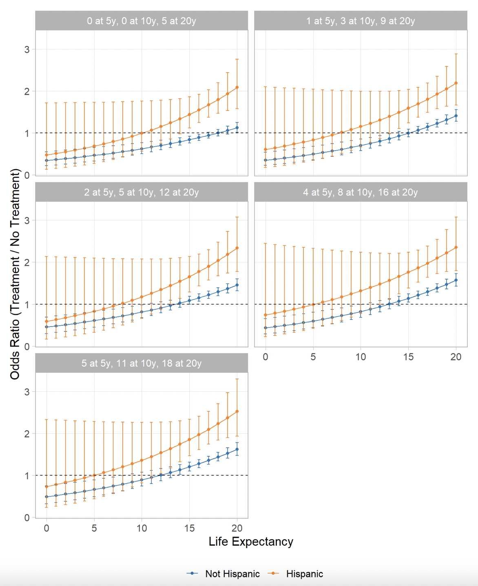
Supplementary Figure 1. Odds Ratio for aggressive treatment choice by life expectancy for Hispanic men versus non-Hispanic men
Tumor risks were represented as the number of additional lives saved by aggressive treatment out of 100 men at 5, 10, and 20 years. Each panel represents increasing tumor risk from (left-to-right, top-to-bottom).

