Supplementary Figure S1. Consort diagram
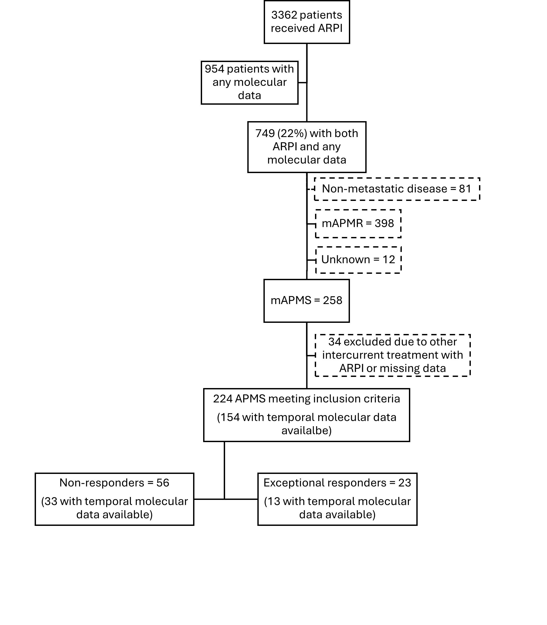
Of 154 with temporal molecular data available, 62% had FoundationOne CDx tissue testing (107 primary tissue, 32 metastatic tissue) and 87 (38%) had cfDNA testing (85 Guardant360, 2 FoundationOne LiquidDx).
ARPI = androgen receptor pathway inhibitor, mAPMS = metastatic androgen pathway modulation sensitive prostate cancer, mAPMR = metastatic androgen pathway modulation resistant prostate cancer.

