USP7 deubiquitinates and stabilizes NOTCH1 in T-cell acute lymphoblastic leukemia
Huizhuang Shan^{1,5}, Xiangyun Li^{1,5}, Xinhua Xiao^{3,5}, Yuting Dai³, Jinyan Huang³, Junjun Song⁴, Meng Liu¹, Li Yang¹, Hu Lei¹, Yin Tong², Li Zhou³, Hanzhang Xu¹, Yingli Wu^{1*}
*Correspondence: wuyingli@shsmu.edu.cn

Supplementary Figure
Supplementary Figure S1. (a-b) JURKAT and MOLT-4 cells were treated with increasing amounts of P22077 for 6 h as indicated. Total RNAs were collected for qRT-PCR analysis. Data were presented as means ± S.D. of three independent experiments, NS indicated no significant.
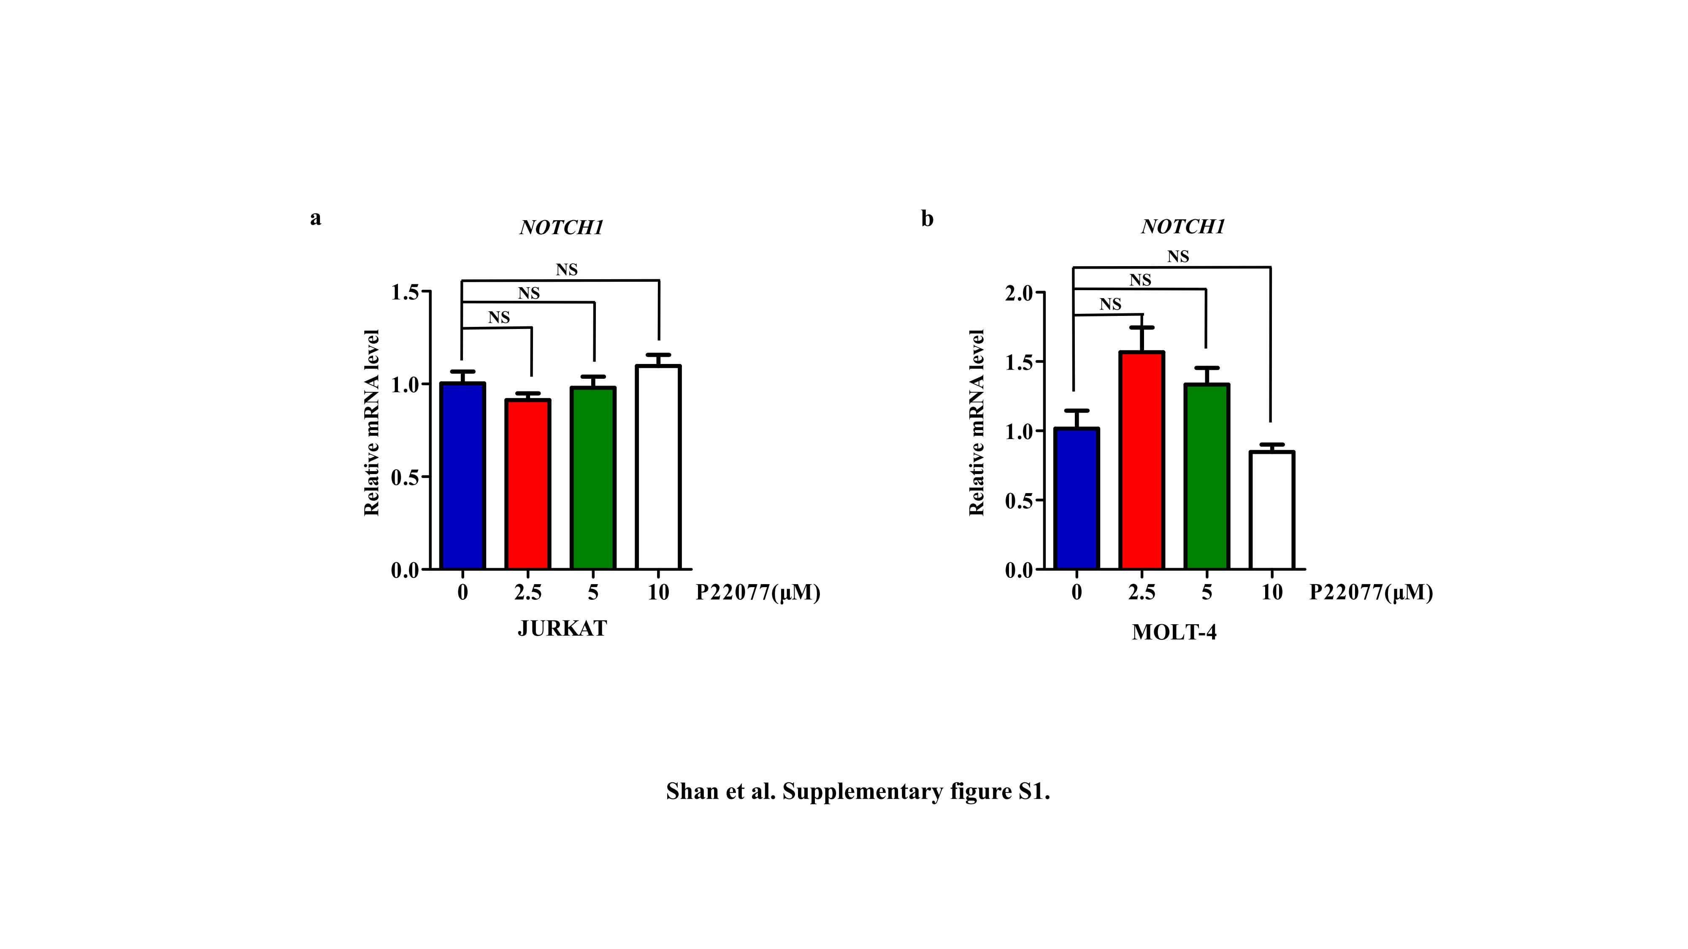

Supplementary Figure S2. Cells (T-ALL cell line: JURKAT; B-ALL cell line: SUP-B15; Multiple Myeloma cell lines: RPMI-8226 and ARP1; Burkitt's Lymphoma cell line: DAUDI) were treated with P22077 (10 μM and 15 μM) for 24 h, followed by assessment of cell viability using CCK-8 assay. Data are presented as means ± S.D.
