Supplementary Materials for

TGIF2 promotes the progression of lung adenocarcinoma by bridging EGFR/RAS/ERK signaling to cancer cell stemness

Renle Du,¹ Wenzhi Shen,² Yi Liu,¹ Wenjuan Gao,¹ Wei Zhou,¹ Jun Li,¹ Shuangtao Zhao,¹ Chong Chen,³ Yanan Chen,^{1, 5, 6} Yanhua Liu,^{1, 5, 6} Peiqing Sun,⁴ Rong Xiang,^{1, 5, 6} Yi Shi,^{1, 5, 6}* and Yunping Luo³*

¹Department of Immunology, School of Medicine, Nankai University, Tianjin 300071, China
²Department of Pathology and Institute of Precision Medicine, Jining Medical University, Jining 272067, China
³Department of Immunology, Institute of Basic Medical Science, Chinese Academy of Medical Science, School of Basic Medicine, Peking Union Medical College, Beijing 100005, China
⁴Department of Cancer Biology, School of Medicine, Wake Forest University, Winston-Salem, NC 27157, USA.
⁵2011 Project Collaborative Innovation Center for Biotherapy of Ministry of Education, Tianjin 300071, China
⁶Tianjin Key Laboratory of Tumour Microenvironment and Neurovascular Regulation, Tianjin 300071, China

* Correspondence to: Yunping Luo, Tel: 86.010.69156475, E-mail: ypluo@ibms.pumc.edu.cn; Yi Shi, Tel: 86.022.23509482, E-mail: yishi@nankai.edu.cn.

This file includes: Figures S1 to S3, Tables S1 to S6.
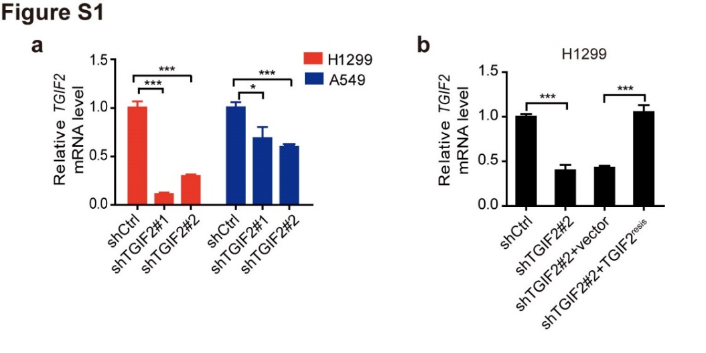
Figure S1. The mRNA levels of TGIF2 in TGIF2-silenced and TGIF2-rescued LUAD cells.
(a) qRT-PCR analysis of TGIF2 mRNA levels in H1299 and A549 cells stably transfected with two shRNAs targeting TGIF2 (shTGIF2#1 and shTGIF2#2). Data are presented as the means ± SD. *P<0.05, ***P<0.001.
(b) qRT-PCR analysis of TGIF2 mRNA levels in H1299 cells stably transfected with shTGIF2#2 and shTGIF2#2-TGIF2^{resis}. Data are presented as the means ± SD. ***P<0.001.
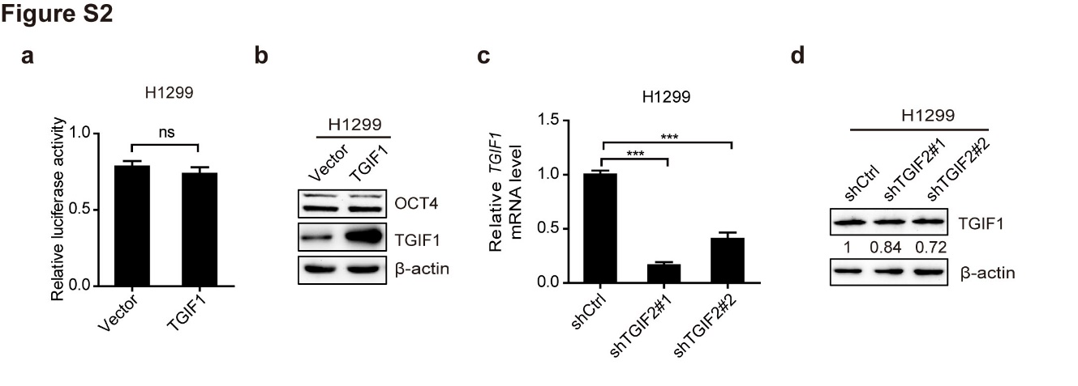
Figure S2. TGIF1 does not compensate for the decreased TGIF2 in H1299 cells
(a) Dual-luciferase assay to show the OCT4 promoter activity. The activity of the human OCT4 promoter was examined by co-transfection of the luciferase reporter construct containing the region from −6169 to +1 of the OCT4 promoter with vector or TGIF1 in H1299 cells. Data are shown as the means ± SD. **P<0.01.
(b) Western blot analysis of OCT4 in TGIF1-overexpressing H1299 cells.
(c) qRT-PCR analysis of TGIF1 mRNA levels in H1299 cells stably transfected with shTGIF2#1 or shTGIF2#2. Data are presented as the means ± SD. ***P<0.001.
(d) Western blots for TGIF1 in indicated stable H1299 cells. The mean values were shown at the bottom of the blot.
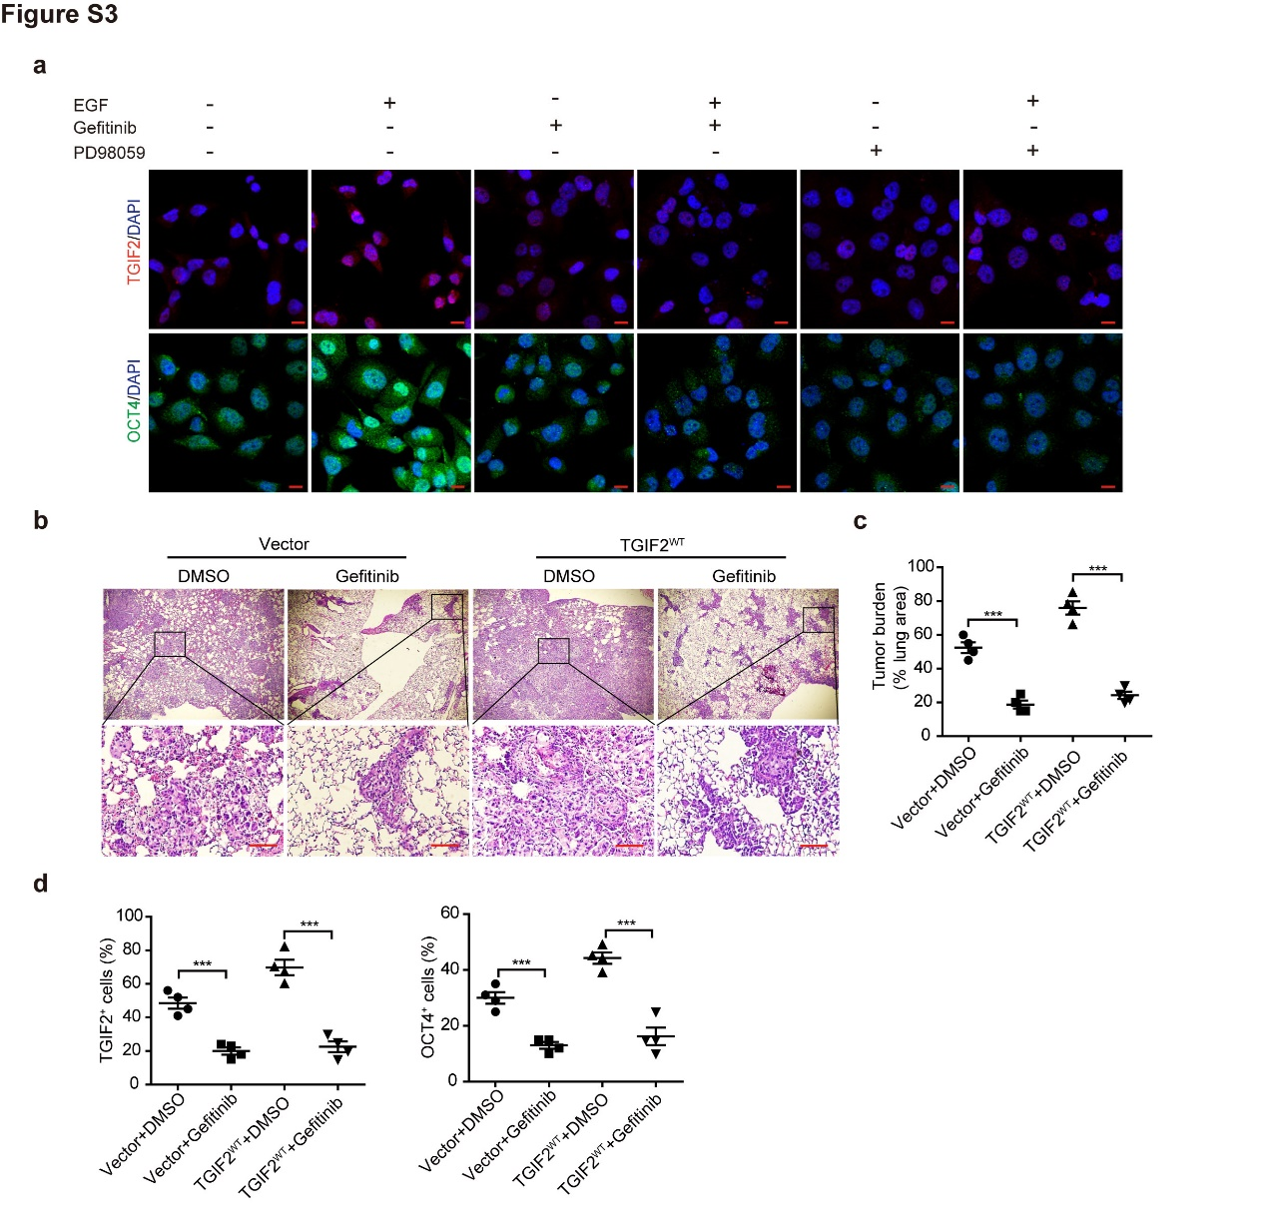
Figure S3. TGIF2-induced OCT4 expression and lung metastasis were inhibited by gefitinib
(a) EGF induced the accumulation of TGIF2 in the nucleus and promoted OCT4 expression in H1299 cells. H1299 cells were FBS-starved overnight, pre-incubated with 10 μM gefitinib or 20 μM PD98059 for 1 h, and then exposed to 50 ng/mL EGF for 5 min (for TGIF2) or 48 h (for OCT4) and then examined by immunofluorescence for TGIF2 and OCT4. Scale bars: 20 μm.
(b, c) The metastases in lungs of the indicated mice were shown by H&E staining (b, scale bars: 100 μm) and quantified (c). Data are presented as the means ± SD. *** P<0.001.
(d) The TGIF2 and OCT4 expression in lung tumors were quantified as positively stained cells. Data are shown as the means ± SD. ***P<0.001.

Supplementary Table S1. The template sequences of shRNAs targeting TGIF2 and negative control shRNA
shRNA | Sequences (5’-3’)
shTGIF2#1 | AAAAGCACACTCCCATCCCTTTAGTTTGGATCCAAACTAAAGGGATGGGAGTGTGC
shTGIF2#2 | AAAAGCACACTTACTCTGCTGACCATTGGATCCAATGGTCAGCAGAGTAAGTGTGC
shCtrl | AAAAGCTACACTATCGAGCAATTTTGGATCCAAAATTGCTCGATAGTGTAGC

Supplementary Table S2. Primer sequences for cloning
Clone | Forward Sequences (5’-3’) | Reverse Sequences (5’-3’)
Flag-TGIF2^{WT} | CGGGATCCGCCACCATGGATTACAAGGATGACGACGATAAGGCCCGGATGTCGGACAGTGATCTAGGT | CGACGCGTCTACTGGGGATTTTCAGAGAC
TGIF2^{AA} | GGTGGACTCTTCAACGCGCCACCACCCGCACCCCCAGAGCAGG | CCTGCTCTGGGGGTGCGGGTGGTGGCGCGTTGAAGAGTCCACC
TGIF2^{DD} | GGTGGACTCTTCAACGACCCACCACCCGACCCCCCAGAGCAGG | CCTGCTCTGGGGGGTCGGGTGGTGGGTCGTTGAAGAGTCCACC
Modified Flag-TGIF2^{WT} sequences with mutation at shTGIF2#2 targeting sites | GTACTCTAACATTACTCACGA
TGIF1 | CGGGATCCATGGTTCTAGCGCAGAGCC | CGACGCGTTTAAGCTGTAAGTTTTGCCTGAAG
–6169~+1 | CGAGCTCCACCTTTTACATGAGCAGGTTTG | CGGCTAGCCAGGCCGGCGGAATCAC
–5129~+1 | CGAGCTCCGACTTAGATTGTGTGATACTTTGGT | CGGCTAGCCAGGCCGGCGGAATCAC

Supplementary Table S3. Primer sequences for qRT-PCR
Gene | Forward Sequences (5’-3’) | Reverse Sequences (5’-3’)
TGIF2 | CGGACAGTGATCTAGGTGAGGACG | GGGAAATGGTAAACTGATTAGGGTCTT
SOX2 | GCCTGGGCGCCGAGTGGA | GGGCGAGCCGTTCATGTAGGTCTG
OCT4 | GCTCGAGAAGGATGTGGTCC | CGTTGTGCATAGTCGCTGCT
NANOG | TCTGGACACTGGCTGAATCCT | CGCTGATTAGGCTCCAACCAT
TGIF1 | CCCCAGTGCTCCTTTTCCAC | GAAGGTAGGCCAAAGTGCCG

Supplementary Table S4. Antibodies used in the study
Antibody | Company (Art.No.) | Apply (dilution)
TGIF2 | Santa Cruz (sc-390870) | WB (1:500), ChIP (6μg for 10⁶ cells)
 | Abcam (ab155948) | IHC (1:100), IF(1:200)
β-actin | Santa Cruz (sc-47778) | WB (1:10000)
α-Tubulin | Cell signaling (2144) | WB (1:1000)
Lamin A/C | Cell signaling (4777) | WB (1:1000)
Flag | Sigma-Aldrich (F1840) | WB (1:1000)
ERK | ZSGB-BIO (ZS-94) | WB (1:1000)
p-ERK | ZSGB-BIO (ZS-7976) | WB (1:1000)
EGFR | Cell signaling (2232) | WB (1:1000)
p-EGFR | Cell signaling (4407) | WB (1:1000)
NANOG | Abcam (ab80892) | WB (1:1000)
OCT4 | Abcam (ab19857) | WB (1:1000),  IHC (1:100),  IF (1:200)
OCT4 | Proteintech (11263-1-AP) | WB (1:1000)
SOX2 | Abcam (ab92494) | IHC (1:100)
 | Santa Cruz (sc-20088) | WB (1:5000)
TGIF1 | Santa Cruz (sc-17800) | WB (1:500)

Supplementary Table S5. Clinicopathological characteristics of patients from NSCLC tissue array
Characteristics | Patients (n=60)
Histologic type
Large cell undifferentiated carcinoma | n=12
Adenocarcinoma | n=24
Squamous cell carcinoma | n=24
Grade
1 | n=16
2 | n=18
3 | n=23
Stage
Ⅰ | n=17
Ⅱ | n=16
Ⅲ-IV | n=14
Tumor size
T1 | n=4
T2 | n=43
T3-T4 | n=13
Lymph node metastasis
N0 | n=25
N1 | n=13
N2 | n=9
Vessel invasion
M0 | n=58
M1 | n=2
Supplementary Table S6. Primer sequences for ChIP-qPCR assay
Fragments of OCT4 promoter | Forward Sequences (5’-3’) | Reverse Sequences (5’-3’)
–1222~+1 | AAATGGGCAGGAAGAGGT | CTTGGTCGCTGTGCAGTC
–2196~–1177 | AGCCCAGGGAATAACCAA | AATAGCGGCACAAGCACC
–3168~–2150 | CCCAGCCACCTTACTCCT | CTCCCATCCACGTACAGC
–4172~–3147 | CCCTGATTGTCCCTCTTC | TTGGCATGACTTATTACTCC
–5129~–4153 | GCATTAGAGGTGGGTTGG | TGCCTTGGCTTACAGGTT
–6169~–5169 | CCCCATGTAATTCTTTCC | CTGCCTGTCTTTGGTTTT

