Supplementary Figures
Fig. S1
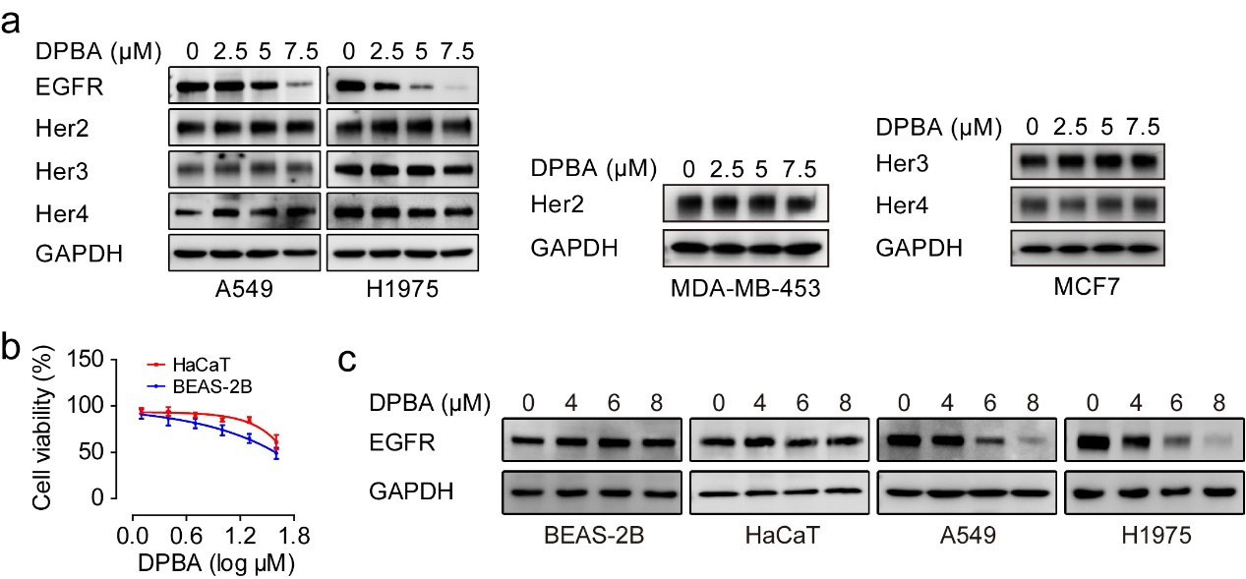

Fig. S2
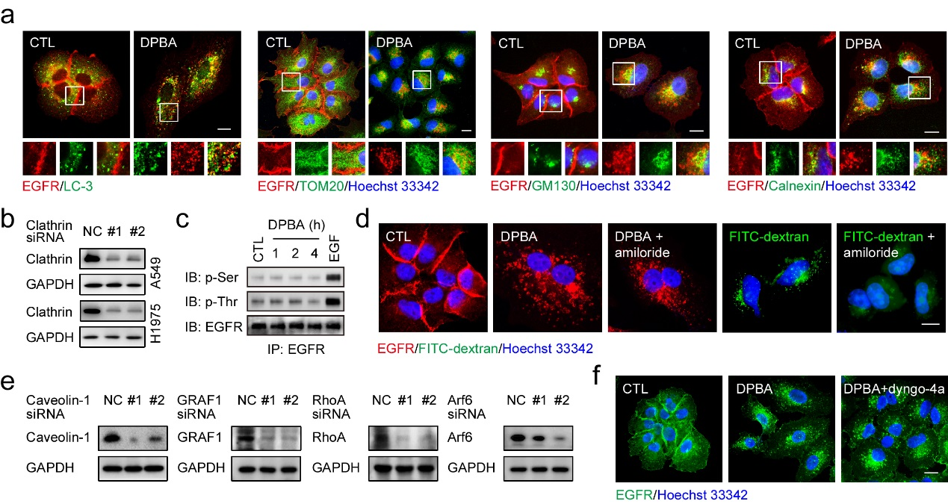

Fig. S3
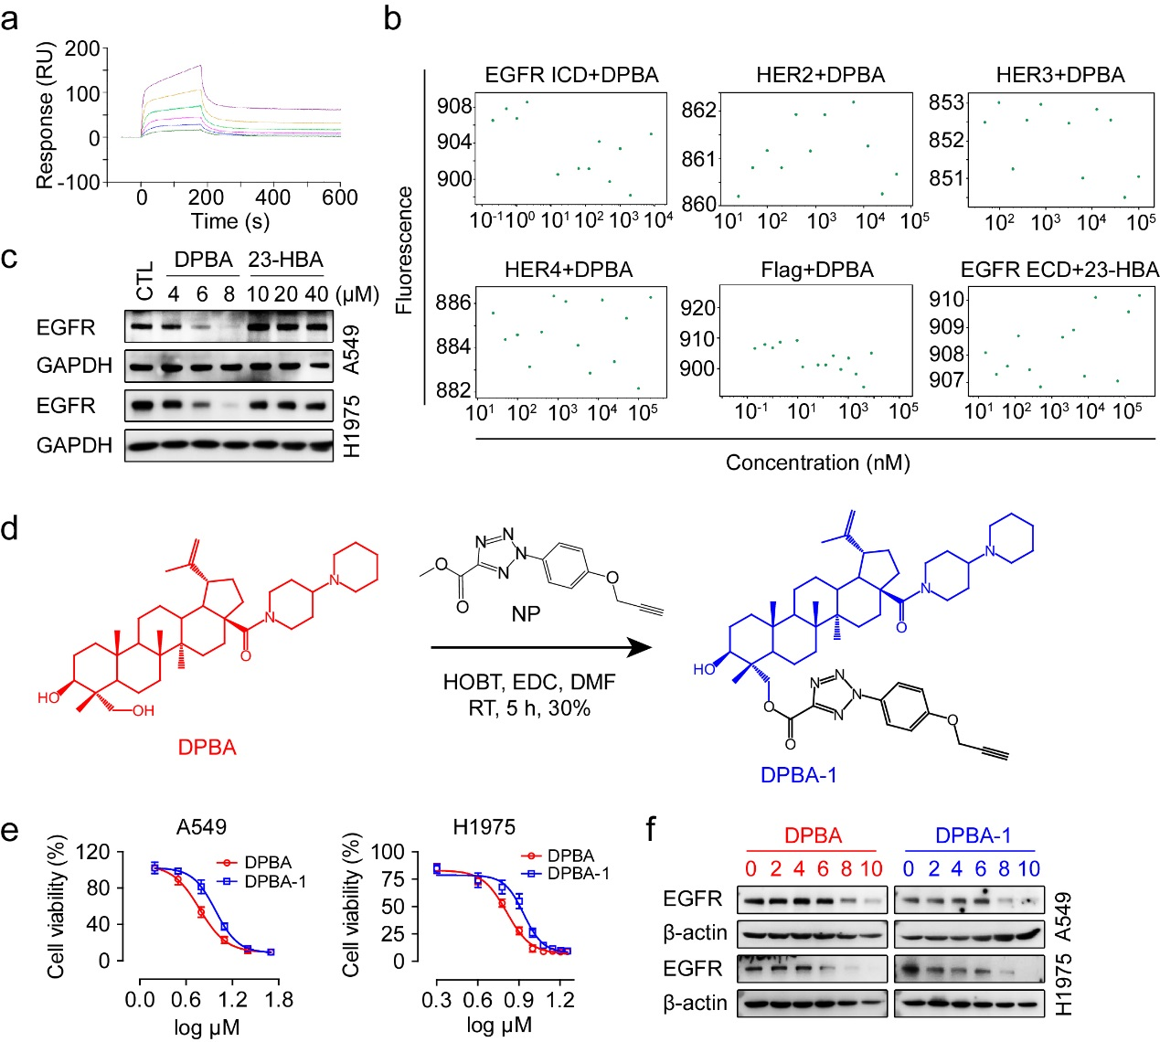

Fig. S4
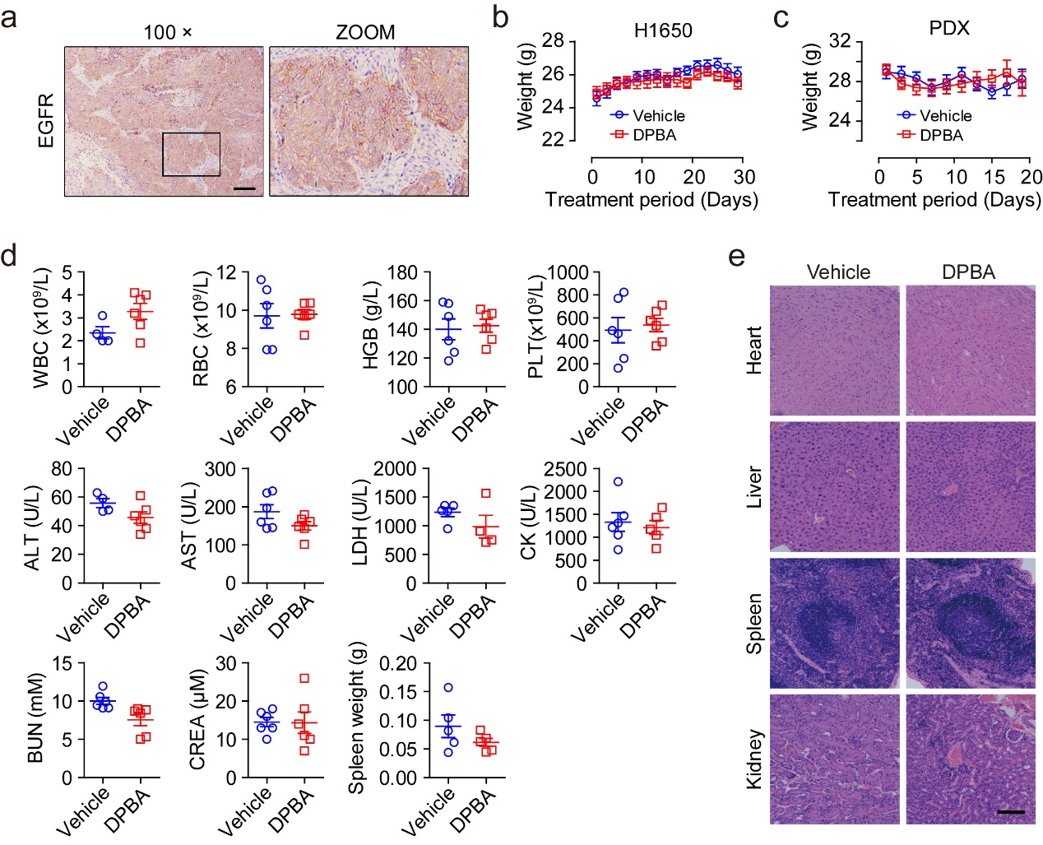

Supplementary Figure legends
Fig. S1 a DPBA specifically reduced EGFR protein level. A549, H1975, MDA-MB-453 (Her2-positive), and MCF7 (Her3- and Her4-positive) were treated with DPBA for 24 h. EGFR, Her2, Her3, and Her4 expression levels were detected by Western blot. b HaCaT and BEAS-2B were treated with indicated concentrations of DPBA for 24 h. Cell viability was measured by MTT assay, n = 3. c DPBA did not reduce EGFR protein level in normal cell lines. BEAS-2B, HaCaT, A549, and H1975 were exposed to DPBA (4 μM, 6 μM, or 8 μM) for 24 h. EGFR protein levels were measured by Western blot.

Fig. S2 a A549 cells were treated with DPBA (6 μM) for 6 h, colocalization of EGFR and LC-3, TOM20, GM130 or calnexin was detected by immunofluorescence assay (magnification, 630×; scale bar, 10 μm). b A549 and H1975 cells were transfected with clathrin siRNA (100 nM) for 48 h, clathrin protein level was detected by Western blot. c A549 cells were treated with DPBA (6 μM) for 1, 2, and 4 h or EGF (50 ng/ml) for 5 min. EGFR serine and threonine phosphorylation were detected by EGFR pull-down assay. d A549 cells were treated with DPBA (6 μM) in the presence or absence of amiloride (100 μM) for 6 h or FITC-dextran (2 μM) with or without amiloride (100 μM) for 1 h, sub-localization of EGFR or FITC-dextran was detected by immunofluorescence assay (magnification, 630×; scale bar, 10 μm). e A549 was transfected with siRNA (100 nM) against caveolin-1, GARF1, RhoA, or Arf6 for 48 h. Proteins levels were measured by Western blot. f A549 cells were treated with DPBA in the presence or absence of dyngo-4a (20 μM) for 6 h, sub-localization of EGFR was detected by immunofluorescence assay (magnification: 630×; scale bar: 10 μm).

Fig. S3 a The interaction between EGF and EGFR ECD was measured by BIACORE. b The interaction between DPBA and EGFR ICD, HER2 ECD, HER3 ECD, HER4 ECD or flag tag in EGFR ECD, as well as interaction between EGFR ECD and 23-HBA were measured by MST. c A549 and H1975 cells were treated with DPBA or 23-HBA for 24 h, EGFR protein level was detected by Western blot. d Synthesis of DPBA-1 probe. e A549 and H1975 cells were treated with indicated concentrations of DPBA or DPBA-1 for 24 h, cell viability was measured by MTT assay, n = 3. f A549 and H1975 cells were treated with indicated concentrations of DPBA or DPBA-1 for 12 h, EGFR protein level was detected by Western blot.

Fig. S4 a Immunohistochemistry staining for EGFR of primary lung cancer PDX (magnification, 100×; scale bar, 200 μm). b Body weight curve of mice bearing H1650 xenografts. c Body weight curve of mice bearing primary NSCLC PDX. d Examination of routine blood indices, serum biochemical indices, and spleen weight of nude mice treated with DPBA (25 mg/kg). e H&E staining of the main organs of nude mice (magnification, 200×; scale bar, 400 μm).

