Supplementary Materials for

Discovery of a novel EGFR ligand DPBA that degrades EGFR and suppresses EGFR-positive NSCLC growth
Nan Yao^{1, 2, a}, Chen-Ran Wang^{1, 2, a}, Ming-Qun Liu¹, Ying-Jie Li¹, Wei-Min Chen¹, Zheng-Qiu Li¹, Qi Qi³, Jin-Jian Lu⁴, Chun-Lin Fan^{1, 2}, Min-Feng Chen^{1, 2}, Ming Qi^{1, 2}, Xiao-Bo Li^{1, 2}, Jian Hong³, Dong-Mei Zhang^{1, 2, *}, Wen-Cai Ye^{1, 2, *}

¹ College of Pharmacy, Jinan University, Guangzhou, China
² Guangdong Province Key Laboratory of Pharmacodynamic Constituents of Traditional Chinese Medicine and New Drugs Research, Jinan University, Guangzhou, China
³ School of Medicine, Jinan University, Guangzhou, China
⁴ State Key Laboratory of Quality Research in Chinese Medicine, Institute of Chinese Medical Sciences, University of Macau, Macao, China
ª These authors contributed equally to this work.

*Corresponding Authors:
Prof. Wencai Ye, College of Pharmacy, Jinan University, 601 Huangpu Avenue. West, Guangzhou 510632, China; Phone: +86-20-85220936; E-mail: chywc@aliyun.com.
Prof. Dongmei Zhang, College of Pharmacy, Jinan University, 601 Huangpu Avenue. West, Guangzhou 510632, China; Phone: +86-20-85222653; E-mail: dmzhang701@jnu.edu.cn.

This PDF file includes:

Figures S1 to S4
Tables S2 to S3

Other Supplementary Materials for this manuscript include the following:

Table S1

Figure. S1.
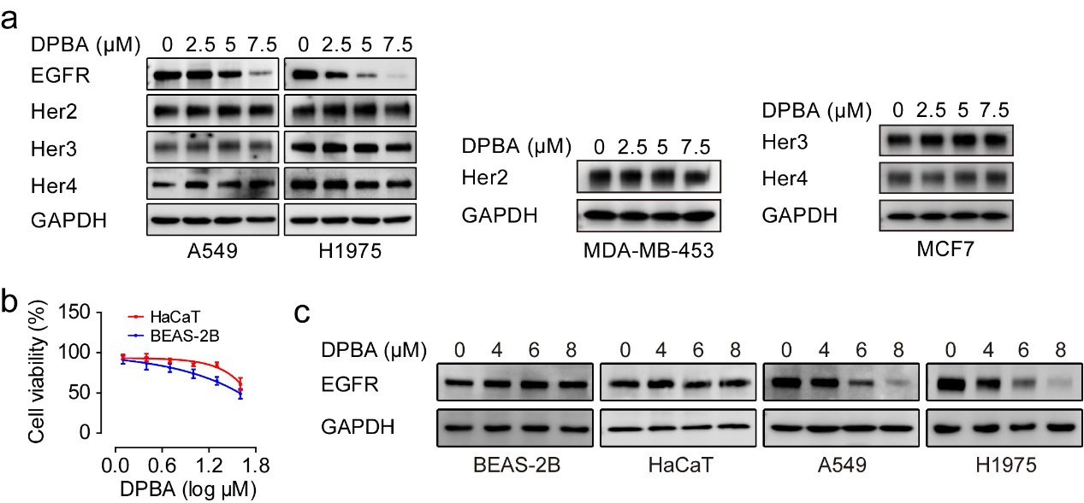
Figure S1 a DPBA specifically reduced EGFR protein level. A549, H1975, MDA-MB-453 (Her2-positive), and MCF7 (Her3- and Her4-positive) were treated with DPBA for 24 h. EGFR, Her2, Her3, and Her4 expression levels were detected by Western blot. b HaCaT and BEAS-2B were treated with indicated concentrations of DPBA for 24 h. Cell viability was measured by MTT assay, n = 3. c DPBA did not reduce EGFR protein level in normal cell lines. BEAS-2B, HaCaT, A549, and H1975 were exposed to DPBA (4 μM, 6 μM, or 8 μM) for 24 h. EGFR protein levels were measured by Western blot.

Figure. S2.
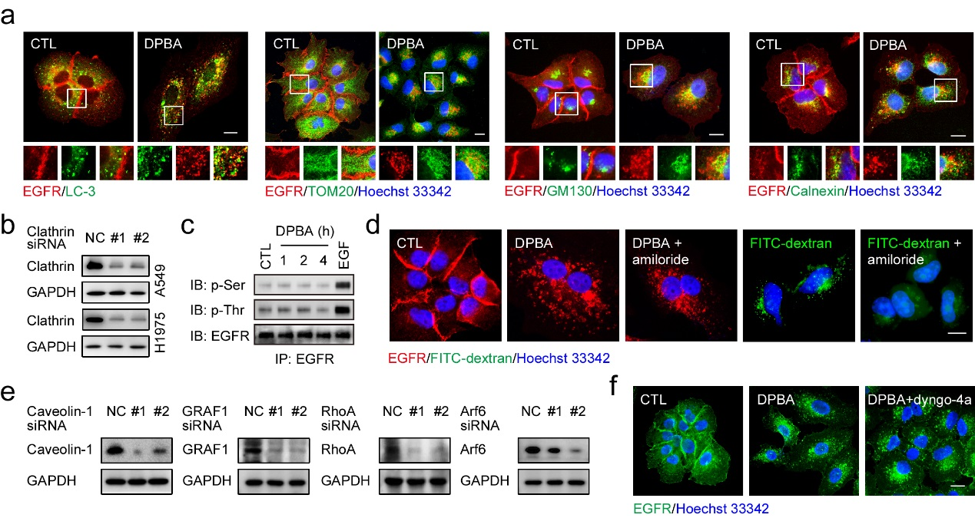
Figure S2 a A549 cells were treated with DPBA (6 μM) for 6 h, colocalization of EGFR and LC-3, TOM20, GM130 or calnexin was detected by immunofluorescence assay (magnification, 630×; scale bar, 10 μm). b A549 and H1975 cells were transfected with clathrin siRNA (100 nM) for 48 h, clathrin protein level was detected by Western blot. c A549 cells were treated with DPBA (6 μM) for 1, 2, and 4 h or EGF (50 ng/ml) for 5 min. EGFR serine and threonine phosphorylation were detected by EGFR pull-down assay. d A549 cells were treated with DPBA (6 μM) in the presence or absence of amiloride (100 μM) for 6 h or FITC-dextran (2 μM) with or without amiloride (100 μM) for 1 h, sub-localization of EGFR or FITC-dextran was detected by immunofluorescence assay (magnification, 630×; scale bar, 10 μm). e A549 was transfected with siRNA (100 nM) against caveolin-1, GARF1, RhoA, or Arf6 for 48 h. Proteins levels were measured by Western blot. f A549 cells were treated with DPBA in the presence or absence of dyngo-4a (20 μM) for 6 h, sub-localization of EGFR was detected by immunofluorescence assay (magnification: 630×; scale bar: 10 μm).

Figure. S3.
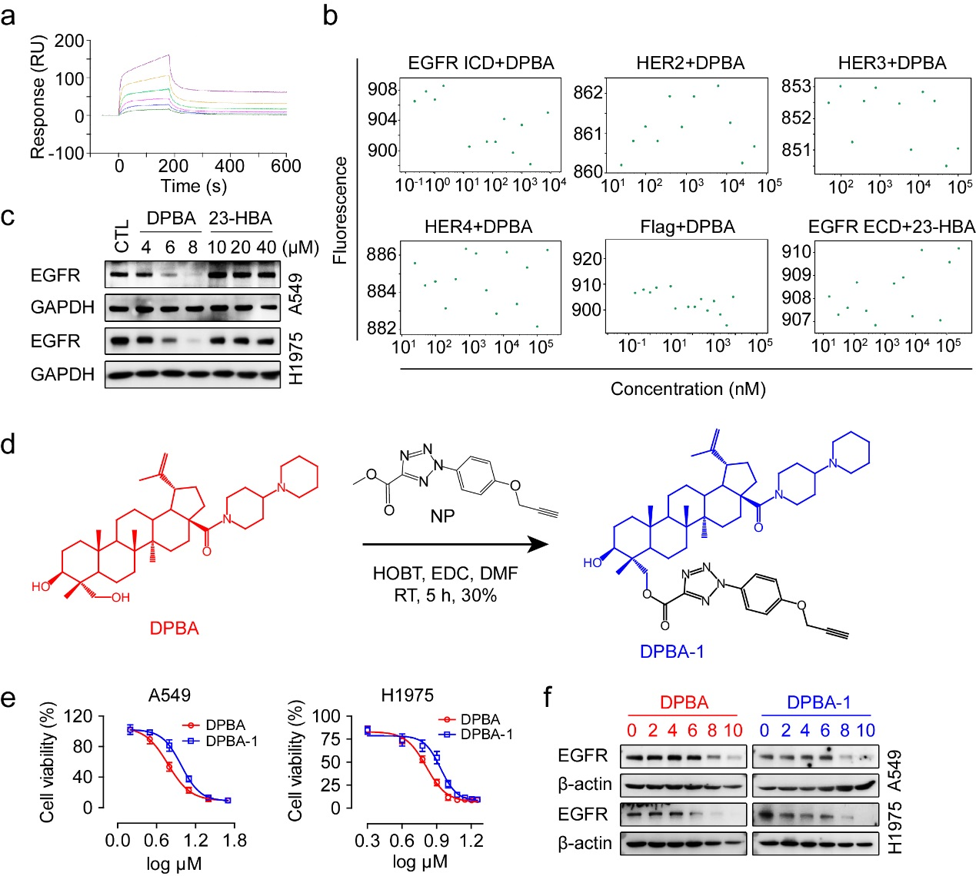
Figure S3 a The interaction between EGF (200, 100, 50, 25, 12.5, and 6.25 μM) and EGFR ECD was measured by BIACORE. b The interaction between DPBA and EGFR ICD, HER2 ECD, HER3 ECD, HER4 ECD or flag tag in EGFR ECD, as well as interaction between EGFR ECD and 23-HBA were measured by MST. c A549 and H1975 cells were treated with DPBA or 23-HBA for 24 h, EGFR protein level was detected by Western blot. d Synthesis of DPBA-1 probe. e A549 and H1975 cells were treated with indicated concentrations of DPBA or DPBA-1 for 24 h, cell viability was measured by MTT assay, n = 3. f A549 and H1975 cells were treated with indicated concentrations of DPBA or DPBA-1 for 12 h, EGFR protein level was detected by Western blot.

Figure. S4.
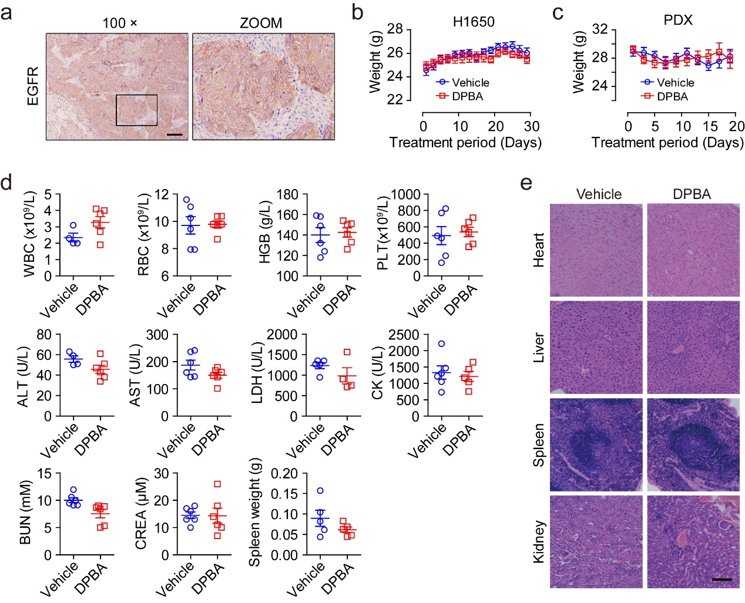
Figure S4 a Immunohistochemistry staining for EGFR of primary lung cancer PDX (magnification, 100×; scale bar, 200 μm). b Body weight curve of mice bearing H1650 xenografts. c Body weight curve of mice bearing primary NSCLC PDX. d Examination of routine blood indices, serum biochemical indices, and spleen weight of nude mice treated with DPBA (25 mg/kg). e H&E staining of the main organs of nude mice (magnification, 200×; scale bar, 400 μm).

Table S2.
Table S2: siRNA sequences of targeted proteins
Name | No. | Sequences
Dynamin-2 | #1 | CCGAATCAATCGCATCTTC
Dynamin-2 | #2 | GACATGATCCTGCAGTTCA
Clathrin | #1 | CCTGCGGTCTGGAGTCAAC
Clathrin | #2 | GAAGAACTCTTTGCCCGGAAATTTA
Caveolin-1 | #1 | GGCCAGCUUCACCACCUUC
Caveolin-1 | #2 | AGACGAGCUGAGCGAGAAGCA
Flotillin-1 | #1 | GCAGAGAAGUCCCAACUAA
Flotillin-1 | #2 | GUGGUUAGCUACACUCUGA
Arf6 | #1 | GCACCGCAUUAUCA AUGACCGUU
Arf6 | #2 | CGGUCAUUGAUAAUGCGGUGCUU
GRAF1 | #1 | GUA AUCUGUGCUGAAUGGGAGAUAA
GRAF1 | #2 | CCACUCAUGAUGUACCAGUUUCAAA
RhoA | #1 | AUGGAAAGCAGGUAGAGUU
RhoA | #2 | TACCCAGATACCGATGTTATA

Table S3.
Table S3: Clinical characteristics of the primary lung cancer
Characteristics | Lung cancer patient
Gender/Age (yr) | Male/60
Date of diagnosis | 2019/6/25
Tumor type | Squamous cell carcinoma
Clinical stage | T3N0M0
EGFR expression | Positive
Treatment status | Post-operative chemotherapy
Clinical metastasis | None

