Supplementary information for
Cryo-EM structure of activated bile acids receptor TGR5 in complex with stimulatory G protein
Geng Chen^{1,2*}, Xiankun Wang ^{1,2*}, Yunjun Ge^{1*}, Ling Ma^{1,2*}, Qiang Chen ^{1,2}, Huihui Liu^{2,3}, Yang Du¹, Richard D. Ye¹, Hongli Hu^{1#}, Ruobing Ren^{1#}

¹ Kobilka Institute of Innovative Drug Discovery, School of Life and Health Sciences, the Chinese University of Hong Kong, Shenzhen, Guangdong 518172, P.R. China
² School of Life Sciences, University of Science and Technology of China, Anhui 230026, P.R. China
³ Warshel Institute for Computational Biology, the Chinese University of Hong Kong, Shenzhen, Guangdong 518172, P.R. China
* These authors contribute equally
# To whom correspondence should be addressed. Email: honglihu@cuhk.edu.cn and renruobing@cuhk.edu.cn

Ruobing Ren
School of Life and Health Sciences, the Chinese University of Hong Kong, Shenzhen, Tu H.L. building, 7th Floor, Longxiang Road, Shenzhen, Guangdong 518172, China.
Email: renruobing@cuhk.edu.cn
Tel.: (86) 755-2351-9515
Hongli Hu
School of Life and Health Sciences, the Chinese University of Hong Kong, Shenzhen, Tu H.L. building, 7th Floor, Longxiang Road, Shenzhen, Guangdong 518172, China.
Email: honglihu@cuhk.edu.cn
Tel.: (86) 755-2351-9007
Supplementary Text
Examination of TGR5 residues for 23H recognition
L71A^{2.60} affected agonist potency by one order of magnitude, indicating hydrophobic interaction with 23H. Bulky side-chain substitutions of A217P^{6.28} and C236W^{6.47} on TM6 also caused the reduction of agonist potency by one order of magnitude. It is worth mentioning that A217P^{6.28}, associated with primary sclerosing cholangitis, is located on the interface between TGR5 and G_{as}. For other substitutions with significant cAMP signal decreasing, such as N93A/F^{3.33}, F161A^{5.35}, and Y165A^{5.39}, the expression level dramatically dropped lower than 20% compared to wild type TGR5 in cell surface (supplementary Fig. 6)

Material and Methods
Construction and expression of TGR5
For TGR5 expression, wild type Homo sapiens TGR5 (NM_001077191.2), truncating from T6 to S307, was cloned into pFastbac vector. To increase protein expression level and stability, an N-terminal FLAG epitope, a 3C protease site, and BRIL fusion protein were inserted after a HA signal peptide. The construct was expressed in sf9 insect cells using the Bac-to-Bac system. Cells were infected at a density of 4×10⁶ cells per ml and expressed at 27 ℃ for 48 hours. For cAMP assays, the full-length TGR5 with indicated point mutants were cloned into mammalian expression vector pCDNA 3.1 with an N-terminal Flag tag and a 3C protease site inserted after a HA signal peptide.
Construction, expression and purification of G_{s} heterotrimer and Nb35
Gs heterotrimer was expressed in High Five insect cells (Invitrogen). Human G_{αs} was cloned in pFastbac vector, and N-terminal 6×His-tagged rat G_{β1}, and bovine G_{γ2} were cloned into pFastBac-Dual vector, and the virus was prepared using Bac-to-Bac baculovirus system. The cells were infected with both G_{αs} and G_{βγ} virus at a ratio of 10:1 at 27 °C for 48 hours. G_{s} heterotrimer was purified as previously reported. Nanobody-35 (Nb35) was expressed in the E. coli BL21 (DE3), extracted, and purified by general nickel affinity chromatography protocol as a small soluble protein.
TGR5-G_{s}-Nb35 complex formation and purification
TGR5 agonist 23H is a kindly gift from Shen Lab in Shanghai Institute of Materia Medica, Chinese Academy of Sciences. 1 L Sf9 cell pellets infected with virus containing TGR5 were lysed in 60 ml lysis buffer 10 mM HEPES, pH 7.5, 1 mM EDTA, 4 mg/ml iodoacetamide, 2.5 μg/ml leupeptin, 0.16 mg/ml Benzamidine, 0.46 μM agonist 23H. The cell membrane was collected by centrifuge at 186,000g. 10 mg of G_{s} and 1.6 mg Nb35 were added and incubated at RT for 1 hr. 10 mM MgCl₂ and apyrase was added, incubated at RT for additional 30 mins. The protein complex was formed on the membrane and then 1% LMNG (NG310 Anatrace), 0.1% CHS (CH210, Anatrace) was added to solubilize the membrane. Extracted protein complex was further purified in two steps, by Ni-NTA resin affinity chromatography and Flag M1 resin affinity chromatography. During wash steps, the buffer was exchanged to 25 mM HEPES, pH 7.5, 150 mM NaCl, 0.06% LMNG, 0.006% CHS, 0.02% GDN (GDN101, Anatrace), 100 μM TCEP, 10% glycerol, 0.46 μM agonist 23H. The protein complex was eluted by elution buffer 25 mM HEPES, pH 7.5, 150 mM NaCl, 0.006% LMNG, 0.0006% CHS, 0.002% GDN, 100 μM TCEP, 0.46 uM agonist 23H, 5 mM EDTA, 200 uM flag peptides. Protein complex was concentrated and loaded onto Superose 6 increase 10/300 GL column with running buffer 25 mM HEPES, pH 7.5, 150 mM NaCl, 0.006% LMNG, 0.0006% CHS, 0.002% GDN, 100 μM TCEP, 0.46 μM agonist 23H. Fractions contains TGR5-G_{s} complex was collected and concentrated for electron microscopy experiments.

Cryo-EM sample preparation and data collection
The purified protein complex was concentrated to about 8 mg/ml for cryo-sample preparation. The amorphous alloy film (CryoMatrix Au300- R1.2/1.3, Zhenjiang Lehua Electronic Technology Co., Ltd.) was glow discharged with air for 40 sec at 10 mA at PELCO easiGlow™ Glow Discharge Cleaning System. Aliquots of 3.5 μl the protein complex was placed on the gird, and then was blotted for 3.5 sec and flash-frozen in liquid ethane cooled by liquid nitrogen with Vitrobot (Mark IV, Thermo Fisher Scientific). For data collection, the 300 kV Titan Krios Gi3 equipped with Gatan K3 Summit detector and GIF Quantum energy filter was operated. Movie stacks with 40 frames were automatically collected using EPU (Thermo Scientific) at a nominal magnification of 105,000X, corresponding to a pixel size of 0.85 Å. The defocus range was set from -1.5 μm to -2.5 μm. Each stack was exposed in the counted-Nanoprobe mode for 2.48 sec and the total dose rate was about 50 e⁻/Å² for each stack.

Cryo-EM image processing
Dose-fractionated movie stacks were subjected to dose-weighted motion correction by MotionCor2 v1.2.2 using 5×5 patches¹. Contrast transfer function parameters were estimated by Gctf v1.06². Micrographs with weak information were thrown away and 8194 images were chosen for further process. The particles auto-picking, 2D and 3D classification, 3D refinement were performed using RELION 3.0³. The total number of 3,683,494 particles were extracted and subjected to a reference-free 2D classification. The selected particles from 2D classification were further subjected to 3D classifications with initial model of a known GPCR-G_{s} complex with EMDB ID 8653 and lowpass-filtered to 30 Å. Eventually, a subset of 450,271 particles were selected from 3D classification were subjected to 3D refinement by subtracting the density of micelle and alpha helical domain, resulting a final map with global resolution of 3.9 Å at FSC 0.143. Local resolution map was calculated from the Bsoft packageat cutoff FSC of 0.5⁴.
Model building and refinement
The initial template of TGR5 was derived using Modeller^{5,6} from a class A GPCR (PDB 6CMO). Sequence alignment was done using Clustal W2.1⁷. The coordinates of Gs and Nb35 from PDB 5VAI⁸ were used as initial models. Models were docked into the EM density map using UCSF Chimera⁹, followed by iterative manual building in Coot¹⁰. The final model was subjected to real space refinement in Phenix¹¹. Molprobity was used to evaluate model geometry.
Computational docking
Computational docking of ligand 23H to TGR5 receptor cryo-EM structures was performed using AutoDock Vina. A 25×25×25 Å³ box centered at the observed density map corresponding to the ligand was selected as the searching region, which is large enough to cover the whole binding pocket of TGR5. Flexibility of the ligand and all side-chain of the residues within the searching region were considered. Exhaustiveness (80) docking was carried out to search the optimized ligand binding pose, with the so-called Broyden-Fletcher-Goldfarb-Shanno (BFGS) algorithm for local optimization. Three representative docking poses were selected and fitted into the EM map using Chimera.
cAMP assay
cAMP accumulation after TGR5 activation was analyzed by a time-resolved fluorescence resonance energy transfer (TR-FRET) technology. TGR5 constructs were transfected into HEK293 cells with Lipofectamine 3000 reagent (Thermo Fisher Scientific; Waltham, MA, USA). After 24 h transfection, the cells were harvested in an assay buffer (HBSS plus 0.5 mM isobutylmethylxanthine, 0.1% BSA (w/v), and 5 mM HEPES) and transferred to a 384-well plate. Various ligands were prepared as a series of eight 10-fold serial dilutions and applied to stimulate the cells in a cell incubator for 30 min. The cAMP levels in the stimulated cells were detected with a cAMP detection kit (PerkinElmer; ‎Waltham, MA, USA) according to the manufacturer’s instructions. The measurement was conducted with Victor Nivo plate reader (PerkinElmer). cAMP concentrations were calculated according to TR-FRET signals of cell samples and cAMP standards. Basal cAMP levels were subtracted and the cAMP responses were shown as percentages of the maximal response. The data were analyzed with a GraphPad Prism 5.0 software (GraphPad Inc, La Jolla, CA, USA).
TGR5 constructs expression level determination by flow cytometry
Approximately 1×10⁶ transfected HEK293 cells were collected and washed with PBS. Cells were blocked with 5% BSA at room temperature for 15 min and then incubated with anti-FLAG antibody (1:100) in PBS containing 1% BSA at 4°C for 1 h. Cells were washed three times with PBS and then incubated with anti-mouse Alexa-488-conjugated secondary antibody (1:300, Beyotime) in PBS containing 1% BSA at 4 °C in the dark. Washed two times with PBS and then the cells were resuspended in 200 μl PBS for detection in BD Accuri™ C6 Plus flow cytometer. Approximately 10,000 cellular events were counted for each sample and the fluorescence intensity data were collected.

Supplementary References
Zheng,

Figure Legends：
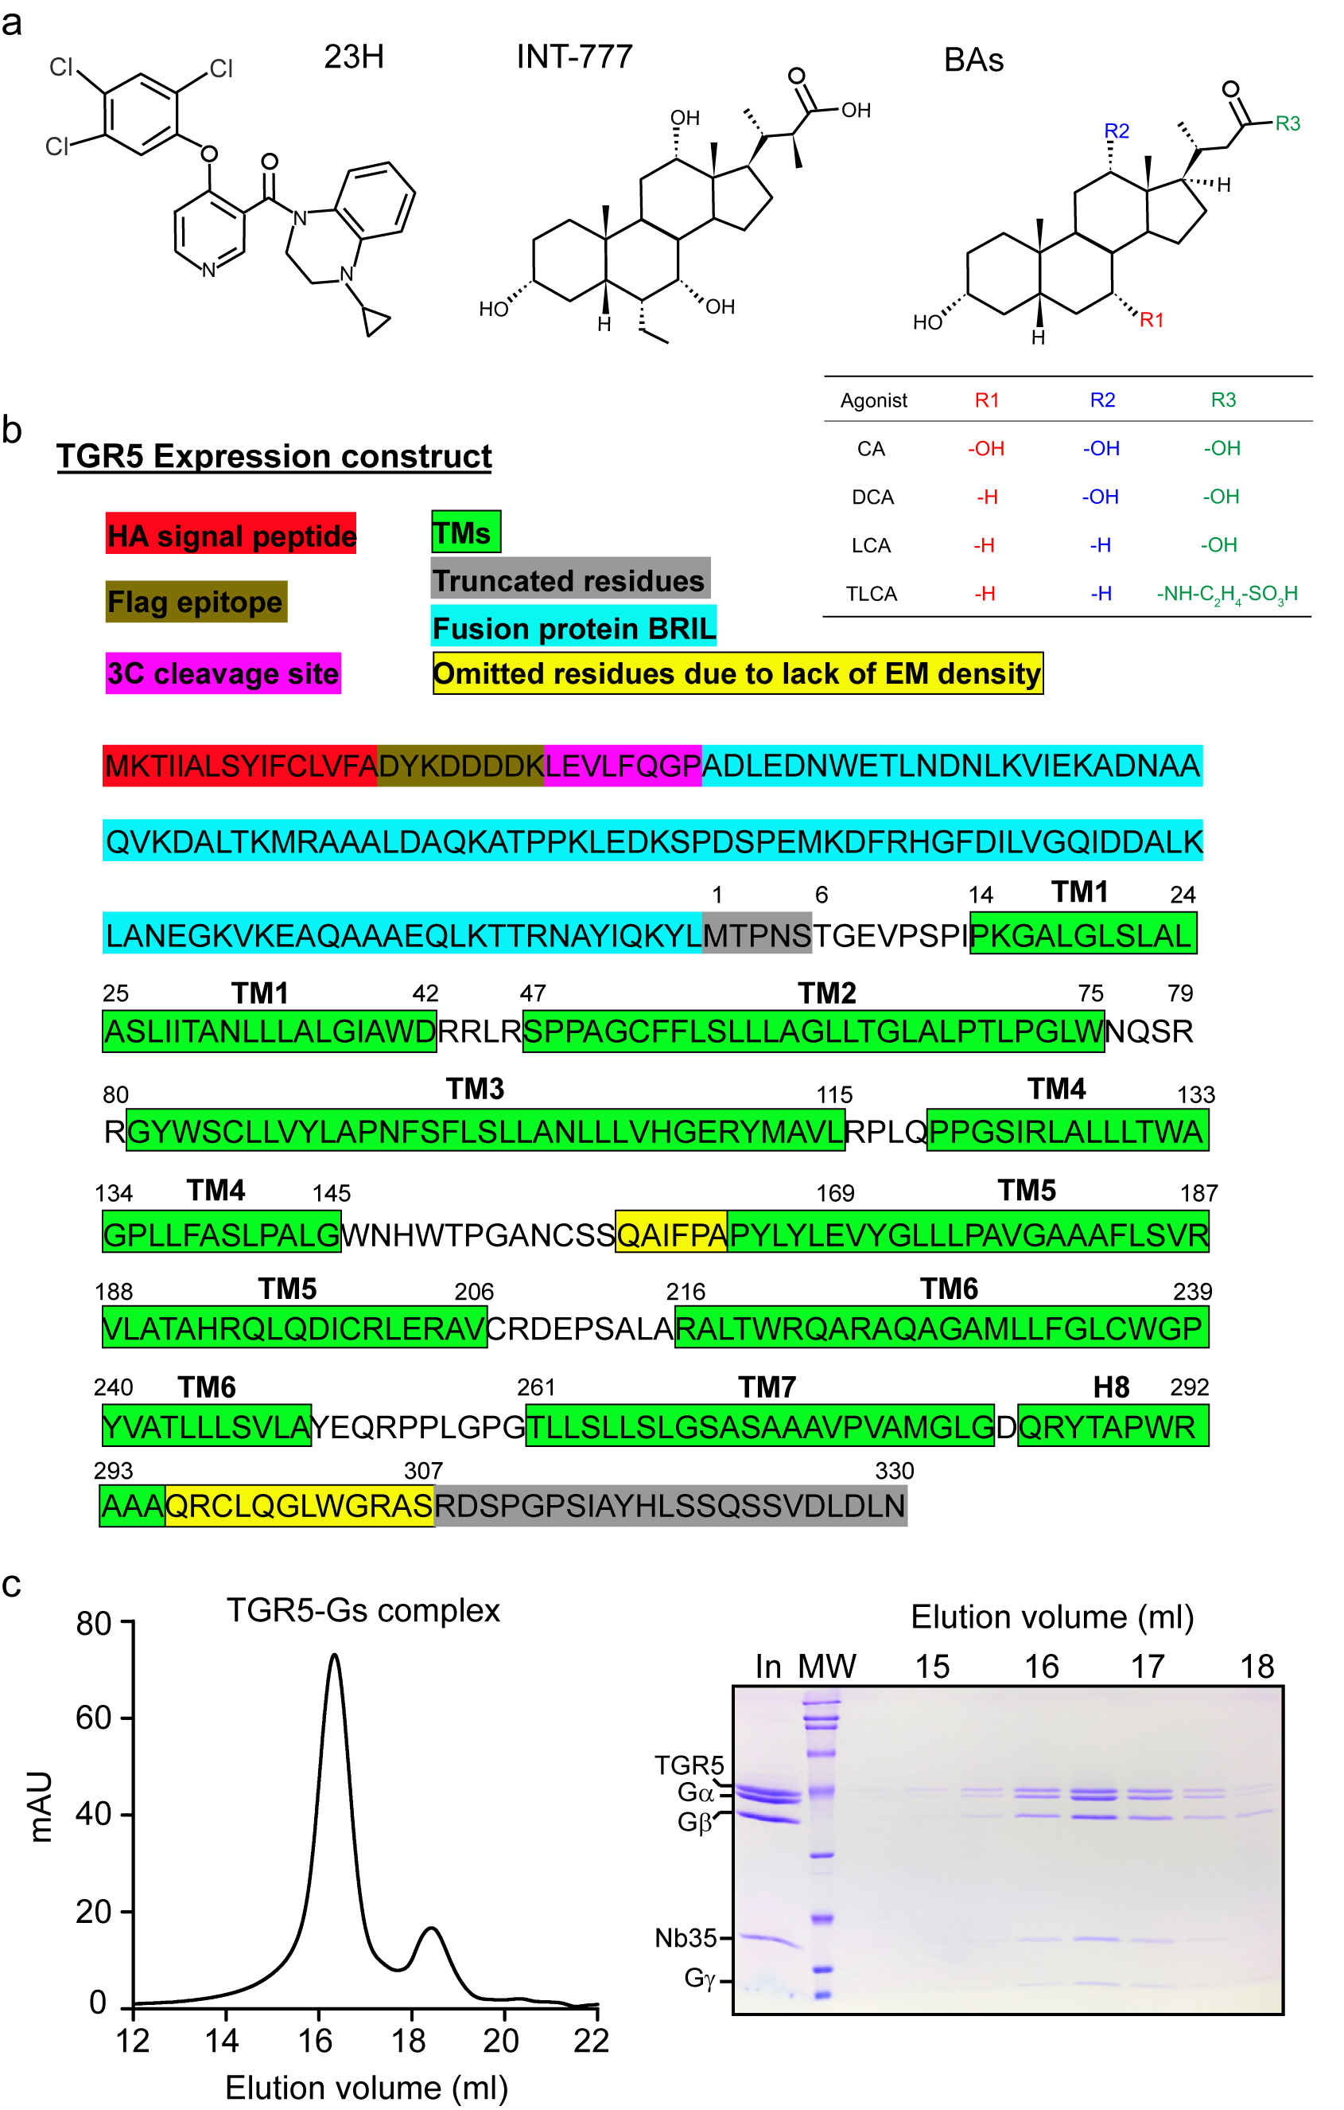
Fig. S1 | Amino acid sequence of the TGR5 construct and the purification of the TGR5-G_{s} complex used for determination of structure. a, Structural formula of non-steroid compound 23H, semi-synthetic compound INT777 and four bile acids (BAs). b, The sequences are annotated to denote the location of the haemagglutinin (HA) signal sequence (red highlight), Flag (brown highlight), 3C cleavage sites (magenta highlight), fusion protein (cyan highlight), truncated residues (grey highlight). Transmembrane helical domains in TGR5 are boxed and highlighted in green. Segments of the TGR5 that were not resolved in the cryo-EM map are highlighted in yellow. c, Left panel shows the final size exclusion chromatography elution profile of the TGR5-G_{s} complex with 23H. Right panel shows the SDS–PAGE and Coomassie blue staining of the size-exclusion chromatography peak, demonstrating the presence of each of the components of the complex.

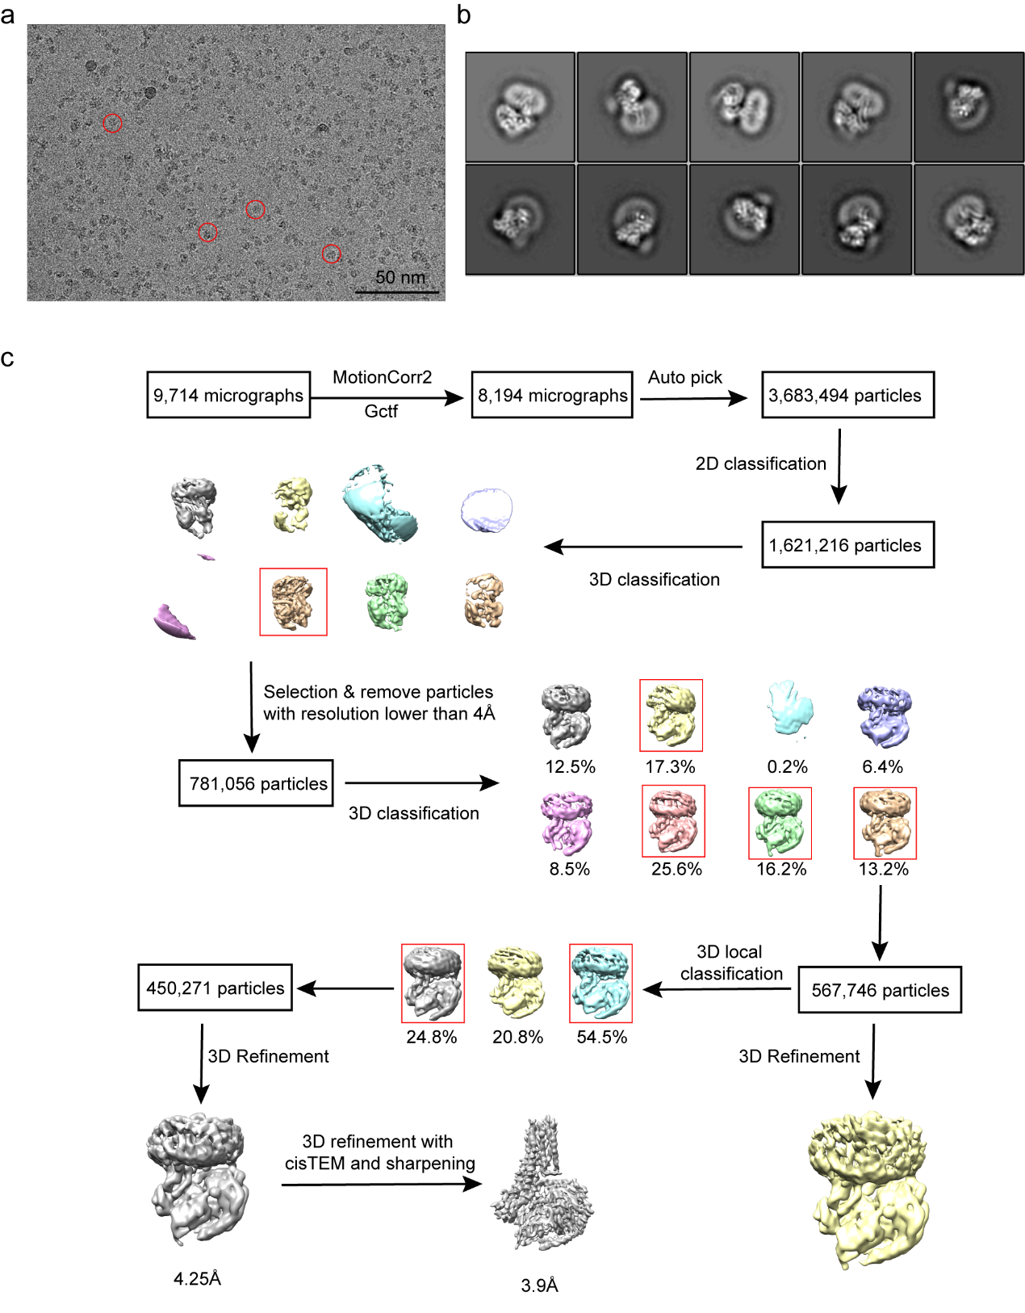
Fig. S2 | Cryo-EM micrograph, 2D class averages, and single-particle cryo-EM analysis of the TGR5-G_{s} complex. a, Cryo-EM micrograph of the activated TGR5-G_{s} complex. Examples of particle projections are circled. Scale bar, 50 nm. b, Representative 2D averages show distinct secondary structure features for TGR5-G_{s} complex. c, Flow chart of cryo-EM data processing of the TGR5-G_{s} complex. Details are provided in the Methods section.

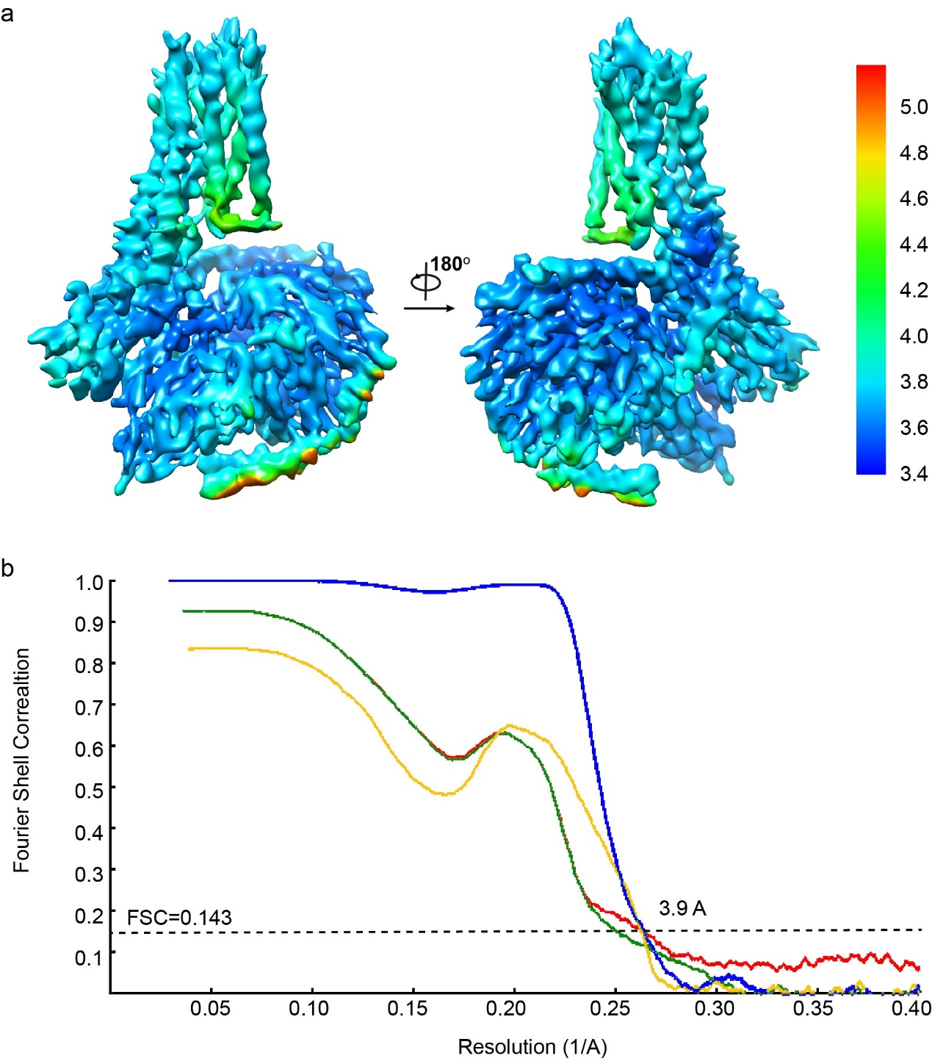
Fig. S3 | Resolution of cryo-EM map and validation of the TGR5-G_{s} structure. a, Final three-dimensional density map colored according to local resolution. b, Resolution estimation of the EM map. Gold standard Fourier shell correlation (FSC) curve (blue) and cross-validation of model to cryo-EM density map. Model overfitting was evaluated through its refinement against one cryo-EM half map after randomly displacing all atoms by 0.2 Å. FSC curves were calculated between the resulting model and the half map used for refinement (red), as well as between the resulting model and the other half map for cross validation (green), and also against the full map (yellow).

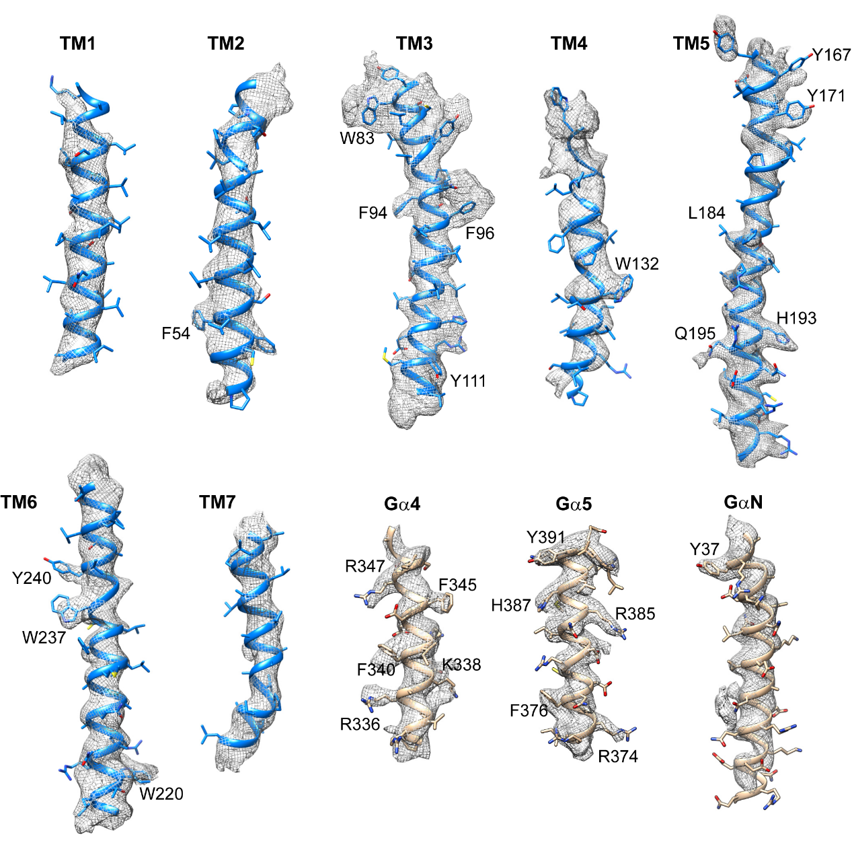
Fig. S4 | Representative Cryo-EM map for key components of TGR5-G_{s} complex. Cryo-EM density map and model are shown for all seven transmembrane α-helices and the α4-, α5-, and αN-helices of the G_{s} protein. Bulky resides are indicated for each segment.

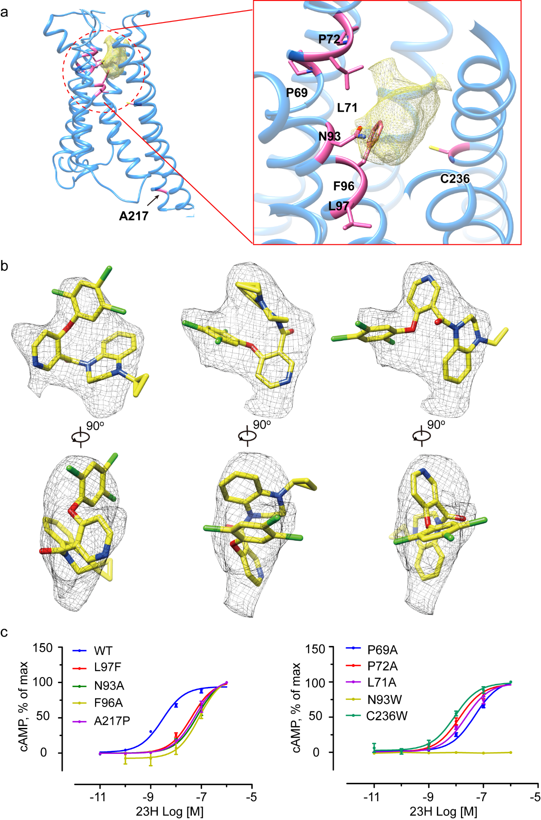

Fig. S5 | cAMP response of mutant TGR5 with 23H. a, Residues in TGR5 that involve in 23H binding. Density of 23H is shown in yellow. Residues involve in 23H binding are shown in pink. b, Three possible binding models for 23H. Two perpendicular views are shown. The black mesh represented the omit map in the putative agonist binding pocket. c, cAMP responses of mutant TGR5. These mutations of TGR5 reduced agonist potency by one order compared with wild type. cAMP responses are shown as percentages of the maximum response of each mutation or the WT (for N93W with significant reduction in efficacy). The corresponding pEC50 is shown in Extended Data Table 2. WT data was not shown on panel b (right) because all the mutations were tested at the same time. The data represent means±S.E.M. (n=3-5).

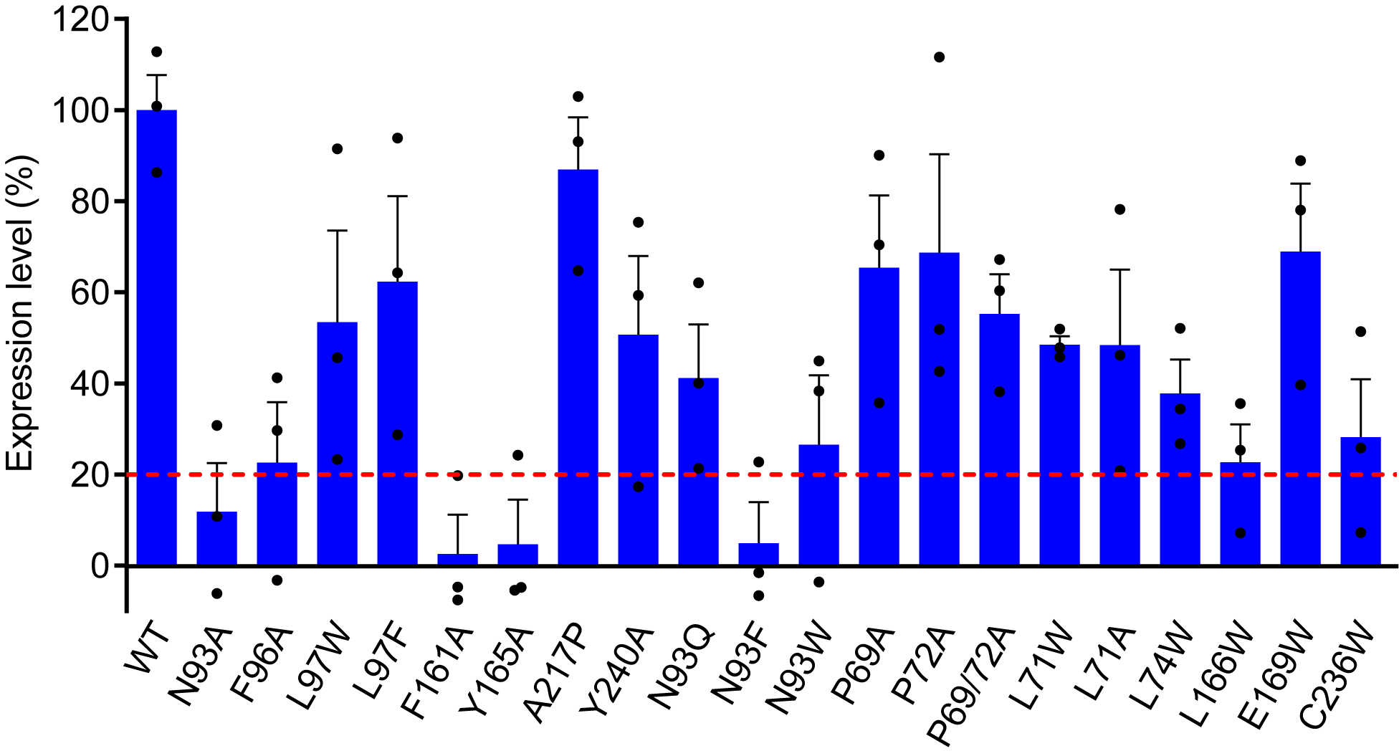
Fig. S6 | Expression level of mutational TGR5 in cells by quantitative flow cytometry. Red dashed line indicates 20% expression level of wild type TGR5. The data are shown as means±S.E.M. of three independent experiments.
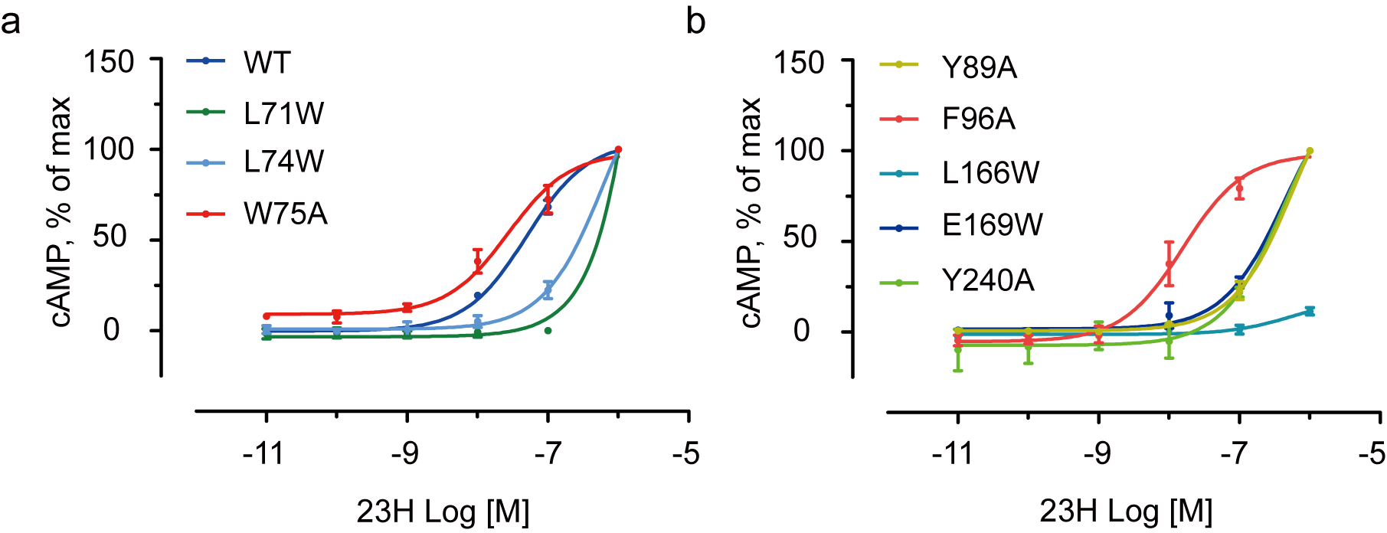
Fig. S7 | cAMP responses of mutant TGR5 to LCA. cAMP responses are shown as percentages of the maximum response of each mutation or the WT (for mutations with significant reduction in efficacy). The corresponding pEC50 is shown in Extended Data Table 3. WT data was not shown on panel b because all the mutations were tested under the same experimental conditions. The data represent means±S.E.M. (n=3-5).

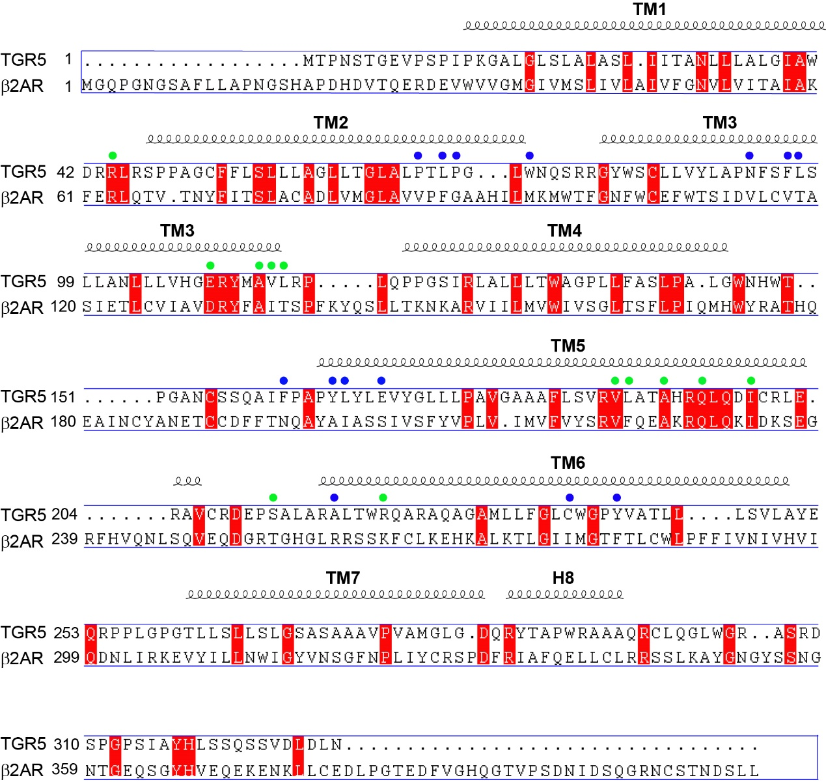
Fig. S8 | Sequence alignment of TGR5 and β₂AR. The alignment was performed using MultAlin and ENDscript programs. Secondary structural elements are shown above the sequence. Sequence identity is shown in white letters on a red background. The blue dots indicate residues that were mutated to verify compound 23H interaction (in Fig. 1c-d and Extended Data Fig. 5). The green dots indicate the residues in TGR5 that interact with G_{s} protein (in Fig. 1f). Some of these residues are identical to that of β₂AR which involve in G_{s} protein binging.

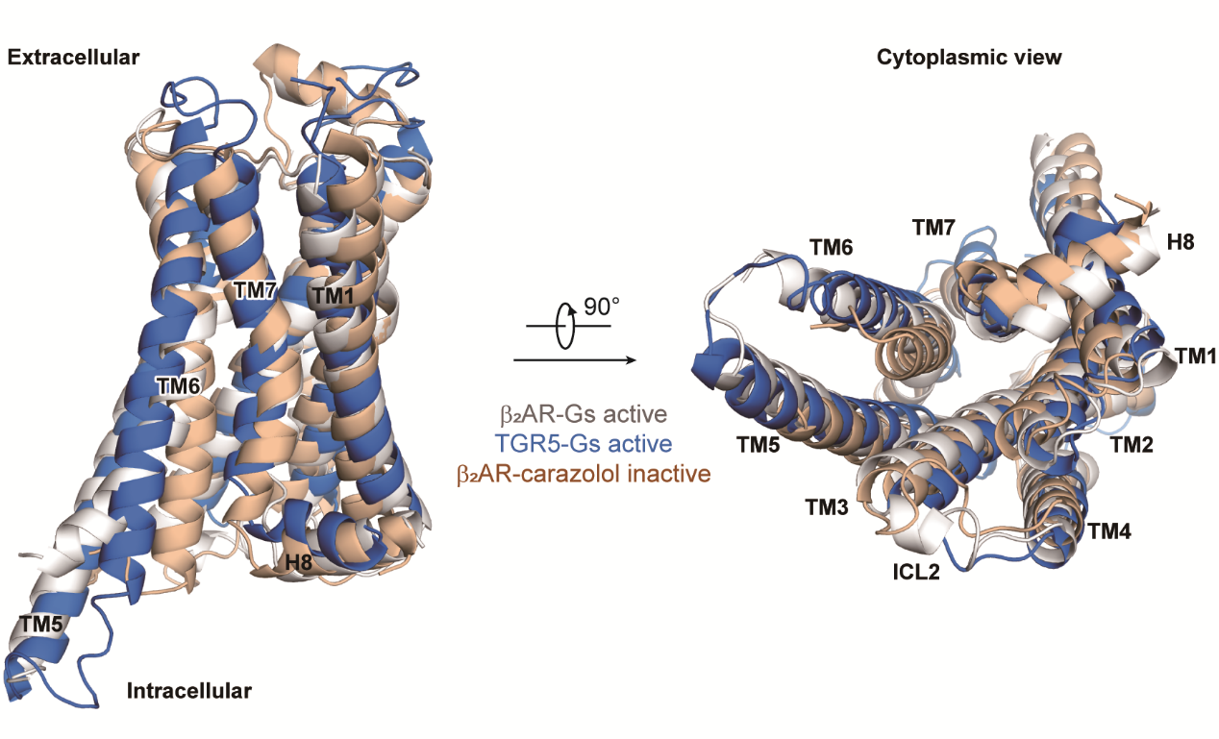
Fig. S9 | Comparisons of active TGR5 with active and inactive β₂AR. Active TGR5, inactive and active β₂AR were shown, by two perpendicular views, in marine, wheat and gray cartoon models, respectively.

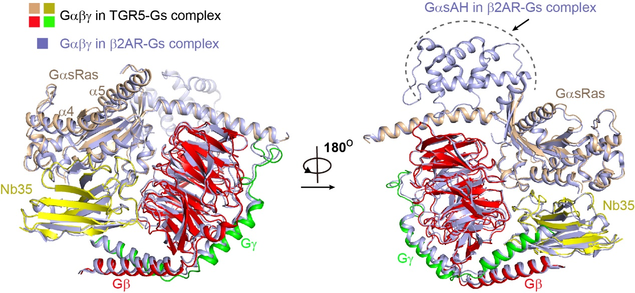

Fig. S10 | Comparison of G_{s} proteins in structures of TGR5-G_{s} complex and β₂AR-G_{s} complex. G_{αβγ} complex and Nb35 in β₂AR-Gs complex are shown in light blue. G_{αs}Ras, G_{β}, G_{γ}, and Nb35 in TGR5-G_{s} complex are shown in wheat, red, green, and yellow. G_{αs}AH domain in β₂AR-Gs complex is invisible due to the limited electron density.

Table S1 | Data collection, phasing and refinement statistics (molecular replacement)

Protein | TGR5-G_{s}-Nb35  EMDB code: EMD-30221  PDB code: 7BW0
Cryo-EM Data Collection
Voltage (kV) | 300
Magnification (x) | 58,823
Pixel size (Å) | 0.85
Electron exposure (e⁻/ Å²) | 50
Defocus range (μm) | [-2.5, -1.5]
Number of image stacks | 9714
Number of frames per stack | 40
Cryo-EM Data Processing
Initial number of particles | 3,683,494
Final number of particles | 450,271
Map sharpening B factor (Å²) | -230
Map resolution (Å) | 3.9
Map resolution range (Å) | 3.4-7.7
FSC threshold | 0.143
Model Refinement
Model resolution range  Number of amino acids | 3.5-9  1031
Total non-hydrogen atoms | 7946
Bond length r.m.s.d. (Å) | 0.004
Bond angle r.m.s.d. (°) | 1.016
Ranmachandran Plot
Favored (%) | 93.79
Allowed (%) | 6.21
Outliers (%) | 0.00
Rotamer outliers (%) | 0.12
MolProbity score | 1.98

Table S2 | The potencies of TGR5 ligands with the receptor or its mutants. The data represent means±S.E.M. (n = 3-5).
pEC50 in  Fig. 1a |  | pEC50 in  Fig. 1d |  | pEC50 in  Extended Data Fig. 5 |  | pEC50 in  Extended Data Fig. 7
Ligands  (TGR5 WT) | pEC₅₀±SEM | TGR5 WT/mutations | pEC₅₀±SEM | TGR5 mutations | pEC₅₀±SEM | TGR5 mutations | pEC₅₀±SEM
23H | 8.4±0.13 | WT | 8.39±0.13 | P69A | 7.23±0.09 | L71W | No response
INT777 | 5.83±0.12 | P69/72A | 6.33±0.33 | L71A | 7.63±0.12 | L74W | 4.17±0.25
CA | 4.97±0.12 | L71W | 6.20±0.29 | P72A | 7.83±0.12 | W75A | 5.50±0.29
LCA | 5.63±0.17 | N93Q | 6.53±0.17 | N93A | 7.13±0.24 | Y89A | 4.13±0.29
TLCA | 6.13±0.12 | L97W | 6.23±0.17 | N93W | 6.97±0.12 | F96A | 6.03±0.26
 |  | L166W | 5.80±0.24 | F96A | No response | L166W | No response
 |  | E169W | 6.27±0.12 | L97F | 7.37±0.12 | E169W | 4.33±0.12
 |  | Y240A | 6.00±0.14 | A217P | 7.23±0.24 | Y240A | 4.37±0.12
 |  |  |  | C236W | 8.00±0.14

