Supplementary Materials for

CDK4/6 inhibition blocks cancer metastasis through a USP51-ZEB1-dependent deubiquitination mechanism

Zhen Zhang¹, Jianjun Li¹, Yang Ou¹, Guang Yang², Kaiyuan Deng¹, Qiong Wang¹, Zhaoyang Wang¹, Wenhao Wang¹, Quansheng Zhang³, Hang Wang¹, Wei Sun¹, Peiqing Sun⁴, Shuang Yang^{1*}

¹Tianjin Key Laboratory of Tumor Microenvironment and Neurovascular Regulation, Medical College of Nankai University, Tianjin 300071, China
²College of Pharmacy, Nankai University, Tianjin 300071, China
³Tianjin Key Laboratory of Organ Transplantation, Tianjin First Center Hospital, Tianjin 300192, China
⁴Department of Cancer Biology, Wake Forest University School of Medicine, Winston-Salem, NC 27157, USA

*Corresponding author: Shuang Yang at Medical College of Nankai University; 94 Weijin Road, Tianjin 300071, China; Tel: +86-22-23509557; Fax: +86-22-23505501;
E-mail: yangshuang@nankai.edu.cn

This file includes: Figures S1 to S7, Tables S1 to S7.

Figure. S1.
Figure. S1. Biochanin A induces ZEB1 protein degradation in breast cancer cells. a Structure of Biochanin A. b, c Western blotting (b) and Q-PCR (c) analysis of ZEB1 expression in MDA-MB-231 and SUM-159 cells by treatment with the indicated concentrations of Biochanin A for 48 h. d CHX pulse-chase analysis of ZEB1 protein stability in MDA-MB-231 and SUM-159 cells by treatment with Biochanin A at the indicated time points. The results were normalized to the levels of β-actin. e, f Western blottingof ZEB1 protein expression in MDA-MB-231 and SUM-159 cells by treatment with MG132 (e) and CQ (f) in the presence or absence of Biochanin A. g Co-immunoprecipitation analysis of ZEB1 protein ubiquitination in MDA-MB-231 and SUM-159 cells by treatment with Biochanin A for 48 h. Cells were treated with MG132 for 12 h prior to harvest. h The binding mode of Biochanin A with CDK4/6. i Cellularthermal shift assay of the binding of CDK4/6 with Biochanin A or Palbciclib in MDA-MB-231 cells. j MDA-MB-231 and SUM-159 cells were synchronized in the G1/S phase using methotrexate and in the G2/M phase using colchicine, respectively. Western blotting analysis of ZEB1 protein expression were performed. β-actin was used as a loading control.

Figure. S2. 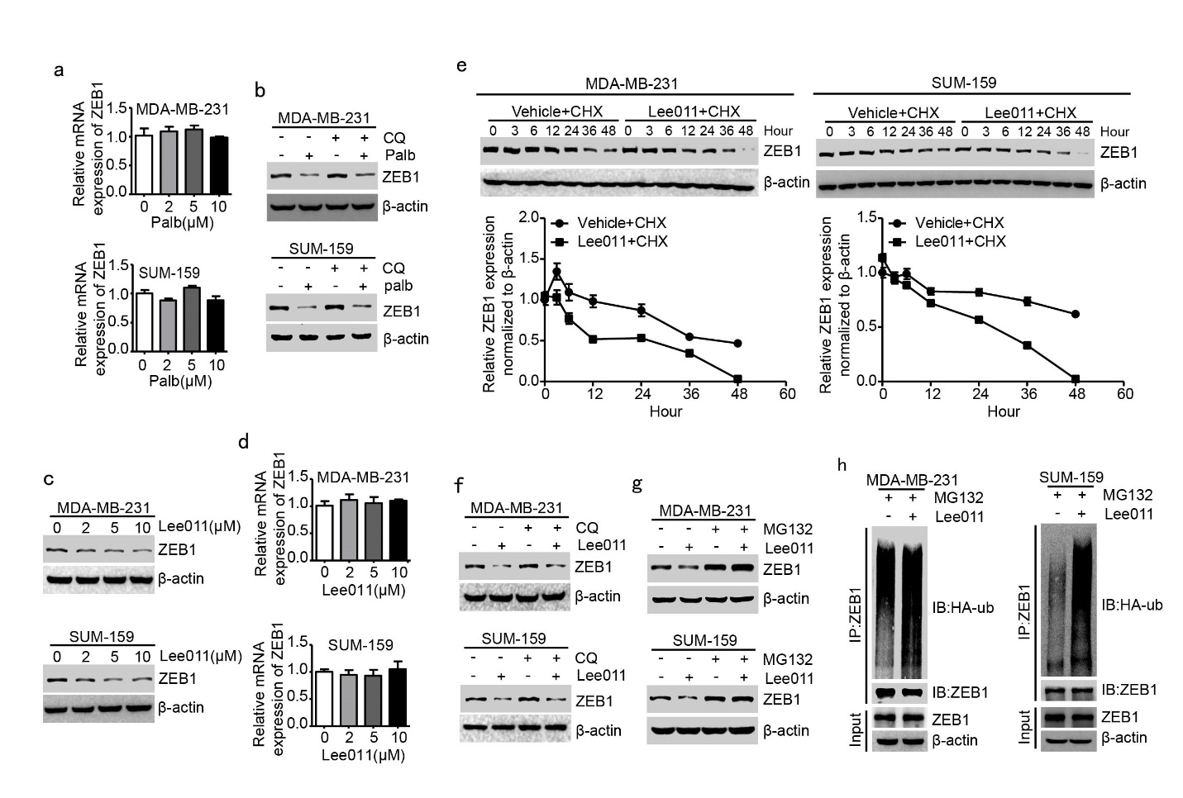
Figure. S2. CDK4/6 Inhibition induces ZEB1 protein degradation. a Q-PCR of ZEB1 expression in MDA-MB-231 and SUM-159 cells by treatment with the indicated concentrations of Palbociclib for 48 h. b Western blotting of ZEB1 protein expression in MDA-MB-231 and
SUM-159 cells by treatment with CQ in the presence or absence of Palbociclib. c, d Western blotting (c) and Q-PCR (d) analysis of ZEB1 expression in MDA-MB-231 and SUM-159 cells by treatment with the indicated concentrations of Lee011 for 48 h. e CHX pulse-chase analysis of ZEB1 protein stability in MDA-MB-231 and SUM-159 cells by treatment with Lee011 at the indicated time points. The results were normalized to the levels of β-actin. f, g Western blotting of ZEB1 protein expression in MDA-MB-231 and SUM-159 cells by treatment with CQ (f) and MG132 (g) in the presence or absence of Lee011. h Co-immunoprecipitation analysis of ZEB1 protein ubiquitination in MDA-MB-231 and SUM-159 cells by treatment with Lee011 for 48 h. The cells were treated with MG132 for 12 h prior to harvest.

Figure. S3.
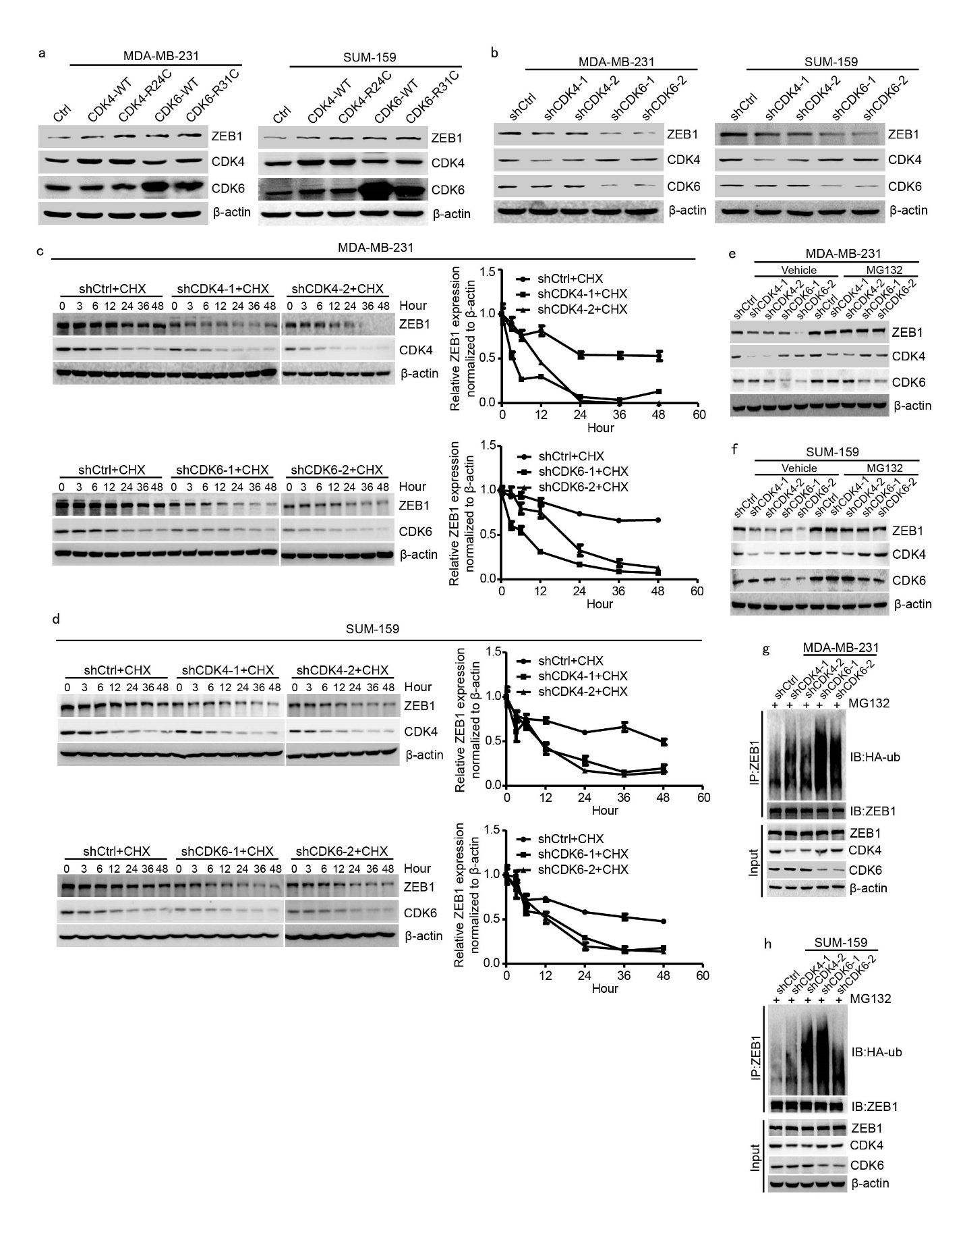Figure. S3. CDK4/6 Inhibition induces ZEB1 protein degradation. a Western blotting of ZEB1 protein expression in MDA-MB-231 and SUM-159 cells that were overexpressed with wild-type or hyperactive mutant forms (CDK4-R24C and CDK4-R31C) of CDK4/6. b Western blotting of ZEB1 protein expression in CDK4/6-interfered MDA-MB-231 and SUM-159 cells. c, d CHX pulse-chase analysis of ZEB1 protein stability in CDK4/6-interfered MDA-MB-231 (c) and SUM-159 (d) cells at the indicated time points. The results were normalized to the levels of β-actin. e, f Western blotting of ZEB1 protein expression in CDK4/6-interfered MDA-MB-231 (e) and SUM-159 (f) cells by treatment with MG132. g, h Co-immunoprecipitation analysis of ZEB1 protein ubquitination in CDK4/6-interfered MDA-MB-231 (g) and SUM-159 (h) cells. The cells were treated with MG132 for 12 h prior to harvest.

Figure. S4.

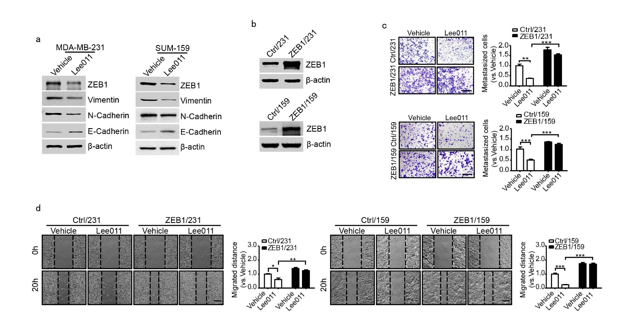
Figure. S4. CDK4/6 inhibition with Lee011 inhibits breast cancer cell migration via regulating ZEB1. a Western blotting of the EMT markers in MDA-MB-231 and SUM-159 cells by treatment with Lee011 for 48 h. b Western blotting of ZEB1 protein expression in MDA-MB-231 and SUM-159 cells that were overexpressed with ZEB1. c, d Transwell migration (c) and wound-healing (d) analysis in ZEB1-expressing MDA-MB-231 and SUM-159 cells by treatment with Lee011. Scale bars, 100 μm. *P < 0.05, **P < 0.01, ***P < 0.001 vs. respective control by unpaired Student’s t-test.

Figure. S5.
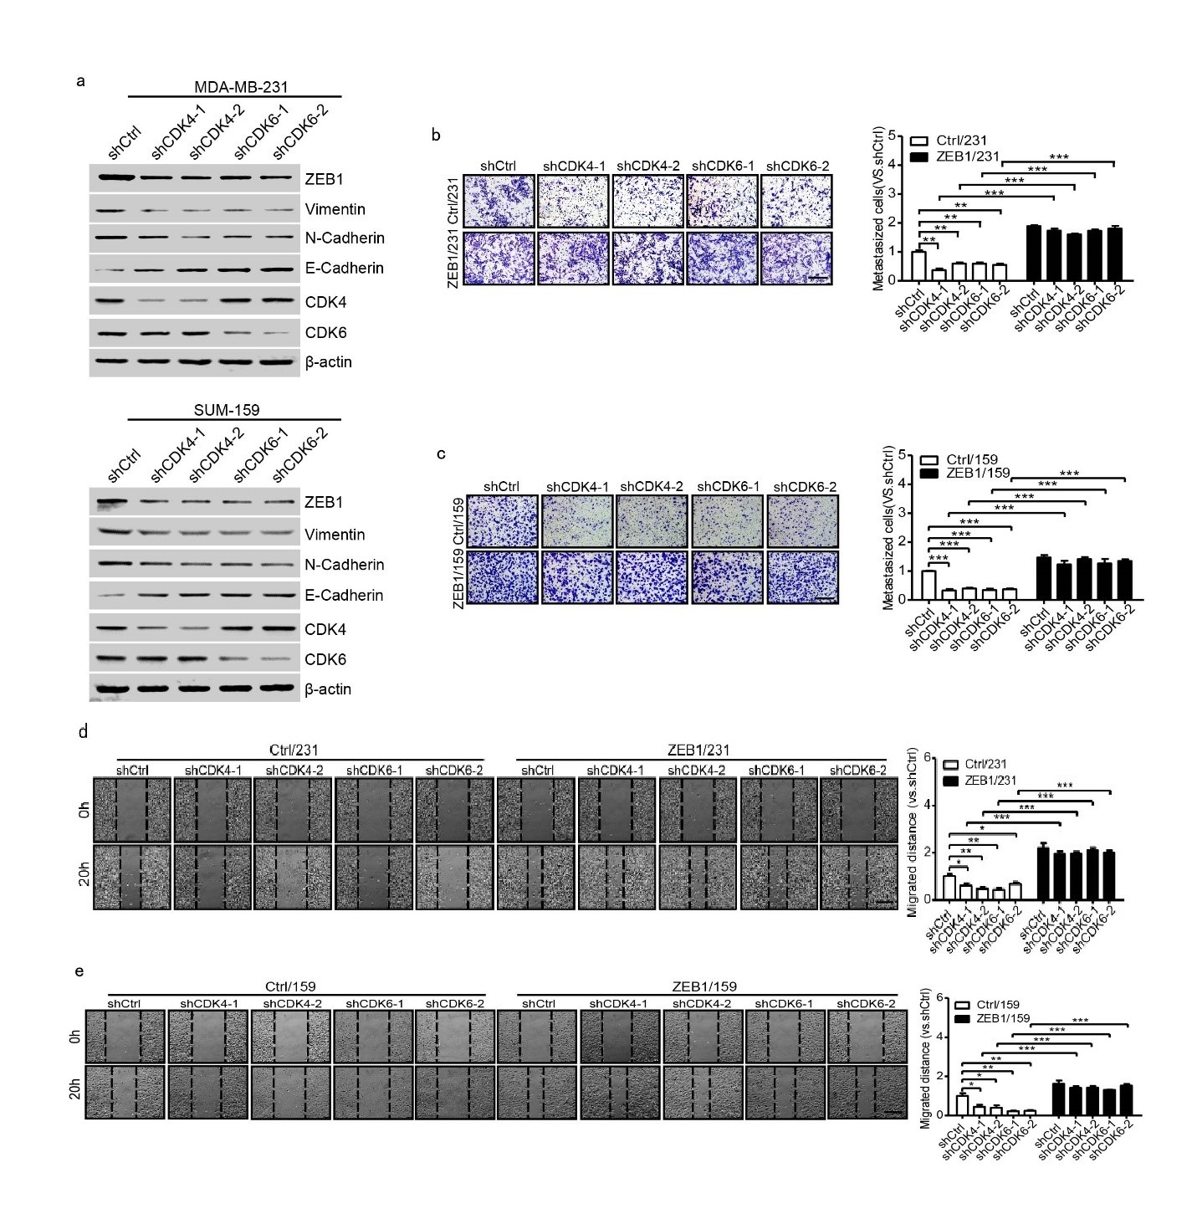`

Figure. S5. CDK4/6 knockdown inhibits breast cancer cell migration via regulating ZEB1. a Western blotting of the EMT markers in CDK4/6-interfered MDA-MB-231 and SUM-159 cells. b, c Transwell migration analysis in CDK4/6-interfered MDA-MB-231 (b) and SUM-159 (c) cells in the presence or absence of rescued ZEB1 expression. Scale bars, 100 μm. **P < 0.01, ***P < 0.001 vs respective control by unpaired Student’s t-test. d, e Wound healing analysis in CDK4/6-interfered MDA-MB-231 (d) and SUM-159 (e) cells in the presence or absence of rescued ZEB1 expression. Scale bars, 100 μm. *P < 0.05, **P < 0.01, ***P < 0.001 vs. respective control by unpaired Student’s t-test.

Figure. S6.
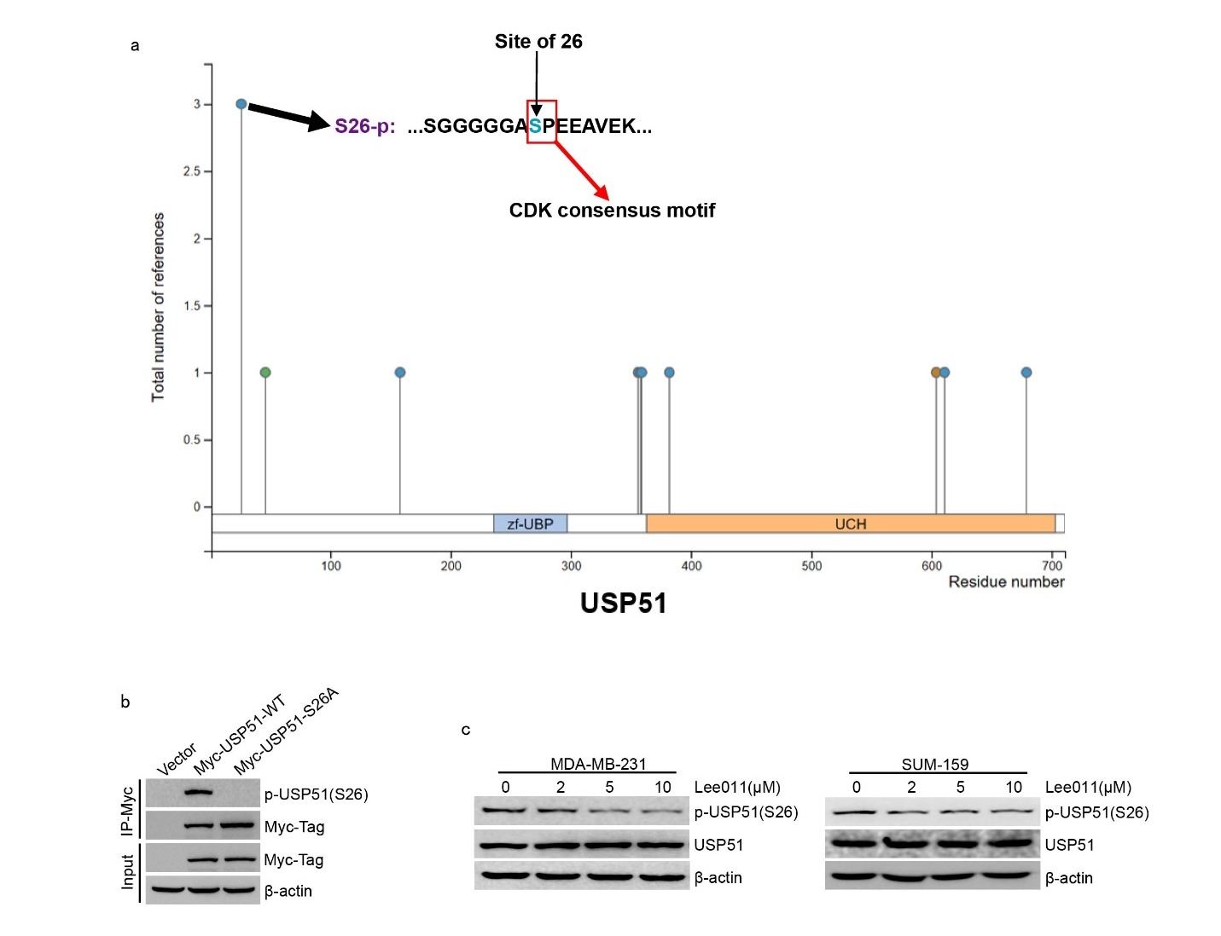
Figure. S6. CDK4/6 phosphorylates USP51 at Ser26. a The phosphorylation site of USP51 identified by PhosphoSitePlus® database. S26-p means that Ser26 is a major phosphorylation site on USP51. b Myc-USP51-WT or Myc-USP51-S26A was transfected in 293T cells. Cell lysates were subjected to co-immunoprecipitation with anti-Myc antibody and the phosphorylation of Ser26 on USP51 was examined. c Western blotting of S26-USP51 phosphorylation in MDA-MB-231 and SUM-159 cells by treatment with the indicated concentrations of Lee011 for 48 h.

Figure. S7.

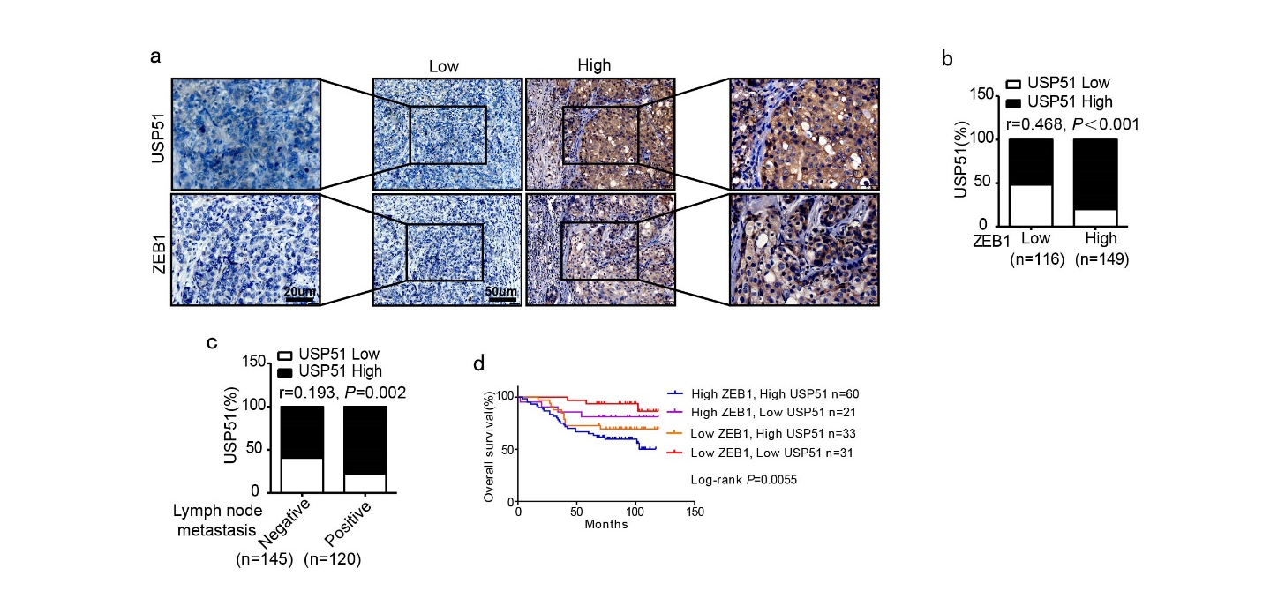
Figure. S7. The expression of USP51 and ZEB1 is positively correlated in human breast cancer. a Representative images of the immunohistochemical staining of USP51 and ZEB1 in serial sections of the same tumor from two cases. Scale bars, 20 μm and 50 μm. b A positive correlation between the expression of USP51 and ZEB1 in the 265 human breast cancer samples.
r = 0.468, P < 0.001 by Spearman’s rank correction test. c Increased expression of UPS51 in metastatic breast cancer. r = 0.193, P = 0.002 by chi-square test. d Kaplan–Meier curves showing shorter overall survival of patients with concomitantly high expression of UPS51 and ZEB1 in their breast tumors. P = 0.0055 by log-rank test.

Table S1. Natural compounds library.
No. | Name | ZEB1/β-actin expression  normalized to Vehicle（$\overline{X}$±S）
1 | Aescine A | 0.81 ± 0.079
2 | Aescine B | 0.77 ± 0.080
3 | Aescine C | 1.04 ± 0.040
4 | Aescine D | 1.04 ± 0.039
5 | Amentoflavone | 0.93 ± 0.079
6 | Atractylenolide I | 1.00 ± 0.081
7 | Biochanin A | 0.44 ± 0.095
8 | Borneol | 1.10 ± 0.021
9 | Casticin | 1.09 ± 0.097
10 | Catharanthine | 1.02 ± 0.134
11 | Chlorogenic acid | 1.10 ± 0.096
12 | Corilagin | 1.14 ± 0.073
13 | Corosolic acid | 1.07 ± 0.043
14 | Curcumol | 1.11 ± 0.063
15 | Epimedin A | 1.16 ± 0.085
16 | Epimedin B | 1.18 ± 0.059
17 | Epimedin C | 1.09 ± 0.074
18 | Geniposide | 1.04 ± 0.023
19 | Ginsenoside Ro | 1.00 ± 0.204
20 | Isomangiferin | 1.00 ± 0.022
21 | Jujuboside B | 0.97 ± 0.041
22 | Lathyrol | 1.11 ± 0.058
23 | Limonin | 1.03 ± 0.098
24 | Mangostin | 0.97 ± 0.142
25 | Mogroside IV | 1.05 ± 0.136
26 | Mogroside VI | 0.99 ± 0.188
27 | Phellodendrine chloride | 0.98 ± 0.168
28 | Praeruptorin C | 1.07 ± 0.073
29 | Pseudolaric acid A-O-β-D-glucopyranoside | 1.03 ± 0.19
30 | Quercetin-3-rhamnoside | 1.01 ± 0.007
31 | Rosin | 1.00 ± 0.085
32 | Saikosaponin A | 1.03 ± 0.066
33 | Scutellarin | 1.14 ± 0.065
34 | Secoisolariciresinol diglucoside | 1.17 ± 0.059
35 | Sennoside A | 1.10 ± 0.067
36 | Sennoside C | 1.06 ± 0.102
37 | Siamenoside I | 1.01 ± 0.070
38 | Tectoridin | 1.06 ± 0.106
39 | Tiliroside | 1.06 ± 0.129
40 | Yohimbine hydrochloride | 1.02 ± 0.021
41 | 2-Hydroxyadenosine | 1.01 ± 0.138
42 | 20(S)-Ginsenoside Rh2 | 1.05 ± 0.024

Table S2. Primer used in this study.
Construction of ZEB1 expression vector
ZEB1 forward | 5’-ATGGCGGATGGCCCCAGG‑3’
ZEB1 reverse | 5’- TTAGGCTTCATTTGTCTTTTC‑3’
ZEB1-NZF forward | 5’-ATGGCGGATGGCCCCAGG‑3’
ZEB1-NZF reverse | 5’-CTAGTTAACAGAAAGTTGTTC‑3’
ZEB1-HD forward | 5’-ATGAACCAAATTAAAACTGAA‑3’
ZEB1-HD reverse | 5’-CTATGCACCCTCAGCTGTGTA‑3’
ZEB1-CZF forward | 5’-ATGGCACAAGAAGAGCCACAA‑3’
ZEB1-CZF reverse | 5’- TTAGGCTTCATTTGTCTTTTC‑3’
Construction of CDK4 expression vector
CDK4 forward | 5’-ATGGCTACCTCTCGATATGAG‑3’
CDK4 reverse | 5’-TCACTCCGGATTACCTTCATC‑3’
Construction of CDK6 expression vector
CDK6 forward | 5’-ATGGAGAAGGACGGCCTG‑3’
CDK6 reverse | 5’-TCAGGCTGTATTCAGCTCCGA‑3’
Construction of shRNA vector
shCDK4-1 | 5’-GAGATTACTTTGCTGCCTTAA‑3’
shCDK4-2 | 5’-GCAGAGATGTTTCGTCGAAAG‑3’
shCDK6-1 | 5’-CAGATGTTGATCAACTAGGAA‑3
shCDK6-2 | 5’-GGATATGATGTTTCAGCTTCT‑3’
shUSP51-1 | 5’-GCATCTGATATGGATCCATGC‑3’
shUSP51-2 | 5’-GCTACCAGGAGTCTACTAAAC‑3’
Quantitative RT-PCR
human ZEB1 forward | 5’-CAGCTTGATACCTGTGAATGGG-3’
human ZEB1 reverse | 5’-TATCTGTGGTCGTGTGGGACT-3’
human GAPDH forward | 5’-GGAGCGAGATCCCTCCAAAAT-3’
human GAPDH reverse | 5’-GGCTGTTGTCATACTTCTCATGG-3’

Table S3. Antibodies.
Antibodies | Species | Application | Manufacturer | Catalog No. | Dilution
anti-ZEB1 | Rabbit | IHC | Abcam | ab87280 | 1:100
anti-ZEB1 | Rabbit | IB | Santa Cruz | sc-25388 | 1:1000
anti-ZEB1 | Rabbit | IP | Proteintech | 21544-1-AP | 4μg/ml
anti-Flag-Tag | Mouse | IP | Sigma-Aldrich | F1804 | 3μg/ml
anti-Flag-Tag | Rabbit | IB | CST | 2368S | 1:1000
anti-β-actin | Mouse | IB | Santa Cruz | sc-47778 | 1:1000
anti-HA-Tag | Rabbit | IB | CST | 3724S | 1:1000
anti-CDK4 | Rabbit | IB | Proteintech | 11026-1-AP | 1:1000
anti-CDK6 | Rabbit | IB | Proteintech | 14052-1-AP | 1:1000
anti-Vimentin | Rabbit | IB | CST | 5741S | 1:1000
anti-N-Cadherin | Mouse | IB | BD Biosciences | 610920 | 1:1000
anti-E-Cadherin | Mouse | IB | CST | 14472S | 1:1000
anti-USP51 | Rabbit | IB | Sigma-Aldrich | SAB1305451 | 1:1000
anti-USP51 | Rabbit | IP | Sigma-Aldrich | SAB1305451 | 5μg/ml
anti-USP51 | Rabbit | IHC | Sigma-Aldrich | SAB1305451 | 1:200
anti-Myc-Tag | Mouse | IP | CST | 2276S | 3μg/ml
anti-Myc-Tag | Rabbit | IB | CST | 2278S | 1:1000
anti- p-serine | Rabbit | IB | Abcam | ab9332 | 1:1000
anti-p-USP51(S26) | Rabbit | IB | Abclonal | Custom order | 1:1000
anti-p-USP51(S26) | Rabbit | IHC | Abclonal | Custom order | 1:200
anti-p-RB | Rabbit | IHC | CST | 8516S | 1:200
anti-p-RB | Rabbit | IB | CST | 8516S | 1:1000
IHC: Immunohistochemistry; IB: Immunoblotting; IP: Immunoprecipitation.

Table S4. p-RB expression and clinicopathologic features of breast tumors.
Clinicopathologic features | Number (n=265) | p-RB expression |  | P value
Clinicopathologic features | Number (n=265) | High | Low | P value
Age (years) |  |  |  | P = 0.889
≤40 | 30 | 13 | 17
＞40 | 235 | 105 | 130
Tumor size (cm) |  |  |  | P = 0.034
≤2.0 | 52 | 15 | 37
＞2.0, ≤5.0 | 167 | 79 | 88
＞5.0 | 46 | 24 | 22
Lymph node metastasis |  |  |  | P = 0.009
Positive | 120 | 64 | 56
Negative | 145 | 54 | 91

Table S5. p-USP51 expression and clinicopathologic features of breast tumors.
Clinicopathologic features | Number (n=265) | p-USP51 expression |  | P value
Clinicopathologic features | Number (n=265) | High | Low | P value
Age (years) |  |  |  | P = 0.948
≤40 | 30 | 22 | 8
＞40 | 235 | 171 | 64
Tumor size (cm) |  |  |  | P = 0.278
≤2.0 | 52 | 36 | 16
＞2.0, ≤5.0 | 167 | 127 | 40
＞5.0 | 46 | 30 | 16
Lymph node metastasis |  |  |  | P ＜ 0.001
Positive | 120 | 102 | 18
Negative | 145 | 91 | 54

Table S6. ZEB1 expression and clinicopathologic features of breast tumors.
Clinicopathologic features | Number (n=265) | ZEB1 expression |  | P value
Clinicopathologic features | Number (n=265) | High | Low | P value
Age (years) |  |  |  | P = 0.959
≤40 | 30 | 17 | 13
＞40 | 235 | 132 | 103
Tumor size (cm) |  |  |  | P = 0.210
≤2.0 | 52 | 24 | 28
＞2.0, ≤5.0 | 167 | 96 | 71
＞5.0 | 46 | 29 | 17
Lymph node metastasis |  |  |  | P ＜ 0.001
Positive | 120 | 82 | 38
Negative | 145 | 67 | 78

Table S7. USP51 expression and clinicopathologic features of breast tumors.
Clinicopathologic features | Number (n=265) | USP51 expression |  | P value
Clinicopathologic features | Number (n=265) | High | Low | P value
Age (years) |  |  |  | P = 0.601
≤40 | 30 | 19 | 11
＞40 | 235 | 160 | 75
Tumor size (cm) |  |  |  | P = 0.126
≤2.0 | 52 | 30 | 22
＞2.0, ≤5.0 | 167 | 120 | 47
＞5.0 | 46 | 29 | 17
Lymph node metastasis |  |  |  | P = 0.002
Positive | 120 | 93 | 27
Negative | 145 | 86 | 59

