Supplementary Material for

Efficacy and safety of systematic corticosteroids among severe COVID-19 patients: A systematic review and meta-analysis of randomized controlled trials

Shaolei Ma, Changsheng Xu, Shijiang Liu, Xiaodi Sun, Renqi Li, Mingjie Mao, Shanwu Feng, Xian Wang

Correspondence to: iamfsw@163.com OR wangxian2002@126.com

This PDF file includes:

Figures. S1 to S6
Tables S1 to S2

Figure. S1 Risk of bias summary: review authors’ judgement about each risk of bias item for included trials.

Figure. S2 Risk of bias graph: review authors’ judgement about each risk of bias item presented as percentages across all included trials.

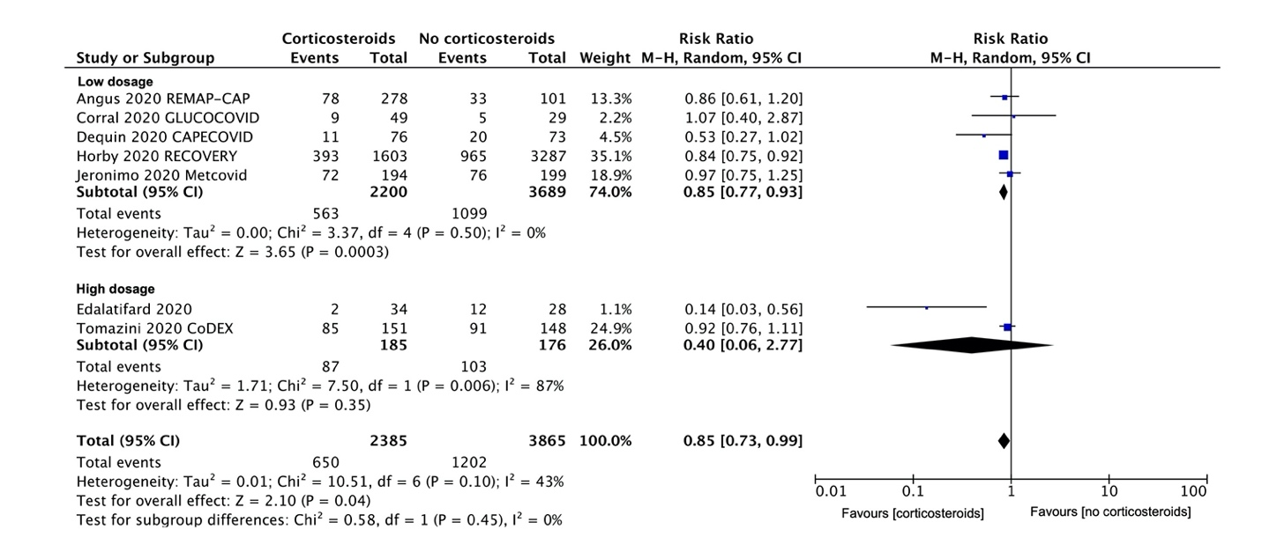

Figure. S3 Subgroup analysis for all-cause mortality based on corticosteroids dosage.

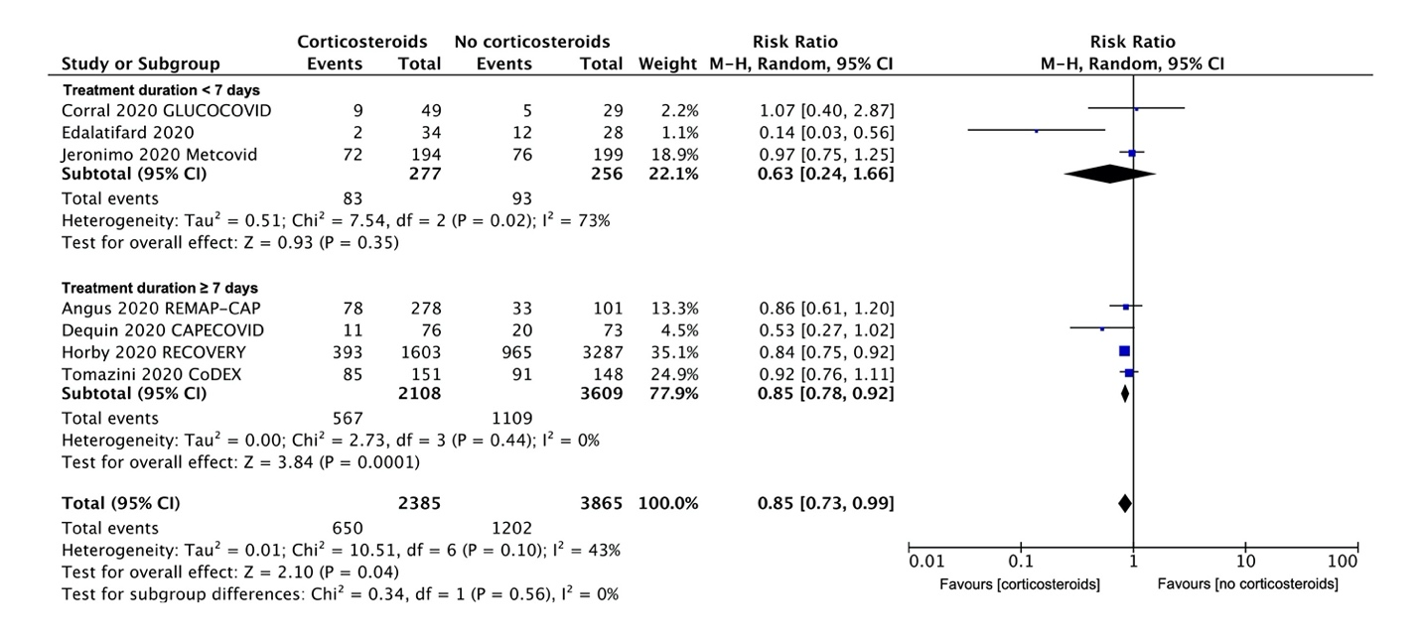

Figure. S4 Subgroup analysis for all-cause mortality based on corticosteroids treatment duration.

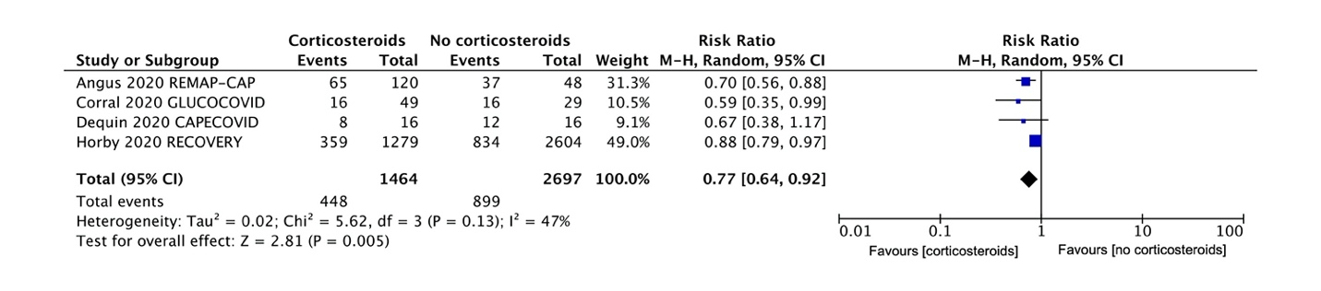

Figure. S5 Meta-analysis for a composite disease progression among patients receiving respiratory support but not ventilation at randomization.

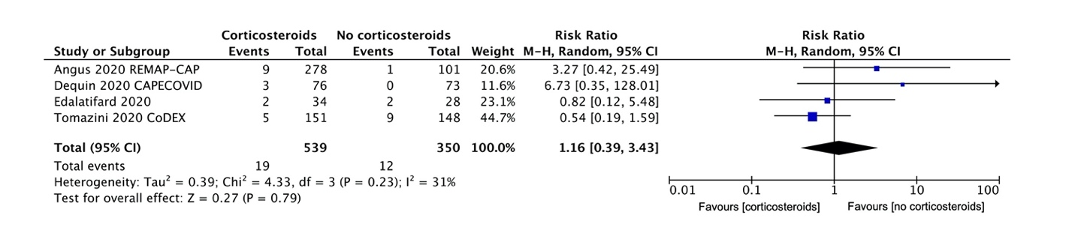

Figure. S6 Meta-analysis for serious adverse events.

Table S1
PUBMED
1 | (corticosteroid [MeSH Terms]) OR (((Hormones, Adrenal Cortex) OR (Corticosteroids)) OR (Corticoids))  "adrenal cortex hormones"[MeSH Terms] OR ("adrenal cortex hormones"[MeSH Terms] OR ("adrenal"[All Fields] AND "cortex"[All Fields] AND "hormones"[All Fields]) OR "adrenal cortex hormones"[All Fields] OR ("hormones"[All Fields] AND "adrenal"[All Fields] AND "cortex"[All Fields]) OR "hormones adrenal cortex"[All Fields] OR ("adrenal cortex hormones"[MeSH Terms] OR ("adrenal"[All Fields] AND "cortex"[All Fields] AND "hormones"[All Fields]) OR "adrenal cortex hormones"[All Fields] OR "corticosteroid"[All Fields] OR "corticosteroids"[All Fields] OR "corticosteroidal"[All Fields] OR "corticosteroide"[All Fields] OR "corticosteroides"[All Fields]) OR ("adrenal cortex hormones"[MeSH Terms] OR ("adrenal"[All Fields] AND "cortex"[All Fields] AND "hormones"[All Fields]) OR "adrenal cortex hormones"[All Fields] OR "corticoid"[All Fields] OR "corticoids"[All Fields] OR "corticoides"[All Fields])) | 352560
2 | (((((((((((COVID-19[MeSH Terms]) OR (2019 novel coronavirus disease)) OR (COVID19)) OR (COVID-19 pandemic)) OR (SARS-CoV-2 infection)) OR (COVID-19 virus disease)) OR (2019 novel coronavirus infection)) OR (2019-nCoV infection)) OR (coronavirus disease 2019)) OR (coronavirus disease-19)) OR (2019-nCoV disease)) OR (COVID-19 virus infection)  "covid 19"[Supplementary Concept] OR "covid 19"[All Fields] OR "2019 novel coronavirus disease"[All Fields] OR "covid 19"[Supplementary Concept] OR "covid 19"[All Fields] OR "covid19"[All Fields] OR "covid 19"[Supplementary Concept] OR "covid 19"[All Fields] OR "covid 19 pandemic"[All Fields] OR "covid 19"[Supplementary Concept] OR "covid 19"[All Fields] OR "sars cov 2 infection"[All Fields] OR "covid 19"[Supplementary Concept] OR "covid 19"[All Fields] OR "covid 19 virus disease"[All Fields] OR "covid 19"[Supplementary Concept] OR "covid 19"[All Fields] OR "2019 novel coronavirus infection"[All Fields] OR "covid 19"[Supplementary Concept] OR "covid 19"[All Fields] OR "2019 ncov infection"[All Fields] OR "covid 19"[Supplementary Concept] OR "covid 19"[All Fields] OR "coronavirus disease 2019"[All Fields] OR "covid 19"[Supplementary Concept] OR "covid 19"[All Fields] OR "coronavirus disease 19"[All Fields] OR "covid 19"[Supplementary Concept] OR "covid 19"[All Fields] OR "2019 ncov disease"[All Fields] OR "covid 19"[Supplementary Concept] OR "covid 19"[All Fields] OR "covid 19 virus infection"[All Fields] | 58214
3 | (((((((randomized controlled trial[Publication Type]) OR (controlled clinical trial[Publication Type])) OR (randomized[Title/Abstract])) OR (randomly[Title/Abstract])) OR (trial[Title/Abstract])) OR (placebo[Title/Abstract])) OR (groups[Title/Abstract])) OR (drug therapy[Title/Abstract])  "randomized controlled trial"[Publication Type] OR "controlled clinical trial"[Publication Type] OR "randomized"[Title/Abstract] OR "randomly"[Title/Abstract] OR "trial"[Title/Abstract] OR "placebo"[Title/Abstract] OR "groups"[Title/Abstract] OR "drug therapy"[Title/Abstract] | 3149576
4 | 1# AND 2# AND 3# | 94
Embase
1 | 'corticosteroid'/exp | 1002142
2 | '11 hydroxycorticosteroid':ab,ti | 118
3 | '17 hydroxycorticosteroid':ab,ti | 352
4 | 'benzodrocortisone':ab,ti | 0
5 | 'corticosteroid':ab,ti | 70740
6 | 'corticosteroid derivative':ab,ti | 13
7 | 'glucocorticoid':ab,ti | 63581
8 | 'hydroxycorticosteroid':ab,ti | 488
9 | 'mineralocorticoid':ab,ti | 12077
10 | #1 OR #2 OR #3 OR #4 OR #5 OR #6 OR #7 OR #8 OR #9 | 1028923
11 | 'coronavirus disease 2019'/exp | 49174
12 | '2019 novel coronavirus disease':ab,ti | 184
13 | 'covid19':ab,ti | 45641
14 | 'covid-19 pandemic':ab,ti | 13052
15 | 'sars-cov-2 infection':ab,ti | 3331
16 | 'covid-19 virus disease':ab,ti | 0
17 | '2019 novel coronavirus infection':ab,ti | 50
18 | '2019-ncov infection':ab,ti | 129
19 | 'coronavirus disease 2019':ab,ti | 9283
20 | 'coronavirus disease-19':ab,ti | 532
21 | '2019-ncov disease':ab,ti | 9
22 | 'covid-19 virus infection':ab,ti | 13
23 | #11 OR #12 OR #13 OR #14 OR #15 OR #16 OR #17 OR #18 OR #19 OR #20 OR #21 OR #22 | 55673
24 | #10 AND #23 | 2133
25 | #24 AND 'randomized controlled trial'/de | 34
Cochrane Central Register of Controlled Trials
1 | MeSH descriptor: [Adrenal Cortex Hormones] explode all trees | 14361
2 | Hormones, Adrenal Cortex | 2498
3 | Corticosteroids | 13844
4 | Corticoids | 213
5 | #1 OR #2 OR #3 OR #4 | 25957
6 | (2019 novel coronavirus disease):ti,ab,kw | 88
7 | COVID19 | 117
8 | COVID-19 pandemic | 377
9 | SARS-CoV-2 infection | 72
10 | COVID-19 virus disease | 299
11 | 2019 novel coronavirus infection | 81
12 | coronavirus disease 2019 | 445
13 | coronavirus disease-19 | 23
14 | COVID-19 virus infection | 272
15 | #6 OR #7 OR #8 OR #9 OR #10 OR #11 OR #12 OR #13 OR #14 | 883
16 | #5 AND #15 | 36
Search strategy.

Table S2
Study | Bias | Support for judgement
Angus, 2020,  REMAP-CAP | Blinding of participants and personnel | Open-label design
Angus, 2020,  REMAP-CAP | Other bias | Early stop, protocol deviation (15% in the control group received corticosteroids for a short period)
Corral, 2020, GLUCOCOVID | Randomized sequence generation | Partially randomized
Corral, 2020, GLUCOCOVID | Blinding of participants and personnel | Open-label design
Dequin, 2020, CAPECOVID | Other bias | Early stop
Edalatifard, 2020 | Blinding of participants and personnel | Single blind design
Horby, 2020, RECOVERY | Blinding of participants and personnel | Open-label design
Tomazini, 2020, CoDEX | Blinding of participants and personnel | Open-label design
Tomazini, 2020, CoDEX | Other bias | Early stop, protocol deviation (35% in the control group received corticosteroids)
Support for judgement for included trials rated as high risk of bias.

