Supplementary Materials for

RNA-induced Liquid Phase Separation of SARS-CoV-2 Nucleocapsid Protein Facilitates NF-κB Hyper-activation and Inflammation

Yaoxing Wu, Ling Ma, Sihui Cai, Zhen Zhuang, Zhiyao Zhao, Shouheng Jin, Weihong Xie, Lingli Zhou, Lei Zhang, Jincun Zhao and Jun Cui

Correspondence to: Jun Cui (cuij5@mail.sysu.edu.cn) or Jincun Zhao (zhaojincun@gird.cn).

This PDF file includes:
Figures. S1 to S6

Figure. S1.
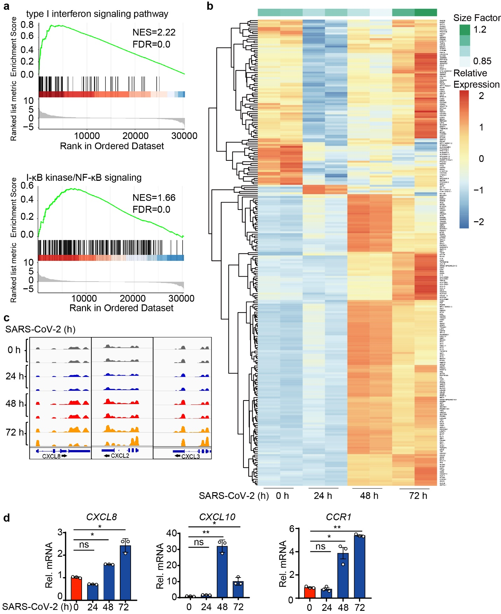
Figure. S1. SARS-CoV-2 infection induces the activation of host NF-κB signaling and inflammatory responses. a GSEA analysis of genes expressed differentially in SARS-CoV-2-infected Calu3 cells at 48 hours post infection. FDR (q-value) was shown. b Top 100 principal upregulated DEGs (p-value < 0.05; log2(FC)＞1) in SARS-CoV-2-infected Calu3 cells at indicated time points post infection. c IGV browser tracks showing the RNA-seq signals of inflammatory response genes in Calu3 cells at indicated time points post infection. d Quantitative PCR with reverse transcription analysis of NF-κB relative cytokines genes (CXCL8, CXCL10, CCR1) of Calu3 cells with SARS-CoV-2 infection at MOI=0.05 for indicated time points. Data in (d) are expressed as mean ± SEM of at least three independent experiments. *p < 0.05, **p < 0.01, ns, not significant (two-tailed Student’s t-test).

Figure. S2.
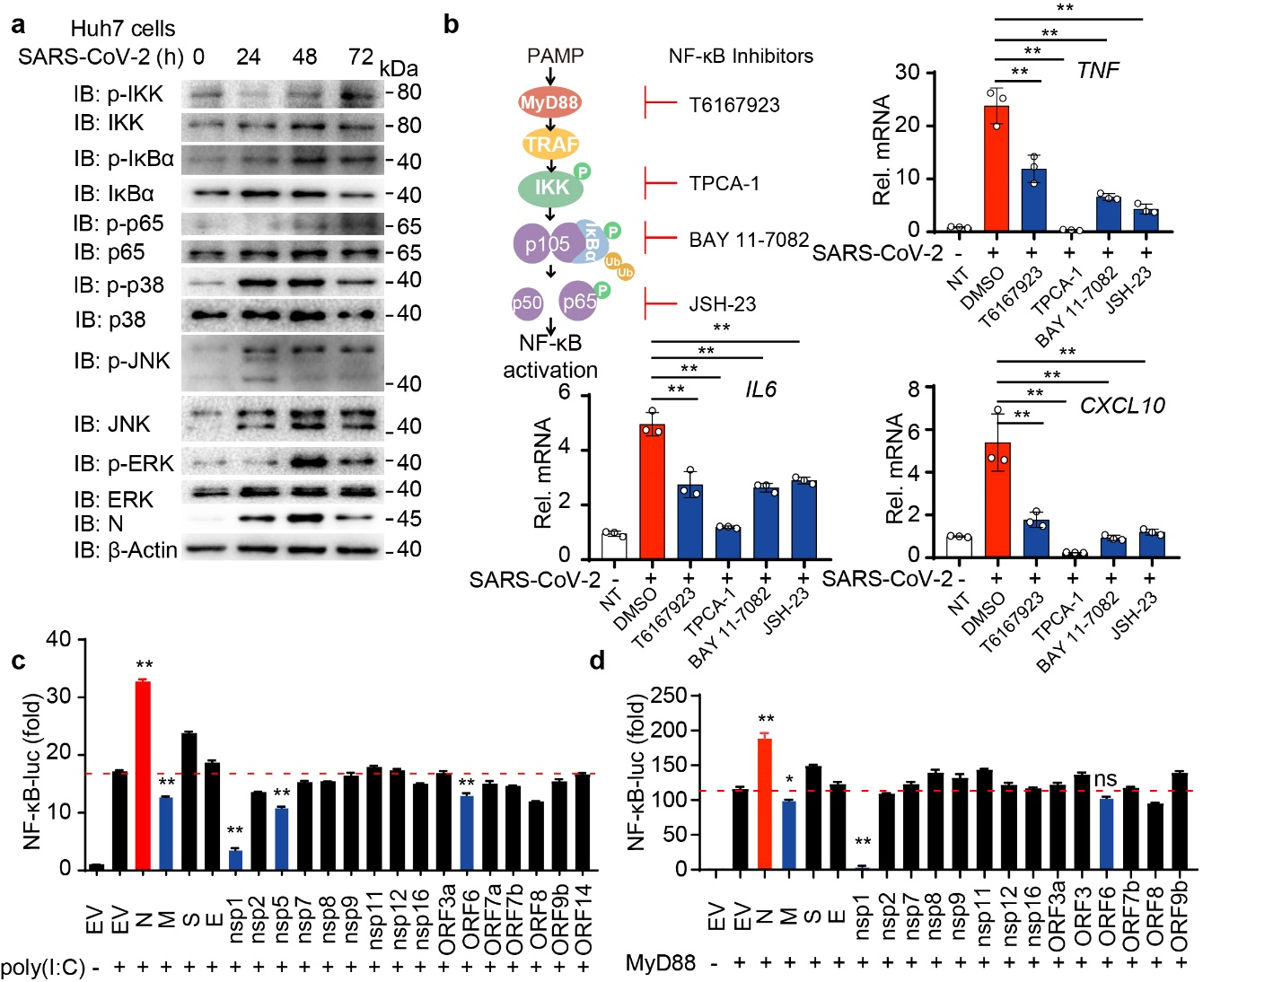
Figure. S2. SARS-CoV-2 enhances NF-κB signaling. a Lysates of Huh7 cells infected with SARS-CoV-2 at MOI=0.2 for indicated time points were collected and immunoblotted with indicated antibodies. b Schematic overview (left) of NF-κB signaling pathway and the target of its inhibitors. Quantitative PCR (right and below) with reverse transcription analysis of TNF, IL6 and CXCL10 mRNA in Calu3 cells with SARS-CoV-2 infection at MOI=0.05 for 24 hours with DMSO, T6167923 (20 μM), TPCA-1 (5 μM), BAY 11-7082 (20 μM) and JSH-23 (10 μM) treatment for 24 hours before harvested. c-d, HEK293T cells were transiently transfected with NF-κB luciferase reporter, TK-luc along with empty vector (EV) or proteins of SARS-CoV-2, followed by 1 μg/mL poly(I:C) (c) treatment for 12 hours or with MyD88 (d) overexpression for 24 hours. Lysates were collected 36 hours post-transfection and luciferase activities were tested. Data in (b-d) are expressed as mean ± SEM of at least three independent experiments. **p < 0.01, ns, not significant (two-tailed Student’s t-test). For a, similar results are obtained for three independent biological experiments.

Figure. S3.
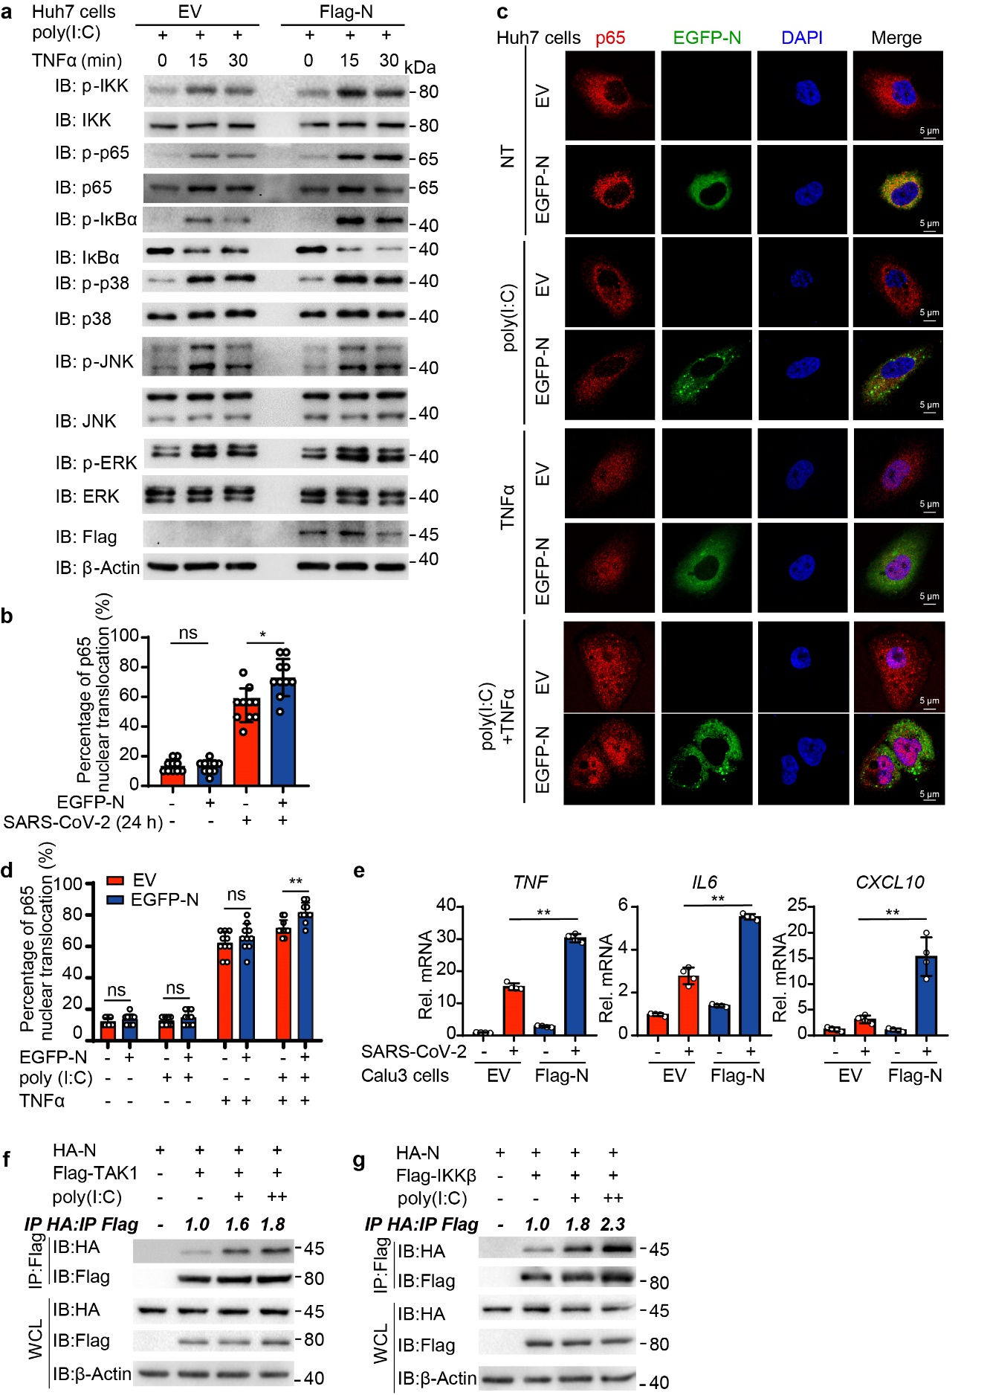
Figure. S3. N protein of SARS-CoV-2 promotes NF-κB signaling pathway through TAK1 and IKKβ. a Huh7 cells stably expressing EGFP-N protein or EV were treated with 1 μg/mL poly(I:C) for 6 hours and 50 ng/mL TNFα for indicated time points. Cell lysates were harvest for immunoblotting with indicated antibodies. b Quantitative analysis of the percentage of p65 nuclear translocation in cells of Fig. 1h (10 cells per sample). c EGFP-N protein or EV stably expressing-Huh7 cells were treated with 1 μg/mL poly(I:C) for 6 hours and 50 ng/mL TNFα for 2 hours or left non-treated (NT), followed by labeling p65 and DAPI. Confocal microscopy of p65 localization was performed. Scale bars, 5 μm. d Quantitative analysis of the percentage of p65 nuclear translocation in Huh7 cells of Supplementary Fig. S3c (10 cells per sample). e Quantitative PCR with reverse transcription analysis of TNF, IL6, CXCL10 in Calu3 cells stably expressing N protein with SARS-CoV-2 infection at MOI=0.05 for 24 hours. f-g HEK293T cells were transiently transfected with HA-N, Flag-TAK1 (f) or Flag-IKKβ (g) and treated with 1 μg/mL poly(I:C) for 6 hours. Cell lysates were collected for co-IP with anti-Flag beads and immunoblotted with indicated antibodies. The ratio of the gray value between IP-HA and IP-Flag were determined. Data in (e) are expressed as mean ± SEM of at least three independent experiments. Data in (b) and (d) are expressed as mean ± SD. **p < 0.01, ns, not significant (two-tailed Student’s t-test). For (a) (c) and (f-g) similar results are obtained for three independent biological experiments.

Figure. S4.
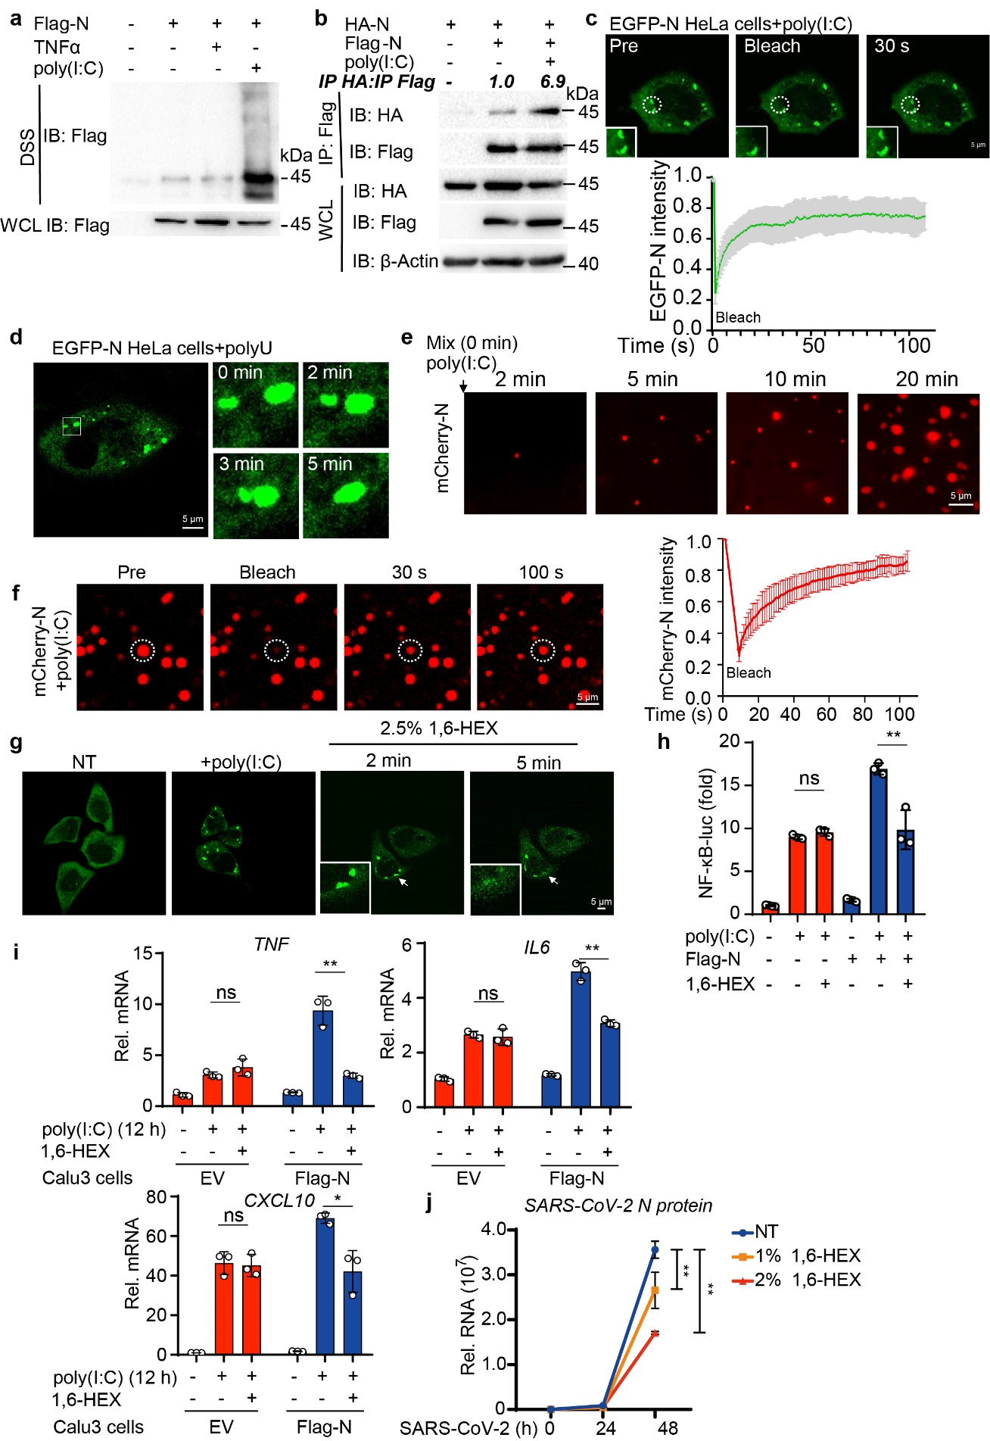
Figure. S4. SARS-CoV-2 N protein undergoes LLPS to promote NF-κB signaling. a HEK293T cells were transfected with Flag- EV and Flag- SARS-CoV-2 N plasmid, treated with 50 ng/mL TNFα for 30 min or 1 μg/mL poly(I:C) for 6 hours. Cell lysates were collected and treated with DSS for immunoblotting with indicated antibodies. b HEK293T cells were transfected with HA-N, Flag-EV and Flag-N, followed by 1 μg/mL poly(I:C) treatment for 6 hours. Cell lysates were collected for co-IP with anti-Flag beads and immunoblotting with indicated antibodies. The ratio of the gray value between IP-HA and IP-Flag were determined. c Representative images (left) of FRAP assay of N protein-poly(I:C) droplets in HeLa cells. HeLa cells stably expressing EGFP-N protein were treated with 1 μg/mL poly(I:C). Bleaching was performed at the indicated time points and the recovery occurred at 37 °C. Scale bars, 5 μm. Fluorescence intensity analysis (right) of fluorescence recovery after photobleaching over a 120-seconds time course. d Representative images of fusion of two EGFP-N protein-polyU puncta in HeLa cells stably expressing EGFP-N protein, along with 1 μg/mL polyU treatment for 6 hours. Scale bar, 5 μm. e Representative images of time-lapse imaging of N protein-poly(I:C) phase separation in vitro. Liquid droplets were formed after mixing of 10 μM mCherry-N protein and 10 ng/mL poly(I:C) and matured at 37 °C for 15 minutes. f Representative images (left) of FRAP assay of mCherry-N protein-poly(I:C) droplets in vitro. 10 μM mCherry-N protein mixed with 10 ng/mL poly(I:C) and incubated at 37 °C for 15 minutes. Bleaching was performed at the indicated time points and the recovery occurred at 37 °C. Scale bar, 5 μm. Fluorescence intensity analysis (right) of fluorescence recovery after photobleaching over a 120-seconds time course. g Representative images of time-lapse micrographs of HeLa cells stably expressing EGFP-N protein with 1 μg/mL poly(I:C) treatment for 6 hours, together with 20 μg/mL digitonin and 2.5% 1.6-hexanediol treatment for indicated time points. h HEK293T cells were transfected with NF-κB luciferase reporter, TK-luc and Flag-EV or Flag-N, followed by 1 μg/mL poly(I:C) treatment for 12 hours, along with 20 μg/mL digitonin and 2.5% 1.6-hexanediol treatment for 2 hours before harvested. Cell culture supernatants were collected at 36 hours post-transfection and luciferase activities were tested. i, Quantitative PCR with reverse transcription analysis of TNF, IL6, and CXCL10 in Calu3 cells stably expressing SARS-CoV-2 N protein with 1 μg/mL poly(I:C) treatment for 12 hours, along with 20 μg/mL digitonin and 2.5% 1.6-hexanediol treatment for 2 hours before harvested. j Quantitative PCR with reverse transcription analysis of SARS-CoV-2 N protein of Calu3 cells with SARS-CoV-2 infection at MOI=0.05 for indicated time points and followed by treatment of 20 μg/mL digitonin and different doses of 1,6-HEX for 2 hours. Data in (c) (f) (h) (i) and (j) are expressed as mean ± SEM of at least three independent experiments. *p < 0.05, **p < 0.01, ns, not significant (two-tailed Student’s t-test for c, f, h and i or two-way ANOVA for j). For (a-g), similar results are obtained for three independent biological experiments.

Figure. S5.
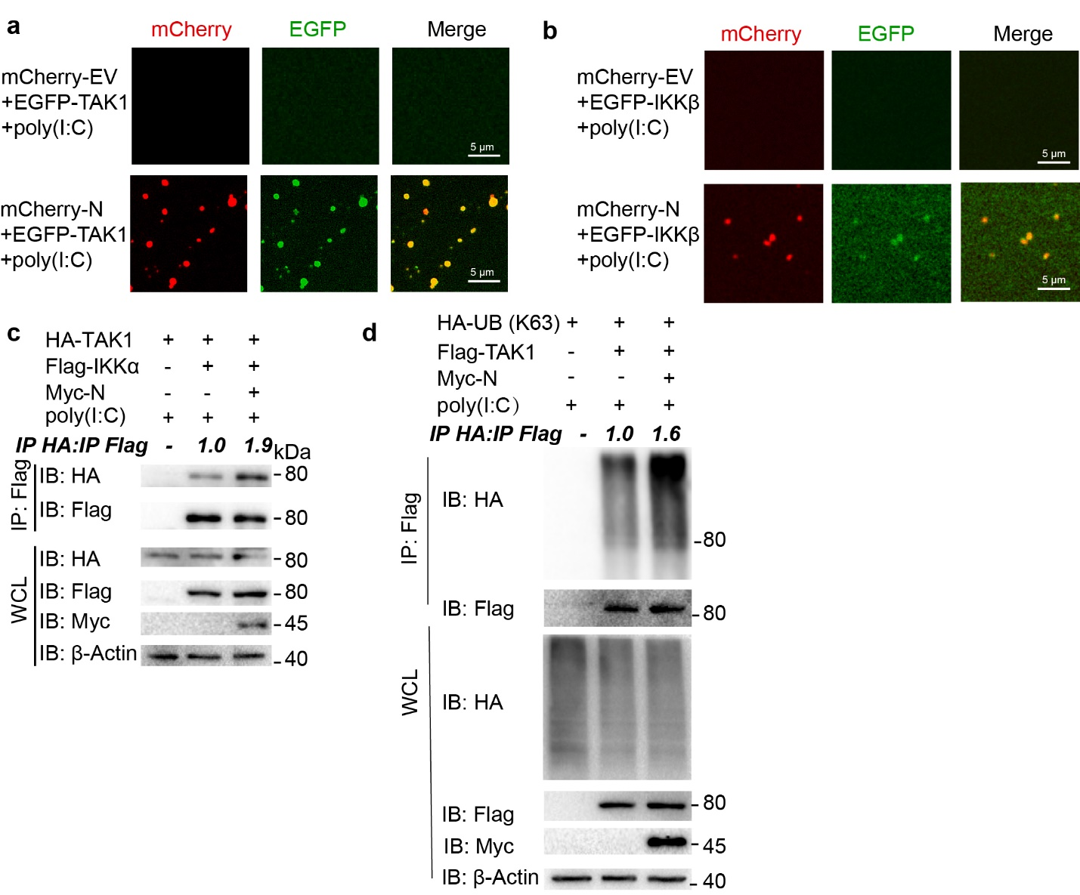
Figure. S5. LLPS of SARS-CoV-2 N protein recruits TAK1 and IKK complex. a-b Representative images showing TAK1 (a) or IKKβ (b) were distributed into N protein-poly(I:C) droplets. 10 µM of mCherry-N protein, 5 µM of EGFP-TAK1 or EGFP-IKKβ were mixed with 10 ng/ml of poly(I:C) and incubated at 37 °C for 15 minutes. Scale bars, 5 μm. c HEK293T cells were transfected with indicated plasmids combinations, followed by 1 μg/mL poly(I:C) treatment for 6 hours. Cell lysates were harvested for co-IP with anti-Flag beads and immunoblotting with indicated antibodies. d HEK293T cells were transfected with HA tagged ubiquitin HA-UB (K63), Myc-N and Flag-TAK1 for 1 μg/mL poly(I:C) treatment for 6 hours. Cell lysates were harvested for co-IP with anti-Flag beads and immunoblotting with indicated antibodies. For (a-d), similar results are obtained for three independent biological experiments.

Figure. S6.
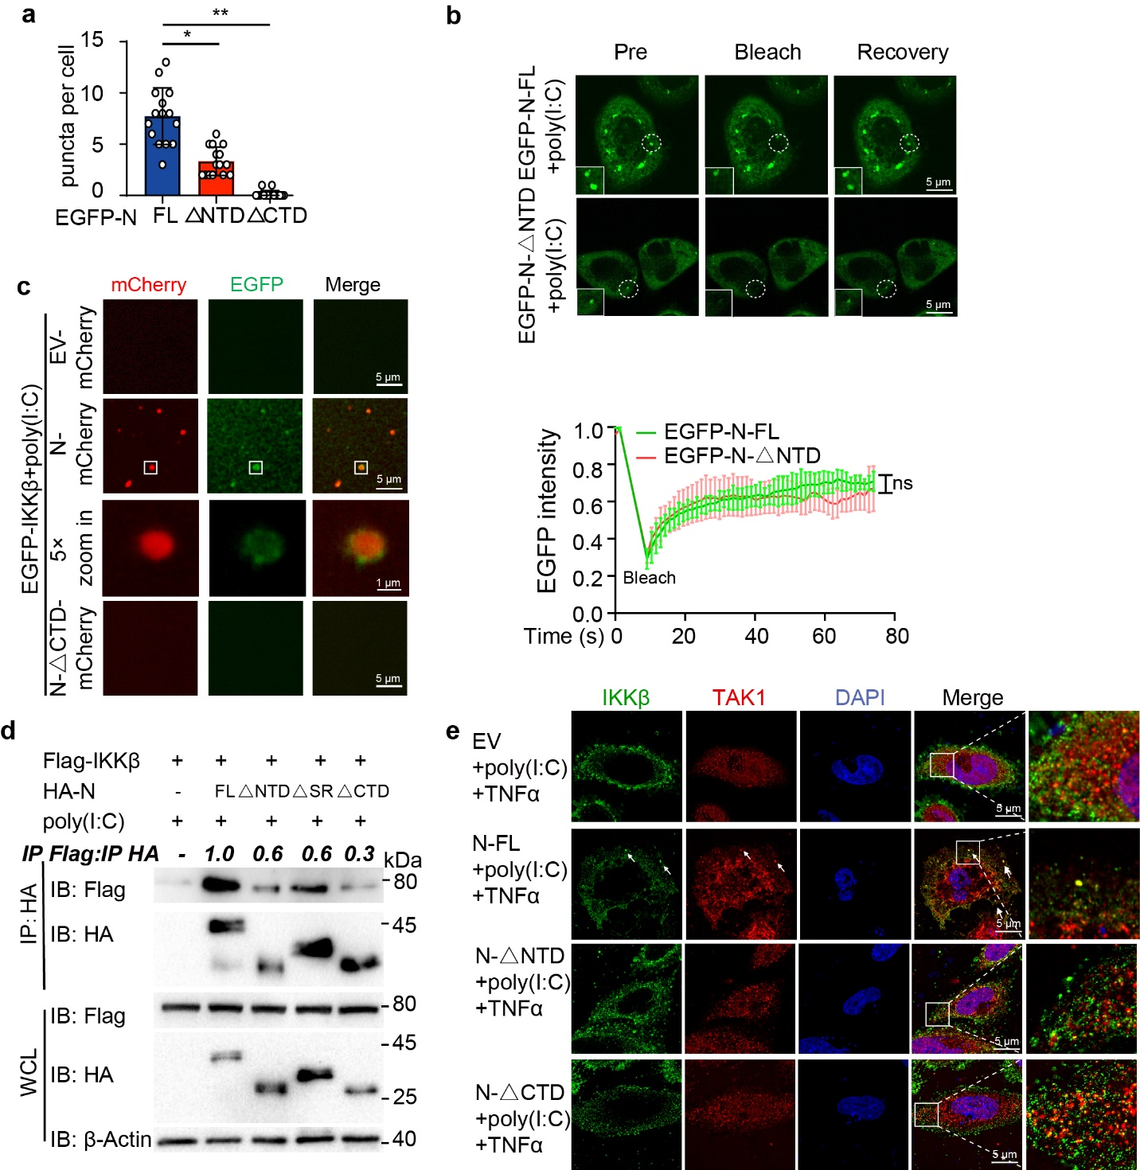
Figure. S6. CTD domain of SARS-CoV-2 N protein is critical for its LLPS and NF-κB regulatory capability. a The quantitative analysis of the number of droplets of Fig. 5c (15 cells each sample). b Representative images (up) of FRAP assay in HeLa cells stably expressing EGFP-N protein or EGFP-△NTD with 1 μg/mL poly(I:C) treatment. Bleaching was performed and the recovery occurred at 37 °C. Scale bars, 5 μm. Representative images (down) of FRAP assay of N protein-poly(I:C) droplets in HeLa cells. c Representative images showing IKKβ was distributed into N protein-poly(I:C) droplets. 10 μM of mCherry-N protein or mCherry-N protein-△CTD, 5 μM of EGFP-IKKβ were mixed with 10 ng/ml of poly(I:C) and incubated at 37 °C for 10 minutes. Confocal 5× zoom-in of the area highlighted above was re-photographed. Scale bars, 5 μm. d HEK293T cells transfected with Flag-IKKβ, HA-EV, HA-N FL, △NTD, △SR and △CTD, followed by 1 μg/mL poly(I:C) treatment for 6 hours, were harvested for co-IP with anti-HA beads and immunoblotting with indicated antibodies. The ratio of the gray value between IP-Flag and IP-HA were determined. e Confocal microscopy of colocalization between IKKβ and TAK1 in HeLa cells expressing N FL, △NTD and △CTD, followed by 1 μg/mL poly(I:C) treatment and 50 ng/mL TNFα treatment. Scale bars, 5 μm. Data in (a-b) are expressed as mean ± SD. *p < 0.05, **p < 0.01, ns, not significant (two-tailed Student’s t-test for a and two-way ANOVA for b). For (b-e), similar results are obtained for three independent biological experiments.

