Supplementary Materials for

Mesenchymal stem cell derived small extracellular vesicles mitigate oxidative stress-induced senescence in endothelial cells via regulation of miR-146a/Src

Xian Xiao¹, Meiqian Xu¹, Hongliang Yu¹, Liping Wang¹, Xiaoxia Li⁴, Janusz Rak³, Shihua Wang^{1*} and Robert Chunhua Zhao^{1,2*}
¹Institute of Basic Medical Sciences Chinese Academy of Medical Sciences，School of Basic Medicine Peking Union Medical College
² Department of Cell Biology, School of Life Sciences, Shanghai University, Shanghai 200444, China
³Research Institute of the McGill University Health Centre, Glen Site, McGill University, Montreal, Quebec H4A 3J1, Canada.
⁴Department of Genetics and Cell Biology, Basic medical college, Qingdao University, 308 Ningxia Road, Qingdao 266071, China. 266071

Correspondence to: wangshihua@ibms.pumc.edu.cn or zhaochunhua@ibms.pumc.edu.cn

This PDF file includes:
Figures. S1 to S4
Tables. S1 to S2

Figure. S1.

Figure S1. Characterization of HUVECs, MSCs and MSC-sEV internalization by HUVECs.
(a), Representative images of endothelial cells marker VWF and CD31 in isolated HUVECs were determined by fluorescence microscopy (scale bar,100 μm).
(b), Flow cytometry analysis found MSC markers CD29, CD44, CD73, CD90, CD105 are positive, and CD34, CD45, CD106, CD206, HLA-DR are negative.
(c), MSC adipogenic differentiation was demonstrated by Oil-red O staining (scale bar,100 μm). (d), MSC osteogenic differentiation was demonstrated by Alizarin Red staining (scale bar, 100 μm).
(e), Identification of MSC chondrogenic differentiation by Alcian Blue Staining.
(f), Representative image of MSCs colony (scale bar, 500 μm).
(g), Uptake of MSC-sEV by HUVEC pretreated with extracellular vesicle internalization inhibitors CPZ, nystatin, or EIPA was shown by confocal microscope (scale bar, 20 μm).
(h), Fluorescence intensity analysis of MSC-sEV uptaken by HUVEC pretreated with internalization inhibitors CPZ, nystatin, or EIPA, n = 3.
(i), Fluorescence intensity analysis of MSC-sEV uptake by HUVEC pretreated with or without H₂O₂ (50 μM, 2 H), n = 3.

Figure. S2.
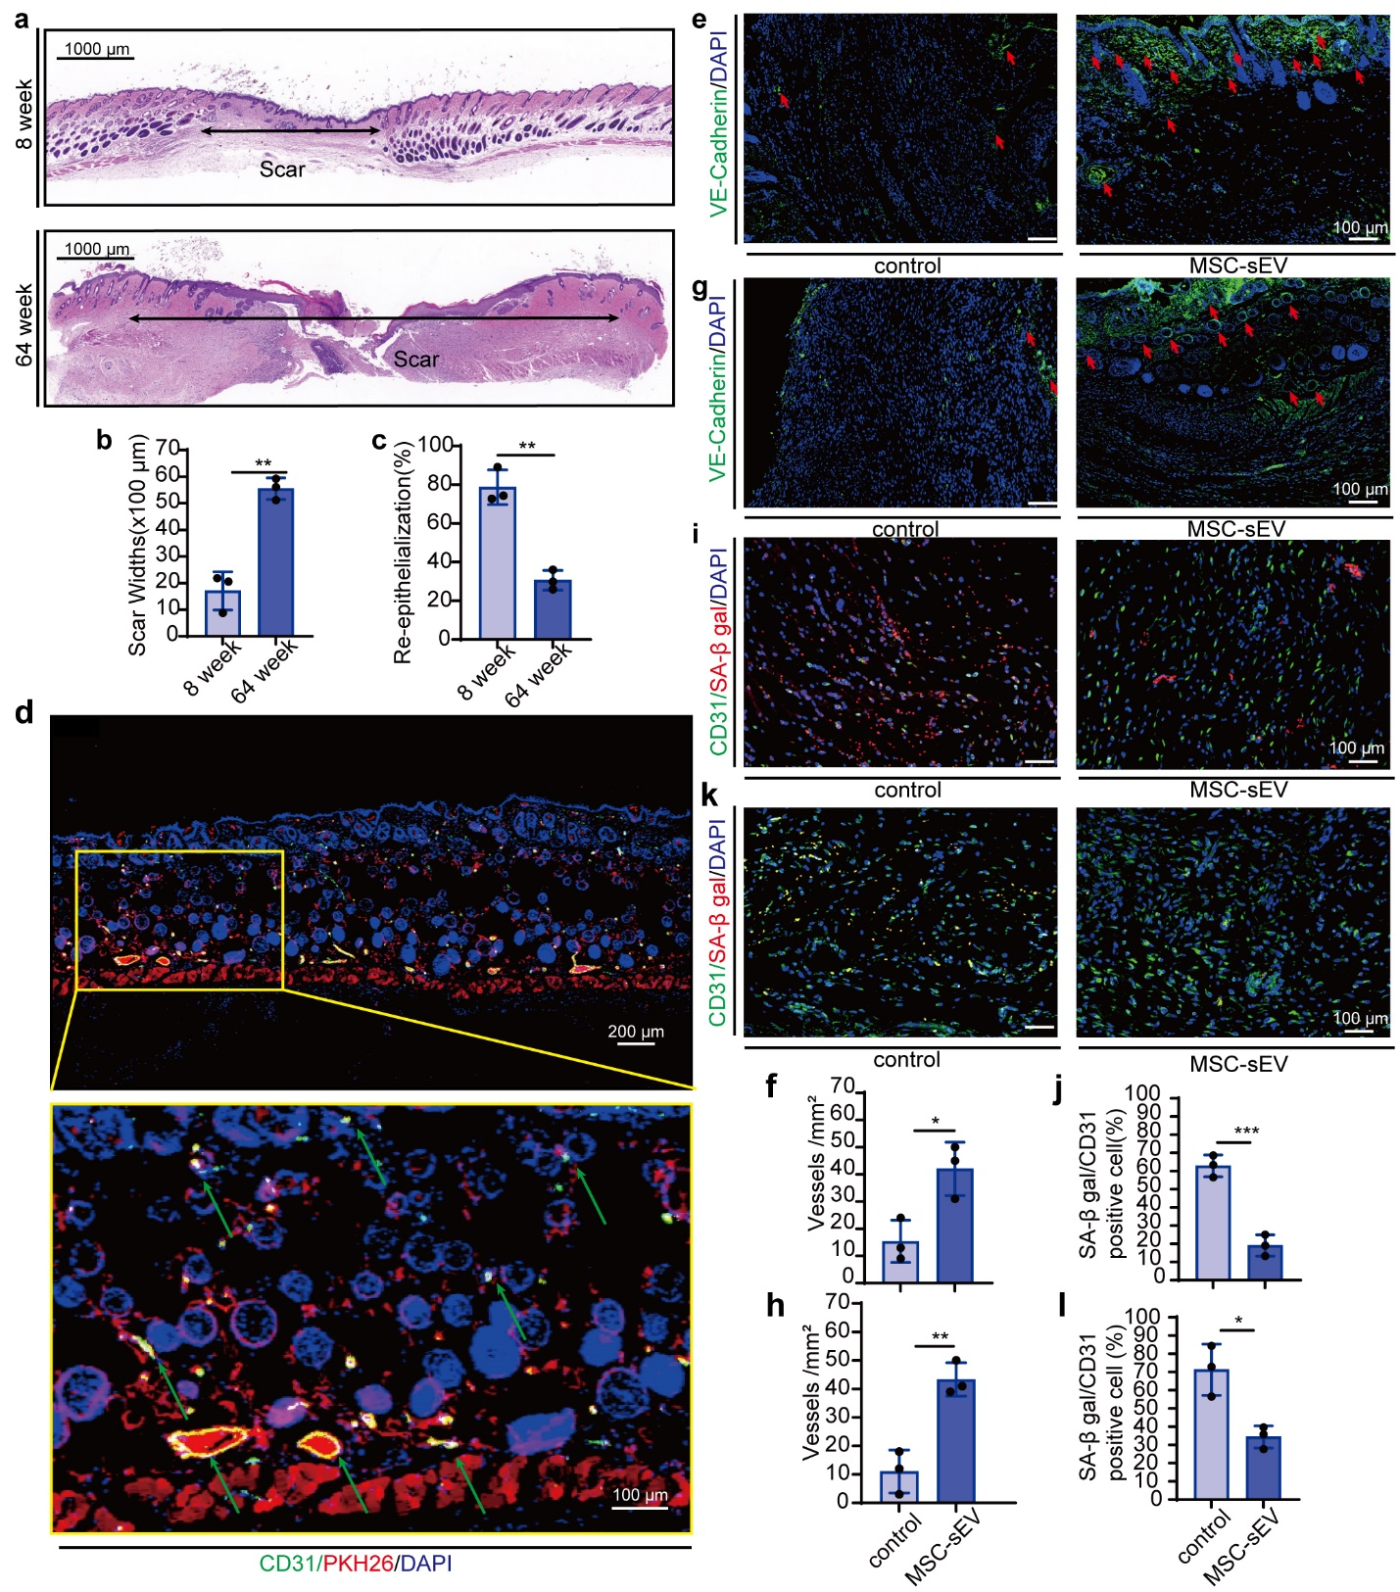

Figure S2. MSC-sEV promoted blood vessel formation attenuated EC senescence in natural aging and type-2 diabetes mice models.
(a), H&E staining of the skin tissue around the wound at day 12 after the operation (horizontal arrows indicated the scar width; scale bar, 1 mm).
(b), Quantification of the scar width around the wound. n = 3, **p < 0.01.
(c), Percentage of re-epithelialization around the wound. n = 3, **p < 0.01.
(d), Representative immunofluorescence staining images of CD31 positive cells (green staining) and DAPI in paraffin-embedded sections of normal C57BL/6mice dorsal skin injected with PKH26-marked MSC-sEV (red staining). Green arrows indicate uptake of PKH26-marked MSC-sEV by EC (scale bar, 200 μm).
(e), Representative immunofluorescence staining images of VE-cadherin positive cells (green staining) and DAPI in paraffin-embedded sections of aged C57BL/6mice dorsal skin injected PBS (control) or MSC-sEV. Red arrows indicate vessels formed around the wound (scale bar, 100 μm).
(f), Quantification of vessels formed around the scar. n = 3, *p < 0.05.
(g), Representative immunofluorescence staining images positive cells of VE-cadherin (green staining) and DAPI in paraffin-embedded sections of diabetic C57BL/6mice dorsal skin injected with PBS (control) or MSC-sEV. Red arrows indicate vessels formed around the wound (scale bar, 100 μm).
(h), Quantification of vessels formed around the scar. n = 3, **p < 0.01.
(i), Representative immunofluorescence staining images of SA b-gal (red staining), and CD31-positive cells (green staining) on paraffin-embedded sections of aged model C57BL/6mice dorsal skin injected with PBS (control) or MSC-sEV (scale bar, 50 μm).
(j), Quantitation of SA b-gal positive cells in CD31-positive cells. n = 3, ***p < 0.001.
(k), Representative immunofluorescence staining images of SA b-gal (red staining), and CD31-positive cells (green staining) on paraffin-embedded sections of type-2 diabetes model C57BL/6mice dorsal skin injected with PBS (control) or MSC-sEV (scale bar, 50 μm).
(l), Quantitation of SA b-gal positive cells in CD31-positive cells. n = 3, *p < 0.05.

Figure. S3.
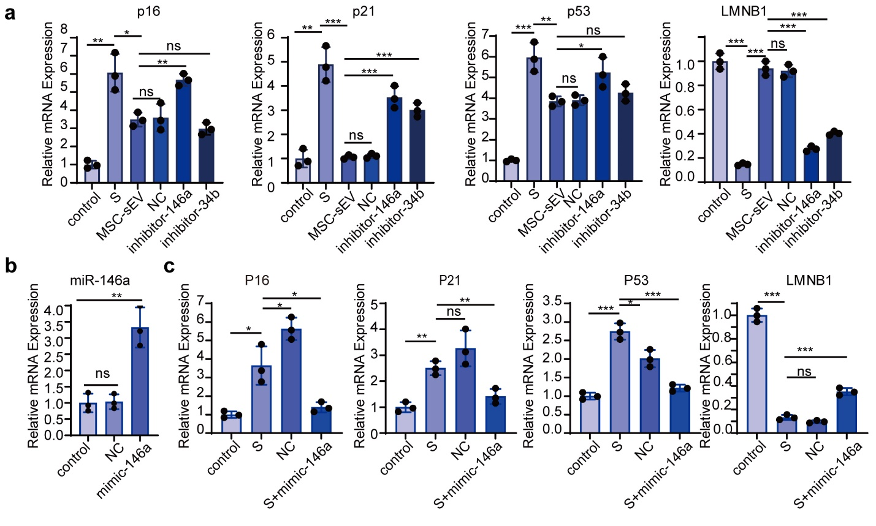

Figure S3. Characterization of transfection of inhibitor-146a, inhibitor-34b, and mimic-146a in HUVECs.
(a), qRT-PCR of miRNA-146a in HUVECs after transfection. n = 3, *p < 0.05, **p < 0.01, ***p<0.001.
(b), qRT-PCR of the senescence markers P16, P21, P53 and LMNB1 mRNA in HUVEC. n = 3, **p < 0.01.
(c), qRT-PCR of the senescence markers P16, P21, P53 and LMNB1 mRNA in HUVECs. n = 3, *p < 0.05, **p < 0.01, ***p<0.001.

Figure S4.
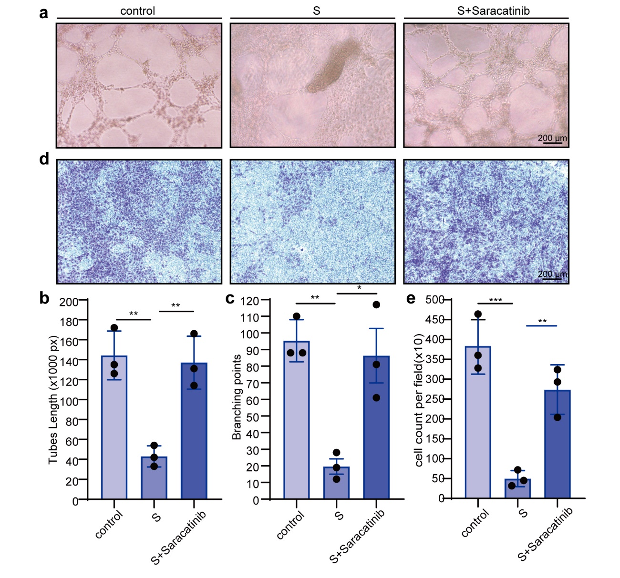

Figure S4. Inhibition of Src rescued senescent HUVECs functions.
(a), Representative images of in vitro tube formation assay (scale bar, 200 μm).
(b), Quantitation of mean tube lengths in the HUVEC network. n = 3, **p < 0.01.
(c), Quantitation of branching points in the HUVEC network. n = 3, *p < 0.05, **p < 0.01.
(d), Representative images of transwell migration assays of HUVECs (scale bar, 200 μm).
(e), Quantitation of transwell migration assays of HUVECs. n = 3, **p < 0.01, ***p<0.001.

Table. S1. Sequences of miRNAs inhibitors, mimics, primers

Sequences of miRNAs inhibitors, mimics
Name | Sequences
hsa-miR-146a-5p inhibitor  hsa-miR-146a-5p mimic  hsa-miR-34b-3p inhibitor | TGAGAACTGAATTCCATGGGTT  UGAGAACUGAAUUCCAUGGGUU  CAAUCACUAACUCCACUGCCAU

Sequences of RT-qPCR primers
Name | Sequences
P53-F1 | CAGCACATGACGGAGGTTGT
P53-R1 | TCATCCAAATACTCCACACGC
P16-F1 | GATCCAGGTGGGTAGAAGGTC
P16-R1 | CCCCTGCAAACTTCGTCCT
P21-F1 | TGTCCGTCAGAACCCATGC
P21-R1 | AAAGTCGAAGTTCCATCGCTC
LMNB1-F | AAGCATGAAACGCGCTTGG
LMNB1-R | AGTTTGGCATGGTAAGTCTGC
PPIA-F | GTCAACCCCACCGTGTTCTT
PPIA-R | CTGCTGTCTTTGGGACCTTGT
GAPDH-F | TCAACGACCACTTTGTCAAGCTCA
GAPDH-R | GCTGGTGGTCCAGGGGTCTTACT
hsa-mir-146a-5p F | CGCGTGAGAACTGAATTCCA
hsa-mir-146a-5p R | AGTGCAGGGTCCGAGGTATT
hsa-miR-28-3p F | CGCGCACTAGATTGTGAGCT
hsa-miR-28-3p R | AGTGCAGGGTCCGAGGTATT
hsa-miR-412-5p F | CGTGGTCGACCAGTTGGAA
hsa-miR-412-5p R | AGTGCAGGGTCCGAGGTATT
hsa-miR-34b-3p F | CGCGCAATCACTAACTCCAC
hsa-miR-34b-3p R | AGTGCAGGGTCCGAGGTATT
RNU6-1F | GCTCGCTTCGGCAGCACATATAC
RNU6-1R | CGAATTTGCGTGTCATCCTTGCG

Table. S2. Antibody and Reagent

Antibody | Source | Identifier
P16 | Proteintech | 10883-1-AP
P21 | Proteintech | 10355-1-AP
P53 | Proteintech | 10442-1-AP
LMNB1 | Proteintech | 12987-1-AP
p-AKT | CST | 4060T
p-ERK1/2 | Abcam | ab76299
p-Src | CST | 4060T
p-c-Jun | CST | 2361S
p-VE cadherin | Abcam | ab119785
p-Caveolin-1 | Abcam | ab38468
p-P38 | Abcam | ab4822
p-JNK | CST | 4669T
JNK | CST | 9252T
P38 | Proteintech | 14064-1-AP
caveolin-1 | Abcam | ab2910
VE cadherin | Abcam | ab33618
c-Jun | CST | 2361S
Src | CST | 2109T
AKT | Proteintech | 60203-2-Ig
ERK1/2 | proteintech | 16443-1-AP
CD63 | Proteintech | 25682-1-AP
Calnexin | CST | 2433S
TSG101 | Abcam | ab83
Alix | CST | 92880S
VWF | Abcam | ab6994
CD31 | Abcam | ab9498
GAPDH | Proteintech | 10494-1-AP  60004-1-Ig
HRP-conjugated anti-rabbit-IgG | NeoBioscience
HRP-conjugated anti-mouse-IgG | NeoBioscience
Reagent | Source | Identifier
Hoechst | Sigma-Aldrich | 33342
Matrigel | BD Biosciences | 354230
ELISA Kit IL-1alpha | R&D | DLA50
ELISA Kit IL-6 | R&D | 550799
ELISA Kit IL-8 | R&D | DY208
Mito Stress Test Kit | Agilent | 103015-100
Fluorometric Intracellular ROS Kit | Sigma Aldrich | MAK144
BCA Protein Assay Kit | Beyotime
  P0011
TRIzol | Invitrogen | 15596018
Lipo2000 | Invitrogen | 11668-019
STZ | Sigma-Aldrich | S0130
MTS | Promega | G3581

