Supplementary Materials for Efficacy and safety of low-dose interleukin-2 in combination with methotrexate in patients with active rheumatoid arthritis: a randomized, double-blind, placebo-controlled phase 2 trial
Xiaoying Zhang, Miao Miao, Ruijun Zhang, Xu Liu, Xiaozhen Zhao, Miao Shao, Tian Liu, Yuebo Jin, Jiali Chen, Huixin Liu, Xia Zhang, Yun Li, Yunshan Zhou, Yue Yang, Ru Li, Haihong Yao, Yanying Liu, Chun Li, Yuhui Li, Limin Ren, Yin Su, Xiaolin Sun, Jing He,△ Zhanguo Li△

△Correspondence to:
Professor Jing He, Email: hejing1105@126.com.
Professor Zhanguo Li, Email: li99@bjmu.edu.cn.

This PDF file includes:
Fig. S1. Ld-IL2 expanded the population of Tregs. 2
Fig. S2. Ld-IL2 therapy increased the proportion of CD56^{bri}NK cells. 3
Fig. S3. Study design. 4
Fig. S4. Representative gating of Tregs and Th17 cells. 5
Table S1. Clinical Characteristics of the Patients with RA in the Study. 6
Table S2. Primary and Secondary Per-protocol Outcomes Analysis.ª 9
Table S3. Primary and Secondary Outcomes Analysis in ITT population.ª 12
Table S4. Factors predicting potential response to low-dose interkleukin-2 treatment in RA. 15
Table S5. Change in Cytokines after Low-dose IL-2 Treatment. 16
Table S6. Inclusion and Exclusion Criteria. 18
Table S7. Antibodies Used in Flow Cytometric Analysis. 20

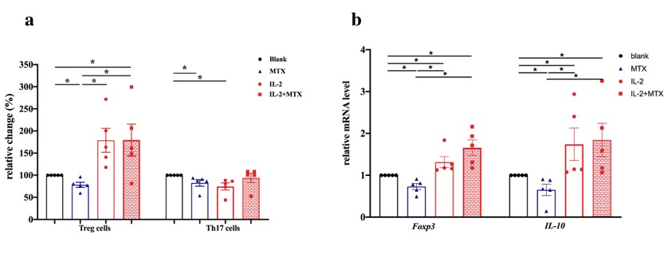

Fig. S1. Ld-IL2 expanded the population of Tregs.
The relative change in Tregs and Th17 cells derived from PBMC of RA patients with MTX, IL-2, and IL-2+MTX, respectively (A). The percentage of Tregs or Th17 cells in blank was normalized to 100%. Foxp3 and IL-10 mRNA expression in PBMC (B).
Ld-IL2=low-dose interleukin-2; MTX=methotrexate; PBMC=peripheral blood mononuclear cell; Tregs= regulatory T cells.

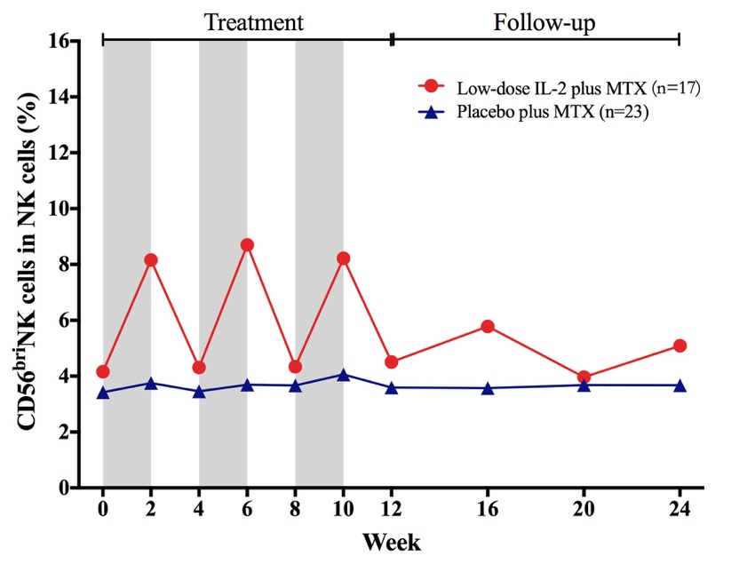

Fig. S2. Ld-IL2 therapy increased the proportion of CD56^{bri}NK cells.
Grey areas indicated the periods on Ld-IL2 or placebo therapy. The proportion of CD56^{bri}NK cells (defined as CD56^{bri}CD16⁻) in NK cells (defined as CD3⁻CD56⁺) was shown.
Ld-IL2=low-dose interleukin-2; MTX=methotrexate; NK=natural killer.
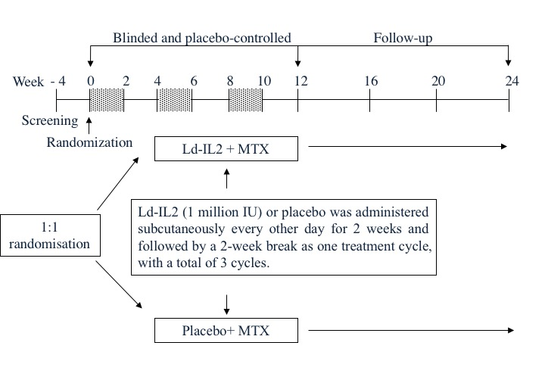

Fig. S3. Study design.
A randomized, double-blind, placebo-controlled study was conducted. Three cycles of Ld-IL2 or placebo were administered subcutaneously every other day for 2 weeks (a total of 7 doses), followed by a 2-week break. Grey areas indicated the periods on Ld-IL2 or placebo therapy.

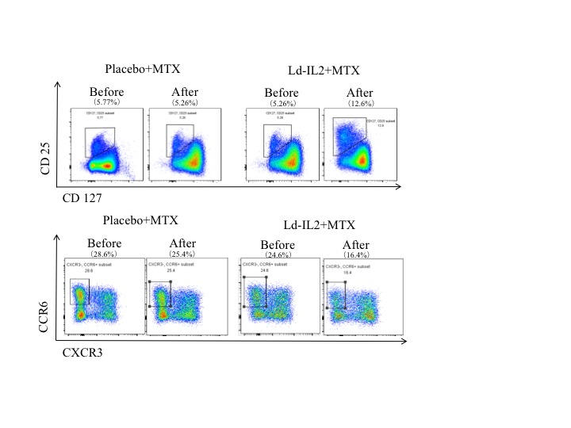

Fig. S4. Representative gating of Tregs and Th17 cells.
The gating of Tregs and Th17 cells before and after treatment for patients.

Table S1. Clinical Characteristics of the Patients with RA in the Study.
ID | Gender/Age (ys) |  | Duration (months) | Extra-articular manifestation | Previous DMARDs, Glucocorticoids or NSAIDs treatment | MTX-maximum dose | Complication | Group | Enrollment date | AEs, SAEs or discontinued from study
1 | F/57 |  | 34 |  | Non | 10mg QW | Hypertension; Hyperlipidaemia | Ld-IL2 | 2015-10-22
2 | F/57 |  | 7 |  | Non | 10mgQW |  | Placebo | 2015-11-5
3 | F/58 |  | 5 |  | Non | 12.5mgQW |  | Ld-IL2 | 2016-1-29 | Injection site reaction
4 | M/55 |  | 32 |  | LEF 20mgQD | 12.5mgQW | Hypothyroidism | Placebo | 2016-4-20
5 | F/69 |  | 7 |  | Non | 10mgQW | Rheumatic heart disease; Hyperuricemia | Placebo | 2016-4-25
6 | F/57 |  | 151 |  | Prednisone 5mgQD | 10mgQW |  | Placebo | 2016-6-8 | Gastrointestinal disorder
7 | F/58 |  | 26 |  | LEF 20mgQD; HCQ 200mgBID; Prednisone 10mgQD | 10mgQW |  | Ld-IL2 | 2016-6-17
8 | F/52 |  | 43 |  | TGP 600mgBID | 10mgQW |  | Ld-IL2 | 2016-7-15 | Injection site reaction
9 | F/52 |  | 32 |  | Non | 10mgQW |  | Placebo | 2016-8-19
10 | F/55 |  | 94 |  | TWP 20mgTID | 10mgQW | Hypertension | Ld-IL2 | 2016-9-9 | Gastrointestinal disorder
11 | F/45 |  | 252 |  | Non | 12.5mgQW | Nephrectomy | Ld-IL2 | 2016-9-22
12 | M/38 |  | 109 |  | LEF 20mgQD | 15mgQW |  | Placebo | 2016-12-12 | Worsening of RA
13 | M/55 |  | 13 | Rheumatoid nodule | TWP 20mgTID;  Loxoprofen sodium 60mgBID | 12.5mgQW |  | Ld-IL2 | 2016-12-13
14 | F/43 |  | 133 |  | LEF 20mgQD; HCQ 200mgBID | 12.5mgQW |  | Placebo | 2016-12-15 | Upper respiratory tract infection
15 | F/65 |  | 450 |  | HCQ 200mgBID; Prednisone 5mgQD | 10mgQW |  | Ld-IL2 | 2016-12-17 | Fever after injection;
16 | F/50 |  | 5 |  | Non | 10mgQW |  | Placebo | 2016-12-22 | Injection site reaction
17 | M/68 |  | 25 | ILD | LEF 20mgQD; HCQ 200mgBID | 7.5mgQW | Hypertension; Diabetes mellitus | Placebo | 2016-12-23 | Hospitalized not related to RA
18 | F/67 |  | 65 |  | LEF 20mgQD; SSZ 500mgTID | 7.5mgQW |  | Ld-IL2 | 2016-12-27 | Withdrew consent
19 | F/54 |  | 231 |  | LEF 20mgQD | 10mgQW |  | Ld-IL2 | 2017-1-5 | Withdrew consent
20 | F/64 |  | 110 |  | LEF 20mgQD | 10mgQW |  | Placebo | 2017-1-10
Table S1. Continued.
ID | Gender/Age (ys) | Duration (months) |  | Extra-articular manifestation | Previous DMARDs, Glucocorticoids or NSAIDs treatment | MTX-maximum dose | Complication | Group | Enrollment date | AEs, SAEs or discontinued from study
21 | F/59 | 183 |  |  | LEF 10mgQD | 10mgQW |  | Ld-IL2 | 2017-1-12 | Hepatic enzyme increased
22 | M/69 | 305 |  | ILD | LEF 20mgQD; Prednisone 10mgQD | 10mgQW | Chronic gastritis | Ld-IL2 | 2017-1-12
23 | F/54 | 86 |  |  | LEF 20mgQD; HCQ 200mgBID | 10mgQW |  | Placebo | 2017-1-16
24 | M/62 | 281 |  |  | LEF 20mgQD; HCQ 200mgBID; SSZ 750mgBID | 10mgQW | Gastric ulcer | Placebo | 2017-1-16
25 | F/30 | 171 |  |  | LEF 20mgBID; HCQ 200mgBID; SSZ 1gBID | 10mgQW |  | Ld-IL2 | 2017-1-20 | Hospitalized not related to RA; worsening of RA;  Withdrew consent
26 | M/64 | 37 |  | ILD; rheumatoid nodule | LEF 20mgBID; HCQ 200mgBIDl; Prednisone 5mgQD; Loxoprofen sodium 60mgBID | 7.5mgQW | Hypertension  Diabetes mellitus | Ld-IL2 | 2017-1-16
27 | F/59 | 62 |  | ILD | HCQ 200mgBID | 10mgQW |  | Placebo | 2017-1-24
28 | F/63 | 75 |  | ILD | LEF 10mgQD (1year ago) | 10mgQW |  | Placebo | 2017-2-5 | Worsening of RA
29 | F/38 | 50 |  |  | Non | 12.5mgQW |  | Ld-IL2 | 2017-2-4
30 | F/26 | 3 |  |  | Non | 10mgQW |  | Placebo | 2017-1-24 | Injection site reaction; Withdrew consent
31 | F/58 | 8 |  |  | Non | 10mgQW |  | Placebo | 2017-2-5
32 | F/61 | 424 |  |  | LEF 10mg QD; SSZ 750mgTID; Prednisone 5mgQD | 10mgQW | Hypertension | Ld-IL2 | 2017-2-9 | Injection site reaction
33 | F/52 | 257 |  |  | LEF 20mgQD; SSZ 750mgTID; TWP 20mgTID | 10mgQW | Hypertension | Placebo | 2017-2-5 | Worsening of RA
34 | F/50 | 306 |  |  | LEF 20mgQD | 10mgQW | Hypertension | Placebo | 2017-2-9
35 | F/54 | 147 |  |  | HCQ 200mgBID | 10mgQW |  | Ld-IL2 | 2017-2-9 | Upper respiratory tract infection
36 | F/41 | 75 |  |  | SSZ 1g BID; TWP 20mg BID | 10mgQW |  | Ld-IL2 | 2017-2-16 | Lost to follow-up
37 | F/52 | 282 |  |  | LEF 20mgQD; SSZ 750mgTID | 10mgQW | Hypertension | Ld-IL2 | 2017-2-16 | Hospitalized not related to RA
38 | F/64 | 257 |  |  | LEF 20mgQD | 10mgQW | Hypertension | Placebo | 2017-2-23
Table S1. Continued.
ID | Gender/Age (ys) |  | Duration (months) | Extra-articular manifestation | Previous DMARDs, Glucocorticoids or NSAIDs treatment | MTX-maximum dose | Complication | Group | Enrollment date | AEs, SAEs or discontinued from study
39 | F/65 |  | 87 |  | LEF 10mgQD; SSZ 750mgTID; TGP 600mgTID; Loxoprofen sodium 60mgBID | 10mgQW | Gallstone | Placebo | 2017-2-23
40 | F/47 |  | 50 |  | Loxoprofen sodium 60mgBID | 10mgQW |  | Ld-IL2 | 2017-2-20 | Withdrew consent
41 | F/54 |  | 51 |  | LEF 20mgQD | 10mgQW |  | Ld-IL2 | 2017-3-2 | Lost to follow-up
42 | F/61 |  | 391 |  | LEF 20mgQD | 10mgQW |  | Placebo | 2017-2-27
43 | F/47 |  | 172 | Rheumatoid nodule | LEF 20mgQD; SSZ 1gBID | 10mgQW |  | Ld-IL2 | 2017-2-19 | Fever after injection;
44 | M/69 |  | 87 |  | HCQ 200mgBID | 10mgQW |  | Placebo | 2017-3-2
45 | F/60 |  | 136 |  | HCQ 200mgBID; TWP 20mg BID | 12.5mgQW |  | Placebo | 2017-3-2 | Hepatic enzyme increased
46 | F/27 |  | 50 |  | HCQ 200mgBID; Prednisone 10mgQD | 12.5mgQW |  | Ld-IL2 | 2017-2-19
47 | F/46 |  | 51 |  | Loxoprofen sodium 60mgBid | 10mgQW |  | Placebo | 2017-3-13
Abbreviations: AE, adverse event; DMARD, disease-modifying anti-rheumatoid drug; HCQ, hydroxycholoroquine; Ld-IL2, low dose interleukin-2; ILD, interstitial lung disease; LEF, Leflunomide; MTX, Methotrexate; NSAID, non-steroidal anti-inflammatory drug; RA, rheumatoid arthritis; SAE, severe adverse event; SSZ, Sulfasalazine; TGP, Total glucosides of paeony; TWP, Tripterygium wilfordii polyglycoside; ys, years.

Table S2. Primary and Secondary Per-protocol Outcomes Analysis.ª
 | Ld-IL2+MTX  (n=17) | Placebo+MTX  （n=23） | Difference (95%CI) | P-value | P-value^{b}
ACR outcomes, no. (%)
ACR20
At week 12 | 12 (70.6) | 10 (43.5) | 0.288 (0.071 to 1.164) | 0.081 | 0.014
At week 24 | 13 (76.5) | 13 (56.5) | 0.211 (0.037 to 1.202) | 0.080
ACR50
At week 12 | 6 (35.3) | 3 (13.0) | 0.077 (0.008 to 0.734) | 0.026 | 0.079
At week 24 | 10 (58.8) | 8 (34.8) | 0.218 (0.047 to 1.014) | 0.052
ACR70
At week 12 | 2 (11.8) | 0 (0.0) | NA | 0.998 | 0.164
At week 24 | 4 (23.5) | 2 (8.8) | 0.300 (0.042 to 2.135) | 0.229
CDAI score change from baseline
At week 12 | -14.7 (-18.3 to -11.1) | -9.8 (-12.9 to -6.7) | 4.851 (0.085 to 9.616) | 0.046 | 0.018
At week 24 | -16.6 (-19.7 to -13.6) | -12.5 (-15.1 to -9.9) | 4.097 (0.062 to 8.131) | 0.047
SDAI score change from baseline
At week 12 | -15.5 (-18.8 to -12.3) | -11.6 (-14.4 to -8.9) | 3.965 (-0.364 to 8.293) | 0.071 | 0.015
At week 24 | -17.5 (-21.0 to -13.6) | -13.0 (-16.1 to -10.0) | 4.433 (-0.229 to 9.095) | 0.062
DAS28-ESR endpoints, no. (%)
DAS28-ESR<2.6
At week 12 | 2 (11.8) | 1 (4.3) | 0.056 (0.001 to 2.824) | 0.149 | 0.462
At week 24 | 6 (35.3) | 6 (26.1) | 0.368 (0.076 to 1.794) | 0.216
DAS28-ESR≤3.2
At week 12 | 7 (41.2) | 7 (30.4) | 0.521 (0.090 to 3.019) | 0.467 | 0.438
At week 24 | 8 (47.1) | 9 (39.1) | 0.453 (0.104 to 1.967) | 0.291
DAS28-ESR change from baseline
At week 12 | -1.69 (-2.13 to -1.24) | -1.27 (-1.65 to -0.89) | 0.416 (-0.174 to 1.006) | 0.162 | 0.337
At week 24 | -2.09 (-2.60 to -1.57) | -1.78 (-2.22 to -1.34) | 0.303 (-0.372 to 0.978) | 0.369
Table S2. (Continued)
 | Ld-IL2+MTX  (n=17) | Placebo+MTX  （n=23） | Difference (95%CI) | P-value | P-value^{b}
Percent change in ACR core components
Tender joint count (0-28)
At week 12 | -63.3 (-79.5 to -47.1) | -47.0 (-60.9 to -33.0) | 0.163 (-0.051 to 0.377) | 0.131 | 0.385
At week 24 | -77.1 (-91.3 to -62.9) | -66.2 (-78.4 to -54.0) | 0.109 (-0.077 to 0.296) | 0.243
Swollen joint count (0-28)
At week 12 | -68.2 (-91.1 to -45.3) | -63.7 (-83.3 to -44.2) | 0.045 (-0.264 to 0.354) | 0.771 | 0.719
At week 24 | -67.9 (-91.0 to -44.8) | -83.9 (-100.0 to -64.1) | 0.160 (-0.472 to 0.153) | 0.307
Pain assessment, cm VAS
At week 12 | -51.3 (-68.5 to -34.0) | -20.4 (-35.2 to -5.5) | 0.309 (0.082 to 0.537) | 0.009 | 0.293
At week 24 | -46.4 (-68.1 to -24.8) | -28.9 (-47.6 to -10.3) | 0.175 (-0.111 to 0.461) | 0.223
PhGA, cm VAS
At week 12 | -50.5 (-64.8 to -36.3) | -30.0 (-42.2 to -17.8) | 0.205 (0.017 to 0.393) | 0.033 | 0.029
At week 24 | -51.0 (-69.7to -32.2) | -31.6 (-47.7 to -15.5) | 0.194 (-0.054 to 0.441) | 0.121
PtGA, cm VAS
At week 12 | -47.7 (-61.3 to -34.0) | -21.9 (-33.6 to -10.2) | 0.257 (0.077 to 0.437) | 0.006 | 0.095
At week 24 | -51.3 (-84.6 to -18.1) | -9.3 (-37.9 to 19.3) | 0.420 (-0.019 to 0.859) | 0.060
HAQ-DI
At week 12 | -31.7 (-59.2 to -4.2) | -16.1 (-39.8 to 7.5) | 0.156 (-0.207 to 0.519) | 0.390 | 0.090
At week 12 | -60.1 (-108.7 to -11.6) | -9.2 (-50.9 to 32.6) | 0.510 (-0.131 to 1.150) | 0.116
CRP
At week 12 | -34.5 (-78.2 to 9.2) | -29.8 (-64.7 to 5.2) | 0.047 (-52.4 to 61.9) | 0.867 | 0.142
At week 24 | -31.3 (-83.1 to 20.5) | 3.3 (-41.0 to 47.7) | 0.346 (-0.344 to 1.036) | 0.316
SF-36 PCS change from baseline at week 24 | 16.44 (9.75 to 23.12) | 8.87 (3.13 to 14.62) | -7.565 (-16.39 to 1.26) | 0.091
SF-36 MCS change from baseline at week 24 | 3.87 (-1.46 to 9.20) | 4.68 (0.10 to 9.26) | 0.811 (-6.213 to 7.835) | 0.816
ESR change from baseline, mm/H
At week 12 | -9.3 (-17.7 to -1.0) | -8.9 (-16.1 to -1.7) | 0.470 (-10.591 to 11.532) | 0.932 | 0.881
At week 24 | -9.8 (-19.2 to -0.4) | -11.4 (-19.5 to -3.3) | -1.637 (-14.060 to 10.786) | 0.791
Table S2. (Continued)
 | Ld-IL2+MTX  (n=17) | Placebo+MTX  （n=23） | Difference (95%CI) | P-value | P-value^{b}
RF change from baseline, IU/ml
At week 12 | -154.2 (-842.0 to -20.1) | -35.0 (-182.5 to 24.6) | 620.6 (-48.81 to 1289.93) | 0.123 | 0.213
At week 24 | -144.8 (-850.0 to -46.1) | -146.7 (-330.5 to 17.3) | 509.3 (-168.27 to 1186.89) | 0.432
IgA change from baseline at week 24, G/L | -0.46 (-0.78 to -0.15) | -0.64 (-0.91 to -0.37) | -0.17 (-0.60 to 0.25) | 0.407
IgM change from baseline at week 24, G/L | -0.12 (-0.29 to 0.04) | -0.17 (-0.31 to -0.03) | -0.05 (-0.26 to 0.17) | 0.678
IgG change from baseline at week 24, G/L | -1.77 (-3.24 to -0.31) | -2.07 (-3.33 to -0.82) | -0.30 (-2.25 to 1.65) | 0.757
Anti-CCP antibody change from baseline at week 24, U/ml | -14.3 (-32.7 to 4.1) | -35.1 (-50.9 to -19.3) | -20.830 (-45.141 to 3.481) | 0.090

ª Data are presented as least squares mean (95% CI) unless stated otherwise.
^{b} For continuous variables, treatment differences across time points were evaluated using a mixed model for repeated-measures analysis. For categorical variables, Generalized Estimation Equations (GEE) was used for analysis.

Abbreviations: ACR, American College of Rheumatology; EULAR, European League Against Rheumatism; ACR20/50/70, ≥20%/50%/70% improvement in the American College of Rheumatology criteria; CCP, cyclic citrullinated peptide; CDAI, Clinical Disease Activity Index; CI, confidence interval; CRP, C reactive protein; DAS28, Disease Activity Score using 28 joints; ESR, erythrocyte sedimentation rate; HAQ-DI, Health Assessment Questionnaire-Disability Index; Ig, immunoglobulin; Ld-IL2: low dose interleukin-2; MTX, methotrexate; PhGA, Physician’s global assessment of disease activity; PtGA, Patient’s global assessment of disease activity; RF, rheumatoid factor; SDAI, Simplified Disease Activity Index; SF-36 PCS, Short Form-36 physical component scores; SF-36 MCS, Short Form-36 mental component scores; SJC, swollen joint count; TJC, tender joint count; VAS, Visual Analogue Scale.

Table S3. Primary and Secondary Outcomes Analysis in ITT population.ª
 | Ld-IL2+MTX  (n=23) | Placebo+MTX  （n=24） | Difference (95%CI) | P-value | P-value^{b}
ACR outcomes, no. (%)
ACR20
At week 12 | 12 (52.2) | 10 (41.7) | 2.076 (0.591 to 7.289) | 0.254 | 0.416
At week 24 | 13 (56.5) | 13 (54.2) | 1.624 (0.435 to 6.066) | 0.471
ACR50
At week 12 | 6 (26.1) | 3 (12.5) | 12.720 (1.212 to 133.514) | 0.034 | 0.278
At week 24 | 10 (43.5) | 8 (33.3) | 2.578 (0.637 to 10.439) | 0.184
ACR70
At week 12 | 2 (8.7) | 0 (0.0) | NA | 0.998 | 0222
At week 24 | 4 (17.4) | 2 (8.3) | 3.020 (0.418 to 21.801) | 0.273
CDAI score change from baseline
At week 12 | -10.5 (-14.2 to -6.7) | -9.8 (-13.5 to -6.1) | 0.670 (-4.627 to 5.968) | 0.800 | 0.834
At week 24 | -11.6 (-15.4 to -7.8) | -12.5 (-16.2 to -8.8) | -0.879 (-6.234 to 4.475) | 0.742
SDAI score change from baseline
At week 12 | -10.8 (-14.6 to -7.0) | -11.5 (-15.2 to -7.8) | -0.718 (-6.066 to 4.629) | 0.788 | 0.743
At week 24 | -11.9 (-16.2 to -7.6) | -13.0 (-17.2 to -8.8) | -1.133 (-7.186 to 4.920) | 0.708
DAS28-ESR endpoints, no. (%)
DAS28-ESR<2.6
At week 12 | 2 (8.7) | 1 (4.2) | 19.561 (0.357 to 1070.407) | 0.145 | 0.462
At week 24 | 6 (26.1) | 6 (25.0) | 2.295 (0.467 to 11.267) | 0.306
DAS28-ESR≤3.2
At week 12 | 7 (30.4) | 7 (29.2) | 1.794 (0.362 to 8.889) | 0.474 | 0.941
At week 24 | 8 (34.8) | 9 (37.5) | 1.733 (0.414 to 7.246) | 0.451
DAS28-ESR change from baseline
At week 12 | -1.17 (-1.62 to -0.72) | -1.26 (-1.70 to -0.82) | -0.087 (-0.722 to 0.547) | 0.783 | 0.699
At week 24 | -1.42 (-1.97 to -0.87) | -1.77 (-2.31 to -1.23) | -0.354 (-1.127 to 0.419) | 0.361
Table S3. (Continued)
 | Ld-IL2+MTX  (n=23) | Placebo+MTX  （n=24） | Difference (95%CI) | P-value | P-value^{b}
Percent change in ACR core components
Tender joint count (0-28)
At week 12 | -36.7 (-59.3 to -14.1) | -47.4 (-69.5 to -25.3) | -10.7 (-42.3 to 20.9) | 0.497 | 0.280
At week 24 | -45.5 (-68.7 to -22.2) | -65.8 (-88.6 to -43.1) | -20.4 (-52.9 to 12.2) | 0.213
Swollen joint count (0-28)
At week 12 | -47.4 (-70.7 to -24.1) | -61.6 (-84.5 to -38.8) | -14.2 (-48.0 to 19.5) | 0.400 | 0.216
At week 24 | -48.9 (-73.2 to -24.6) | -80.3 (-104.0 to -56.5) | -31.4 (-66.6 to 3.8) | 0.079
Pain assessment, cm VAS
At week 12 | -39.1 (-54.5 to -23.6) | -20.5 (-35.6 to -5.3) | 18.6 (-3.0 to 40.3) | 0.090 | 0.702
At week 24 | -33.2 (-51.8 to -14.5) | -28.9 (-47.1 to -10.6) | 4.3 (-21.9 to 30.5) | 0.742
Physician’s GA, cm VAS
At week 12 | --35.6 (-49.9 to 21.3) | -28.0 (-42.0 to -14.0) | 7.6 (-12.5 to 27.7) | 0.448 | 0.286
At week 24 | -34.0 (-51.4 to -16.5) | -32.0 (-49.1 to -14.9) | 2.0 (-22.5 to 26.5) | 0.870
Patient’s GA, cm VAS
At week 12 | -35.8 (-48.4 to -23.2) | -22.9 (-35.2 to -10.6) | 12.9 (-4.7 to 30.6) | 0.147 | 0.469
At week 24 | -35.5 (-63.4 to -7.6) | -11.3 (-38.5 to 16.0) | 24.2 (-14.8 to 63.3) | 0.218
HAQ-DI
At week 12 | -27.2 (-592.2 to -2.2) | -8.1 (-32.5 to 16.4) | 19.1 (-16.9 to 55.2) | 0.291 | 0.138
At week 12 | -50.1 (-90.9 to -9.4) | 2.1 (-37.8 to 42.0) | 52.2 (-6.6 to 111.1) | 0.080
CRP, mg/L
At week 12 | 27.7 (-24.1 to 79.6) | -35.3 (-83.8 to 13.1) | -63.1 (-134.9 to 8.8) | 0.084 | 0.691
At week 24 | 39.2 (-27.9 to 106.3) | -3.2 (-68.8 to 62.5) | -42.3 (-137.0 to 52.3) | 0.372
SF-36 PCS change from baseline at week 24 | 11.57 (5.69 to 17.44) | 9.29 (3.54 to 15.04) | -2.28 (-10.51 to 5.96) | 0.580
SF-36 MCS change from baseline at week 24 | 2.59 (-1.74 to 6.91) | 3.63 (-0.60 to 7.86) | 1.05 (-5.00 to 7.09) | 0.729
ESR change from baseline, mm/H
At week 12 | -3.9 (-11.3 to 3.6) | -9.4 (-16.6 to -2.1) | -5.45 (-15.92 to 5.01) | 0.299 | 0.473
At week 24 | -3.9 (-12.3 to 4.6) | -12.1 (-20.4 to -3.8) | -8.25 (-20.14 to 3.63) | 0.169
Table S3. (Continued)
 | Ld-IL2+MTX  (n=23) | Placebo+MTX  （n=24） | Difference (95%CI) | P-value | P-value^{b}
RF change from baseline, IU/ml
At week 12 | -404.5 (-679.6 to -129.4) | -37.7 (-328.5 to 253.2) | 366.84 (-33.71 to 767.39) | 0.071 | 0.198
At week 24 | -406.2 (-625.1 to -187.3) | -158.3 (-389.7 to 73.2) | 247.90 (-70.88 to 566.67) | 0.123
IgA change from baseline at week 24, G/L | -0.37 (-0.63 to -0.12) | -0.58 (0.82 to -0.33) | -0.20 (-0.56 to 0.16) | 0.260
IgM change from baseline at week 24, G/L | -0.09 (-0.22 to -0.05) | -0.16 (-0.29 to -0.03) | -0.07 (-0.26 to 0.12) | 0.444
IgG change from baseline at week 24, G/L | -1.59 (-2.77 to -0.41) | -2.01 (-3.16 to -0.85) | -0.42 (-2.08 to 1.25) | 0.616
Anti-CCP antibody change from baseline at week 24, U/ml | -10.1 (-24.7 to 4.5) | -33.8 (-48.0 to -19.5) | -23.68 (-44.12 to -3.26) | 0.078

ª Data are presented as least squares mean (95% CI) unless stated otherwise.
^{b} For continuous variables, treatment differences across time points were evaluated using a mixed model for repeated-measures analysis. For categorical variables, Generalized Estimation Equations (GEE) was used for analysis.

Abbreviations: ACR, American College of Rheumatology; EULAR, European League Against Rheumatism; ACR20/50/70, ≥20%/50%/70% improvement in the American College of Rheumatology criteria; CCP, cyclic citrullinated peptide; CDAI, Clinical Disease Activity Index; CI, confidence interval; DAS28, Disease Activity Score using 28 joints; ESR, erythrocyte sedimentation rate; GA, global assessment of disease activity; HAQ-DI, Health Assessment Questionnaire-Disability Index; Ld-IL2, low-dose interleukin-2; mITT, modified intent-to-treat; MTX, methotrexate; RF, rheumatoid factor; SDAI, Simplified Disease Activity Index; SF-36 PCS, Short Form-36 physical component scores; SF-36 MCS, Short Form-36 mental component scores; SJC, swollen joint count; TJC, tender joint count; VAS, Visual Analogue Scale.

Table S4. Factors predicting potential response to low-dose interkleukin-2 treatment in RA.
Characteristic | Responder  n=11 | Non-responder  n=10 | p-value
Duration, months | 94 (34, 183) | 63 (47, 317.5) | 0.605
ESR, mm/H | 30 (17, 42) | 49 (23.75, 74.5) | 0.114
CRP, mg/L | 11.34 (2,14, 31.22) | 18.11 (6.12, 42.11) | 0.557
DAS28-ESR | 4.90 (4.78, 5.69) | 5.55 (4.95, 6.50) | 0.132
RF, IU/ml | 197.0 (20, 489) | 410.5 (37, 1677.5) | 0.282
anti-CCP, U/ml | 211.8 (178.4, 249.4) | 200.7 (145.8, 228.3) | 0.349
Tregs, % in CD4+ T cells | 5.83% (4.28%, 6.65%) | 7.46% (5.95%, 8.97%) | 0.036
IL-2, pg/ml | 9.66 (5.80, 13.73) | 12.99 (5.60, 29.64) | 0.426
IL-6, pg/ml | 45.90 (29.54, 147.49) | 43.32 (23.14, 193.05) | 1.000
IL-17A, pg/ml | 84.88 (40.03, 300.20) | 111.17 (8.23, 244.48) | 0.557
IL-21, pg/ml | 10.80 (4.10, 22.84) | 3.57 (1.81, 7.15) | 0.012
TNF-α, pg/ml | 353.48 (171.02, 591.15) | 379.45 (149.89, 522.33) | 0.654
IFN-γ, pg/ml | 11.11 (3.42, 24.35) | 4.78 (1.45, 29.48) | 0.468
sCD25, ng/ml | 5.56 (1.94, 12.18) | 2.19 (1.26, 5.13) | 0.314
IL-7, pg/ml | 7.15 (4.58, 11.83) | 6.45 (3.77, 9.72) | 0.633
IL-4, pg/ml | 43.09 (5.36, 102.38) | 19.44 (6.61, 116.01) | 0.829
IL-10, pg/ml | 16.46 (4.54, 42.11) | 13.09 (3.76, 41.26) | 1.000
IL-12, ng/ml | 14.18 (7.69, 30.77) | 20.45 (7.57, 58.12) | 0.696
TGF-β, ng/ml | 1.76 (0.72, 2.21) | 1.99 (1.63, 2.76) | 0.460
CXCL13, pg/ml | 69.03 (38.27, 127.95) | 90.12 (33.06, 110.21) | 0.762

Abbreviations: CCP, cyclic citrullinated peptide; CRP, C reactive protein; DAS28, Disease Activity Score using 28 joints; ESR, erythrocyte sedimentation rate; IL, interleukin; Ld-IL2, low-dose interleukin; RA, rheumatoid arthritis; Tregs, regulatory T cells; TGF, transforming growth factor; TNF, tumor necrosis factor.

Table S5. Change in Cytokines after Low-dose IL-2 Treatment.
Characteristicsª | Baseline | Week 12 | Week 24 | P value  (baseline-week 12) | P value  (baseline-week24) | P value^{b}
IL-2, pg/ml
IL-2+MTX | 10.15 (5.96, 14.85) | 8.56 (6.11, 15.08) | 6.96 (5.75, 10.09) | 0.301 | 0.026 | 0.346
placebo+MTX | 8.86 (4.06, 20.90) | 8.81 (4.17, 15.28) | 7.57 (4.24, 15.68) | 0.614 | 0.627
IL-6, pg/ml
IL-2+MTX | 47.22 (34.07, 200.00) | 73.05 (24.95, 139.43) | 43.91 (26.24, 61.98) | 0.134 | 0.136 | 0.194
placebo+MTX | 61.57 (28.99, 181.66) | 37.26 (13.43, 113.87) | 36.93 (11.53, 151.67) | 0.067 | 0.218
IL-17A, pg/ml
IL-2+MTX | 116.28 (38.28, 274.14) | 112.25 (11.91, 199.59) | 102.15 (20.64, 179.12) | 0.004 | 0.177 | 0.790
placebo+MTX | 143.59 (10.28, 264.05) | 54.13 (7.91, 192.04) | 51.16 (9.24, 168.55) | 0.173 | 0.455
IL-21, pg/ml
IL-2+MTX | 7.39 (4.1, 16.82) | 5.96 (4.56, 21.95) | 6.5 (4.56, 13.03) | 0.737 | 0.363 | 0.233
placebo+MTX | 5.02 (2.10, 10.81) | 6.2 (2.39, 13.78) | 4.79 (2.59, 9.82) | 0.679 | 1.000
TNF-α, pg/ml
IL-2+MTX | 407.29 (237.44, 574.59) | 346.33 (152.10, 517.10) | 324.94 (186.00, 509.56) | 0.020 | 0.093 | 0.579
placebo+MTX | 348.42 (141.87, 597.98) | 269.97 (108.91, 552.78) | 229.76 (86.92, 617.47) | 0.073 | 0.135
IFN-γ, pg/ml
IL-2+MTX | 8.61 (3.27, 23.51) | 6.61 (2.53, 12.52) | 6.54 (2.72, 12.39) | 0.028 | 0.093 | 0.386
placebo+MTX | 5.45 (0.75, 31.02) | 2.20 (0.63, 29.00) | 2.77 (0.69, 15.01) | 0.108 | 0.520
sCD25, ng/ml
IL-2+MTX | 3.76 (2.00, 7.16) | 3.19 (1.26, 5.68) | 3.13 (1.43, 5.10) | 0.050 | 0.177 | 0.407
placebo+MTX | 1.39 (0.66, 8.02) | 1.37 (0.43, 2.62) | 1.52 (0.71, 4.54) | 0.411 | 0.717
Table S5. Continued.
Characteristicsª | Baseline | Week 12 | Week 24 | P value  (baseline-week 12) | P value  (baseline-week24) | P value^{b}
IL-7, pg/ml
IL-2+MTX | 6.81 (4.46, 11.59) | 7.03 (3.20, 10.18) | 6.15 (2.37, 9.98) | 0.509 | 0.522 | 0.642
placebo+MTX | 6.09 (5.16, 7.47) | 5.94 (4.58, 8.43) | 6.62 (4.29, 8.48) | 0.540 | 0.719
IL-4, pg/ml
IL-2+MTX | 26.93 (6.28, 101.91) | 27.80 (6.47, 34.94) | 21.13 (4.32, 42.07) | 0.051 | 0.267 | 0.712
placebo+MTX | 14.18 (3.15, 128.26) | 7.95 (2.51, 113.98) | 6.8 (2.90, 121.00) | 0.064 | 0.716
IL-12, ng/ml
IL-2+MTX | 14.86 (8.67, 50.83) | 5.49 (2.42, 37.25) | 7.03 (1.32, 37.12) | 0.015 | 0.069 | 0.780
placebo+MTX | 12.60 (2.68, 38.73) | 13.62 (1.94, 52.05) | 12.91 (1.62, 35.67) | 0.624 | 0.484
TGF-β, ng/ml
IL-2+MTX | 1.85 (0.92, 2.20) | 1.77 (0.88, 2.42) | 1.75 (0.90, 2.58) | 0.917 | 0.775 | 0.948
placebo+MTX | 1.77 (0.65, 2.55) | 2.38 (1.66, 2.84) | 1.77 (0.58, 2.66) | 0.085 | 0.868
CXCL13, pg/ml
IL-2+MTX | 88.09 (46.14, 98.13) | 52.25 (36.62, 188.10) | 62.43 (45.42, 225.86) | 0.576 | 0.440 | 0.863
placebo+MTX | 69.64 (42.79, 98.86) | 52.09 (35.64, 116.65) | 57.85 (35.08, 81.10) | 0.496 | 0.750
ª Data are presented as median (IQR). ^{b} Treatment differences across time points were evaluated using a mixed model for repeated-measures analysis, with visit, treatment group, treatment-by-visit interactions included in the model.

Table S6. Inclusion and Exclusion Criteria.
Inclusion criteria
1. Male or female ≥18 and ≤70 years of age at time of screening.
2. Diagnosed with rheumatoid arthritis as determined by meeting 1987 American College of Rheumatology (ACR) classification criteria.
3. Moderate rheumatoid arthritis during screening, as defined by a disease activity score (28 joint) calculated using erythrocyte sedimentation rate formula (DAS28-ESR) > 3.2.
4. Have given written informed consent.
Exclusion criteria
1. Patient presenting or having a history of other inflammatory joint disease.
2. Patient with ongoing or previous Stevens-Johnson syndrome, toxic epidermal necrolysis or erythema multiform.
3. Patient with significantly impaired bone marrow function or significant anemia, leucopenia or thrombocytopenia due to causes or other than active rheumatoid arthritis.
4. Persistent infection or severe infection within 3 months before enrollment.
5. Uncontrolled hypertension, uncontrolled diabetes, unstable ischemic heart disease, active inflammatory bowel disease, active peptic ulcer disease, terminal illness or other medical condition which, in the opinion of the investigator, would put the patient at risk to participate in the study.
6. Clinically relevant cardiovascular, hepatic, neurological, endocrine, or other major systemic disease making implementation of the protocol or interpretation of the study results difficult.
7. Severe hypoproteinemia (e.g. in case of severe liver disease or nephrotic syndrome) with serum albumin < 30 g/L.
8. Moderate or severe impairment of renal function, as known by serum creatinine > 133μmol/L (or 1.5 mg/dl).
9. Patient with history of recent and clinically significant drug or alcohol abuse.
10. Impairment of liver function or persisting ALT (SGPT) elevations of more than 2-fold the upper limit of normal.
11. Pregnancy.
12. Breastfeeding.
13. Women of childbearing potential, except if they fulfill specific conditions.
14. Men wishing to father children during the course of the study or within the 24 months thereafter (or 3 months with the washout procedure)
15. Patient with a congenital or acquired severe immuno-deficiency, a history of cancer or lymphoproliferative disease, or any patient who has received total lymphoid irradiation.
16. Known HIV positive status.
17. Known positive serology for hepatitis B or C.
18. Patient with hypersensitivity to any of the excipients in the tablets of methotrexate.
19. Prior treatment with any kind of biologics, such as anti-TNF, abatacept, tocilizumab or rituximab, etc., within 3 months before enrollment.
20. Enrollment in any other clinical trial involving off-label use of an investigational drug or device, or enrollment in any other type of medical research.
21. Any active infection (including chronic or localized infections) for which anti-infectives were indicated within 28 days prior to first investigational product dose.
22. BMI (body mass index) under 18.5 kg/m² or more than 30 kg/m².

Table S7. Antibodies Used in Flow Cytometric Analysis.
Target antigen | Fluorochrome | Vendor
assay for patients
CD3 | Alexa Fluor 700 | Biolegend
CD4 | FITC | Biolegend
CD8 | PerCP | Biolegend
CD25 | PE | Biolegend
CD127 | Brilliant Violet 605 | Biolegend
CD45RA | Brilliant Violet 510 | Biolegend
CXCR3 | PE-CF594 | Biolegend
CCR6 | Brilliant Violet 650 | Biolegend

