Supplementary Materials for

Antigen-induced chimeric antigen receptor multimerization amplifies on-tumor cytotoxicity

Authors: Yan Sun¹, Xiu-Na Yang², Shuang-Shuang Yang¹, Yi-Zhu Lyu^{1,3}, Bing Zhang², Kai-Wen Liu¹, Na Li⁴, Jia-Chen Cui¹, Guang-Xiang Huang¹, Cheng-Lin Liu¹, Jie Xu¹, Jian-Qing Mi¹, Zhu Chen¹, Xiao-Hu Fan^{5,7✉}, Sai-Juan Chen^{1✉}, Shuo Chen^{1,6✉}

Correspondence to Xiao-Hu Fan(frankfanwondercel@gmail.com), Sai-Juan Chen(sjchen@stn.sh.cn) & Shuo Chen(shuochen@sjtu.edu.cn)

This PDF file includes:

Supplementary Figure 1-6 with their legends

Supplementary Table 1- 2

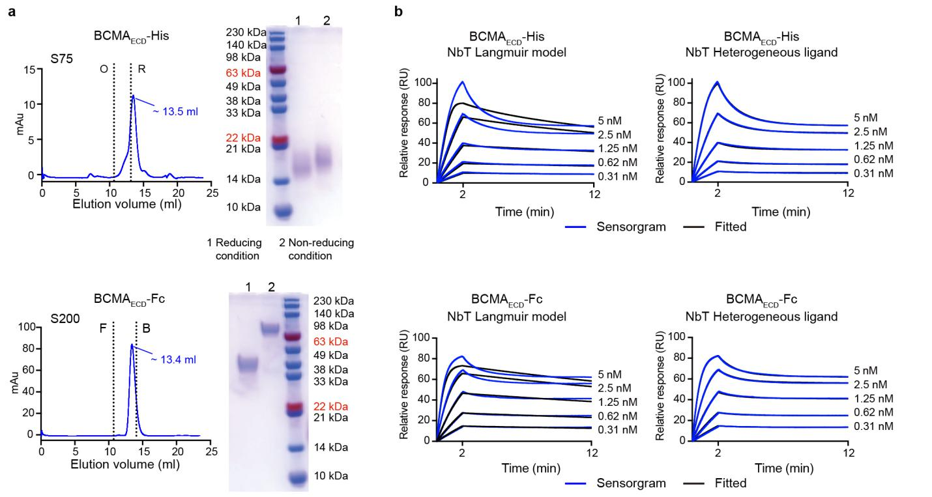

Supplementary Fig 1. Surface Plasmon Resonance (SPR) analysis prompts binding model of NbT and BCMA_{ECD}. a Gel filtration and SDS-PAGE analysis of BCMA_{ECD}-His and BCMA_{ECD}-Fc. BCMA_{ECD}-His had the same molecular weight under both reducing and non-reducing conditions, while BCMA_{ECD}-Fc in non-reducing conditions presents twice that of BCMA_{ECD}-Fc under reducing conditions. The elution volume of the peak is labeled. Standard molecular weight is shown as a black dotted line as a reference. F stands for Ferritin (molecular weight [Mw] 440 kDa), B indicates BSA (Mw 67 kDa), O for Ovalbumin (Mw 43 kDa), and R for Ribonuclease A (Mw 13.7 kDa). SDS-PAGE was run on the same gel and the marker lane is duplicated here. b Heterogeneous ligands and Langmuir kinetics model of BCMA_{ECD}-His and BCMA_{ECD}-Fc fit with NbT respectively. Sensorgrams are shown in blue, fitted ones in black.

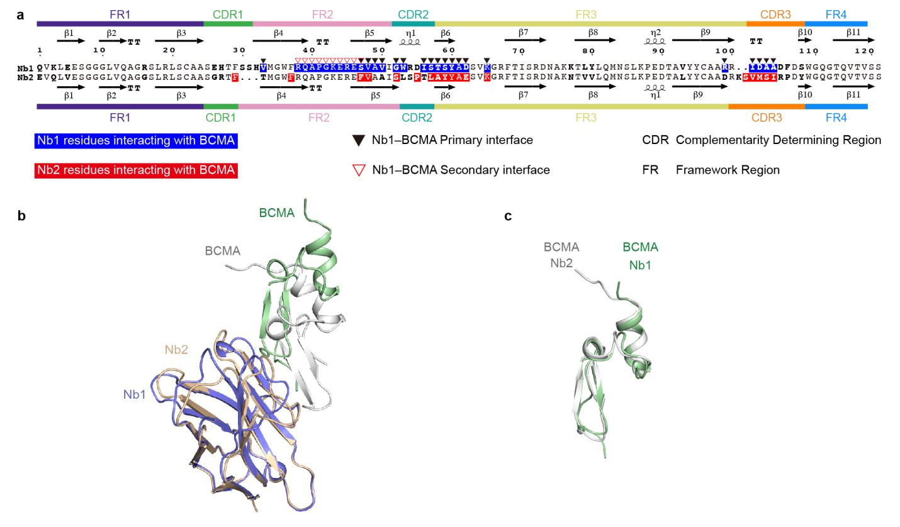

Supplementary Fig 2. Structural basis of nanobody and BCMA complex. a Sequence alignment of Nb1 and Nb2 using ESPript 3.0. Different residues between Nb1 and Nb2 are marked in bold. Nb1 residues interacting with BCMA are shown in the blue box, while Nb2 in red box. Black and white triangles indicate residues in Nb1–BCMA_{ECD} interface, respectively. The secondary structure elements of Nb1 are listed at the top of the alignment, and those of Nb2 are listed at the bottom. β-sheets, 3₁₀-helix, and strict β-turns are denoted β, η, and ΤΤ, respectively. The complementarity-determining region (CDR) and framework region (FR) regions are defined according to the IgBlast tool and solved crystal structure. b the cartoon shows the alignment of Nb1 and Nb2. c the alignment of BCMA interacting with Nb1 and Nb2.

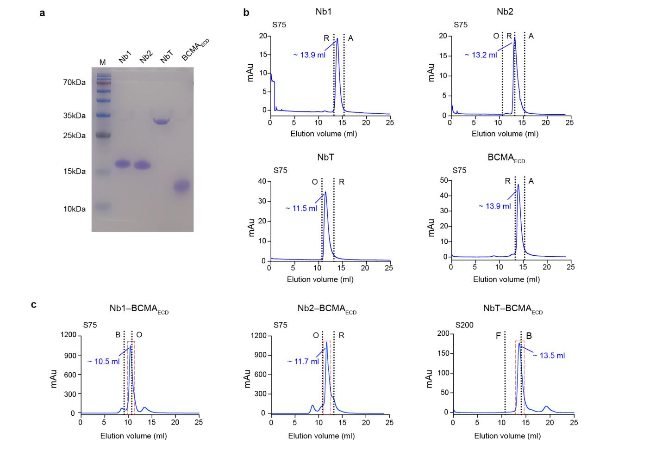

Supplementary Fig 3. Gel filtration studies of nanobody and nanobody–BCMA_{ECD} complex. a SDS-PAGE analysis of BCMA_{ECD}, Nb1, Nb2, and NbT. b BCMA_{ECD}, Nb1, Nb2, and NbT were purified by size-exclusion chromatography using a Superdex 75 column. The elution volume of the peak is labeled. Standard molecular weight is shown as a black dotted line as a reference. A stand for Aprotinin (Mw 6.5 kDa), others are described in supplementary Fig. S1. c Gel filtration of Nb1–BCMAE_{CD}, Nb2–BCMA_{ECD}, and NbT–BCMA_{ECD} using the indicated Superdex column. The proteins in the red dashed square were collected for crystal screening and SAXS data collection.

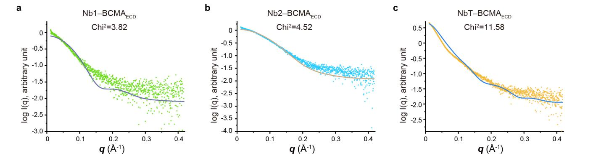

Supplementary Fig 4. Comparison of the simulated atomic structures with the physiological state in solution. a The fitting line (blue) for the Nb1–BCMA_{ECD} model is shown (green dots). The Chi² equals 3.82.
b Model fitting (orange line) against experimental profiles (light blue dots) of Nb2–BCMA_{ECD}. The Chi² equals 4.52. c the fitting (blue line) of the NbT–BCMA_{ECD} model to the experimental profiles (orange dots) is shown. The Chi² equals 11.58.

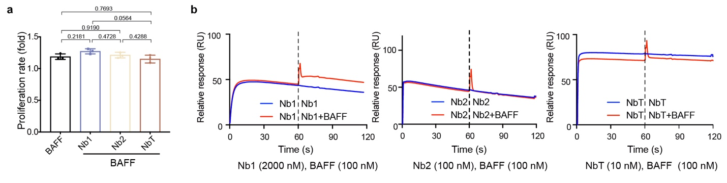

Supplementary Fig 5. The competitive binding of nanobody and BAFF with BCMA_{ECD}. a Nbs exerted no significant effect on MM cells proliferation induced by BAFF. Data are represented as means and SEMs of n = 3 replicates per group, the one-way analysis of variance (ANOVA) followed by Tukey's multiple comparisons test was used to assess the differences among different groups. b Nb1 (2000nM; left), Nb2 (100 nM; middle), and NbT (10 nM; right) were probed for competitive binding against BAFF using SPR.

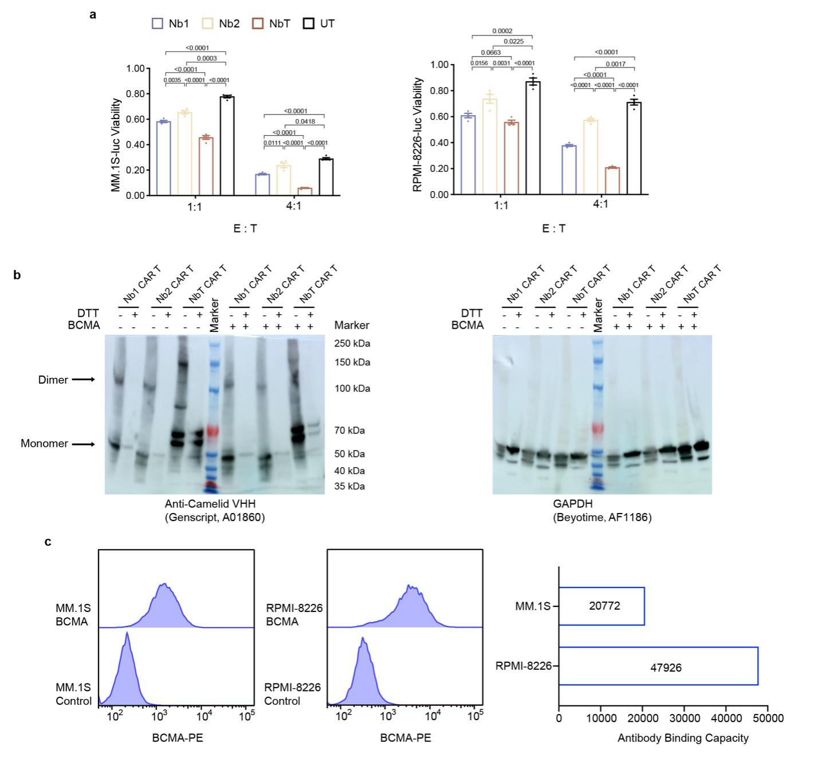

Supplementary Fig 6. CAR T cell cytotoxicity against MM cell lines. a Viability of MM.1S-luc and RPMI 8226-luc cells co-cultured with the indicated CAR T cells from another donor for 24 hrs at the effector: target (E: T) ratios of 1 : 1 and 4 : 1. Data are represented as means and SEMs of n = 4 replicates, using unpaired two-tailed Student’s t test without adjustments for multiple comparisons. b Representative Western blots of nanobody in CAR T cells and control (GAPDH) samples incubate with or without BCMA. Immunoblotting of disulfide-linked nanobody CARs and loading control with respectively primary and secondary antibodies (see Immunoblotting in Methods of main text for details). Synthesized BCMA was incubated with CAR T cells at 4°C for 30min. c Evaluation of cell-surface BCMA levels on MM.1S and RPMI-8226 cells.

Supplementary Table 1. Crystallographic data collection and refinement statistics
 | Nb1–BCMA complex | Nb2–BCMA complex
Data collection
Space group | P4₁2₁2 | P41
Cell dimensions
a, b, c (Å) | 66.77, 66.77, 174.24 | 80.06, 80.06, 78.96
α, β, γ (°) | 90, 90, 90 | 90, 90, 90
Wavelength (Å) | 0.97853 | 0.97853
Resolution (Å) | 50.00-2.39 (2.45-2.39) | 50.00-2.70 (2.86-2.70)
R_{sym} or R_{merge} | 13.6 (137.1) | 26.3 (101.9)
I / σ(Ι) | 11.33 (1.75) | 6.25 (1.65)
Completeness (%) | 99.6 (96.2) | 99.8 (99.6)
Redundancy | 12.6 (12.2) | 4.6 (4.7)
CC1/2 (%) | 99.4 (84.7) | 97.3 (62.3)
Refinement
Resolution (Å) | 47.22-2.4 | 40.03-2.7
No. reflections | 16,136 | 13,778
R_{work} / R_{free} | 22.6 / 27.3 | 24.0 / 28.7
No. atoms
Protein | 2,518 | 2,446
Ligand/ion
Water | 22 | 77
B-factors
Protein | 66.25 | 30.01
Ligand/ion
Water | 53.43 | 23.72
R.m.s. deviations
Bond lengths (Å) | 0.006 | 0.003
Bond angles (°) | 0.96 | 0.65
Ramachandran plot (%)
Favored | 97.8 | 96.14
Allowed | 1.6 | 3.22
Outliers | 0.6 | 0.64

Supplementary Table 2. SAXS data analysis, model fitting and software used
(a) Sample details | Nb1–BCMA_{ECD} | Nb2–BCMA_{ECD} |  | NbT–BCMA_{ECD}
Organism | Homo sapiens BCMA; Camelid nanobodies
Source (Catalogue No. or reference) | Synthesized BCMA_{ECD;} E.coli expressed nanobodies
UniProt sequence ID (residues in construct) | BCMA_{ECD} Q02223(1-54) |  | BCMA_{ECD} Q02223(1-54) |  | BCMA_{ECD} Q02223(1-54)
Molecular mass M from chemical composition (kDa) | 40 |  | 20 |  | 80
Concentration (range/values) measured (mg/mL) | 4-5.6
Solvent composition and source | 20 mM Tris, 100 mM NaCl, pH 8.0
(b) SAS data collection parameters
Source, instrument and description or reference | BL19U2 BioSAXS Beamline, National Facility for Protein Science Shanghai with two detectors inline: Pilatus2M (SAXS)
Wavelength (Å) | 1.03
Beam geometry (size, sample-to-detector distance) (H x V) mm² | 330μm x 50μm (H x V), 2.74m
q-measurement range (Å⁻¹ ) | 0.008-0.47
Method for monitoring radiation damage, X-ray dose where relevant | SAXS data were collected as continuous serial exposures and scattering profiles for the passes were compared to monitor the radiation damage
Exposure time, number of exposures | 1 s per frame, total 20 frames
Sample temperature (ºC) | 25
(c) Software employed for SAS data reduction, analysis and interpretation
SAS data reduction | ln(I) versus q2 using Origin, solvent subtraction using PRIMUS
Extinction coefficient estimate | http://protcalc.sourceforge.net/
Basic analyses: Guinier, P(r), Vp | PRIMUS (ATSAS 2.8.0) ¹
volume (e.g. Porod volume VP or volume of correlation Vc) | PRIMUS (ATSAS 2.8.0) ¹
Shape/bead modelling | DAMMIF ²
Molecular graphics | PyMOL

(d) Structural parameters
Guinier Analysis
Rg (Å) | 29.51±1.01 | 20.53 ± 0.57 | 47.61 ± 0.48
q_{min} (Å⁻¹) | 0.0108 | 0.0181 | 0.0170
qRg max (q_{min}=0.0071 Å⁻¹) | 1.27 | 1.25 | 1.32
P(r) analysis
Rg (Å) | 29.38 | 20.46 | 53.66
D_{max} (Å) | 98.25 | 78.5 | 149.3
q-range (Å⁻¹) | 0.0108-0.2654 | 0.0181-0.3449 | 0.0170-0.1967
Chi² (total estimate from GNOM) | 0.921 (0.96) | 0.87 (0.91) | 0.89 (0.930)
Volume (e.g. VP and/or Vc) (Å³) | 44048 | 23177.5 | 124430
(e) Shape modelling results (a complete panel for each method)
DAMMIF
q-range for fitting | 0.0108-0.4176 | 0.0181-0.4176 | 0.0170-0.4176
Symmetry/anisotropy assumptions | P1, none | P1, none | P1, none
NSD (standard deviation), No. of clusters | 0.87 (0.01),1 | 0.85 (0.02),1 | 0.91 (0.01),1
χ^2 value/range | 1.098 | 0.921 | 1.606
resolution (from SASRES) (Å) | 25 ± 2 | 29 ± 3 | 27 ± 2
(f) Atomistic modelling
CRYSOL
χ^2 value | 3.82 | 4.52 | 11.58
P value | 0.05 | 0 | 0.08
Predicted Rg (Å) | 29.51 | 20.53 | 42.34
(g) Data and model deposition IDs
 | Nb1–BCMA_{ECD} | Nb2–BCMA_{ECD} | NbT–BCMA_{ECD}
 | SASDQV9 | SASDQW9 | SASDQX9

References
1 Franke, D. et al. ATSAS 2.8 : a comprehensive data analysis suite for small-angle scattering from macromolecular solutions. Journal of applied crystallography 50, 1212-1225 (2017).
2 Franke, D. & Svergun, D. I. DAMMIF, a program for rapid ab-initio shape determination in small-angle scattering. J Appl Crystallogr 42, 342-346, doi:10.1107/S0021889809000338 (2009).

