Supplementary Materials for

A novel engineered IL-21 receptor arms T-cell receptor-engineered T cells (TCR-T cells) against hepatocellular carcinoma
Wei Zhu*, Zhiming Zhang*, Jinzhang Chen*, Xiaolan Chen, Lei Huang, Xiaoyong Zhang, Xuan Huang, Na Ma, Weikang Xu, Xuan Yi, Xinyu Lu, Xin Fu, Siwei Li, Guoheng Mo, Yiyue Wang, Guosheng Yuan, Mengya Zang, Qi Li, Xiaotao Jiang, Yajing He, Sha Wu, Yukai He, Yongyin Li,†, Jinlin Hou,†
Correspondence to: jlhousmu@163.com and yongyinli@foxmail.com.
*Authors share co-first authorship.
†Authors share co-corresponding authors.

This PDF file includes:

Figures. S1 to S11
Table S1: Overview of CD8⁺ T cell cluster characteristics
Table S2: Gene markers for computing the immune-related score
Table S3: Jaccard similarity between proliferating T-cell clusters and other clusters
Table S4: Regulon specificity score (RSS) for regulons in TCR-T cells and IL-21R-TCR-T cells

Other Supplementary Materials for this manuscript include the following:

None.

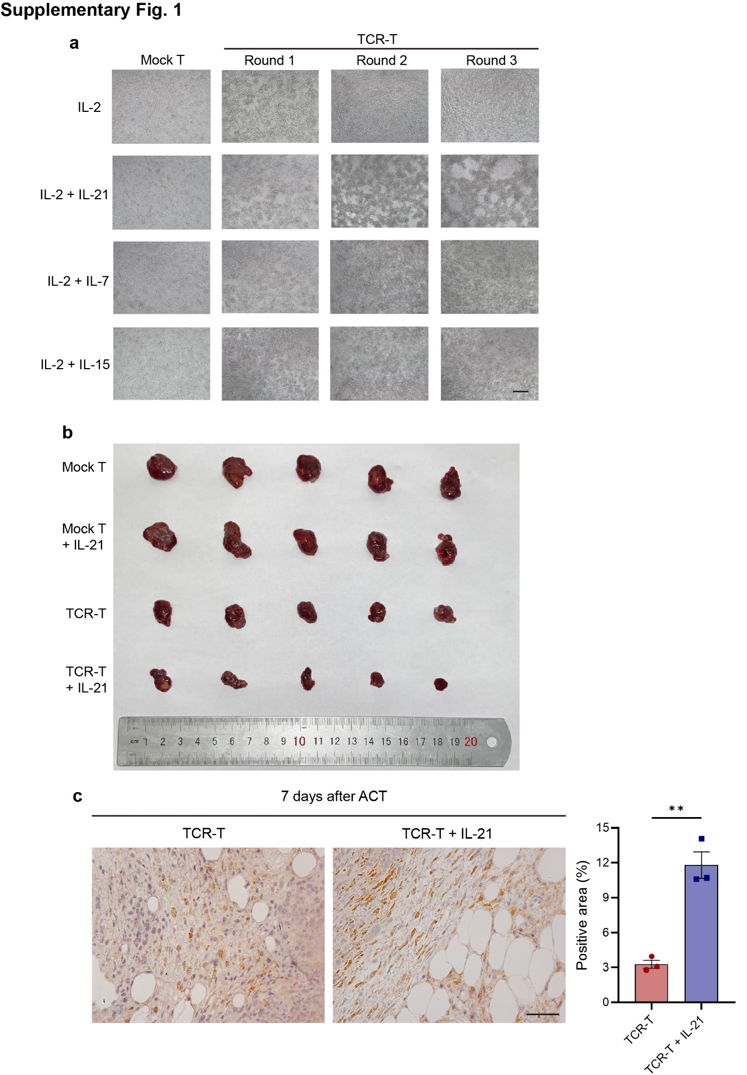

Figure. S1. TCR-T with IL-21 showed enhanced killing function and tumor infiltration. (a) Representative pictures of HepG2 were taken after 36 h cocultured with mock-transduced T or TCR-T in the presence of different cytokines. Scale bar = 100 μm. (b) Tumors were isolated at the end of the experiment from tumor-bearing mice receiving mock-transduced T or TCR-T treatment with or without IL-21. The picture of isolated tumors was shown (n = 5). (c) IHC pictures of the mice tumor 7 days after AFP-TCR-T or AFP-TCR-T with IL-21 transferring targeting the mouse TCR β chain and the quantification of the positive area in each group were shown (n = 3). Scale bar = 50μm. The data was shown as Mean ± SEM, **p <0.01.

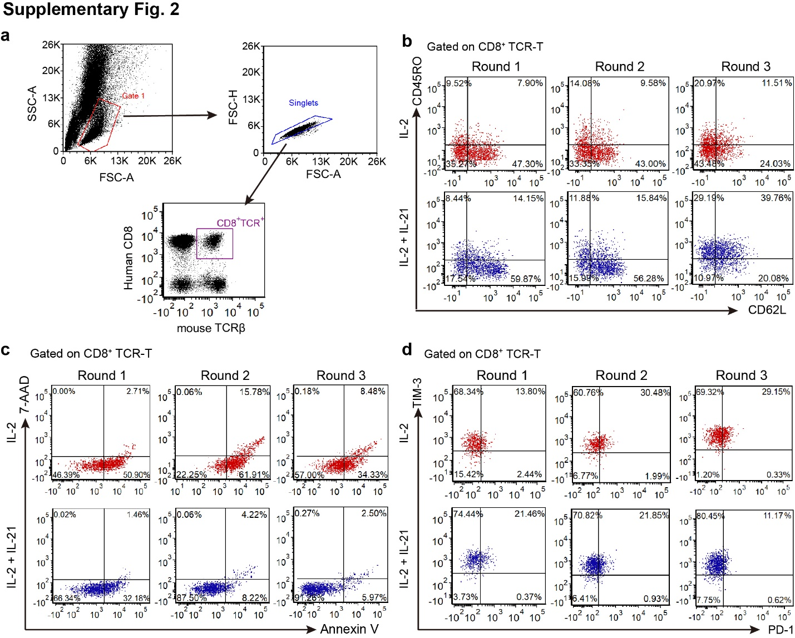

Figure. S2. IL-21-supplemented TCR-T showed increased stemness and alleviated apoptosis and exhaustion after repetitive tumor antigen stimulation. (a) The gating strategy of CD8⁺ TCR-T subsets in IL-2 or IL-21-supplemented TCR-T during repetitive coculture assay was shown. The expression of CD45RO and CD62L (b), Annexin V and 7-AAD (c), and PD-1 and TIM-3 (d) in CD8⁺ TCR-T subsets after 36h coculture with HepG2 in the presence of IL-2 or IL-2 + IL-21 was detected by flow cytometry. Representative pictures of the dot plots at each timepoint were shown.

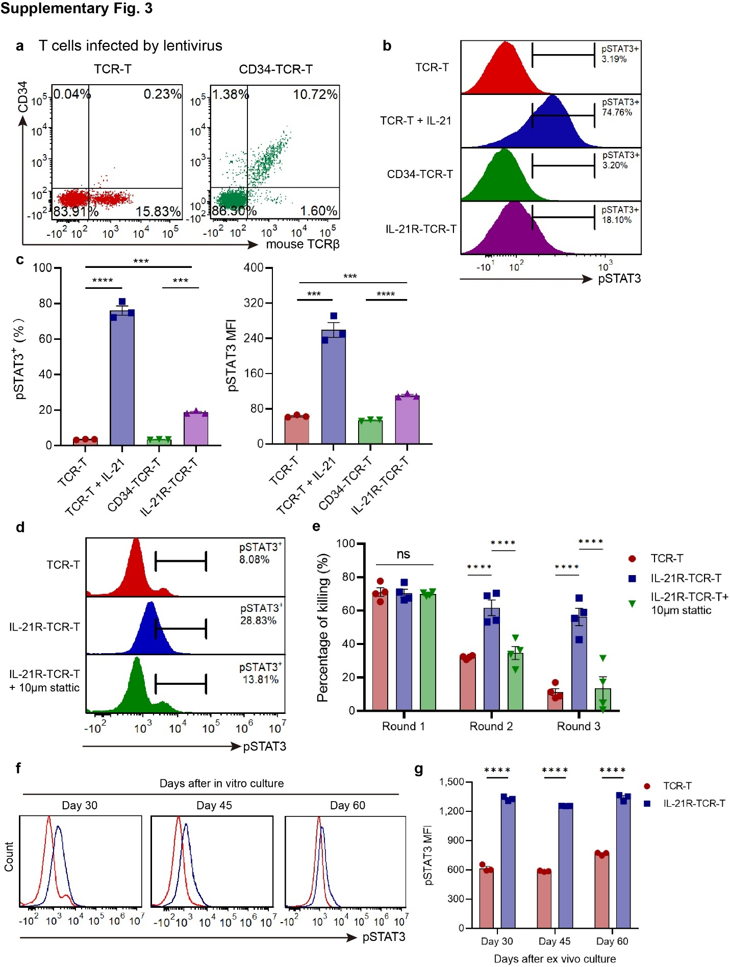

Figure. S3. Expression of the engineered IL-21R and CD34 ectodomain in CD34-TCR-T and validation of the IL-21 signal. (a) The AFP-TCR and CD34 expression in human TCR-T and CD34-TCR-T was measured by flow cytometry. The representative dot plots were shown. (b) The STAT3 phosphorylation level in human TCR-T with or without IL-21, CD34-TCR-T and IL-21R-TCR-T was measured by flow cytometry. The representative histogram of phosphorylation STAT3 expression was shown. (c) The percentage of pSTAT3⁺ cells and MFI of pSTAT3 were shown (n = 3). (d) The STAT3 phosphorylation levels in conventional TCR-T, IL-21R-TCR-T and IL-21R-TCR-T with 10µM stattic were detected by flow cytometry. Representative histograms of each group were shown. (e) The CTL activity of conventional TCR-T, IL-21R-TCR-T and IL-21R-TCR-T with 10µM stattic after 36h coculture with HepG2 was measured by LDH assay (n = 4). (f) The STAT3 phosphorylation level of conventional TCR-T and IL-21R-TCR-T after 30, 45 and 60 days in vitro culture was detected by flow cytometry. The representative histogram and the MFI of pSTAT3 (g) were shown (n = 3). The data was shown as Mean ± SEM, ***p <0.001, ****p <0.0001.

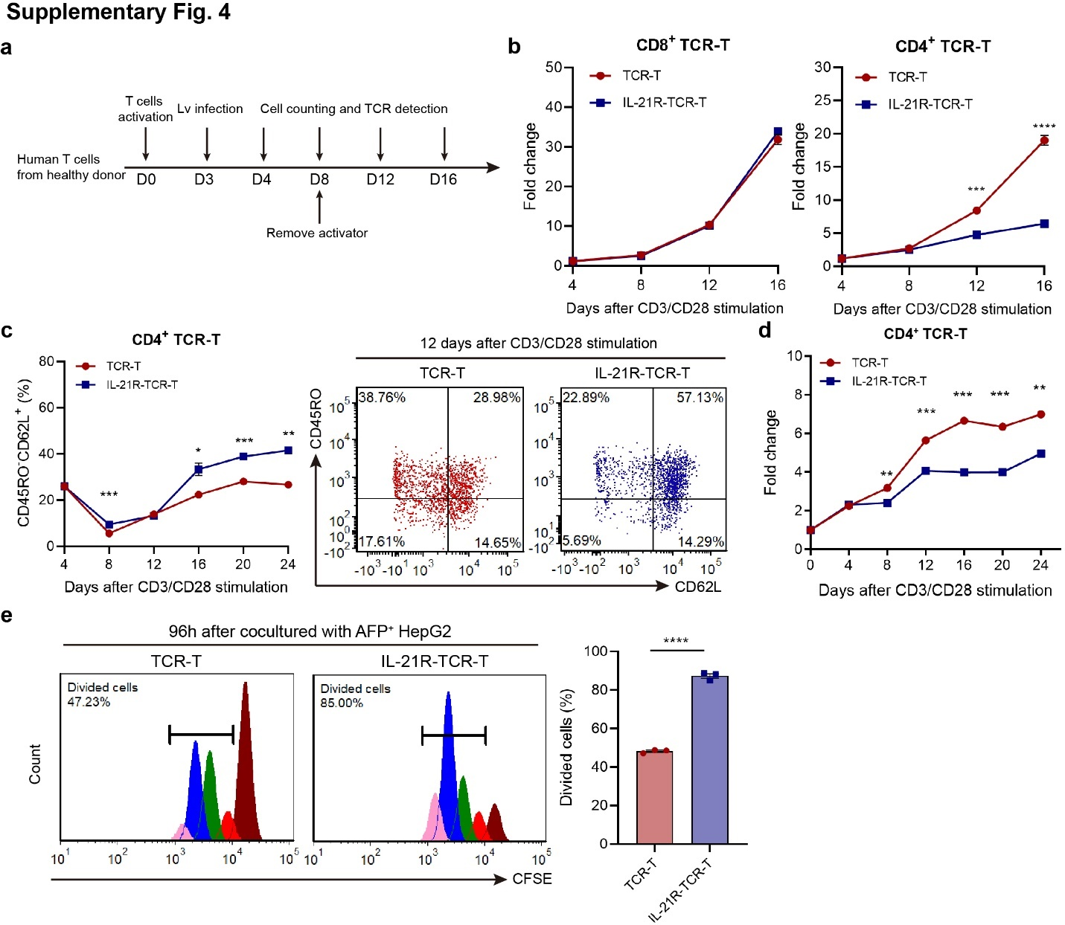

Figure. S4. Proliferation of IL-21R-TCR-T and memory phenotype of CD4⁺ TCR-T subsets. (a) The ex vivo generating process of TCR-T and IL-21R-TCR-T. (b) The proliferating fold change of CD8⁺ and CD4⁺ TCR-T and IL-21R-TCR-T during the initial generating process was shown respectively (n = 3). (c) The percentage of the CD45RO⁻CD62L⁺ population in CD4⁺ TCR-T or IL-21R-TCR-T from Day 4 to Day 24 after CD3/CD28 activation was monitored by flow cytometry (n = 3). The CD45RO and CD62L expression of CD4⁺ TCR-T and IL-21R-TCR-T 12 days after CD3/CD28 activation was shown. (d) The proliferating fold change of CD4⁺ TCR-T and IL-21R-TCR-T after CD3/CD28 activation was shown (n = 3). (e) CFSE labeled TCR-T or IL-21R-TCR-T were cocultured with HepG2 for 96h and analyzed by flow cytometry. The brown peak indicated the first proliferating generation, the red indicated the second, the green indicated the third, the blue indicated the fourth and the pink indicated the fifth. The percentage of divided cells in the TCR⁺ population was shown (n = 3). Data were shown as Mean ± SEM, *p <0.05, **p <0.01, ***p <0.001, ****p <0.0001.

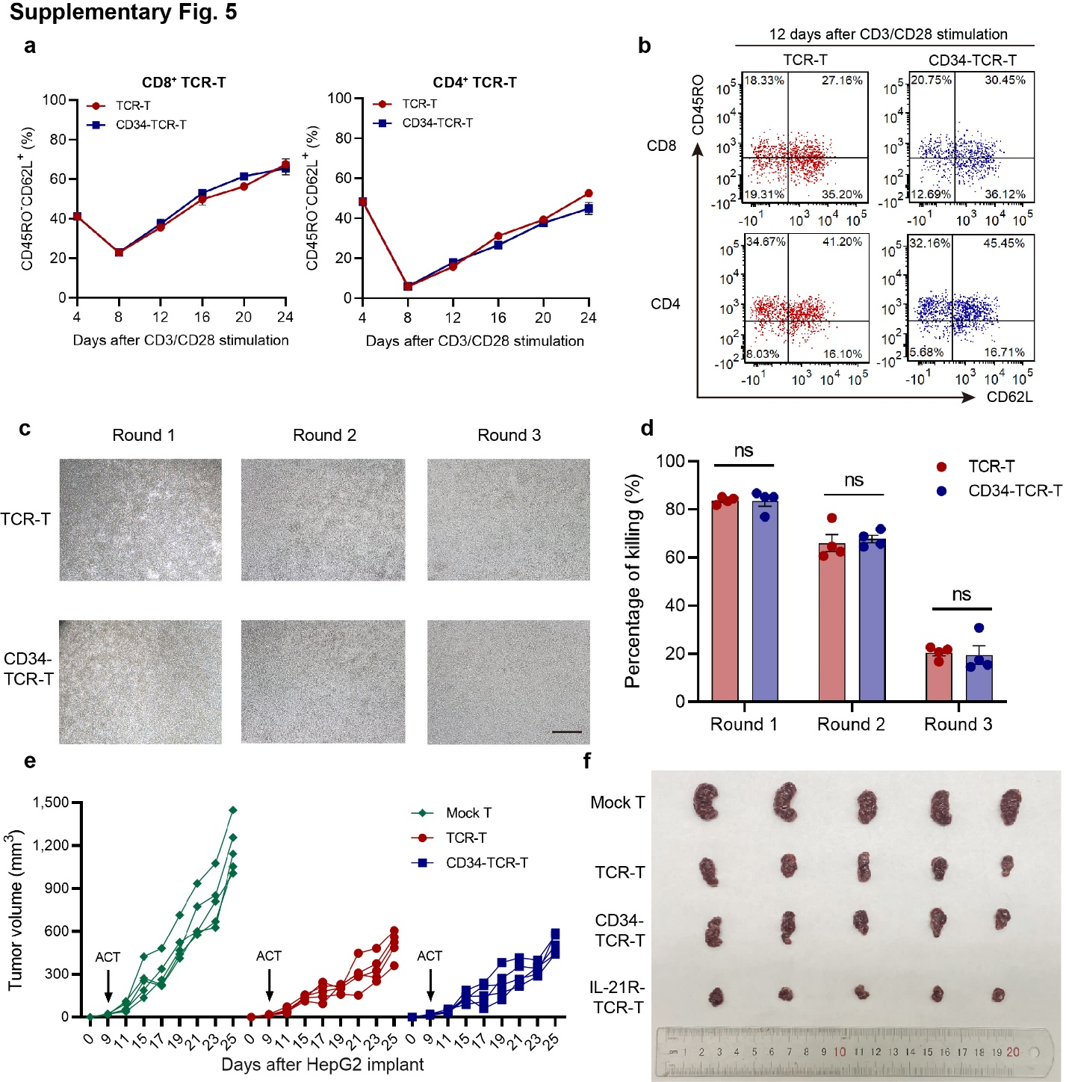

Figure. S5. The proliferation, memory phenotype and antitumor function of CD34-TCR-T. (a) The percentage of the CD45RO⁻CD62L⁺ population in CD8⁺ and CD4⁺ TCR-T or CD34-TCR-T from Day 4 to Day 24 after CD3/CD28 activation was monitored by flow cytometry (n = 3). (b) The CD45RO and CD62L expression of CD8⁺ and CD4⁺ TCR-T and CD34-TCR-T 12 days after CD3/CD28 activation was shown. (c) The CTL activity of conventional TCR-T and CD34-TCR-T after multiple-round coculture with HepG2 was measured by LDH assay (n = 4). Scale bar =100 μm. (d) Representative pictures of HepG2 after 36h coculture (Round 1, Round 2 and Round 3, the same procedure as Fig. 1a) with conventional TCR-T or CD34-TCR-T were shown. (e) The tumor volume of each mouse after HepG2 implantation and mock-transduced T, TCR-T or CD34-TCR-T transfer was monitored (n = 5). (f) Tumors from tumor-bearing mice receiving mock-transduced T, TCR-T, CD34-TCR-T or IL-21R-TCR-T treatment were isolated at the end of the experiment. The picture of isolated tumors was shown (n = 5). Data were shown as Mean ± SEM, NS, not significant.

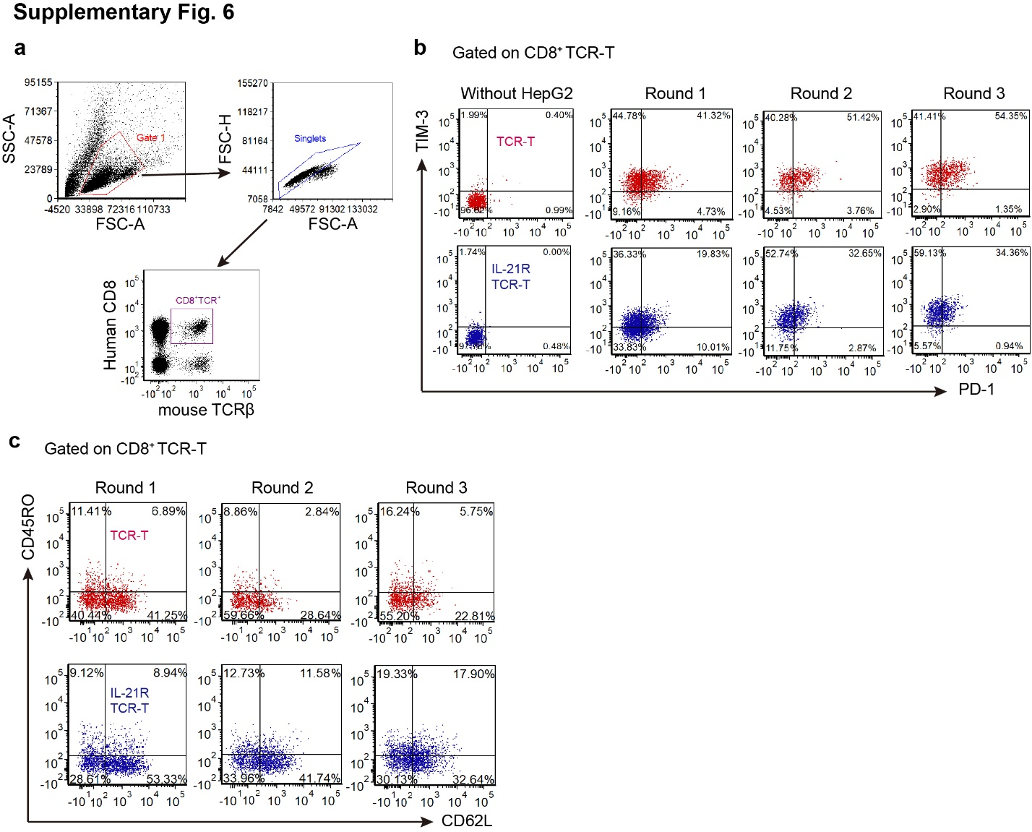

Figure. S6. Expression of exhaustion and memory related markers in CD8⁺ IL-21R-TCR-T during repetitive tumor stimulation. (a) The gating strategy of CD8⁺ TCR-T subsets in conventional TCR-T and IL-21R-TCR-T during repetitive coculture assay was shown. The expression of PD-1, TIM-3 (b) and CD45RO, CD62L (c) in CD8⁺ TCR-T subsets of conventional TCR-T and IL-21R-TCR-T after 36h coculture with HepG2 was detected by flow cytometry. Representative pictures of the dot plots at each timepoint were shown.

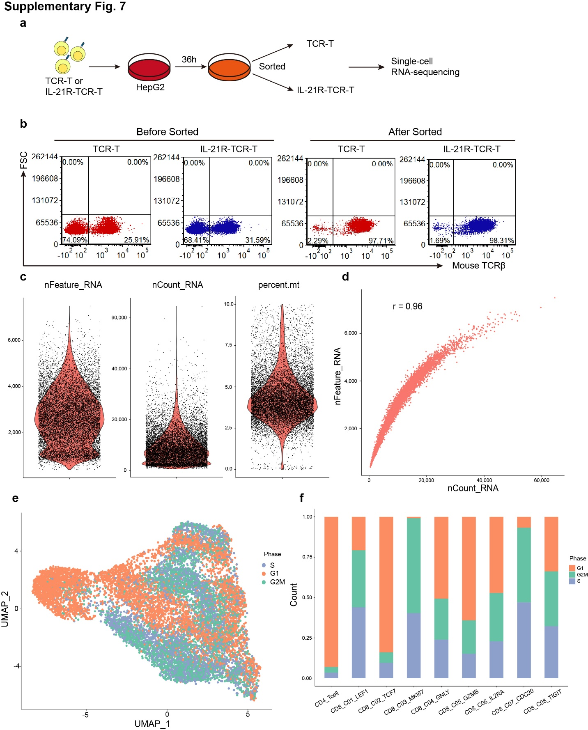

Figure. S7. Cells preparation procedure and basic information of the single-cell RNA-seq data. (a) IL-21R-TCR-T or TCR-T after 36h cocultured with HepG2 were sorted and analyzed by single-cell RNA sequencing. The procedure was shown. (b) The percentage of AFP-TCR⁺ proportion in TCR-T and IL-21R-TCR-T before and after sorting was measured by flow cytometry. (c) Violin plots showed the distribution of the number of detected genes per cell, the number of total UMI counts per cell, and the proportion of mitochondrial gene counts. (d) The scatter plot showed the correlation between the number of detected genes per cell and the number of total UMI counts per cell. (e) UMAP plot (Fig. 7a) colored by cell cycle phase. (f) Bar plot showing the contribution of the cell cycle phase to each cell type.

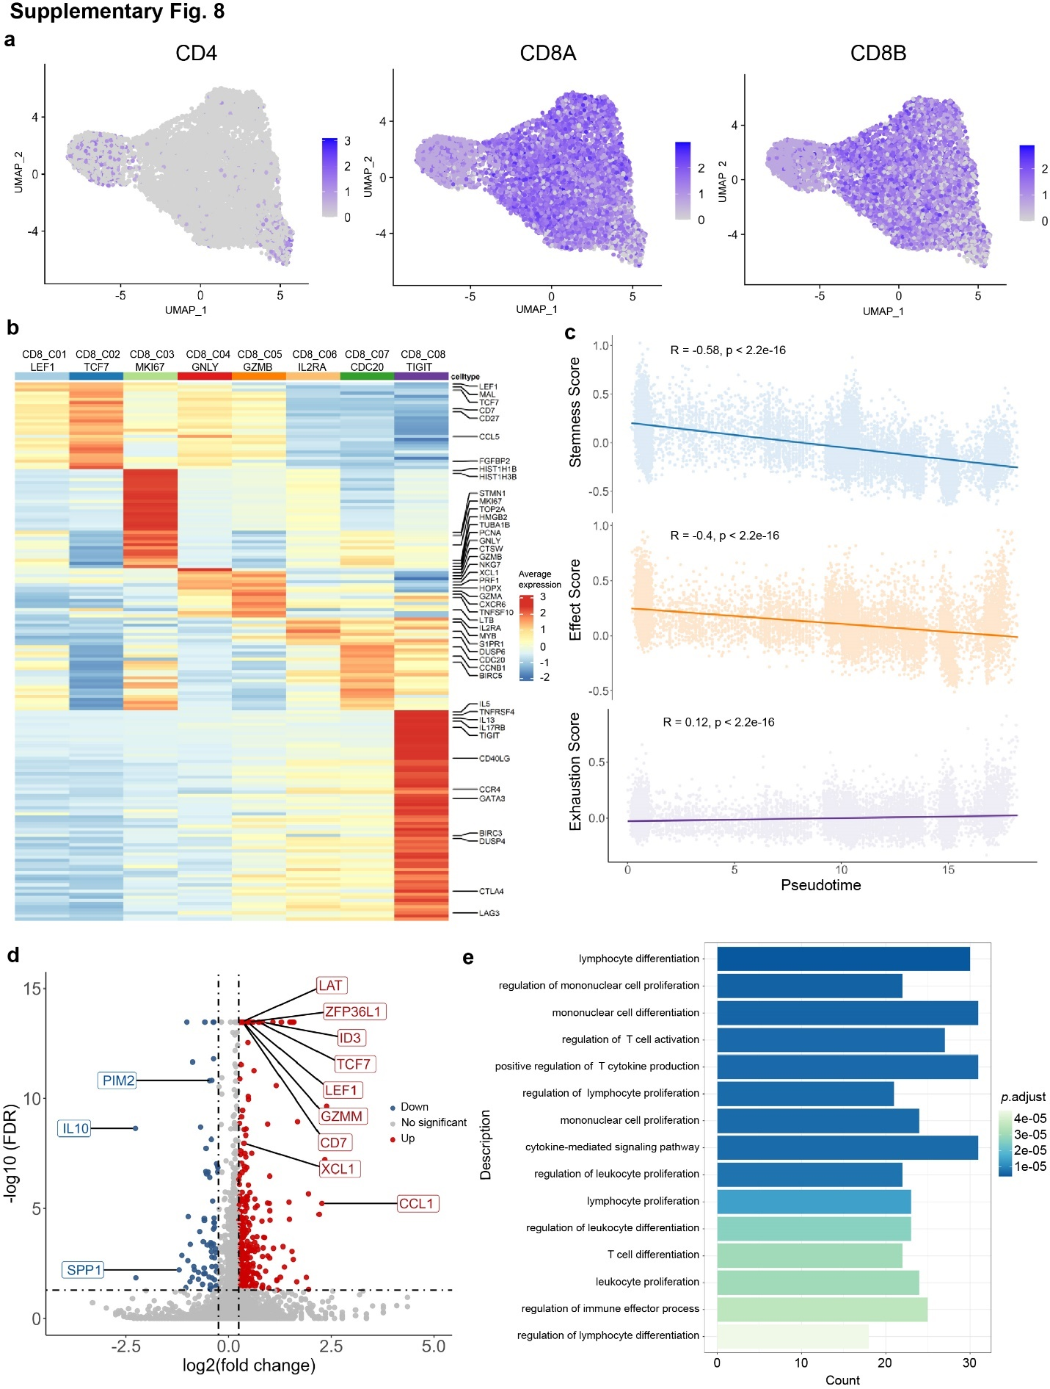

Figure. S8. Cluster Characterization of T cells and DEGs analysis between IL-21R-TCR-T and TCR-T. (a) The canonical marker genes expression to distinguish CD4⁺ T cells and CD8⁺ T cells. (b) Gene expression heatmap of 8 CD8⁺ T cell clusters. Rows represent signature genes and columns represent different clusters. The expression value is the z-score normalized mean expression. (c) Correlation of immune related score and pseudotime defined by monocle2 trajectory plot of all CD8⁺ T cells. Each dot represents a cell (Pearson’s correlation analysis). (d) Volcano plot showing differentially expressed genes between CD8⁺ TCR-T cells and CD8⁺ IL-21R-TCR-T cells. Red dots are upregulated significant genes (log2 (FC) > 0.25, FDR < 0.05), and blue dots are downregulated significant genes (log2 (FC) < -0.25, FDR < 0.05). (e) Enriched GO terms of differentially expressed genes in D.

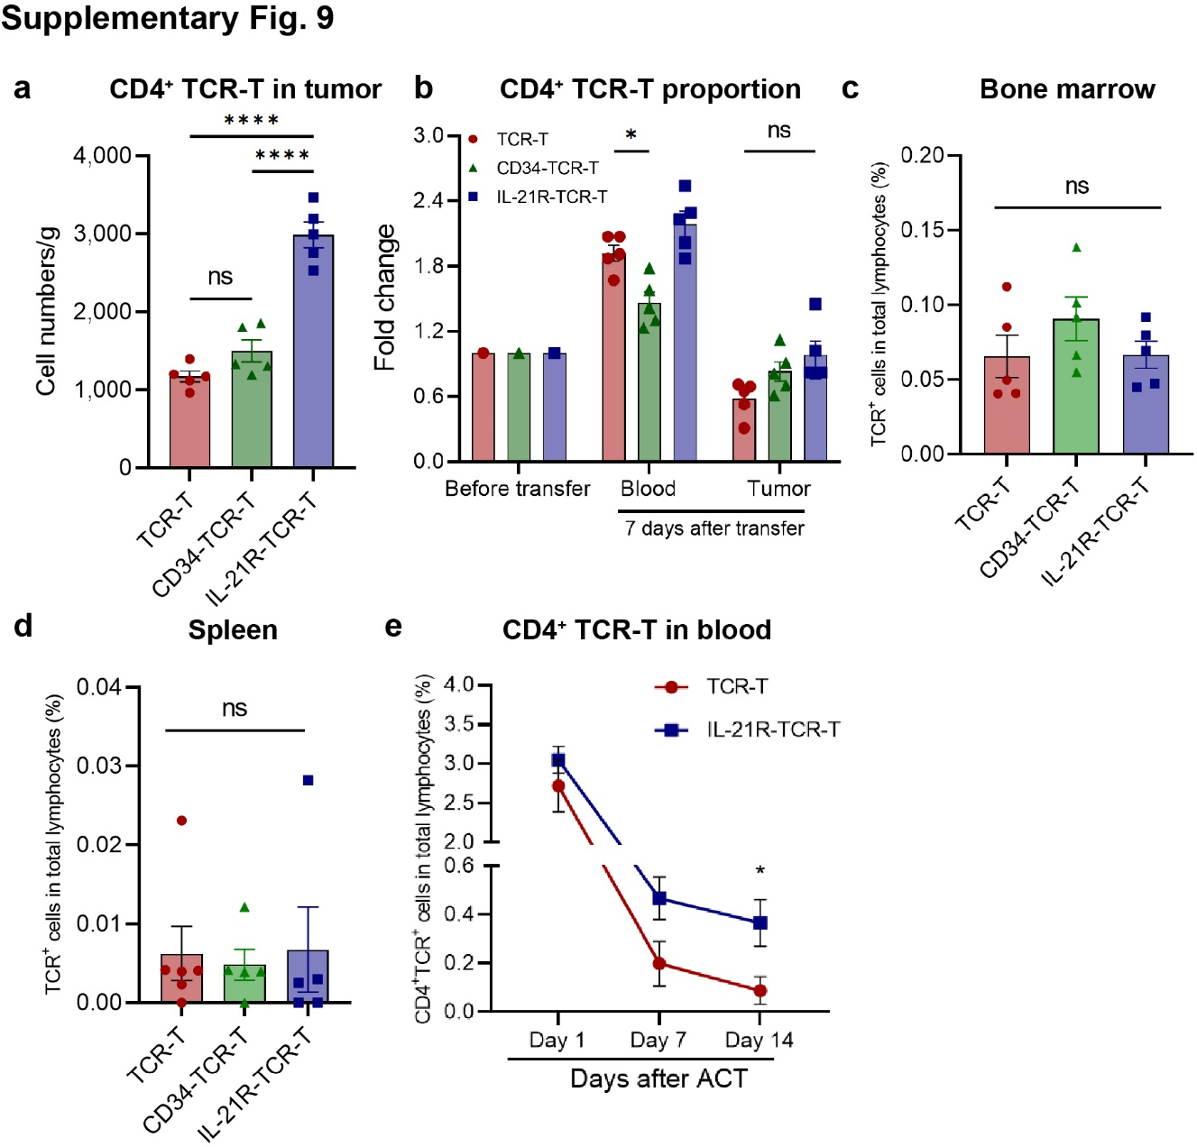

Figure. S9. CD4⁺ TCR-T in tumor and peripheral blood and monitoring of bone marrow and spleen cells after transfer. (a) The numbers of tumor-infiltrating CD4⁺ TCR-T in mice receiving TCR-T, CD34-TCR-T, and IL-21R-TCR-T were measured by flow cytometry and shown (n = 5). (b) The CD4⁺ TCR-T percentage in TCR-T, CD34-TCR-T and IL-21R-TCR-T before and after 7 days of transfer was measured by flow cytometry. The fold change of CD4⁺ TCR-T percentage in peripheral blood and tumor 7 days after transfer was shown (n = 5). The percentage of TCR⁺ cells in mice bone marrow (c) and spleen (d) 7 days after transfer was shown (n = 5). (e) The percentage of CD4⁺ TCR-T cells in total lymphocytes (mice and human lymphocytes) in the peripheral blood of each mouse 1, 7 and 14 days after TCR-T transfer was shown (n = 5). Data were shown as Mean ± SEM, *p <0.05, **p <0.01, ***p <0.001, ****p <0.0001, NS, not significant.

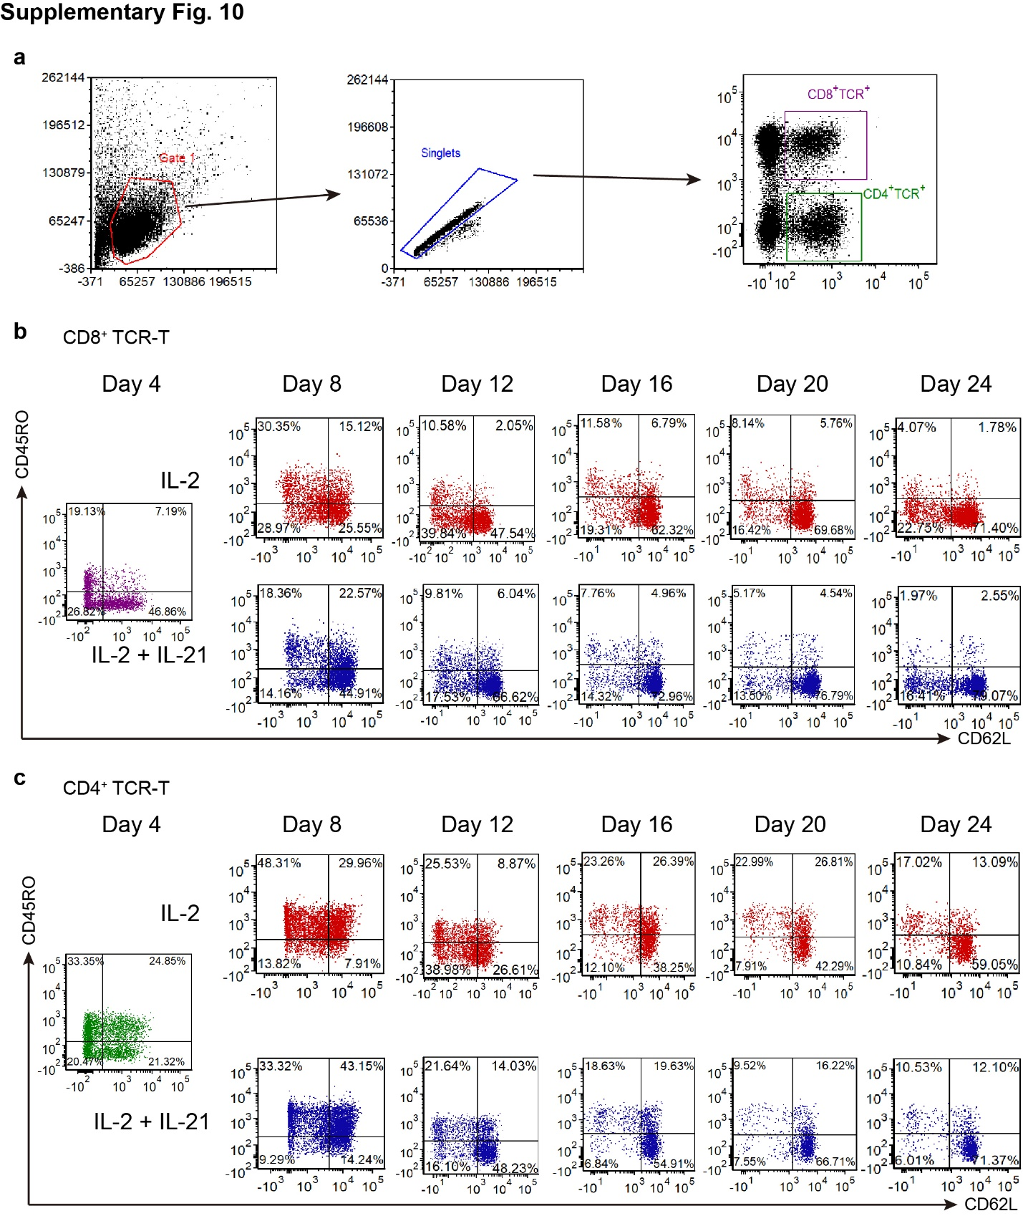

Figure. S10. Memory phenotype of the CD8⁺ and CD4⁺ TCR-T during in vitro culture at each time point. (a) The gating strategy of the CD8⁺ and CD4⁺ TCR-T subsets of TCR-T cultured in the presence of IL-2 or IL-2 and IL-21 was shown. The representative dot plots of CD45RO and CD62L expression at each timepoint in CD8⁺ TCR-T (b) and CD4⁺ TCR-T (c) from Day 4 to Day 24 were shown.
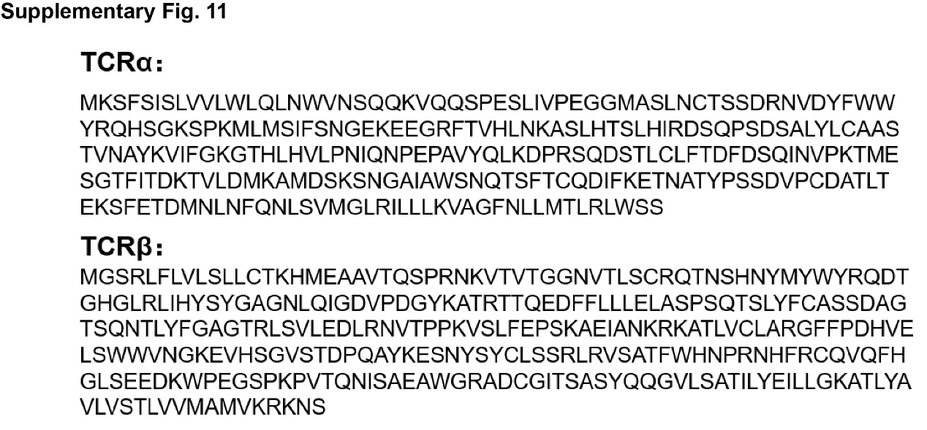

Figure. S11. The TCR α and β chain sequence of AFP-TCR-T.

Table S1 Overview of CD8⁺ T cell cluster characteristics.

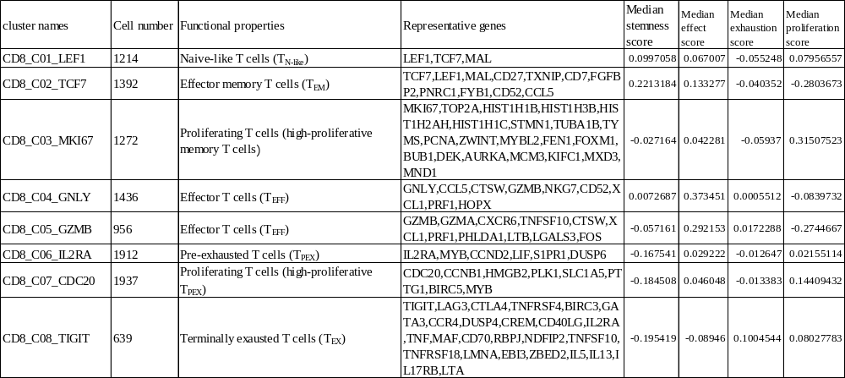

Table S2 Gene markers for computing the immune-related score.
Gene | Feature | Gene | Feature
TCF7 | stemness | CST7 | effect
SELL | stemness | ZWINT | proliferation
LEF1 | stemness | E2F1 | proliferation
CCR7 | stemness | FEN1 | proliferation
IL7R | stemness | FOXM1 | proliferation
FOXP1 | stemness | H2AFZ | proliferation
BACH2 | stemness | HMGB2 | proliferation
CD27 | stemness | MCM2 | proliferation
ID3 | stemness | MCM3 | proliferation
LTB | stemness | MCM4 | proliferation
CX3CR1 | effect | MCM5 | proliferation
IL2 | effect | MCM6 | proliferation
PRF1 | effect | MKI67 | proliferation
GZMA | effect | MYBL2 | proliferation
GZMB | effect | PCNA | proliferation
KLRG1 | effect | PLK1 | proliferation
NKG7 | effect | CCND1 | proliferation
IFNG | effect | AURKA | proliferation
FGFBP2 | effect | BUB1 | proliferation
EOMES | effect | TOP2A | proliferation
ID2 | effect | TYMS | proliferation
TBX21 | effect | DEK | proliferation
CD28 | effect | CCNB1 | proliferation
GZMH | effect | CCNE1 | proliferation
CD7 | effect | LAYN | exhaustion
GNLY | effect | ITGAE | exhaustion
FCGR3A | effect | PDCD1 | exhaustion
GZMK | effect | CTLA4 | exhaustion
LYAR | effect | HAVCR2 | exhaustion
GZMM | effect | LAG3 | exhaustion
TXNIP | effect | TIGIT | exhaustion
FCRL6 | effect | TOX | exhaustion
KLRD1 | effect | ENTPD1 | exhaustion
 |  | PRDM1 | exhaustion

Table S3 Jaccard similarity between proliferating T-cell clusters and other clusters.
 | CD8_C03_MKI67 | CD8_C07_CDC20
CD8_C01_LEF1 | 0.071428571 | 0.035375324
CD8_C02_TCF7 | 0.024765158 | 0
CD8_C04_GNLY | 0.020408163 | 0.001669449
CD8_C05_GZMB | 0.011804384 | 0.005025126
CD8_C06_IL2RA | 0.01095198 | 0.133144476
CD8_C08_TIGIT | 0.003344482 | 0.057268722

Table S4 Regulon specificity score (RSS) for regulons in TCR-T cells and IL-21R-TCR-T cells.
 | TCRT | IL21R_TCRT | TCRT_rank | IL21R_TCRT_rank
JUNB_extended (70g) | 0.668305353 | 0.217151491 | 1 | 24
YY1 (1418g) | 0.666451169 | 0.22257948 | 2 | 4
JUND_extended (259g) | 0.666171498 | 0.222553683 | 3 | 5
JUND (81g) | 0.665941635 | 0.221453472 | 4 | 10
GTF2A2 (11g) | 0.665239579 | 0.220820623 | 5 | 13
YBX1_extended (1808g) | 0.664617397 | 0.221369089 | 6 | 11
FOS (1903g) | 0.66440264 | 0.22180037 | 7 | 8
JUNB (20g) | 0.661212079 | 0.215611593 | 8 | 29
JUN_extended (373g) | 0.656178775 | 0.221716745 | 9 | 9
JUN (148g) | 0.649073057 | 0.220878691 | 10 | 12
POLE4_extended (1102g) | 0.646950179 | 0.219728721 | 11 | 18
KLF6_extended (28g) | 0.645844098 | 0.219962072 | 12 | 17
STAT1_extended (740g) | 0.642130994 | 0.22336076 | 13 | 3
IKZF1_extended (693g) | 0.637753603 | 0.220148071 | 14 | 15
STAT3_extended (951g) | 0.632669541 | 0.22378403 | 15 | 2
SF1 (297g) | 0.629857287 | 0.218337732 | 16 | 22
POLE3_extended (797g) | 0.626941445 | 0.220452395 | 17 | 14
RUNX3_extended (154g) | 0.626905311 | 0.220100698 | 18 | 16
STAT1 (323g) | 0.624079559 | 0.222138216 | 19 | 6
MYB_extended (172g) | 0.622123307 | 0.199276714 | 20 | 49
STAT3 (119g) | 0.620415745 | 0.216566248 | 21 | 26
KDM5A (682g) | 0.619659853 | 0.215495198 | 22 | 30
ZNF706 (17g) | 0.619191214 | 0.208744562 | 23 | 41
RUNX3 (97g) | 0.619166793 | 0.216755038 | 24 | 25
SAP30 (119g) | 0.618846349 | 0.210513594 | 25 | 36
TFDP1_extended (541g) | 0.617920681 | 0.213681752 | 26 | 32
ATF4 (68g) | 0.615850838 | 0.211407866 | 27 | 34
SMARCC2 (1189g) | 0.608970563 | 0.216402205 | 28 | 27
ATF4_extended (81g) | 0.60640527 | 0.209043257 | 29 | 39
IRF1 (105g) | 0.603126367 | 0.211296963 | 30 | 35
RBPJ (46g) | 0.58889487 | 0.193110862 | 31 | 55
IKZF1 (49g) | 0.587969101 | 0.21919898 | 32 | 21
MYBL2_extended (258g) | 0.584768355 | 0.208493916 | 33 | 42
MYBL2 (257g) | 0.584705138 | 0.208493285 | 34 | 43
NFKB1_extended (44g) | 0.582139257 | 0.219655083 | 35 | 19
E2F4 (171g) | 0.582098454 | 0.209843963 | 36 | 37
ZBTB7A_extended (309g) | 0.579120403 | 0.209800824 | 37 | 38
BATF_extended (64g) | 0.57880101 | 0.215893184 | 38 | 28
KLF13_extended (281g) | 0.577698074 | 0.219650069 | 39 | 20
TBX21_extended (200g) | 0.563097781 | 0.1954182 | 40 | 52
MYB (79g) | 0.560812392 | 0.182505599 | 41 | 69
UBTF (377g) | 0.560697136 | 0.214915252 | 42 | 31
TBX21 (152g) | 0.558614062 | 0.194484627 | 43 | 53
LEF1_extended (78g) | 0.54971977 | 0.225675072 | 44 | 1
IRF2_extended (432g) | 0.53919719 | 0.212816338 | 45 | 33
TFDP1 (135g) | 0.53109228 | 0.199550178 | 46 | 48
E2F1_extended (1068g) | 0.530513166 | 0.202887146 | 47 | 45
FOXP1_extended (463g) | 0.530460061 | 0.22206075 | 48 | 7
E2F8 (154g) | 0.508454328 | 0.190474566 | 49 | 56
FOXP1 (243g) | 0.502056759 | 0.218066825 | 50 | 23
E2F8_extended (188g) | 0.501052723 | 0.188090748 | 51 | 61
IRF2 (176g) | 0.499808054 | 0.205974334 | 52 | 44
E2F1 (637g) | 0.499338132 | 0.200762516 | 53 | 47
SP4_extended (829g) | 0.498512487 | 0.184658427 | 54 | 66
PRDM1_extended (61g) | 0.490390176 | 0.160256077 | 55 | 95
BPTF (15g) | 0.485836658 | 0.200996025 | 56 | 46
NFYB_extended (837g) | 0.48133672 | 0.180577468 | 57 | 73
NR3C1_extended (1526g) | 0.480443773 | 0.195442323 | 58 | 51
E2F7 (379g) | 0.480317218 | 0.187077218 | 59 | 62
NR3C1 (1348g) | 0.480208923 | 0.195857558 | 60 | 50
NFYB (724g) | 0.474580939 | 0.178176991 | 61 | 75
E2F7_extended (423g) | 0.471498234 | 0.183552971 | 62 | 68
XBP1_extended (32g) | 0.469554634 | 0.208799971 | 63 | 40
GATA3_extended (78g) | 0.461904207 | 0.173140259 | 64 | 83
SMARCA4 (287g) | 0.449806032 | 0.189065043 | 65 | 59
STAT5A_extended (704g) | 0.439602476 | 0.185580769 | 66 | 64
BCL3_extended (30g) | 0.436847145 | 0.176665199 | 67 | 77
SIN3A (1222g) | 0.434166305 | 0.186128014 | 68 | 63
CHD2_extended (304g) | 0.434106839 | 0.190284012 | 69 | 57
EP300 (548g) | 0.431306213 | 0.178217414 | 70 | 74
SP1_extended (331g) | 0.431303982 | 0.174324042 | 71 | 80
E2F2_extended (405g) | 0.429417202 | 0.174759582 | 72 | 79
TAF1_extended (1516g) | 0.428249042 | 0.182481238 | 73 | 70
E2F2 (309g) | 0.425099261 | 0.174318023 | 74 | 81
CHD2 (216g) | 0.424081314 | 0.189709632 | 75 | 58
SRF_extended (1173g) | 0.417505754 | 0.162195649 | 76 | 93
NFATC3_extended (18g) | 0.412946377 | 0.180765797 | 77 | 72
FOXO3_extended (111g) | 0.412846165 | 0.175314035 | 78 | 78
NFATC3 (13g) | 0.410819656 | 0.181930778 | 79 | 71
THAP11_extended (1107g) | 0.403485412 | 0.164166791 | 80 | 89
ELF2_extended (1656g) | 0.400399296 | 0.165876264 | 81 | 87
ELF2 (1205g) | 0.397093702 | 0.164635087 | 82 | 88
ATF6_extended (755g) | 0.394163403 | 0.163893384 | 83 | 90
ZMIZ1_extended (853g) | 0.392900388 | 0.159101364 | 84 | 96
FOXP3_extended (20g) | 0.392157682 | 0.16278301 | 85 | 92
RELB_extended (77g) | 0.390610713 | 0.184866177 | 86 | 65
RELB (59g) | 0.387799995 | 0.184267055 | 87 | 67
NFYC_extended (609g) | 0.386779892 | 0.1617173 | 88 | 94
RAD21 (17g) | 0.384572747 | 0.155140062 | 89 | 100
FOSB_extended (32g) | 0.381243534 | 0.148276333 | 90 | 106
ELK4_extended (1507g) | 0.380591433 | 0.169939055 | 91 | 85
FOSB (20g) | 0.379704054 | 0.148333126 | 92 | 105
FOXO1_extended (939g) | 0.376671529 | 0.172820592 | 93 | 84
REL_extended (128g) | 0.375735161 | 0.193577835 | 94 | 54
FOXO1 (847g) | 0.374603257 | 0.173612566 | 95 | 82
BATF (44g) | 0.366060724 | 0.17812451 | 96 | 76
GTF2B_extended (252g) | 0.361357095 | 0.16378171 | 97 | 91
REL (70g) | 0.35611283 | 0.188452387 | 98 | 60
SREBF2_extended (1117g) | 0.35425431 | 0.168971386 | 99 | 86
SP3_extended (1092g) | 0.353991215 | 0.158337075 | 100 | 97
RCOR1_extended (666g) | 0.346593917 | 0.154107198 | 101 | 101
TAF1 (954g) | 0.346108094 | 0.156589693 | 102 | 99
NFYC (335g) | 0.334728833 | 0.149924544 | 103 | 104
IRF3_extended (340g) | 0.321030573 | 0.147288824 | 104 | 107
CEBPB_extended (589g) | 0.320409631 | 0.142625732 | 105 | 109
PKNOX1_extended (109g) | 0.316740044 | 0.132609733 | 106 | 113
ATF1_extended (606g) | 0.309435126 | 0.134478687 | 107 | 112
ELK3_extended (394g) | 0.296545731 | 0.108779606 | 108 | 135
ELK1_extended (553g) | 0.293901131 | 0.124002425 | 109 | 121
ATF5_extended (649g) | 0.288486646 | 0.13204911 | 110 | 114
GATA3 (34g) | 0.287791892 | 0.118593618 | 111 | 126
THAP11 (385g) | 0.286365121 | 0.131605252 | 112 | 115
TP53_extended (438g) | 0.286258378 | 0.128237251 | 113 | 117
THAP1_extended (666g) | 0.284922066 | 0.128005221 | 114 | 118
POLE3 (49g) | 0.280368326 | 0.14996281 | 115 | 102
NR2C2_extended (586g) | 0.278987399 | 0.124749637 | 116 | 120
GABPB1_extended (666g) | 0.277145446 | 0.124775754 | 117 | 119
STAT5B_extended (416g) | 0.27559752 | 0.128378865 | 118 | 116
HIVEP1_extended (133g) | 0.270108016 | 0.149960467 | 119 | 103
RBBP5_extended (732g) | 0.267839041 | 0.121803121 | 120 | 122
KLF9_extended (87g) | 0.267025014 | 0.157676395 | 121 | 98
SREBF1_extended (453g) | 0.264285722 | 0.11345621 | 122 | 132
STAT2_extended (236g) | 0.257176443 | 0.120699943 | 123 | 124
GMEB1_extended (364g) | 0.252398857 | 0.116411638 | 124 | 129
HIC1_extended (22g) | 0.246693506 | 0.118339431 | 125 | 127
NFKB2_extended (99g) | 0.242421604 | 0.143775426 | 126 | 108
ATF5 (329g) | 0.23525477 | 0.104541255 | 127 | 140
SREBF2 (131g) | 0.23503132 | 0.141404407 | 128 | 110
CREM_extended (12g) | 0.234326867 | 0.117316711 | 129 | 128
KLF2_extended (68g) | 0.230015594 | 0.091979194 | 130 | 155
NFKB2 (90g) | 0.230013839 | 0.139948472 | 131 | 111
SRF (141g) | 0.229932129 | 0.106886562 | 132 | 137
IRF7_extended (154g) | 0.228708095 | 0.120187551 | 133 | 125
IRF3 (55g) | 0.225743771 | 0.11607598 | 134 | 130
GABPA_extended (427g) | 0.225546513 | 0.107564734 | 135 | 136
CHD1_extended (43g) | 0.223473378 | 0.098831921 | 136 | 146
SP1 (192g) | 0.217678138 | 0.105922561 | 137 | 138
RUNX2_extended (131g) | 0.213256781 | 0.114832692 | 138 | 131
EGR2 (67g) | 0.207744138 | 0.109015326 | 139 | 134
SP2_extended (279g) | 0.206283775 | 0.094171489 | 140 | 150
IRF7 (108g) | 0.201968739 | 0.104125937 | 141 | 141
FOXJ3_extended (128g) | 0.198740687 | 0.096664216 | 142 | 148
E2F3_extended (231g) | 0.19809516 | 0.092517258 | 143 | 154
USF2_extended (286g) | 0.196385394 | 0.093429392 | 144 | 152
ELK1 (171g) | 0.195148557 | 0.090053122 | 145 | 159
E2F3 (213g) | 0.193905025 | 0.091831403 | 146 | 156
STAT2 (97g) | 0.192845385 | 0.092600685 | 147 | 153
RUNX2 (123g) | 0.192351077 | 0.102879425 | 148 | 142
FOXO3 (60g) | 0.191135111 | 0.101323035 | 149 | 144
GABPA (312g) | 0.188790693 | 0.094420763 | 150 | 149
GTF3C2 (224g) | 0.187976157 | 0.098336854 | 151 | 147
ZNF384 (234g) | 0.187181 | 0.08975084 | 152 | 160
ZNF143_extended (302g) | 0.186943027 | 0.085862751 | 153 | 164
ZNF274_extended (287g) | 0.186797949 | 0.086392598 | 154 | 162
MYC (159g) | 0.185993889 | 0.121334081 | 155 | 123
GABPB1 (247g) | 0.185375413 | 0.090649549 | 156 | 158
XRCC4_extended (259g) | 0.182891633 | 0.093731979 | 157 | 151
TBL1XR1_extended (43g) | 0.18271763 | 0.112503478 | 158 | 133
NFATC1_extended (89g) | 0.178396523 | 0.099976611 | 159 | 145
ETV3_extended (239g) | 0.17780747 | 0.080697908 | 160 | 170
BRF1_extended (286g) | 0.177328692 | 0.09142055 | 161 | 157
HIVEP1 (57g) | 0.175835689 | 0.105052946 | 162 | 139
CREBL2_extended (146g) | 0.174096426 | 0.08440859 | 163 | 167
SP2 (198g) | 0.173683666 | 0.07569208 | 164 | 176
KLF13 (11g) | 0.169624805 | 0.101776056 | 165 | 143
FOXJ3 (59g) | 0.166148275 | 0.085792672 | 166 | 165
TBP_extended (198g) | 0.164893975 | 0.076163281 | 167 | 174
ESRRA_extended (264g) | 0.164471843 | 0.078939265 | 168 | 173
NFIL3_extended (26g) | 0.164193234 | 0.083672537 | 169 | 168
SETDB1_extended (249g) | 0.160707811 | 0.079147471 | 170 | 172
TFE3_extended (152g) | 0.160497296 | 0.06997989 | 171 | 180
BATF3_extended (21g) | 0.155881305 | 0.0736183 | 172 | 179
ZNF76_extended (220g) | 0.153423097 | 0.065656117 | 173 | 186
PHF8_extended (175g) | 0.151503934 | 0.069228922 | 174 | 182
CREB1 (140g) | 0.149653235 | 0.068363223 | 175 | 183
BDP1_extended (25g) | 0.148132757 | 0.088884651 | 176 | 161
MAF_extended (50g) | 0.143013453 | 0.076027676 | 177 | 175
ETV3 (140g) | 0.142301941 | 0.06588468 | 178 | 185
ATF3_extended (90g) | 0.138028446 | 0.062978119 | 179 | 187
HSF1_extended (98g) | 0.135048442 | 0.069961865 | 180 | 181
RFX5_extended (112g) | 0.134895618 | 0.073658539 | 181 | 178
NFE2L2_extended (141g) | 0.134480223 | 0.062284432 | 182 | 188
NPDC1_extended (56g) | 0.13043566 | 0.080510059 | 183 | 171
RXRA_extended (38g) | 0.125521025 | 0.073932215 | 184 | 177
TFE3 (78g) | 0.124106916 | 0.048017842 | 185 | 199
IRF4_extended (32g) | 0.124027496 | 0.085617166 | 186 | 166
ZNF76 (154g) | 0.122145469 | 0.060631633 | 187 | 190
MLXIP_extended (47g) | 0.12021444 | 0.083073013 | 188 | 169
USF1_extended (99g) | 0.114479929 | 0.062077132 | 189 | 189
EOMES_extended (49g) | 0.108063125 | 0.067525188 | 190 | 184
RARG_extended (80g) | 0.106940047 | 0.059406333 | 191 | 191
NFE2L3_extended (39g) | 0.106927522 | 0.086226399 | 192 | 163
VDR_extended (17g) | 0.106699793 | 0.047952466 | 193 | 200
FOSL2_extended (41g) | 0.104787829 | 0.046962385 | 194 | 202
RFX5 (51g) | 0.100095959 | 0.055266761 | 195 | 195
CEBPG_extended (76g) | 0.099275688 | 0.053400061 | 196 | 196
RXRB_extended (98g) | 0.095472992 | 0.046722439 | 197 | 204
EOMES (29g) | 0.092773512 | 0.052456924 | 198 | 197
FOXN2_extended (70g) | 0.091954732 | 0.05005866 | 199 | 198
MXI1 (49g) | 0.091186806 | 0.046855356 | 200 | 203
HSF1 (61g) | 0.089971754 | 0.055624997 | 201 | 194
CLOCK_extended (122g) | 0.089080307 | 0.047693794 | 202 | 201
CREB3L2_extended (31g) | 0.085966441 | 0.028888542 | 203 | 230
MAF (16g) | 0.084928049 | 0.044623946 | 204 | 206
CHD1 (27g) | 0.083537679 | 0.041557399 | 205 | 208
RXRA (18g) | 0.083412913 | 0.057142437 | 206 | 192
AHRR (94g) | 0.079914542 | 0.037914131 | 207 | 213
DBP_extended (45g) | 0.078410245 | 0.044391054 | 208 | 207
ZNF143 (76g) | 0.077508432 | 0.036253523 | 209 | 217
ZEB1_extended (21g) | 0.072850995 | 0.036471706 | 210 | 216
KLF2 (15g) | 0.072781126 | 0.030635929 | 211 | 228
HDAC2 (14g) | 0.071617179 | 0.057008231 | 212 | 193
ETS2_extended (56g) | 0.071436389 | 0.031280747 | 213 | 226
ERF_extended (92g) | 0.070614746 | 0.045777706 | 214 | 205
RXRB (73g) | 0.070391357 | 0.036593756 | 215 | 215
RARG (38g) | 0.069459088 | 0.041437674 | 216 | 210
CEBPB (45g) | 0.069234403 | 0.036988213 | 217 | 214
KLF16_extended (78g) | 0.067810238 | 0.039901257 | 218 | 212
MTF1 (40g) | 0.061480352 | 0.02862576 | 219 | 231
MAX (12g) | 0.060452022 | 0.034472071 | 220 | 219
POLR3G_extended (72g) | 0.058541531 | 0.03303069 | 221 | 223
USF1 (32g) | 0.055475415 | 0.031777219 | 222 | 225
SETDB1 (55g) | 0.055354451 | 0.033460175 | 223 | 222
CDK2AP1 (12g) | 0.054401531 | 0.034878004 | 224 | 218
FOSL2 (13g) | 0.052812149 | 0.022413177 | 225 | 238
PPARA_extended (44g) | 0.051518713 | 0.041454002 | 226 | 209
PBX3_extended (50g) | 0.051435633 | 0.02696204 | 227 | 232
IRF9_extended (25g) | 0.050137375 | 0.030814422 | 228 | 227
VDR (12g) | 0.050089822 | 0.025425744 | 229 | 235
ZNF770 (16g) | 0.048468777 | 0.032230167 | 230 | 224
MBD4_extended (15g) | 0.046133672 | 0.030100266 | 231 | 229
ATF7_extended (50g) | 0.045903651 | 0.023354393 | 232 | 236
BACH1_extended (21g) | 0.045872692 | 0.026499917 | 233 | 233
MLXIP (18g) | 0.043782036 | 0.040089133 | 234 | 211
ARNT_extended (25g) | 0.042297312 | 0.020875344 | 235 | 241
TGIF2 (25g) | 0.040661926 | 0.020445435 | 236 | 243
CREB3L4_extended (42g) | 0.040604642 | 0.014887805 | 237 | 262
E2F6_extended (49g) | 0.040232134 | 0.020524349 | 238 | 242
HES6_extended (41g) | 0.038788845 | 0.017887146 | 239 | 253
CD59_extended (15g) | 0.03821548 | 0.014696578 | 240 | 263
FOXK1_extended (24g) | 0.036888976 | 0.019079949 | 241 | 248
TCF3_extended (22g) | 0.036416742 | 0.018682352 | 242 | 251
ZFY_extended (18g) | 0.0362191 | 0.026413619 | 243 | 234
PBX3 (28g) | 0.036043531 | 0.018950232 | 244 | 249
ETV2_extended (26g) | 0.034856748 | 0.016729577 | 245 | 257
KLF7_extended (11g) | 0.034071672 | 0.034378376 | 246 | 220
ETV2 (23g) | 0.034036297 | 0.015844302 | 247 | 260
ZNF639 (22g) | 0.033928455 | 0.019634322 | 248 | 245
NFYA_extended (17g) | 0.033493965 | 0.021903433 | 249 | 239
NR2F6_extended (27g) | 0.03309947 | 0.033528297 | 250 | 221
ZNF181 (12g) | 0.032554456 | 0.013889531 | 251 | 268
FOXJ2_extended (20g) | 0.031470291 | 0.015931703 | 252 | 259
CREB3_extended (26g) | 0.031177957 | 0.021511469 | 253 | 240
RUNX1_extended (13g) | 0.027980807 | 0.013062833 | 254 | 270
KLF12_extended (25g) | 0.027475181 | 0.023035261 | 255 | 237
ATF7 (29g) | 0.027351578 | 0.01209214 | 256 | 274
SNAI3_extended (15g) | 0.027178325 | 0.014260274 | 257 | 266
BACH2_extended (23g) | 0.025663891 | 0.018568687 | 258 | 252
RFXAP_extended (35g) | 0.025254993 | 0.019222514 | 259 | 247
ZNF846 (22g) | 0.024926684 | 0.008255694 | 260 | 282
MIOS_extended (18g) | 0.02492099 | 0.012824109 | 261 | 272
HIVEP2_extended (14g) | 0.024061897 | 0.017176402 | 262 | 255
RFXAP (28g) | 0.022832569 | 0.018692667 | 263 | 250
TCF12_extended (12g) | 0.022624522 | 0.00975889 | 264 | 280
TFAP4_extended (22g) | 0.02237944 | 0.020088179 | 265 | 244
NRF1_extended (30g) | 0.022124647 | 0.014529251 | 266 | 265
TFEB_extended (13g) | 0.022089723 | 0.011104931 | 267 | 276
TFAP4 (19g) | 0.021868007 | 0.019406514 | 268 | 246
SOX12 (14g) | 0.021850605 | 0.012520048 | 269 | 273
NR2F6 (23g) | 0.021723494 | 0.016216764 | 270 | 258
ZNF460_extended (15g) | 0.021306821 | 0.017490218 | 271 | 254
MNT_extended (22g) | 0.021202739 | 0.01405707 | 272 | 267
RARA_extended (14g) | 0.020792275 | 0.016880166 | 273 | 256
FOXK2_extended (18g) | 0.020527366 | 0.015456647 | 274 | 261
NR2C1_extended (15g) | 0.019888356 | 0.013544531 | 275 | 269
BRF2_extended (15g) | 0.019659785 | 0.008420045 | 276 | 281
RFX2_extended (23g) | 0.019653776 | 0.014682037 | 277 | 264
NRF1 (25g) | 0.018996665 | 0.01177792 | 278 | 275
MNT (18g) | 0.018666733 | 0.012927504 | 279 | 271
THAP1 (18g) | 0.018560269 | 0.006087355 | 280 | 287
RFX7_extended (11g) | 0.017886931 | 0.011018654 | 281 | 277
CUX1_extended (11g) | 0.017360665 | 0.009941161 | 282 | 279
E4F1 (13g) | 0.01533026 | 0.006828724 | 283 | 284
HES6 (13g) | 0.015116515 | 0.002407963 | 284 | 292
ERF (22g) | 0.014464092 | 0.005723349 | 285 | 289
ESRRA (12g) | 0.014376525 | 0.010485462 | 286 | 278
RARA (11g) | 0.013664241 | 0.008059731 | 287 | 283
MAFK_extended (16g) | 0.013475817 | 0.006085774 | 288 | 288
ADNP2 (13g) | 0.011604703 | 0.003573584 | 289 | 291
POU2F1_extended (13g) | 0.011009098 | 0.006163641 | 290 | 286
ZNF611 (12g) | 0.009828469 | 0.003900739 | 291 | 290
E2F6 (12g) | 0.008300526 | 0.00648579 | 292 | 285

